Twin Research and Human Genetics
Supplementary Material
Epigenome-Wide Association Study of Tic Disorders
Nuno R. Zilhão,^{1,3,a} Shanmukha S. Padmanabhuni,^{2*a} Luca Pagliaroli,⁵ Csaba Barta,⁵ BIOS Consortium,* Dirk J. A. Smit,³ Danielle Cath,^{3,4} Michel G. Nivard,¹ Bart M. L. Baselmans,¹ Jenny van Dongen,¹ Peristera Paschou,^{2b} Dorret I. Boomsma^{1b}

¹ Department of Biological Psychology, VU University Amsterdam, Neuroscience Campus Amsterdam, Amsterdam, the Netherlands
² Department of Molecular Biology and Genetics, Democritus University of Thrace, Alexandroupolis, Greece
³ Department of Clinical and Health Psychology, Utrecht University, Utrecht, the Netherlands
⁴ Altrecht Academic Anxiety Disorders Center, Utrecht, the Netherlands
⁵ Institute of Medical Chemistry, Molecular Biology and Pathobiochemistry, Semmelweis University, Budapest, Hungary
* The Biobank-based Integrative Omics Study consortium. For a full list of authors, see supplementary material (BIOS Consortium).
ª Both authors contributed equally to this manuscript and should be referred to as joint first authors.
^{b} Joint last authors.

BIOS Consortium
(Biobank-based Integrative Omics Study)
Management Team Bastiaan T. Heijmans (chair)¹, Peter A. C.’t Hoen², Joyce van Meurs³, Aaron Isaacs⁴, Rick Jansen⁵, Lude Franke⁶.
Cohort collection Dorret I. Boomsma⁷, René Pool⁷, Jenny van Dongen⁷, Jouke J. Hottenga⁷ (Netherlands Twin Register); Marleen M. J. van Greevenbroek⁸, Coen D.A. Stehouwer⁸, Carla J. H. van der Kallen⁸, Casper G. Schalkwijk⁸ (Cohort study on Diabetes and Atherosclerosis Maastricht); Cisca Wijmenga⁶, Lude Franke⁶, Sasha Zhernakova⁶, Ettje F. Tigchelaar⁶ (LifeLines Deep); P. Eline Slagboom¹, Marian Beekman¹, Joris Deelen¹, Diana van Heemst⁹ (Leiden Longevity Study); Jan H. Veldink¹⁰, Leonard H. van den Berg¹⁰ (Prospective ALS Study Netherlands); Cornelia M. van Duijn⁴, Bert A. Hofman¹¹, Aaron Isaacs⁴, André G. Uitterlinden³ (Rotterdam Study).
Data Generation Joyce van Meurs (Chair)³, P. Mila Jhamai³, Michael Verbiest³, H. Eka D. Suchiman¹, Marijn Verkerk³, Ruud van der Breggen¹, Jeroen van Rooij³, Nico Lakenberg¹.
Data management and computational infrastructure Hailiang Mei (Chair)¹², Maarten van Iterson¹, Michiel van Galen², Jan Bot¹³, Dasha V. Zhernakova⁶, Rick Jansen⁵, Peter van ’t Hof¹², Patrick Deelen⁶, Irene Nooren¹³, Peter A.C. ’t Hoen², Bastiaan T. Heijmans¹, Matthijs Moed¹.
Data Analysis Group Lude Franke (Co-Chair)⁶, Martijn Vermaat², Dasha V. Zhernakova⁶, René Luijk¹, Marc Jan Bonder⁶, Maarten van Iterson¹, Patrick Deelen⁶, Freerk van Dijk¹⁴, Michiel van Galen², Wibowo Arindrarto¹², Szymon M. Kielbasa¹⁵, Morris A. Swertz¹⁴, Erik. W. van Zwet¹⁵, Rick Jansen⁵, Peter-Bram ’t Hoen (Co-Chair)², Bastiaan T. Heijmans (Co-Chair)¹.
1. Molecular Epidemiology Section, Department of Medical Statistics and Bioinformatics, Leiden University Medical Center, Leiden, the Netherlands
2. Department of Human Genetics, Leiden University Medical Center, Leiden, the Netherlands
3. Department of Internal Medicine, ErasmusMC, Rotterdam, the Netherlands
4. Department of Genetic Epidemiology, ErasmusMC, Rotterdam, the Netherlands
5. Department of Psychiatry, VU University Medical Center, Neuroscience Campus Amsterdam, Amsterdam, the Netherlands
6. Department of Genetics, University of Groningen, University Medical Centre Groningen, Groningen, the Netherlands
7. Department of Biological Psychology, VU University Amsterdam, Neuroscience Campus Amsterdam, Amsterdam, the Netherlands
8. Department of Internal Medicine and School for Cardiovascular Diseases (CARIM), Maastricht University Medical Center, Maastricht, the Netherlands
9. Department of Gerontology and Geriatrics, Leiden University Medical Center, Leiden, the Netherlands
10. Department of Neurology, Brain Center Rudolf Magnus, University Medical Center Utrecht, Utrecht, the Netherlands
11. Department of Epidemiology, Erasmus MC, Rotterdam, the Netherlands
12. Sequence Analysis Support Core, Leiden University Medical Center, Leiden, the Netherlands
13. SURFsara, Amsterdam, the Netherlands
14. Genomics Coordination Center, University Medical Center Groningen, University of Groningen, Groningen, the Netherlands
15. Medical Statistics Section, Department of Medical Statistics and Bioinformatics, Leiden University Medical Center, Leiden, the Netherlands.

Supplementary methods
Principal Component Analysis (PCA)
Supplementary Figure S1 shows the distribution of genome-wide methylation level for all individuals included in the analysis. Supplementary Figure S2 depicts the PCA plot labeled by sex. As sex in Supplementary Figure S3 shows high correlation with the first principal component (PC 1), we decided to discard sex as a covariate in our final model.

GEE Model and Correlation
Inflation in our initial gee model with the DNA methylation as outcome and tics as the single predictor can be seen the Quantile-Quantile plot (QQ plot) of p values, with inflation factor λ = 1.306 (Supplementary Figure S4). To overcome this problem the other covariates age, smoking status, neutrophils, monocytes and eosinophils count and array row number, were added to the model. Despite the addition of covariates to the model the inflation still exists but is reduced (λ = 1.273, Supplementary Figure S5). At this point, it appears the inflation in the QQ plot is due to variance unaccounted for by the above covariates in the data. To correct for this, we decided to include the top 5 principal components (PCs) in our final model.
Before correcting the inflation in the gee model, correlation of the covariates with the top 20 PCs provided a clear idea as to which covariates should be used from Supplementary Figure S3. Covariates sex, neutrophils count and age were not included due to high correlation values with top 5 PCs. Covariate neutrophil count was highly correlated with the second PC and the covariate age is moderately correlated with fifth PC. Due to the inclusion of the top 5 PCs in the final gee model covariates sex, age and neutrophils count were excluded. Basophil percentage was not included because it showed little variation between subjects, with a large number of subjects having 0% of basophils.

Supplementary Figures and Tables
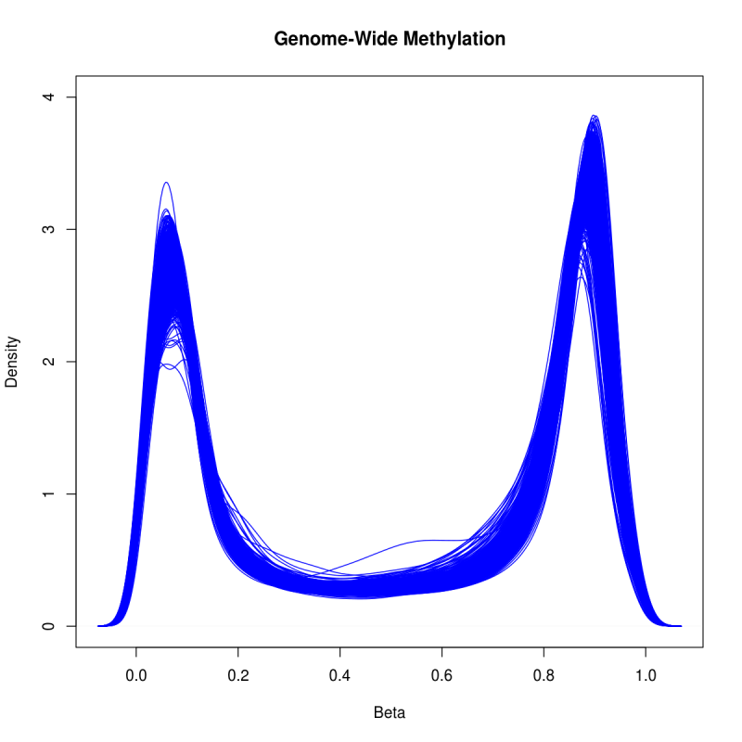
Supplementary Figure S1: Density of methylation levels after normalization for the entire dataset (n = 1,678).

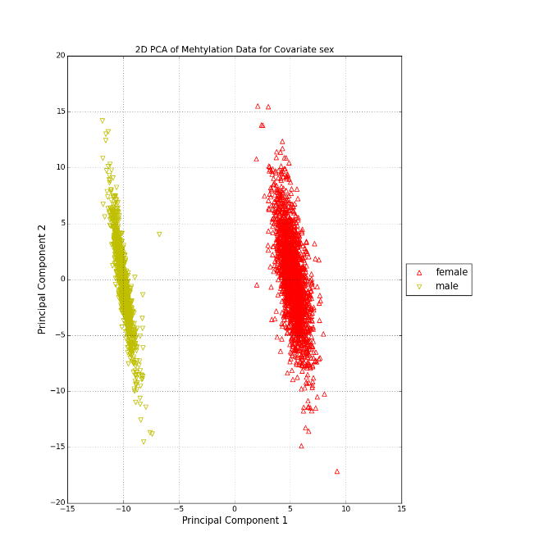
Supplementary Figure S2: Two-dimensional PCA plot labelled by sex.

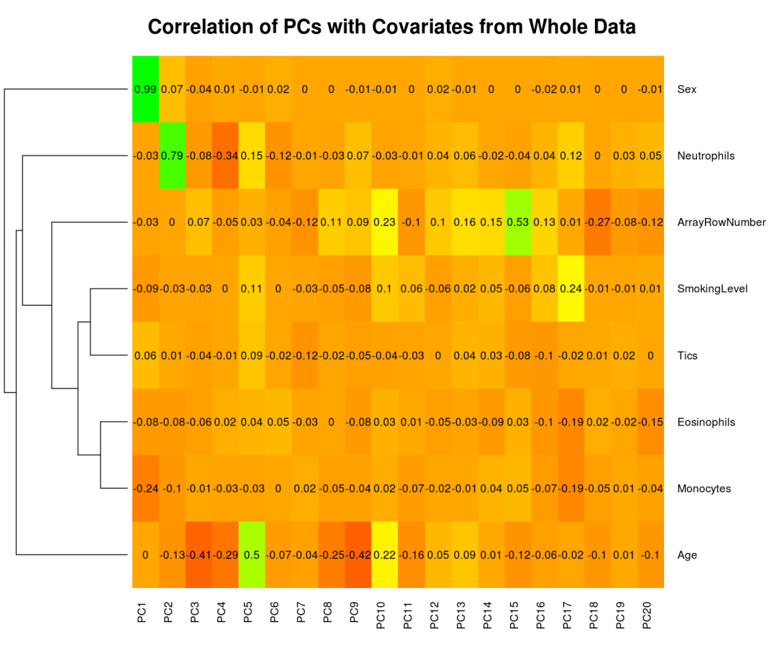
Supplementary Figure S3: Correlation of the top 20 principal components with the covariates. Green indicates a positive correlation and red indicates a negative correlation.

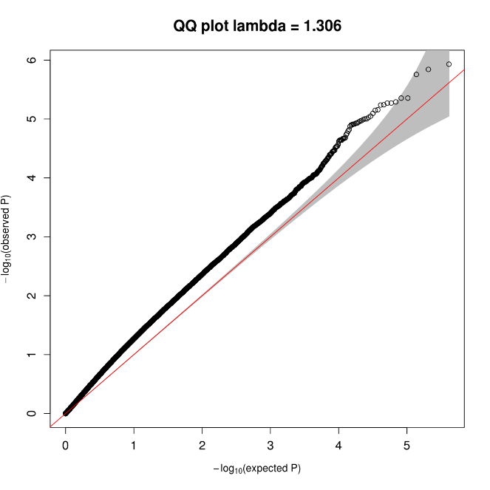
Supplementary Figure S4: QQ plot of p values from gee model with tics as the single predictor.

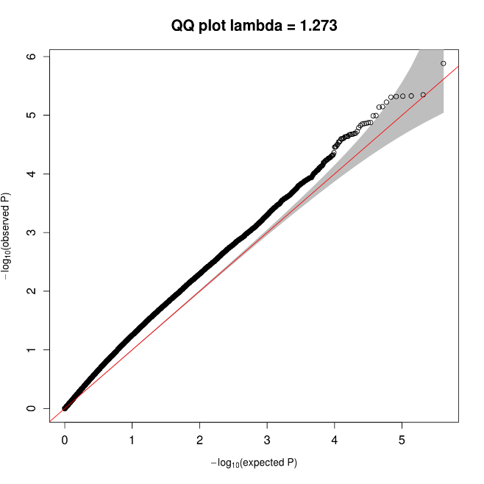
Supplementary Figure S5: QQ plot of p values from gee model with predictors tics and additional covariates age, sex, smoking status, neutrophils count, monocytes count, eosinophils count and array row number.

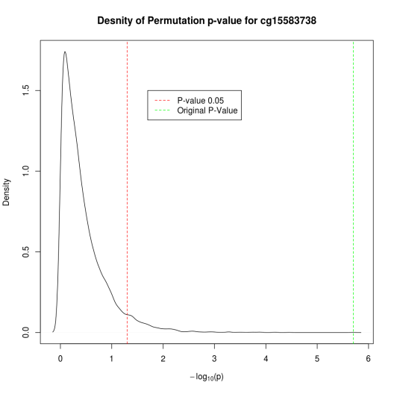
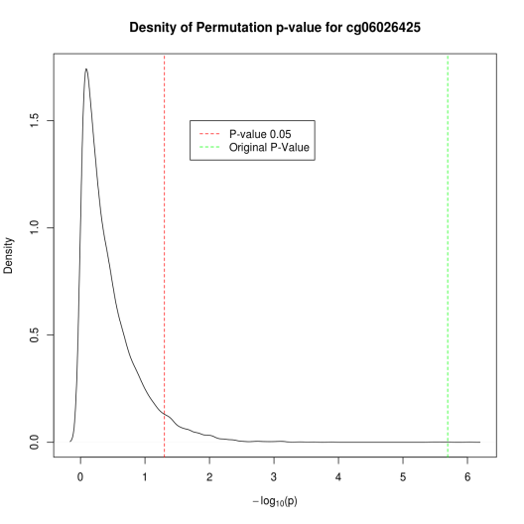
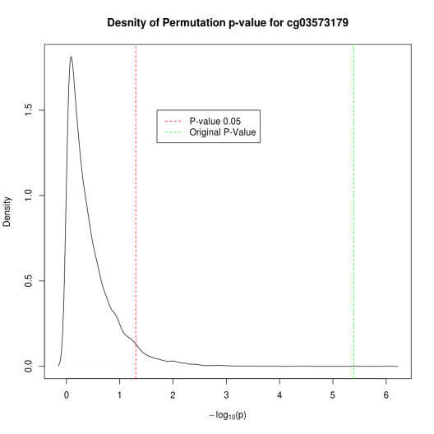
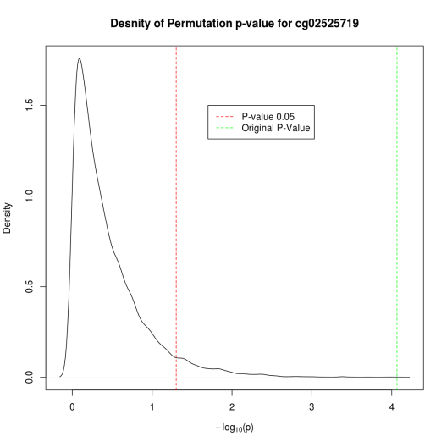
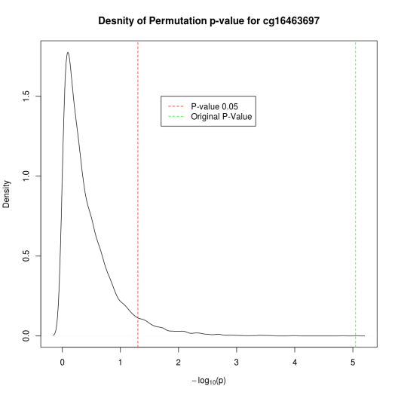
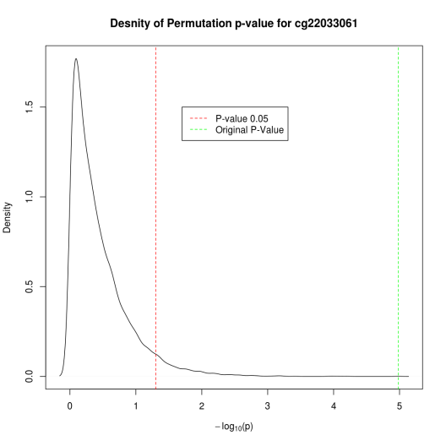
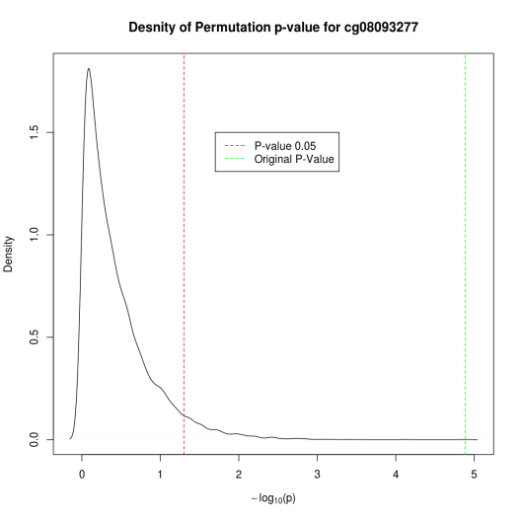
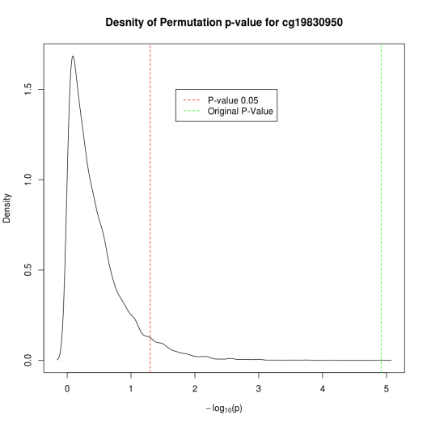
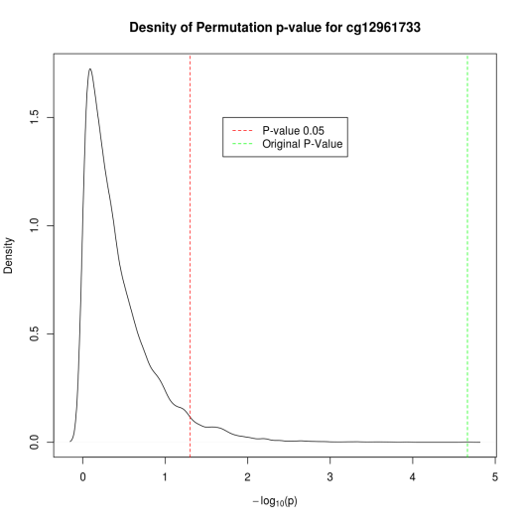
Supplementary Figure S6: Density of permutation p values and original p value for top 9 CpGs. Green line indicates original p value and red line indicates the density of permutation p values < .05.

Supplementary Table T1: Gene Ontology (GO) Analysis Results for Process
GO Term | Description | p value | FDR q value | Enrichment
GO:0009653 | anatomical structure morphogenesis | 3.08E-19 | 4.16E-15 | 1.36
GO:0032502 | developmental process | 3.98E-16 | 2.69E-12 | 1.16
GO:0048869 | cellular developmental process | 4.35E-16 | 1.96E-12 | 1.24
GO:0044767 | single-organism developmental process | 6.57E-16 | 2.22E-12 | 1.17
GO:0048856 | anatomical structure development | 1.93E-15 | 5.20E-12 | 1.36
GO:0048522 | positive regulation of cellular process | 5.46E-14 | 1.23E-10 | 1.14
GO:0044763 | single-organism cellular process | 5.50E-14 | 1.06E-10 | 1.08
GO:0048518 | positive regulation of biological process | 1.32E-13 | 2.23E-10 | 1.14
GO:0010646 | regulation of cell communication | 2.65E-13 | 3.98E-10 | 1.19
GO:0006357 | regulation of transcription from RNA polymerase II promoter | 4.10E-13 | 5.53E-10 | 1.27
GO:0023051 | regulation of signaling | 4.28E-13 | 5.25E-10 | 1.2
GO:0009987 | cellular process | 4.87E-13 | 5.48E-10 | 1.06
GO:0050793 | regulation of developmental process | 1.84E-12 | 1.91E-09 | 1.33
GO:2000026 | regulation of multicellular organismal development | 5.59E-12 | 5.39E-09 | 1.39
GO:0009887 | organ morphogenesis | 7.86E-12 | 7.07E-09 | 1.68
GO:0009893 | positive regulation of metabolic process | 7.95E-12 | 6.71E-09 | 1.16
GO:0019222 | regulation of metabolic process | 2.51E-11 | 1.99E-08 | 1.1
GO:0030154 | cell differentiation | 3.39E-11 | 2.54E-08 | 1.23
GO:0051960 | regulation of nervous system development | 3.82E-11 | 2.71E-08 | 1.39
GO:0048731 | system development | 4.53E-11 | 3.06E-08 | 1.37
GO:0048519 | negative regulation of biological process | 6.54E-11 | 4.21E-08 | 1.13
GO:0097485 | neuron projection guidance | 8.33E-11 | 5.11E-08 | 1.48
GO:0007411 | axon guidance | 8.33E-11 | 4.89E-08 | 1.48
GO:0048513 | organ development | 1.11E-10 | 6.26E-08 | 1.49
GO:0030182 | neuron differentiation | 1.15E-10 | 6.24E-08 | 1.63
GO:0045892 | negative regulation of transcription, DNA-templated | 1.42E-10 | 7.37E-08 | 1.3
GO:1903507 | negative regulation of nucleic acid-templated transcription | 1.54E-10 | 7.72E-08 | 1.41
GO:0048523 | negative regulation of cellular process | 1.59E-10 | 7.65E-08 | 1.13
GO:0048812 | neuron projection morphogenesis | 2.13E-10 | 9.91E-08 | 1.83
GO:1902679 | negative regulation of RNA biosynthetic process | 2.44E-10 | 1.10E-07 | 1.4
GO:0048583 | regulation of response to stimulus | 3.00E-10 | 1.31E-07 | 1.15
GO:0048598 | embryonic morphogenesis | 4.11E-10 | 1.73E-07 | 1.45
GO:0050767 | regulation of neurogenesis | 4.12E-10 | 1.69E-07 | 1.4
GO:0051253 | negative regulation of RNA metabolic process | 7.75E-10 | 3.08E-07 | 1.38
GO:0045934 | negative regulation of nucleobase-containing compound metabolic process | 8.58E-10 | 3.31E-07 | 1.47
GO:0031327 | negative regulation of cellular biosynthetic process | 1.13E-09 | 4.23E-07 | 1.43
GO:0009890 | negative regulation of biosynthetic process | 1.28E-09 | 4.67E-07 | 1.43
GO:0010558 | negative regulation of macromolecule biosynthetic process | 1.36E-09 | 4.84E-07 | 1.44
GO:0003002 | regionalization | 1.37E-09 | 4.74E-07 | 1.56
GO:0045893 | positive regulation of transcription, DNA-templated | 1.54E-09 | 5.21E-07 | 1.23
GO:1903508 | positive regulation of nucleic acid-templated transcription | 1.54E-09 | 5.08E-07 | 1.23
GO:0032989 | cellular component morphogenesis | 1.63E-09 | 5.25E-07 | 1.42
GO:0009966 | regulation of signal transduction | 1.86E-09 | 5.84E-07 | 1.17
GO:2000113 | negative regulation of cellular macromolecule biosynthetic process | 2.17E-09 | 6.65E-07 | 1.27
GO:0000122 | negative regulation of transcription from RNA polymerase II promoter | 2.23E-09 | 6.69E-07 | 1.35
GO:0045944 | positive regulation of transcription from RNA polymerase II promoter | 2.64E-09 | 7.74E-07 | 1.33
GO:0010604 | positive regulation of macromolecule metabolic process | 2.66E-09 | 7.63E-07 | 1.16
GO:1902680 | positive regulation of RNA biosynthetic process | 3.34E-09 | 9.40E-07 | 1.22
GO:0010628 | positive regulation of gene expression | 3.76E-09 | 1.04E-06 | 1.2
GO:0051239 | regulation of multicellular organismal process | 3.92E-09 | 1.06E-06 | 1.28
GO:0044699 | single-organism process | 4.47E-09 | 1.18E-06 | 1.05
GO:0031325 | positive regulation of cellular metabolic process | 6.18E-09 | 1.60E-06 | 1.15
GO:0051254 | positive regulation of RNA metabolic process | 6.99E-09 | 1.78E-06 | 1.22
GO:0051172 | negative regulation of nitrogen compound metabolic process | 7.18E-09 | 1.80E-06 | 1.42
GO:0045664 | regulation of neuron differentiation | 7.24E-09 | 1.78E-06 | 1.41
GO:0051173 | positive regulation of nitrogen compound metabolic process | 7.47E-09 | 1.80E-06 | 1.29
GO:0045935 | positive regulation of nucleobase-containing compound metabolic process | 7.80E-09 | 1.85E-06 | 1.3
GO:0031323 | regulation of cellular metabolic process | 9.23E-09 | 2.15E-06 | 1.1
GO:0006928 | movement of cell or subcellular component | 1.14E-08 | 2.62E-06 | 1.26
GO:0006355 | regulation of transcription, DNA-templated | 1.41E-08 | 3.17E-06 | 1.13
GO:0022603 | regulation of anatomical structure morphogenesis | 1.70E-08 | 3.76E-06 | 1.55
GO:0051093 | negative regulation of developmental process | 1.72E-08 | 3.73E-06 | 1.46
GO:0010557 | positive regulation of macromolecule biosynthetic process | 1.93E-08 | 4.14E-06 | 1.3
GO:2001141 | regulation of RNA biosynthetic process | 2.08E-08 | 4.38E-06 | 1.13
GO:0060284 | regulation of cell development | 2.12E-08 | 4.41E-06 | 1.31
GO:1903506 | regulation of nucleic acid-templated transcription | 2.19E-08 | 4.48E-06 | 1.13
GO:0031328 | positive regulation of cellular biosynthetic process | 2.34E-08 | 4.72E-06 | 1.29
GO:0007409 | axonogenesis | 2.50E-08 | 4.97E-06 | 2.16
GO:0045595 | regulation of cell differentiation | 2.80E-08 | 5.48E-06 | 1.33
GO:0051252 | regulation of RNA metabolic process | 2.98E-08 | 5.75E-06 | 1.13
GO:0048729 | tissue morphogenesis | 3.43E-08 | 6.52E-06 | 1.42
GO:0045596 | negative regulation of cell differentiation | 3.89E-08 | 7.29E-06 | 1.52
GO:0009891 | positive regulation of biosynthetic process | 3.99E-08 | 7.38E-06 | 1.28
GO:0065009 | regulation of molecular function | 4.57E-08 | 8.34E-06 | 1.15
GO:0016043 | cellular component organization | 4.79E-08 | 8.63E-06 | 1.11
GO:0060255 | regulation of macromolecule metabolic process | 7.78E-08 | 1.38E-05 | 1.09
GO:0010629 | negative regulation of gene expression | 7.80E-08 | 1.37E-05 | 1.4
GO:0071840 | cellular component organization or biogenesis | 8.75E-08 | 1.51E-05 | 1.11
GO:0035239 | tube morphogenesis | 1.09E-07 | 1.87E-05 | 1.53
GO:0009892 | negative regulation of metabolic process | 1.12E-07 | 1.89E-05 | 1.28
GO:0010468 | regulation of gene expression | 1.15E-07 | 1.92E-05 | 1.11
GO:0007166 | cell surface receptor signaling pathway | 1.28E-07 | 2.10E-05 | 1.17
GO:2000112 | regulation of cellular macromolecule biosynthetic process | 1.60E-07 | 2.60E-05 | 1.12
GO:0019219 | regulation of nucleobase-containing compound metabolic process | 1.70E-07 | 2.73E-05 | 1.17
GO:0051171 | regulation of nitrogen compound metabolic process | 1.94E-07 | 3.09E-05 | 1.11
GO:0007389 | pattern specification process | 2.10E-07 | 3.29E-05 | 1.41
GO:0010605 | negative regulation of macromolecule metabolic process | 2.59E-07 | 4.02E-05 | 1.29
GO:0048589 | developmental growth | 2.59E-07 | 3.98E-05 | 2.01
GO:0032879 | regulation of localization | 2.63E-07 | 4.00E-05 | 1.16
GO:0031326 | regulation of cellular biosynthetic process | 2.86E-07 | 4.28E-05 | 1.3
GO:0002009 | morphogenesis of an epithelium | 3.24E-07 | 4.81E-05 | 1.43
GO:0080090 | regulation of primary metabolic process | 3.29E-07 | 4.82E-05 | 1.09
GO:0048858 | cell projection morphogenesis | 3.32E-07 | 4.82E-05 | 1.53
GO:0043269 | regulation of ion transport | 3.70E-07 | 5.31E-05 | 1.36
GO:0010648 | negative regulation of cell communication | 4.62E-07 | 6.56E-05 | 1.22
GO:0032990 | cell part morphogenesis | 5.67E-07 | 7.98E-05 | 1.48
GO:0010556 | regulation of macromolecule biosynthetic process | 5.95E-07 | 8.27E-05 | 1.11
GO:0051240 | positive regulation of multicellular organismal process | 6.11E-07 | 8.42E-05 | 1.33
GO:0031324 | negative regulation of cellular metabolic process | 6.13E-07 | 8.36E-05 | 1.28
GO:0065007 | biological regulation | 6.28E-07 | 8.47E-05 | 1.05
GO:0009889 | regulation of biosynthetic process | 6.52E-07 | 8.71E-05 | 1.29
GO:0040007 | growth | 6.73E-07 | 8.90E-05 | 1.83
GO:0023057 | negative regulation of signaling | 7.55E-07 | 9.89E-05 | 1.22
GO:0050789 | regulation of biological process | 8.05E-07 | 1.04E-04 | 1.05
GO:0048562 | embryonic organ morphogenesis | 8.10E-07 | 1.04E-04 | 1.69
GO:0032774 | RNA biosynthetic process | 1.12E-06 | 1.43E-04 | 1.14
GO:0007610 | behavior | 1.13E-06 | 1.42E-04 | 1.52
GO:0035295 | tube development | 1.32E-06 | 1.65E-04 | 1.54
GO:0051094 | positive regulation of developmental process | 1.40E-06 | 1.73E-04 | 1.41
GO:0009968 | negative regulation of signal transduction | 1.42E-06 | 1.74E-04 | 1.22
GO:1901699 | cellular response to nitrogen compound | 1.56E-06 | 1.90E-04 | 1.38
GO:0051962 | positive regulation of nervous system development | 1.57E-06 | 1.89E-04 | 2.54
GO:0034654 | nucleobase-containing compound biosynthetic process | 1.62E-06 | 1.93E-04 | 1.13
GO:0050794 | regulation of cellular process | 1.90E-06 | 2.25E-04 | 1.05
GO:0044093 | positive regulation of molecular function | 2.25E-06 | 2.65E-04 | 1.17
GO:0048732 | gland development | 2.51E-06 | 2.92E-04 | 1.73
GO:0050769 | positive regulation of neurogenesis | 3.29E-06 | 3.80E-04 | 2.63
GO:0014015 | positive regulation of gliogenesis | 3.40E-06 | 3.89E-04 | 23.29
GO:0016055 | Wnt signaling pathway | 3.49E-06 | 3.96E-04 | 1.46
GO:0042476 | odontogenesis | 3.68E-06 | 4.13E-04 | 3.67
GO:0018130 | heterocycle biosynthetic process | 4.04E-06 | 4.51E-04 | 1.12
GO:0010975 | regulation of neuron projection development | 4.10E-06 | 4.54E-04 | 1.4
GO:0051128 | regulation of cellular component organization | 4.13E-06 | 4.53E-04 | 1.15
GO:0010647 | positive regulation of cell communication | 4.90E-06 | 5.33E-04 | 1.24
GO:0045165 | cell fate commitment | 4.93E-06 | 5.33E-04 | 2.14
GO:0009888 | tissue development | 5.67E-06 | 6.07E-04 | 1.58
GO:0031344 | regulation of cell projection organization | 6.00E-06 | 6.38E-04 | 1.34
GO:0071310 | cellular response to organic substance | 6.45E-06 | 6.81E-04 | 1.36
GO:0051056 | regulation of small GTPase mediated signal transduction | 6.62E-06 | 6.93E-04 | 1.42
GO:0034762 | regulation of transmembrane transport | 6.64E-06 | 6.89E-04 | 1.39
GO:0097659 | nucleic acid-templated transcription | 6.94E-06 | 7.15E-04 | 1.14
GO:0048585 | negative regulation of response to stimulus | 7.27E-06 | 7.44E-04 | 1.19
GO:0006351 | transcription, DNA-templated | 7.79E-06 | 7.91E-04 | 1.13
GO:0048468 | cell development | 9.08E-06 | 9.14E-04 | 1.52
GO:0061005 | cell differentiation involved in kidney development | 9.68E-06 | 9.68E-04 | 3.73
GO:0021952 | central nervous system projection neuron axonogenesis | 9.72E-06 | 9.65E-04 | 3.04
GO:0019438 | aromatic compound biosynthetic process | 1.04E-05 | 1.03E-03 | 1.12
GO:0018205 | peptidyl-lysine modification | 1.13E-05 | 1.10E-03 | 1.68
GO:0010595 | positive regulation of endothelial cell migration | 1.15E-05 | 1.12E-03 | 2.47
GO:0009059 | macromolecule biosynthetic process | 1.16E-05 | 1.12E-03 | 1.11
GO:0035107 | appendage morphogenesis | 1.21E-05 | 1.16E-03 | 2.09
GO:0035108 | limb morphogenesis | 1.21E-05 | 1.15E-03 | 2.09
GO:0007626 | locomotory behavior | 1.22E-05 | 1.16E-03 | 1.54
GO:0061061 | muscle structure development | 1.23E-05 | 1.16E-03 | 2.59
GO:0051049 | regulation of transport | 1.27E-05 | 1.18E-03 | 1.16
GO:0034765 | regulation of ion transmembrane transport | 1.31E-05 | 1.21E-03 | 1.37
GO:0010720 | positive regulation of cell development | 1.32E-05 | 1.21E-03 | 2.33
GO:0043087 | regulation of GTPase activity | 1.48E-05 | 1.35E-03 | 1.33
GO:0023056 | positive regulation of signaling | 1.54E-05 | 1.39E-03 | 1.18
GO:0071417 | cellular response to organonitrogen compound | 1.62E-05 | 1.46E-03 | 1.36
GO:0030111 | regulation of Wnt signaling pathway | 1.64E-05 | 1.47E-03 | 1.39
GO:0023052 | signaling | 1.65E-05 | 1.47E-03 | 1.23
GO:0006139 | nucleobase-containing compound metabolic process | 1.66E-05 | 1.47E-03 | 1.1
GO:0051961 | negative regulation of nervous system development | 1.78E-05 | 1.56E-03 | 1.66
GO:0048646 | anatomical structure formation involved in morphogenesis | 1.80E-05 | 1.56E-03 | 1.37
GO:0030036 | actin cytoskeleton organization | 1.82E-05 | 1.58E-03 | 2.04
GO:0007167 | enzyme linked receptor protein signaling pathway | 1.90E-05 | 1.64E-03 | 1.5
GO:0070887 | cellular response to chemical stimulus | 2.10E-05 | 1.79E-03 | 1.3
GO:0016477 | cell migration | 2.15E-05 | 1.82E-03 | 1.28
GO:0044700 | single organism signaling | 2.22E-05 | 1.88E-03 | 1.23
GO:0007517 | muscle organ development | 2.48E-05 | 2.08E-03 | 2.56
GO:0007169 | transmembrane receptor protein tyrosine kinase signaling pathway | 2.48E-05 | 2.07E-03 | 1.55
GO:0016070 | RNA metabolic process | 2.51E-05 | 2.08E-03 | 1.11
GO:0021955 | central nervous system neuron axonogenesis | 2.77E-05 | 2.28E-03 | 2.67
GO:0051179 | localization | 2.79E-05 | 2.28E-03 | 1.09
GO:0009790 | embryo development | 2.90E-05 | 2.36E-03 | 1.66
GO:0050768 | negative regulation of neurogenesis | 3.00E-05 | 2.42E-03 | 1.56
GO:0030030 | cell projection organization | 3.29E-05 | 2.64E-03 | 1.28
GO:0060231 | mesenchymal to epithelial transition | 3.33E-05 | 2.66E-03 | 4.18
GO:0045666 | positive regulation of neuron differentiation | 3.33E-05 | 2.65E-03 | 1.72
GO:0050804 | modulation of synaptic transmission | 3.34E-05 | 2.63E-03 | 1.41
GO:0060429 | epithelium development | 3.64E-05 | 2.86E-03 | 1.99
GO:0045597 | positive regulation of cell differentiation | 3.72E-05 | 2.90E-03 | 1.23
GO:0060560 | developmental growth involved in morphogenesis | 3.77E-05 | 2.92E-03 | 2.63
GO:0042127 | regulation of cell proliferation | 3.81E-05 | 2.94E-03 | 1.44
GO:0051241 | negative regulation of multicellular organismal process | 3.81E-05 | 2.93E-03 | 1.34
GO:0044708 | single-organism behavior | 3.84E-05 | 2.93E-03 | 1.46
GO:0032501 | multicellular organismal process | 3.85E-05 | 2.92E-03 | 1.16
GO:0043547 | positive regulation of GTPase activity | 4.09E-05 | 3.08E-03 | 1.33
GO:0022604 | regulation of cell morphogenesis | 4.09E-05 | 3.07E-03 | 1.29
GO:0044707 | single-multicellular organism process | 4.28E-05 | 3.19E-03 | 1.16
GO:0007399 | nervous system development | 4.63E-05 | 3.43E-03 | 1.44
GO:0007267 | cell-cell signaling | 4.87E-05 | 3.59E-03 | 1.23
GO:0046483 | heterocycle metabolic process | 5.07E-05 | 3.72E-03 | 1.09
GO:0048663 | neuron fate commitment | 5.11E-05 | 3.73E-03 | 8.28
GO:0030900 | forebrain development | 5.15E-05 | 3.74E-03 | 1.96
GO:0048845 | venous blood vessel morphogenesis | 5.16E-05 | 3.73E-03 | 5
GO:0008285 | negative regulation of cell proliferation | 5.22E-05 | 3.75E-03 | 1.84
GO:0050885 | neuromuscular process controlling balance | 5.26E-05 | 3.76E-03 | 4.16
GO:0009952 | anterior/posterior pattern specification | 5.49E-05 | 3.90E-03 | 1.55
GO:0031290 | retinal ganglion cell axon guidance | 5.59E-05 | 3.95E-03 | 2.48
GO:0072091 | regulation of stem cell proliferation | 5.87E-05 | 4.13E-03 | 1.7
GO:0006366 | transcription from RNA polymerase II promoter | 6.02E-05 | 4.21E-03 | 1.28
GO:0044249 | cellular biosynthetic process | 6.13E-05 | 4.26E-03 | 1.09
GO:0035556 | intracellular signal transduction | 6.18E-05 | 4.28E-03 | 1.15
GO:0048870 | cell motility | 6.25E-05 | 4.31E-03 | 1.25
GO:0006793 | phosphorus metabolic process | 6.44E-05 | 4.41E-03 | 1.29
GO:0040011 | locomotion | 6.45E-05 | 4.40E-03 | 1.5
GO:0042475 | odontogenesis of dentin-containing tooth | 6.50E-05 | 4.41E-03 | 3.74
GO:0006796 | phosphate-containing compound metabolic process | 6.69E-05 | 4.52E-03 | 1.3
GO:0046578 | regulation of Ras protein signal transduction | 6.80E-05 | 4.57E-03 | 1.46
GO:0048584 | positive regulation of response to stimulus | 6.93E-05 | 4.63E-03 | 1.14
GO:0035264 | multicellular organism growth | 8.54E-05 | 5.68E-03 | 2.57
GO:0090596 | sensory organ morphogenesis | 8.62E-05 | 5.70E-03 | 2.65
GO:0045665 | negative regulation of neuron differentiation | 8.64E-05 | 5.69E-03 | 1.64
GO:0042692 | muscle cell differentiation | 8.65E-05 | 5.67E-03 | 2.39
GO:0048592 | eye morphogenesis | 8.74E-05 | 5.70E-03 | 2.79
GO:0060537 | muscle tissue development | 8.89E-05 | 5.77E-03 | 2.5
GO:0010721 | negative regulation of cell development | 9.26E-05 | 5.98E-03 | 1.63
GO:0032970 | regulation of actin filament-based process | 9.54E-05 | 6.13E-03 | 1.51
GO:0044271 | cellular nitrogen compound biosynthetic process | 9.67E-05 | 6.19E-03 | 1.1
GO:0071495 | cellular response to endogenous stimulus | 9.77E-05 | 6.22E-03 | 1.41
GO:0048015 | phosphatidylinositol-mediated signaling | 9.78E-05 | 6.20E-03 | 1.51
GO:0000902 | cell morphogenesis | 9.92E-05 | 6.25E-03 | 2.03
GO:0048754 | branching morphogenesis of an epithelial tube | 1.01E-04 | 6.33E-03 | 1.49
GO:0006725 | cellular aromatic compound metabolic process | 1.08E-04 | 6.78E-03 | 1.08
GO:0034645 | cellular macromolecule biosynthetic process | 1.17E-04 | 7.27E-03 | 1.1
GO:0010941 | regulation of cell death | 1.17E-04 | 7.26E-03 | 1.15
GO:0001763 | morphogenesis of a branching structure | 1.19E-04 | 7.33E-03 | 1.44
GO:0030029 | actin filament-based process | 1.21E-04 | 7.41E-03 | 1.86
GO:0032956 | regulation of actin cytoskeleton organization | 1.30E-04 | 7.94E-03 | 1.47
GO:0030534 | adult behavior | 1.33E-04 | 8.07E-03 | 1.71
GO:0010769 | regulation of cell morphogenesis involved in differentiation | 1.35E-04 | 8.15E-03 | 1.36
GO:0001701 | in utero embryonic development | 1.37E-04 | 8.24E-03 | 1.42
GO:0009792 | embryo development ending in birth or egg hatching | 1.37E-04 | 8.23E-03 | 1.66
GO:1901362 | organic cyclic compound biosynthetic process | 1.39E-04 | 8.30E-03 | 1.1
GO:0043009 | chordate embryonic development | 1.39E-04 | 8.29E-03 | 1.66
GO:0014013 | regulation of gliogenesis | 1.41E-04 | 8.34E-03 | 12.61
GO:0021953 | central nervous system neuron differentiation | 1.44E-04 | 8.47E-03 | 1.71
GO:0051090 | regulation of sequence-specific DNA binding transcription factor activity | 1.52E-04 | 8.93E-03 | 1.6
GO:0050790 | regulation of catalytic activity | 1.56E-04 | 9.13E-03 | 1.12
GO:0035137 | hindlimb morphogenesis | 1.57E-04 | 9.15E-03 | 3.37
GO:0035116 | embryonic hindlimb morphogenesis | 1.67E-04 | 9.65E-03 | 3.7
GO:0007010 | cytoskeleton organization | 1.77E-04 | 1.02E-02 | 1.25
GO:0048017 | inositol lipid-mediated signaling | 1.87E-04 | 1.07E-02 | 1.48
GO:0043065 | positive regulation of apoptotic process | 1.88E-04 | 1.07E-02 | 1.66
GO:0007268 | synaptic transmission | 1.90E-04 | 1.08E-02 | 1.27
GO:2000027 | regulation of organ morphogenesis | 1.96E-04 | 1.11E-02 | 1.79
GO:1902578 | single-organism localization | 1.97E-04 | 1.11E-02 | 1.1
GO:0048048 | embryonic eye morphogenesis | 2.06E-04 | 1.16E-02 | 3.69
GO:0090304 | nucleic acid metabolic process | 2.26E-04 | 1.26E-02 | 1.09
GO:0010942 | positive regulation of cell death | 2.29E-04 | 1.27E-02 | 1.64
GO:0038127 | ERBB signaling pathway | 2.31E-04 | 1.28E-02 | 1.39
GO:0043068 | positive regulation of programmed cell death | 2.40E-04 | 1.33E-02 | 1.65
GO:0048711 | positive regulation of astrocyte differentiation | 2.40E-04 | 1.32E-02 | 45.41
GO:0007173 | epidermal growth factor receptor signaling pathway | 2.54E-04 | 1.39E-02 | 1.39
GO:0060411 | cardiac septum morphogenesis | 2.65E-04 | 1.45E-02 | 2.81
GO:2000177 | regulation of neural precursor cell proliferation | 2.66E-04 | 1.45E-02 | 1.86
GO:0007154 | cell communication | 2.71E-04 | 1.47E-02 | 1.18
GO:0009953 | dorsal/ventral pattern formation | 2.73E-04 | 1.47E-02 | 1.76
GO:0050905 | neuromuscular process | 2.74E-04 | 1.47E-02 | 2.82
GO:0045687 | positive regulation of glial cell differentiation | 2.80E-04 | 1.50E-02 | 23.29
GO:0051345 | positive regulation of hydrolase activity | 2.83E-04 | 1.51E-02 | 1.2
GO:1901019 | regulation of calcium ion transmembrane transporter activity | 2.90E-04 | 1.54E-02 | 5.26
GO:0016310 | phosphorylation | 2.98E-04 | 1.58E-02 | 1.38
GO:0060251 | regulation of glial cell proliferation | 2.99E-04 | 1.58E-02 | 47.9
GO:0060548 | negative regulation of cell death | 3.00E-04 | 1.58E-02 | 1.19
GO:0018022 | peptidyl-lysine methylation | 3.14E-04 | 1.64E-02 | 1.76
GO:0043067 | regulation of programmed cell death | 3.20E-04 | 1.67E-02 | 1.15
GO:0048705 | skeletal system morphogenesis | 3.21E-04 | 1.67E-02 | 1.65
GO:0030326 | embryonic limb morphogenesis | 3.31E-04 | 1.71E-02 | 1.99
GO:0035113 | embryonic appendage morphogenesis | 3.31E-04 | 1.70E-02 | 1.99
GO:0090287 | regulation of cellular response to growth factor stimulus | 3.33E-04 | 1.71E-02 | 1.36
GO:0030177 | positive regulation of Wnt signaling pathway | 3.49E-04 | 1.78E-02 | 1.44
GO:0009967 | positive regulation of signal transduction | 3.53E-04 | 1.80E-02 | 1.23
GO:1903169 | regulation of calcium ion transmembrane transport | 3.81E-04 | 1.93E-02 | 5.09
GO:0051089 | constitutive protein ectodomain proteolysis | 3.81E-04 | 1.93E-02 | 2,623.83
GO:1901576 | organic substance biosynthetic process | 3.85E-04 | 1.94E-02 | 1.08
GO:1902531 | regulation of intracellular signal transduction | 3.93E-04 | 1.97E-02 | 1.15
GO:0051147 | regulation of muscle cell differentiation | 3.94E-04 | 1.97E-02 | 1.92
GO:0035148 | tube formation | 3.96E-04 | 1.97E-02 | 1.53
GO:0072201 | negative regulation of mesenchymal cell proliferation | 4.10E-04 | 2.04E-02 | 13.12
GO:0042981 | regulation of apoptotic process | 4.16E-04 | 2.06E-02 | 1.14
GO:0021521 | ventral spinal cord interneuron specification | 4.48E-04 | 2.21E-02 | 8.9
GO:0060573 | cell fate specification involved in pattern specification | 4.48E-04 | 2.20E-02 | 8.9
GO:0044260 | cellular macromolecule metabolic process | 4.57E-04 | 2.24E-02 | 1.06
GO:0070243 | regulation of thymocyte apoptotic process | 4.70E-04 | 2.29E-02 | 173
GO:0002730 | regulation of dendritic cell cytokine production | 4.80E-04 | 2.33E-02 | 11.01
GO:1902589 | single-organism organelle organization | 4.97E-04 | 2.41E-02 | 1.15
GO:0098609 | cell-cell adhesion | 5.00E-04 | 2.41E-02 | 1.33
GO:0045950 | negative regulation of mitotic recombination | 5.03E-04 | 2.42E-02 | 3,935.75
GO:0055006 | cardiac cell development | 5.19E-04 | 2.49E-02 | 4.37
GO:0040012 | regulation of locomotion | 5.22E-04 | 2.49E-02 | 1.22
GO:0010959 | regulation of metal ion transport | 5.26E-04 | 2.50E-02 | 1.33
GO:0060539 | diaphragm development | 5.27E-04 | 2.50E-02 | 5.07
GO:0006807 | nitrogen compound metabolic process | 5.29E-04 | 2.50E-02 | 1.07
GO:0051234 | establishment of localization | 5.36E-04 | 2.52E-02 | 1.09
GO:1901360 | organic cyclic compound metabolic process | 5.36E-04 | 2.51E-02 | 1.07
GO:0030855 | epithelial cell differentiation | 5.37E-04 | 2.51E-02 | 1.86
GO:0098742 | cell-cell adhesion via plasma-membrane adhesion molecules | 5.39E-04 | 2.51E-02 | 1.53
GO:2001257 | regulation of cation channel activity | 5.44E-04 | 2.52E-02 | 4.48
GO:0003337 | mesenchymal to epithelial transition involved in metanephros morphogenesis | 5.56E-04 | 2.57E-02 | 4.74
GO:0090066 | regulation of anatomical structure size | 5.70E-04 | 2.63E-02 | 1.51
GO:0009058 | biosynthetic process | 5.71E-04 | 2.62E-02 | 1.08
GO:0051966 | regulation of synaptic transmission, glutamatergic | 5.75E-04 | 2.63E-02 | 2.36
GO:0044087 | regulation of cellular component biogenesis | 5.78E-04 | 2.63E-02 | 1.25
GO:0010594 | regulation of endothelial cell migration | 5.82E-04 | 2.65E-02 | 1.86
GO:0035850 | epithelial cell differentiation involved in kidney development | 5.91E-04 | 2.68E-02 | 4.7
GO:0098727 | maintenance of cell number | 6.09E-04 | 2.75E-02 | 1.58
GO:0017145 | stem cell division | 6.13E-04 | 2.76E-02 | 39.36
GO:0048566 | embryonic digestive tract development | 6.20E-04 | 2.78E-02 | 3.69
GO:0051091 | positive regulation of sequence-specific DNA binding transcription factor activity | 6.21E-04 | 2.78E-02 | 1.69
GO:0030902 | hindbrain development | 6.28E-04 | 2.80E-02 | 4.05
GO:0072178 | nephric duct morphogenesis | 6.28E-04 | 2.79E-02 | 2.8
GO:0051726 | regulation of cell cycle | 6.62E-04 | 2.93E-02 | 1.68
GO:0045359 | positive regulation of interferon-beta biosynthetic process | 6.77E-04 | 2.99E-02 | 10.07
GO:0060538 | skeletal muscle organ development | 6.81E-04 | 2.99E-02 | 4.46
GO:0043069 | negative regulation of programmed cell death | 6.84E-04 | 3.00E-02 | 1.19
GO:0016337 | single organismal cell-cell adhesion | 6.87E-04 | 3.00E-02 | 1.92
GO:0065008 | regulation of biological quality | 6.88E-04 | 3.00E-02 | 1.23
GO:0051716 | cellular response to stimulus | 6.91E-04 | 3.00E-02 | 1.17
GO:0060314 | regulation of ryanodine-sensitive calcium-release channel activity | 6.99E-04 | 3.02E-02 | 8.2
GO:0043066 | negative regulation of apoptotic process | 7.01E-04 | 3.02E-02 | 1.19
GO:1903522 | regulation of blood circulation | 7.07E-04 | 3.04E-02 | 1.82
GO:0070848 | response to growth factor | 7.08E-04 | 3.03E-02 | 1.83
GO:0040037 | negative regulation of fibroblast growth factor receptor signaling pathway | 7.08E-04 | 3.02E-02 | 5.44
GO:0034641 | cellular nitrogen compound metabolic process | 7.13E-04 | 3.04E-02 | 1.07
GO:0010564 | regulation of cell cycle process | 7.54E-04 | 3.20E-02 | 1.93
GO:0003012 | muscle system process | 7.92E-04 | 3.35E-02 | 1.39
GO:2000647 | negative regulation of stem cell proliferation | 7.96E-04 | 3.36E-02 | 3.18
GO:0000904 | cell morphogenesis involved in differentiation | 7.97E-04 | 3.35E-02 | 1.41
GO:0050770 | regulation of axonogenesis | 8.09E-04 | 3.39E-02 | 1.64
GO:0051301 | cell division | 8.13E-04 | 3.40E-02 | 3.18
GO:0051130 | positive regulation of cellular component organization | 8.24E-04 | 3.43E-02 | 1.2
GO:2000415 | positive regulation of fibronectin-dependent thymocyte migration | 8.26E-04 | 3.43E-02 | 1,211.00
GO:2000413 | regulation of fibronectin-dependent thymocyte migration | 8.26E-04 | 3.42E-02 | 1,211.00
GO:0003149 | membranous septum morphogenesis | 8.42E-04 | 3.48E-02 | 92.06
GO:0045321 | leukocyte activation | 8.69E-04 | 3.58E-02 | 2.13
GO:0030316 | osteoclast differentiation | 8.80E-04 | 3.61E-02 | 3.48
GO:0021983 | pituitary gland development | 8.96E-04 | 3.67E-02 | 3.87
GO:0060444 | branching involved in mammary gland duct morphogenesis | 9.01E-04 | 3.67E-02 | 4.35
GO:0007193 | adenylate cyclase-inhibiting G-protein coupled receptor signaling pathway | 9.06E-04 | 3.68E-02 | 1.79
GO:0072104 | glomerular capillary formation | 9.06E-04 | 3.67E-02 | 9.34
GO:0060113 | inner ear receptor cell differentiation | 9.11E-04 | 3.68E-02 | 6.86
GO:0006816 | calcium ion transport | 9.40E-04 | 3.79E-02 | 1.39
GO:0016049 | cell growth | 9.59E-04 | 3.85E-02 | 2.25
GO:2000648 | positive regulation of stem cell proliferation | 9.81E-04 | 3.93E-02 | 1.68
GO:2000406 | positive regulation of T cell migration | 9.93E-04 | 3.96E-02 | 127.47

Supplementary Table T2: Gene Ontology (GO) Analysis Results for Function
GO Term | Description | p value | FDR q value | Enrichment
GO:0005515 | protein binding | 1.10E-17 | 4.55E-14 | 1.08
GO:0005488 | binding | 3.81E-14 | 7.87E-11 | 1.05
GO:0043565 | sequence-specific DNA binding | 1.53E-13 | 2.11E-10 | 1.37
GO:0000981 | RNA polymerase II transcription factor activity, sequence-specific DNA binding | 7.53E-12 | 7.77E-09 | 1.43
GO:0000975 | regulatory region DNA binding | 1.30E-11 | 1.07E-08 | 1.38
GO:0001067 | regulatory region nucleic acid binding | 1.30E-11 | 8.92E-09 | 1.38
GO:0044212 | transcription regulatory region DNA binding | 1.68E-11 | 9.90E-09 | 1.38
GO:0000976 | transcription regulatory region sequence-specific DNA binding | 2.29E-09 | 1.18E-06 | 1.38
GO:0001012 | RNA polymerase II regulatory region DNA binding | 3.23E-09 | 1.48E-06 | 1.39
GO:0001071 | nucleic acid binding transcription factor activity | 3.23E-09 | 1.34E-06 | 1.25
GO:0003700 | transcription factor activity, sequence-specific DNA binding | 3.23E-09 | 1.21E-06 | 1.25
GO:0000977 | RNA polymerase II regulatory region sequence-specific DNA binding | 3.60E-09 | 1.24E-06 | 1.39
GO:0001228 | transcriptional activator activity, RNA polymerase II transcription regulatory region sequence-specific binding | 4.88E-08 | 1.55E-05 | 1.5
GO:0000982 | transcription factor activity, RNA polymerase II core promoter proximal region sequence-specific binding | 8.77E-08 | 2.59E-05 | 1.76
GO:0044877 | macromolecular complex binding | 3.76E-07 | 1.04E-04 | 1.23
GO:0001227 | transcriptional repressor activity, RNA polymerase II transcription regulatory region sequence-specific binding | 1.73E-06 | 4.46E-04 | 1.56
GO:0003682 | chromatin binding | 2.64E-06 | 6.41E-04 | 1.36
GO:0008134 | transcription factor binding | 2.93E-06 | 6.73E-04 | 1.31
GO:0003677 | DNA binding | 4.97E-06 | 1.08E-03 | 1.14
GO:1901363 | heterocyclic compound binding | 5.62E-06 | 1.16E-03 | 1.08
GO:0097159 | organic cyclic compound binding | 7.26E-06 | 1.43E-03 | 1.08
GO:0004714 | transmembrane receptor protein tyrosine kinase activity | 9.13E-06 | 1.71E-03 | 2.92
GO:0019899 | enzyme binding | 1.33E-05 | 2.40E-03 | 1.17
GO:0000978 | RNA polymerase II core promoter proximal region sequence-specific DNA binding | 1.79E-05 | 3.08E-03 | 1.78
GO:0003674 | molecular_function | 1.80E-05 | 2.97E-03 | 1.02
GO:0019904 | protein domain specific binding | 1.91E-05 | 3.04E-03 | 1.44
GO:0003779 | actin binding | 3.03E-05 | 4.64E-03 | 1.36
GO:0016278 | lysine N-methyltransferase activity | 3.52E-05 | 5.19E-03 | 2.01
GO:0016279 | protein-lysine N-methyltransferase activity | 3.52E-05 | 5.01E-03 | 2.01
GO:0000987 | core promoter proximal region sequence-specific DNA binding | 3.96E-05 | 5.45E-03 | 1.72
GO:0008092 | cytoskeletal protein binding | 3.97E-05 | 5.29E-03 | 1.25
GO:0098772 | molecular function regulator | 4.49E-05 | 5.80E-03 | 1.18
GO:0016301 | kinase activity | 5.17E-05 | 6.47E-03 | 1.48
GO:0001159 | core promoter proximal region DNA binding | 5.19E-05 | 6.31E-03 | 1.71
GO:0004222 | metalloendopeptidase activity | 8.54E-05 | 1.01E-02 | 35.34
GO:0016773 | phosphotransferase activity, alcohol group as acceptor | 1.19E-04 | 1.36E-02 | 1.56
GO:0019199 | transmembrane receptor protein kinase activity | 1.26E-04 | 1.41E-02 | 2.14
GO:0016772 | transferase activity, transferring phosphorus-containing groups | 1.38E-04 | 1.51E-02 | 1.29
GO:0032559 | adenyl ribonucleotide binding | 1.49E-04 | 1.58E-02 | 1.22
GO:0001077 | transcriptional activator activity, RNA polymerase II core promoter proximal region sequence-specific binding | 1.52E-04 | 1.57E-02 | 1.63
GO:0001078 | transcriptional repressor activity, RNA polymerase II core promoter proximal region sequence-specific binding | 1.57E-04 | 1.58E-02 | 2.19
GO:0008237 | metallopeptidase activity | 1.68E-04 | 1.65E-02 | 20.34
GO:0022836 | gated channel activity | 2.01E-04 | 1.93E-02 | 1.35
GO:0030554 | adenyl nucleotide binding | 2.32E-04 | 2.18E-02 | 1.22
GO:0003676 | nucleic acid binding | 2.36E-04 | 2.17E-02 | 1.09
GO:0022832 | voltage-gated channel activity | 2.51E-04 | 2.25E-02 | 1.58
GO:0005244 | voltage-gated ion channel activity | 2.51E-04 | 2.21E-02 | 1.58
GO:0001047 | core promoter binding | 3.58E-04 | 3.08E-02 | 1.57
GO:0001046 | core promoter sequence-specific DNA binding | 4.14E-04 | 3.49E-02 | 1.7
GO:0018024 | histone-lysine N-methyltransferase activity | 4.68E-04 | 3.87E-02 | 1.95
GO:0004713 | protein tyrosine kinase activity | 4.77E-04 | 3.86E-02 | 1.91
GO:0009378 | four-way junction helicase activity | 5.03E-04 | 4.00E-02 | 3,935.75
GO:0005088 | Ras guanyl-nucleotide exchange factor activity | 5.17E-04 | 4.03E-02 | 1.53
GO:0043167 | ion binding | 6.47E-04 | 4.95E-02 | 1.06
GO:0046872 | metal ion binding | 7.12E-04 | 5.35E-02 | 1.12
GO:0043169 | cation binding | 7.22E-04 | 5.33E-02 | 1.12
GO:0008170 | N-methyltransferase activity | 7.61E-04 | 5.52E-02 | 1.7
GO:0005524 | ATP binding | 8.61E-04 | 6.13E-02 | 1.2
GO:0042805 | actinin binding | 9.17E-04 | 6.42E-02 | 2.09

Supplementary Table T3: Gene Ontology (GO) Analysis Results for Component
GO Term | Description | p value | FDR q-value | Enrichment
GO:0030054 | cell junction | 6.73E-09 | 1.09E-05 | 1.29
GO:0098589 | membrane region | 1.93E-07 | 1.57E-04 | 1.24
GO:0043005 | neuron projection | 4.23E-07 | 2.28E-04 | 1.33
GO:0097458 | neuron part | 4.39E-07 | 1.78E-04 | 1.22
GO:0044424 | intracellular part | 4.10E-06 | 1.33E-03 | 1.03
GO:0044456 | synapse part | 5.13E-06 | 1.39E-03 | 1.34
GO:0014069 | postsynaptic density | 1.67E-05 | 3.87E-03 | 1.54
GO:0005912 | adherens junction | 2.32E-05 | 4.69E-03 | 1.34
GO:0042995 | cell projection | 3.35E-05 | 6.03E-03 | 1.2
GO:0098590 | plasma membrane region | 4.09E-05 | 6.63E-03 | 1.22
GO:0070776 | MOZ/MORF histone acetyltransferase complex | 4.21E-05 | 6.20E-03 | 449.8
GO:0070775 | H3 histone acetyltransferase complex | 4.21E-05 | 5.68E-03 | 449.8
GO:0070161 | anchoring junction | 4.57E-05 | 5.69E-03 | 1.32
GO:0097060 | synaptic membrane | 6.36E-05 | 7.36E-03 | 1.45
GO:0043197 | dendritic spine | 8.40E-05 | 9.07E-03 | 1.77
GO:0030425 | dendrite | 1.04E-04 | 1.05E-02 | 1.41
GO:0044309 | neuron spine | 1.19E-04 | 1.14E-02 | 1.75
GO:0045211 | postsynaptic membrane | 1.78E-04 | 1.60E-02 | 1.47
GO:0045202 | synapse | 2.01E-04 | 1.72E-02 | 1.42
GO:0034702 | ion channel complex | 2.29E-04 | 1.86E-02 | 1.39
GO:0005667 | transcription factor complex | 3.83E-04 | 2.95E-02 | 1.32
GO:0044297 | cell body | 4.72E-04 | 3.47E-02 | 2.93
GO:0098797 | plasma membrane protein complex | 5.53E-04 | 3.89E-02 | 1.28
GO:0005829 | cytosol | 5.69E-04 | 3.84E-02 | 1.09
GO:0038037 | G-protein coupled receptor dimeric complex | 6.16E-04 | 3.99E-02 | 16.52
GO:0097648 | G-protein coupled receptor complex | 6.16E-04 | 3.84E-02 | 16.52
GO:0043025 | neuronal cell body | 6.62E-04 | 3.97E-02 | 2.94
GO:0033017 | sarcoplasmic reticulum membrane | 7.44E-04 | 4.30E-02 | 6.75
GO:0032127 | dense core granule membrane | 8.26E-04 | 4.61E-02 | 1,211.00
GO:0071133 | alpha9-beta1 integrin-ADAM8 complex | 8.26E-04 | 4.46E-02 | 1,211.00
GO:0002116 | semaphorin receptor complex | 8.67E-04 | 4.53E-02 | 4.14
GO:0044459 | plasma membrane part | 9.33E-04 | 4.72E-02 | 1.11
GO:0043231 | intracellular membrane-bounded organelle | 9.58E-04 | 4.70E-02 | 1.12
GO:0014701 | junctional sarcoplasmic reticulum membrane | 9.95E-04 | 4.74E-02 | 13.12

Supplementary Table T4: Genes With a Previous Association to Neurological Disorders
CpG Sites | CHR | Gene | Gene Location | Associated disorder | Reference
cg06026425 | 5 | CLINT1 | 5q33.3 | Schizophrenia | (Wang et al., 2010)
cg01321816 | 15 | BLM | 15q26.1 | Alzheimer’s disease | (Schrötter et al., 2013)
cg00785856 | 15 | ADAM10 | 15q21.3 | Alzheimer’s disease | (Vassar, 2013)
cg20519670 | 14 | PLEKHG3 | 14q23.3 | Mental retardation | (Lehalle et al., 2014; Lybaek et al., 2008)
cg12961733 | 22 | BRD1 | 22q13.33 | Schizophrenia and bipolar disorder [Histone Modification MOZ/MORF complex] | (Christensen et al., 2012; Sapountzi & Cote, 2011; Severinsen et al., 2006)
cg26548492 | 5 | LOC153328/ SLC25A48 | — | Parkinson’s disease | (Liu et al., 2011)
cg21879791, cg08093277 | 6 | GABBR1 | 6p22.1 | Autism, schizophrenia, tremor, and obsessive-compulsive disorder | (Fatemi et al., 2009; Hegyi, 2013; Luo et al., 2012; Richter et al., 2012)

References
Christensen, J. H., Elfving, B., Muller, H. K., Fryland, T., Nyegaard, M., Corydon, T. J., … Borglum, A. D. (2012). The Schizophrenia and Bipolar Disorder associated BRD1 gene is regulated upon chronic restraint stress. European Neuropsychopharmacology, 22, 651–656.
Fatemi, S. H., Folsom, T. D., Reutiman, T. J., & Thuras, P. D. (2009). Expression of GABAB receptors is altered in brains of subjects with autism. The Cerebellum, 8, 64–69.
Hegyi, H. (2013). GABBR1 has a HERV-W LTR in its regulatory region — A possible implication for schizophrenia. Biology Direct, 8(5).
Lehalle, D., Sanlaville, D., Guimier, A., Plouvier, E., Leblanc, T., Galmiche, L., … Amiel, J. (2014). Multiple congenital anomalies-intellectual disability (MCA-ID) and neuroblastoma in a patient harboring a de novo 14q23.1q23.3 deletion. American Journal of Medical Genetics Part A, 164A, 1310–1317.
Liu, X., Cheng, R., Verbitsky, M., Kisselev, S., Browne, A., Mejia-Sanatana, H., … Lee, J. H. (2011). Genome-wide association study identifies candidate genes for Parkinson’s disease in an Ashkenazi Jewish population. BMC Medical Genetics, 12, 104.
Luo, C., Rajput, A., Robinson, C., & Rajput, A. (2012). Gamma-aminobutyric acid (GABA)-B receptor 1 in cerebellar cortex of essential tremor. Journal of Clinical Neuroscience, 19, 920-921.
Lybaek, H., Oyen, N., Fauske, L., & Houge, G. (2008). A 2.1 Mb deletion adjacent but distal to a 14q21q23 paracentric inversion in a family with spherocytosis and severe learning difficulties. Clinical Genetics, 74, 553–559.
Richter, M. A., de Jesus, D. R., Hoppenbrouwers, S., Daigle, M., Deluce, J., Ravindran, L. N., … Daskalakis, Z. J. (2012). Evidence for cortical inhibitory and excitatory dysfunction in obsessive compulsive disorder. Neuropsychopharmacology, 37, 1144–1151.
Sapountzi, V., & Cote, J. (2011). MYST-family histone acetyltransferases: Beyond chromatin. Cellular and Molecular LifeSciences, 68, 1147–1156.
Schrötter, A., Mastalski, T., Nensa, F. M., Neumann, M., Loosse, C., Pfeiffer, K., … Theiss, C. (2013). FE65 regulates and interacts with the Bloom syndrome protein in dynamic nuclear spheres–potential relevance to Alzheimer’s disease. Journal of Cell Science, 126, 2480–2492.
Severinsen, J., Bjarkam, C. R., Kiar-Larsen, S., Olsen, I. M., Nielsen, M. M., Blechingberg, J., … Young, B. D. (2006). Evidence implicating BRD1 with brain development and susceptibility to both schizophrenia and bipolar affective disorder. Molecular Psychiatry, 11, 1126–1138.
Vassar, R. (2013). ADAM10 prodomain mutations cause late-onset Alzheimer’s disease: Not just the latest FAD. Neuron, 80, 250–253.
Wang, K. S., Liu, X. F., & Aragam, N. (2010). A genome-wide meta-analysis identifies novel loci associated with schizophrenia and bipolar disorder. Schizophrenia Research, 124, 192–199.

