Twin Research and Human Genetics
Large Autosomal Copy Number Differences Within Unselected Monozygotic Twin Pairs are Rare
Allan F. McRae, Peter M. Visscher, Grant W. Montgomery, and Nicholas G. Martin

Supplementary Figures 1-5: Copy number differences identified within MZ pairs by both QuantiSNP and PennCNV that are concluded to be likely false positive calls upon manual annotation. For each figure, the twin that containing putative CNV is on the left, with the co-twin on the right. All CNVs are called as deletions, on chromosomes 2, 2, 8, 15 and 17 respectively. Log-R ratios are shown on the top row and B-allele frequencies on the bottom. In all cases, no significant difference is demonstrated in the Log-R ratio and B-allele frequencies within the twin pairs, indicating that CNV call is either a false positive or there is a false negative call in the co-twin.

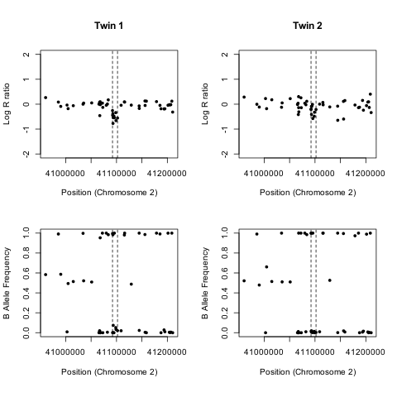
Supplementary Figure 1
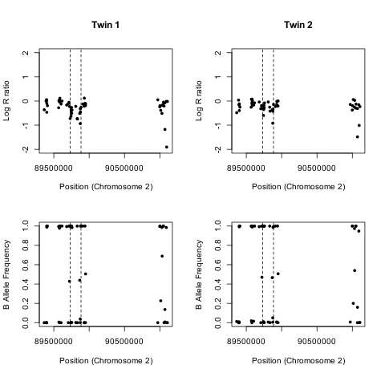
Supplementary Figure 2

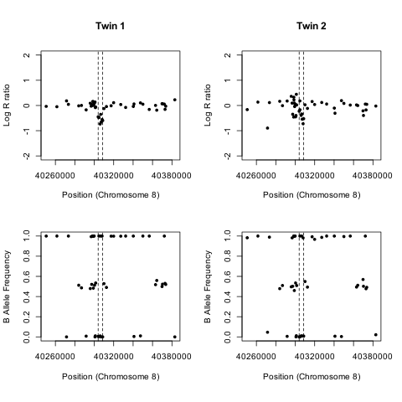
Supplementary Figure 3

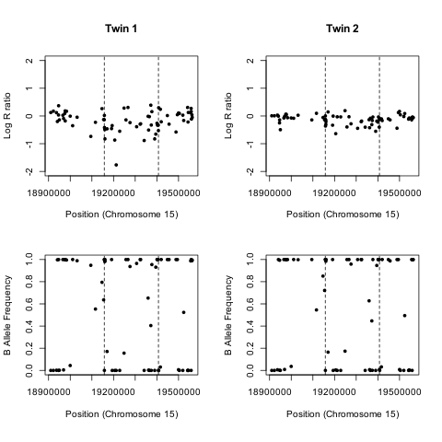
Supplementary Figure 4

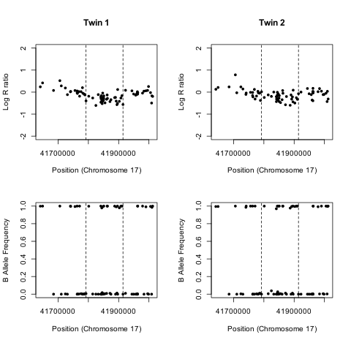
Supplementary Figure 5

