Twin Research and Human Genetics: Supplementary material
Operating Characteristics of Statistical Methods for Detecting Gene-By- Measured Environment Interaction in the Presence of Gene-Environment Correlation Under Violations of Distributional Assumptions

Carol A. Van Hulle and Paul J. Rathouz

Supplemental Table S1. Percent of Simulated LRT Statistics Under the Null Hypothesis Exceeding Critical Value for Pairs of Nested Models Based on 2,000 replicates of N = 1,000.
 |  |  |  |  |  | % Type I error rates
 |  | DGM |  |  | LRT df |  | Ordinalizedª on P |  |  |  | Censored^{b} on P
Model for H_{A} |  | Model for H₀ |  | Condition of H₀ |  |  | 10 | 5 | 1 |  | 10 | 5 | 1
Cholesky with GxM | (3) | Cholesky | (2) | high r_{AM} | 6 |  | 20.8 | 11.7 | 2.7 |  | 5.4 | 2.7 | 0.6
 |  |  |  | low r_{AM} | 6 |  | 28.3 | 17.7 | 5.4 |  | 7.8 | 3.4 | 0.9
NL main effects | (4*) | Lin main effects | (4†) |  | 1 |  | 13.4 | 7.3 | 1.6 |  | 8.8 | 4.2 | 1.1
Cholesky | (2) | Lin Main effects | (4†) |  | 2 |  | 9.6 | 4.9 | 0.7 |  | 9.3 | 4.3 | 0.9
Note: P refers to a phenotype of interest, M refers to a putative moderator; LRT refers to the likelihood ratio test.
ª Data divided into groups of size 12%, 20%, 30%, 20%, 10%, and 8% and assigned a score from 0 to 5.
^{b} Bottom 10% assigned the 10th percentile score and top 5% assigned the 95th percentile score.

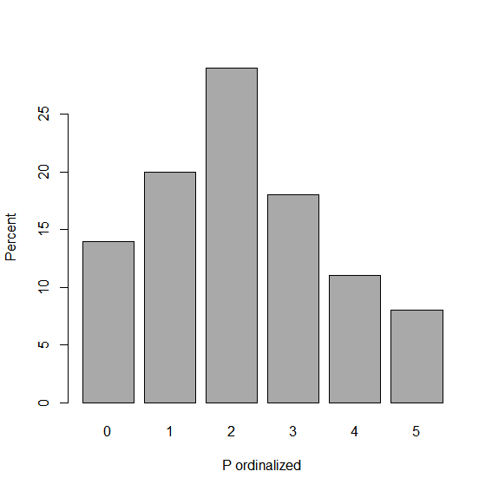
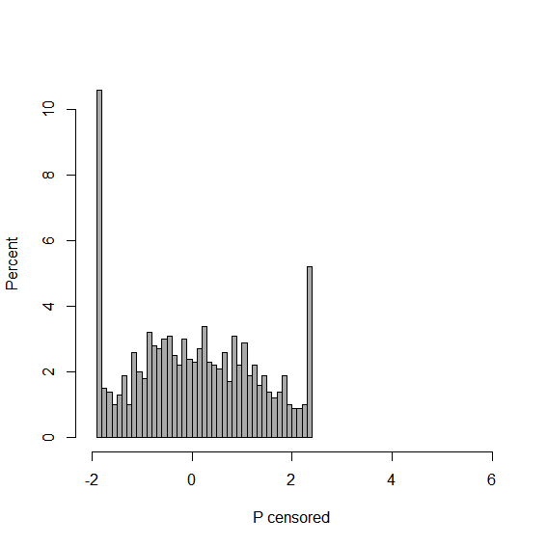

Supplementary Figure S1. Example of distribution for ordinalized (left panel) or censored data (right panel) after imposing less severe deviations on normality. For ordinalized data, scores were divided into groups of size 12%, 20%, 30%, 20%, 10%, and 8% and assigned a value from 0 to 5. Data were censored by replacing scores in the bottom 10% with the value of the 10th percentile and replacing scores in the top 5% with the value of the 95th percentile.
Note: For left panel M = 2.1, SD = 1.4, Skew = 0.3, Kurtosis=-0.7; for right panel M = 0.5, SD = 1.2, Skew = 0.2, Kurtosis = -1.0.

