Appendix to the article ‘Populism and the scales of statehood: localism and populist attitudes in Western Europe’, European Political Science Review
Daniel Kübler, Michael A. Strebel, Frank Marcinkowski
Table A1: Question wording
Variable | Item
Dependent variables | Now think about the current political situation in [country] and consider whether you would tend to agree or disagree with the following statements [0=strongly disagree, 4=strongly agree]
Anti-elitism | Politicians are not really interested in what people like me think.
 | MPs in Parliament very quickly lose touch with ordinary people
People-centrism | Ordinary people are of good and honest character.
 | Ordinary people all pull together
 | The [citizens of country] are basically honest and upright.
 | The [citizens of country] are a coherent entity, rather than just a bunch of individuals
Popular sovereignty | The people should have the final say the most important political issues by voting on them directly in referendums.
 | The people should be asked whenever important decisions are taken
Independent variables
Scalar orientation | How attached do you feel to…  [0=not at all attached 10=very attached]
Local | …the local authority area in which you live
National | …the [country] as a whole
European | …Europe
Control variables
Gender | Are you…  [Female, Male, Other]
Age | In what year were you born?
Education | What is the highest level of education you have successfully completed?  [recoded into ISCED levels, levels 5 and 6 are equal to tertiary education]
Anti-immigrant sentiment | To what extent do you agree or disagree with each of the following statements?  …too many immigrants just don't want to fit into [country’s] society  [0=strongly disagree 10=strongly agree]
Left-right self-placement | In politics people sometimes speak of “left” and “right”. Where would you place yourself on a left-right scale?  [0=left, 10=right]
Party identification | Do you generally think of yourself as a supporter of a political party or is there some party that you feel closer to than the others?  [Yes, No, Don’t know]
[If yes:] Which party is that?
[List of main parties in country]

Figure A1: Populist attitudes and party identification
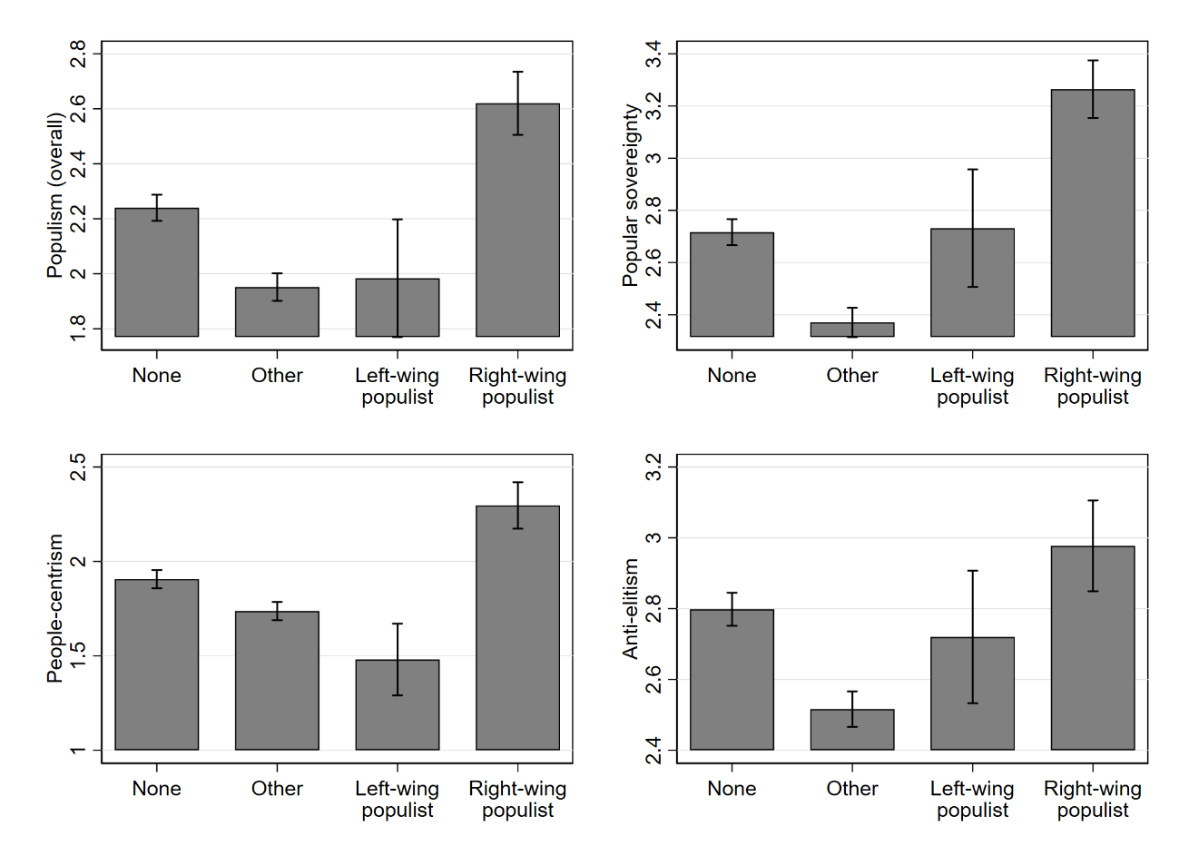

Table A2: Scalar orientations and populist attitudes (anti-elitism; people-centrism, popular sovereignty and overall): OLS regression

 | Anti-elitism | People-centrism | Popular sovereignty | Populism (overall)
Independent variables
Local scalar orientation | 0.022* | 0.040*** | 0.036*** | 0.050***
 | (0.009) | (0.010) | (0.010) | (0.010)
European scalar orientation | -0.021* | -0.033*** | -0.036*** | -0.030**
 | (0.009) | (0.010) | (0.010) | (0.010)
Control variables
Gender (male=1) | -0.056 | -0.035 | -0.144** | -0.077
 | (0.046) | (0.045) | (0.052) | (0.047)
Age cohorts (B = ≤25)
26-35 | -0.008 | 0.081 | -0.007 | 0.004
 | (0.080) | (0.083) | (0.089) | (0.084)
36-45 | 0.078 | 0.116 | 0.012 | 0.107
 | (0.075) | (0.078) | (0.082) | (0.076)
56-65 | 0.051 | 0.096 | -0.009 | 0.040
 | (0.081) | (0.079) | (0.084) | (0.079)
>65 | -0.100 | 0.118 | -0.211* | -0.095
 | (0.080) | (0.082) | (0.096) | (0.084)
Tertiary education (=1) | -0.194*** | -0.296*** | -0.449*** | -0.334***
 | (0.048) | (0.044) | (0.053) | (0.047)
Anti-immigrant sentiments | 0.074*** | 0.079*** | 0.074*** | 0.094***
 | (0.067) | (0.065) | (0.081) | (0.071)
Country (B = Switzerland)
France | 1.011*** | -0.041 | 0.196** | 0.352***
 | (0.062) | (0.063) | (0.064) | (0.062)
United Kingdom | 0.713*** | 0.500*** | 0.091 | 0.540***
 | (0.060) | (0.053) | (0.059) | (0.053)
Intercept | 1.787*** | 1.462*** | 2.542*** | 1.615***
 | (0.082) | (0.085) | (0.093) | (0.087)
N | 2831 | 2594 | 2865 | 2526
F-Test | 45.018 | 41.762 | 26.196 | 42.029
p>F | 0.000 | 0.000 | 0.000 | 0.000
Adjusted-R² | 0.199 | 0.213 | 0.129 | 0.216

Note: Weighted data. Table entries are unstandardized OLS regression coefficients with estimated standard errors in parentheses. * p < 0.05, ** p < 0.01, *** p < 0.001

Figure A2: OLS Regression coefficients (with 95% CI) for local orientation and European orientation on populist attitudes (overall index). Regressions include country-dummies and control variables, and exclude indicated country one at a time.

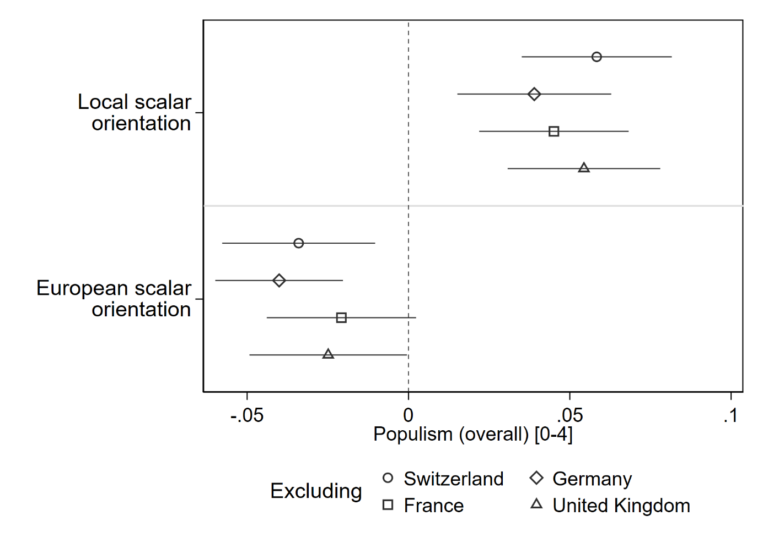

Table A3: Populist attitudes: scalar orientation and left-right self-placement
 | Interaction: local scalar orientation |  |  |  |  | Interaction: European scalar orientation
 | (1) | (2) | (3) | (4) |  | (5) | (6) | (7) | (8)
 | Anti-  elitism | People-centrism | Popular  sovereignty | Populism (overall) |  | Anti-  elitism | People-centrism | Popular  sovereignty | Populism (overall)
Local scalar orientation | 0.044* | 0.027 | 0.062** | 0.042* |  | 0.037*** | 0.043*** | 0.046*** | 0.056***
 | (0.021) | (0.020) | (0.024) | (0.020) |  | (0.010) | (0.010) | (0.011) | (0.011)
European scalar orientation | -0.048*** | -0.049*** | -0.063*** | -0.056*** |  | -0.013 | -0.043* | 0.002 | -0.027
 | (0.010) | (0.010) | (0.011) | (0.011) |  | (0.020) | (0.022) | (0.024) | (0.023)
Left-right self-placement | -0.000 | 0.055*** | -0.007 | 0.027* |  | -0.009 | 0.050*** | -0.021 | 0.016
 | (0.012) | (0.011) | (0.013) | (0.011) |  | (0.013) | (0.011) | (0.013) | (0.012)
Local scalar orientation *  left-right self-placement | -0.001 | 0.003 | -0.003 | 0.003
 | (0.004) | (0.004) | (0.004) | (0.004)
European scalar orientation *  left-right self-placement |  |  |  |  |  | -0.006* | -0.001 | -0.012*** | -0.006
 |  |  |  |  |  | (0.003) | (0.003) | (0.003) | (0.004)
Gender (male=1) | -0.041 | -0.039 | -0.122* | -0.090 |  | -0.045 | -0.040 | -0.128* | -0.094
 | (0.049) | (0.048) | (0.056) | (0.051) |  | (0.049) | (0.048) | (0.055) | (0.051)
Age cohorts (B = <26)
26-35 | 0.058 | 0.115 | 0.012 | 0.063 |  | 0.063 | 0.115 | 0.021 | 0.065
 | (0.084) | (0.090) | (0.096) | (0.090) |  | (0.084) | (0.090) | (0.096) | (0.091)
36-45 | 0.171* | 0.150 | 0.073 | 0.209* |  | 0.176* | 0.151 | 0.080 | 0.211*
 | (0.080) | (0.085) | (0.092) | (0.083) |  | (0.080) | (0.085) | (0.092) | (0.083)
56-65 | 0.116 | 0.198* | 0.055 | 0.153 |  | 0.120 | 0.199* | 0.063 | 0.155
 | (0.086) | (0.086) | (0.093) | (0.087) |  | (0.085) | (0.086) | (0.093) | (0.087)
>65 | 0.056 | 0.189* | -0.103 | 0.048 |  | 0.060 | 0.189* | -0.097 | 0.049
 | (0.085) | (0.091) | (0.104) | (0.093) |  | (0.085) | (0.091) | (0.104) | (0.093)
Tertiary education ( = 1) | -0.234*** | -0.349*** | -0.529*** | -0.405*** |  | -0.235*** | -0.351*** | -0.530*** | -0.407***
 | (0.048) | (0.045) | (0.055) | (0.049) |  | (0.048) | (0.045) | (0.055) | (0.049)
Country (B = Switzerland)
Germany | 0.721*** | -0.087 | -0.120 | 0.142 |  | 0.717*** | -0.088 | -0.127 | 0.139
 | (0.074) | (0.070) | (0.087) | (0.079) |  | (0.074) | (0.070) | (0.087) | (0.079)
France | 1.100*** | 0.031 | 0.248*** | 0.419*** |  | 1.107*** | 0.040 | 0.259*** | 0.437***
 | (0.062) | (0.065) | (0.067) | (0.065) |  | (0.061) | (0.065) | (0.066) | (0.064)
United Kingdom | 0.756*** | 0.599*** | 0.152* | 0.627*** |  | 0.761*** | 0.602*** | 0.160* | 0.634***
 | (0.063) | (0.055) | (0.062) | (0.056) |  | (0.062) | (0.055) | (0.062) | (0.056)
Constant | 2.047*** | 1.509*** | 2.886*** | 1.857*** |  | 2.077*** | 1.530*** | 2.935*** | 1.899***
 | (0.091) | (0.099) | (0.100) | (0.100) |  | (0.093) | (0.100) | (0.103) | (0.102)
Observations | 2696 | 2472 | 2728 | 2403 |  | 2696 | 2472 | 2728 | 2403
F-Test | 31.793 | 27.879 | 17.180 | 24.480 |  | 33.151 | 28.403 | 21.675 | 26.110
p > F | 0.000 | 0.000 | 0.000 | 0.000 |  | 0.000 | 0.000 | 0.000 | 0.000
Adjusted-R² | 0.159 | 0.177 | 0.091 | 0.145 |  | 0.161 | 0.177 | 0.097 | 0.146
Note: Weighted data. Table entries are undstandardized OLS regression coefficients with standard errors in parentheses. * p < 0.05, ** p < 0.01, *** p < 0.001

Table A4: Populist attitudes: scalar orientation and party identification
 | Interaction: local scalar orientation |  |  |  |  | Interaction: European scalar orientation
 | (1) | (2) | (3) | (4) |  | (5) | (6) | (7) | (8)
 | Anti-  elitism | People-centrism | Popular sovereignty | Populism (overall) |  | Anti-  elitism | People-centrism | Popular sovereignty | Populism (overall)
Local scalar orientation | 0.019 | 0.035** | 0.044** | 0.049*** |  | 0.021* | 0.039*** | 0.035*** | 0.049***
 | (0.012) | (0.013) | (0.014) | (0.015) |  | (0.009) | (0.010) | (0.010) | (0.010)
European scalar orientation | -0.020* | -0.034** | -0.033** | -0.029** |  | -0.030* | -0.020 | -0.038** | -0.022
 | (0.010) | (0.010) | (0.011) | (0.010) |  | (0.012) | (0.013) | (0.013) | (0.012)
Party identification (B = None)
Other | -0.227*** | -0.100 | -0.200** | -0.230*** |  | -0.190*** | -0.129* | -0.170** | -0.233***
 | (0.054) | (0.052) | (0.061) | (0.053) |  | (0.057) | (0.055) | (0.065) | (0.056)
Left-wing populist | 0.031 | -0.049 | 0.134 | 0.055 |  | 0.048 | -0.078 | 0.158 | 0.047
 | (0.146) | (0.172) | (0.177) | (0.178) |  | (0.150) | (0.171) | (0.185) | (0.177)
Right-wing populist | -0.039 | -0.002 | 0.009 | -0.089 |  | -0.127 | -0.069 | -0.107 | -0.240
 | (0.120) | (0.117) | (0.113) | (0.116) |  | (0.182) | (0.153) | (0.163) | (0.169)
Party identification *
local scalar orientation
Other *  local scalar orientation | 0.007 | 0.001 | -0.002 | 0.002
 | (0.019) | (0.020) | (0.022) | (0.022)
Left-wing populist *  local scalar orientation | -0.001 | 0.026 | -0.035 | 0.007
 | (0.048) | (0.052) | (0.056) | (0.050)
Right-wing populist *  local scalar orientation | -0.016 | 0.018 | -0.070* | -0.019
 | (0.029) | (0.034) | (0.027) | (0.033)
Party identification *
European scalar orientation
Other *  European scalar orientation |  |  |  |  |  | 0.033 | -0.022 | 0.023 | -0.001
 |  |  |  |  |  | (0.020) | (0.021) | (0.023) | (0.020)
Left-wing populist *  European scalar orientation |  |  |  |  |  | 0.015 | -0.040 | 0.032 | -0.013
 |  |  |  |  |  | (0.037) | (0.060) | (0.072) | (0.069)
Right-wing populist *  European scalar orientation |  |  |  |  |  | -0.024 | -0.021 | -0.055 | -0.056
 |  |  |  |  |  | (0.032) | (0.029) | (0.028) | (0.033)
Anti-immigration sentiments | 0.071*** | 0.078*** | 0.070*** | 0.090*** |  | 0.072*** | 0.077*** | 0.070*** | 0.091***
 | (0.008) | (0.008) | (0.009) | (0.009) |  | (0.008) | (0.008) | (0.009) | (0.009)
Gender (male = 1) | -0.050 | -0.034 | -0.141** | -0.071 |  | -0.051 | -0.032 | -0.143** | -0.071
 | (0.046) | (0.045) | (0.051) | (0.046) |  | (0.046) | (0.044) | (0.051) | (0.046)
Age cohorts (B = <26)
26-35 | 0.019 | 0.094 | 0.006 | 0.024 |  | 0.008 | 0.092 | 0.001 | 0.017
 | (0.079) | (0.083) | (0.089) | (0.084) |  | (0.079) | (0.082) | (0.090) | (0.083)
36-45 | 0.106 | 0.132 | 0.025 | 0.132 |  | 0.102 | 0.127 | 0.030 | 0.128
 | (0.074) | (0.079) | (0.083) | (0.076) |  | (0.074) | (0.078) | (0.083) | (0.075)
56-65 | 0.113 | 0.127 | 0.031 | 0.098 |  | 0.109 | 0.125 | 0.038 | 0.095
 | (0.084) | (0.080) | (0.086) | (0.082) |  | (0.084) | (0.081) | (0.087) | (0.082)
>65 | -0.024 | 0.150 | -0.154 | -0.024 |  | -0.030 | 0.149 | -0.151 | -0.026
 | (0.081) | (0.084) | (0.096) | (0.085) |  | (0.081) | (0.083) | (0.096) | (0.083)
Tertiary education ( = 1) | -0.158*** | -0.286*** | -0.409*** | -0.301*** |  | -0.159*** | -0.284*** | -0.413*** | -0.302***
 | (0.047) | (0.045) | (0.053) | (0.047) |  | (0.047) | (0.044) | (0.053) | (0.046)
Country (B = Switzerland)
Germany | 0.678*** | -0.194** | -0.126 | 0.065 |  | 0.676*** | -0.199** | -0.125 | 0.059
 | (0.068) | (0.065) | (0.081) | (0.071) |  | (0.068) | (0.064) | (0.081) | (0.071)
France | 1.025*** | -0.036 | 0.211*** | 0.365*** |  | 1.022*** | -0.039 | 0.208** | 0.362***
 | (0.062) | (0.063) | (0.064) | (0.061) |  | (0.061) | (0.064) | (0.064) | (0.061)
United Kingdom | 0.747*** | 0.515*** | 0.124* | 0.569*** |  | 0.748*** | 0.510*** | 0.128* | 0.568***
 | (0.061) | (0.054) | (0.060) | (0.055) |  | (0.061) | (0.054) | (0.060) | (0.054)
Constant | 1.830*** | 1.480*** | 2.593*** | 1.669*** |  | 1.819*** | 1.506*** | 2.575*** | 1.682***
 | (0.084) | (0.085) | (0.095) | (0.087) |  | (0.083) | (0.085) | (0.095) | (0.086)
N | 2831 | 2594 | 2865 | 2526 |  | 2831 | 2594 | 2865 | 2526
F-Test | 32.937 | 28.276 | 20.212 | 31.086 |  | 34.873 | 28.486 | 23.713 | 31.886
p > F | 0.000 | 0.000 | 0.000 | 0.000 |  | 0.000 | 0.000 | 0.000 | 0.000
Adjusted-R² | 0.209 | 0.214 | 0.140 | 0.227 |  | 0.211 | 0.215 | 0.141 | 0.229
Note: Weighted data. Table entries are undstandardized OLS regression coefficients with standard errors in parentheses. * p < 0.05, ** p < 0.01, *** p < 0.001.

Figure A3: The relationship between populist attitudes and local scalar orientation depending on party identification
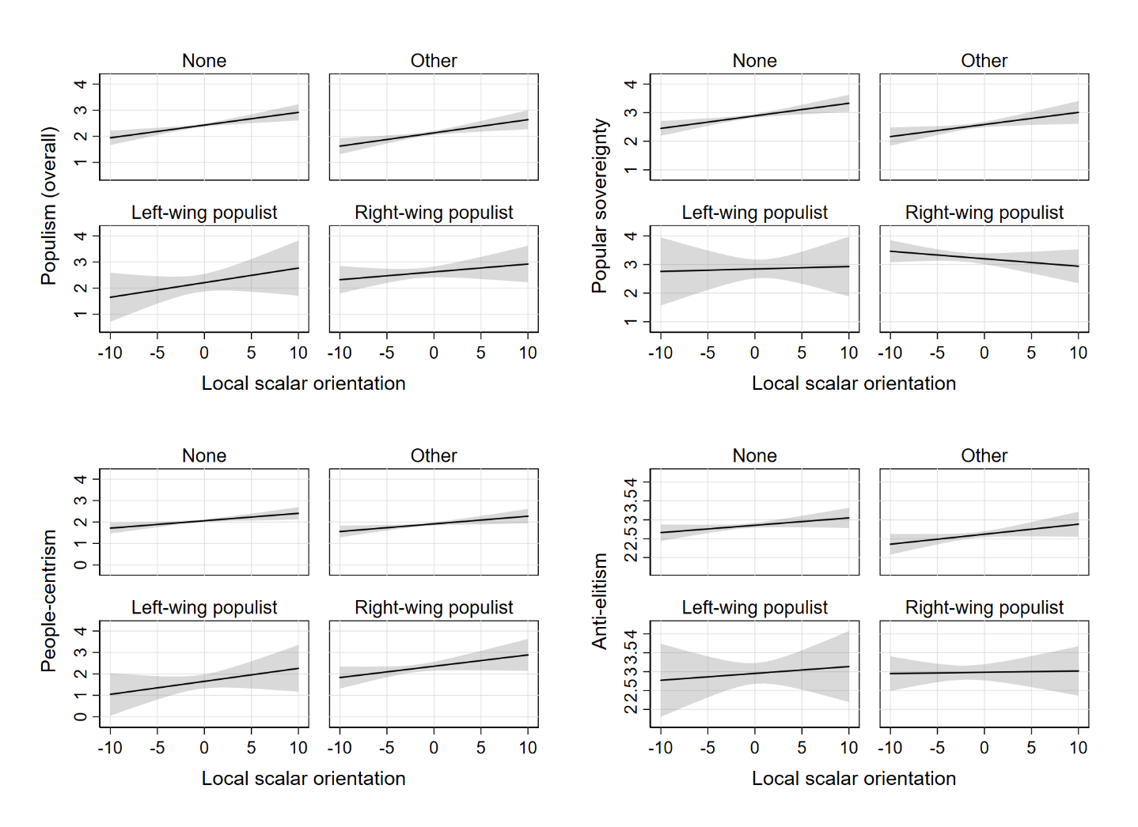

Figure A4: The relationship between populist attitudes and European scalar orientation depending on party identification
