Online Appendix

Fig. A.1. Distribution of Anti-Immigration Levels Among Latinos and Whites in Florida, According to Their Ideology
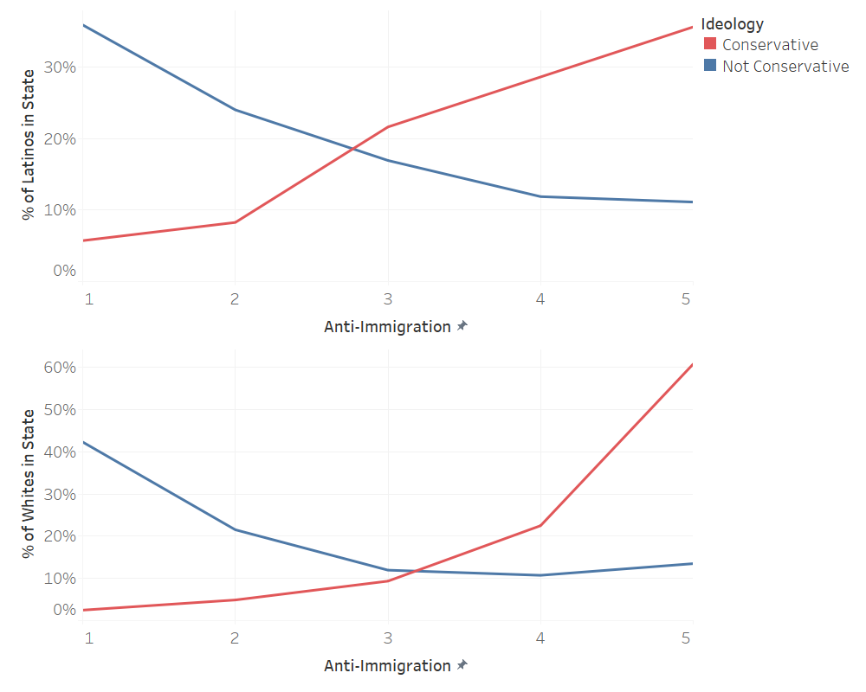
Fig. A.2. Distribution of Anti-Immigration Levels Among Latinos and Whites in Arizona, According to Their Ideology
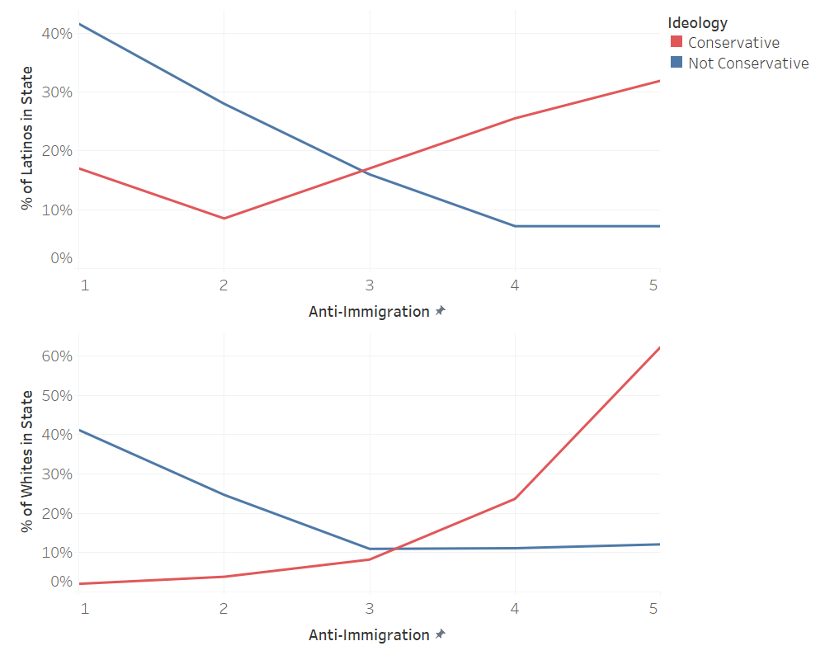
Fig. A.3. Ideology Among Latinos in Florida and Arizona
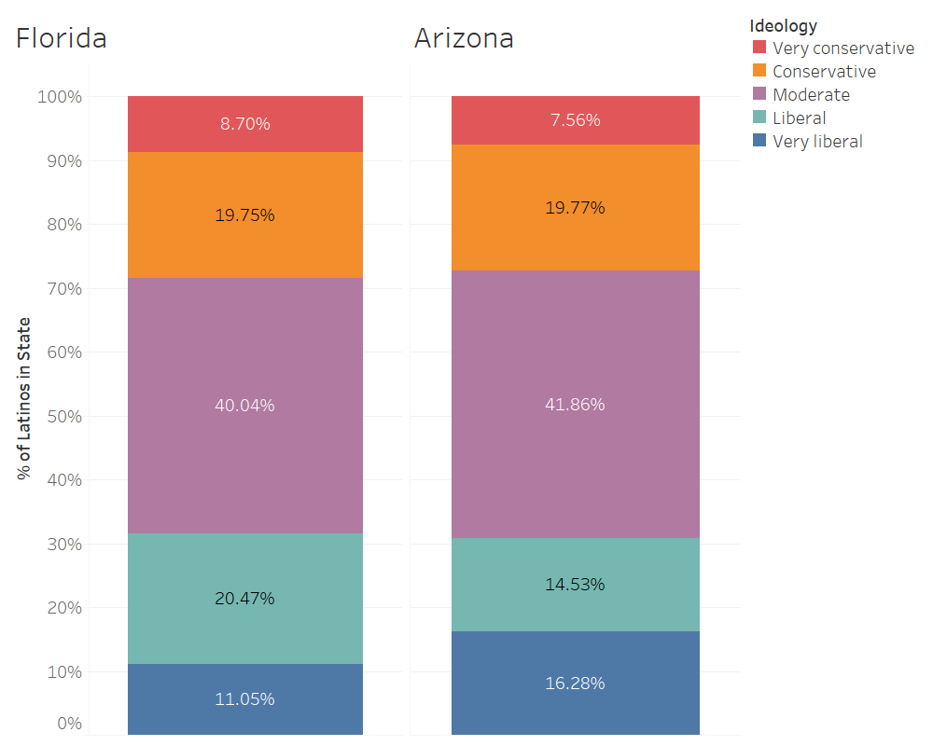

Fig. A.4. Levels of Anti-Immigration Sentiments Among Latino and White Men in FL and AZ
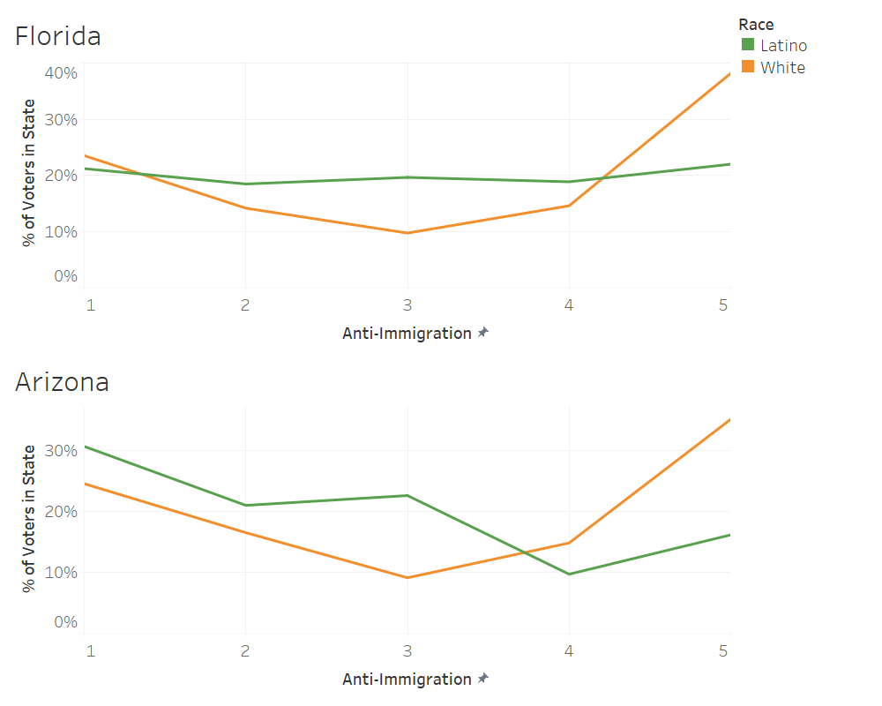

Fig. A.5. Distribution of Anti-Immigration Sentiments Among Latinos in New Mexico, According to Their Perception of Economic conditions
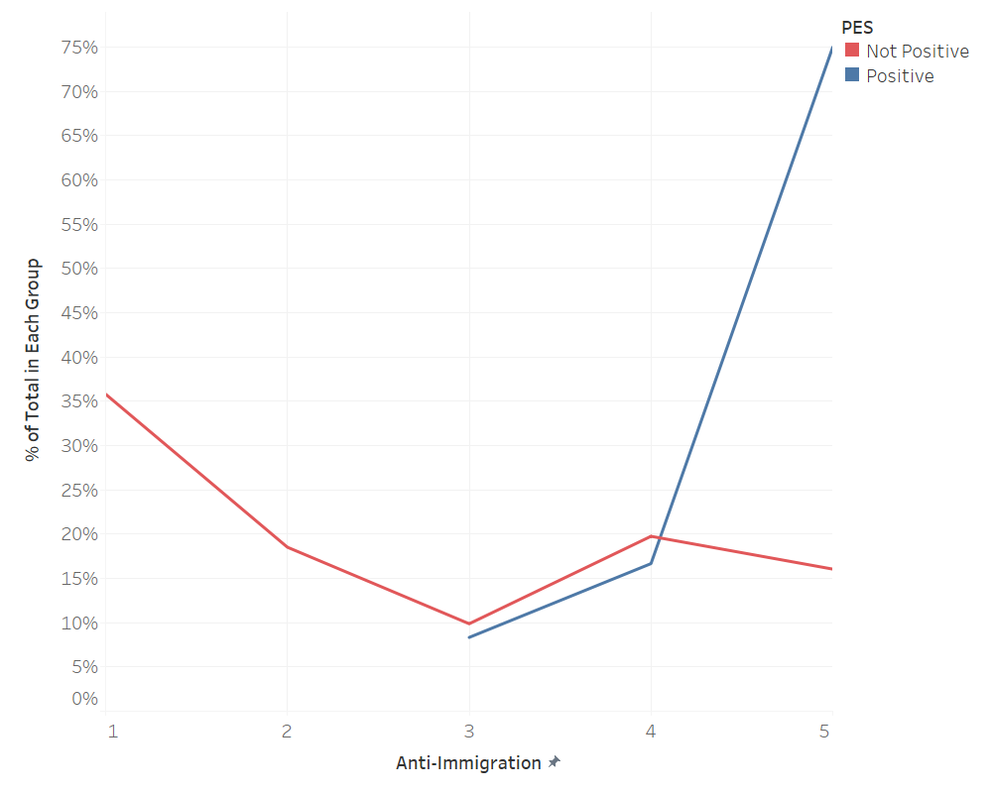

Table A.1.
Regression results for White voters (early voters and Election Day voters)
Variables | Model 7  Early Voters | Model 8  Election Day Voters
Anti-Immigration | 3.376***  (0.150) | 3.412***  (0.0685)
Perception of the Economy | 1.872***  (0.0705) | 1.702***  (0.0276)
Ideology | 4.910*** | 4.951***
 | (0.369) | (0.168)
Constant | 5.84e-06*** | 1.41e-05***
 | (1.90e-06) | (2.03e-06)
Number of Observations | 8,224 | 31,889
Standard error in parentheses
*** p<0.01, ** p<0.05, * p<0.1

Table A.2.
Regression results for Latino voters in 2016 (Election Day voters)

Variables | Model 1 Election Day Voters | Model 2  Election Day Voters Without Anti-Immigration | Model 3  Election Day Voters With Only Anti-Immigration
Anti-Immigration | 2.197***  (0.114) |  | 2.873***  (0.121)
Perception of the Economy | 0.688***  (0.0252) | 0.631***  (0.0217)
Ideology | 2.921*** | 3.610***
 | (0.235) | (0.269)
R-squared | 0.4267 | 0.3280 | 0.2688
Constant | 0.0124*** | 0.0817*** | 0.0264***
 | (0.00450) | (0.0249) | (0.00343)
Number of Observations | 2,220 | 2,220 | 2,643
Standard error in parentheses
*** p<0.01, ** p<0.05, * p<0.1

Table A.3.
Regression results for Latino voters in 2012 (Election Day voters)

Variables | Model 1 Election Day Voters | Model 2  Election Day Voters Without Anti-Immigration | Model 3  Election Day Voters With Only Anti-Immigration
Anti-Immigration | 1.798***  (0.138) |  | 2.397***  (0.113)
Perception of the Economy | 0.495***  (0.0269) | 0.464***  (0.0243)
Ideology | 2.407*** | 2.519***
 | (0.162) | (0.269)
R-squared | 0.5345 | 0.4926 | 0.1987
Constant | 0.0658*** | 0.315*** | 0.0450***
 | (0.0286) | (0.116) | (0.00640)
Number of Observations | 1,589 | 1,589 | 1,807
Standard error in parentheses
*** p<0.01, ** p<0.05, * p<0.1

Table A.4.
Regression results for Latino voters in 2020 (Election Day voters)

Variables | Model 1  Election Day Voters With Only Anti-Immigration
Anti-Immigration | 3.525***  (0.147)
R-squared | 0.4031
Constant | 0.0112***
 | (0.00162)
Number of Observations | 3,085
Standard error in parentheses
*** p<0.01, ** p<0.05, * p<0.1

Item | Observations | Sign | Item-Test Correlation | Item-Rest Correlation | Average Interitem Covariance | Alpha
Anti-Immigration | 60839 | + | 0.8417 | 0.5896 | 0.9676662 | 0.557
Perception of the Economy | 58413 | + | 0.8209 | 0.4791 | 1.211961 | 0.757
Ideology | 56208 | + | 0.7858 | 0.6015 | 1.361756 | 0.625
Test Scale |  |  |  |  | 1.1848 | 0.730
Table A.5.
Cronbach’s alpha scores for items constituting the scales used to measure key variables
Anti-Immigration |  | 1 |  | 2 |  | 3 |  | 4 |  | 5
 |  | Arizona | Florida | Arizona | Florida | Arizona | Florida | Arizona | Florida | Arizona | Florida
Not Positive PES | Latino | 36.25% | 31.91% | 26.88% | 21.63% | 16.25% | 18.63% | 9.38% | 13.49% | 11.25% | 14.35%
 | White | 30.94% | 31.74% | 19.47% | 17.97% | 10.89% | 11.45% | 13.90% | 13.73% | 24.80% | 25.10%
Positive PES | Latino | 13.04% | 6.09% | 8.70% | 10.43% | 21.74% | 20.87% | 30.43% | 27.83% | 26.09% | 34.78%
 | White | 1.26% | 1.47% | 1.89% | 2.32% | 6.92% | 9.89% | 27.04% | 22.11% | 62.89% | 64.21%
Table A.6.
Complete results for Figures 7 and 8

Table A.7.
Anti-Immigration |  | 1 |  | 2 |  | 3 |  | 4 |  | 5
 |  | Arizona | Florida | Arizona | Florida | Arizona | Florida | Arizona | Florida | Arizona | Florida
 | Latino | 30.65% | 21.18% | 20.97% | 18.43% | 22.58% | 19.61% | 9.68% | 18.82% | 16.13% | 21.96%
 | White | 24.52% | 23.50% | 16.49% | 14.11% | 9.09% | 9.67% | 14.80% | 14.54% | 35.10% | 38.18%
Complete results for Figure A.4
Table A.8.

Complete results for Figure 9

Perception of the Economy |  | 1 |  | 2 |  | 3 |  | 4 |  | 5 |  | 6 |  | 7 |  | 8 |  | 9
 |  | AZ | NM | AZ | NM | AZ | NM | AZ | NM | AZ | NM | AZ | NM | AZ | NM | AZ | NM | AZ | NM
 | Latino | 13.66% | 10.78% | 10.38% | 15.05% | 25.14% | 26.88% | 18.03% | 17.20% | 11.48% | 11.83% | 8.74% | 5.38% | 7.10% | 7.53% | 2.73% | 5.38% | 2.73%
 | White | 5.87% | 7.28% | 10.47% | 15.53% | 27.30% | 29.13% | 21.53% | 20.39% | 9.98% | 11.17% | 9.20% | 5.34% | 7.83% | 6.31% | 5.28% | 3.40% | 2.45% | 1.46%

Table A.9.
Regression results for Latino, White, and Black voters in 2016 (Democracy Fund + UCLA Nationscape survey: phase 1)
 | Model 1 | Model 2 | Model 3 | Model 4 | Model 5 | Model 6
Variables | Latino Voters | Latino Voters | White Voters | White Voters | Black Voters | Black Voters
Anti-Immigration | 2.354*** | 3.757*** | 2.401*** | 2.110*** | 1.105 | 0.453
 | (0.619) | (1.918) | (0.265) | (0.317) | (0.334) | (0.280)
Perception of the Economy | 3.489*** | 4.398** | 4.592*** | 4.306*** | 16.27*** | 34.93**
 | (1.495) | (2.809) | (0.940) | (1.067) | (13.75) | (51.87)
Ideology | 1.962*** | 1.353 | 3.108*** | 3.432*** | 2.720*** | 3.347*
 | (0.498) | (0.464) | (0.440) | (0.643) | (0.995) | (2.119)
Group Unfavourability: Undocumented |  | 3.222** |  | 1.807*** |  | 2.587
 |  | (1.582) |  | (0.367) |  | (1.581)
Group Unfavourability: Latinos |  | 2.229 |  | 2.215** |  | 6.275
 |  | (1.309) |  | (0.783) |  | (8.561)
Group Unfavourability: Asians |  | 0.126*** |  | 0.466** |  | 0.311
 |  | (0.0961) |  | (0.152) |  | (0.368)
Group Unfavourability: Whites |  | 0.755 |  | 0.776 |  | 0.276*
 |  | (0.349) |  | (0.182) |  | (0.209)
Group Unfavourability: Blacks |  | 1.464 |  | 1.062 |  | 1.606
 |  | (0.839) |  | (0.305) |  | (0.810)
Constant | 0.000843*** | 0.000467*** | 0.000165*** | 5.35e-05*** | 5.77e-06*** | 3.92e-07***
 | (0.00105) | (0.000917) | (0.000111) | (5.29e-05) | (1.65e-05) | (1.98e-06)
Number of Observations | 117 | 100 | 703 | 583 | 122 | 90
Standard error in parentheses
*** p<0.01, ** p<0.05, * p<0.1

Table A.10.
Regression results for Latino, White, and Black voters in 2016 (Democracy Fund + UCLA Nationscape survey: phase 1)
 | Model 1 | Model 2 | Model 3 | Model 4 | Model 5 | Model 6
Variables | Latino Voters | Latino Voters | White Voters | White Voters | Black Voters | Black Voters
Anti-Immigration | 2.035*** | 1.244 | 2.758*** | 2.331*** | 0.923 | 0
 | (0.442) | (0.376) | (0.341) | (0.356) | (0.523) | (0)
Perception of the Economy | 3.444*** | 5.136** | 4.985*** | 4.855*** | 3.655
 | (1.573) | (3.493) | (0.976) | (1.140) | (3.050)
Ideology | 1.574* | 1.505 | 2.366*** | 2.102*** | 3.686**
 | (0.385) | (0.562) | (0.301) | (0.321) | (1.942)
Group Unfavourability: Undocumented |  | 4.234*** |  | 1.535** |  | 0
 |  | (2.189) |  | (0.271) |  | (0)
Group Unfavourability: Latinos |  | 0.610 |  | 1.182
 |  | (0.322) |  | (0.320)
Group Unfavourability: Asians |  | 0.396 |  | 1.220
 |  | (0.227) |  | (0.312)
Group Unfavourability: Whites |  | 1.130 |  | 0.728
 |  | (0.464) |  | (0.160)
Group Unfavourability: Blacks |  | 1.004 |  | 0.829
 |  | (0.461) |  | (0.180)
Constant | 0.000937*** | 0.000271*** | 0.000223*** | 0.000200*** | 4.28e-05*** | 0
 | (0.00137) | (0.000637) | (0.000147) | (0.000175) | (0.000131) | (0)
Number of Observations | 101 | 84 | 655 | 515 | 97 | 72
Standard error in parentheses
*** p<0.01, ** p<0.05, * p<0.1

Table A.11.
Regression results for Latino, White, and Black voters in 2016 (Democracy Fund + UCLA Nationscape survey: phase 1)
 | Model 1 | Model 2 | Model 3 | Model 4 | Model 5 | Model 6
Variables | Latino Voters | Latino Voters | White Voters | White Voters | Black Voters | Black Voters
Anti-Immigration | 2.190*** | 3.825 | 2.175*** | 2.847*** | 3.715* | 1.590e+26
 | (0.635) | (3.177) | (0.261) | (0.553) | (2.698) | (0)
Perception of the Economy | 4.360** | 1.936 | 4.459*** | 5.282*** | 20.53** | 9.992e+57
 | (2.685) | (2.061) | (0.910) | (1.414) | (26.16) | (0)
Ideology | 3.016*** | 4.852** | 3.548*** | 3.151*** | 4.230** | 314,837
 | (1.121) | (3.562) | (0.554) | (0.626) | (2.769) | (0)
Group Unfavourability: Undocumented |  | 17.66* |  | 1.346 |  | 0.0729
 |  | (28.28) |  | (0.291) |  | (0)
Group Unfavourability: Latinos |  | 99.42 |  | 0.472** |  | 0
 |  | (304.2) |  | (0.165) |  | (0)
Group Unfavourability: Asians |  | 18.43 |  | 1.692* |  | 0.00423
 |  | (38.67) |  | (0.529) |  | (0)
Group Unfavourability: Whites |  | 0.00183* |  | 0.750 |  | 0
 |  | (0.00599) |  | (0.188) |  | (0)
Group Unfavourability: Blacks |  | 0.0413 |  | 0.892 |  | 8.749e+21
 |  | (0.0989) |  | (0.266) |  | (0)
Constant | 6.24e-05*** | 1.24e-06** | 0.000210*** | 0.000178*** | 1.21e-08*** | 0
 | (0.000125) | (7.68e-06) | (0.000139) | (0.000168) | (6.88e-08) | (0)
Number of Observations | 103 | 77 | 645 | 500 | 124 | 94
Standard error in parentheses
*** p<0.01, ** p<0.05, * p<0.1

Table A.12.
Regression results for Latino, White, and Black voters in 2016 (Democracy Fund + UCLA Nationscape survey: phase 1)
 | Model 1 | Model 2 | Model 3 | Model 4 | Model 5
Variables | Latino Voters | Latino Voters | White Voters | White Voters | Black Voters
Anti-Immigration | 2.240*** | 2.484*** | 2.563*** | 2.476*** | 1.714
 | (0.511) | (0.828) | (0.355) | (0.495) | (0.866)
Perception of the Economy | 4.412*** | 5.503*** | 6.857*** | 8.458*** | 9.497**
 | (1.672) | (2.766) | (1.580) | (2.477) | (10.82)
Ideology | 1.961*** | 3.484*** | 3.575*** | 3.589*** | 2.122*
 | (0.511) | (1.360) | (0.575) | (0.734) | (0.855)
Group Unfavourability: Undocumented |  | 0.435** |  | 1.506*
 |  | (0.175) |  | (0.358)
Group Unfavourability: Latinos |  | 2.365* |  | 2.486**
 |  | (1.079) |  | (1.015)
Group Unfavourability: Asians |  | 0.621 |  | 0.599
 |  | (0.294) |  | (0.209)
Group Unfavourability: Whites |  | 0.444** |  | 0.374***
 |  | (0.172) |  | (0.114)
Group Unfavourability: Blacks |  | 1.678 |  | 0.828
 |  | (0.715) |  | (0.256)
Constant | 0.000612*** | 0.000447*** | 6.41e-05*** | 5.43e-05*** | 1.45e-05***
 | (0.000779) | (0.000819) | (5.25e-05) | (6.17e-05) | (4.62e-05)
Number of Observations | 128 | 106 | 583 | 482 | 88
Standard error in parentheses
*** p<0.01, ** p<0.05, * p<0.1

Table A.13.
Regression results for Latino, White, and Black voters in 2016 (Democracy Fund + UCLA Nationscape survey: phase 1)
 | Model 1 | Model 2 | Model 3 | Model 4 | Model 5 | Model 6
Variables | Latino Voters | Latino Voters | White Voters | White Voters | Black Voters | Black Voters
Anti-Immigration | 1.311 | 1.492 | 2.044*** | 1.649*** | 1.585 | 1.521
 | (0.329) | (0.470) | (0.233) | (0.236) | (0.520) | (0.535)
Perception of the Economy | 2.956*** | 2.467** | 4.828*** | 4.434*** | 2.038 | 4.888*
 | (1.063) | (1.082) | (0.950) | (1.016) | (1.041) | (4.237)
Ideology | 1.509* | 1.368 | 2.764*** | 2.306*** | 1.736 | 1.827
 | (0.355) | (0.410) | (0.382) | (0.372) | (0.671) | (0.742)
Group Unfavourability: Undocumented |  | 0.990 |  | 2.134*** |  | 0.968
 |  | (0.333) |  | (0.414) |  | (0.705)
Group Unfavourability: Latinos |  | 1.000 |  | 1.131 |  | 0.143
 |  | (0.564) |  | (0.312) |  | (0.176)
Group Unfavourability: Asians |  | 2.270 |  | 0.937 |  | 1.787
 |  | (1.281) |  | (0.251) |  | (1.287)
Group Unfavourability: Whites |  | 0.490* |  | 0.703* |  | 2.929*
 |  | (0.190) |  | (0.148) |  | (1.885)
Group Unfavourability: Blacks |  | 0.630 |  | 0.737 |  | 1.251
 |  | (0.310) |  | (0.193) |  | (1.256)
Constant | 0.0122*** | 0.0461** | 0.000328*** | 0.000396*** | 0.00209*** | 0.000220***
 | (0.0121) | (0.0645) | (0.000211) | (0.000343) | (0.00338) | (0.000631)
Number of Observations | 84 | 66 | 593 | 493 | 93 | 69
Standard error in parentheses
*** p<0.01, ** p<0.05, * p<0.1

Table A.14.
Regression results for Latino, White, and Black voters in 2016 (Democracy Fund + UCLA Nationscape survey: phase 1)
 | Model 1 | Model 2 | Model 3 | Model 4 | Model 5 | Model 6
Variables | Latino Voters | Latino Voters | White Voters | White Voters | Black Voters | Black Voters
Anti-Immigration | 1.838** | 1.395 | 2.100*** | 1.709*** | 2.578** | 1.865
 | (0.513) | (0.731) | (0.245) | (0.285) | (1.040) | (1.588)
Perception of the Economy | 4.232** | 5.478* | 4.983*** | 4.366*** | 5.383*** | 7.571*
 | (2.638) | (5.057) | (0.964) | (0.971) | (3.352) | (9.287)
Ideology | 3.842*** | 7.405*** | 3.629*** | 3.923*** | 1.112 | 4.112*
 | (1.384) | (4.658) | (0.593) | (0.793) | (0.410) | (3.237)
Group Unfavourability: Undocumented |  | 1.716 |  | 1.895*** |  | 8.977**
 |  | (1.340) |  | (0.425) |  | (9.964)
Group Unfavourability: Latinos |  | 0.671 |  | 0.707 |  | 0.0118
 |  | (0.471) |  | (0.202) |  | (0.0320)
Group Unfavourability: Asians |  | 2.953 |  | 1.223 |  | 3.884
 |  | (3.022) |  | (0.363) |  | (7.500)
Group Unfavourability: Whites |  | 0.579 |  | 0.908 |  | 0.273
 |  | (0.498) |  | (0.229) |  | (0.470)
Group Unfavourability: Blacks |  | 1.124 |  | 0.831 |  | 11.60
 |  | (0.888) |  | (0.207) |  | (27.23)
Constant | 8.39e-05*** | 1.47e-06*** | 0.000153*** | 9.39e-05*** | 0.000329*** | 7.24e-07**
 | (0.000169) | (5.32e-06) | (0.000106) | (9.14e-05) | (0.000558) | (4.28e-06)
Number of Observations | 90 | 73 | 629 | 509 | 108 | 82
Standard error in parentheses
*** p<0.01, ** p<0.05, * p<0.1

Table A.15.
Regression results for Latino, White, and Black voters in 2016 (Democracy Fund + UCLA Nationscape survey: phase 1)
 | Model 1 | Model 2 | Model 3 | Model 4 | Model 5 | Model 6
Variables | Latino Voters | Latino Voters | White Voters | White Voters | Black Voters | Black Voters
Anti-Immigration | 1.675** | 1.387 | 2.522*** | 2.088*** | 0.678 | 0.0655
 | (0.423) | (0.540) | (0.327) | (0.322) | (0.427) | (0.141)
Perception of the Economy | 2.381** | 3.076** | 4.066*** | 4.853*** | 2.310 | 4.572
 | (0.901) | (1.557) | (0.785) | (1.124) | (1.589) | (6.651)
Ideology | 2.803*** | 3.508*** | 3.678*** | 3.052*** | 3.314** | 44.60*
 | (0.896) | (1.699) | (0.590) | (0.581) | (1.838) | (98.84)
Group Unfavourability: Undocumented |  | 3.275** |  | 1.711*** |  | 11.95*
 |  | (1.612) |  | (0.325) |  | (17.87)
Group Unfavourability: Latinos |  | 1.503 |  | 1.156 |  | 0.00357
 |  | (0.751) |  | (0.337) |  | (0.0133)
Group Unfavourability: Asians |  | 0.468 |  | 0.698 |  | 9.653
 |  | (0.300) |  | (0.197) |  | (19.12)
Group Unfavourability: Whites |  | 1.821 |  | 1.008 |  | 1.127
 |  | (0.999) |  | (0.243) |  | (1.242)
Group Unfavourability: Blacks |  | 0.397 |  | 0.860 |  | 25.41
 |  | (0.260) |  | (0.248) |  | (63.86)
Constant | 0.000806*** | 5.18e-05*** | 0.000182*** | 0.000131*** | 0.000659*** | 2.24e-09**
 | (0.00115) | (0.000128) | (0.000131) | (0.000121) | (0.00112) | (2.20e-08)
Number of Observations | 110 | 92 | 611 | 497 | 93 | 71
Standard error in parentheses
*** p<0.01, ** p<0.05, * p<0.1

Table A.16.
Regression results for Latino, White, and Black voters in 2016 (Democracy Fund + UCLA Nationscape survey: phase 1)
 | Model 1 | Model 2 | Model 3 | Model 4 | Model 5 | Model 6
Variables | Latino Voters | Latino Voters | White Voters | White Voters | Black Voters | Black Voters
Anti-Immigration | 2.910*** | 2.625** | 2.704*** | 2.477*** | 2.053 | 1.547
 | (0.897) | (1.087) | (0.358) | (0.441) | (0.931) | (0.834)
Perception of the Economy | 5.799*** | 8.997*** | 4.464*** | 4.043*** | 5.435** | 14.73*
 | (2.987) | (7.153) | (0.952) | (0.985) | (4.114) | (20.38)
Ideology | 2.494** | 2.277* | 4.741*** | 3.959*** | 2.348* | 1.645
 | (0.906) | (1.034) | (0.874) | (0.854) | (1.176) | (0.854)
Group Unfavourability: Undocumented |  | 1.194 |  | 1.498** |  | 4.389
 |  | (0.575) |  | (0.305) |  | (4.400)
Group Unfavourability: Latinos |  | 0.299 |  | 0.882 |  | 3.616
 |  | (0.228) |  | (0.310) |  | (3.757)
Group Unfavourability: Asians |  | 1.912 |  | 0.723 |  | 0.795
 |  | (1.521) |  | (0.216) |  | (0.875)
Group Unfavourability: Whites |  | 1.066 |  | 0.780 |  | 0.730
 |  | (0.746) |  | (0.229) |  | (0.467)
Group Unfavourability: Blacks |  | 2.112 |  | 2.009** |  | 0.519
 |  | (1.573) |  | (0.670) |  | (0.571)
Constant | 5.90e-05*** | 8.20e-06*** | 5.58e-05*** | 4.52e-05*** | 5.34e-05*** | 1.13e-06**
 | (0.000115) | (2.57e-05) | (4.54e-05) | (4.88e-05) | (0.000129) | (6.15e-06)
Number of Observations | 111 | 88 | 645 | 513 | 84 | 65
Standard error in parentheses
*** p<0.01, ** p<0.05, * p<0.1

Table A.17.
Regression results for Latino, White, and Black voters in 2016 (Democracy Fund + UCLA Nationscape survey: phase 1)
 | Model 1 | Model 2 | Model 3 | Model 4 | Model 5 | Model 6
Variables | Latino Voters | Latino Voters | White Voters | White Voters | Black Voters | Black Voters
Anti-Immigration | 1.813** | 1.550 | 2.148*** | 2.327*** | 1.641 | 2.214
 | (0.432) | (0.475) | (0.257) | (0.382) | (0.648) | (1.447)
Perception of the Economy | 3.693*** | 3.225*** | 5.953*** | 4.777*** | 3.009* | 0.879
 | (1.390) | (1.455) | (1.259) | (1.112) | (1.936) | (0.860)
Ideology | 1.469 | 1.321 | 3.035*** | 2.716*** | 2.588** | 6.020*
 | (0.375) | (0.401) | (0.441) | (0.464) | (1.038) | (5.755)
Group Unfavourability: Undocumented |  | 1.126 |  | 1.422* |  | 2.166
 |  | (0.440) |  | (0.284) |  | (1.822)
Group Unfavourability: Latinos |  | 1.629 |  | 0.667 |  | 0.0814*
 |  | (1.183) |  | (0.193) |  | (0.122)
Group Unfavourability: Asians |  | 0.565 |  | 0.900 |  | 3.479
 |  | (0.303) |  | (0.256) |  | (3.099)
Group Unfavourability: Whites |  | 0.454 |  | 0.600** |  | 0.136*
 |  | (0.263) |  | (0.138) |  | (0.156)
Group Unfavourability: Blacks |  | 0.909 |  | 1.348 |  | 3.240
 |  | (0.735) |  | (0.358) |  | (3.999)
Constant | 0.00291*** | 0.0359** | 0.000150*** | 0.000419*** | 0.000169*** | 0.000481**
 | (0.00351) | (0.0542) | (0.000107) | (0.000364) | (0.000358) | (0.00170)
Number of Observations | 94 | 71 | 624 | 511 | 97 | 72
Standard error in parentheses
*** p<0.01, ** p<0.05, * p<0.1

Table A.18.
Regression results for Latino, White, and Black voters in 2016 (Democracy Fund + UCLA Nationscape survey: phase 1)
 | Model 1 | Model 2 | Model 3 | Model 4 | Model 5 | Model 6
Variables | Latino Voters | Latino Voters | White Voters | White Voters | Black Voters | Black Voters
Anti-Immigration | 4.080*** | 3.396*** | 2.386*** | 1.772*** | 2.437** | 2.699*
 | (1.353) | (1.546) | (0.268) | (0.249) | (0.860) | (1.534)
Perception of the Economy | 4.936*** | 5.180** | 4.109*** | 4.248*** | 12.93*** | 7.816**
 | (2.487) | (3.615) | (0.728) | (0.884) | (9.233) | (8.155)
Ideology | 1.705** | 1.306 | 2.538*** | 2.254*** | 1.281 | 0.922
 | (0.464) | (0.489) | (0.330) | (0.349) | (0.380) | (0.406)
Group Unfavourability: Undocumented |  | 1.620 |  | 1.488** |  | 0.975
 |  | (0.932) |  | (0.267) |  | (0.656)
Group Unfavourability: Latinos |  | 7.754** |  | 1.643* |  | 4.956
 |  | (6.636) |  | (0.426) |  | (4.994)
Group Unfavourability: Asians |  | 0.549 |  | 0.981 |  | 0.177
 |  | (0.340) |  | (0.238) |  | (0.204)
Group Unfavourability: Whites |  | 0.410 |  | 0.583** |  | 0.341
 |  | (0.350) |  | (0.131) |  | (0.291)
Group Unfavourability: Blacks |  | 0.590 |  | 1.111 |  | 2.388
 |  | (0.491) |  | (0.278) |  | (2.286)
Constant | 0.000190*** | 0.000194*** | 0.000489*** | 0.000332*** | 3.19e-05*** | 0.000182**
 | (0.000318) | (0.000528) | (0.000283) | (0.000286) | (7.28e-05) | (0.000779)
Number of Observations | 120 | 94 | 658 | 518 | 104 | 72
Standard error in parentheses
*** p<0.01, ** p<0.05, * p<0.1

Table A.19.
Regression results for Latino, White, and Black voters in 2016 (Democracy Fund + UCLA Nationscape survey: phase 2)
 | Model 1 | Model 2 | Model 3 | Model 4 | Model 5 | Model 6
Variables | Latino Voters | Latino Voters | White Voters | White Voters | Black Voters | Black Voters
Anti-Immigration | 2.126*** | 3.689** | 2.280*** | 1.917*** | 1.604* | 19.83*
 | (0.521) | (1.899) | (0.253) | (0.248) | (0.450) | (32.33)
Perception of the Economy | 3.302*** | 4.776** | 4.261*** | 3.889*** | 5.270*** | 0.177
 | (1.474) | (3.448) | (0.839) | (0.854) | (3.279) | (0.272)
Ideology | 3.490*** | 6.866*** | 3.000*** | 3.132*** | 1.227 | 3.705
 | (1.195) | (4.663) | (0.415) | (0.513) | (0.357) | (3.277)
Group Unfavourability: Undocumented |  | 0.941 |  | 1.358* |  | 0.409
 |  | (0.437) |  | (0.230) |  | (0.480)
Group Unfavourability: Latinos |  | 0.728 |  | 1.176 |  | 16.76
 |  | (0.606) |  | (0.322) |  | (31.31)
Group Unfavourability: Asians |  | 6.839** |  | 1.251 |  | 6.418
 |  | (6.186) |  | (0.353) |  | (9.372)
Group Unfavourability: Whites |  | 0.836 |  | 0.855 |  | 0.000367*
 |  | (0.399) |  | (0.189) |  | (0.00151)
Group Unfavourability: Blacks |  | 0.415 |  | 1.099 |  | 9.426
 |  | (0.318) |  | (0.273) |  | (18.77)
Constant | 0.000235*** | 3.93e-06*** | 0.000261*** | 0.000106*** | 0.000673*** | 0.00145**
 | (0.000354) | (1.36e-05) | (0.000176) | (0.000101) | (0.00113) | (0.00431)
Number of Observations | 113 | 90 | 597 | 501 | 103 | 79
Standard error in parentheses
*** p<0.01, ** p<0.05, * p<0.1

Table A.20.
Regression results for Latino, White, and Black voters in 2016 (Democracy Fund + UCLA Nationscape survey: phase 2)
 | Model 1 | Model 2 | Model 3 | Model 4 | Model 5
Variables | Latino Voters | Latino Voters | White Voters | White Voters | Black Voters
Anti-Immigration | 1.509* | 0.909 | 2.185*** | 2.036*** | 1.946*
 | (0.360) | (0.345) | (0.237) | (0.262) | (0.741)
Perception of the Economy | 5.596*** | 7.793*** | 4.656*** | 5.246*** | 4.089**
 | (2.478) | (5.177) | (0.881) | (1.200) | (2.661)
Ideology | 2.065*** | 2.813*** | 3.033*** | 2.727*** | 1.641
 | (0.527) | (1.082) | (0.399) | (0.430) | (0.664)
Group Unfavourability: Undocumented |  | 1.288 |  | 1.118
 |  | (0.593) |  | (0.188)
Group Unfavourability: Latinos |  | 1.646 |  | 0.984
 |  | (0.851) |  | (0.261)
Group Unfavourability: Asians |  | 0.487 |  | 0.743
 |  | (0.271) |  | (0.191)
Group Unfavourability: Whites |  | 0.497 |  | 0.738
 |  | (0.264) |  | (0.171)
Group Unfavourability: Blacks |  | 2.669** |  | 1.060
 |  | (1.255) |  | (0.262)
Constant | 0.000633*** | 0.000175*** | 0.000228*** | 0.000512*** | 0.000173***
 | (0.000873) | (0.000425) | (0.000150) | (0.000427) | (0.000394)
Number of Observations | 107 | 81 | 637 | 505 | 90
Standard error in parentheses
*** p<0.01, ** p<0.05, * p<0.1

Table A.21.
Regression results for Latino, White, and Black voters in 2016 (Democracy Fund + UCLA Nationscape survey: phase 2)
 | Model 1 | Model 2 | Model 3 | Model 4 | Model 5 | Model 6
Variables | Latino Voters | Latino Voters | White Voters | White Voters | Black Voters | Black Voters
Anti-Immigration | 1.883** | 1.821 | 1.815*** | 1.687*** | 2.244** | 2.346**
 | (0.503) | (1.138) | (0.189) | (0.214) | (0.716) | (1.012)
Perception of the Economy | 7.547*** | 90.27*** | 5.710*** | 6.257*** | 6.951*** | 8.888**
 | (3.601) | (124.9) | (1.154) | (1.516) | (4.546) | (8.829)
Ideology | 1.923** | 3.528** | 3.533*** | 3.162*** | 0.964 | 0.965
 | (0.510) | (1.877) | (0.539) | (0.560) | (0.290) | (0.449)
Group Unfavourability: Undocumented |  | 1.696 |  | 1.783*** |  | 0.585
 |  | (1.343) |  | (0.337) |  | (0.373)
Group Unfavourability: Latinos |  | 33.08*** |  | 1.244 |  | 2.806
 |  | (40.84) |  | (0.371) |  | (2.241)
Group Unfavourability: Asians |  | 0.230 |  | 0.756 |  | 1.313
 |  | (0.269) |  | (0.216) |  | (1.379)
Group Unfavourability: Whites |  | 0.298 |  | 0.680* |  | 1.214
 |  | (0.280) |  | (0.159) |  | (0.931)
Group Unfavourability: Blacks |  | 1.855 |  | 0.699 |  | 1.160
 |  | (2.439) |  | (0.204) |  | (0.686)
Constant | 0.000286*** | 5.73e-09*** | 0.000114*** | 0.000130*** | 0.000284*** | 2.01e-05***
 | (0.000458) | (3.03e-08) | (8.40e-05) | (0.000122) | (0.000603) | (7.30e-05)
Number of Observations | 105 | 78 | 616 | 504 | 110 | 81
Standard error in parentheses
*** p<0.01, ** p<0.05, * p<0.1

Table A.22.
Regression results for Latino, White, and Black voters in 2016 (Democracy Fund + UCLA Nationscape survey: phase 2)
 | Model 1 | Model 2 | Model 3 | Model 4 | Model 5 | Model 6
Variables | Latino Voters | Latino Voters | White Voters | White Voters | Black Voters | Black Voters
Anti-Immigration | 1.861*** | 1.788** | 2.201*** | 2.210*** | 2.126** | 2.635
 | (0.392) | (0.497) | (0.219) | (0.294) | (0.703) | (1.796)
Perception of the Economy | 2.185* | 2.077 | 4.455*** | 6.979*** | 7.184*** | 19.27**
 | (0.885) | (0.964) | (0.823) | (1.663) | (4.931) | (24.61)
Ideology | 2.726*** | 3.473*** | 2.265*** | 2.095*** | 2.053** | 1.946
 | (0.796) | (1.278) | (0.257) | (0.298) | (0.718) | (1.011)
Group Unfavourability: Undocumented |  | 1.130 |  | 1.610*** |  | 1.111
 |  | (0.411) |  | (0.273) |  | (1.081)
Group Unfavourability: Latinos |  | 0.648 |  | 1.200 |  | 0.425
 |  | (0.380) |  | (0.324) |  | (0.655)
Group Unfavourability: Asians |  | 0.547 |  | 0.445*** |  | 1.014
 |  | (0.239) |  | (0.114) |  | (1.066)
Group Unfavourability: Whites |  | 0.673 |  | 1.247 |  | 0.371
 |  | (0.255) |  | (0.249) |  | (0.287)
Group Unfavourability: Blacks |  | 1.660 |  | 1.323 |  | 8.991
 |  | (0.770) |  | (0.307) |  | (13.40)
Constant | 0.000970*** | 0.00261*** | 0.000517*** | 8.90e-05*** | 3.51e-05*** | 2.57e-06***
 | (0.00117) | (0.00391) | (0.000293) | (8.04e-05) | (8.64e-05) | (1.11e-05)
Number of Observations | 136 | 110 | 685 | 548 | 89 | 69
Standard error in parentheses
*** p<0.01, ** p<0.05, * p<0.1

Table A.23.
Regression results for Latino, White, and Black voters in 2016 (Democracy Fund + UCLA Nationscape survey: phase 2)
 | Model 1 | Model 2 | Model 3 | Model 4 | Model 5
Variables | Latino Voters | Latino Voters | White Voters | White Voters | Black Voters
Anti-Immigration | 2.275*** | 1.846 | 1.948*** | 1.295* | 3.169**
 | (0.634) | (1.095) | (0.227) | (0.194) | (1.510)
Perception of the Economy | 3.907*** | 10.94** | 6.783*** | 8.832*** | 4.064
 | (1.859) | (13.01) | (1.498) | (2.460) | (3.581)
Ideology | 3.919*** | 18.31** | 4.164*** | 4.056*** | 2.240
 | (1.555) | (20.77) | (0.693) | (0.778) | (1.268)
Group Unfavourability: Undocumented |  | 3.426 |  | 2.113***
 |  | (3.092) |  | (0.424)
Group Unfavourability: Latinos |  | 0.355 |  | 1.277
 |  | (0.296) |  | (0.384)
Group Unfavourability: Asians |  | 0.688 |  | 1.263
 |  | (0.745) |  | (0.353)
Group Unfavourability: Whites |  | 0.667 |  | 0.841
 |  | (0.582) |  | (0.236)
Group Unfavourability: Blacks |  | 0.904 |  | 1.141
 |  | (0.832) |  | (0.367)
Constant | 5.95e-05*** | 1.15e-07*** | 4.37e-05*** | 3.22e-06*** | 2.19e-05***
 | (0.000116) | (6.01e-07) | (3.59e-05) | (4.13e-06) | (5.83e-05)
Number of Observations | 102 | 70 | 627 | 512 | 84
Standard error in parentheses
*** p<0.01, ** p<0.05, * p<0.1

Table A.24.
Regression results for Latino, White, and Black voters in 2016 (Democracy Fund + UCLA Nationscape survey: phase 2)
 | Model 1 | Model 2 | Model 3 | Model 4 | Model 5 | Model 6
Variables | Latino Voters | Latino Voters | White Voters | White Voters | Black Voters | Black Voters
Anti-Immigration | 2.393*** | 2.359** | 2.264*** | 2.168*** | 1.179 | 4.918
 | (0.726) | (0.908) | (0.261) | (0.318) | (0.463) | (6.318)
Perception of the Economy | 4.250*** | 5.846*** | 5.489*** | 6.176*** | 8.784***
 | (2.060) | (3.573) | (1.116) | (1.486) | (7.238)
Ideology | 1.634* | 1.761* | 2.687*** | 2.822*** | 1.992* | 1.332
 | (0.473) | (0.588) | (0.365) | (0.472) | (0.817) | (1.026)
Group Unfavourability: Undocumented |  | 2.174* |  | 1.267 |  | 0.562
 |  | (0.941) |  | (0.242) |  | (1.254)
Group Unfavourability: Latinos |  | 0.490 |  | 0.798 |  | 1.514
 |  | (0.282) |  | (0.228) |  | (3.654)
Group Unfavourability: Asians |  | 0.398 |  | 0.743 |  | 0.0160
 |  | (0.283) |  | (0.206) |  | (0.0429)
Group Unfavourability: Whites |  | 0.944 |  | 1.028 |  | 20.09
 |  | (0.507) |  | (0.228) |  | (50.28)
Group Unfavourability: Blacks |  | 1.794 |  | 1.326 |  | 3.292
 |  | (1.353) |  | (0.334) |  | (6.492)
Constant | 0.000783*** | 0.000542*** | 0.000217*** | 0.000125*** | 7.27e-05*** | 0.00164
 | (0.00108) | (0.00116) | (0.000146) | (0.000115) | (0.000184) | (0.00646)
Number of Observations | 98 | 80 | 614 | 491 | 78 | 16
Standard error in parentheses
*** p<0.01, ** p<0.05, * p<0.1

Table A.25.
Regression results for Latino, White, and Black voters in 2016 (Democracy Fund + UCLA Nationscape survey: phase 2)
 | Model 1 | Model 2 | Model 3 | Model 4 | Model 5 | Model 6
Variables | Latino Voters | Latino Voters | White Voters | White Voters | Black Voters | Black Voters
Anti-Immigration | 1.869*** | 2.178** | 2.711*** | 2.634*** | 2.389*** | 16.33
 | (0.367) | (0.661) | (0.332) | (0.419) | (0.719) | (31.26)
Perception of the Economy | 3.032*** | 4.696** | 5.424*** | 5.195*** | 2.016 | 1.352
 | (1.109) | (2.969) | (1.176) | (1.348) | (0.942) | (1.864)
Ideology | 1.954*** | 3.960*** | 3.144*** | 2.858*** | 1.442 | 12.23*
 | (0.434) | (1.908) | (0.442) | (0.481) | (0.428) | (15.83)
Group Unfavourability: Undocumented |  | 6.609*** |  | 1.548** |  | 3.710
 |  | (3.628) |  | (0.322) |  | (4.197)
Group Unfavourability: Latinos |  | 0.857 |  | 0.858 |  | 0.526
 |  | (0.687) |  | (0.265) |  | (0.734)
Group Unfavourability: Asians |  | 0.966 |  | 1.573 |  | 6.228
 |  | (0.704) |  | (0.488) |  | (8.767)
Group Unfavourability: Whites |  | 0.629 |  | 0.794 |  | 1.055
 |  | (0.316) |  | (0.208) |  | (1.433)
Group Unfavourability: Blacks |  | 0.616 |  | 0.775 |  | 12.93
 |  | (0.418) |  | (0.198) |  | (24.45)
Constant | 0.00145*** | 4.95e-06*** | 8.36e-05*** | 5.80e-05*** | 0.00222*** | 0*
 | (0.00163) | (1.50e-05) | (6.67e-05) | (6.44e-05) | (0.00304) | (0)
Number of Observations | 130 | 103 | 592 | 469 | 105 | 68
Standard error in parentheses
*** p<0.01, ** p<0.05, * p<0.1

Table A.26.
Regression results for Latino, White, and Black voters in 2016 (Democracy Fund + UCLA Nationscape survey: phase 2)
 | Model 1 | Model 2 | Model 3 | Model 4 | Model 5 | Model 6
Variables | Latino Voters | Latino Voters | White Voters | White Voters | Black Voters | Black Voters
Anti-Immigration | 2.093*** | 1.838* | 1.971*** | 1.872*** | 4.146*** | 16.55*
 | (0.518) | (0.660) | (0.203) | (0.250) | (1.829) | (24.58)
Perception of the Economy | 5.477*** | 9.681*** | 5.578*** | 6.175*** | 16.16*** | 16.13*
 | (2.570) | (7.099) | (1.140) | (1.515) | (13.87) | (23.42)
Ideology | 2.120** | 1.687 | 2.418*** | 2.518*** | 2.905** | 2.303
 | (0.669) | (0.642) | (0.305) | (0.360) | (1.322) | (2.219)
Group Unfavourability: Undocumented |  | 4.252*** |  | 1.128 |  | 0.262
 |  | (2.341) |  | (0.190) |  | (0.372)
Group Unfavourability: Latinos |  | 1.047 |  | 1.232 |  | 0.612
 |  | (0.689) |  | (0.311) |  | (1.156)
Group Unfavourability: Asians |  | 1.111 |  | 0.590** |  | 4.519
 |  | (0.699) |  | (0.139) |  | (11.20)
Group Unfavourability: Whites |  | 1.994 |  | 1.144 |  | 0.996
 |  | (0.960) |  | (0.234) |  | (1.006)
Group Unfavourability: Blacks |  | 0.426 |  | 1.147 |  | 3.983
 |  | (0.319) |  | (0.276) |  | (5.054)
Constant | 0.000415*** | 1.05e-05*** | 0.000362*** | 0.000208*** | 5.53e-07*** | 2.87e-09***
 | (0.000720) | (3.42e-05) | (0.000234) | (0.000178) | (2.00e-06) | (2.11e-08)
Number of Observations | 86 | 74 | 606 | 484 | 107 | 82
Standard error in parentheses
*** p<0.01, ** p<0.05, * p<0.1

Table A.27.
Regression results for Latino, White, and Black voters in 2016 (Democracy Fund + UCLA Nationscape survey: phase 2)
 | Model 1 | Model 2 | Model 3 | Model 4 | Model 5 | Model 6
Variables | Latino Voters | Latino Voters | White Voters | White Voters | Black Voters | Black Voters
Anti-Immigration | 2.310*** | 3.529*** | 2.133*** | 2.001*** | 2.171** | 0
 | (0.642) | (1.557) | (0.247) | (0.276) | (0.777) | (0)
Perception of the Economy | 7.024*** | 10.70*** | 4.266*** | 4.726*** | 4.819*** | 7.833e+39
 | (4.036) | (8.551) | (0.778) | (1.024) | (2.859) | (0)
Ideology | 2.534*** | 2.188** | 2.660*** | 2.122*** | 1.689* | 4.216
 | (0.700) | (0.697) | (0.347) | (0.322) | (0.500) | (0)
Group Unfavourability: Undocumented |  | 0.992 |  | 1.593*** |  | 2.527e+11
 |  | (0.379) |  | (0.281) |  | (0)
Group Unfavourability: Latinos |  | 2.176 |  | 0.935 |  | 9.757e+14
 |  | (1.468) |  | (0.263) |  | (0)
Group Unfavourability: Asians |  | 2.314 |  | 0.787
 |  | (1.258) |  | (0.194)
Group Unfavourability: Whites |  | 0.490 |  | 1.046
 |  | (0.277) |  | (0.244)
Group Unfavourability: Blacks |  | 0.993 |  | 1.662** |  | 0
 |  | (0.552) |  | (0.430) |  | (0)
Constant | 3.05e-05*** | 1.68e-06*** | 0.000523*** | 0.000168*** | 0.000148*** | 0
 | (6.59e-05) | (6.55e-06) | (0.000325) | (0.000155) | (0.000289) | (0)
Number of Observations | 102 | 81 | 580 | 468 | 96 | 19
Standard error in parentheses
*** p<0.01, ** p<0.05, * p<0.1

Table A.28.
Regression results for Latino, White, and Black voters in 2016 (Democracy Fund + UCLA Nationscape survey: phase 2)
 | Model 1 | Model 2 | Model 3 | Model 4 | Model 5 | Model 6
Variables | Latino Voters | Latino Voters | White Voters | White Voters | Black Voters | Black Voters
Anti-Immigration | 1.052 | 0.797 | 1.984*** | 1.422** | 1.337 | 0.433
 | (0.311) | (0.335) | (0.230) | (0.195) | (0.498) | (0.255)
Perception of the Economy | 9.866*** | 16.44*** | 4.007*** | 5.099*** | 6.070*** | 25.51**
 | (5.650) | (14.57) | (0.696) | (1.103) | (3.887) | (34.06)
Ideology | 3.807*** | 12.75*** | 2.259*** | 1.962*** | 2.797** | 4.971**
 | (1.471) | (11.32) | (0.289) | (0.287) | (1.238) | (4.050)
Group Unfavourability: Undocumented |  | 0.535 |  | 1.754*** |  | 4.440**
 |  | (0.352) |  | (0.332) |  | (3.231)
Group Unfavourability: Latinos |  | 5.549* |  | 1.755** |  | 1.168
 |  | (5.344) |  | (0.463) |  | (1.272)
Group Unfavourability: Asians |  | 1.617 |  | 0.966 |  | 0.173
 |  | (1.134) |  | (0.238) |  | (0.190)
Group Unfavourability: Whites |  | 0.0937** |  | 0.613** |  | 5.758**
 |  | (0.0986) |  | (0.144) |  | (4.824)
Group Unfavourability: Blacks |  | 2.140 |  | 0.934 |  | 3.622
 |  | (2.072) |  | (0.256) |  | (3.266)
Constant | 2.79e-05*** | 8.69e-07*** | 0.00126*** | 0.000518*** | 6.45e-05*** | 2.72e-09**
 | (5.79e-05) | (3.19e-06) | (0.000710) | (0.000420) | (0.000136) | (2.13e-08)
Number of Observations | 100 | 75 | 546 | 441 | 97 | 71
Standard error in parentheses
*** p<0.01, ** p<0.05, * p<0.1

Table A.29.
Regression results for Latino, White, and Black voters and individuals intended to vote in 2020 (Democracy Fund + UCLA Nationscape survey: phase 3)
 | Model 1 | Model 2 | Model 3 | Model 4 | Model 5 | Model 6
Variables | Latino Voters | Latino Voters | White Voters | White Voters | Black Voters | Black Voters
Anti-Immigration | 1.809*** | 1.436* | 2.005*** | 1.547*** | 1.603 | 0.170
 | (0.290) | (0.306) | (0.177) | (0.186) | (0.564) | (0.326)
Perception of the Economy | 1.712** | 2.053** | 2.652*** | 3.235*** | 3.112** | 36.68
 | (0.428) | (0.629) | (0.421) | (0.644) | (1.415) | (80.71)
Ideology | 1.854*** | 1.840*** | 2.958*** | 2.676*** | 1.136 | 1.846
 | (0.323) | (0.398) | (0.329) | (0.352) | (0.327) | (1.315)
Group Unfavourability: Undocumented |  | 1.636* |  | 1.949*** |  | 1.138
 |  | (0.488) |  | (0.297) |  | (0.934)
Group Unfavourability: Latinos |  | 1.547 |  | 1.254 |  | 4.962
 |  | (0.677) |  | (0.267) |  | (6.401)
Group Unfavourability: Asians |  | 0.554 |  | 0.691* |  | 0.320
 |  | (0.214) |  | (0.149) |  | (0.412)
Group Unfavourability: Whites |  | 0.544** |  | 0.866 |  | 0.468
 |  | (0.169) |  | (0.141) |  | (0.483)
Group Unfavourability: Blacks |  | 1.680 |  | 1.053 |  | 2.417
 |  | (0.623) |  | (0.199) |  | (2.271)
Constant | 0.0111*** | 0.00868*** | 0.00181*** | 0.000996*** | 0.00577*** | 0.000456**
 | (0.00832) | (0.00920) | (0.000852) | (0.000672) | (0.00755) | (0.00151)
Number of Observations | 171 | 138 | 715 | 573 | 88 | 62
Standard error in parentheses
*** p<0.01, ** p<0.05, * p<0.1

Table A.30.
Regression results for Latino, White, and Black voters and individuals intended to vote in 2020 (Democracy Fund + UCLA Nationscape survey: phase 3)
 | Model 1 | Model 2 | Model 3 | Model 4 | Model 5 | Model 6
Variables | Latino Voters | Latino Voters | White Voters | White Voters | Black Voters | Black Voters
Anti-Immigration | 1.592*** | 1.349 | 2.075*** | 1.696*** | 1.727* | 1.134
 | (0.278) | (0.348) | (0.193) | (0.196) | (0.524) | (0.620)
Perception of the Economy | 4.527*** | 7.168*** | 5.620*** | 6.192*** | 7.667*** | 22.79***
 | (1.347) | (3.123) | (1.135) | (1.453) | (3.650) | (23.73)
Ideology | 2.408*** | 3.518*** | 3.992*** | 3.922*** | 1.665* | 1.443
 | (0.534) | (1.145) | (0.533) | (0.613) | (0.498) | (0.683)
Group Unfavourability: Undocumented |  | 1.817* |  | 1.307* |  | 3.568
 |  | (0.586) |  | (0.192) |  | (2.808)
Group Unfavourability: Latinos |  | 0.678 |  | 0.957 |  | 0.192
 |  | (0.246) |  | (0.225) |  | (0.197)
Group Unfavourability: Asians |  | 1.885* |  | 1.095 |  | 1.084
 |  | (0.709) |  | (0.236) |  | (0.858)
Group Unfavourability: Whites |  | 0.631 |  | 0.629** |  | 1.101
 |  | (0.201) |  | (0.128) |  | (0.705)
Group Unfavourability: Blacks |  | 1.066 |  | 1.398* |  | 2.963
 |  | (0.356) |  | (0.279) |  | (2.768)
Constant | 0.00207*** | 0.000174*** | 0.000261*** | 0.000205*** | 0.000413*** | 1.52e-05***
 | (0.00210) | (0.000292) | (0.000163) | (0.000169) | (0.000754) | (6.35e-05)
Number of Observations | 153 | 126 | 726 | 605 | 91 | 69
Standard error in parentheses
*** p<0.01, ** p<0.05, * p<0.1

Table A.31.
Regression results for Latino, White, and Black voters and individuals intended to vote in 2020 (Democracy Fund + UCLA Nationscape survey: phase 3)
 | Model 1 | Model 2 | Model 3 | Model 4 | Model 5 | Model 6
Variables | Latino Voters | Latino Voters | White Voters | White Voters | Black Voters | Black Voters
Anti-Immigration | 2.386*** | 2.694*** | 2.199*** | 1.775*** | 1.517 | 1.311
 | (0.567) | (0.931) | (0.220) | (0.219) | (0.488) | (0.568)
Perception of the Economy | 3.560*** | 3.608*** | 3.563*** | 4.863*** | 4.027*** | 5.435***
 | (1.382) | (1.769) | (0.617) | (1.025) | (1.683) | (3.383)
Ideology | 1.844*** | 2.157*** | 2.835*** | 2.639*** | 1.143 | 1.095
 | (0.386) | (0.580) | (0.305) | (0.340) | (0.352) | (0.520)
Group Unfavourability: Undocumented |  | 1.344 |  | 2.130*** |  | 1.786
 |  | (0.502) |  | (0.321) |  | (0.926)
Group Unfavourability: Latinos |  | 1.228 |  | 0.682 |  | 0.738
 |  | (0.499) |  | (0.168) |  | (0.481)
Group Unfavourability: Asians |  | 0.569 |  | 0.854 |  | 0.184
 |  | (0.220) |  | (0.198) |  | (0.190)
Group Unfavourability: Whites |  | 1.090 |  | 0.759 |  | 1.527
 |  | (0.397) |  | (0.130) |  | (0.710)
Group Unfavourability: Blacks |  | 1.443 |  | 1.294 |  | 4.266
 |  | (0.520) |  | (0.240) |  | (3.796)
Constant | 0.00225*** | 0.000653*** | 0.00101*** | 0.000461*** | 0.00280*** | 0.00142***
 | (0.00232) | (0.00104) | (0.000500) | (0.000331) | (0.00388) | (0.00297)
Number of Observations | 139 | 110 | 730 | 602 | 112 | 83
Standard error in parentheses
*** p<0.01, ** p<0.05, * p<0.1

Table A.32.
Regression results for Latino, White, and Black voters and individuals intended to vote in 2020 (Democracy Fund + UCLA Nationscape survey: phase 3)
 | Model 1 | Model 2 | Model 3 | Model 4 | Model 5 | Model 6
Variables | Latino Voters | Latino Voters | White Voters | White Voters | Black Voters | Black Voters
Anti-Immigration | 3.115*** | 2.300** | 2.326*** | 1.729*** | 1.807 | 0
 | (0.869) | (0.768) | (0.231) | (0.212) | (0.670) | (0)
Perception of the Economy | 3.247*** | 4.309*** | 3.348*** | 3.987*** | 8.751*** | 1.537e+256
 | (1.188) | (1.931) | (0.602) | (0.854) | (4.571) | (0)
Ideology | 1.917** | 1.756 | 3.498*** | 3.017*** | 1.684 | 2.869e+156
 | (0.522) | (0.622) | (0.406) | (0.390) | (0.605) | (0)
Group Unfavourability: Undocumented |  | 4.966*** |  | 1.741*** |  | 0
 |  | (2.809) |  | (0.281) |  | (0)
Group Unfavourability: Latinos |  | 1.362 |  | 0.693 |  | 1.253e+87
 |  | (1.002) |  | (0.160) |  | (0)
Group Unfavourability: Asians |  | 0.547 |  | 1.097 |  | 1.838e+225
 |  | (0.504) |  | (0.266) |  | (0)
Group Unfavourability: Whites |  | 0.284** |  | 0.624*** |  | 0
 |  | (0.174) |  | (0.109) |  | (0)
Group Unfavourability: Blacks |  | 0.588 |  | 1.463** |  | 1.086e+101
 |  | (0.388) |  | (0.277) |  | (0)
Constant | 0.00170*** | 0.00219*** | 0.000840*** | 0.000844*** | 0.000190*** | 0
 | (0.00191) | (0.00384) | (0.000422) | (0.000583) | (0.000361) | (0)
Number of Observations | 124 | 105 | 764 | 637 | 106 | 82
Standard error in parentheses
*** p<0.01, ** p<0.05, * p<0.1

Table A.33.
Regression results for Latino, White, and Black voters and individuals intended to vote in 2020 (Democracy Fund + UCLA Nationscape survey: phase 3)
 | Model 1 | Model 2 | Model 3 | Model 4 | Model 5 | Model 6
Variables | Latino Voters | Latino Voters | White Voters | White Voters | Black Voters | Black Voters
Anti-Immigration | 1.906*** | 1.783* | 2.959*** | 2.322*** | 1.474 | 1.178
 | (0.363) | (0.526) | (0.355) | (0.371) | (0.382) | (0.380)
Perception of the Economy | 2.214*** | 3.142*** | 2.837*** | 4.686*** | 2.531** | 2.492**
 | (0.644) | (1.358) | (0.553) | (1.220) | (0.996) | (1.083)
Ideology | 1.558** | 1.634 | 3.744*** | 4.215*** | 1.783** | 1.673*
 | (0.318) | (0.535) | (0.511) | (0.763) | (0.476) | (0.498)
Group Unfavourability: Undocumented |  | 1.605 |  | 2.179*** |  | 1.315
 |  | (0.495) |  | (0.388) |  | (0.577)
Group Unfavourability: Latinos |  | 1.506 |  | 1.013 |  | 0.910
 |  | (0.747) |  | (0.281) |  | (0.530)
Group Unfavourability: Asians |  | 1.204 |  | 0.934 |  | 1.171
 |  | (0.480) |  | (0.235) |  | (0.539)
Group Unfavourability: Whites |  | 0.392** |  | 0.742 |  | 0.545
 |  | (0.157) |  | (0.147) |  | (0.239)
Group Unfavourability: Blacks |  | 2.445** |  | 1.113 |  | 0.924
 |  | (0.859) |  | (0.250) |  | (0.393)
Constant | 0.0165*** | 0.00208*** | 0.000513*** | 6.63e-05*** | 0.00391*** | 0.0190**
 | (0.0135) | (0.00373) | (0.000314) | (6.36e-05) | (0.00488) | (0.0302)
Number of Observations | 135 | 104 | 681 | 566 | 91 | 72
Standard error in parentheses
*** p<0.01, ** p<0.05, * p<0.1

Table A.34.
Regression results for Latino, White, and Black voters and individuals intended to vote in 2020 (Democracy Fund + UCLA Nationscape survey: phase 3)
 | Model 1 | Model 2 | Model 3 | Model 4 | Model 5 | Model 6
Variables | Latino Voters | Latino Voters | White Voters | White Voters | Black Voters | Black Voters
Anti-Immigration | 1.805** | 0.943 | 2.133*** | 1.728*** | 2.014*** | 3.267**
 | (0.461) | (0.491) | (0.213) | (0.216) | (0.511) | (1.831)
Perception of the Economy | 7.211*** | 96.99*** | 3.814*** | 4.523*** | 2.615** | 7.817*
 | (2.998) | (137.2) | (0.691) | (0.950) | (1.064) | (8.694)
Ideology | 3.606*** | 20.20*** | 3.935*** | 3.330*** | 1.011 | 0.492
 | (1.167) | (19.60) | (0.475) | (0.448) | (0.318) | (0.306)
Group Unfavourability: Undocumented |  | 2.351 |  | 2.113*** |  | 0.618
 |  | (1.305) |  | (0.352) |  | (0.403)
Group Unfavourability: Latinos |  | 0.489 |  | 0.796 |  | 25.13**
 |  | (0.359) |  | (0.194) |  | (34.87)
Group Unfavourability: Asians |  | 1.142 |  | 1.081 |  | 0.00182*
 |  | (0.870) |  | (0.246) |  | (0.00593)
Group Unfavourability: Whites |  | 2.307 |  | 0.873 |  | 0.193*
 |  | (1.992) |  | (0.164) |  | (0.174)
Group Unfavourability: Blacks |  | 1.402 |  | 1.068 |  | 4.568
 |  | (0.835) |  | (0.213) |  | (5.802)
Constant | 0.000131*** | 1.18e-09*** | 0.000474*** | 0.000189*** | 0.00511*** | 0.287
 | (0.000200) | (7.15e-09) | (0.000256) | (0.000148) | (0.00592) | (0.636)
Number of Observations | 131 | 97 | 763 | 624 | 117 | 89
Standard error in parentheses
*** p<0.01, ** p<0.05, * p<0.1

Table A.35.
Regression results for Latino, White, and Black voters and individuals intended to vote in 2020 (Democracy Fund + UCLA Nationscape survey: phase 3)
 | Model 1 | Model 2 | Model 3 | Model 4 | Model 5 | Model 6
Variables | Latino Voters | Latino Voters | White Voters | White Voters | Black Voters | Black Voters
Anti-Immigration | 1.571** | 1.451 | 1.995*** | 1.755*** | 1.161 | 0.723
 | (0.302) | (0.400) | (0.174) | (0.196) | (0.397) | (0.371)
Perception of the Economy | 2.514*** | 2.809** | 3.482*** | 4.281*** | 3.275*** | 3.647**
 | (0.804) | (1.210) | (0.602) | (0.871) | (1.373) | (2.188)
Ideology | 2.693*** | 2.939*** | 2.711*** | 2.599*** | 1.257 | 1.981*
 | (0.648) | (1.091) | (0.270) | (0.310) | (0.352) | (0.757)
Group Unfavourability: Undocumented |  | 1.178 |  | 1.982*** |  | 1.317
 |  | (0.505) |  | (0.275) |  | (0.632)
Group Unfavourability: Latinos |  | 2.272 |  | 0.615** |  | 0.843
 |  | (1.405) |  | (0.135) |  | (0.770)
Group Unfavourability: Asians |  | 0.377 |  | 0.681* |  | 2.375
 |  | (0.226) |  | (0.147) |  | (2.205)
Group Unfavourability: Whites |  | 0.493* |  | 0.968 |  | 0.548
 |  | (0.185) |  | (0.149) |  | (0.252)
Group Unfavourability: Blacks |  | 1.387 |  | 1.405* |  | 1.588
 |  | (0.739) |  | (0.250) |  | (0.749)
Constant | 0.00496*** | 0.00944*** | 0.00208*** | 0.00110*** | 0.00756*** | 0.000976***
 | (0.00468) | (0.0125) | (0.000898) | (0.000674) | (0.00871) | (0.00201)
Number of Observations | 126 | 101 | 815 | 680 | 112 | 97
Standard error in parentheses
*** p<0.01, ** p<0.05, * p<0.1

Table A.36.
Regression results for Latino, White, and Black voters and individuals intended to vote in 2020 (Democracy Fund + UCLA Nationscape survey: phase 3)
 | Model 1 | Model 2 | Model 3 | Model 4 | Model 5 | Model 6
Variables | Latino Voters | Latino Voters | White Voters | White Voters | Black Voters | Black Voters
Anti-Immigration | 1.677*** | 1.200 | 2.320*** | 1.851*** | 2.015*** | 1.488
 | (0.306) | (0.356) | (0.223) | (0.213) | (0.535) | (0.620)
Perception of the Economy | 3.587*** | 6.780*** | 4.594*** | 4.802*** | 1.508 | 2.384*
 | (0.907) | (2.770) | (0.762) | (0.921) | (0.606) | (1.244)
Ideology | 1.918*** | 4.042*** | 2.677*** | 2.490*** | 1.389 | 1.904
 | (0.411) | (1.654) | (0.293) | (0.309) | (0.399) | (0.776)
Group Unfavourability: Undocumented |  | 1.254 |  | 1.552*** |  | 1.408
 |  | (0.461) |  | (0.220) |  | (0.611)
Group Unfavourability: Latinos |  | 13.44*** |  | 1.728** |  | 1.266
 |  | (9.711) |  | (0.426) |  | (0.898)
Group Unfavourability: Asians |  | 0.309** |  | 0.826 |  | 0.480
 |  | (0.150) |  | (0.196) |  | (0.306)
Group Unfavourability: Whites |  | 0.308*** |  | 0.485*** |  | 0.408*
 |  | (0.137) |  | (0.0936) |  | (0.191)
Group Unfavourability: Blacks |  | 0.418** |  | 1.003 |  | 1.477
 |  | (0.164) |  | (0.195) |  | (0.848)
Constant | 0.00379*** | 0.00108*** | 0.000846*** | 0.00107*** | 0.00676*** | 0.0126***
 | (0.00348) | (0.00188) | (0.000421) | (0.000728) | (0.00766) | (0.0205)
Number of Observations | 158 | 132 | 778 | 656 | 104 | 77
Standard error in parentheses
*** p<0.01, ** p<0.05, * p<0.1

Table A.37.
Regression results for Latino, White, and Black voters and individuals intended to vote in 2020 (Democracy Fund + UCLA Nationscape survey: phase 3)
 | Model 1 | Model 2 | Model 3 | Model 4 | Model 5 | Model 6
Variables | Latino Voters | Latino Voters | White Voters | White Voters | Black Voters | Black Voters
Anti-Immigration | 1.791*** | 1.734** | 2.136*** | 1.606*** | 0.950 | 0.927
 | (0.304) | (0.421) | (0.190) | (0.180) | (0.233) | (0.365)
Perception of the Economy | 2.445*** | 3.243*** | 2.632*** | 3.881*** | 2.441*** | 4.635***
 | (0.577) | (1.053) | (0.388) | (0.737) | (0.784) | (2.547)
Ideology | 1.641*** | 1.575* | 2.636*** | 2.483*** | 1.447 | 2.492**
 | (0.296) | (0.381) | (0.281) | (0.321) | (0.356) | (0.980)
Group Unfavourability: Undocumented |  | 0.929 |  | 1.904*** |  | 0.398*
 |  | (0.301) |  | (0.287) |  | (0.220)
Group Unfavourability: Latinos |  | 2.267** |  | 0.666* |  | 0.507
 |  | (0.926) |  | (0.151) |  | (0.326)
Group Unfavourability: Asians |  | 0.732 |  | 1.009 |  | 2.022
 |  | (0.275) |  | (0.213) |  | (1.126)
Group Unfavourability: Whites |  | 0.434*** |  | 0.670** |  | 0.161***
 |  | (0.140) |  | (0.123) |  | (0.0980)
Group Unfavourability: Blacks |  | 1.647 |  | 1.456* |  | 3.414**
 |  | (0.552) |  | (0.284) |  | (1.881)
Constant | 0.0116*** | 0.0114*** | 0.00211*** | 0.00103*** | 0.0167*** | 0.0225**
 | (0.00856) | (0.0143) | (0.000941) | (0.000743) | (0.0158) | (0.0401)
Number of Observations | 156 | 127 | 736 | 594 | 120 | 95
Standard error in parentheses
*** p<0.01, ** p<0.05, * p<0.1

Table A.38.
Regression results for Latino, White, and Black voters and individuals intended to vote in 2020 (Democracy Fund + UCLA Nationscape survey: phase 3)
 | Model 1 | Model 2 | Model 3 | Model 4 | Model 5 | Model 6
Variables | Latino Voters | Latino Voters | White Voters | White Voters | Black Voters | Black Voters
Anti-Immigration | 1.470* | 1.534 | 1.971*** | 1.705*** | 1.473 | 1.761*
 | (0.325) | (0.498) | (0.183) | (0.195) | (0.359) | (0.546)
Perception of the Economy | 2.248*** | 4.036*** | 3.180*** | 3.577*** | 3.956*** | 3.201**
 | (0.660) | (1.893) | (0.523) | (0.695) | (1.463) | (1.476)
Ideology | 1.837*** | 1.683* | 2.754*** | 2.458*** | 2.396*** | 2.674**
 | (0.380) | (0.496) | (0.305) | (0.313) | (0.779) | (1.137)
Group Unfavourability: Undocumented |  | 2.780*** |  | 1.907*** |  | 0.675
 |  | (0.990) |  | (0.284) |  | (0.297)
Group Unfavourability: Latinos |  | 1.109 |  | 0.771 |  | 1.551
 |  | (0.634) |  | (0.182) |  | (1.005)
Group Unfavourability: Asians |  | 0.503 |  | 1.023 |  | 0.676
 |  | (0.256) |  | (0.218) |  | (0.324)
Group Unfavourability: Whites |  | 1.005 |  | 0.883 |  | 1.228
 |  | (0.491) |  | (0.160) |  | (0.446)
Group Unfavourability: Blacks |  | 1.436 |  | 1.324 |  | 1.781
 |  | (0.595) |  | (0.243) |  | (0.628)
Constant | 0.00965*** | 0.000655*** | 0.00177*** | 0.000605*** | 0.000687*** | 0.000339***
 | (0.00951) | (0.00113) | (0.000847) | (0.000424) | (0.00102) | (0.000732)
Number of Observations | 108 | 87 | 685 | 577 | 112 | 86
Standard error in parentheses
*** p<0.01, ** p<0.05, * p<0.1

Complete results for this figure are reported in Table A.7.
Anti-immigration is the sum of four questions, each measuring agreement with statements concerning immigration. These four statements are: “Grant legal status to all illegal immigrants who have held jobs and paid taxes for at least 3 years, and not been convicted of any felony crimes,” “Increase the number of border patrols on the U.S.-Mexican border,” “Grant legal status to people who were brought to the US illegally as children, but who have graduated from a U.S. high school,” and “Identify and deport illegal immigrants.” The variable has been recoded on a scale of 1 to 5 so that higher scores reflect higher levels of anti-immigration sentiments.
As Trump wasn’t the incumbent in 2016, this decreasing effect is in line with our review of economic voting.
Anti-immigration is the sum of four questions, each measuring agreement with statements concerning immigration. These four statements are: “Grant legal status to all illegal immigrants who have held jobs and paid taxes for at least 3 years, and not been convicted of any felony crimes,” “Increase the number of border patrols on the US Mexican border,” “Fine US businesses that hire illegal immigrants,” and “Deny automatic citizenship to American-born children of illegal immigrants.” The variable has been recoded on a scale of 1 to 5 so that higher scores reflect higher levels of anti-immigration sentiments.
As Romney wasn’t the incumbent in 2016, this decreasing effect is in line with our review of economic voting.

