**Online Appendix for:**

**The Effect of Accumulated Losses on Perceptions of Legitimacy**

**Contents**

A. Vignettes and Questionnaire 3

B. Sample Descriptive Statistics and Population Reference Figures 9

C. Main Outcome Variables 10

D. Robustness Tests 16

D.1 Complier Average Causal Effect (CACE) Analysis 18

D.2 Issue Salience 19

D.3 Models with Additional Covariates 25

D.4 Models on the effect of accumulated losses on decision acceptance, by pre-treatment attitudes 26

E. Additional Analyses 27

# Vignettes and Questionnaire

**Table A.1. Description of the voting rounds**

|  |  |
| --- | --- |
| *Introduction* | In recent years a couple of referendums were held in Ireland. Some more referendums are planned for 2019. We would like you to imagine that you are participating in these referendums. In the following part of this study you will be asked to cast a vote on three different policy proposals. Every time you can either accept or reject the proposal, by answering “yes” or “no.” Please vote as you would vote in real referendums. Please read the brief information about each of the proposals carefully, and vote according to your personal preference. Currently, several thousand Irish citizens are participating in this referendum study. After you cast your vote on the policy issues, the computer will calculate the outcome of the vote. Once you have voted on all three issues you will get a chance to see for each issue if your vote choice is shared by the majority of other citizens participating in this study, or not. |
| *Policy Proposal Information I* | Article 41.2 of the Constitution reads: “In particular, the State recognizes that by her life within the home, woman gives to the State a support without which the common good cannot be achieved.” It goes on: “The State shall, therefore, endeavour to ensure that mothers shall not be obliged by economic necessity to engage in labour to the neglect of their duties in the home.” Some people believe this section of Article 41.2 should be removed or amended. Others believe it should remain part of the constitution. A proposal is put forward to remove these references to women in terms of her life within the home. |
| *Voting I* | A realistic-looking ballot paper (see Figure 1 for an example). |
| *Winning or Losing (Treatment)* | Up to this moment, there have been 2998 online votes cast on the issue of women’s role within home. You voted [“Approve”/“Not approve”]. On the next page, you will see what decision has been taken by the majority. The majority has voted for [“Approve”/ “Not approve”]. Voters have decided [“to remove the references to women in terms of her life within the home from the constitution”/“to keep the references to women in terms of her life within the home as part of Article 41.2 of the constitution”].  *Note:* The first “approve” or “not approve” simply reminds respondents of their vote choice. The second “approve” or “not approve” depends on the respondent’s vote choice and the condition he/she is assigned. For example, if he/she is assigned to “losing the first vote,” the outcome will be opposite to his/her vote on this issue. |
| *Policy Proposal Information II* | Another issue under discussion at the moment is the waiting time to initiate divorce proceedings. Currently, couples must have lived apart for four years out of the preceding five years before they can initiate divorce proceedings. Some people think that this waiting time should be reduced to two years while others think it should remain four years. |
| *Voting II* | A realistic-looking ballot paper (see Figure 1 for an example). |
| *Winning or Losing (Treatment)* | Regarding the issue of reducing the waiting time for divorce, 3,001 online votes have been cast. You voted [“Approve”/“Not approve”]. On the next page, you will see what decision has been taken by the majority. The majority has voted for [“Approve”/“Not approve”]. Voters have decided [“to reduce the waiting time for divorce from four years to two years” / “that the waiting time for divorce will remain four years”].  *Note:* The first “approve” or “not approve” simply reminds respondents of their vote choice. The second “approve” or “not approve” depends on the vote choice of the respondent and the condition to which he/she is assigned. For example, if he/she is assigned to “winning the second vote,” the outcome will be in line with his/her vote on this issue. |
| *Policy Proposal Information III* | Finally, another topic that is being currently debated is whether the legal voting age in national elections should be lowered to 16 years. While some people back a reduction in the legal voting age, others think it should remain 18 years. |
| *Voting III* | A realistic-looking ballot paper (see Figure 1 for an example). |
| *Winning or Losing (Treatment)* | Currently, we have recorded 3006 online votes on the issue of reducing the legal voting age. You voted [“Approve”/“Not approve”]. On the next page, you will see what decision has been taken by the majority. The majority has voted for [“Approve”/“Not approve”]. Voters have decided [“to reduce the legal voting age from 18 to 16”/“that the legal voting age will remain 18”].  *Note:* The first “approve” or “not approve” simply reminds respondents of their vote choice. The second “approve” or “not approve” depends on the vote choice of the respondent and the condition to which he/she is assigned. For example, if he/she is assigned to “losing the third vote,” the outcome will be opposite to his/her vote on this issue. |

***Sample policy issue, seen by respondents***

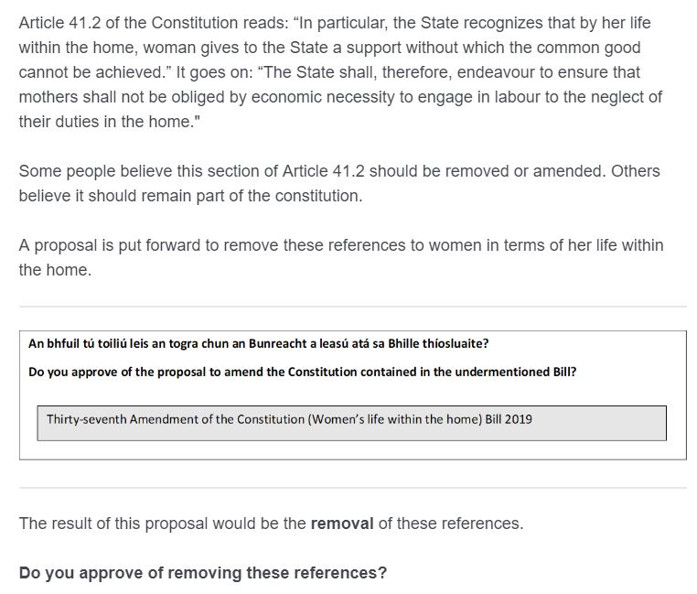

***Sample voting question, seen by respondents***

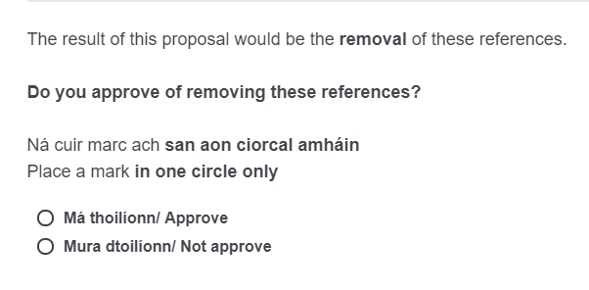

***Sample announcement of the majority vote (respondent’s vote choices was embedded within this vignette)***

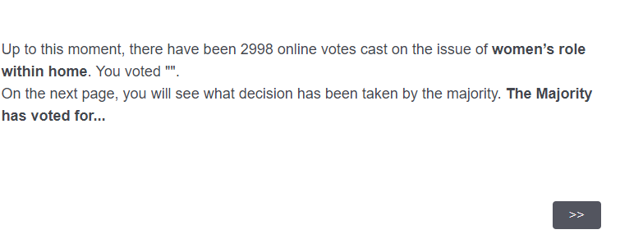

***Sample announcement of the referendum result***

“Approve”. Voters have decided to remove the references to women in terms of her life within the home from the constitution.

**Mediator**

*Procedural Fairness*

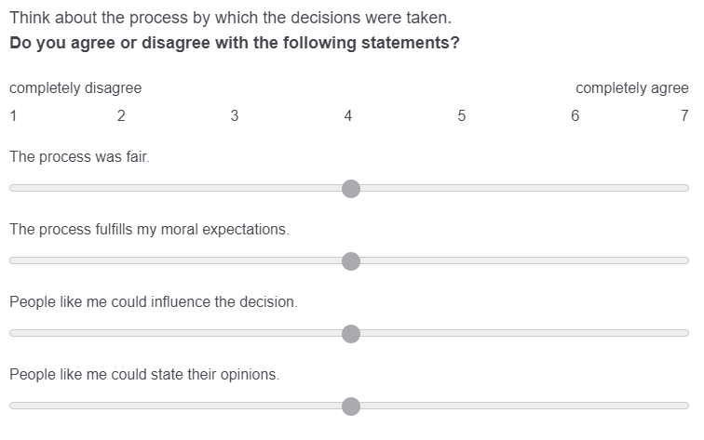

**Dependent Variables**

*Decision Acceptance*

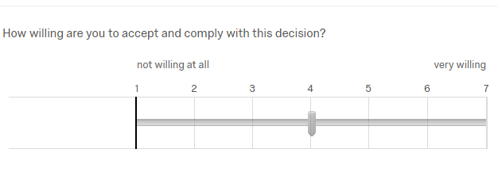

*Perceived legitimacy of the decision-making procedure*

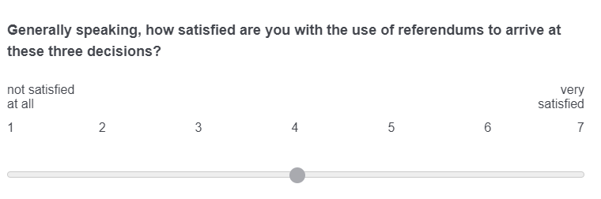

*Satisfaction with Democracy*

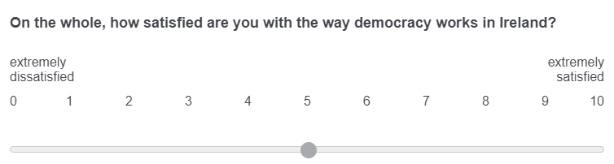

*Political Trust*

**Please indicate on a scale from 0 to 10 how much you personally trust each of the following institutions in Ireland.**

|  |  |  |
| --- | --- | --- |
|  | no trust  at all | complete  trust |

|  |  |  |  |  |  |  |  |  |  |  |  |
| --- | --- | --- | --- | --- | --- | --- | --- | --- | --- | --- | --- |
|  | 0 | 1 | 2 | 3 | 4 | 5 | 6 | 7 | 8 | 9 | 10 |

|  |  |
| --- | --- |
| Dáil Éireann () |  |
| The government () |  |
| Politicians () |  |
| Political Parties () |  |

*Manipulation Check Question*

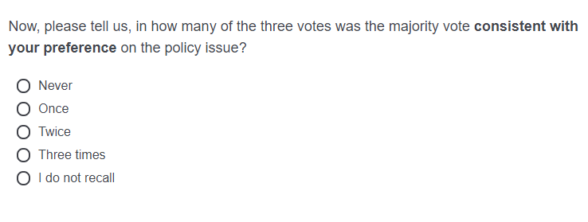

*Debriefing*

Thank you for taking part in our study. We would like to inform you that the voting process in which you just participated was **entirely fictitious**. While there are indeed other people participating in this study at this moment, their opinions on the three policy proposals did not matter for what we presented as outcome of the vote. We apologize for this deception! Actually, we are interested in citizens' reaction to winning or losing in referendums. And we have therefore invented a possible outcome of the vote. Hence, what we have presented as outcome is not true and in no way an indication of how Irish citizens think about the three issues that we presented. If we would have held a real vote, we might not have had enough participants in the groups of (repeated) decision winners and losers. For example, we might have had 500 participants who won all three decisions but only 50 participants who lost all three decisions and this would not allow us to study the effects of winning and losing well. Therefore, we assigned you to those groups randomly. Please remember that you have the right to withdraw your data from the study, without any adverse consequences. If you are interested in the results of this study or want to withdraw your data, please contact [[Author’s email address]](mailto:anna.kern@kuleuven.be). Thank you again for your participation.

# Sample Descriptive Statistics and Population Reference Figures

**Table B.1. Descriptive statistics of the sample and the population**

|  |  |  |
| --- | --- | --- |
|  | Sample | Population |
| *Gender (n=2142)* | | |
| women | 52% | 51% |
| men | 48% | 49% |
| *Age (n=2145)* | | |
| 18-24 | 9% | 11% |
| 25-39 | 30% | 36% |
| 40-60 | 37% | 34% |
| 60 plus | 25% | 20% |
| *Education (n=2146)* | | |
| did not finish 3rd level education | 42% | 58% |
| finished 3rd level | 58% | 42% |
| *Political partisanship (n=761)* | | |
| Fianna Fáil | 23% | 14% |
| FineGael | 32% | 13% |
| LabourParty | 8% | 3% |
| SinnFéin | 20% | 18% |
| GreenParty | 5% | 4% |
| Other | 11% | 11% |
| *Note:* Population figures for gender, age, and education are based on the 2016 census of Ireland. The frequently named other parties in our sample were Socialist Party, Solidarity - People Before Profit, RENUA Irleand, Social Democrats, Independent Alliance, Workers' Party, and Independents. Partisanship was captured with "future intention in future election" for population reference. | | |

# Main Outcome Variables

**Table C.1. Description of outcome variables**

|  |  |  |  |  |
| --- | --- | --- | --- | --- |
| **Outcome Variable** | **Quetion Wording** | **Mean** | **SD** | **N** |
| Decision Acceptance after 1st Vote | How willing are you to accept and comply with this decision? | 5.27 | 1.78 | 2146 |
| Decision Acceptance after 2nd Vote | How willing are you to accept and comply with this decision? | 5.02 | 2.08 | 2146 |
| Decision Acceptance after 3rd Vote | How willing are you to accept and comply with this decision? | 5.01 | 2.11 | 2146 |
| Perceived legitimacy of the decision making procedure | Some people are satisfied with the way in which national referendums are held in Ireland nowadays. Others call for changes to the voting process. Do you think the rules of the voting procedure for referendums should be changed or remain the same? | 5.29 | 1.52 | 2146 |
| Satisfaction with democracy (pre-experimental) | On the whole, how satisfied are you with the way democracy works in Ireland? | 5.02 | 2.64 | 2146 |
| Satisfaction with democracy (post-experimental) | On the whole, how satisfied are you with the way democracy works in Ireland? | 5.50 | 2.64 | 2146 |

**Table C.2. Bivariate Pearson correlations of outcome variables**

|  |  |  |  |  |  |
| --- | --- | --- | --- | --- | --- |
|  | **1st time decision acceptance** | **3rd time decision acceptance** | **perceived legitimacy of decision-making procedure** | **political trust** | **satisfaction with democracy** |
| 1st time decision acceptance | 1 |  |  |  |  |
| 3rd time decision acceptance | 0.203* | 1 |  |  |  |
| perceived legitimacy of | 0.382* | 0.322* | 1 |  |  |
| decision making procedure |  |  |  |  |  |
| political trust | 0.096* | 0.087* | 0.247* | 1 |  |
| satisfaction with democracy | 0.139* | 0.109* | 0.345* | 0.740* | 1 |

# Robustness Tests

We run several kinds of robustness analyses and we present them in sub-sections of this appendix. Appendix D.1 contains the results of the complier average causal effect (CACE) analysis, in Appendix D.2 we tackle issue saliency of the different referendum items and in Appendix D.3 we tested our models including additional covariates. Finally, in Appendix D.4 we study the effect of accumulated losses on decision acceptance by taking pre-treatment attitudes (on divorce proceedings and on lowering the voting age) into account.

First, consistent with the pre-analysis plan, we estimated a complier average causal effect (CACE) to measure the impact of losing on the subgroup of the population that complied with the treatment. We used an instrumental variable approach and conducted a two-stage least squares analysis, whereby assignment to the treatment was regarded as an instrument for receiving the treatment; therefore, it could be considered as an endogenous variable. The results remain robust and strong (see online Appendix D.1). Individual’s perceptions of legitimacy diminish with each loss and the effect sizes are larger among compliers.

Second, during pre-treatment, we measured the saliency of the three policy issues. Descriptive statistics show that the *constitution’s reference to women’s role in the home* is the most important policy issue for our respondents (M=3.62, SD=1.2, range: 1–5), whereas the *waiting time before divorce proceedings can be initiated* is the least important (M=2.44, SD=1.27, range: 1–5) (Figure D.2.1, online Appendix D.2). For robustness, we reran our main models, together with an interaction term between the issue saliency of each issue and the amount of losing. The objective was to discount the assumption that certain issues may be more salient for some respondents than others, and this saliency may drive individuals’ reactions to losing. Our main findings remain robust, with the following exceptions: (a) When we estimate the effect of 1st time losing on decision acceptance, losing has a much stronger dampening effect on decision acceptance of those who find the policy issue highly salient. It still negatively affects the decision acceptance among those who do not find the issue salient, but to a smaller degree. (b) The inclusion of the interaction terms to the model dilutes the statistical significance of the main negative effect of amount of losing on change in satisfaction with democracy (Model 2, Figure D.2.2(e)). However, the inclusion of the interaction terms to the model does not affect the main negative effect of amount of losing on perceived legitimacy of the decision-making procedure and change in political trust (see Appendix D.2).

Third, we ran all the analyses together with other covariates (Figure D.3.1, online Appendix D.3). In these models we controlled for gender, age, political ideology (based on a left-right self-placement scale), political interest and media consumption. Results remained robust. We had initially planned to include political party identification in the models as a covariate, but we had too many missing variables for this, and the sample size would have shrunk from *n*=2,116 to *n*=755, reducing the power of our analyses substantively. Given the applied randomization, we have no reason to suspect that partisanship is a confounding variable, even though we cannot test it empirically. However, future research could examine how the effects of losing differ among subgroups with different strengths of partisanship, for example, with a randomized block design.

# D.1 Complier Average Causal Effect (CACE) Analysis

**Figure D.1. Effect of losing among compliers only (using 2SLS instrumental approach)**



# D.2 Issue Salience

The order of which policy issues were presented to respondents: women’s role in the household; divorce; voting age 16 years.

**Figure D.2.1. Mean issue saliency**

**

**Figure D.2.2. Models controlling for moderating effect of issue saliency**

**Figure D.2.2(a). DV: Decision acceptance after the 1st loss**



We replicate the H1 analysis, estimating the effect of first-time losing on decision acceptance after the first vote, this time controlling for the interaction term between issue saliency of women’s role in the household (the first policy issue in the study) and first time losing. The main effect remains robust. Yet, the interaction term is negative and statistically significant. The sub-figure D.2.2(b) below plots the marginal mean of decision acceptance among winners and losers at each level of issue saliency. It shows that when the issue is highly salient to the respondent, the effect of losing on decision acceptance is greater than when the issue is not salient to the respondent. To put it differently, losing has a stronger dampening effect on decision acceptance of those who find the policy issue highly salient.

**Figure D.2.2(b). Marginsplot, first-time losers and first-time winners**



Furthermore, we repeate the analysis with the decision acceptance measured after the 3rd vote and estimate the effect of the number of previous losses on decision acceptance together with an interaction term between the treatment and issue saliency of the last policy issue – voting age (Figure D.2.2(c)).

**Figure D.2.2(c). DV: Decision Acceptance (measured after the third vote) and the number of previous losses.**



As it can be seen, the inclusion of the interaction term dilutes the main effect of the number of previous losses on decision acceptance. There is, however, no significant interaction effect. The loss of significant effect of the amount of losing taking into account the previous losses could be due to underpowered nature of the sample.

**Figure D.2.2(d) DV: Perceived legitimacy of the decision-making procedure**



Figure D.2.2(d) plots the main model, with the dependent variable of perceived legitimacy of the decision-making procedure and this time accounting for issue saliency and its interaction term with the treatment (e.g. the amount of losing).

We run three separate models in order not to overfit our models and/or lose power: Model 1 accounts for an interaction between treatment and saliency of the issue of divorce. Model 2 accounts for an interaction between treatment and the saliency of the issue of women’s role in the household and lastly Model 3 includes the interaction term between the treatment and the issue saliency of voting age. The inclusion of the interaction terms in the models does not dilute the main effect of losing. Out of three policy issues, only the *voting age* seems to have a moderating effect on people’s perceived legitimacy of the decision-making procedure. Below, we plot the marginal means in order to make the relationship more interpretable.

**Figure D.2.3: Moderating effect of issue saliency on the effect of losing on perceived legitimacy of the decision- making procedure**



Figure D.2.3 shows that the moderating effect of issue saliency on the effect of losing on perceived legitimacy of the decision-making procedure is trivial, as the difference is very small and the CIs overlap substantially.

Furthermore, we replicate the same analyses with the rest of the DVs: change in satisfaction with democracy and change in political trust. Consistently, Model 1 includes the interaction term between saliency of divorce and treatment, Model 2 women’s role saliency and treatment, and consequently, Model 3 includes the interaction between the treatment and voting age saliency.

**Figure D.2.2(e). DV: Change in SWD**



The main results are consistent with our main analyses (see the manuscript, Figure 5). Losing three times has a negative effect on change in people’s satisfaction with democracy and this effect is robust to the inclusion of the interaction term between issue saliency and the treatment (at p<0.05 and p<0.10 significance level for Model 1 and Model 3 respectively), with an exception of Model 2, when we add the interaction term between issue saliency of women’s role in the household and the amount of losing, where it loses its statistical significance. Yet, there seems to be no interaction effect between issue saliency and treatment for SWD measure.

Figure D.2.2(f) visualizes the results of the models with our last dependent variable - change in political trust.

**Figure D.2(f). DV: (change in) political trust**



What we observe is that the inclusion of the policy issues, together with their interaction terms to the models increases the statistical significance of the number of losing. As it shows, with each loss, the change in political trust decreases further and this decrease is a lot greater after the third loss.

In sum, the findings of these analyses, i.e. whether issue saliency moderates the effect of repeated losing on perceived democratic legitimacy, are mixed. Whether issue saliency interacts with losing or not depends on the proxy we use to capture the perceived democratic legitimacy.

# D.3 Models with Additional Covariates

**Figure D.3.1. Models with covariates**



# D.4 Models on the effect of accumulated losses on decision acceptance, by pre-treatment attitudes

**Figure D.4.1. The effect of accumulated losses on decision acceptance by pre-treatment attitudes on divorce proceedings**



**Figure E.D.2. The effect of accumulated losses on decision acceptance by pre-treatment attitudes on lowering the voting age**



# Additional Analyses

In this section we present the analyses of the three hypotheses that were pre-registered but not discussed in the main text of the manuscript.

*H3: Legitimacy beliefs of consecutive losers are stronger than legitimacy beliefs of discontinuous losers after several rounds of direct democratic decision-making.*

To test this hypothesis we compare the levels and change in satisfaction with democracy and political trust of those who lost consecutively (LLL) with those whose “streak of bad luck” was interrupted by a win (LWL) (see Table F.1). Throughout the experiment satisfaction with democracy increased for both groups significantly. However, the change (i.e. increase) is significantly more pronounced for discontinuous losers (LWL) than for consecutive losers (LLL). This is different when we focus on political trust. We find that for consecutive losers (LLL), political trust slightly but significantly declined, whereas there is no statistically significant change for discontinuous losers (LWL) (t(248)=-0.3, p = 0.743). Furthermore, the difference between the changes of these two groups is not statistically significant (t(503) = -1.7, p = 0.10). The levels of post-treatment satisfaction with democracy and political trust do not differ significantly. Although the findings are mixed and depend on the measure of legitimacy belief that we study, we can conclude that there are no indications, that consecutive losers have stronger legitimacy beliefs than discontinuous losers. On the contrary, the results regarding satisfaction with democracy even point in the opposite direction, with discontinuous losers having experienced a significantly larger increase throughout the experiment.

**Table E.1. Levels and changes in legitimacy beliefs for consecutive and discontinuous losers**

|  |  |  |  |
| --- | --- | --- | --- |
|  | Consecutive losers (LLL) | Discontinuous losers  (LWL) | Difference |
| Pre-treatment level of swd | 4.96 | 4.98 | -0.02 |
| Post-treatment level of swd | 5.17 | 5.47 | -0.30 |
| Change in swd | 0.21* | 0.49*** | -0.28* |
|  |  |  |  |
| Pre-treatment level of pol. trust | 15.86 | 15.73 | 0.13 |
| Post-treatment level of pol. trust | 15.44 | 15.80 | -0.36 |
| Change in political trust | -0.42* | 0.07 | -0.49 |

*Note:* swd: satisfaction democracy; pol. trust: political trust; * p <0.05, ** p < 0.01, *** p < 0.001.

*H4: The gap between winners and losers is asymmetric, as losing hurts more than winning eases.*

To test this hypothesis we compare changes in satisfaction with democracy and changes in political trust between three-times losers (LLL) and three-times winners (WWW) (see Table F.2). We find evidence supporting the idea that losing hurts more than winning eases when looking at changes in political trust. The level of trust decreased significantly for three-time losers (t(503)=-2.2, p = 0.03) whereas it slightly rose for three-time winners, although this increase is not statistically significant (t(282)=-1.5, p = 0.13). Also, in terms of effect size, the effect of losing is more substantial. For satisfaction with democracy, however, the findings differ in the sense that satisfaction rose significantly among both, three-time winners and three-time losers. Although the change is significantly more pronounced among consecutive winners, the fact that consecutive losers’ satisfaction levels increased is incompatible with the idea that losing hurts. With these mixed results, H4 cannot be unequivocally supported.

**Table E.2. Levels and changes in legitimacy beliefs for three-times losers and three-times winners**

|  |  |  |  |
| --- | --- | --- | --- |
|  | Consecutive losers (LLL) | Consecutive winners  (WWW) | Difference |
| Pre-treatment level of swd | 4.96 | 5.07 | -0.11 |
| Post-treatment level of swd | 5.17 | 5.54 | -0.37 |
| Change in swd | 0.21* | 0.47*** | -0.26* |
|  |  |  |  |
| Pre-treatment level of pol. trust | 15.86 | 16.16 | -0.30 |
| Post-treatment level of pol. trust | 15.44 | 16.44 | -1.00 |
| Change in political trust | -0.42* | 0.28 | -0.70* |

*Note:* swd: satisfaction democracy; pol. trust: political trust; * p <0.05, ** p < 0.01, *** p < 0.001.

*H5: The effect of all types of losing is moderated by citizens’ degree of news consumption.*

To test the fifth hypothesis we test the interaction effect between the number of losses with respondents’ news consumption. To this end, we created a sum scale for news consumption which is based on the five items that were included in the survey, namely (a) watching television news, (b) read the newspaper, (c) listen to radio news, (d) visit social media sites such as Facebook and Twitter and (e) browse online for news. Respondents could indicate their news consumption on a scale ranging from 0 (‘never’) to 7 (‘7 days a week’). The question which was asked reads as follows: *“On approximately how many days in a typical week, if at all, do you do each of the following?”* We then estimated the interaction effect between this media consumption sum scale and the amounts that respondents had lost in the experiment on the four different indicators of legitimacy perceptions. Our results show (see Figure F.1) that none of these interaction effects had a significant effect on respondents’ legitimacy perceptions, which provides no support for H5.

**Figure E.1. Models that include the interaction between the number of losses and respondents’ news consumption**

*Note:* decision acceptance is the decision acceptance after the third decision outcome has been announced. * the reference category is no loss.

Furthermore, we provide some additional insights from this study. In effect, by measuring the decision acceptance of every respondent following each of the three votes, we can gain additional insights into individuals’ reactions to a series of losses and wins (beyond the focus on the accumulation of losses) (see Figure E.2). For instance, additional analyses reveal that the order of these losses *does* matter (see Figure E.3): the acceptance of a loss in the third round of voting is not significantly different from the acceptance of those losing once or twice before *if* these two previous losses are interrupted by a win. Moreover, one or even two losses do not seem to have a lasting effect on decision acceptance levels if they are followed by a win. The highest level of decision acceptance is not observed among those who never lost. These insights suggest that individuals can withstand a loss as long as the losses are interrupted by (a) win(s).

**Figure E.2. Overview of average decision acceptance after each vote (DA1, DA2 and DA3) across all experimental conditions**



**Figure E.3. Average decision acceptance after third vote with CIs across all experimental conditions**



Figure E.3 shows the average decision acceptance after the third vote across all eight experimental conditions. It shows that the highest decision acceptance in the third vote is observed among respondents in the WLW group, who won, lost and then won in a row (M=6.43; SD=1; CI: [6.31 to 6.55]), followed by mean decision acceptance among respondents in the LWW condition, whose double win was preceded by a loss (M=6.38; SD=1.18; CI: [6.24 to 6.52]. The mean decision acceptance of three-times winners equals to M= 6.36 (SD=0.07; CI: [6.22 to 6.49]. Simple difference-in-means two-tailed t-tests show that, however, the differences in mean decision acceptance between these groups are statistically insignificant (at conventional *p*<0.05 level), leading us to conclude that people can take a loss.

Finally, we also asked our respondents whether they wanted to change the rules of the game. To capture the willingness to change the rules of the voting procedure for referendums, we asked the respondents the following question, post-treatment.

“**Do you think the rules of the voting procedure for referendums should be changed or remain the same?**”

* Definitely be changed
* Probably be changed
* Might or might not be changed
* Probably remain the same
* Definitely remain the same
* Don't know

For our analyses (see Figure E.4), we dropped the “don’t know” response and rescaled the variable so the greater numbers indicate a greater willingness to change the rules of the game.

**Figure E.4. Mean willingness to change the rules of the procedure by number of losses**



The willingness to change the rules of the game does not differ in statistically significant way across the experimental conditions. Interestingly, when losses accumulated, our respondents did not necessarily want to do this; rather, they started questioning the fairness of the process. This could suggest that when confronted with accumulated losses following democratic procedures, individuals’ perceptions of the legitimacy of democratic systems and their associated procedures are eroded; however, this dissatisfaction does not necessarily lead to more public support for drastic reforms or undemocratic systems.