Supplementary Material

The Micro-foundations of Social Democratic Welfare Chauvinism and inclusion: Class Demands and Policy Reforms in Western Europe, 1980-2018

Eloisa Harris, University of Lausanne and the Max-Planck Institute for the study of religious and ethnic diversity
Matthias Enggist, University of Lausanne

Contact: Eloisa.harris@unil.ch

Micro Level
A1: Comparison of Size of Middle Class-Working Class Divide Regarding Welfare Chauvinism Relative to Size of Other Divides
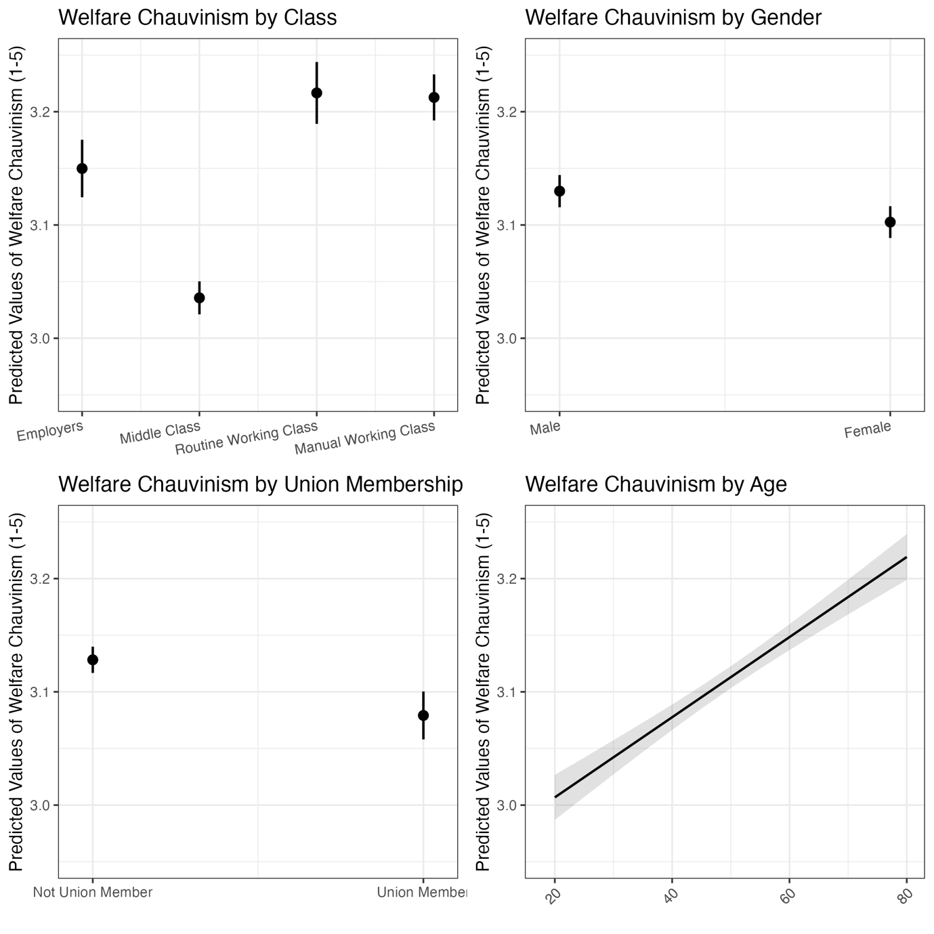

A2: Level of welfare chauvinism by class, binary variable
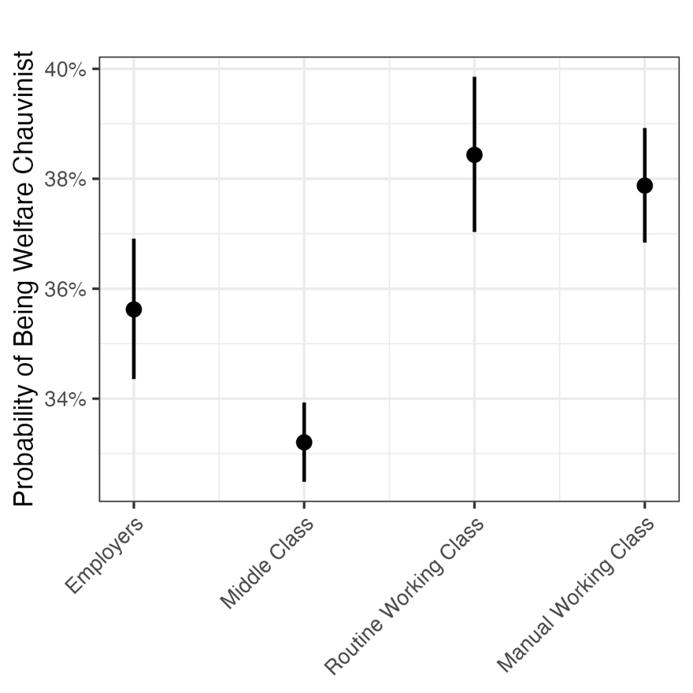

A3: Micro-level regressions which serve as a basis for Figures 1, panel A and B
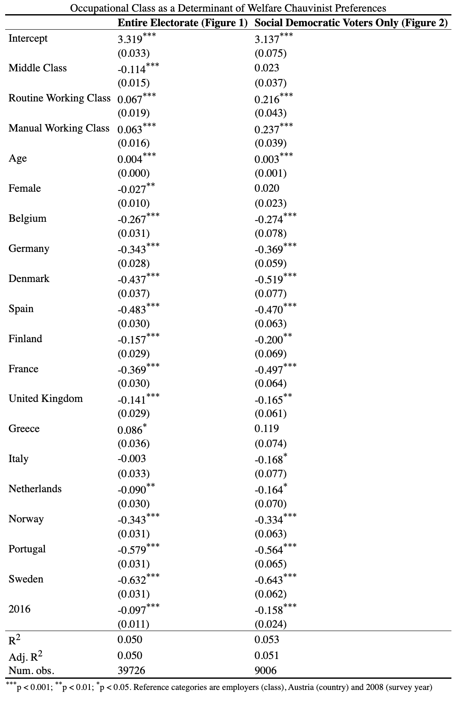

A4: Welfare chauvinist preferences by class among all citizens in 2008 and 2016.
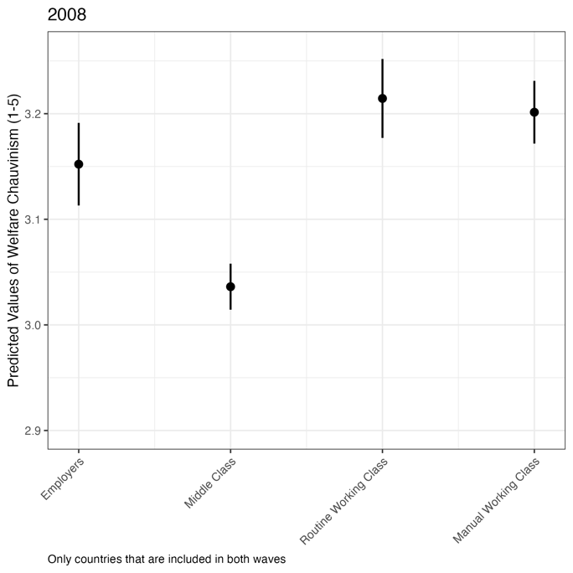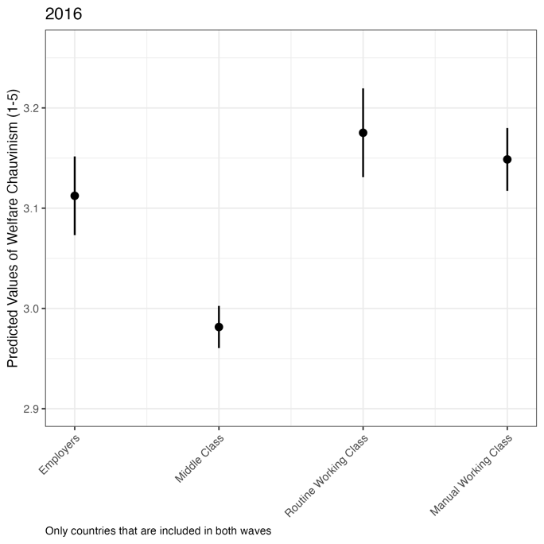

A5: Welfare chauvinist preferences by class in the entire electorate, by country.
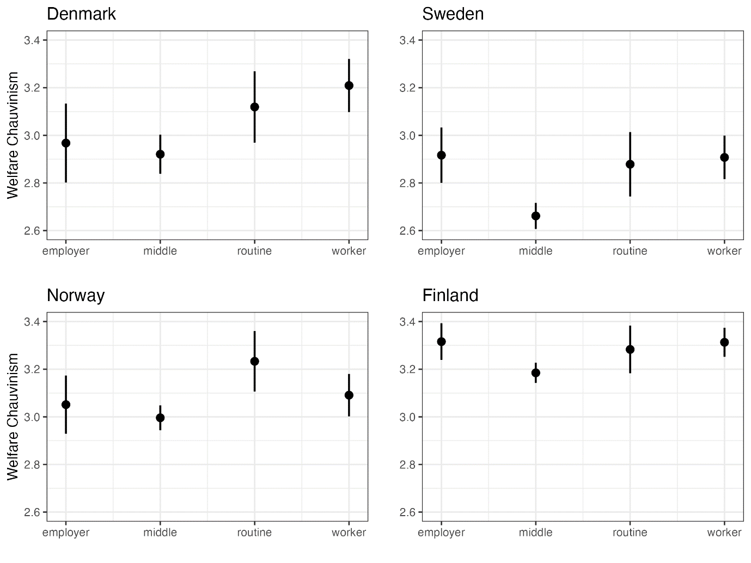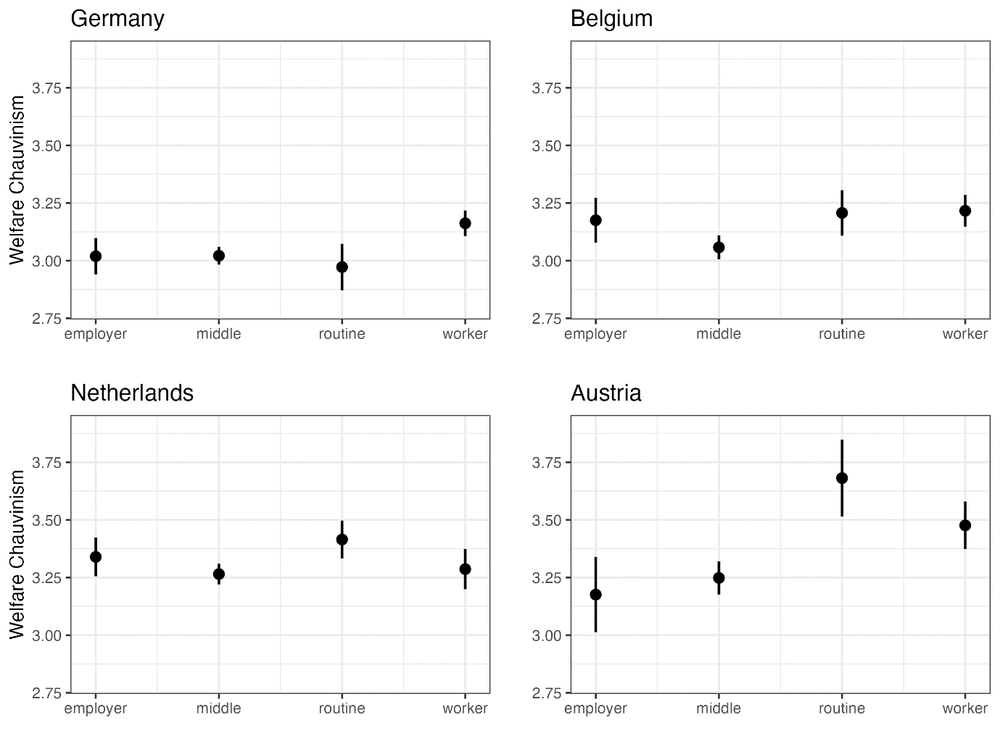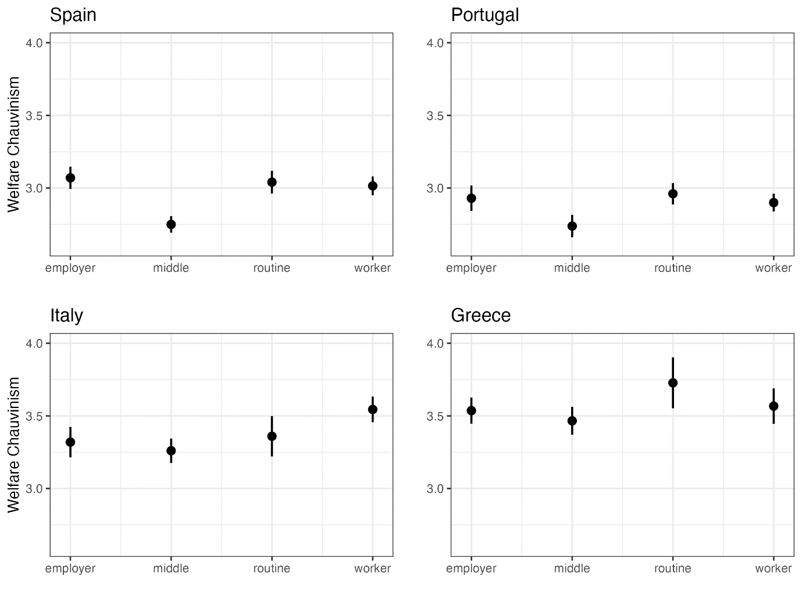 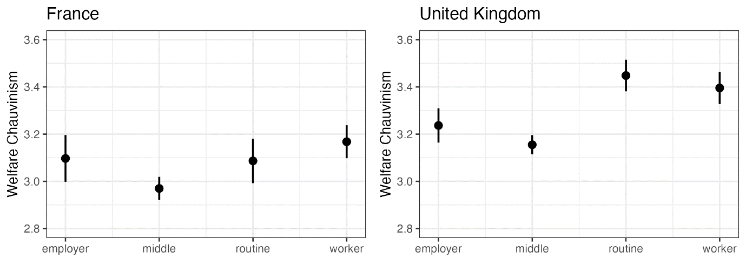

A6: Level of welfare chauvinism by class in social democratic electorates only, binary variable
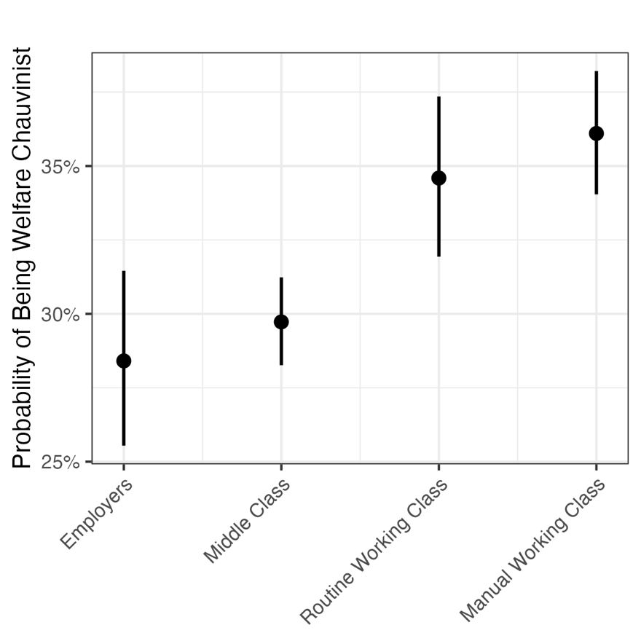

A7: Replication of the Regressions in A3 (which serve as the basis for Figure 1 panel A and B) including cluster-robust standard errors (clustered at the level of countries).
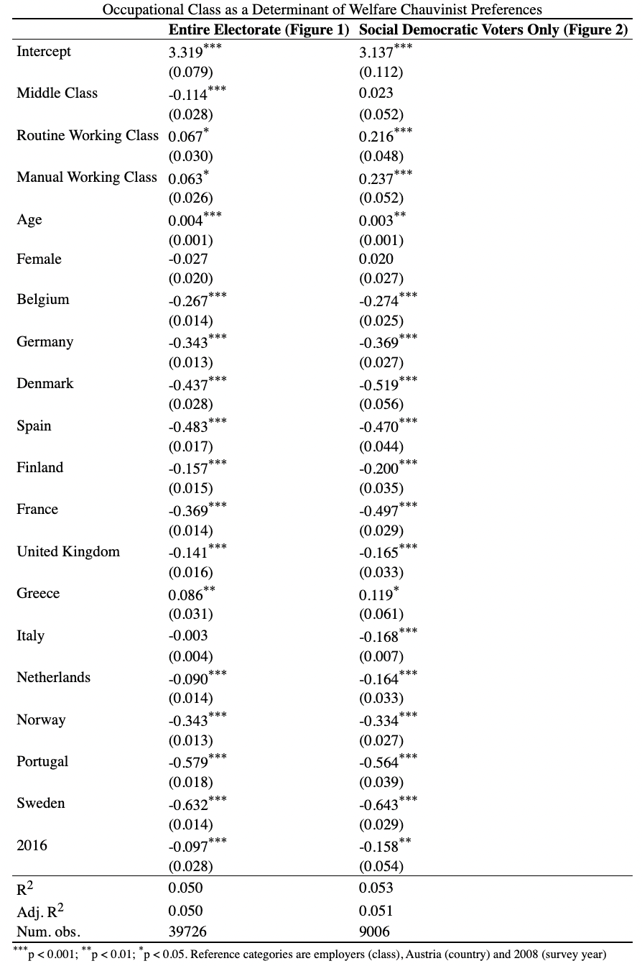
A8: Welfare chauvinist preferences by class among social democratic voters, by country.
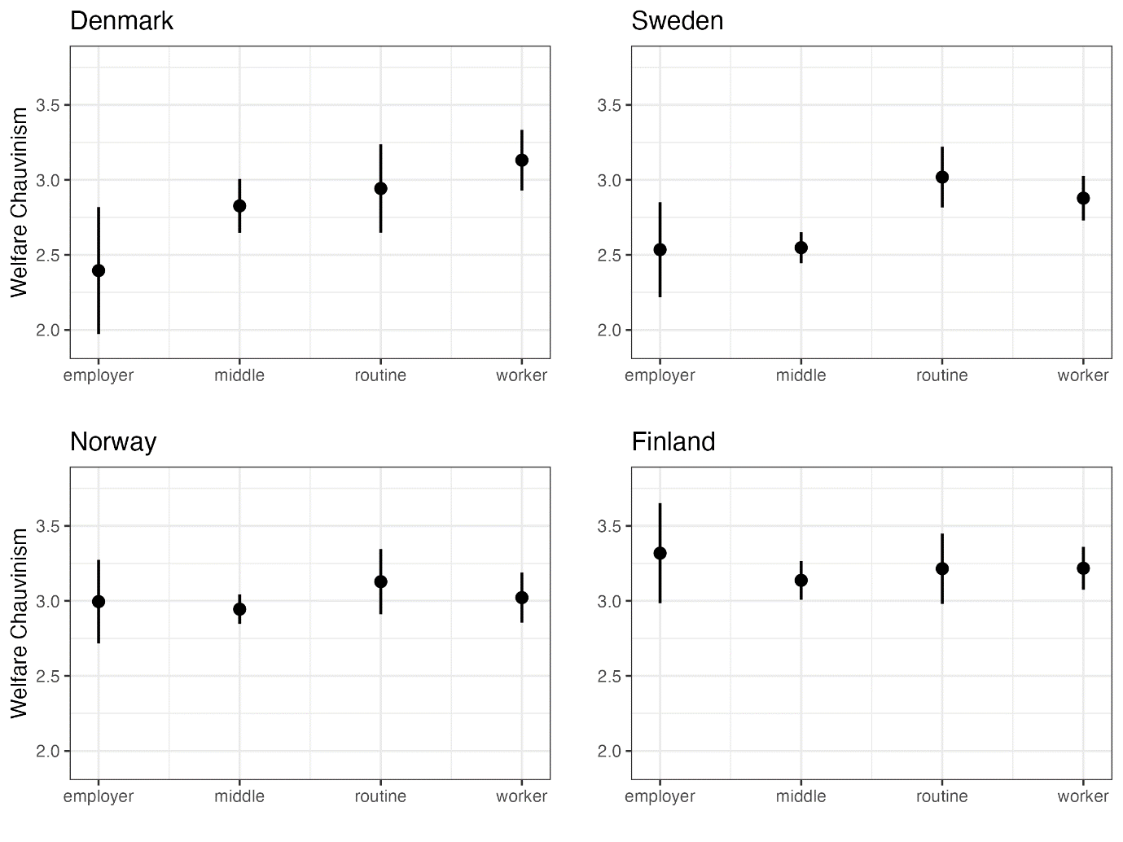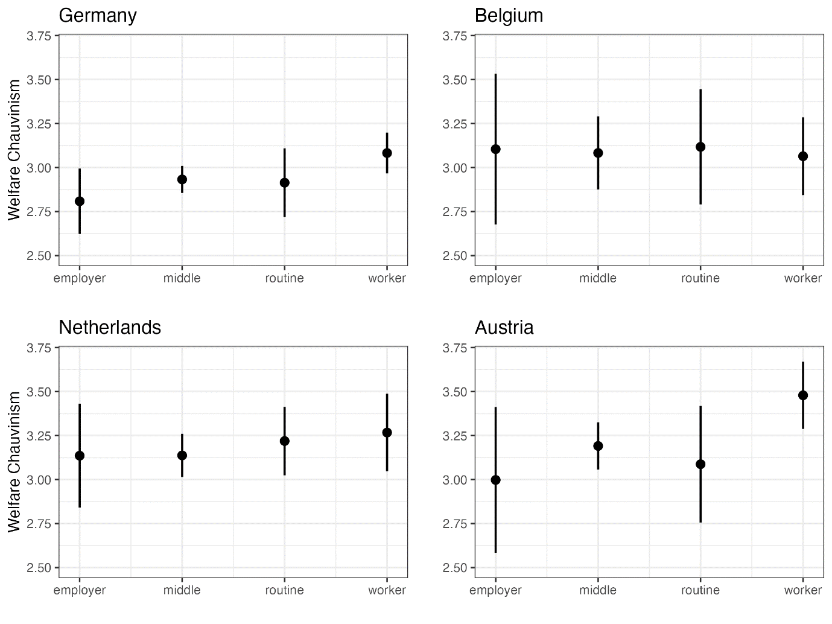 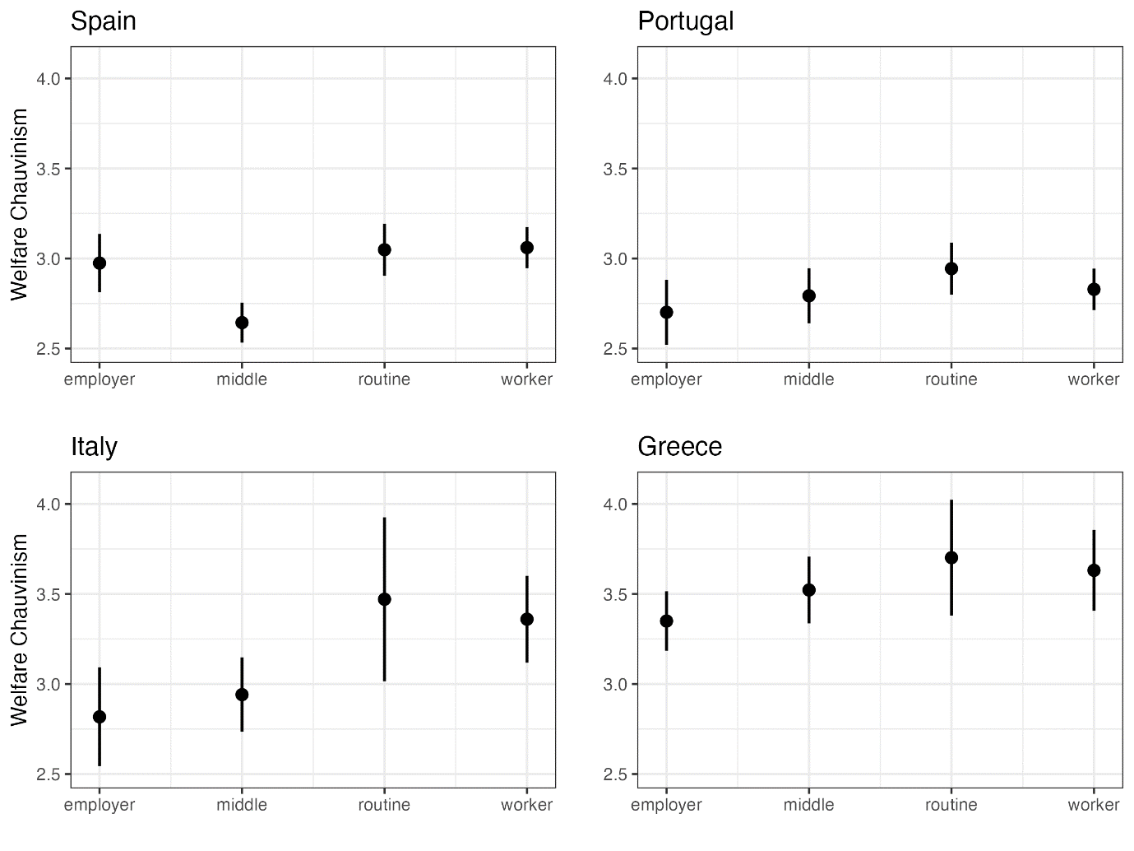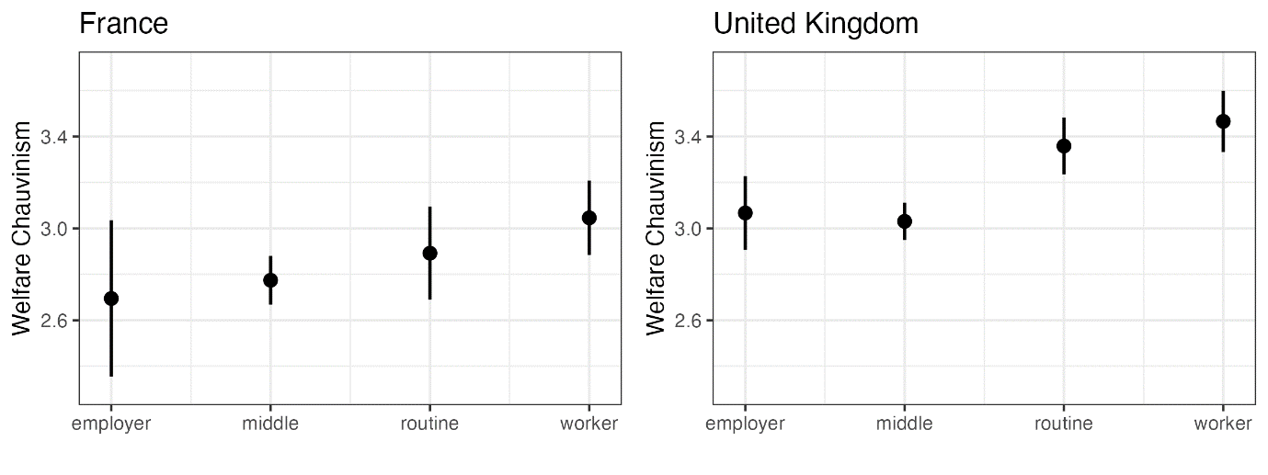

A9: Welfare chauvinist preferences by class in social democratic electorates only, in 2008 and 2016.
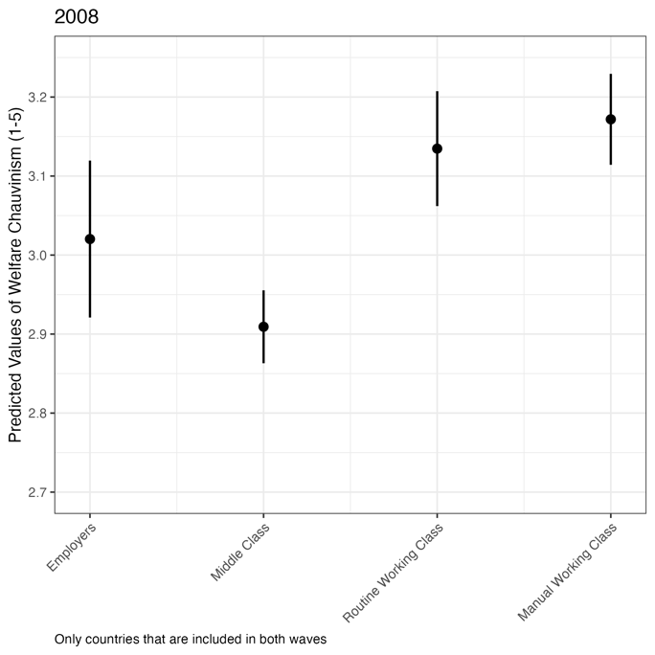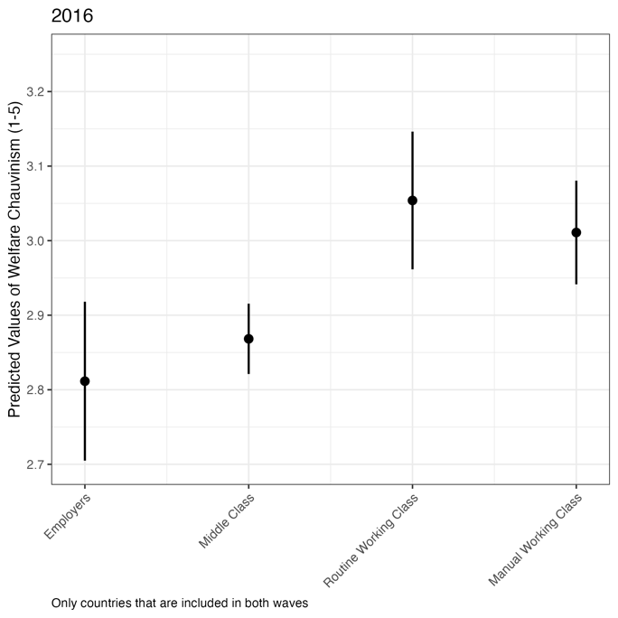

Figure A10: Importance of welfare chauvinism by class (based on data from Germany, Spain, Sweden and the United Kingdom)
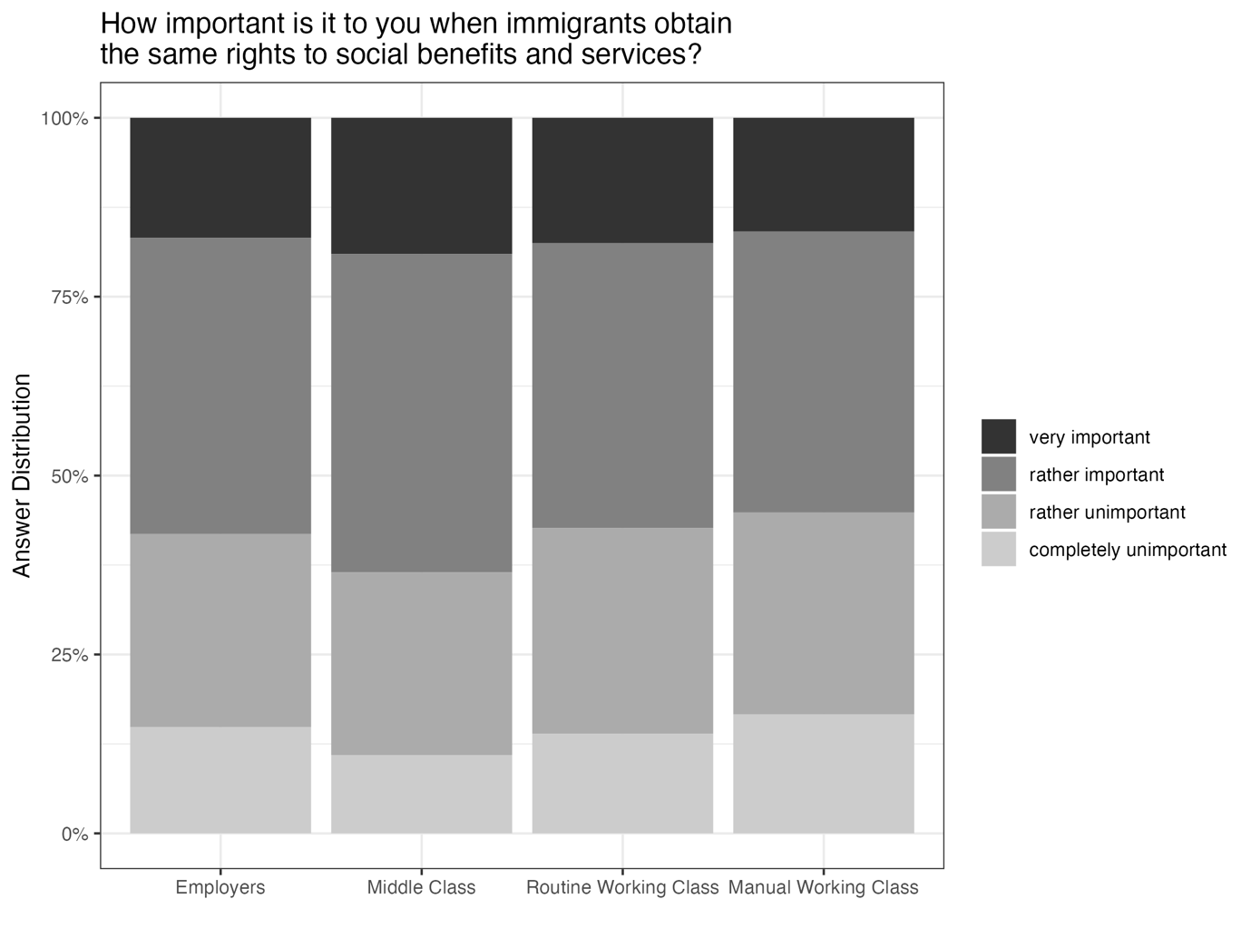
Note: Analysis is based not on the ESS but on a different survey fielded in 2021 in Germany, Spain, Sweden and the United Kingdom. The question was asked directly after a question identical to the ESS question we use for all other analyses (Thinking of people coming to live in [Country] from other countries, when do you think they should obtain the same rights to social benefits and services as citizens already living here?). Thus, it should be clear that the importance refers to the importance attributed to their answer to the previous question.

Macro level

Appendix A2.1A : Construction of middle and working class shares of the electorate (Social democrats)
- Constructing middle and working class shares
We use a moderated version of the 16-cateogory class-scheme developed by Daniel Oesch and follow Gingrich and Häusermann (2015) in their operationalization of class.
1. Employer class: The small and large employer grouping includes agricultural routine workers, large employers, small employers, self-employed professional and small proprietors.
2. The middle-class grouping includes socio- cultural professionals and semi-profession- als, skilled service workers, technical experts, higher managers, associate managers and skilled office workers.
3. The manual worker grouping includes technicians, skilled craft workers and technical routine workers.
4. The routine workers grouping include routine service workers and routine office workers.
Similarly to Gingrich and Häusermann, we add a condition that service workers with higher education (School finishing exam at 18 or higher) enter the middle class.

Eurobarometer (1980-2001)
For the Eurobarometer data, we wrote our own code to match occupation with one of the four classes above.
We then use the question of vote intention to match each respondent in the Eurobarometer with party preferences. We then construct the share of each class that vote for the social democratic party (or similar) in the country in question (as coded by Parlgov “social democracy”).
European Social Survey (2002-2018)
For the ESS survey data, we use code from Seth Joly accessible here https://philippejoly.net/files/code/oesch-class-ess-R/vignette.html to match occupation with one of the 16 classes. We then construct the classes using the rules above (Oesch 16 + higher education condition for middle classes).
We then use the question of reported vote at the last election to construct the shares of voters for social democratic parties in each ESS round (1-9).

- Constructing the variable at the country year and cabinet unit
Different tactics were used to construct the final independent variable “middle class” and “working class” share for the social democrats. At the country year level, following Gingrich and Häusermann, we construct a 3-year-moving average of the data. We experiment with 2 year and 3 year moving averages and lags, too, but in general the results remain the same.
At the cabinet level, rather than averaging the effects for the years in cabinet, we opt for a more specific, albeit time-intensive construction of the class composition of the electorate in the following steps.
Step 1: For each cabinet in our sample, we check which was the parliamentary election that led to the cabinet’s creation. If no election led to this cabinet (for example, following a loss of confidence in the government, death or otherwise), the closest national election prior to the start of that cabinet was coded.
Step 2: We then opted to use data from the Eurobarometer (Election before 1998), data from ESS (Election after 2003) or potentially both (Election between 1998 and 2003).
Step 3: We then checked which data waves/points specifically could be used to gather information about the election that led to the respective cabinet. The steps are different dependent on the dataset we will use – Eurobarometer or ESS.
For Eurobarometer data (data points each year): The question is about vote intention
Step 3.1: Consider data from the year of the election, from the calendar year before the election and from the calendar year after the election.
If for example an election took place in 1986, consider all waves of the EB from 1985, from 1986 and from 1987.
For European Social Survey Data: Remember here, the question asked was about how an individual voted in the last election.
Step 3.1: We coded which ESS waves were fielded in this country during the period between the election bringing about the parliament on which the cabinet is based and the next general election in that country.
To do this accurately, we checked when exactly the fieldwork period for the respective wave in the respective country was. Generally, this information can be found for each wave either in a document called “Quality Matrix” (https://ess-search.nsd.no/) or just on the ESS homepage (e.g. for wave 6 here under country documentation: https://ess-search.nsd.no/en/study/7ccf7f30-fd1a-470a-9b90-4c91b0bc7438).
Example: If the relevant election for a cabinet took place in May 2016, we can use the ESS wave, if the data was collected e.g. between July 2016 and October 2016 but not if it was collected between January 2016 and April 2016.
Special case: If a fieldwork period encompasses the election data (e.g. April 2016-July 2016), we code the beginning of the period and match it with the election.
We then compile the cabinet-unit class composition for the cabinet in question as an average of the waves/data points which we code as valid for the election in question.

Appendix A2.1B: Cabinet periodization
We conceptualize cabinet periodization as follows: A new cabinet emerges when a government is formed following a general election, when there is a change in party composition of the cabinet or a change of head of government. Cabinets of less than one year, or caretaker cabinets, are not included. This strategy is contrary to Schmitt (2016), who disregarded changes due to elections where the government head remained the same, but aligns with other studies (Immergut and Abou-Chadi 2014; Lutz 2019). We code the start year of a cabinet as the year a cabinet begins if the new cabinet is formed before 31st June, otherwise the start year is the following year. For all independent variables apart from vote share, cabinet length and cabinet party composition, the periodisation process creates cabinet-level variables which are the average of the first half of country years in cabinet period. Given that our dependent variable does not move as much as welfare reforms in general, the dependent variable is measured at the level of the final year of cabinet. In the cabinet models, we also include control variables that are not part of the country year models, notably cabinet duration in months and the first-year value of the dependent variable.

Appendix A2.2: Full list of indicators and sources
(CWS = Comparative Welfare States Dataset, CPDS = Comparative Political Dataset):
Note, For a full overview of which parties belong to which party families, please see Armingeon, Klaus, Virginia Wenger, Fiona Wiedemeier, Christian Isler, Laura Knöpfel, David Weisstanner and Sarah Engler. 2018. Comparative Political Data Set 1960-2016. Bern: Institute of Political Science, University of Berne. Appendix 2 (pp42-80)
Variable | Description | Source
GDP per capita | Constant purchasing power parity dollars | CWS
Generosity | Coverage of specific programmes, qualifying periods for eligibility and replacement rates for unemployment programmes for an average production worker in the manufacturing sector who is 40 years old and has been working for 20 years preceding the benefit period (Scruggs et al. 2014) | CWS
Migrant Stock | Stocks of Migrants as a % of population | CWS/OECD
Social Expenditure | Spending on welfare cash and noncash transfers and welfare services as a percentage of the GDP | CPDS
Unemployment rate | Absolute unemployment rate - the number of unemployed persons as a percentage of the civilian labour force. | CWS/CPDS
Budget Deficit | Difference between gov spending and revenue, as percentage of GDP (pos for deficits and neg for surpluses) | CPDS
Social Democrat cabinet Share | Share of cabinet seats , social democrats | CPDS / Parlgov(years 2016-2018)
Vote shares | social1-social8, leftsoc1-leftsoc5, comm1-comm4, postcom1-postcom2, agrarian1-agrarian3, conserv1-conserv8, relig1-relig7, liberal1-liberal9, protest1-protest5, green1-green3, ethnic1-ethnic4, right1-right5, regio1, femin1, monarch1, person1, pension1-pension2, nonlbl1-nonlbl2, allia1-allia3, others | CPDS / Parlgov(years 2016-2018)

Table A2.4 : Cabinet level unit, no LDV
 | Dependent variable:
 | last_year_wc1
 | (1) | (2) | (3)
social democratic cabinet share | 0.002 | -0.005 | 0.016**
 | (0.003) | (0.010) | (0.008)
social expenditure | -0.113 | -0.107 | -0.116
 | (0.105) | (0.085) | (0.093)
GDP per capita | -0.00003 | -0.00004 | -0.00003
 | (0.00003) | (0.00003) | (0.00003)
Net immigration | 0.00000 | 0.00000 | 0.00000
 | (0.00000) | (0.00000) | (0.00000)
Unemployment | -0.051 | 0.053 | -0.015
 | (0.052) | (0.050) | (0.051)
union_cab | -0.002 | 0.041 | 0.040
 | (0.031) | (0.030) | (0.032)
Cabinet duration (m) | 0.009 | 0.011 | 0.010
 | (0.009) | (0.008) | (0.008)
Working class voters SD |  | -0.080***
 |  | (0.018)
SD cabinet*Working class |  | 0.0002
 |  | (0.0002)
Middle class voters SD |  |  | 0.072***
 |  |  | (0.023)
SD cabinet*Middle class |  |  | -0.0004*
 |  |  | (0.0002)
Observations | 151 | 151 | 151
R² | 0.096 | 0.298 | 0.204
Adjusted R² | -0.200 | 0.051 | -0.076
F Statistic | 1.718 (df = 7; 113) | 5.237*** (df = 9; 111) | 3.163*** (df = 9; 111)
Note: | *p<0.1; **p<0.05; ***p<0.01

Table 2A.5: Cabinet level unit, Country FE only and LDV
Dependent variable:
 | last_year_wc1
 | (1) | (2) | (3)
lag_lastyear_wc1 | 0.802*** | 0.771*** | 0.785***
 | (0.051) | (0.054) | (0.049)
social democratic cabinet share | 0.002 | 0.001 | 0.009**
 | (0.002) | (0.006) | (0.004)
social expenditure | 0.019 | 0.008 | 0.007
 | (0.026) | (0.027) | (0.028)
GDP per capita | 0.00001 | 0.00000 | 0.00001
 | (0.00001) | (0.00001) | (0.00001)
Net immigration | 0.00000 | 0.00000 | 0.00000
 | (0.00000) | (0.00000) | (0.00000)
Unemployment | 0.005 | 0.026 | 0.020
 | (0.028) | (0.031) | (0.029)
union_cab | 0.002 | 0.012 | 0.015
 | (0.016) | (0.018) | (0.018)
Cabinet duration (m) | 0.007 | 0.006 | 0.007
 | (0.005) | (0.005) | (0.005)
Working class voters SD |  | -0.015*
 |  | (0.008)
SD cabinet*Working class |  | 0.00001
 |  | (0.0001)
Middle class voters SD |  |  | 0.017**
 |  |  | (0.008)
SD cabinet*Middle class |  |  | -0.0002**
 |  |  | (0.0001)
Observations | 144 | 144 | 144
R² | 0.685 | 0.692 | 0.696
Adjusted R² | 0.631 | 0.633 | 0.638
F Statistic | 33.201*** (df = 8; 122) | 26.997*** (df = 10; 120) | 27.524*** (df = 10; 120)
Note: | *p<0.1; **p<0.05; ***p<0.01

Table 2A.6: Cabinet unit, Spain and Denmark imputation
 | Dependent variable:
 | last_year_wc1
 | (1) | (2) | (3)
lag_lastyear_wc1 | 0.782*** | 0.739*** | 0.761***
 | (0.054) | (0.060) | (0.056)
social democratic cabinet share | 0.003 | 0.001 | 0.011**
 | (0.002) | (0.006) | (0.005)
social expenditure | -0.020 | -0.024 | -0.022
 | (0.034) | (0.034) | (0.033)
GDP per capita | -0.00003* | -0.00003* | -0.00003*
 | (0.00002) | (0.00002) | (0.00002)
Net immigration | -0.00000 | -0.000 | -0.00000
 | (0.00000) | (0.00000) | (0.00000)
Unemployment | 0.004 | 0.024 | 0.015
 | (0.030) | (0.033) | (0.031)
union_cab | 0.021 | 0.028 | 0.033**
 | (0.019) | (0.020) | (0.020)
Cabinet duration (m) | 0.007 | 0.007 | 0.008
 | (0.005) | (0.005) | (0.005)
Working class voters SD |  | -0.017
 |  | (0.011)
SD cabinet*Working class |  | 0.00004
 |  | (0.0001)
Middle class voters SD |  |  | 0.018*
 |  |  | (0.010)
SD cabinet*Middle class |  |  | -0.0002*
 |  |  | (0.0001)
Observations | 144 | 144 | 144
R² | 0.696 | 0.703 | 0.707
Adjusted R² | 0.589 | 0.592 | 0.597
F Statistic | 30.293*** (df = 8; 106) | 24.664*** (df = 10; 104) | 25.069*** (df = 10; 104)
Note: | *p<0.1; **p<0.05; ***p<0.01

Table 2A.7: Cabinet unit, Green and radical right vote share included
Dependent variable:
 | last_year_wc1
 | (1) | (2) | (3)
lag_lastyear_wc1 | 0.785*** | 0.732*** | 0.758***
 | (0.055) | (0.060) | (0.056)
social democratic cabinet share | 0.003** | -0.001 | 0.014***
 | (0.002) | (0.006) | (0.005)
social expenditure | -0.018 | -0.021 | -0.020
 | (0.034) | (0.034) | (0.034)
GDP per capita | -0.00003* | -0.00003* | -0.00003
 | (0.00002) | (0.00002) | (0.00002)
Net immigration | -0.00000 | 0.00000 | 0.000
 | (0.00000) | (0.00000) | (0.00000)
Unemployment | 0.006 | 0.032 | 0.021
 | (0.030) | (0.033) | (0.031)
union_cab | 0.023 | 0.033* | 0.037*
 | (0.019) | (0.019) | (0.020)
Cabinet duration (m) | 0.008 | 0.009* | 0.009*
 | (0.005) | (0.005) | (0.005)
prrp_vote_cab | 0.016 | 0.022* | 0.021*
 | (0.015) | (0.013) | (0.013)
green_vote_cab | 0.006 | 0.010 | 0.005
 | (0.039) | (0.039) | (0.038)
Working class voters SD |  | -0.022**
 |  | (0.011)
SD cabinet*Working class |  | 0.0001
 |  | (0.0001)
Middle class voters SD |  |  | 0.023**
 |  |  | (0.010)
SD cabinet*Middle class |  |  | -0.0003**
 |  |  | (0.0001)
Observations | 144 | 144 | 144
R² | 0.702 | 0.714 | 0.719
Adjusted R² | 0.590 | 0.599 | 0.606
F Statistic | 24.499*** (df = 10; 104) | 21.214*** (df = 12; 102) | 21.731*** (df = 12; 102)
Note: | *p<0.1; **p<0.05; ***p<0.01

Table 2A.8: Cabinet unit, Working Pop only
Dependent variable:
 | last_year_wc1
 | (1) | (2) | (3)
lag_lastyear_wc1 | 0.782*** | 0.723*** | 0.768***
 | (0.054) | (0.061) | (0.055)
social democratic cabinet share | 0.003* | -0.001 | 0.013***
 | (0.002) | (0.006) | (0.005)
social expenditure | -0.021 | -0.033 | -0.016
 | (0.033) | (0.035) | (0.033)
GDP per capita | -0.00003** | -0.00003** | -0.00003
 | (0.00002) | (0.00002) | (0.00002)
Net immigration | -0.00000 | 0.00000 | -0.000
 | (0.00000) | (0.00000) | (0.00000)
Unemployment | 0.005 | 0.044 | 0.010
 | (0.030) | (0.037) | (0.031)
union_cab | 0.022 | 0.022 | 0.031
 | (0.019) | (0.021) | (0.020)
Cabinet duration (m) | 0.007 | 0.010* | 0.009*
 | (0.005) | (0.005) | (0.005)
wshare_workers_cab |  | -0.018
 |  | (0.012)
SD cabinet*wshare_workers_cab |  | 0.0001
 |  | (0.0001)
mshare_workers_cab |  |  | 0.013
 |  |  | (0.010)
SD cabinet*mshare_workers_cab |  |  | -0.0002**
 |  |  | (0.0001)
Observations | 144 | 135 | 141
R² | 0.699 | 0.697 | 0.716
Adjusted R² | 0.594 | 0.573 | 0.606
F Statistic | 30.732*** (df = 8; 106) | 21.881*** (df = 10; 95) | 25.448*** (df = 10; 101)
Note: | *p<0.1; **p<0.05; ***p<0.01

Table 2A.9: Country year analysis, without LDV
 | Dependent variable:
 | dv_wc
 | (1) | (2) | (3)
Social Democratic cabinet share | 0.003 | -0.008 | 0.018***
 | (0.002) | (0.005) | (0.004)
Social expenditure | -0.046 | -0.071 | -0.067
 | (0.024) | (0.022) | (0.024)
GDP per capita | -0.00001 | -0.00002 | -0.00001
 | (0.00001) | (0.00001) | (0.00001)
Net immigration | -0.00000 | 0.00000 | -0.000
 | (0.00000) | (0.00000) | (0.00000)
Unemployment | -0.018 | 0.052 | 0.016
 | (0.028) | (0.028) | (0.028)
Union Density | -0.038*** | 0.008 | -0.008
 | (0.013) | (0.014) | (0.014)
Working class share SD |  | -0.055**
 |  | (0.018)
SD cabinet share*working |  | 0.0002
 |  | (0.0001)
Middle class share SD |  |  | 0.037*
 |  |  | (0.021)
SD cabinet share*middle |  |  | -0.0004**
 |  |  | (0.0002)
Observations | 464 | 464 | 464
R² | 0.039 | 0.154 | 0.089
Adjusted R² | -0.002 | 0.114 | 0.046
F Statistic | 3.041*** (df = 6; 444) | 10.046*** (df = 8; 442) | 5.386*** (df = 8; 442)
Note: All independent variables lagged 1 year. *p<0.1; **p<0.05; ***p<0.01

Table 2A.10: Country year analysis, with LDV
 | Dependent variable:
 | dv_wc
 | (1) | (2) | (3)
Lagged DV | 0.926*** | 0.916*** | 0.921***
 | (0.017) | (0.018) | (0.017)
Social Democratic cabinet share | 0.001* | 0.002 | 0.003*
 | (0.001) | (0.002) | (0.002)
Social expenditure | 0.004 | 0.002 | 0.002
 | (0.009) | (0.009) | (0.009)
GDP per capita | 0.00000 | 0.00000 | 0.00000
 | (0.00000) | (0.00000) | (0.00000)
Net immigration | 0.000 | 0.000 | 0.00000
 | (0.00000) | (0.00000) | (0.00000)
Unemployment | -0.003 | 0.002 | 0.0004
 | (0.010) | (0.011) | (0.010)
Union Density | 0.003 | 0.006 | 0.006
 | (0.005) | (0.005) | (0.005)
Working class share SD |  | -0.005
 |  | (0.003)
SD cabinet share*working |  | -0.00001
 |  | (0.00004)
Middle class share SD |  |  | 0.004
 |  |  | (0.003)
SD cabinet share*middle |  |  | -0.00005
 |  |  | (0.00004)
Observations | 464 | 464 | 464
R² | 0.875 | 0.876 | 0.876
Adjusted R² | 0.870 | 0.870 | 0.870
F Statistic | 443.653*** (df = 7; 443) | 346.687*** (df = 9; 441) | 345.259*** (df = 9; 441)
Note: | *p<0.1; **p<0.05; ***p<0.01
All independent variables lagged 1 year.

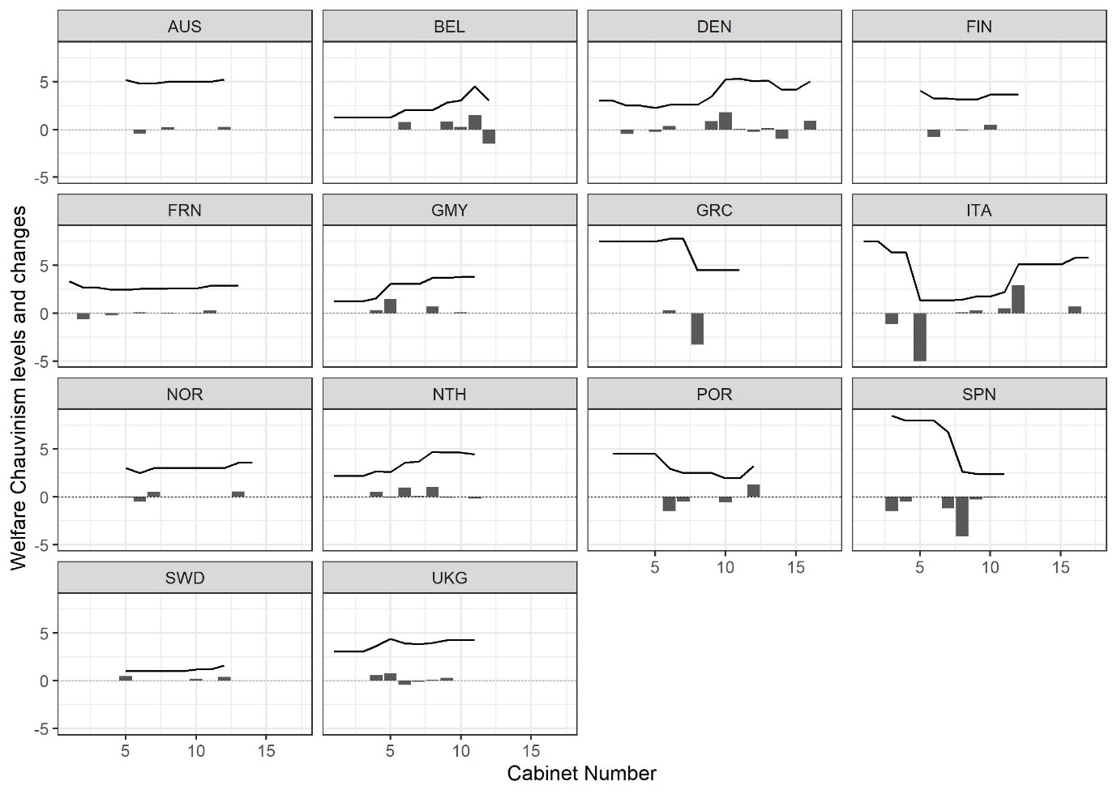
2A.11 : Changes and Levels, Welfare Chauvinism cabinets.

Appendix 2A.12 Distribution of the independent variable (interaction effect): Class shares
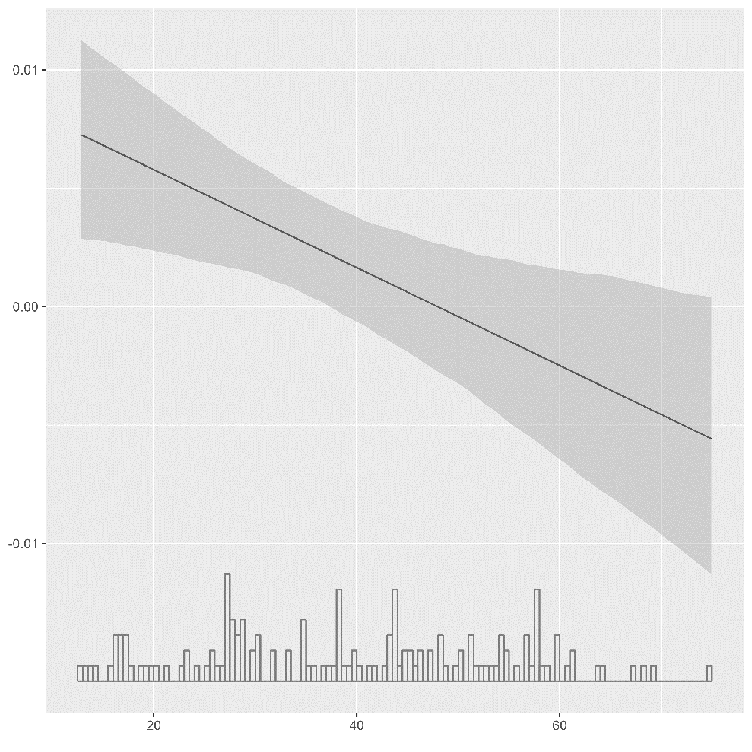
Middle class interaction

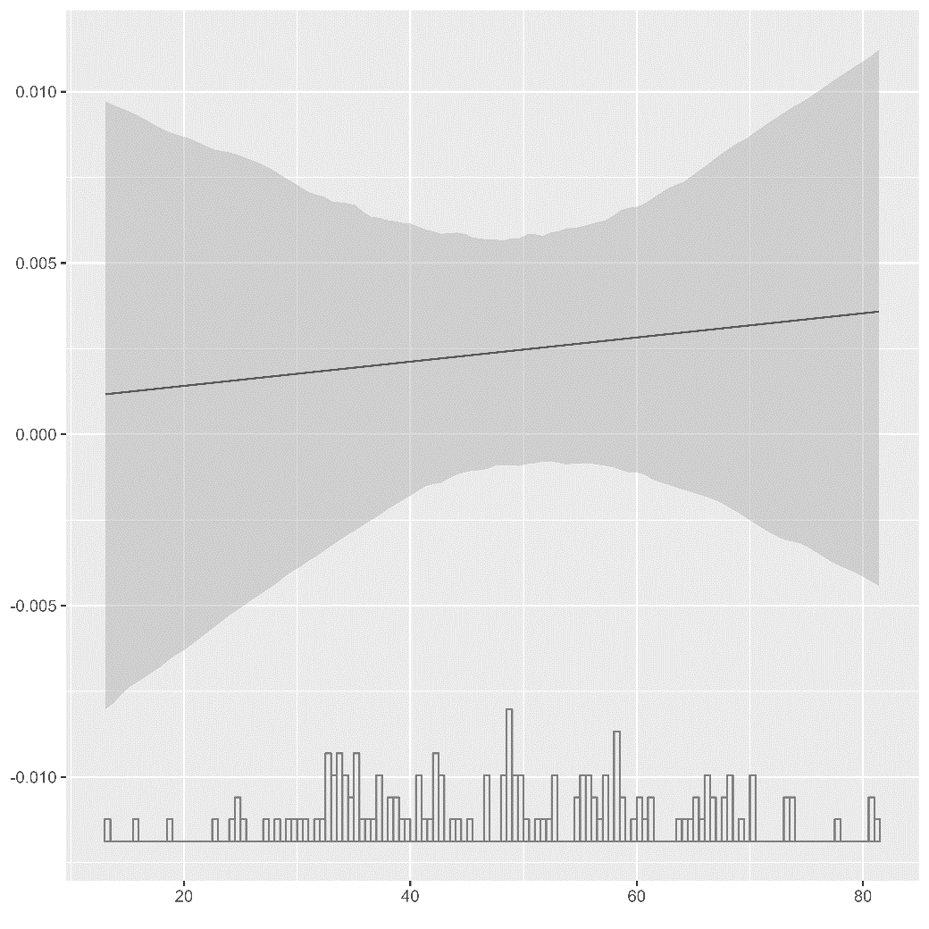
Working class interaction

Appendix. 2A.13. Cabinets and directions welfare chauvinism
Cabinets and immigrant welfare rights:
Expand, if last year cabinet X+1 > last year cabinet X, Retrench if last year cabinet X+1 < last year cabinet X
Gov Party: 1 = Hegemony of Right wing, 2 = Dominance of Right wing, 3 = Balance of Power, 4 = Dominance of Left, 5 = Hegemony of Left
Cntry | Cabinet start | Cabinet end | Cabinet name | Welfare chauvinism? | Gov Party | SD in cabinet | Green in cabinet | Far left in cabinet
AUS | 1980 | 1982 | Kreisky IV | none | 5 | 100 | 0 | 0
AUS | 1983 | 1986 | Sinowatz | none | 4 | 88.2 | 0 | 0
AUS | 1987 | 1990 | Vranitzky II | none | 3 | 51 | 0 | 0
AUS | 1991 | 1994 | Vranitzky III | welfare inclusion | 3 | 57.1 | 0 | 0
AUS | 1995 | 1996 | Vranitzky IV | none | 3 | 55.6 | 0 | 0
AUS | 1997 | 1999 | Klima I | welfare inclusion | 3 | 57.7 | 0 | 0
AUS | 2000 | 2002 | Schuessel I | none | 1 | 0 | 0 | 0
AUS | 2003 | 2006 | Schuessel III | welfare chauvinism | 1 | 0 | 0 | 0
AUS | 2007 | 2008 | Gusenbauer | none | 3 | 50.7 | 0 | 0
AUS | 2009 | 2013 | Faymann I | none | 3 | 52.8 | 0 | 0
AUS | 2014 | 2015 | Faymann II | none | 3 | 52.5 | 0 | 0
AUS | 2016 | 2017 | Kern | welfare chauvinism | 3 | 52.5 | 0 | 0
AUS | 2018 | 2018 | Kurz | none | 1 | 0 | 0 | 0
BEL | 1980 | 1980 | Martens I | none | 3 | 38.4 | 0 | 0
BEL | 1981 | 1981 | Martens IV | none | 3 | 41.4 | 0 | 0
BEL | 1982 | 1985 | Martens V | none | 1 | 0 | 0 | 0
BEL | 1986 | 1987 | Martens VI | none | 1 | 0 | 0 | 0
BEL | 1988 | 1991 | Martens VIII | none | 3 | 48 | 0 | 0
BEL | 1992 | 1994 | Dehaene I | welfare chauvinism | 3 | 52.5 | 0 | 0
BEL | 1995 | 1999 | Dehaene II | none | 3 | 50 | 0 | 0
BEL | 2000 | 2003 | Verhofstadt I | none | 3 | 35.1 | 21.3 | 0
BEL | 2004 | 2008 | Verhofstadt II | welfare chauvinism | 3 | 49.5 | 0 | 0
BEL | 2009 | 2011 | Rompuy | welfare chauvinism | 2 | 21.3 | 0 | 0
BEL | 2012 | 2014 | Di Rupo | welfare chauvinism | 3 | 41.9 | 0 | 0
BEL | 2015 | 2018 | Michel I | welfare inclusion | 1 | 0 | 0 | 0
DEN | 1980 | 1981 | Jorgensen V | none | 5 | 100 | 0 | 0
DEN | 1982 | 1982 | Jorgensen VI | none | 4 | 100 | 0 | 0
DEN | 1983 | 1983 | Schluter I | welfare inclusion | 1 | 0 | 0 | 0
DEN | 1984 | 1987 | Schluter II | none | 1 | 0 | 0 | 0
DEN | 1988 | 1990 | Schluter IV | welfare inclusion | 1 | 0 | 0 | 0
DEN | 1991 | 1992 | Schluter V | welfare chauvinism | 1 | 0 | 0 | 0
DEN | 1993 | 1994 | Rasmussen N I | none | 3 | 77.5 | 0 | 0
DEN | 1995 | 1997 | Rasmussen N II | none | 4 | 82.7 | 0 | 0
DEN | 1998 | 2001 | Rasmussen N IV | welfare chauvinism | 4 | 90 | 0 | 0
DEN | 2002 | 2004 | Rasmussen F I | welfare chauvinism | 1 | 0 | 0 | 0
DEN | 2005 | 2007 | Rasmussen F II | welfare chauvinism | 1 | 0 | 0 | 0
DEN | 2008 | 2008 | Rasmussen F III | welfare inclusion | 1 | 0 | 0 | 0
DEN | 2009 | 2011 | Rasmussen L I | welfare chauvinism | 1 | 0 | 0 | 0
DEN | 2012 | 2013 | Thorning-Schmidt I | welfare inclusion | 4 | 57.1 | 20.8 | 0
DEN | 2014 | 2014 | Thorning-Schmidt II | none | 3 | 72.1 | 0 | 0
DEN | 2015 | 2016 | Rasmussen L II | welfare chauvinism | 1 | 0 | 0 | 0
DEN | 2017 | 2018 | Rasmussen L III | welfare chauvinism | 1 | 0 | 0 | 0
FIN | 1980 | 1982 | Koivisto II | none | 3 | 39.4 | 0 | 26.5
FIN | 1983 | 1986 | Sorsa VI | none | 3 | 46.7 | 0 | 0
FIN | 1987 | 1990 | Holkeri I | none | 3 | 43.1 | 0 | 0
FIN | 1991 | 1994 | Aho I | welfare inclusion | 1 | 0 | 0 | 0
FIN | 1995 | 1998 | Lipponen I | none | 3 | 43.8 | 6.2 | 15.3
FIN | 1999 | 2001 | Lipponen II | welfare inclusion | 3 | 36.7 | 7.9 | 14.4
FIN | 2002 | 2002 | Lipponen III | none | 3 | 39.8 | 0 | 15.6
FIN | 2003 | 2006 | Vanhanen I | welfare inclusion | 3 | 45.7 | 0 | 0
FIN | 2007 | 2010 | Vanhanen II | none | 2 | 0 | 12 | 0
FIN | 2011 | 2014 | Katainen I | welfare chauvinism | 3 | 33.6 | 8 | 11.2
FIN | 2015 | 2016 | Sipilae I | none | 1 | 0 | 0 | 0
FIN | 2017 | 2018 | Sipilae II | none | 1 | 0 | 0 | 0
FRN | 1980 | 1980 | Barre II | none | 1 | 0 | 0 | 0
FRN | 1981 | 1985 | Mauroy II | welfare inclusion | 5 | 86.8 | 0 | 13.2
FRN | 1986 | 1987 | Chirac II | none | 1 | 0 | 0 | 0
FRN | 1988 | 1991 | Rocard II | welfare inclusion | 5 | 100 | 0 | 0
FRN | 1992 | 1992 | Beregovoy I | none | 4 | 100 | 0 | 0
FRN | 1993 | 1995 | Balladur | welfare chauvinism | 1 | 0 | 0 | 0
FRN | 1996 | 1996 | Juppe II | none | 1 | 0 | 0 | 0
FRN | 1997 | 2001 | Jospin | welfare chauvinism | 5 | 86.6 | 0 | 13.4
FRN | 2002 | 2004 | Raffarin II | none | 1 | 0 | 0 | 0
FRN | 2005 | 2006 | Villepin | welfare chauvinism | 1 | 0 | 0 | 0
FRN | 2007 | 2011 | Fillon II | welfare chauvinism | 1 | 0 | 0 | 0
FRN | 2012 | 2013 | Ayrault II | none | 5 | 94.5 | 5.5 | 0
FRN | 2014 | 2016 | Valls I | none | 5 | 100 | 0 | 0
FRN | 2017 | 2018 | Philippe II | none | 1 | 0.6 | 0 | 0
GMY | 1980 | 1980 | Schmidt II | none | 4 | 84.6 | 0 | 0
GMY | 1981 | 1982 | Schmidt III | none | 4 | 80.4 | 0 | 0
GMY | 1983 | 1986 | Kohl II | none | 1 | 0 | 0 | 0
GMY | 1987 | 1990 | Kohl III | welfare chauvinism | 1 | 0 | 0 | 0
GMY | 1991 | 1994 | Kohl IV | welfare chauvinism | 1 | 0 | 0 | 0
GMY | 1995 | 1998 | Kohl V | none | 1 | 0 | 0 | 0
GMY | 1999 | 2002 | Schroeder I | none | 5 | 86.4 | 13.6 | 0
GMY | 2003 | 2005 | Schroeder II | welfare chauvinism | 5 | 82 | 18 | 0
GMY | 2006 | 2009 | Merkel I | none | 3 | 49.6 | 0 | 0
GMY | 2010 | 2013 | Merkel II | welfare chauvinism | 1 | 0 | 0 | 0
GMY | 2014 | 2017 | Merkel III | none | 3 | 38.3 | 0 | 0
GMY | 2018 | 2018 | Merkel V | none | 3 | 38.3 | 0 | 0
ICE | 1980 | 1982 | Thoroddsen | none | 2 | 0 | 0 | 22.4
ICE | 1983 | 1987 | Hermannsson I | none | 1 | 0 | 0 | 0
ICE | 1988 | 1988 | Palsson | none | 3 | 24.4 | 0 | 0
ICE | 1989 | 1990 | Hermannsson II | none | 3 | 32.3 | 0 | 25.8
ICE | 1991 | 1994 | Oddsson I | none | 3 | 27.8 | 0 | 0
ICE | 1995 | 1998 | Oddsson II | none | 1 | 0 | 0 | 0
ICE | 1999 | 2002 | Oddsson III | welfare chauvinism | 1 | 0 | 0 | 0
ICE | 2003 | 2004 | Oddsson IV | welfare inclusion | 1 | 0 | 0 | 0
ICE | 2005 | 2006 | Asgrimsson | none | 1 | 0 | 0 | 0
ICE | 2007 | 2008 | Haarde II | none | 3 | 41.9 | 0 | 0
ICE | 2009 | 2012 | Sigurdardottir I | none | 5 | 66.7 | 33.3 | 0
ICE | 2013 | 2016 | Gunnlaugsson | none | 1 | 0 | 0 | 0
ICE | 2017 | 2017 | Benediktsson III | none | 1 | 0 | 0 | 0
ICE | 2018 | 2018 | Jakobsdottir | none | 2 | 0 | 31.4 | 0
ITA | 1980 | 1980 | Cossiga I | none | 2 | 6.9 | 0 | 0
ITA | 1981 | 1983 | Spadolini I | none | 3 | 22.2 | 0 | 0
ITA | 1984 | 1987 | Craxi I | welfare inclusion | 2 | 26.2 | 0 | 0
ITA | 1988 | 1989 | De Mita | none | 3 | 29.4 | 0 | 0
ITA | 1990 | 1990 | Andreotti VI | welfare inclusion | 3 | 29.4 | 0 | 0
ITA | 1991 | 1992 | Andreotti VII | none | 3 | 31.2 | 0 | 0
ITA | 1993 | 1993 | Ciampi | none | 2 | 32.6 | 0 | 0
ITA | 1994 | 1995 | Berlusconi I | welfare chauvinism | 1 | 0 | 0 | 0
ITA | 1996 | 1998 | Prodi I | welfare chauvinism | 3 | 59.4 | 5.6 | 0
ITA | 1999 | 1999 | D'Alema I | none | 3 | 59.2 | 4.3 | 6.4
ITA | 2000 | 2000 | Amato II | welfare chauvinism | 2 | 65.4 | 4.7 | 7.1
ITA | 2001 | 2005 | Berlusconi II | welfare chauvinism | 1 | 0 | 0 | 0
ITA | 2006 | 2007 | Prodi II | welfare inclusion | 4 | 70.6 | 4.5 | 16.9
ITA | 2008 | 2011 | Berlusconi IV | none | 1 | 0 | 0 | 0
ITA | 2012 | 2013 | Monti | none | 3 | 0 | 0 | 0
ITA | 2014 | 2016 | Renzi | welfare chauvinism | 4 | 79.6 | 0 | 0
ITA | 2017 | 2017 | Gentiloni | none | 4 | 88.9 | 0 | 0
ITA | 2018 | 2018 | Conte | none | 1 | 0 | 0 | 0
NOR | 1980 | 1981 | Nordli II | none | 5 | 100 | 0 | 0
NOR | 1982 | 1982 | Willoch I | none | 1 | 0 | 0 | 0
NOR | 1983 | 1985 | Willoch II | none | 1 | 0 | 0 | 0
NOR | 1986 | 1989 | Brundtland II | welfare inclusion | 5 | 100 | 0 | 0
NOR | 1990 | 1990 | Syse | welfare inclusion | 2 | 0 | 0 | 0
NOR | 1991 | 1993 | Brundtland III | welfare inclusion | 5 | 100 | 0 | 0
NOR | 1994 | 1996 | Brundtland IV | welfare chauvinism | 5 | 100 | 0 | 0
NOR | 1997 | 1997 | Jagland | none | 4 | 100 | 0 | 0
NOR | 1998 | 1999 | Bondevik I | none | 1 | 0 | 0 | 0
NOR | 2000 | 2001 | Stoltenberg I | none | 4 | 100 | 0 | 0
NOR | 2002 | 2005 | Bondevik II | none | 1 | 0 | 0 | 0
NOR | 2006 | 2009 | Stoltenberg II | none | 4 | 70.1 | 0 | 17.2
NOR | 2010 | 2013 | Stoltenberg III | welfare chauvinism | 4 | 74.4 | 0 | 12.8
NOR | 2014 | 2017 | Solberg I | none | 1 | 0 | 0 | 0
NOR | 2018 | 2018 | Solberg III | none | 1 | 0 | 0 | 0
NTH | 1980 | 1981 | Van Agt I | none | 1 | 0 | 0 | 0
NTH | 1982 | 1982 | Van Agt II | none | 3 | 40.4 | 0 | 0
NTH | 1983 | 1986 | Lubbers I | none | 1 | 0 | 0 | 0
NTH | 1987 | 1989 | Lubbers II | welfare chauvinism | 1 | 0 | 0 | 0
NTH | 1990 | 1994 | Lubbers III | welfare inclusion | 3 | 47.6 | 0 | 0
NTH | 1995 | 1998 | Kok I | welfare chauvinism | 3 | 40.2 | 0 | 0
NTH | 1999 | 2002 | Kok II | welfare chauvinism | 3 | 46.4 | 0 | 0
NTH | 2003 | 2006 | Balkenende III | welfare chauvinism | 1 | 0 | 0 | 0
NTH | 2007 | 2010 | Balkenende V | welfare inclusion | 3 | 41.2 | 0 | 0
NTH | 2011 | 2012 | Rutte I | none | 1 | 0 | 0 | 0
NTH | 2013 | 2017 | Rutte III | welfare inclusion | 3 | 48.1 | 0 | 0
NTH | 2018 | 2018 | Rutte V | none | 1 | 0 | 0 | 0
POR | 1980 | 1981 | Carneiro I | none | 1 | 0 | 0 | 0
POR | 1982 | 1982 | Balsemao II | none | 1 | 0 | 0 | 0
POR | 1983 | 1985 | Soares III | none | 3 | 57.4 | 0 | 0
POR | 1986 | 1987 | Silva I | none | 1 | 0 | 0 | 0
POR | 1988 | 1991 | Silva II | none | 1 | 0 | 0 | 0
POR | 1992 | 1995 | Silva III | welfare inclusion | 1 | 0 | 0 | 0
POR | 1996 | 1999 | Guterres I | welfare inclusion | 5 | 100 | 0 | 0
POR | 2000 | 2001 | Guterres II | none | 5 | 100 | 0 | 0
POR | 2002 | 2004 | Barroso | none | 1 | 0 | 0 | 0
POR | 2005 | 2009 | Socrates I | welfare inclusion | 5 | 100 | 0 | 0
POR | 2010 | 2010 | Socrates II | none | 5 | 100 | 0 | 0
POR | 2011 | 2015 | Passos Coelho I | welfare chauvinism | 1 | 0 | 0 | 0
POR | 2016 | 2018 | Costa | welfare inclusion | 5 | 100 | 0 | 0
SPN | 1980 | 1980 | Suarez II | none | 1 | 0 | 0 | 0
SPN | 1981 | 1982 | Calvo-Sotelo | none | 2 | 0 | 0 | 0
SPN | 1983 | 1986 | Gonzalez I | welfare inclusion | 5 | 100 | 0 | 0
SPN | 1987 | 1989 | Gonzalez II | welfare inclusion | 5 | 100 | 0 | 0
SPN | 1990 | 1993 | Gonzalez III | none | 5 | 100 | 0 | 0
SPN | 1994 | 1995 | Gonzalez IV | none | 5 | 100 | 0 | 0
SPN | 1996 | 1999 | Aznar I | welfare inclusion | 1 | 0 | 0 | 0
SPN | 2000 | 2003 | Aznar II | welfare inclusion | 1 | 0 | 0 | 0
SPN | 2004 | 2007 | Zapatero I | welfare inclusion | 5 | 100 | 0 | 0
SPN | 2008 | 2011 | Zapatero II | welfare inclusion | 5 | 100 | 0 | 0
SPN | 2012 | 2015 | Rajoy I | none | 1 | 0 | 0 | 0
SPN | 2016 | 2018 | Rajoy II | none | 1 | 0 | 0 | 0
SWD | 1980 | 1982 | Falldin II | none | 1 | 0 | 0 | 0
SWD | 1983 | 1985 | Palme IV | none | 5 | 100 | 0 | 0
SWD | 1986 | 1989 | Carlsson I | welfare chauvinism | 5 | 100 | 0 | 0
SWD | 1990 | 1991 | Carlsson III | none | 5 | 100 | 0 | 0
SWD | 1992 | 1994 | Bildt | welfare chauvinism | 1 | 0 | 0 | 0
SWD | 1995 | 1995 | Carlsson IV | none | 5 | 100 | 0 | 0
SWD | 1996 | 1998 | Persson I | none | 5 | 100 | 0 | 0
SWD | 1999 | 2002 | Persson II | none | 5 | 100 | 0 | 0
SWD | 2003 | 2006 | Persson III | none | 5 | 100 | 0 | 0
SWD | 2007 | 2010 | Reinfeldt I | welfare chauvinism | 1 | 0 | 0 | 0
SWD | 2011 | 2014 | Reinfeldt II | none | 1 | 0 | 0 | 0
SWD | 2015 | 2018 | Lofven I | welfare chauvinism | 5 | 81.9 | 18.1 | 0
UKG | 1980 | 1982 | Thatcher I | none | 1 | 0 | 0 | 0
UKG | 1983 | 1986 | Thatcher II | none | 1 | 0 | 0 | 0
UKG | 1987 | 1990 | Thatcher III | none | 1 | 0 | 0 | 0
UKG | 1991 | 1996 | Major I | welfare chauvinism | 1 | 0 | 0 | 0
UKG | 1997 | 2000 | Blair I | welfare chauvinism | 5 | 100 | 0 | 0
UKG | 2001 | 2004 | Blair II | welfare inclusion | 5 | 100 | 0 | 0
UKG | 2005 | 2006 | Blair III | welfare inclusion | 5 | 100 | 0 | 0
UKG | 2007 | 2009 | Brown | welfare chauvinism | 5 | 100 | 0 | 0
UKG | 2010 | 2014 | Cameron I | welfare chauvinism | 1 | 0 | 0 | 0
UKG | 2015 | 2016 | Cameron II | none | 1 | 0 | 0 | 0
UKG | 2017 | 2018 | May I | none | 1 | 0 | 0 | 0

