Appendix A. Descriptive statistics and figures.
A1. Descriptive statistics, all variables.
 | Mean | Standard Deviation | Range | Minimum | Maximum | Count
Presidential popularity | 45,12 | 16,46 | 91,10 | 2,90 | 94,00 | 1054
Presidential powers (Siaroff) | 6,02 | 2,03 | 6,00 | 2,00 | 8,00 | 1054
Presidential powers (Doyle & Elgie) | 0,33 | 0,13 | 0,52 | 0,05 | 0,57 | 1054
Honeymoon | 0,07 | 0,25 | 1,00 | 0,00 | 1,00 | 1054
End of term | 0,07 | 0,25 | 1,00 | 0,00 | 1,00 | 1054
Corruption | 51,95 | 18,34 | 96,5 | 3,50 | 100,00 | 1054
GDP pc growth | 2,50 | 3,09 | 21,83 | -11,85 | 9,97 | 1054
Unemployment | 7,83 | 3,77 | 17,68 | 2,24 | 19,92 | 1054

A2. Descriptive statistics, presidential popularity ratings.
 | Mean | Standard Deviation | Range | Minimum | Maximum | Count
Argentina | 46,95 | 11,65 | 44,28 | 23,48 | 67,76 | 75
Brazil | 41,57 | 18,05 | 68,03 | 8,03 | 76,05 | 80
Chile | 44,33 | 11,24 | 47,21 | 22,89 | 70,10 | 78
Costa Rica | 37,27 | 9,69 | 36,57 | 19,25 | 55,82 | 77
Korea | 44,08 | 10,98 | 55,13 | 25,33 | 80,46 | 73
Panama | 47,43 | 13,63 | 68,04 | 20,40 | 88,44 | 80
United states | 45,38 | 8,03 | 42,78 | 29,17 | 71,96 | 78
Uruguay | 51,55 | 13,54 | 57,13 | 24,15 | 81,28 | 76
Finland | 84,65 | 7,24 | 32,00 | 62,00 | 94,00 | 36
Czech Republic | 41,25 | 5,17 | 18,08 | 32,15 | 50,23 | 20
Bulgaria | 48,99 | 11,26 | 42,99 | 27,78 | 70,77 | 74
Poland | 49,64 | 12,19 | 44,38 | 25,96 | 70,34 | 78
Portugal | 57,13 | 13,28 | 50,28 | 32,31 | 82,59 | 75
France | 34,77 | 12,64 | 45,57 | 11,47 | 57,04 | 77
Peru | 21,17 | 11,11 | 37,86 | 2,79 | 40,65 | 77

A3. Presidential popularity ratings in each country, quarterly data.
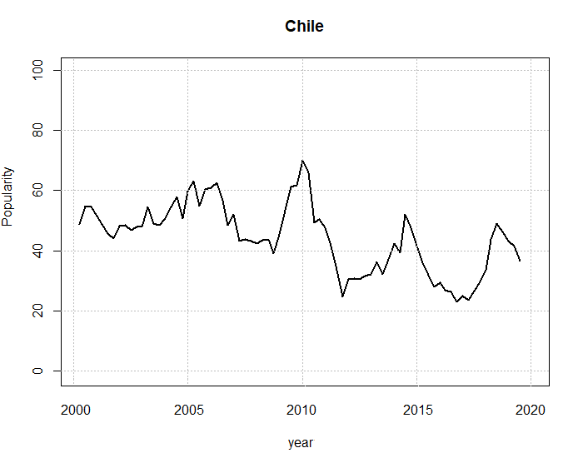
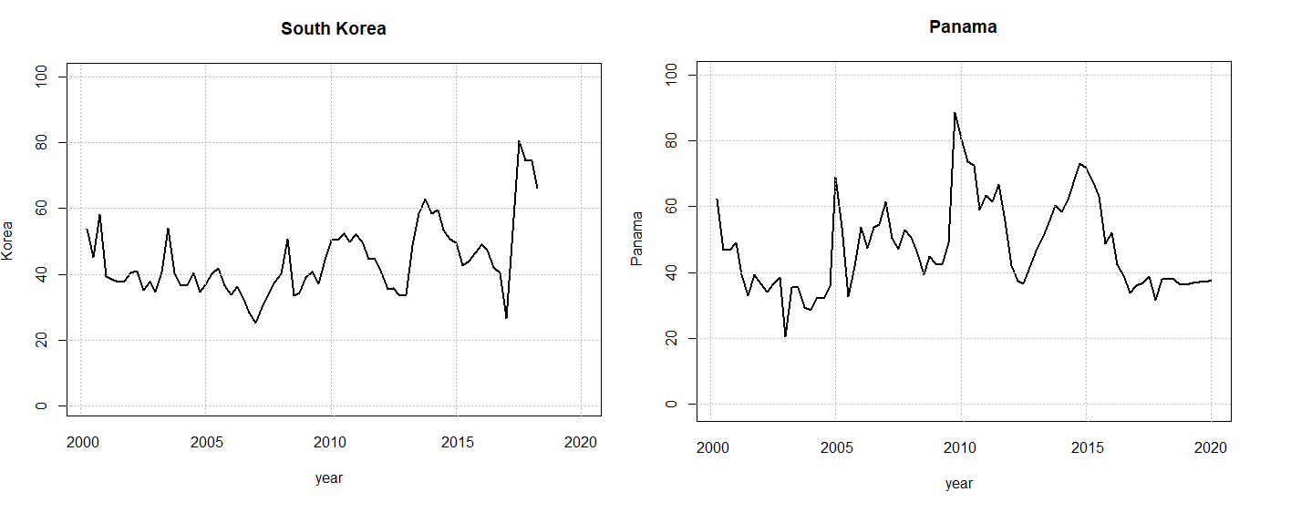
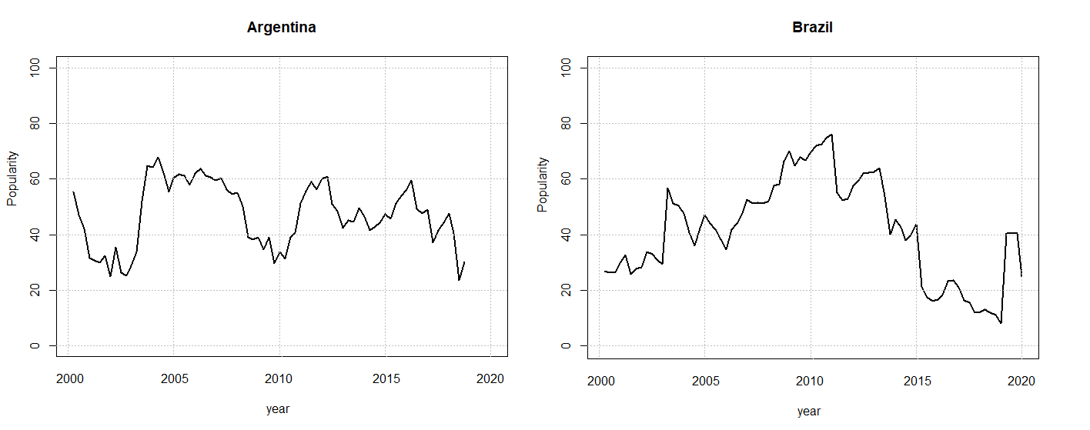

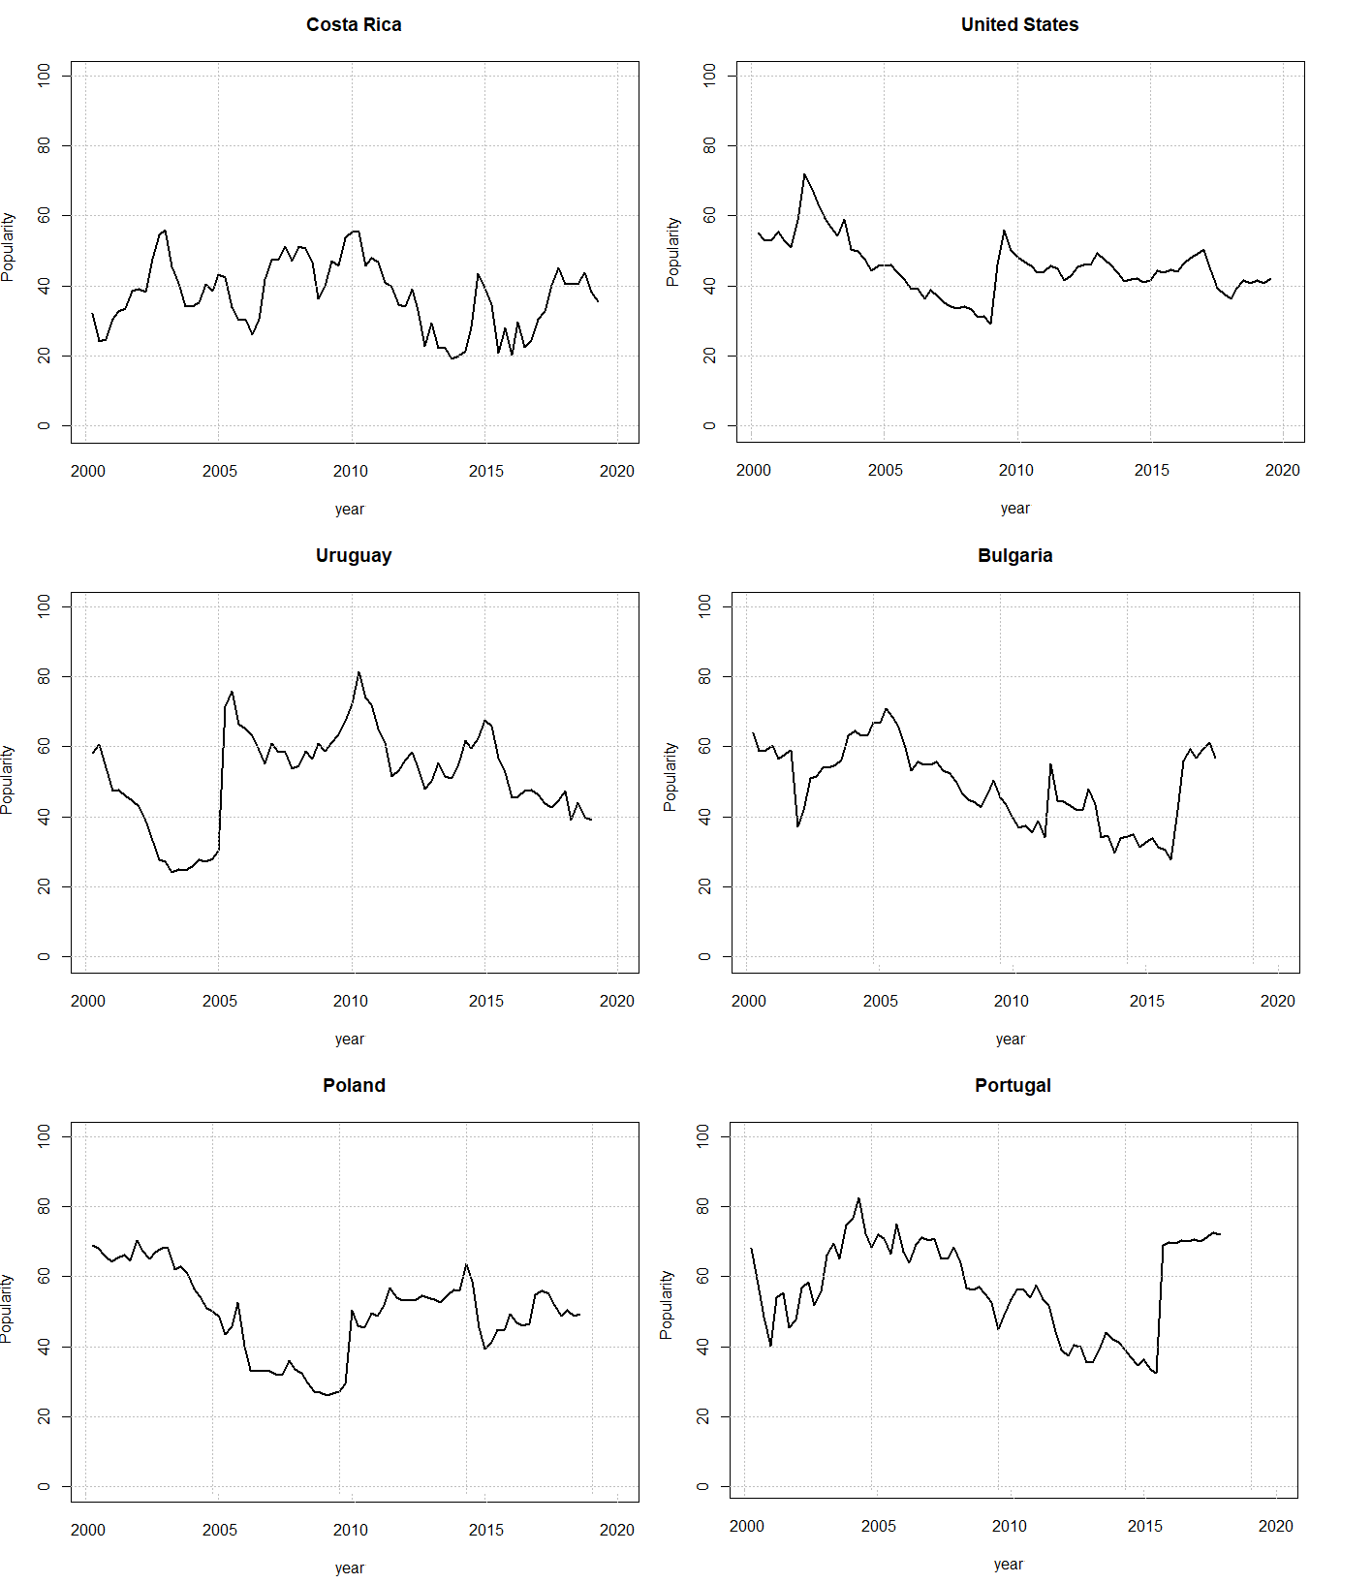

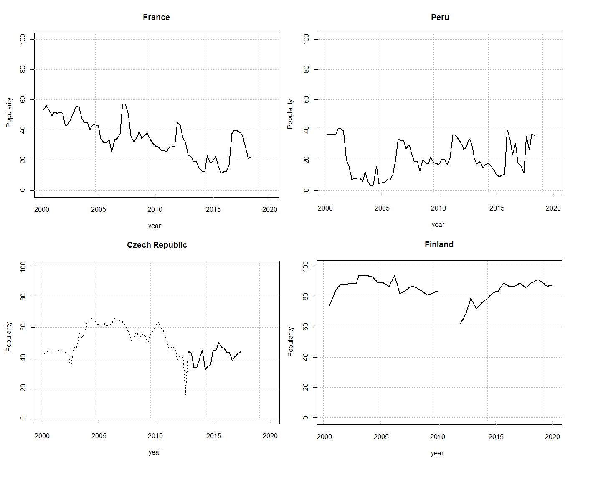Notes: Gaps refer to missing data points (Finland) and dots refer to a time period not included in the analysis (Czech Republic).

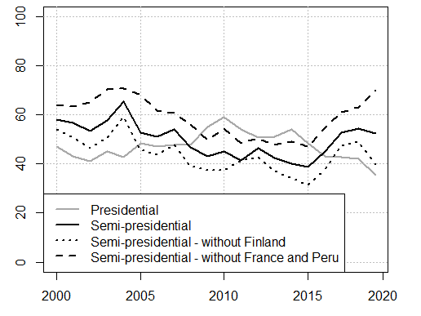
A4. Presidential popularity ratings in presidential and semi-presidential regimes, annual values. Adjustments with Finland, France and Peru excluded.

Appendix B. Robustness checks.
B1. Siaroff’s presidential power scores replaced with power scores by Doyle and Elgie.
 | Dependent: level of presidential popularity
 | Model 1 | Model 2 | Model 3
Corruption (control) | 0.032 | 0.040 | 0.020
 | (0.036) | (0.037) | (0.037)
Presidential powers | -0.629*** | -0.739*** | -0.637***
 | (0.044) | (0.092) | (0.043)
Unemployment | -0.067* | 0.035 | -0.064*
 | (0.029) | (0.069) | (0.029)
GDP pc growth | 0.255*** | 0.050 | 0.261***
 | (0.030) | (0.079) | (0.029)
Honeymoon | 0.074*** | 0.076*** | -0.043
 | (0.016) | (0.016) | (0.039)
End of term | 0.009 | 0.010 | -0.032
 | (0.017) | (0.017) | (0.038)
Interactions:
Presidential powers x unemployment |  | -0.229
 |  | (0.146)
Presidential powers x GDP pc growth |  | 0.325*
 |  | (0.133)
Presidential powers x honeymoon |  |  | 0.220**
 |  |  | (0.067)
Presidential powers x end of term |  |  | 0.073
 |  |  | (0.067)
Country dummies | Included | Included | Included
Constant | 0.763*** | 0.847*** | 0.768***
 | (0.027) | (0.048) | (0.026)
Observations | 1 054 | 1 054 | 1 054
R² | 0.517 | 0.521 | 0.523
Adjusted R² | 0.508 | 0.512 | 0.513

Notes: ***p <0.001; **p <0.01; *p <0.05. All variables are standardized between 0 and 1. Robust standard errors are in parentheses.
B2. OLS regression models without country dummies.
 | Dependent: level of presidential popularity
 | Model 1 | Model 2 | Model 3
Corruption (control) | -0.232*** | -0.203*** | -0.234***
 | (0.027) | (0.028) | (0.027)
Presidential powers | -0.158*** | -0.546*** | -0.168***
 | (0.016) | (0.080) | (0.016)
Unemployment | 0.080** | 0.067 | 0.081***
 | (0.025) | (0.047) | (0.025)
GDP pc growth | 0.193*** | -0.209*** | 0.199***
 | (0.037) | (0.086) | (0.037)
Honeymoon | 0.050* | 0.054** | -0.074
 | (0.020) | (0.019) | (0.048)
End of term | 0.011 | 0.010 | 0.013
 | (0.020) | (0.020) | (0.052)
Interactions:
Presidential powers x unemployment |  | 0.055
 |  | (0.073)
Presidential powers x GDP pc growth |  | 0.559***
 |  | (0.107)
Presidential powers x honeymoon |  |  | 0.178**
 |  |  | (0.062)
Presidential powers x end of term |  |  | -0.001
 |  |  | (0.066)
Country dummies | Not included | Not included | Not included
Constant | 0.529*** | 0.788*** | 0.532***
 | (0.031) | (0.059) | (0.031)
Observations | 1 054 | 1 054 | 1 054
R² | 0.204 | 0.225 | 0.211
Adjusted R² | 0.200 | 0.219 | 0.205

Notes: ***p <0.001; **p <0.01; *p <0.05. All variables are standardized between 0 and 1. Robust standard errors are in parentheses.

B3. Fixed effects regression with a lagged dependent variable.
 | Dependent variable: presidential popularity (lagged)
 | Model 1 | Model 2 | Model 3
Corruption (control) | 0.007 | 0.005 | 0.005
 | (0.037) | (0.037) | (0.037)
Presidential powers | -0.400*** | -0.258*** | -0.401***
 | (0.030) | (0.065) | (0.030)
Unemployment | -0.068* | 0.116** | -0.067*
 | (0.030) | (0.042) | (0.030)
GDP pc growth | 0.212*** | 0.146* | 0.214***
 | (0.030) | (0.062) | (0.030)
Honeymoon | -0.033* | -0.032* | -0.078*
 | (0.017) | (0.016) | (0.037)
End of term | -0.021 | -0.020 | -0.007
 | (0.017) | (0.017) | (0.044)
Interactions:
Presidential powers x unemployment |  | -0.402***
 |  | (0.071)
Presidential powers x GDP pc growth |  | 0.044
 |  | (0.082)
Presidential powers x honeymoon |  |  | 0.064
 |  |  | (0.051)
Presidential powers x end of term |  |  | -0.019
 |  |  | (0.057)
Country dummies | Included | Included | Included
Constant | 0.790*** | 0.763*** | 0.790***
 | (0.028) | (0.043) | (0.027)
Observations | 1 054 | 1 054 | 1 054
R² | 0.497 | 0.513 | 0.498
Adjusted R² | 0.488 | 0.503 | 0.488

Notes: ***p <0.001; **p <0.01; *p <0.05. All variables are standardized between 0 and 1. Robust standard errors are in parentheses.

