Online Appendix

Emmenegger, Patrick, and André Walter, “Partisan Districting and the Adoption of Proportional Representation: Gerrymandering and its Discontents.” European Political Science Review, forthcoming.

Appendix A contains the variable descriptions, summary statistics, and additional robustness tests for the different multivariate analyses in the paper. Table A1 contains the summary statistics for the data used in Tables 3 and 4. Moreover, Table A2 replicates the analysis of the effectiveness of redistricting (Table 4 in the paper) but excludes all cantons with only one seat. Table A3 provides information on the measurement of all variables for our estimations in Table 5; Table A4 provides the accompanying summary statistics. In Table A5, we have replicated the analysis of MP support for proportional representation (Table 5 in the paper) but excluded all socialist MPs from the sample. Figure A1 shows the development of partisan bias in favor of the Liberals, using the indicator of Keena et al. (2021). Figure A2 displays a histogram of vote-seat distortions in the four votes on the adoption of PR in Switzerland (1900-1918). This data was used for our estimations in Table 5 and Figure 3 (in the paper). Finally, Figure A3, based on Table 5, plots the predicted probabilities for different levels of socialist electoral strength on support for PR, using disproportionality scores of 0.2 and -0.1.
Appendix B discusses three concrete instances of gerrymandering in Switzerland. First, we look at the canton Luzern. The short Swiss civil war of 1847 between the liberal proponents of a federal state and modern democracy and the (often Catholic) conservative defenders of cantonal sovereignty and traditional authorities (the so-called ‘Sonderbund’) ended with the attack and subsequent capitulation of Luzern, the Sonderbund’s unofficial ‘capital’. Yet, despite Luzern’s central role in the Sonderbund, this key Catholic conservative canton sent for a long time a majority liberal delegation to the national council. Luzern is also a good illustration for gerrymandering because the restricting process is very visible on maps of electoral districts. Second, we turn to the canton St. Gallen. Unlike majority Catholic Luzern, St. Gallen is a confessionally divided canton with a small Catholic majority (61% according to the 1860 historical census). In cantonal elections, the Liberals and the Catholic Conservatives generally obtained similar vote shares. Yet, due to gerrymandering by the national parliament, St. Gallen sent mostly liberal delegations to the national parliament. St. Gallen is a good example to show how electoral districts were always adapted in response to the election of candidates of the Catholic Conservatives. Finally, we discuss the canton Zürich. This heavily industrialized canton hosted Switzerland’s strongest socialist party section. Yet, the Socialists struggled to translate their large vote shares into a relevant number of seats. As we will show in the short case study, the main reason can be found in the way electoral districts were created and adapted.
Finally, Appendix C offers a detailed explanation of Erich Gruner’s approach to measure electoral strength.

Appendix A: Variable description, summary statistics, and robustness tests

Table A1: Summary statistics (for Tables 3 and 4)
 | Mean | SD | Min | Max
Parliamentary debates (Table 3)
Accepted proposals | 0.53 | 0.50 | 0.00 | 1.00
Member of parliament | 0.62 | 0.49 | 0.00 | 1.00
Cantonal government | 0.11 | 0.31 | 0.00 | 1.00
Liberal camp | 0.57 | 0.50 | 0.00 | 1.00
Redistricting (Table 3)
Seat adjustment | 0.43 | 0.50 | 0.00 | 1.00
Minority party vote share | 0.35 | 0.37 | 0.00 | 1.00
Redistricting | 0.30 | 0.46 | 0.00 | 1.00
ln district magnitude | 1.86 | 0.95 | 0.00 | 3.47
Disproportionality (Table 4)
Disproportionality | -4.51 | 16.16 | -53.40 | 53.30
ln district magnitude | 1.33 | 0.93 | 0.00 | 3.47
Redistricting | 0.07 | 0.26 | 0.00 | 1.00

Table A2: Effectiveness of Redistricting (replication of Table 4 without SMD cantons)
 | Disproportionality
Redistricting | -2.66* | -2.69* | -2.48* | -3.60*
 | (1.17) | (1.16) | (1.11) | (1.62)
ln District Magnitude |  |  | -3.88 | -2.01
 |  |  | (3.99) | (2.78)
Lagged Dependent Variable |  |  |  | 0.27***
 |  |  |  | (0.07)
Canton FE | Yes | Yes | Yes | Yes
Quadratic Time Trends | No | Yes | Yes | Yes
N | 459 | 459 | 459 | 440
*** p < 0.001; ** p < 0.01; * p < 0.05.

Table A3: Variable description and sources (for Table 5)
Variable | Description | Source
PR Vote | The vote of the individual legislator | Bulletin (various years)
Electoral disproportionality | A party’s cantonal seat share subtracted by its electoral vote share | Gruner (1978b)
Socialist electoral strength | The cantonal electoral strength of the Social Democratic Party | Gruner (1978b)
Right Margin | Vote margin of the two strongest non-socialist parties | Gruner (1978b)
Number of strikes | The number of strikes per 10,000 inhabitants | Hirter (1988)
Trade | The size of the work force in export-oriented industries as a fraction of total work force | Eidgenössisches Statistisches Amt (1850-1920)
Co-specific assets | The number of people attending vocational education as a fraction of the total population | Hubert (1899-1918)
Party elites | Dummy variable capturing whether a MP is leader of the party or the parliamentary group | Historical Lexicon of Switzerland, URL: https://hls-dhs-dss.ch

Table A4: Summary statistics (for Table 5)
Variable | Mean | SD | Min | Max
PR Vote | 0.37 | 0.48 | 0.00 | 1.00
Right Margin | 0.55 | 0.39 | 0.00 | 1.00
Number of strikes | 115.11 | 119.71 | 0.00 | 425.00
Trade | 0.21 | 0.13 | 0.01 | 0.55
Electoral disproportionality | 0.10 | 0.13 | -0.33 | 0.50
Socialist electoral strength | 16.52 | 15.26 | 0.00 | 50.30
Co-specific assets | 0.02 | 0.02 | 0.00 | 0.07

Table A5: Disproportionality, Socialist Electoral Strength, and Support for PR (replication of Table 5 without socialist MPs)
 | Linear (Outlier-Robust) |  |  | Firth Logit
 | Model 1 | Model 2 | Model 3 | Model 4 | Model 5 | Model 6
Disproportionality | -1.12 | -0.79 | -0.79 | -6.34*** | -3.23* | -3.22*
 | (0.60) | (0.48) | (0.46) | (1.37) | (1.55) | (1.55)
Socialist Electoral Strength | -0.01 | -0.01 | -0.01 | -0.05** | -0.02 | -0.02
 | (0.01) | (0.00) | (0.01) | (0.02) | (0.02) | (0.02)
Disproportionality x Socialist Electoral Strength |  | -0.03** | -0.02** |  | -0.37*** | -0.35**
 |  | (0.01) | (0.01) |  | (0.10) | (0.12)
Co-Specific Assets |  |  | -1.96 |  |  | -12.61
 |  |  | (2.66) |  |  | (15.77)
Trade |  |  | 0.17 |  |  | 0.45
 |  |  | (0.26) |  |  | (1.15)
Right Margin |  |  | -0.01 |  |  | -0.08
 |  |  | (0.05) |  |  | (0.33)
Party Elite |  |  | 0.13 |  |  | 0.53
 |  |  | (0.09) |  |  | (0.44)
Number of Strikes |  |  | -0.00 |  |  | -0.00
 |  |  | (0.00) |  |  | (0.00)
Year FE | Yes | Yes | Yes | Yes | Yes | Yes
N | 504 | 504 | 504 | 504 | 504 | 504
AIC |  |  |  | 533.95 | 517.87 | 527.08
BIC |  |  |  | 559.29 | 547.43 | 581.98
Log Likelihood |  |  |  | -260.98 | -251.93 | -250.54
Deviance |  |  |  | 521.95 | 503.87 | 501.08
Notes: Cluster robust standard errors in parentheses. *** p < 0.001; ** p < 0.01; * p < 0.05.

Figure A1: Partisan bias, 1848-1917
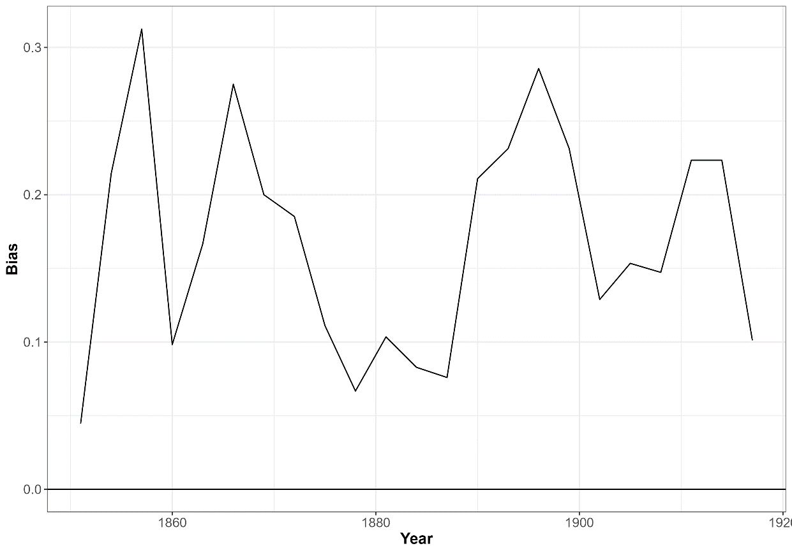
Notes: This figure displays the partisan bias in favor of the Liberals, using the indicator of Keena et al. (2021, 30-31). The indicator is calculated as the proportion of seats with a liberal vote share 5% more than the nationwide average minus the proportion of seats with a minority party vote share 5% more than the nationwide average.

Figure A2: Histogram of vote-seat distortions (for Table 5 and Figure 3 in the paper)
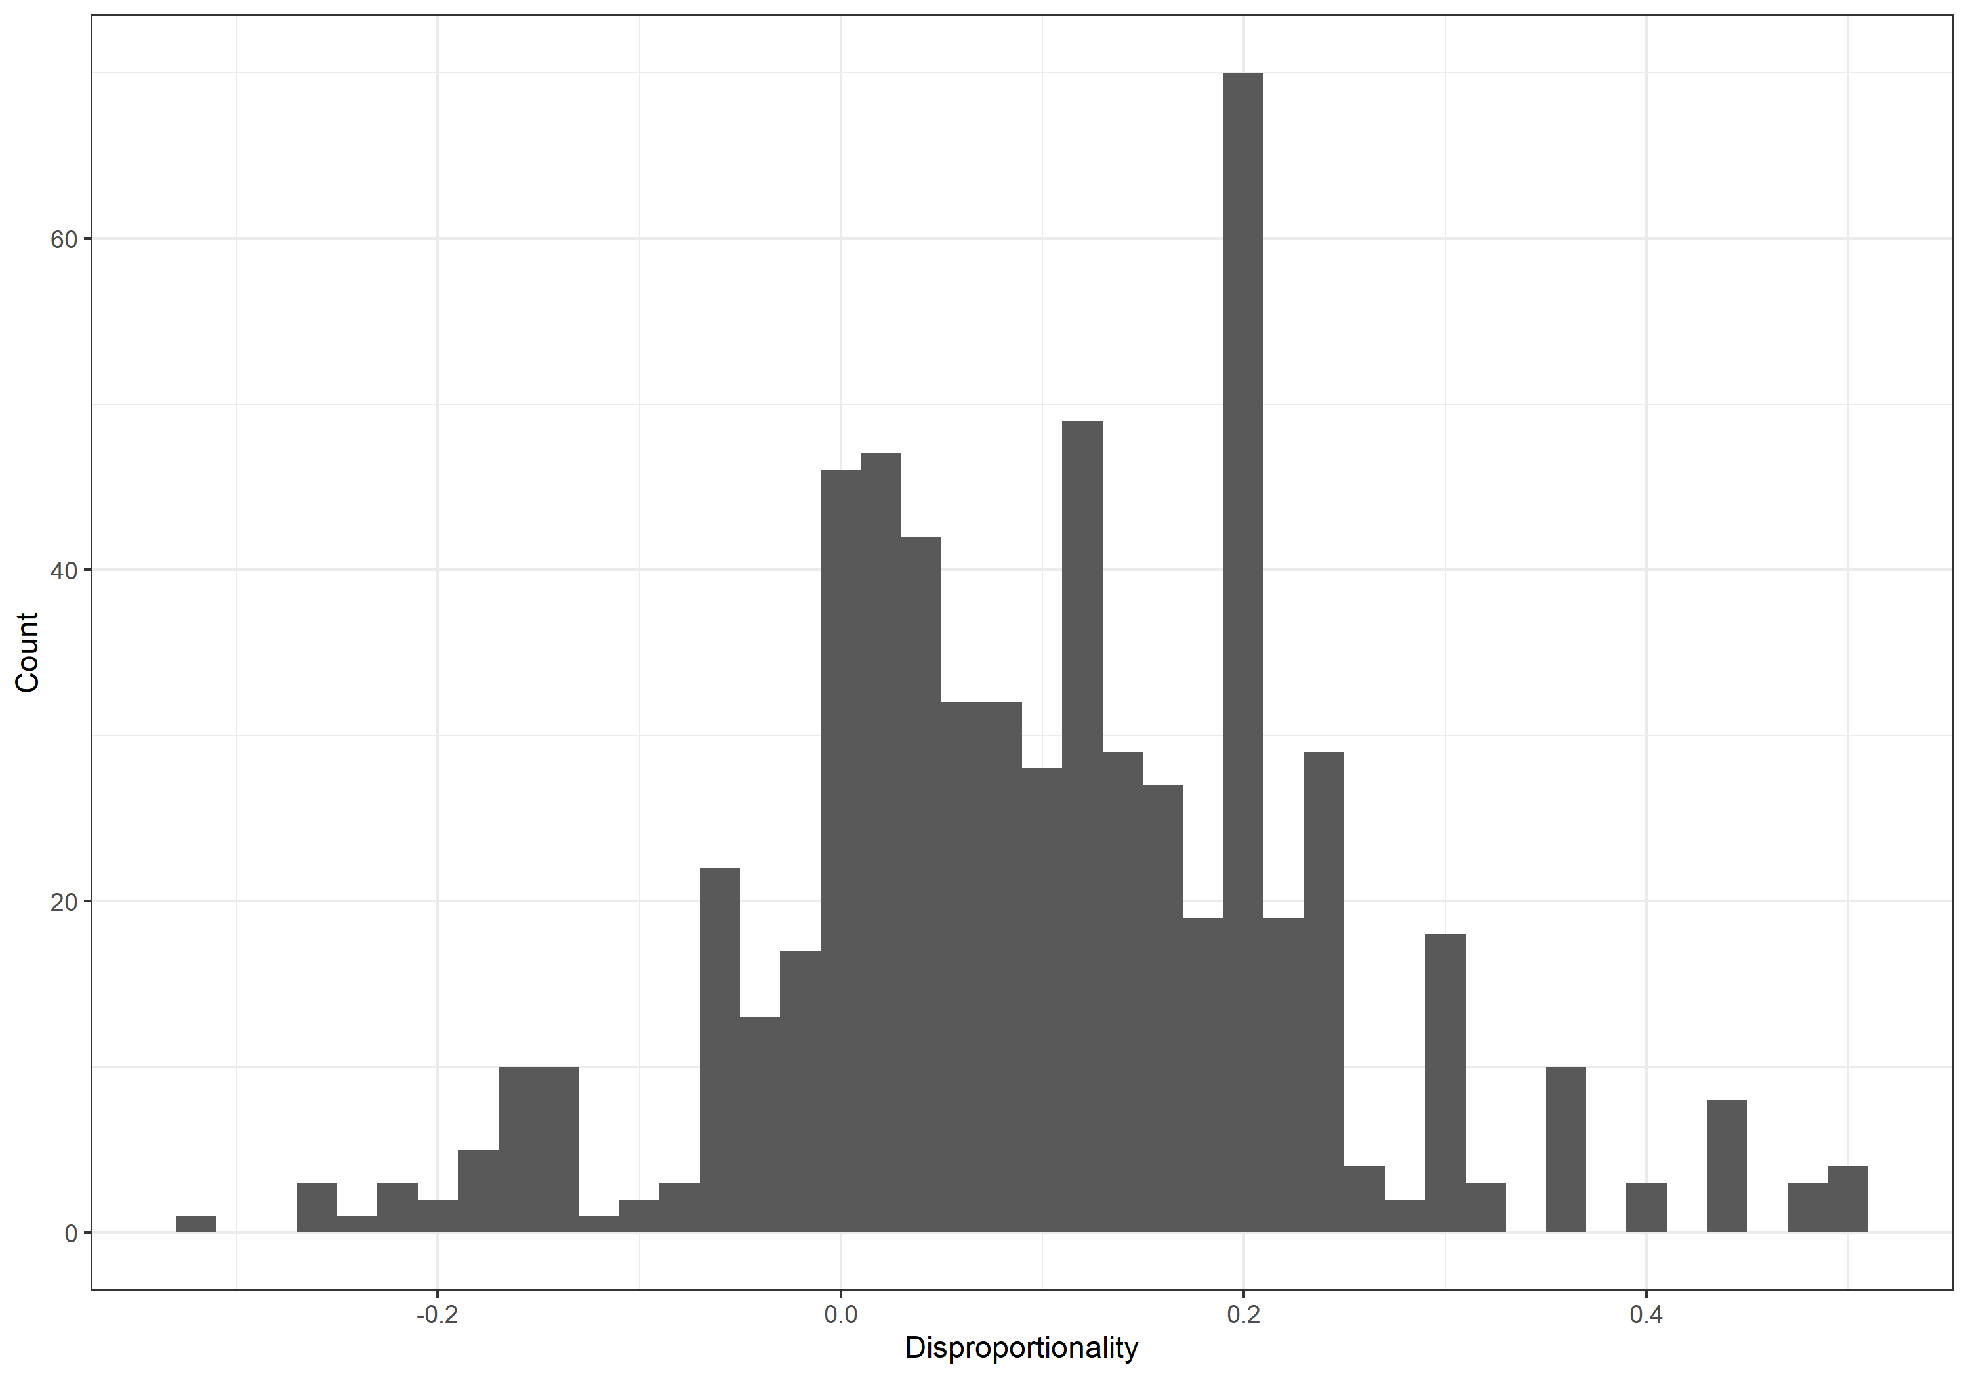

Figure A3: Effect of socialist electoral strength on support for PR conditional on disproportionality (based on Table 5)
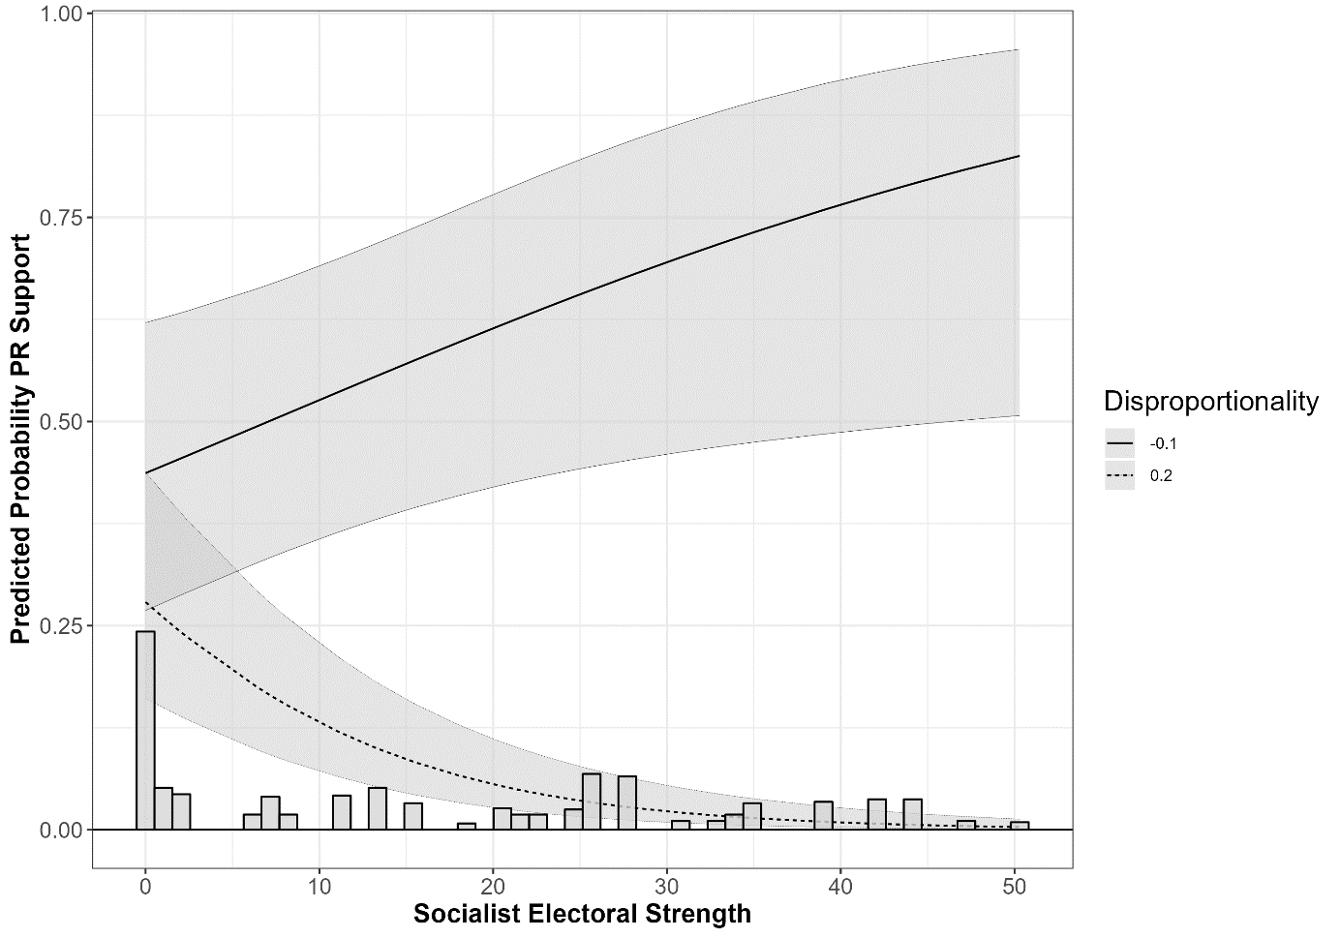

Appendix B: Gerrymandering in the cantons Luzern, St. Gallen, and Zürich

Luzern
The canton Luzern was the lead canton of the Catholic Conservatives throughout much of Swiss political history. When in 1847, the liberal proponents of a federal state clashed with the conservative (and often Catholic) defenders of cantonal sovereignty, Luzern led the conservative alliance (‘Sonderbund’). The 1847 civil war ended with the attack and subsequent capitulation of Luzern. The significance of Luzern is also reflected in the privileged political position of Luzern. After the 1815 Congress of Vienna gave Switzerland its modern territorial form, representatives of all cantons met annually in the Federal Diet (‘Tagsatzung’). These meetings were always chaired by the representatives of Bern, Luzern, or Zürich. Between meetings, these three lead cantons (‘Direktorialkantone’) also oversaw the daily business. Still today, in official communication (or visual representations), Swiss cantons always appear in the same sequence. The cantons Zürich and Bern, the two leaders of the anti-Sonderbund coalition in 1847 civil war, come first, followed by Luzern. Only then are cantons listed in the sequence in which they joined the Old Swiss Confederacy. Hence, although Luzern is only a mid-sized canton, it has a considerable symbolic relevance. If the Sonderbund had won the civil war, the city of Luzern – rather than the city of Bern – would have been the likely capital city of Switzerland.
After the end of the civil war in 1847, the liberal winners installed liberal cantonal governments in the Sonderbund cantons (including Luzern), which were also in charge of devising the electoral districts for the first national election in 1848. Put differently, a liberal government created the districts for an election, which would pitch liberal candidates, as representatives of the victors, against Catholic conservative candidates immediately after a short civil war. The liberal government opted for six single-member districts (see Figure B1), which proved to be a successful strategy, as the Liberals managed to win five out of six seats in 1848. However, this decisive victory was also facilitated by massive mobilization problems on behalf of the Catholic Conservatives in the immediate aftermath of the civil war. In subsequent elections, this advantage was likely to disappear. In addition, the Catholic conservative seat was won by Philipp Anton von Segesser, whose family had played a leading role in the Sonderbund and who would immediately become the leading voice of the Catholic conservative parliamentary faction. Getting rid of von Segesser would remain a key goal in subsequent district reforms and elections.
In the run up to the 1851 national election, the national parliament, now responsible for district reform, revisited the original electoral districts and adapted their size (following the 1850 census). Due to population growth, Luzern received a 7th seat. Yet, there were considerable concerns that the Catholic Conservatives were preparing for a political comeback. The electoral districts in Luzern were thus the topic of a long and controversial discussion in the national council. At one point, the leading liberal MP Alfred Escher (Zurich, also president of the national council in 1849/50) remarked that all liberal cantons (i.e., cantons where the liberal movement had won the 1848 election) were satisfied with the new electoral districts except Luzern. “But the latter is hard to help if you do not want to want to leave the principled ground [i.e., constitution rules]” (personal letter, cited in Gagliardi, 1920, 168). The liberal majority in the national parliament in 1851 ultimately opted for three most unusual electoral districts (see Figure B1). By packing as many Catholic conservative voters as possible into the 12th district, the national parliament had created an electoral district in which two Catholic conservative candidates were elected virtually unopposed (with vote shares of 78.4% and 76.1%, respectively (Gruner, 1978b, 30). Yet, the national parliament kept the 12th district deliberately small, thus ensuring that the 12th district would not be allocated more than two seats. In this process, they even cut the 12th district into two parts without a direct point of contact. Instead, they created two districts of two and three seats respectively, which were structured in a way to make a liberal victory in both districts likely. For this purpose, they combined most unlikely areas, such as the very rural and catholic conservative Entlebuch with the city of Luzern, a liberal stronghold. This combination was necessary to ensure that another seat could be allocated to the 11th district (which the Liberals won) instead of the 12th district (which the Catholic Conservatives won).

Figure B1: District maps of the canton Luzern
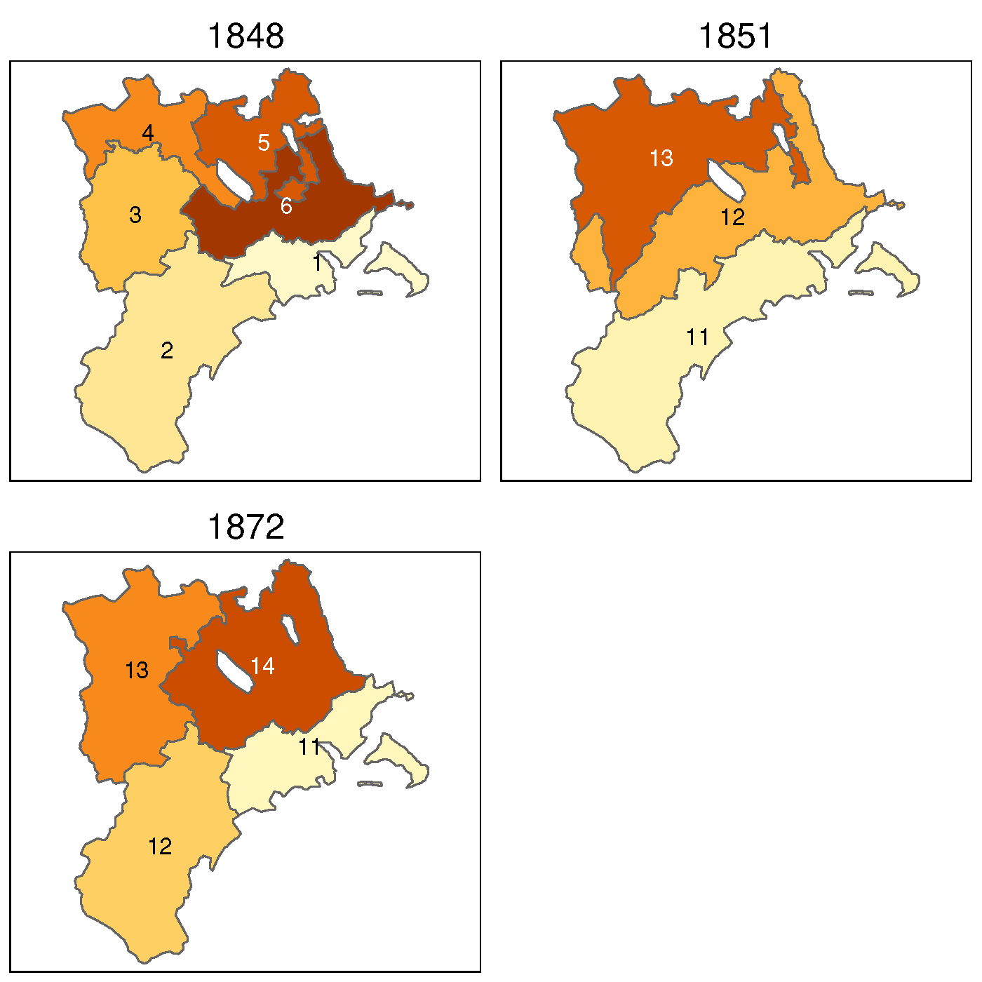

Catholic conservative MPs in the national parliament immediately spotted and criticized this most unusual combination of historical regions. Pressed to justify these electoral districts, the liberal speaker pointed to geological reasons, arguing that the ground below the 11th district was characterized by limestone, while the ground below the 12th district contained molasse. The 13th district was simply referred to as plain land (‘Ebene’) (Gruner, 1978a, 340). Unimpressed by this argument, the Catholic conservative speaker, MP von Segesser (Luzern), mockingly described the Liberals’ behavior in the following words: “Leave it to me to find districts for the canton Luzern, and tell me, which party is supposed to win the majority. I will find districts for any party, so they can win the majority” (cited in Gruner, 1978a, 341). Yet, the liberal majority in the national parliament went ahead as planned and the Liberals won five out of seven seats in the 1851, 1854, 1857, and 1860 elections.
Given this success, there was no need to change electoral districts for the 1863 election (following the 1863 census). The Liberals continued to win five out of seven seats in the 1863 and 1866 elections. Yet, in the 1869 election, the Catholic Conservatives finally captured the 13th district, thus winning five of seven seats. Little surprise then that the Liberals took advantage of the 1872 electoral district reform (following the 1872 census) to reorganize electoral districts in the canton Luzern. The Liberals completely restructured the electoral districts. As Figure B1 shows, there is hardly any resemblance between the districts set in 1851 and the ones set in 1872. By the 1870s, the Catholic Conservatives had regained most of their former strength and now won about 70% of the votes (Gruner, 1978b, 381-383). Hence, the Liberals had to accept that the Catholic Conservatives would send a larger delegation to the national council. Yet, with the careful selection of electoral districts, often with references to the need to protect political minorities (albeit only liberal ones, see the cases of St. Gallen and Zürich below), they were still determined to win as many seats as possible. By expanding the 11th district (the city of Luzern) to the surrounding areas in 1872, they were able to protect their majority in this district, all the while keeping the district large enough to merit two seats. However, given the overwhelming strength of the Catholic Conservatives, the rest of the canton was now finally left to the political opposition.
Hence, the case of Luzern not only demonstrates how the Liberals used gerrymandering to increase their seat share, but the case also shows how the Catholic Conservatives could gain substantial representation in parliament over time due to their geographically highly concentrated voter base in the Catholic heartlands of Switzerland (in particular the former ‘Sonderbund’ cantons). Given the electoral strength of the Catholic Conservatives in these cantons (e.g., ca. 70% of the vote in the canton Luzern), partisan redistricting as a containment strategy lost some of its effectiveness. Over time, the Liberals therefore opted to integrate – rather than exclude – the Catholic Conservatives. In 1891, a prominent member of the Catholic Conservatives, Joseph Zemp of Entlebuch, was elected to become a member of the Swiss Federal Council (consisting of seven members, all other members were part of the Liberals). However, this is not to suggest that the Liberals refrained from using gerrymandering in the case of the Catholic Conservatives. For instance, the Radicals used the 1902 district reform (following the 1902 census) to move some municipalities and thus one seat from the 13th (formerly the 12th district, a Catholic conservative stronghold) to the 12th district (formerly the 11th district, a liberal stronghold), which allowed the Liberals to win three out of seven seats in the 1902, 1905, and 1908 elections. Yet, the Catholic Conservatives secured the additional eight seat, which was allocated to the canton Lucerne in 1911 (following the 1911 census) due to population growth.

St. Gallen
Unlike the majority Catholic canton Luzern, St. Gallen is a confessionally divided canton with a small Catholic majority (61% according to the 1860 historical census). In cantonal elections before the 1847 civil war, Liberals and Catholic Conservatives obtained similar seat shares in the cantonal parliament: 75 seats each in the 1845 cantonal election (150 seats in total), and 77 Liberals to 73 Catholic Conservatives in the 1847 cantonal election (Ehrenzeller, 1947, 146). The small majority in favor of the Liberals in the 1847 cantonal election proved to be crucial, because it made St. Gallen side with the liberal victors in the 1847 civil war.
Like other cantons with large Catholic population shares, the Catholic Conservatives struggled to mobilize their voters in the first national elections after the civil war. During the first three elections (1848, 1851, 1854), Gruner (1978b, 373-375) estimates the Catholic Conservatives’ vote share to be around 25%. However, in subsequent elections, they increased their vote share to around 40% (Gruner 1978b, 376-396). Yet, the Catholic Conservatives struggled to turn this electoral strength into parliamentary seats.
For the first national election, in 1848, the canton St. Gallen was split in four districts with two seats each (see Figure B2). According to Baumgartner (1890, 341), the choice of four two-member districts was made to prevent Catholic Conservatives from getting elected. The liberal newspaper St. Galler Bote applauded the design the districts, calling their design “excellently suited for the Liberals” (St. Galler Bote, 1848, 46, cited in Gruner, 1978c, 70). Similarly, the liberal MP Gmür argued that the very purpose of district design was to increase the likelihood that no conservative candidate would be elected (Der Wahrheitsfreund, 1848, 40-41, cited in Gruner, 1978a, 328). Indeed, although the Catholic Conservatives ran in all four districts, the Liberals managed to win all eight seats, albeit sometimes with narrow margins. After the election, the Liberals openly talked about gerrymandering, noting that “the addition of the [liberal municipalities] Rebstein and Marbach would not have been necessary to win the first district” (St. Galler Bote, 1848, 48, cited in Gruner, 1978c, 70).

Figure B2: District maps of the canton St. Gallen
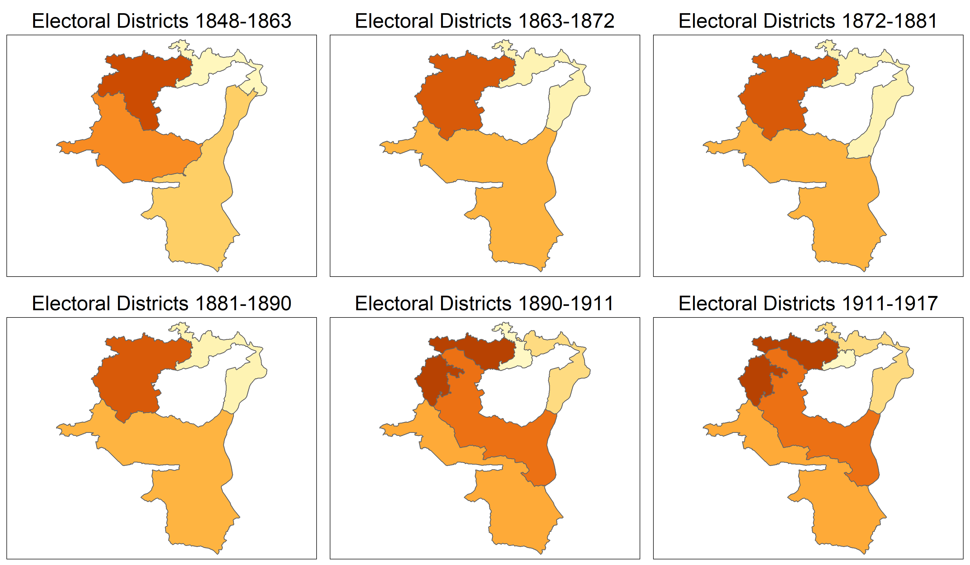

After failing to win seats in the 1851 and 1854 elections, the Catholic Conservatives were more successful in the 1857 election. With a vote share of 37.4%, they managed to win three of eight seats (Christian Rohrer of Buchs, Joseph Guldin of Mels, and Johann Josef Müller of St. Gallen). Although the Catholic Conservatives lost the three seats again in the 1860 election (despite a vote share of 40.4%, see Gruner, 1978b, 377), the Liberals considered it necessary to adapt the electoral district map following the 1863 census (which also awarded St. Gallen an additional 9th seat). Dividing the canton St. Gallen into three districts of three seats each, the Liberals managed to win all nine seats in the 1863 election despite a Catholic conservative vote share of 34.3% (Gruner, 1978, 378). Yet, already in the 1866 election, the Catholic Conservatives managed to reclaim a seat (out of nine), albeit now in a different corner of the canton (Johannes Zündt of Altstätten). The 1872 census awarded the canton St. Gallen a 10th seat and the Liberals with yet another opportunity to rearrange the districts. The new district map successfully prevented the reelection of the incumbent Johannes Zündt in the 1872 election, but now the Catholic Conservatives managed to win a seat in a different district (Johann Fridolin Müller of Wil).
In two ways, these developments are revealing. On the one hand, they show how the Liberals regularly adapted electoral districts in response to the election of candidates of the Catholic Conservatives. Each time a Catholic Conservative managed to get elected, the Liberals used the subsequent population census to restructure the canton’s electoral districts and undermine the Conservatives’ reelection chances. On the other hand, these developments also show that the Liberals struggled to contain the increasingly popular Catholic Conservatives. As they moved liberal municipalities to a district to prevent the reelection of Catholic conservative incumbents, they ran the risk of losing seats in other districts. Nevertheless, with an electoral strength of 32.4% in the 1872 election but only one of ten seats, the Catholic Conservatives remained strongly underrepresented.
In the 1875 election, the Catholic Conservatives managed to win a second seat (vote share 31.5%) and in the 1878 election, they even won four seats (vote share 41.6%). The 1881 census awarded St. Gallen an 11th seat, which the Liberals immediately secured. However, already in the 1884 and 1887 elections, with vote shares of 42.3% and 53.4%, respectively, the Catholic Conservatives managed to win five of eleven seats. Towards the end of the 19th century, it was becoming increasingly clear that in the canton St. Gallen, the two main parties had to come to an arrangement. From the 1880s onwards, the two parties began to divide the canton in a way that is known in Switzerland as “voluntary proportionality” (‘freiwilliger Proporz’). In this arrangement, the leading parties agree to divide the available seats among themselves based on the parties’ expected electoral support. To protect this division of the canton between the leading parties, the parties support each other’s candidates. For instance, in the 1890 election, of the five Catholic Conservatives elected to the national parliament, two were also supported by the Liberals and two ran unopposed. The Catholic Conservatives returned the favor and supported the five successful liberal candidates. The 11th seat in the canton went to a Socialist.
Clearly, in the canton St. Gallen, the potential of gerrymandering to contain the Catholic Conservatives had been exhausted. Yet, the Liberals now increasingly directed their containment by means of redistricting at the Socialists, who began to suffer from electoral disproportionalities that eclipsed even the ones the Catholic Conservatives had suffered in the first decades after 1848 (see Figure 2 in the paper). The final brief case study thus turns to the canton Zürich, where the Socialists were electorally strong but nevertheless failed to secure a substantial representation in the national parliament. As we will show, the main reason was partisan gerrymandering.

Zürich
The canton Zurich had been a liberal stronghold since the creation of the Swiss Federal State in 1848. Yet, at the turn of the century, the emerging Socialists became a serious political challenger. In the 1899 national elections, the Socialists received 25.5% of the vote but gained only one of then 17 seats in the canton (6%). Following the 1900 census, the number of seats allocated to the canton Zurich increased from 17 to 22. When the reform of electoral districts was discussed in the national parliament (where decisions on redistricting were made), the only socialist MP elected in Zürich, Jakob Vogelsanger, was complaining about the size and boundaries of the current districts. To ensure a better representation of the voters’ preferences, he demanded the adjustment of district boundaries to reduce the bias against the Socialists. However, his proposal was rejected by 71 to 38 votes. Instead, the parliament enacted the Liberals’ proposal for Zürich’s electoral district map. Hence, while adjusting the magnitude of some electoral districts as well as shifting a few municipalities across districts, the reform did not remove the bias against the socialist candidates (Bulletin, 1902). The Socialists’ disadvantage did not change. In the 1902 election, with a vote share of 25.9%, the Socialists won two out of 22 seats (9%). In the election before the next national census, in 1908, the Socialists received 35% of the votes, yet still only two of 22 seats (Gruner, 1978b).
The 1910 national census showed that rapid population growth in the canton Zürich made the reform of electoral districts inevitable. The number of seats allocated to the canton Zürich increased from 22 to 25. Since much of the population growth was concentrated in the industrial center of the canton (the first district, the city of Zürich), the ensuing discussion was dominated by the question whether the first district, now consisting of twelve seats, should be split into two districts. The dominant political force in the national parliament, the Liberals, was split on this question. One group of liberal MPs supported the division of the first district to reduce the level of electoral competition and make the outcome more predictable. To do so, they wanted to create a new district (the new second district) with five of the first district’s twelve seats (see Figure B3). This new district was supposed to become a socialist stronghold, where all the socialist votes would be concentrated, thereby denying the Socialists an efficient use of their votes.

Figure B3: District maps of the canton Zürich
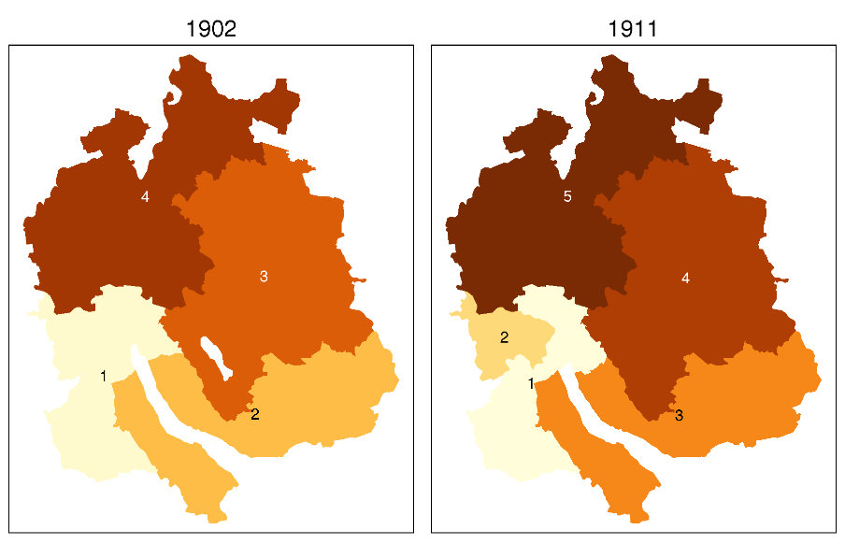

However, a second group criticized the proposal. The liberal MP Walter Bissegger (Zürich) summarized the position. Responding to the socialist MP Herman Greulich’s (Zürich) claim that the Socialists’ rise was unstoppable, the liberal MP Bissegger remained unimpressed: “Claims about the unstoppable growth of the Socialist Party are quite self-serving. Yet, these claims are neither important nor instructive for this hall [i.e., the National Council]. Once again, the bourgeois parties will not have to fear this electoral contest and in fact they do not” (Bulletin, 1911, 110). However, a parliamentary majority ultimately voted in favor of splitting the first district. In this way, a new second district was created, which was designed to become a Socialist stronghold. The Liberals thus opted to contain the Socialists by means of redistricting (“packing”) rather than to engage in direct electoral competition.
In the parliamentary debate, the Socialists attempted to push for better representation by demanding that the first district should be split evenly. The newly founded district in the socialist stronghold had about 95,000 inhabitants. Assigning a municipality with about 5,000 inhabitants from the old first district to this new district would have resulted in the reallocation of an additional seat from the first district to the newly created second district. Taking the mismatch of the socialist vote and seat share of the 1908 election as a point of reference (35 % of the votes but only 9 % of the seats), such a demand seems justified. However, the proposal was clearly defeated in parliament by 118 to 7 votes (Bulletin, 1911, 119).
Unsurprisingly, the socialist MPs reacted strongly to this decision. After several liberal MPs had argued for a reform of electoral districts in the canton Fribourg to protect the minority of liberal voters in this otherwise Catholic conservative canton, the socialist MP Greulich (Zürich) remarked mockingly that if only the Liberals were equally concerned when minorities other than liberal ones were affected. He then provided a whole list of district reforms that would help socialist candidates win seats and reduce some of the most extreme electoral disproportionalities, including a reform of districts in the canton Zürich (Bulletin, 1911, 132). In addition, Greulich explicitly described the electoral districts in the canton Zürich as an example of gerrymandering (‘Wahlkreisgeometrie’) in “its most absurd form” (Bulletin, 1911, 104).
Tellingly, the liberal MP Robert Forrer (St. Gallen) immediately responded to Greulich, arguing that the situation in the canton Fribourg was particularly bad and thus not comparable to the examples provided by Greulich (Bulletin, 1911, 134). Given the overall level of electoral disproportionality in Switzerland (see Figure 2 in the paper), this is a questionable claim. In fact, in the 1908 election, the Catholic Conservatives had won five of six seats (83%) in Fribourg with a vote share of 74%. The 6th seat went to the Liberals (Gruner, 1978b, 393). While indeed reflecting vote-seat distortions, the case of Fribourg does not appear to be particularly bad (at least in comparison to the situation of the Socialists in the canton Zürich). Yet, Forrer’s statement lends evidence to Wong’s (2017) argument that gerrymandering is a particularly subtle form of electoral malpractice, because its use is difficult to conclusively prove. In any case, Greulich’s demand for an additional seat for the newly created second district was rejected.
In the end, the new second district in the canton Zürich slightly reduced the mismatch between vote and seat shares for the Socialists. In the 1911 election, the Socialists received 42% of the votes and 6 out of now 25 seats (24%; the Liberals and their political allies won the other 19 seats, i.e., 76%). However, concentrating all socialist voters in a “safe district” limited their ability to make any further electoral advances in the canton Zürich. In the second district, the socialist candidates ran unopposed and won all seats with overwhelming majorities (with vote shares between 77% and 91% percent, see Gruner, 1978b, 299). Despite continuing vote growth, the Socialists thus struggled to gain any additional seats in subsequent elections. Hence, although the Socialists had by now become the electorally strongest party (in terms of vote shares), they were still denied an adequate representation in the national parliament. Tellingly, the Socialists had to wait for the first election under proportional representation (1919) to win more seats than the Liberals in the canton Zürich (9 seats with a vote share of 32.9% for the Socialists, and 7 seats with a vote share of 29.3% for the Liberals, 25 seats in total).

Appendix C: Erich Gruner’s electoral strength data
In this section, we provide, based on (Gruner, 1978a, 1978b), a detailed explanation of how the electoral strength is calculated. The electoral strength estimates the expected vote share a party would have received under proportional representation (PR). The electoral strength needs to be calculated because district-level vote shares received under majoritarian rules (MR) in multi-member districts, as used in Switzerland before 1918, are inadequate predictors of how a party would fare under PR.
Gruner’s electoral strength data compensates for three problems of district-level vote shares. First, given that cantonal borders constituted legal barriers to redistricting under MR and cantons were the expected districts under any PR system, the parties’ electoral strength at canton level (and not their vote share at the district level) is a more valid indicator of the Social Democrats’ electoral strength and thus the MPs’ position vis-à-vis PR. Second, multi-member districts under MR incentivize the creation of district-level electoral alliances between parties. A party’s district-level vote share can therefore misrepresent its actual electoral strength, because voter preferences are not necessarily expressed by party but by district-level electoral alliances. Third, district-level vote shares might underestimate some of the parties’ electoral strength (in particular in case of smaller or emerging parties), because voters might refrain from using all of their votes (e.g. voters choosing only three candidates although there are five seats in the district, thus leaving two lines “empty”). Admittedly, the electoral strength data cannot correct for all elements of strategic voting (Cox, 1997). Therefore, strategic voting remains a concern with Gruner’s electoral strength data (as in all electoral studies). Yet, his data proves to be an excellent predictor of election outcomes under PR, as we show below.
The data can be found in Gruner (1978b, 373-397), while Gruner (1978a, 58-73) provides a detailed explanation of how the parties’ electoral strength at the cantonal level has been calculated. As Gruner’s work is available only in German, we summarize his approach in the following. Gruner and his team had the following data at their disposal to estimate the parties’ electoral strength at the cantonal level.
- All candidates, their party affiliations, and the vote share per candidate.
- A complete list of other parties that supported these candidates as part of district-level electoral alliances (although these candidates were not affiliated with these parties). Importantly, such electoral alliances were often created to support specific candidates. They did not necessarily cover all of a party’s candidates.
- The number of voters, the number of seats in a district, and the number of votes cast, which allowed them to calculate the number of votes that went unused (“empty lines”).
- An extensive documentation of the candidate selection processes and the political debates preceding the election for each district.
In addition, Gruner and his team took advantage of the fact that the districts under PR are identical with Swiss cantons, while electoral districts under MR were not allowed to cut across cantonal borders (as stipulated by the Swiss constitution in art. 73 of the 1874 constitution). Each electoral district under PR therefore corresponds exactly to one or more electoral districts under MR. Hence, no adjustments for electoral districts under MR cutting across electoral districts under PR are necessary.
To estimate the parties’ electoral strength, Gruner needed to answer two questions. First, in presence of a district-level electoral alliance between at least two parties, which party would the voters have supported if they had to vote for a party rather than the alliance? For instance, if parties A and B form an electoral alliance with one candidate each and both candidates obtain about 5,000 votes, which share of these 5,000 voters are supporters of party A and which share would have supported party B? Second, what party would those voters support, which did not use all of their votes? For instance, in a district with five seats, each voter has five votes to give. Yet voters often refrained from using all of their votes, because they did not find a sufficient number of candidates appealing. Hence, an estimate of electoral strength must consider these “empty lines,” because these votes would not have been lost if voters had casted their vote for parties.
Gruner and his team developed a series of strategies to answer these two questions, which we briefly discuss below. Needless to say, these strategies are not perfect, and the data must be considered an approximation of the real electoral strength. In addition, this research, conducted in the early 1970s, does not live up to today’s standards in terms of transparency and replicability. Nevertheless, Gruner’s work is an impressive and path-breaking contribution. In more than 2,000 pages, Gruner provided a detailed documentation of every single national election from 1848 (creation of the federal state) to 1917 (last election under MR) – including a description of all major political issues, the candidate selection, and the election campaigns.
In addition, although clearly imperfect, Gruner’s data on electoral strength turn out to be excellent predictors of party vote shares under PR. More concretely, we would expect Gruner’s estimates of electoral strength based on the 1917 election (the last one under MR) to be a good predictor of vote shares in the 1919 election (the first one under PR). This is indeed the case. In the case of the Social Democratic Party, the bivariate correlation amounts to 0.87. In addition, we would expect the 1917 electoral strength (as calculated by Gruner) to be a better predictor of 1919 vote shares (under PR) than the 1917 vote shares (under MR). Table C1 shows that this is clearly the case. Model 1 shows a strong and highly significant effect of the 1917 electoral strength on 1919 votes shares. When the 1917 vote share (aggregated to the cantonal level) is added (Model 2), the coefficient of the electoral strength variable remains highly significant, while the 1917 vote share does not have a significant effect on the 1919 vote share. In addition, the explanatory power does not improve because of the inclusion of the 1917 vote share (see last row of Table C1). Given the eventful period between 1917 and 1919, including the end of the First World War, an economic crisis, and the country’s first general strike (in 1918), the ability of the 1917 electoral strength to predict 1919 vote shares is impressive.

Table C1: Effect of 1917 electoral strength on 1919 vote share (at cantonal level)
 | Vote share 1919
 | Model 1 | Model 2
Electoral strength 1917 | 0.682*** | 0.536***
 | (0.080) | (0.162)
Vote share 1917 (cantonal level) |  | 0.164
 |  | (0.157)
Constant | 4.119* | 4.483*
 | (2.199) | (2.223)
N | 25 | 25
Adj. R² | 0.75 | 0.75
*** p < 0.01; ** p < 0.05; * p < 0.1

How exactly did Gruner and his team proceed? Gruner calculated the electoral strength taking each district’s specific situation into account. Hence, there is no statistical model to report but rather a series of calculation strategies that were used dependent on the concrete situation in each electoral district. When different candidates of the same party received more or less the same number of votes, no electoral alliances were used, and there were few “empty lines,” Gruner assumed that electoral strength and vote share did not differ, because voters seemed to have voted exclusively along partisan lines. Yet, electoral strength and vote share were assumed to differ when different candidates of the same party received different numbers of votes (typically the case when electoral alliances were used, because electoral alliances did not necessarily include all of a party’s candidates), when the number of possible votes and the number of actual votes differed substantially (indicating a large number of “empty lines”), when fewer candidates per party run for office than seats were available, and when voters were expected to also cast votes for candidates of other parties.
To deal with such situations, Gruner used a series of strategies to gauge the electoral strength. Most importantly, he compared candidates of the same party with and without electoral alliances to distinguish between party voters and supporters from other parties. Yet, when electoral alliances were contentious, i.e., when there were visible disagreements within the party regarding the decision to support a candidate of another party, he assumed that electoral alliances would generate a lower number of supporters from other parties. In addition, he took into account whether parties suggested fewer candidates than there were seats in a district. Parties fielding fewer candidates than seats were likely to receive fewer votes than their electoral strength would have suggested. Finally, in cases where these strategies did not work, Gruner compared the results of previous and later elections to get an estimate of the party’s electoral strength.
An example might be able to illustrate how these strategies work (Gruner 1978a, 66-67). The example nicely demonstrates the complexity but also the ingenuity of Gruner’s approach. In a district with four seats, five parties (A to E) field in total eight candidates (1 to 8). 12,000 voters participated in the election, which gives a possible total of 48,000 votes (four votes per voter). Yet, not all voters used all of their votes. There are 3,000 “empty lines,” indicating that a number of voters voted for only three or fewer candidates (thus leaving lines on their ballot papers “empty”). Table C2 shows the party affiliations of the eight candidates (cells marked grey), the parties supporting these candidates as part of an electoral alliance (indicated as “support”), and the number of votes that these candidates have received (second column in table). Five candidates were part of electoral alliances (albeit different ones), while three candidates were not supported by other parties. All of this information was available to Gruner.

Table C2: Calculation of electoral strength: Party affiliations, electoral alliances, and votes by candidates
 | Votes | Party A | Party B | Party C | Party D | Party E
Candidate 1 | 10,500 | Support | Support | Support | Support | Affiliation
Candidate 2 | 9,000 | Support | Support |  | Support | Affiliation
Candidate 3 | 8,000 | Affiliation |  |  |  | Support
Candidate 4 | 8,000 | Affiliation |  |  |  | Support
Candidate 5 | 3,000 |  | Support | Affiliation
Candidate 6 | 3,000 | Affiliation
Candidate 7 | 2,000 |  | Affiliation
Candidate 8 | 1,500 |  |  |  | Affiliation
Total votes given | 45,000
Empty lines | 3,000
Total possible votes | 48,000

As Table C2 shows, parties A and E win the election by getting two seats each (with candidates 1 to 4), while candidate 1 received the most votes with 10,500. Yet what is the five parties’ electoral strength? In a first step, Gruner needs to deal with the problem of electoral alliances, which make it difficult to distinguish between party voters and supporters from other parties. Gruner assumes that candidates receive votes (and voters vote for candidates) only if the candidates are affiliated with the voter’s party or if the voter’s party supports the candidate as part of an electoral alliance. In addition, it is important to note that voters cannot vote multiple times for the same candidate.
Gruner’s approach is to fill the empty cells akin to a crossword puzzle. Given that candidates 6, 7, and 8 are not part of electoral alliances and their parties have not fielded more candidates than seats, Gruner concludes that all of the votes these candidates have received must come from supporters of these parties. For instance, candidate 6 is supported only by Party B. Hence, all of his 2,000 votes must come from party B voters. There are thus 2,000 party B voters. In a similar vein, Gruner concludes that there are 3,000 party A voters and 1,500 party D voters.
Candidates 3, 4, and 5 are supported by electoral alliances consisting of two parties. In each case, we already have information about one of the two parties’ number of voters. Based on this information, Gruner concludes that party C must have 1,000 voters, because candidate 5 with a total of 3,000 votes already receives 2,000 votes from party B. In a similar vein, he concludes that party E must have 5,000 voters, because candidates 3 and 4 with a total of 8,000 votes already each receive 3,000 votes from party A.
Candidates 1 and 2 provide the biggest challenge because they are part of electoral alliances consisting of four and five parties respectively. A first step to resolve this puzzle is to note that party A supports five candidates although there are only four seats. For the sake of the example, Gruner cites qualitative evidence from the party’s delegate assembly that there was no agreement whether to support candidate 1 or candidate 2 from party E – next to party A’s own three candidates (no. 3, 4, and 6). Gruner (1978a, 67) thus assumes that the votes of the 3,000 party A voters were evenly split between candidate 1 and candidate 2 (each receiving 1,500 votes). Another plausible assumption would be that the two candidates of party E receive full support by party E voters. Yet, again for the sake of the example, Gruner cites qualitative evidence that candidate 2 is not popular among all party E voters. Hence, in this example, Gruner assumes that the well-liked candidate 1 receives all 5,000 votes from party E voters, while the less popular candidate 2 receives only 4,000 votes.
The remaining cells can now be filled. The 2,000 party B voters and the 1,500 party D voters together with the 1,500 party A voters and the 4,000 party E voters amount to the 9,000 votes candidate 2 has received. Subtracting the 1,500 party A voters and the 5,000 party E voters from the 10,500 votes received by candidate 1 shows that not all voters of parties B, C, and D have supported candidate 1. Again citing qualitative evidence that candidate 1 was particularly controversial among party B voters, Gruner concludes that not all 2,000 party B voters decided to vote for candidate 1 (1,500 rather than 2,000 voters).
Table C3 shows how Gruner’s approach allows for the allocation of votes received by candidates to parties. The last row displays the sum of all votes per party. Party E received the most votes with 19,000, while party A comes second with 12,000 votes.

Table C3: Calculation of electoral strength: votes by party
 | Votes | Party A | Party B | Party C | Party D | Party E
Candidate 1 | 10,500 | 1,500 | 1,500 | 1,000 | 1,500 | 5,000
Candidate 2 | 9,000 | 1,500 | 2,000 |  | 1,500 | 4,000
Candidate 3 | 8,000 | 3,000 |  |  |  | 5,000
Candidate 4 | 8,000 | 3,000 |  |  |  | 5,000
Candidate 5 | 3,000 |  | 2,000 | 1,000
Candidate 6 | 3,000 | 3,000
Candidate 7 | 2,000 |  | 2,000
Candidate 8 | 1,500 |  |  |  | 1,500
Total votes given | 45,000 | 12,000 | 7,500 | 2,000 | 4,500 | 19,000

Gruner now turns to the second problem, the “empty lines.” As mentioned above, 3,000 votes were cast empty (of a total of 48,000 votes). Which parties would have received these votes? Gruner’s approach is to look at discrepancies between the number of seats and the number of candidates supported by a party. In the example, although there are four seats, party C supports only two candidates, while party D supports three candidates. Gruner assumes that most party C and party D voters followed their parties’ vote recommendations and voted for only two (party C voters) or three candidates (party D voters) respectively. Hence, he allocates two thirds of the “empty votes” to party C (because its voters left two lines empty), which thus receives another 2,000 votes, and one third to party D. Hence, party C’s total vote is raised to 4,000, while party D’s total is raised to 5,500 (see Table C4). Hence, according to Gruner’s approach, for each party with a number of candidates below district magnitude, the total votes (incl. “empty lines”) are calculated as if the party had supported as many candidates as there are seats.

Table C4: Calculation of electoral strength: correcting for “empty lines”
 | Total votes (excl. “empty lines” | Additional votes (due to “empty lines”) | Total votes (incl. “empty lines”)
Party A | 12,000 | 0 | 12,000
Party B | 7,500 | 0 | 7,500
Party C | 2,000 | 2,000 | 4,000
Party D | 4,500 | 1,000 | 5,500
Party E | 19,000 | 0 | 19,000
Total | 45,000 | 3,000 | 48,000

Finally, based on these numbers, Gruner now calculates the parties’ electoral strength (third column in Table C5). Compared to the total number of possible votes (48,000), party A’s vote share of 12,000 amounts to 25 percent, while party’s B vote share of 7,500 amounts to 15.6 percent. With 39.6 percent, party E has the largest electoral strength.
Importantly, these numbers differ starkly from the parties’ vote share (last two columns in Table C5) A party’s vote share is calculated by dividing the sum of its candidates’ vote share by the number of votes cast (45,000). In the case of party E with its candidates 1 and 2 (which received 10,500 and 9,000 votes respectively), the vote share amounts to 19,500/45,000 = 43.3 percent (i.e., vote shares of party E’s two candidates divided by votes cast). This is just slightly more than what party A has received (42.2 percent). Yet party A’s numbers are misleading, because party A’s vote share is inflated due to its electoral alliance with party E (i.e. a large share of voters supporting party A’s candidates 3 and 4 are in fact party E voters). At the same time, the vote shares of parties B, C, and D underestimate these parties’ electoral strength because they do not take into account that they are less often part of electoral alliances and that they have supported fewer candidates than there are seats. For instance, candidate 8, affiliated with party D, received only 1,500 votes. Yet party D voters have also supported candidates 1 and 2 (as part of electoral alliances). In addition, a large number are likely to have left an “empty line” on their ballot papers. Hence, party D’s true electoral strength is not a meagre 3.3 percent (1,500/45,000), as suggested by the votes share of its candidate, but in fact an impressive 11.5 percent (5,500/48,000).

Table C5: Calculation of electoral strength: total votes and electoral strength
 | Electoral strength as calculated by Gruner |  | Vote share (uncorrected)
 | Total votes (incl. “empty lines” | Electoral strength in % | Total votes for party’s candidates | Vote share in %
Party A | 12,000 | 25.0 | 19,000 | 42.2
Party B | 7,500 | 15.6 | 2,000 | 4.4
Party C | 4,000 | 8.3 | 3,000 | 6.7
Party D | 5,500 | 11.5 | 1,500 | 3.3
Party E | 19,000 | 39.6 | 19,500 | 43.3
Total | 48,000 | 100 | 45,000 | 100

As this example illustrates, Gruner’s approach strongly relies on contextual knowledge. In addition, at multiple times, expert judgements play a central role. Yet, as the detailed documentation of every election in the period 1848 to 1917 demonstrates, there might be nobody in a better position to make these decisions than Gruner himself. In addition, the resulting indicator proves to be a powerful predictor of vote shares under PR rules (see Table C1 above). Hence, although these estimates are unlikely to be perfect, they are highly likely better predictors of parties’ electoral strength than their vote shares.

References
Baumgartner, Gallus J. (1890). Die Schweiz in ihren Kämpfen und Umgestaltungen von 1830-1850, Band 4. Zürich: Schulthess.
Bulletin (1900). “Initiativbegehren für die Proportionalwahl des Nationalrates und die Wahl des Bundesrates durch das Volk,” Bulletin der Bundesversammlung 1900, 325–335.
Bulletin (1902). “Bundesgesetz betreffend die Nationalratswahlkreise. Anträge der Kommission des Nationalrats,” Bulletin der Bundesversammlung 1902, 1-21.
Bulletin (1910). “Initiativbegehren um Einführung des Verhältniswahlsystems für den schweizerischen Nationalrat,” Bulletin der Bundesversammlung 1910, 95–112.
Bulletin (1911). “Bundesgesetz betreffend die Nationalratswahlkreise. Anträge der Kommission des Nationalrats,” Bulletin der Bundesversammlung 1911, 95-120.
Bulletin (1914). “Volksbegehren um Einführung der Verhältniswahl für die Wahlen in den schweizerischen Nationalrat,” Bulletin der Bundesversammlung 1914, 487–488.
Bulletin (1918). “Verhältniswahl für die Nationalratswahlen. Volksbegehren,” Bulletin der Bundesversammlung 1918, 198–199.
Cox, Gary W. (1997). Making Votes Count: Strategic Coordination in the World’s Electoral Systems. Cambridge, Cambridge University Press.
Ehrenzeller, Ernst (1947). Der konservativ-liberale Gegensatz im Kanton St. Gallen bis zur Verfassungsrevision von 1861. St. Gallen: Fehr.
Eidgenössisches Statistisches Amt (1850-1920). Eidgenössische Volkszählung. Bern, Francke.
Emmenegger, Patrick, & André Walter (2021). “Disproportional Threat: Redistricting as an Alternative to Proportional Representation.” Journal of Politics, 83(3), 917–933.
Gruner, Erich (1978a). Die Wahlen in den schweizerischen Nationalrat, 1848-1919. Wahlrecht, Wahlsystem, Wahlbeteiligung, Verhalten von Wählern und Parteien, Wahlthemen und Wahlkämpfe. Band 1. Bern, Francke.
Gruner, Erich (1978b). Die Wahlen in den schweizerischen Nationalrat, 1848-1919. Wahlrecht, Wahlsystem, Wahlbeteiligung, Verhalten von Wählern und Parteien, Wahlthemen und Wahlkämpfe. Band 3. Bern, Francke.
Gruner, Erich (1978c). Die Wahlen in den schweizerischen Nationalrat, 1848-1919. Wahlrecht, Wahlsystem, Wahlbeteiligung, Verhalten von Wählern und Parteien, Wahlthemen und Wahlkämpfe. Band 2. Bern, Francke.
Hirter, Hans (1988). Die Streiks in der Schweiz in den Jahren 1880-1914. Arbeiterschaft und Wirtschaft in der Schweiz 1880-1914, edited by Erich Gruner. Zürich, Chronos, pp. 837-1008.
Hubert, Albert (1899-1918). Jahrbuch des Unterrichtswesens in der Schweiz. Zürich, Orell Füssli.
Keena, Alex, Michael Latner, Anthony J. McGann, and Charles A. Smith (2021). Gerrymandering the States. Cambridge, Cambridge University Press.
Schröder, Valentin, & Philip Manow (2020). “An intra-party account of electoral system choice.” Political Science Research and Methods, 8(2), 251–267.
Wong, Stan H.-W. (2017). “Gerrymandering in electoral autocracies: Evidence from Hong Kong.” British Journal of Political Science, 49(2), 579–610.

These case discussions partly draw on Emmenegger and Walter (2021).
Please note that multi-member districts of three or four seats were defined as the rule.
According to the constitution, one MP was given per 20,000 residents. Hence, the newly created second district was rather malapportioned.
District-level electoral alliances are defined as the endorsement of a candidate (or set of candidates) by more than one party (Schröder and Manow, 2020). In contrast to electoral cartels (cf. Cox, 1997), seats are still allocated to candidates directly.
However, the data and documents used by Gruner and his team are accessible in the Swiss Federal Archive (https://www.swiss-archives.ch/detail.aspx?ID=3790354), which reflects the unique status of Gruner's work in Switzerland's political science community.
We look at the Social Democratic Party because this party did not change its organizational structure between 1917 and 1919. In contrast, the liberal camp reorganized following the introduction of PR. Among others, the liberal camp's farmers' wing created its own party, which ultimately resulted in today's Swiss People's Party. Hence, for the liberal camp, a comparison between 1917 and 1919 is not meaningful.
However, coefficient and t-value of the electoral strength variable become smaller because the 1917 electoral strength and the 1917 vote share are of course positively correlated.

