Appendix A – Supplementary information on the data collection and measurement for control variables included in the regression models

In this section, we report information on the measurement strategy and data sources for the control variables included in our regression models. To recall, they include classic second-order elections elements (such as the national electoral cycle, the horizontal simultaneity, and municipal powers) alongside the type of electoral system, political culture, and a time variable capturing the passage of time within our period of observation (January 1991- December 2019).
As standard practice in the second-order elections literature, for each observation in our dataset, the national cycle is measured as the fraction of an entire cycle elapsed at the moment of that particular municipal election (Jeffery and Hough 2003; Schakel and Dandoy 2014), and it is included in the regression models with both the linear and a quadratic term to account for the expected parabolic effect (Marsh 1998; Hix and Marsh 2007).
The horizontal simultaneity captures the placement of each municipal election relatively to the rest of the municipal elections within a given country. Holding subnational elections simultaneously may provide them with a nationwide resonance, thus increasing participation (Hough and Jeffery 2006, 249). It is measured as the fraction of the overall national municipalities voting in a given municipal electoral wave along with the particular observation in our dataset.
Municipal powers are operationalized through the Local Autonomy Index (LAI) scores (Ladner et al. 2019). This is a quantitative measure especially designed to comparatively assess municipal autonomy across countries, combining multiple indicators capturing various aspects of decentralization.
For the features of the electoral system applied in the municipal elections, we include two dummy indicators. One measures its general nature, with proportional representation (PR) coded as 1, and everything else coded with a 0. The second dichotomous electoral-system predictor looks at whether the mayor is directly elected, and it is coded with a 1 if she is and with 0 if she is not.
To control for national political culture in our municipalities, we have constructed a national-level indicator aimed at measuring the extent of subject political culture (Verba and Almond 1963) within each polity. This was calculated by measuring the portion of national respondents showing both acceptance for the political system and lack of confidence in their personal ability to affect it in the ESS (Wave 9 – Wave 2 for Luxembourg and Wave 6 for Albania, which are missing in Wave 9). Alternatively, as a measurement robustness test, we have replaced the subject-political-culture variable with an indicator measuring the portion of national respondents adhering to the “conformity” value of the Schwartz (1994) conceptualization. As a further robustness test, we have also used a behavioural indicator for this dimension – namely, the average turnout at national legislative elections for each country in the (1991-2019) period of observation. Regardless of which of these three measures is employed, the pattern does not change. No measure yields a significant effect, nor its inclusion affects the significant effects emerging for the other predictors (Appendix B: Table B13, Appendix B: Table B14).

References in the Appendix A

Almond, Gabriel, Sidney, Verba. 1963. The Civic Culture. Princeton: Princeton University Press.

Bolgherini Silvia, Greta Klotz, Uwe Fromm. 2021. ‘Context-driven Local Autonomy’. Revue internationale de politique comparée, 28 (1-2): 207-255.

Hix, Simon, Michael Marsh. 2007. ‘Punishment or protest? Understanding European parliament elections’. The journal of politics 69(2): 495-510.

Hough, Dan, Charlie Jeffery. 2006. Devolution and electoral politics. Manchester: Manchester University Press.

Jeffery, Charlie, Dan Hough. 2003. ‘Regional Elections in Multi-level Systems’. European Urban and Regional Studies 10 (3): 199–212.

Ladner Andreas, Harald Baldersheim, Nikos Hlepas, Nicolas Keuffer, Carmen Navarro, Kristof Steyvers, Pawel Swianiewicz. 2019. Patterns of Local Autonomy in Europe. Cham: Palgrave.

Marsh, Michael. 1998. ‘Testing the second-order election model after four European elections’. British journal of political science 28 (4): 591-607.

Schwartz Shalom 1994. ‘Are There Universal Aspects in the Structure and Contents of Human Values?’ Journal of Social Issues 50 (4): 19–45.

Appendix B – Additional tables and figures

Figure B1 – Expected effects of cross-unit population polarization on municipal turnout after amalgamation, in the case of amalgamation between two units.
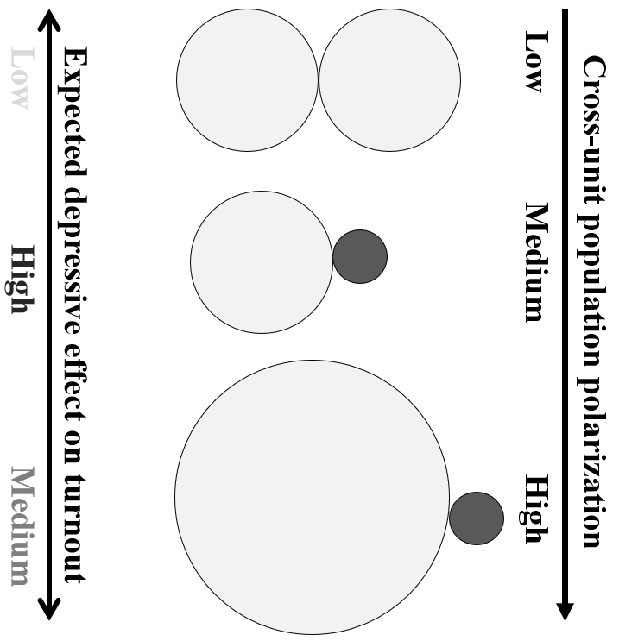

Table B1 – Post-amalgamation municipal elections included in the dataset.
 | Albania | Austria | Denmark | Finland | Germany | Iceland | Italy | Luxembourg | Netherlands | Norway
1991 |  |  |  |  |  |  |  |  |  | 8-sep
1992 |  |  |  | 18-oct
1993
1994 |  |  |  |  |  |  |  |  | 3-feb
1995 |  |  |  |  |  |  |  |  |  | 10-sep
1996 |  |  |  | 20-oct
1997
1998 |  |  |  |  |  |  |  |  | 4-mar
1999 |  |  |  |  | 13-jun
2000 |  |  |  | 22-oct
2001
2002 |  |  |  |  |  |  |  |  | 6-mar
2003 |  |  |  |  |  |  |  |  |  | 15-sep
2004 |  |  |  | 24-oct | 13,27-jun  21-dec
2005 |  |  | 15-nov |  | 18-sep |  |  | 9-oct
2006 |  |  |  |  |  | 27-may |  |  | 7-mar
2007 |  |  |  |  | 22-apr |  |  |  |  | 10-sep
2008 |  |  |  | 26-oct | 28-sep
2009 |  |  |  |  | 7-jun |  |  |  | 22-nov
2010 |  |  |  |  |  | 29-may |  |  | 3-mar  24-nov
2011 |  |  |  |  |  |  | 15-may | 9-oct | 23-nov | 12-sep
2012 |  |  |  | 28-oct |  |  |  |  | 21-nov
2013 |  |  |  |  |  |  |  |  | 13-nov
2014 |  |  |  |  | 25-may | 31-may | 25-may |  | 19-mar  19-nov
2015 | 21-jun | 22-mar |  |  |  |  | 10,31-may |  | 18-nov | 14-sep
2016 |  |  |  |  |  |  | 8-may  5-jun  6-nov |  | 23-nov
2017 |  |  |  | 9-apr |  |  | 11-jun | 8-oct | 22-nov
2018 |  |  |  |  |  | 26-may | 29-apr  27-may  10-jun  29-jul |  | 21-sep
2019 |  |  |  |  | 26-may |  | 26-may |  |  | 9-sep

Table B2 – Descriptive evidence on our dependent variable and the predictors.
Variable | Obs | Mean | Std. Dev. | Min | Max
Turnout variation | 1,174 | -3.0 | 8.6 | -29.6 | 30.3
Post-amalgamation municipal size | 1,174 | 18,156 | 33,438 | 165 | 608,886
Time (days since January 1, 1991) | 1,174 | 7,537.136 | 2,422.257 | 252 | 10,478
National electoral cycle | 1,174 | -0.1 | 0.3 | -0.8 | 1.0
Horizontal simultaneity | 1,174 | 0.9 | 0.3 | 0.0 | 1.0
Municipal powers | 1,174 | 25.2 | 2.9 | 18.2 | 29.7
Proportional electoral system | 1,174 | 0.9 | 0.3 | 0.0 | 1.0
Direct major election | 1,174 | 0.5 | 0.5 | 0.0 | 1.0
Subject political culture | 1,174 | 38.7 | 12.0 | 19.8 | 65.5
Forced amalgamation | 1,174 | 0.7 | 0.4 | 0.0 | 1.0
Amalgamation wave overall scope | 1,174 | 0.4 | 0.3 | 0.0 | 1.0
Number of constituent units | 1,174 | 3.6 | 2.7 | 2.0 | 30.0
Amalgamation type | 1,174 | 1.6 | 0.8 | 1.0 | 3.0

Figure B2 – Marginal plot for the effect of the national electoral cycle on voter turnout in municipal elections, from Model 1 in Table 2.
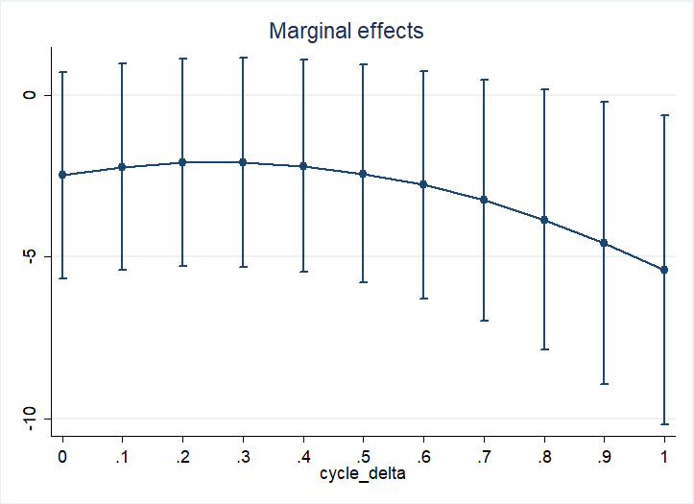

Figure B3 – Marginal plot for the effect of the national electoral cycle on voter turnout in municipal elections, from Model 2 in Table 2.
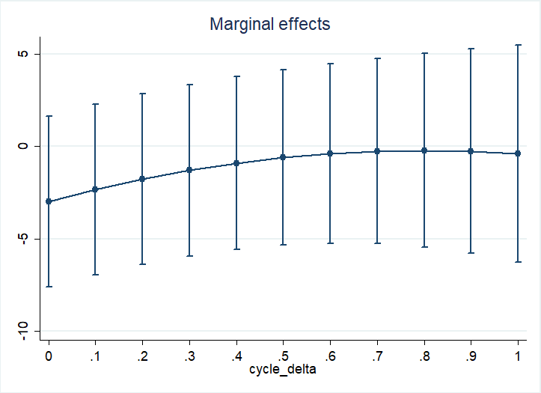

Figure B4 – Marginal plot for the effect of the national electoral cycle on voter turnout in municipal elections, from Model 3 in Table 2
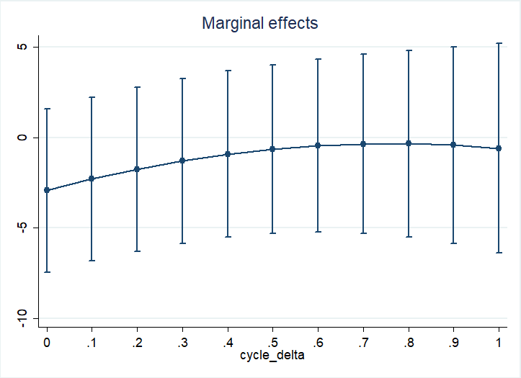

Table B3 – Replication of the main models (from Table 2) excluding Albania.
 | (1) |  | (2) |  | (3) |  | (4)
Time | 0.002*** | (0.000) | 0.001*** | (0.000) | 0.001*** | (0.000)
National electoral cycle | 3.127*** | (0.000) | 6.963*** | (0.000) | 6.810*** | (0.000)
National electoral cycle² | -6.058*** | (0.000) | -4.361** | (0.001) | -4.529*** | (0.001)
Horizontal simultaneity | 8.558*** | (0.000) | 4.444*** | (0.000) | 4.510*** | (0.000)
Municipal powers | 0.657** | (0.003) | 0.633** | (0.005) | 0.580* | (0.010)
Proportional electoral system | -2.354 | (0.544) | -2.670 | (0.510) | -2.182 | (0.587)
Direct major election | 4.242 | (0.454) | 3.797 | (0.630) | 3.935 | (0.610)
Subject political culture | -0.083 | (0.708) | -0.105 | (0.714) | -0.116 | (0.681)
H1. Forced (1) v. voluntary (0) amalgamation process |  |  | -4.480*** | (0.000) | -4.476*** | (0.000) | -8.071*** | (0.000)
H2. Amalgamation wave overall scope: Gradual (0) v. massive (1) |  |  | 12.517*** | (0.000) | 11.820*** | (0.000) | 14.951*** | (0.000)
H3. Post-amalgamation municipal size |  |  |  |  | -0.000 | (0.084) | -0.000 | (0.510)
H4. Cross- unit population polarization:
Type=‘One large’ (v. ‘Mixed’, 0) |  |  |  |  | 0.615 | (0.204) | 1.240* | (0.036)
Type=‘Equal’ (v. ‘Mixed’, 0) |  |  |  |  | 1.658** | (0.004) | 2.041** | (0.004)
H5. Number of constituent units |  |  |  |  | 0.190** | (0.009) | 0.211* | (0.017)
Constant | -52.654*** | (0.000) | -37.449** | (0.002) | -37.690** | (0.002) | -4.824* | (0.025)
lns1_1_1
_cons | 1.457*** | (0.000) | 1.808*** | (0.000) | 1.786*** | (0.000) | 1.770*** | (0.000)
lnsig_e
_cons | 1.758*** | (0.000) | 1.713*** | (0.000) | 1.705*** | (0.000) | 1.911*** | (0.000)
N | 1114 |  | 1114 |  | 1114 |  | 1114
AIC | 7133.029 |  | 7043.638 |  | 7034.798 |  | 7472.735  7517.876  -3727.367
BIC | 7188.202 |  | 7108.842 |  | 7120.065
Log likelihood | -3555.515 |  | -3508.819 |  | -3500.399
p-values in parentheses
* p < 0.05, ** p < 0.01, *** p < 0.001

Table B4 – Replication of the main models (from Table 2) with robust standard errors.
 | (1) |  | (2) |  | (3) |  | (4)
Time | 0.002* | (0.019) | 0.001 | (0.111) | 0.001 | (0.105)
National electoral cycle | 3.122 | (0.116) | 6.944*** | (0.000) | 6.819*** | (0.000)
National electoral cycle² | -6.060 | (0.184) | -4.347* | (0.033) | -4.487* | (0.016)
Horizontal simultaneity | 8.552*** | (0.000) | 4.428 | (0.063) | 4.506 | (0.061)
Municipal powers | 0.659 | (0.051) | 0.668** | (0.007) | 0.615* | (0.013)
Proportional electoral system | -2.393 | (0.098) | -3.586** | (0.005) | -3.125* | (0.015)
Direct major election | 4.202 | (0.215) | 3.190 | (0.443) | 3.332 | (0.408)
Subject political culture | -0.085 | (0.664) | -0.161 | (0.504) | -0.166 | (0.484)
H1. Forced (1) v. voluntary (0) amalgamation process |  |  | -4.541* | (0.011) | -4.525* | (0.012) | -8.087*** | (0.000)
H2. Amalgamation wave overall scope: Gradual (0) v. massive (1) |  |  | 12.373*** | (0.000) | 11.800*** | (0.000) | 14.861*** | (0.000)
H3. Post-amalgamation municipal size |  |  |  |  | -0.000 | (0.215) | -0.000 | (0.200)
H4. Cross- unit population polarization:
Type=‘One large’ (v. ‘Mixed’, 0) |  |  |  |  | 0.683 | (0.280) | 1.250* | (0.039)
Type=‘Equal’ (v. ‘Mixed’, 0) |  |  |  |  | 1.727*** | (0.000) | 2.038*** | (0.000)
H5. Number of constituent units |  |  |  |  | 0.171*** | (0.000) | 0.185** | (0.002)
Constant | -52.580** | (0.010) | -35.750 | (0.057) | -36.172 | (0.054) | -5.551** | (0.003)
lns1_1_1
_cons | 1.404*** | (0.000) | 1.776*** | (0.000) | 1.758*** | (0.000) | 1.798*** | (0.000)
lnsig_e
_cons | 1.754*** | (0.000) | 1.711*** | (0.000) | 1.705*** | (0.000) | 1.901*** | (0.000)
N | 1174 |  | 1174 |  | 1174 |  | 1114
AIC | 7504.376 |  | 7411.671 |  | 7396.888 |  | 7855.411  7901.024  -3918.705
BIC | 7549.989 |  | 7457.285 |  | 7442.501
Log likelihood | -3743.188 |  | -3696.836 |  | -3689.444
p-values in parentheses
* p < 0.05, ** p < 0.01, *** p < 0.001

Table B5 – Replication of the main models (from Table 2) with clustered by country standard errors.
 | (1) |  | (2) |  | (3) |  | (4)
Time | 0.002* | (0.019) | 0.001 | (0.111) | 0.001 | (0.105)
National electoral cycle | 3.122 | (0.116) | 6.944*** | (0.000) | 6.819*** | (0.000)
National electoral cycle² | -6.060 | (0.184) | -4.347* | (0.033) | -4.487* | (0.016)
Horizontal simultaneity | 8.552*** | (0.000) | 4.428 | (0.063) | 4.506 | (0.061)
Municipal powers | 0.659 | (0.051) | 0.668** | (0.007) | 0.615* | (0.013)
Proportional electoral system | -2.393 | (0.098) | -3.586** | (0.005) | -3.125* | (0.015)
Direct major election | 4.202 | (0.215) | 3.190 | (0.443) | 3.332 | (0.408)
Subject political culture | -0.085 | (0.664) | -0.161 | (0.504) | -0.166 | (0.484)
H1. Forced (1) v. voluntary (0) amalgamation process |  |  | -4.541* | (0.011) | -4.525* | (0.012) | -8.087*** | (0.000)
H2. Amalgamation wave overall scope: Gradual (0) v. massive (1) |  |  | 12.373*** | (0.000) | 11.800*** | (0.000) | 14.861*** | (0.000)
H3. Post-amalgamation municipal size |  |  |  |  | -0.000 | (0.215) | -0.000 | (0.200)
H4. Cross- unit population polarization:
Type=‘One large’ (v. ‘Mixed’, 0) |  |  |  |  | 0.683 | (0.280) | 1.250* | (0.039)
Type=‘Equal’ (v. ‘Mixed’, 0) |  |  |  |  | 1.727*** | (0.000) | 2.038*** | (0.000)
H5. Number of constituent units |  |  |  |  | 0.171*** | (0.000) | 0.185** | (0.002)
Constant | -52.580** | (0.010) | -35.750 | (0.057) | -36.172 | (0.054) | -5.551** | (0.003)
lns1_1_1
_cons | 1.404*** | (0.000) | 1.776*** | (0.000) | 1.758*** | (0.000) | 1.798*** | (0.000)
lnsig_e
_cons | 1.754*** | (0.000) | 1.711*** | (0.000) | 1.705*** | (0.000) | 1.901*** | (0.000)
N | 1174 |  | 1174 |  | 1174 |  | 1174  7855.411  7901.024  -3918.705
AIC | 7504.376 |  | 7411.671 |  | 7396.888
BIC | 7549.989 |  | 7457.285 |  | 7442.501
Log likelihood | -3743.188 |  | -3696.836 |  | -3689.444
p-values in parentheses
* p < 0.05, ** p < 0.01, *** p < 0.001

Table B6 – Replication of the multi-level models from Table 2 with country fixed effects in place of random intercepts.
 | (1) |  | (2) |  | (3) |  | (4)
Time | 0.002*** | (0.000) | 0.001*** | (0.000) | 0.001*** | (0.000)
National electoral cycle | 3.217*** | (0.000) | 7.183*** | (0.000) | 7.062*** | (0.000)
National electoral cycle² | -5.979*** | (0.000) | -4.203** | (0.002) | -4.340** | (0.001)
Horizontal simultaneity | 8.554*** | (0.000) | 4.327*** | (0.000) | 4.409*** | (0.000)
Municipal powers | 0.674** | (0.004) | 0.660** | (0.005) | 0.605* | (0.011)
Proportional electoral system | -3.283 | (0.477) | -2.897 | (0.512) | -2.437 | (0.580)
Direct major election | 0.473 | (0.893) | -9.135** | (0.009) | -7.813* | (0.025)
Subject political culture | -0.082 | (0.546) | -0.094 | (0.480) | -0.129 | (0.330)
Country= Austria | -5.507** | (0.001) | -9.744*** | (0.000) | -9.249*** | (0.000) | 6.120*** | (0.000)
Denmark | -14.576*** | (0.000) | -22.074*** | (0.000) | -21.739*** | (0.000) | -5.591*** | (0.000)
Finland | -0.356 | (0.859) | -4.915* | (0.039) | -4.361 | (0.067) | 9.672*** | (0.000)
Germany | 1.215 | (0.507) | 6.828*** | (0.000) | 6.111** | (0.001) | 10.470*** | (0.000)
Iceland | -1.188 | (0.572) | -4.239 | (0.080) | -4.160 | (0.086) | 10.164*** | (0.000)
Italy | -1.758 | (0.741) | 4.807 | (0.380) | 5.057 | (0.354) | 7.093*** | (0.000)
Luxembourg | -3.889 | (0.366) | -6.250 | (0.139) | -5.862 | (0.165) | 9.307*** | (0.001)
Netherlands | 0.000 | (.) | 0.000 | (.) | 0.000 | (.) | 9.318*** | (0.000)
Norway | 0.000 | (.) | 0.000 | (.) | 0.000 | (.) | 18.611*** | (0.000)
H1. Forced (1) v. voluntary (0) amalgamation process |  |  | -4.482*** | (0.000) | -4.457*** | (0.000) | -7.959*** | (0.000)
H2. Amalgamation wave overall scope: Gradual (0) v. massive (1) |  |  | 12.947*** | (0.000) | 12.394*** | (0.000) | 15.256*** | (0.000)
H3. Post-amalgamation municipal size |  |  |  |  | -0.000 | (0.222) | -0.000 | (0.619)
H4. Cross- unit population polarization:
Type=‘One large’ (v. ‘Mixed’, 0) |  |  |  |  | 0.659 | (0.151) | 1.207* | (0.030)
Type=‘Equal’ (v. ‘Mixed’, 0) |  |  |  |  | 1.717** | (0.002) | 2.014** | (0.003)
H5. Number of constituent units |  |  |  |  | 0.167* | (0.016) | 0.181* | (0.031)
Constant | -48.508*** | (0.000) | -31.085*** | (0.001) | -30.832*** | (0.001) | -13.227*** | (0.000)
lnsig_e _cons | 1.750*** | (0.000) | 1.707*** | (0.000) | 1.700*** | (0.000) | 1.897*** | (0.000)
N | 1174  7473.998  7560.157  -3719.999 |  | 1174  7376.984  7473.280  -3669.492 |  | 1174  7370.433  7487.001  -3662.217 |  | 1174  7820.104  7906.263  -3893.052
AIC
BIC
ll
p-values in parentheses * p < 0.05, ** p < 0.01, *** p < 0.001
Table B7 – Replication of the main models (from Table 2) with OLS regression and country fixed effects, operationalized as country dummies.
 | (1) |  | (2) |  | (3) |  | (4)
Time | 0.002*** | (0.000) | 0.001*** | (0.000) | 0.001*** | (0.000)
National electoral cycle | 3.217*** | (0.000) | 7.183*** | (0.000) | 7.062*** | (0.000)
National electoral cycle² | -5.979*** | (0.000) | -4.203** | (0.002) | -4.340** | (0.001)
Horizontal simultaneity | 8.554*** | (0.000) | 4.327*** | (0.000) | 4.409*** | (0.000)
Municipal powers | 0.674** | (0.004) | 0.660** | (0.006) | 0.605* | (0.011)
Proportional electoral system | -3.283 | (0.480) | -2.897 | (0.516) | -2.437 | (0.583)
Direct major election | 0.473 | (0.893) | -9.135** | (0.009) | -7.813* | (0.027)
Subject political culture | -0.082 | (0.548) | -0.094 | (0.483) | -0.129 | (0.334)
Country= Austria | -5.507** | (0.002) | -9.744*** | (0.000) | -9.249*** | (0.000) | 6.120*** | (0.000)
Denmark | -14.576*** | (0.000) | -22.074*** | (0.000) | -21.739*** | (0.000) | -5.591*** | (0.000)
Finland | -0.356 | (0.860) | -4.915* | (0.041) | -4.361 | (0.070) | 9.672*** | (0.000)
Germany | 1.215 | (0.510) | 6.828*** | (0.000) | 6.111** | (0.002) | 10.470*** | (0.000)
Iceland | -1.188 | (0.575) | -4.239 | (0.083) | -4.160 | (0.089) | 10.164*** | (0.000)
Italy | -1.758 | (0.743) | 4.807 | (0.383) | 5.057 | (0.359) | 7.093*** | (0.000)
Luxembourg | -3.889 | (0.370) | -6.250 | (0.143) | -5.862 | (0.169) | 9.307** | (0.001)
Netherlands | 0.000 | (.) | 0.000 | (.) | 0.000 | (.) | 9.318*** | (0.000)
Norway | 0.000 | (.) | 0.000 | (.) | 0.000 | (.) | 18.611*** | (0.000)
H1. Forced (1) v. voluntary (0) amalgamation process |  |  | -4.482*** | (0.000) | -4.457*** | (0.000) | -7.959*** | (0.000)
H2. Amalgamation wave overall scope: Gradual (0) v. massive (1) |  |  | 12.947*** | (0.000) | 12.394*** | (0.000) | 15.256*** | (0.000)
H3. Post-amalgamation municipal size |  |  |  |  | -0.000 | (0.226) | -0.000 | (0.622)
H4. Cross- unit population polarization:
Type=‘One large’ (v. ‘Mixed’, 0) |  |  |  |  | 0.659 | (0.155) | 1.207* | (0.031)
Type=‘Equal’ (v. ‘Mixed’, 0) |  |  |  |  | 1.717** | (0.002) | 2.014** | (0.003)
H5. Number of constituent units |  |  |  |  | 0.167* | (0.017) | 0.181* | (0.032)
Constant | -48.508*** | (0.000) | -31.085*** | (0.001) | -30.832*** | (0.001) | -13.227*** | (0.000)
N | 1174 |  | 1174 |  | 1174 |  | 1174  0.402
R² | 0.555 |  | 0.591 |  | 0.596
p-values in parentheses
* p < 0.05, ** p < 0.01, *** p < 0.001
Table B8 – Replication of the main models (from Table 2) with the alternative non-dichotomous measure for the forced/voluntary dimension of the amalgamation replacing the dichotomous indicator.
 | (1) |  | (2) |  | (3) |  | (4)
Time | 0.002*** | (0.000) | 0.001*** | (0.000) | 0.001*** | (0.000)
National electoral cycle | 3.122*** | (0.000) | 6.934*** | (0.000) | 6.810*** | (0.000)
National electoral cycle² | -6.060*** | (0.000) | -4.378** | (0.001) | -4.515*** | (0.001)
Horizontal simultaneity | 8.552*** | (0.000) | 4.427*** | (0.000) | 4.508*** | (0.000)
Municipal powers | 0.659** | (0.002) | 0.657** | (0.003) | 0.603** | (0.005)
Proportional electoral system | -2.393 | (0.487) | -3.135 | (0.402) | -2.667 | (0.472)
Direct major election | 4.202 | (0.434) | 3.865 | (0.587) | 3.998 | (0.567)
Subject political culture | -0.085 | (0.669) | -0.144 | (0.570) | -0.149 | (0.551)
H1. Forced (1) v. voluntary (0) amalgamation process |  |  | -7.707*** | (0.000) | -7.687*** | (0.000) | -13.637*** | (0.000)
H2. Amalgamation wave overall scope: Gradual (0) v. massive (1) |  |  | 12.415*** | (0.000) | 11.839*** | (0.000) | 14.947*** | (0.000)
H3. Post-amalgamation municipal size |  |  |  |  | -0.000 | (0.200) | -0.000 | (0.567)
H4. Cross- unit population polarization:
Type=‘One large’ (v. ‘Mixed’, 0) |  |  |  |  | 0.681 | (0.139) | 1.244* | (0.026)
Type=‘Equal’ (v. ‘Mixed’, 0) |  |  |  |  | 1.723** | (0.002) | 2.021** | (0.003)
H5. Number of constituent units |  |  |  |  | 0.172* | (0.013) | 0.186* | (0.026)
Constant | -52.580*** | (0.000) | -36.301** | (0.002) | -36.735** | (0.001) | -4.981** | (0.009)
lns1_1_1
_cons | 1.404*** | (0.000) | 1.706*** | (0.000) | 1.686*** | (0.000) | 1.662*** | (0.000)
lnsig_e
_cons | 1.754*** | (0.000) | 1.711*** | (0.000) | 1.705*** | (0.000) | 1.901*** | (0.000)
N | 1174 |  | 1174 |  | 1174 |  | 1174  7852.734  7898.348  -3917.367
AIC | 7508.376 |  | 7418.274 |  | 7411.483
BIC | 7564.126 |  | 7484.160 |  | 7497.642
Log likelihood | -3743.188 |  | -3696.137 |  | -3688.741
p-values in parentheses
* p < 0.05, ** p < 0.01, *** p < 0.001
Table B9 – Replication of the main models (from Table 2 – models 3, 4) including an interactive term between cross-unit population polarization and post-amalgamation size.
 | (3) |  | (4)
Time | 0.001*** | (0.000)
National electoral cycle | 6.796*** | (0.000)
National electoral cycle² | -4.439*** | (0.001)
Horizontal simultaneity | 4.518*** | (0.000)
Municipal powers | 0.617** | (0.005)
Proportional electoral system | -3.118 | (0.409)
Direct major election | 3.269 | (0.662)
Subject political culture | -0.165 | (0.535)
H1. Forced (1) v. voluntary (0) amalgamation process | -4.453*** | (0.000) | -7.995*** | (0.000)
H2. Amalgamation wave overall scope: Gradual (0) v. massive (1) | 11.752*** | (0.000) | 14.868*** | (0.000)
H3. Number of constituent units | 0.174* | (0.012) | 0.187* | (0.026)
H4. Cross- unit population polarization:
Type=One large (v. mixed) | 1.045 | (0.071) | 1.958** | (0.005)
Type=Equal (v. mixed) | 2.327** | (0.001) | 2.940*** | (0.001)
H5. Post-amalgamation municipal size | 0.000 | (0.504) | 0.000 | (0.146)
Type=One large (v. mixed) * Size | -0.000 | (0.321) | -0.000 | (0.103)
Type=Equal (v. mixed) * Size | -0.000 | (0.220) | -0.000 | (0.152)
Constant | -36.734** | (0.002) | -6.370** | (0.004)
lns1_1_1
_cons | 1.760*** | (0.000) | 1.811*** | (0.000)
lnsig_e
_cons | 1.704*** | (0.000) | 1.900*** | (0.000)
N | 1174  7415.222  7511.517  -3688.611 |  | 1174  7856.323  7912.073  -3917.161
AIC
BIC
ll
p-values in parentheses
* p < 0.05, ** p < 0.01, *** p < 0.001

Table B10 – Replication of the regression models from Table 2 with post-amalgamation turnout level as DV and pre-amalgamation turnout at the municipal level as a control.
 | (1) |  | (2) |  | (3) |  | (4)
Pre-amalgamation turnout in the municipality | 0.771*** | (0.000) | 0.800*** | (0.000) | 0.777*** | (0.000) | 0.664*** | (0.000)
Time | 0.001*** | (0.000) | 0.001*** | (0.000) | 0.001*** | (0.000)
National electoral cycle | 3.181*** | (0.000) | 4.528*** | (0.000) | 4.104*** | (0.000)
National electoral cycle² | -1.588 | (0.233) | -1.823 | (0.167) | -1.790 | (0.171)
Horizontal simultaneity | 9.562*** | (0.000) | 7.472*** | (0.000) | 7.892*** | (0.000)
Municipal powers | 0.173 | (0.370) | 0.297 | (0.133) | 0.225 | (0.236)
Proportional electoral system | -5.855 | (0.050) | -4.803 | (0.124) | -4.155 | (0.158)
Direct major election | -1.839 | (0.667) | -0.430 | (0.926) | -0.612 | (0.882)
Subject political culture | -0.048 | (0.766) | -0.104 | (0.548) | -0.100 | (0.521)
H1. Forced (1) v. voluntary (0) amalgamation process |  |  | -4.158*** | (0.000) | -4.008*** | (0.000) | -6.975*** | (0.000)
H2. Amalgamation wave overall scope: Gradual (0) v. massive (1) |  |  | 4.949*** | (0.001) | 3.411* | (0.017) | 4.989*** | (0.000)
H3. Post-amalgamation municipal size |  |  |  |  | -0.000** | (0.001) | -0.000*** | (0.000)
H4. Cross- unit population polarization:
Type=‘One large’ (v. ‘Mixed’, 0) |  |  |  |  | 0.034 | (0.940) | 0.127 | (0.798)
Type=‘Equal’ (v. ‘Mixed’, 0) |  |  |  |  | 1.586** | (0.003) | 1.753** | (0.003)
H5. Number of amalgamated units |  |  |  |  | 0.150* | (0.025) | 0.101 | (0.174)
Constant | -15.744 | (0.088) | -12.495 | (0.189) | -10.741 | (0.232) | 22.224*** | (0.000)
lns1_1_1
_cons | 1.153*** | (0.000) | 1.244*** | (0.000) | 1.113*** | (0.000) | 1.456*** | (0.000)
lnsig_e
_cons | 1.692*** | (0.000) | 1.677*** | (0.000) | 1.666*** | (0.000) | 1.781*** | (0.000)
N | 1174  7360.820  7421.638  -3668.410 |  | 1174  7333.215  7404.170  -3652.608 |  | 1174  7311.804  7403.031  -3637.902 |  | 1174  7569.373  7620.055  -3774.687
AIC
BIC
ll
p-values in parentheses
* p < 0.05, ** p < 0.01, *** p < 0.001
Table B11 – Replication of the regression models from Table 2 with national post-amalgamation national average turnout level included as an additional control.
 | (1) |  | (2) |  | (3) |  | (4)
Post-amalgamation turnout at the national level | -0.187 | (0.233) | -0.201 | (0.352) | -0.204 | (0.335) | 0.008 | (0.960)
Time | 0.002*** | (0.000) | 0.001*** | (0.000) | 0.001*** | (0.000)
National electoral cycle | 3.178*** | (0.000) | 6.947*** | (0.000) | 6.820*** | (0.000)
National electoral cycle² | -5.954*** | (0.000) | -4.309** | (0.001) | -4.450*** | (0.001)
Horizontal simultaneity | 8.596*** | (0.000) | 4.453*** | (0.000) | 4.531*** | (0.000)
Municipal powers | 0.690*** | (0.001) | 0.692** | (0.002) | 0.639** | (0.004)
Proportional electoral system | -4.267 | (0.250) | -4.904 | (0.219) | -4.493 | (0.257)
Direct major election | -0.565 | (0.930) | -2.284 | (0.807) | -2.205 | (0.809)
Subject political culture | -0.020 | (0.917) | -0.073 | (0.790) | -0.078 | (0.773)
H1. Forced (1) v. voluntary (0) amalgamation process |  |  | -4.609*** | (0.000) | -4.598*** | (0.000) | -8.082*** | (0.000)
H2. Amalgamation wave overall scope: Gradual (0) v. massive (1) |  |  | 12.287*** | (0.000) | 11.704*** | (0.000) | 14.865*** | (0.000)
H3. Post-amalgamation municipal size |  |  |  |  | -0.000 | (0.181) | -0.000 | (0.555)
H4. Cross- unit population polarization:
Type=‘One large’ (v. ‘Mixed’, 0) |  |  |  |  | 0.689 | (0.134) | 1.250* | (0.025)
Type=‘Equal’ (v. ‘Mixed’, 0) |  |  |  |  | 1.722** | (0.002) | 2.038** | (0.003)
H5. Number of amalgamated units |  |  |  |  | 0.172* | (0.013) | 0.185* | (0.028)
Constant | -40.230** | (0.005) | -23.265 | (0.188) | -23.455 | (0.177) | -6.096 | (0.579)
lns1_1_1
_cons | 1.328*** | (0.000) | 1.720*** | (0.000) | 1.697*** | (0.000) | 1.799*** | (0.000)
lnsig_e
_cons | 1.754*** | (0.000) | 1.711*** | (0.000) | 1.705*** | (0.000) | 1.901*** | (0.000)
N | 1174 |  | 1174  7420.866  7491.821  -3696.433 |  | 1174  7414.030  7505.257  -3689.015 |  | 1174  7857.408  7908.090  -3918.704
AIC | 7509.063  7569.881  -3742.531
BIC
ll
p-values in parentheses
* p < 0.05, ** p < 0.01, *** p < 0.001
Table B12 – Replication of the main models (from Table 2) without the quadratic element for the national electoral cycle.
 | (1) |  | (2) |  | (3) |  | (4)
Time | 0.002*** | (0.000) | 0.001*** | (0.000) | 0.001*** | (0.000)
National electoral cycle | 5.062*** | (0.000) | 8.536*** | (0.000) | 8.459*** | (0.000)
Horizontal simultaneity | 9.237*** | (0.000) | 4.707*** | (0.000) | 4.818*** | (0.000)
Municipal powers | 0.857*** | (0.000) | 0.797*** | (0.000) | 0.746*** | (0.001)
Proportional electoral system | -2.195 | (0.531) | -3.758 | (0.329) | -3.308 | (0.387)
Direct major election | 3.079 | (0.578) | 2.227 | (0.777) | 2.334 | (0.763)
Subject political culture | -0.023 | (0.912) | -0.121 | (0.664) | -0.125 | (0.648)
H1. Forced (1) v. voluntary (0) amalgamation process |  |  | -4.436*** | (0.000) | -4.454*** | (0.000) | -8.087*** | (0.000)
H2. Amalgamation wave overall scope: Gradual (0) v. massive (1) |  |  | 13.105*** | (0.000) | 12.523*** | (0.000) | 14.861*** | (0.000)
H3. Post-amalgamation municipal size |  |  |  |  | -0.000 | (0.255) | -0.000 | (0.554)
H4. Cross- unit population polarization:
Type=‘One large’ (v. ‘Mixed’, 0) |  |  |  |  | 0.614 | (0.184) | 1.250* | (0.025)
Type=‘Equal’ (v. ‘Mixed’, 0) |  |  |  |  | 1.629** | (0.004) | 2.038** | (0.003)
H5. Number of constituent units |  |  |  |  | 0.180** | (0.010) | 0.185* | (0.028)
Constant | -61.103*** | (0.000) | -40.708*** | (0.001) | -41.228*** | (0.001) | -5.551** | (0.009)
lns1_1_1
_cons | 1.436*** | (0.000) | 1.814*** | (0.000) | 1.798*** | (0.000) | 1.798*** | (0.000)
lnsig_e
_cons | 1.762*** | (0.000) | 1.715*** | (0.000) | 1.709*** | (0.000) | 1.901*** | (0.000)
N | 1174 |  | 1174 |  | 1174 |  | 1174  7855.411  7901.024  -3918.705
AIC | 7525.785 |  | 7428.187 |  | 7422.133
BIC | 7576.466 |  | 7489.005 |  | 7503.223
Log likelihood | -3752.892 |  | -3702.094 |  | -3695.066
p-values in parentheses
* p < 0.05, ** p < 0.01, *** p < 0.001
Table B13 – Replication of the main models (from Table 2) with national percentage of adherents to conformism value replacing subject political culture as the political-culture indicator.
 | (1) |  | (2) |  | (3) |  | (4)
Time | 0.002*** | (0.000) | 0.001*** | (0.000) | 0.001*** | (0.000)
National electoral cycle | 3.099*** | (0.000) | 6.947*** | (0.000) | 6.827*** | (0.000)
National electoral cycle² | -6.122*** | (0.000) | -4.369** | (0.001) | -4.503*** | (0.001)
Horizontal simultaneity | 8.553*** | (0.000) | 4.424*** | (0.000) | 4.503*** | (0.000)
Municipal powers | 0.632** | (0.002) | 0.645** | (0.003) | 0.595** | (0.006)
Proportional electoral system | -2.456 | (0.412) | -3.595 | (0.303) | -3.062 | (0.378)
Direct major election | 2.536 | (0.373) | -0.028 | (0.995) | -0.024 | (0.995)
Conformism | -0.156 | (0.241) | -0.239 | (0.203) | -0.229 | (0.218)
H1. Forced (1) v. voluntary (0) amalgamation process |  |  | -4.465*** | (0.000) | -4.451*** | (0.000) | -8.087*** | (0.000)
H2. Amalgamation wave overall scope: Gradual (0) v. massive (1) |  |  | 12.420*** | (0.000) | 11.855*** | (0.000) | 14.861*** | (0.000)
H3. Post-amalgamation municipal size |  |  |  |  | -0.000 | (0.210) | -0.000 | (0.554)
H4. Cross- unit population polarization:
Type=‘One large’ (v. ‘Mixed’, 0) |  |  |  |  | 0.680 | (0.139) | 1.250* | (0.025)
Type=‘Equal’ (v. ‘Mixed’, 0) |  |  |  |  | 1.728** | (0.002) | 2.038** | (0.003)
H5. Number of constituent units |  |  |  |  | 0.170* | (0.014) | 0.185* | (0.028)
Constant | -44.647*** | (0.000) | -25.007 | (0.087) | -26.330 | (0.069) | -5.551** | (0.009)
lns1_1_1
_cons | 1.346*** | (0.000) | 1.719*** | (0.000) | 1.708*** | (0.000) | 1.798*** | (0.000)
lnsig_e
_cons | 1.754*** | (0.000) | 1.711*** | (0.000) | 1.705*** | (0.000) | 1.901*** | (0.000)
N | 1174 |  | 1174 |  | 1174 |  | 1174  7855.411  7901.024  -3918.705
AIC | 7507.262 |  | 7418.513 |  | 7411.850
BIC | 7563.012 |  | 7484.399 |  | 7498.009
Log likelihood | -3742.631 |  | -3696.257 |  | -3688.925
p-values in parentheses
* p < 0.05, ** p < 0.01, *** p < 0.001
Table B14 – Replication of the main models (from Table 2) with nation-wide average turnout percentage in national elections replacing subject political culture as the political-culture indicator.
 | (1) |  | (2) |  | (3) |  | (4)
Time | 0.002*** | (0.000) | 0.001*** | (0.000) | 0.001*** | (0.000)
National electoral cycle | 3.199*** | (0.000) | 6.968*** | (0.000) | 6.845*** | (0.000)
National electoral cycle² | -5.910*** | (0.000) | -4.293** | (0.001) | -4.431*** | (0.001)
Horizontal simultaneity | 8.517*** | (0.000) | 4.437*** | (0.000) | 4.514*** | (0.000)
Municipal powers | 0.717*** | (0.000) | 0.698** | (0.001) | 0.646** | (0.003)
Proportional electoral system | -3.438 | (0.299) | -3.195 | (0.398) | -2.739 | (0.465)
Direct major election | 0.100 | (0.977) | -1.526 | (0.762) | -1.566 | (0.752)
Voting participation tradition | -0.232 | (0.245) | -0.104 | (0.719) | -0.112 | (0.694)
H1. Forced (1) v. voluntary (0) amalgamation process |  |  | -4.538*** | (0.000) | -4.521*** | (0.000) | -8.087*** | (0.000)
H2. Amalgamation wave overall scope: Gradual (0) v. massive (1) |  |  | 12.340*** | (0.000) | 11.765*** | (0.000) | 14.861*** | (0.000)
H3. Post-amalgamation municipal size |  |  |  |  | -0.000 | (0.193) | -0.000 | (0.554)
H4. Cross- unit population polarization:
Type=‘One large’ (v. ‘Mixed’, 0) |  |  |  |  | 0.682 | (0.138) | 1.250* | (0.025)
Type=‘Equal’ (v. ‘Mixed’, 0) |  |  |  |  | 1.727** | (0.002) | 2.038** | (0.003)
H5. Number of constituent units |  |  |  |  | 0.170* | (0.014) | 0.185* | (0.028)
Constant | -36.657* | (0.039) | -33.041 | (0.185) | -33.020 | (0.179) | -5.551** | (0.009)
lns1_1_1
_cons | 1.346*** | (0.000) | 1.788*** | (0.000) | 1.769*** | (0.000) | 1.798*** | (0.000)
lnsig_e
_cons | 1.754*** | (0.000) | 1.711*** | (0.000) | 1.705*** | (0.000) | 1.901*** | (0.000)
N | 1174 |  | 1174 |  | 1174 |  | 1174  7855.411  7901.024  -3918.705
AIC | 7507.284 |  | 7419.893 |  | 7413.119
BIC | 7563.034 |  | 7485.779 |  | 7499.277
Log likelihood | -3742.642 |  | -3696.946 |  | -3689.559
p-values in parentheses
* p < 0.05, ** p < 0.01, *** p < 0.001

Table B12 in the Appendix B reports our main models from Table 2 in the main text without the quadratic cyclical terms. No significant differences in the relevant effects emerge.
Incorporating the appropriate State/region-based integration proposed by Bolgherini et al. (2021).

