Online Appendix to:
The Emotional Fabric of Populism during a Public Health Crisis. How Anger Shapes the Relationship between Pandemic Threat and Populist Attitudes
Table S1 Detailed Description of the Surveys
Survey 1 | November 24, 2020 – January 18, 2021
Target population | Residents aged 18 years or older in Germany, France, Italy, Switzerland, Spain, and the United Kingdom
Survey mode | Online
Sample size | 6,210 respondents (target sample size: 1,000 per country)
Quotas | Age, Sex, Education (language for Switzerland)
Sampling | SurveyEngine access panel
Interview language | German, French, Italian, Spanish, English
Response rate | 7.03% (RR5/6)*
Institute | SurveyEngine
Survey 2 | April 22, 2021 – May 21, 2021
Target population | Residents aged 18 years or older in Germany, France, Italy, Switzerland, Spain, and the United Kingdom
Survey mode | Online
Sample size | 6,069 respondents (target sample size: 1,000 per country)
Quotas | Age, Sex, Education (language for Switzerland)
Sampling | SurveyEngine access panel
Interview language | German, French, Italian, Spanish, English
Response rate | 17.86% (RR5/6)*
Institute | SurveyEngine
Survey 3 | January 25, 2022 – March 08, 2022
Target population | Residents aged 18 years or older in Germany, France, Italy, Switzerland, Spain, and the United Kingdom
Survey mode | Online
Sample size | 6,379 respondents (target sample size: 1,000 per country)
Quotas | Age, Sex, Education (language for Switzerland)
Sampling | SurveyEngine access panel
Interview language | German, French, Italian, Spanish, English
Response rate | 19.16% (RR5/6)*
Institute | SurveyEngine

Table S2 Summary Statistics Survey Wave 1
 | N | Mean | SD | Min | Max
Populist attitudes | 6136 | .51 | .20 | 0 | 1
POP 1 | 6136 | 2.96 | .92 | 0 | 4
POP 2 | 6136 | 2.77 | .95 | 0 | 4
POP 3 | 6136 | 2.4 | 1.05 | 0 | 4
POP 4 | 6136 | 2.14 | 1.06 | 0 | 4
POP 5 | 6136 | 2.73 | .96 | 0 | 4
POP 6 | 6136 | 1.49 | 1.08 | 0 | 4
POP 7 | 6136 | 1.72 | 1.01 | 0 | 4
Anger | 6136 | .3 | .25 | 0 | 1
Fear | 6136 | .47 | .26 | 0 | 1
Age | 6136 | 47.93 | 16.45 | 18 | 91
Sex | 6136 | .50 | .50 | 0 | 1
Education | 6136 | 2.11 | .77 | 1 | 3
Primary & lower secondary | 1535
Upper, post-secondary | 2391
Tertiary | 2210
Income situation | 6136 | 2.97 | 1.08 | 1 | 5
Subjective social status | 6136 | 4.82 | 2.32 | 0 | 10
Left-right self-placement | 6136 | 3.26 | 1.15 | 1 | 5
Political interest | 6136 | 3.67 | .90 | 1 | 5
Extraversion | 6136 | 2.86 | .85 | 1 | 5
Agreeableness | 6136 | 3.63 | .74 | 1 | 5
Conscientiousness | 6136 | 3.93 | .79 | 1 | 5
Neuroticism | 6136 | 2.55 | .88 | 1 | 5
Openness | 6136 | 3.43 | .77 | 1 | 5
Perceived infectious threat | 4315 | 2.54 | .9 | 1 | 4
Perceived financial threat | 6136 | 2.30 | 1.0 | 1 | 4
Perceived social threat | 6136 | 2.30 | .91 | 1 | 4
Infection with Covid-19 | 6201 | 2.11 | .77 | 1 | 3
No | 4309
Infection friends/family | 1366
Own infection | 455
Observations | 6136
Source: Original survey data collected from November 24, 2020 to January 18, 2021 by SurveyEngine.

Table S3 Summary Statistics Survey Wave 2
 | N | Mean | SD | Min | Max
Populist attitudes | 5923 | .50 | .21 | 0 | 1
POP 1 | 5923 | 2.92 | 0.95 | 0 | 4
POP 2 | 5923 | 2.75 | 0.97 | 0 | 4
POP 3 | 5923 | 2.41 | 1.05 | 0 | 4
POP 4 | 5923 | 2.19 | 1.07 | 0 | 4
POP 5 | 5923 | 2.74 | 0.98 | 0 | 4
POP 6 | 5923 | 1.45 | 1.10 | 0 | 4
POP 7 | 5923 | 1.67 | 0.99 | 0 | 4
Anger | 5923 | .28 | .25 | 0 | 1
Fear | 5923 | .45 | .26 | 0 | 1
Age | 5923 | 48.02 | 16.15 | 18 | 90
Sex | 5923 | .50 | .50 | 0 | 1
Education | 5923 | 2.17 | .75 | 1 | 3
Primary & lower secondary | 1262
Upper, post-secondary | 2414
Tertiary | 2247
Income situation | 5923 | 3.06 | 1.06 | 1 | 5
Subjective social status | 5923 | 4.93 | 2.38 | 0 | 10
Left-right self-placement | 5923 | 3.29 | 1.19 | 1 | 5
Political interest | 5923 | 3.71 | .95 | 1 | 5
Extraversion | 5923 | 2.87 | 0.86 | 1 | 5
Agreeableness | 5923 | 3.66 | 0.76 | 1 | 5
Conscientiousness | 5923 | 3.96 | 0.80 | 1 | 5
Neuroticism | 5923 | 2.51 | 0.89 | 1 | 5
Openness | 5923 | 3.44 | 0.78 | 1 | 5
Perceived infectious threat | 3750 | 2.33 | 0.90 | 1 | 4
Perceived financial threat | 5923 | 2.21 | 0.97 | 1 | 4
Perceived social threat | 5923 | 2.25 | 0.90 | 1 | 4
Infection with Covid-19 | 5895 | 1.47 | 0.68 | 1 | 3
No | 3722
Infection friends/family | 1554
Own infection | 619
Observations | 5923
Source: Original survey data collected from April 22, 2021 to May 21, 2021 by SurveyEngine.

Table S4 Summary Statistics Survey Wave 3
 | N | Mean | SD | Min | Max
Populist attitudes | 6208 | .50 | .21 | 0 | 1
POP 1 | 6208 | 2.92 | 0.94 | 0 | 4
POP 2 | 6208 | 2.73 | 0.98 | 0 | 4
POP 3 | 6208 | 2.41 | 1.05 | 0 | 4
POP 4 | 6208 | 2.21 | 1.08 | 0 | 4
POP 5 | 6208 | 2.70 | 1.00 | 0 | 4
POP 6 | 6208 | 1.45 | 1.09 | 0 | 4
POP 7 | 6208 | 1.68 | 0.98 | 0 | 4
Anger | 6208 | .28 | .25 | 0 | 1
Fear | 6208 | .43 | .27 | 0 | 1
Age | 6208 | 48.27 | 15.79 | 18 | 91
Sex | 6208 | .51 | .50 | 0 | 1
Education | 6208 | 2.10 | .77 | 1 | 3
Primary & lower secondary | 1575
Upper, post-secondary | 2447
Tertiary | 2186
Income situation | 6208 | 3.00 | 1.05 | 1 | 5
Subjective social status | 6208 | 4.95 | 2.33 | 0 | 10
Left-right self-placement | 6208 | 3.27 | 1.19 | 1 | 5
Political interest | 6208 | 3.67 | .94 | 1 | 5
Extraversion | 6208 | 2.83 | 0.84 | 1 | 5
Agreeableness | 6208 | 3.64 | 0.76 | 1 | 5
Conscientiousness | 6208 | 3.94 | 0.82 | 1 | 5
Neuroticism | 6208 | 2.54 | 0.88 | 1 | 5
Openness | 6208 | 3.41 | 0.77 | 1 | 5
Perceived infectious threat | 2663 | 2.30 | 0.89 | 1 | 4
Perceived financial threat | 6208 | 2.17 | 0.93 | 1 | 4
Perceived social threat | 6208 | 2.22 | 0.90 | 1 | 4
Infection with Covid-19 | 6156 | 1.79 | 0.77 | 1 | 3
No | 2611
Infection friends/family | 2220
Own infection | 1325
Observations | 6208
Source: Original survey data collected from January 25, 2022 to March 08, 2022 by SurveyEngine.

Table S5 Spearman Brown for people centrism
Model | Pooled Sample | FRA | GER | ITA | SPA | CH | UK
Survey Wave 1 | .50 | .58 | .51 | .61 | .49 | .38 | .50
Survey Wave 2 | .52 | .49 | .55 | .58 | .62 | .43 | .47
Survey Wave 3 | .56 | .58 | .59 | .64 | .59 | .51 | .54
Notes: Shows Spearman Brown reliability coefficients between POP 1 ““The will of the people should be the highest principle in this country’s politics” and POP2 “The differences between ordinary people and the ruling elite are much greater than the differences between ordinary people”. Source: Original survey data collected by SurveyEngine (survey wave 1: 24th November 2020 - 18th January 2021; survey wave 2: 22nd April and 21st May 2021; survey wave 3: 25th January and 8th March 2022).

Table S6 Inter-item correlations between items for people centrism
Model | Pooled Sample | FRA | GER | ITA | SPA | CH | UK
Survey Wave 1 | .33 | .41 | .34 | .44 | .32 | .23 | .34
Survey Wave 2 | .35 | .33 | .38 | .41 | .45 | .27 | .31
Survey Wave 3 | .38 | .41 | .42 | .47 | .42 | .34 | .37
Notes: Shows correlations between POP 1 “The will of the people should be the highest principle in this country’s politics” and POP2 “The differences between ordinary people and the ruling elite are much greater than the differences between ordinary people”. Source: Original survey data collected by SurveyEngine (survey wave 1: 24th November 2020 - 18th January 2021; survey wave 2: 22nd April and 21st May 2021; survey wave 3: 25th January and 8th March 2022).

Table S7 Cronbach’s alpha for anti-elitism
Model | Pooled Sample | FRA | GER | ITA | SPA | CH | UK
Survey Wave 1 | .56 | .61 | .67 | .37 | .51 | .49 | .52
Survey Wave 2 | .57 | .61 | .65 | .4 | .57 | .50 | .5
Survey Wave 3 | .58 | .63 | .70 | .46 | .58 | .49 | .5
Notes: Shows Cronbach’s alpha for POP 3 “I would rather be represented by a citizen than by a specialized politician”, POP4 “Government officials use their power to try to improve people’s lives” and POP5 “The particular interests of the political class negatively affect the welfare of the people”. Source: Original survey data collected by SurveyEngine (survey wave 1: 24th November 2020 - 18th January 2021; survey wave 2: 22nd April and 21st May 2021; survey wave 3: 25th January and 8th March 2022).

Table S8 Average inter-item correlations for items of anti-elitism
Model | Pooled Sample | FRA | GER | ITA | SPA | CH | UK
Survey Wave 1 | .32 | .34 | .43 | .18 | .26 | .23 | .25
Survey Wave 2 | .33 | .33 | .42 | .2 | .3 | .24 | .25
Survey Wave 3 | .35 | .37 | .49 | .26 | .31 | .24 | .25
Notes: Shows average inter-item correlations between POP 3 “I would rather be represented by a citizen than by a specialized politician”, POP4 “Government officials use their power to try to improve people’s lives” and POP5 “The particular interests of the political class negatively affect the welfare of the people” Source: Original survey data collected by SurveyEngine (survey wave 1: 24th November 2020 - 18th January 2021; survey wave 2: 22nd April and 21st May 2021; survey wave 3: 25th January and 8th March 2022).

Table S9 Spearman Brown for Manichean outlook
Model | Pooled Sample | FRA | GER | ITA | SPA | CH | UK
Survey Wave 1 | .61 | .5 | .58 | .7 | .57 | .65 | .62
Survey Wave 2 | .62 | .53 | .66 | .7 | .54 | .64 | .66
Survey Wave 3 | .65 | .68 | .63 | .74 | .58 | .69 | .55
Notes: Shows Spearman Brown reliability coefficients between POP 6 “You can tell if a person is good or bad if you know their politics.” and POP7 “The people I disagree with politically are just misinformed.”. Source: Original survey data collected by SurveyEngine (survey wave 1: 24th November 2020 - 18th January 2021; survey wave 2: 22nd April and 21st May 2021; survey wave 3: 25th January and 8th March 2022).

Table S10 Inter-item correlations between items for Manichean outlook
Model | Pooled Sample | FRA | GER | ITA | SPA | CH | UK
Survey Wave 1 | .44 | .33 | .41 | .54 | .40 | .48 | .45
Survey Wave 2 | .45 | .36 | .49 | .54 | .37 | .48 | .49
Survey Wave 3 | .48 | .52 | .46 | .59 | .41 | .53 | .38
Notes: Shows correlations between POP 6 “You can tell if a person is good or bad if you know their politics.” and POP7 “The people I disagree with politically are just misinformed.”. Source: Original survey data collected by SurveyEngine (survey wave 1: 24th November 2020 - 18th January 2021; survey wave 2: 22nd April and 21st May 2021; survey wave 3: 25th January and 8th March 2022).

Figure S1 Mean Level of Populist Attitudes with 95% Confidence Intervals per Country and Survey Wave
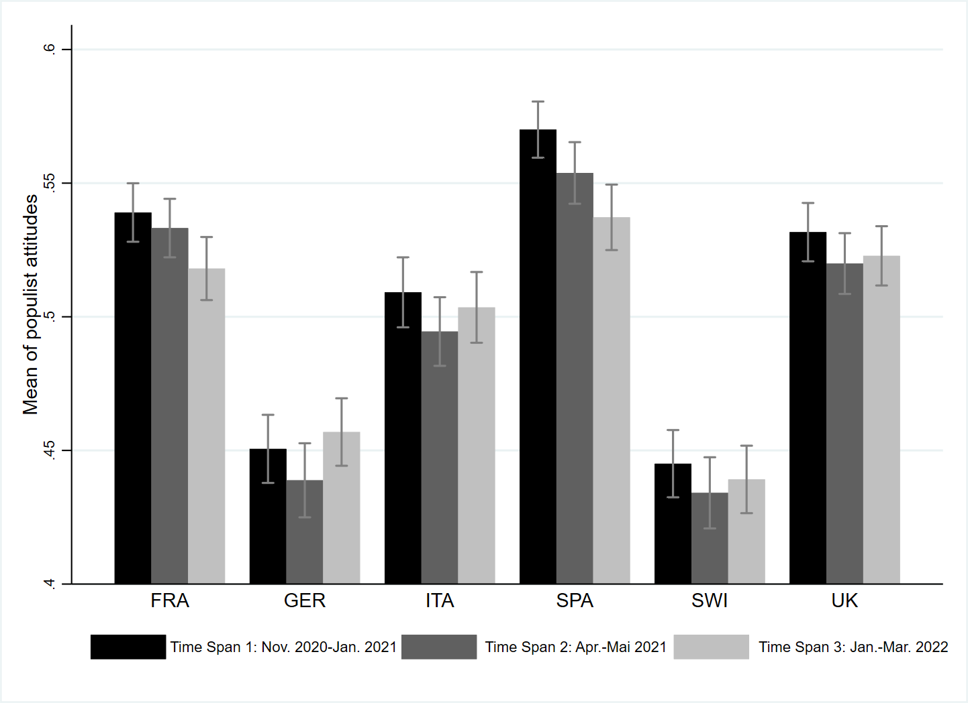
Note: Displayed are country and survey-wave mean levels of populist attitudes with 95% confidence intervals. Variable ranges from 0 (no populist attitudes) to 1 (high populist attitudes). Source: Original survey data collected by SurveyEngine (survey wave 1: 24th November 2020 - 18th January 2021; survey wave 2: 22nd April and 21st May 2021; survey wave 3: 25th January and 8th March 2022).

Table S11 Dimensionality of Emotions - Model Fit Comparison of Confirmatory factor analysis
Model | AIC | ΔAIC | RMSEA | Δ RMSEA | CFI | Δ CFI | TLI | Δ TLI
One Dimension | 206756 | - | .285 | - | .870 | - | .610 | -
Two dimensions | 203928 | 2828 | .088 | -.197 | .994 | .124 | .963 | .353
Notes: N = 18,257; RMSEA = root mean square error of approximation; CFI = comparative fit index; TLI = Tucker-Lewis index; CFI = comparative fit index. Source: Original survey data collected by SurveyEngine from (survey wave 1: 24th November 2020 - 18th January 2021; survey wave 2: 22nd April and 21st May 2021; survey wave 3: 25th January and 8th March 2022). Estimations are done with the SEM command implemented in Stata 17.

Table S12 Spearman Brown for fear (“anxious” and “worried”)
Model | Pooled Sample | FRA | GER | ITA | SPA | CH | UK
Survey Wave 1 | .75 | .52 | .81 | .79 | .67 | .75 | .87
Survey Wave 2 | .76 | .55 | .83 | .8 | .69 | .77 | .87
Survey Wave 3 | .77 | .61 | .82 | .80 | .71 | .74 | .88
Notes: Shows Spearman Brown reliability coefficients between “anxious” and “worried”. Source: Original survey data collected by SurveyEngine from (survey wave 1: 24th November 2020 - 18th January 2021; survey wave 2: 22nd April and 21st May 2021; survey wave 3: 25th January and 8th March 2022).

Table S13 Spearman Brown for anger (“angry” and “hostile”)
Model | Pooled Sample | FRA | GER | ITA | SPA | CH | UK
Survey Wave 1 | .73 | .74 | .68 | .75 | .77 | .7 | .73
Survey Wave 2 | .74 | .74 | .69 | .77 | .75 | .7 | .78
Survey Wave 3 | .74 | .74 | .74 | .78 | .78 | .75 | .72
Notes: Shows Spearman Brown reliability coefficients between “angry” and “hostile”. Source: Original survey data collected by SurveyEngine (survey wave 1: 24th November 2020 - 18th January 2021; survey wave 2: 22nd April and 21st May 2021; survey wave 3: 25th January and 8th March 2022).

Table S14 Correlation between anger and fear
Model | Pooled Sample | FRA | GER | ITA | SPA | CH | UK
Survey Wave 1 | .5 | .4 | .37 | .55 | .62 | .43 | .52
Survey Wave 2 | .52 | .45 | .44 | .52 | .62 | .47 | .57
Survey Wave 3 | .55 | .43 | .47 | .62 | .6 | .52 | .56
Notes: Shows correlations between anger and fear. Source: Original survey data collected by SurveyEngine (survey wave 1: 24th November 2020 - 18th January 2021; survey wave 2: 22nd April and 21st May 2021; survey wave 3: 25th January and 8th March 2022).
Table S15 Linear Regression Model for the Relationship between Pandemic Elicited Emotions and Populist attitudes including survey-wave and country interactions
 | DV: Populist attitudes | DV: People centrism | DV: Anti elitism | DV: Manichean outlook
Anger | 0.114***  (0.019) | 0.069**  (0.022) | 0.130***  (0.033) | 0.105**  (0.032)
Fear | -0.044*  (0.021) | 0.022  (0.027) | -0.023  (0.029) | -0.090**  (0.027)
GER # anger | 0.021  (0.046) | 0.030  (0.029) | 0.082*  (0.040) | 0.006  (0.052)
ITA # anger | 0.073*  (0.035) | 0.011  (0.030) | -0.052  (0.042) | 0.095*  (0.047)
SPA # anger | -0.067  (0.042) | -0.128***  (0.032) | -0.122**  (0.043) | -0.033  (0.052)
SWI # anger | -0.070  (0.045) | -0.039  (0.033) | -0.026  (0.041) | -0.066  (0.049)
UK # anger | 0.008  (0.031) | -0.024  (0.044) | 0.006  (0.044) | 0.002  (0.047)
GER # fear | 0.024  (0.039) | -0.055  (0.033) | -0.126**  (0.037) | 0.093*  (0.045)
ITA # fear | -0.053  (0.043) | -0.019  (0.038) | -0.020  (0.043) | -0.033  (0.047)
SPA # fear | 0.034  (0.034) | 0.051  (0.034) | 0.050  (0.035) | 0.030  (0.046)
SWI # fear | 0.042  (0.044) | -0.011  (0.043) | -0.082  (0.042) | 0.099*  (0.044)
UK # fear | 0.020  (0.032) | 0.011  (0.039) | 0.003  (0.038) | 0.068  (0.038)
Survey Wave 2 # anger | 0.004  (0.035) | -0.045  (0.027) | 0.011  (0.038) | -0.010  (0.039)
Survey Wave 3 # anger | 0.031  (0.021) | 0.014  (0.032) | 0.004  (0.028) | 0.030  (0.034)
Survey Wave 2 # fear | -0.058*  (0.028) | -0.000  (0.032) | -0.039  (0.032) | -0.023  (0.032)
Survey Wave 3 # fear | -0.042  (0.031) | -0.037  (0.034) | -0.055  (0.035) | 0.022  (0.034)
GER # Survey Wave 2 | -0.017  (0.030) | 0.007  (0.021) | 0.010  (0.014) | -0.003  (0.034)
GER # Survey Wave 3 | 0.039  (0.024) | 0.017  (0.017) | 0.020  (0.020) | 0.053  (0.028)
ITA # Survey Wave 2 | -0.030  (0.028) | -0.019  (0.024) | -0.028  (0.022) | -0.015  (0.038)
ITA # Survey Wave 3 | 0.018  (0.026) | 0.020  (0.017) | -0.004  (0.018) | 0.027  (0.035)
SPA # Survey Wave 2 | -0.054**  (0.020) | -0.007  (0.020) | -0.031*  (0.015) | -0.047  (0.032)
SPA # Survey Wave 3 | -0.002  (0.024) | 0.009  (0.019) | -0.016  (0.017) | 0.018  (0.027)
SWI # Survey Wave 2 | -0.036  (0.024) | 0.001  (0.022) | -0.048**  (0.017) | -0.009  (0.032)
SWI # Survey Wave 3 | 0.003  (0.021) | -0.003  (0.020) | -0.037*  (0.018) | 0.020  (0.027)
UK # Survey Wave 2 | -0.033  (0.025) | -0.015  (0.025) | -0.031  (0.018) | 0.001  (0.035)
UK # Survey Wave 3 | 0.005  (0.023) | -0.021  (0.021) | 0.004  (0.021) | 0.044  (0.029)
GER # Survey Wave 2 # anger | -0.104  (0.075) | 0.004  (0.044) | -0.054  (0.047) | -0.077  (0.063)
GER # Survey Wave 3 # anger | -0.087  (0.055) | -0.105*  (0.045) | -0.066  (0.046) | -0.059  (0.061)
ITA # Survey Wave 2 # anger | -0.072  (0.053) | -0.024  (0.046) | -0.040  (0.051) | -0.060  (0.058)
ITA # Survey Wave 3 # anger | -0.178***  (0.049) | -0.181**  (0.061) | -0.096  (0.050) | -0.137*  (0.053)
SPA # Survey Wave 2 # anger | -0.022  (0.056) | 0.046  (0.048) | -0.047  (0.054) | -0.012  (0.064)
SPA # Survey Wave 3 # anger | -0.048  (0.037) | -0.024  (0.045) | -0.035  (0.060) | -0.025  (0.048)
SWI # Survey Wave 2 # anger | 0.059  (0.051) | 0.071  (0.046) | 0.061  (0.049) | 0.052  (0.051)
SWI # Survey Wave 3 # anger | 0.017  (0.055) | -0.038  (0.048) | 0.021  (0.039) | 0.028  (0.061)
UK # Survey Wave 2 # anger | 0.036  (0.058) | 0.069  (0.062) | -0.020  (0.055) | 0.100  (0.079)
UK # Survey Wave 3 # anger | -0.083*  (0.038) | -0.099  (0.057) | -0.080  (0.043) | -0.039  (0.055)
GER # Survey Wave 2 # fear | 0.078  (0.050) | -0.024  (0.038) | 0.052  (0.042) | 0.051  (0.055)
GER # Survey Wave 3 # fear | 0.028  (0.057) | 0.012  (0.046) | 0.017  (0.058) | -0.000  (0.062)
ITA # Survey Wave 2 # fear | 0.099*  (0.048) | 0.036  (0.053) | 0.063  (0.058) | 0.065  (0.053)
ITA # Survey Wave 3 # fear | 0.121*  (0.054) | 0.067  (0.042) | 0.077  (0.047) | 0.054  (0.062)
SPA # Survey Wave 2 # fear | 0.099*  (0.039) | 0.003  (0.041) | 0.083  (0.045) | 0.087  (0.056)
SPA # Survey Wave 3 # fear | 0.007  (0.050) | -0.021  (0.053) | 0.048  (0.050) | -0.038  (0.048)
SWI # Survey Wave 2 # fear | 0.022  (0.057) | -0.088*  (0.042) | 0.014  (0.048) | 0.013  (0.061)
SWI # Survey Wave 3 # fear | 0.016  (0.051) | 0.003  (0.046) | 0.061  (0.050) | -0.019  (0.053)
UK # Survey Wave 2 # fear | 0.040  (0.041) | -0.051  (0.058) | 0.014  (0.045) | -0.018  (0.044)
UK # Survey Wave 3 # fear | 0.079  (0.050) | 0.067  (0.049) | 0.073  (0.055) | -0.032  (0.056)
Age | -0.000  (0.000) | 0.002***  (0.000) | 0.001***  (0.000) | -0.002***  (0.000)
Sex
Male | 0.013***  (0.004) | 0.009*  (0.004) | 0.002  (0.004) | 0.021***  (0.004)
Education
Upper, post-secondary | -0.005  (0.005) | 0.010*  (0.005) | 0.015***  (0.004) | -0.015**  (0.005)
Tertiary | -0.016**  (0.005) | -0.015**  (0.005) | -0.001  (0.005) | -0.016**  (0.006)
Income situation | -0.017***  (0.002) | -0.014***  (0.002) | -0.022***  (0.002) | -0.014***  (0.002)
Left-right self-placement | -0.026***  (0.003) | -0.017***  (0.003) | -0.017***  (0.003) | -0.030***  (0.003)
Left-right self-placement (squared) | 0.003***  (0.000) | 0.002***  (0.000) | 0.002***  (0.000) | 0.003***  (0.000)
Political interest | 0.006**  (0.002) | 0.009***  (0.002) | -0.010***  (0.002) | 0.014***  (0.002)
Self-rated health | -0.003  (0.002) | 0.007**  (0.002) | -0.001  (0.002) | -0.004  (0.002)
Constant | 0.631***  (0.018) | 0.588***  (0.020) | 0.694***  (0.023) | 0.590***  (0.022)
Observations | 18090 | 18090 | 18090 | 18090
R² | 0.085 | 0.060 | 0.120 | 0.084
Adjusted R² | 0.082 | 0.057 | 0.117 | 0.081
Notes: Linear regression coefficients with region-clustered standard errors in parentheses, * p < 0.05, ** p < 0.01, *** p < 0.001. Reference Category (RF) for sex: female; RF Education: lower secondary or less; RF Position on countermeasures: Don’t go nearly far enough. Source: Source: Original survey data collected by SurveyEngine (survey wave 1: 24th November 2020 - 18th January 2021; survey wave 2: 22nd April and 21st May 2021; survey wave 3: 25th January and 8th March 2022).

Table S16 Linear regression models for the relationship between pandemic-elicited emotions and populist attitudes (Robustness checks)
DV: Populist attitudes | Robustness
Anger | 0.083***  (0.009)
Fear | -0.027***  (0.010)
Age | -0.000  (0.000)
Sex
Male | 0.014***  (0.004)
Education
Upper, post-secondary | -0.005  (0.005)
Tertiary | -0.016***  (0.005)
Income situation | -0.016***  (0.002)
Left-right self-placement | -0.026***  (0.003)
Left-right self-placement (squared) | 0.002***  (0.000)
Political interest | 0.006***  (0.002)
Self-rated health | -0.003  (0.002)
Position on countermeasures
Don't go far enough | -0.013**  (0.005)
Appropriate | -0.032***  (0.006)
Go too far | -0.008  (0.006)
Go much too far | 0.012  (0.010)
Constant | 0.637***  (0.014)
Country fixed-effects
Survey Wave fixed-effects
Observations | 18090
R² | 0.086
Adjusted R² | 0.084
Notes: Linear regression coefficients with region-clustered standard errors in parentheses, * p < 0.05, ** p < 0.01, *** p < 0.001. Reference Category (RF) for sex: female; RF Education: lower secondary or less; RF Position on countermeasures: Don’t go nearly far enough. Source: Original survey data collected by SurveyEngine (survey wave 1: 24th November 2020 - 18th January 2021; survey wave 2: 22nd April and 21st May 2021; survey wave 3: 25th January and 8th March 2022).

Table S17 Linear Regression Model for the Relationship between Pandemic Elicited Emotions and Populist attitudes (Robustness checks)
 | Robustness 1 | Robustness 2 | Robustness 3
DV: Populist attitudes
Anger | 0.075***  (0.009) | 0.088***  (0.010) | 0.093***  (0.009)
Fear | -0.030**  (0.010) | -0.040**  (0.013) | -0.034***  (0.010)
Age | 0.000  (0.000) | -0.000  (0.000) | -0.000  (0.000)
Sex
Male | 0.008*  (0.004) | 0.014**  (0.005) | 0.013***  (0.004)
Education
Upper, post-secondary | -0.002  (0.005) | -0.007  (0.007) | -0.004  (0.005)
Tertiary | -0.013*  (0.005) | -0.022**  (0.007) | -0.016**  (0.005)
Income situation | -0.016***  (0.002) | -0.017***  (0.003) | -0.018***  (0.002)
Left-right self-placement | -0.026***  (0.003) | -0.025***  (0.003) | -0.027***  (0.003)
Left-right self-placement (squared) | 0.003***  (0.000) | 0.002***  (0.000) | 0.003***  (0.000)
Political interest | 0.007**  (0.002) | 0.007*  (0.003) | 0.006**  (0.002)
Self-rated health | 0.000  (0.002) | -0.003  (0.003) | -0.003  (0.002)
Big-5 Personality Traits
Extraversion | 0.001  (0.002) | - | -
Agreeableness | -0.016***  (0.003) | - | -
Conscientiousness | -0.013***  (0.003) | - | -
Neuroticism | 0.006**  (0.002) | - | -
Openness | -0.005*  (0.002) | - | -
Threat Perceptions
Perceived infectious threat | - | -0.005  (0.003) | -
Perceived financial threat | - | 0.005*  (0.003) | -
Perceived social threat | - | 0.006*  (0.003) | -
Infection with Covid-19
Infection friends/family | - | - | -0.004  (0.004)
Own infection | - | - | 0.012*  (0.005)
Constant | 0.710***  (0.022) | 0.608***  (0.024) | 0.630***  (0.016)
Observations | 18090 | 10610 | 18008
Country fixed-effects
Survey Wave fixed-effects
R² | 0.091 | 0.080 | 0.082
Adjusted R² | 0.090 | 0.078 | 0.081
Notes: Linear regression coefficients with region-clustered standard errors in parentheses, * p < 0.05, ** p < 0.01, *** p < 0.001. Reference Category (RF) for sex: female; RF Education: lower secondary or less; RF Infection with Covid-19: No infection. Source: Original survey data collected by SurveyEngine (survey wave 1: 24th November 2020 - 18th January 2021; survey wave 2: 22nd April and 21st May 2021; survey wave 3: 25th January and 8th March 2022).

Figure S2 Marginal effects of pandemic-elicited emotions on populist attitudes by country-survey wave including personality traits as additional control variables
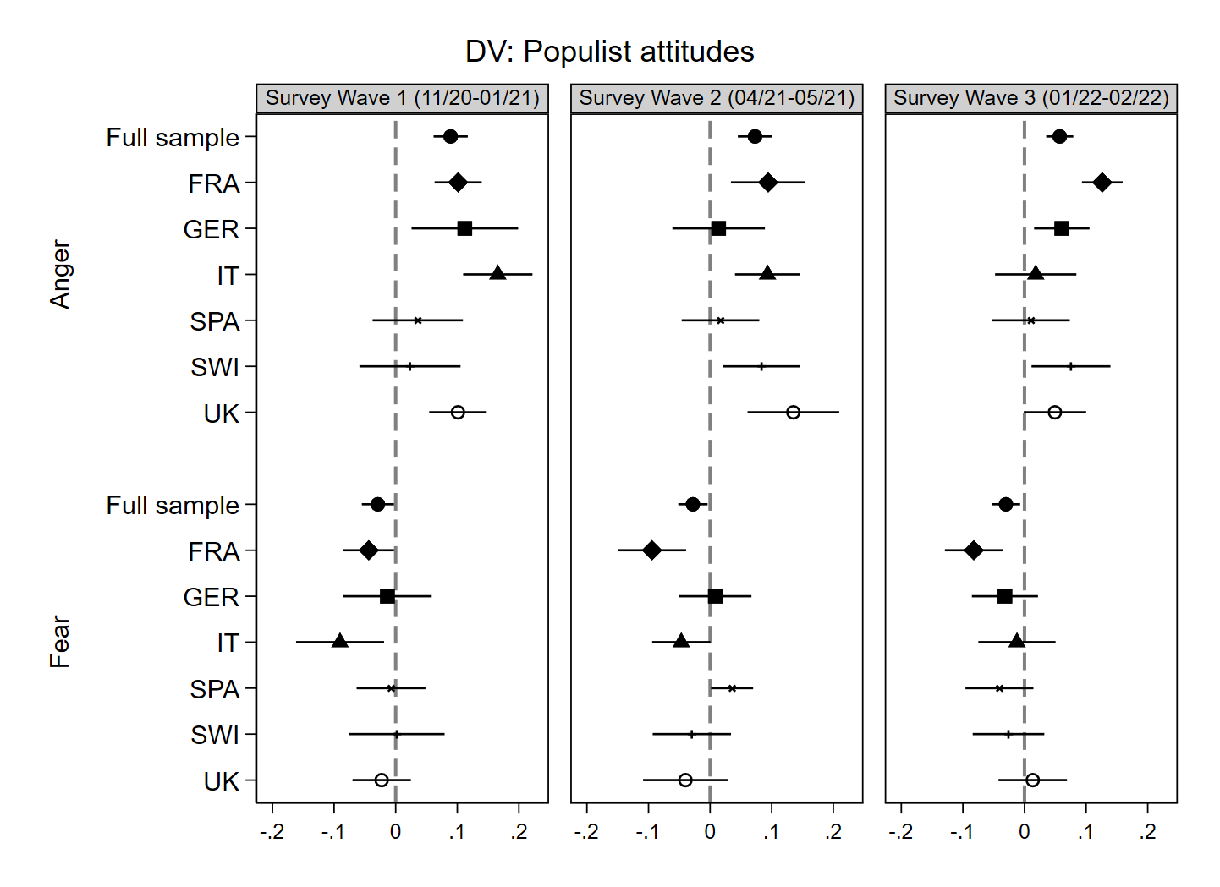Notes: Marginal effects calculated from a linear regression model with region-clustered standard errors, 95% confidence intervals, N = 18,090. Source: Original survey data collected by SurveyEngine (survey wave 1: 24th November 2020 - 18th January 2021; survey wave 2: 22nd April and 21st May 2021; survey wave 3: 25th January and 8th March 2022).

Figure S3 Marginal effects of pandemic-elicited emotions on populist attitudes by country-survey wave including threat perceptions as additional control variables
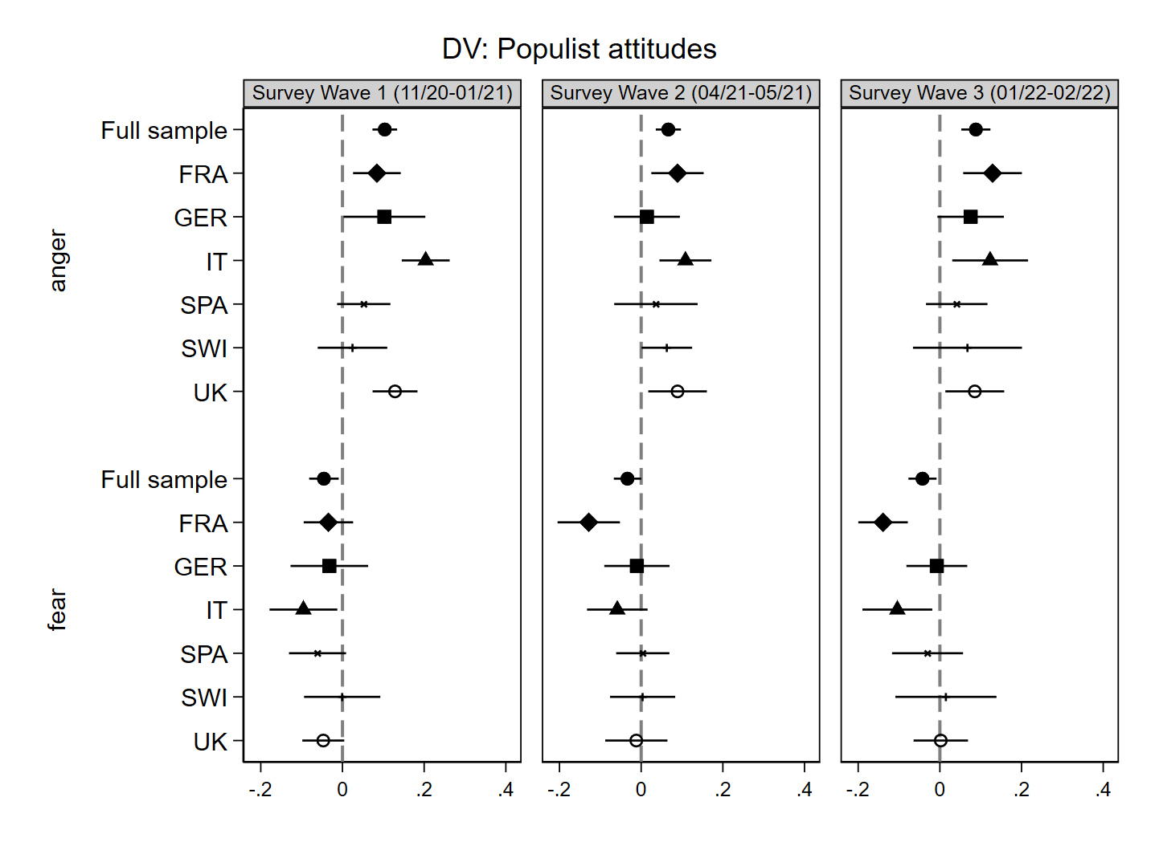 Notes: Marginal effects calculated from a linear regression model with region-clustered standard errors, 95% confidence intervals, N = 18,090. Source: Original survey data collected by SurveyEngine (survey wave 1: 24th November 2020 - 18th January 2021; survey wave 2: 22nd April and 21st May 2021; survey wave 3: 25th January and 8th March 2022).

Figure S4 Marginal effects of pandemic-elicited emotions on populist attitudes by country-survey wave including Covid-19 infection as additional control variable
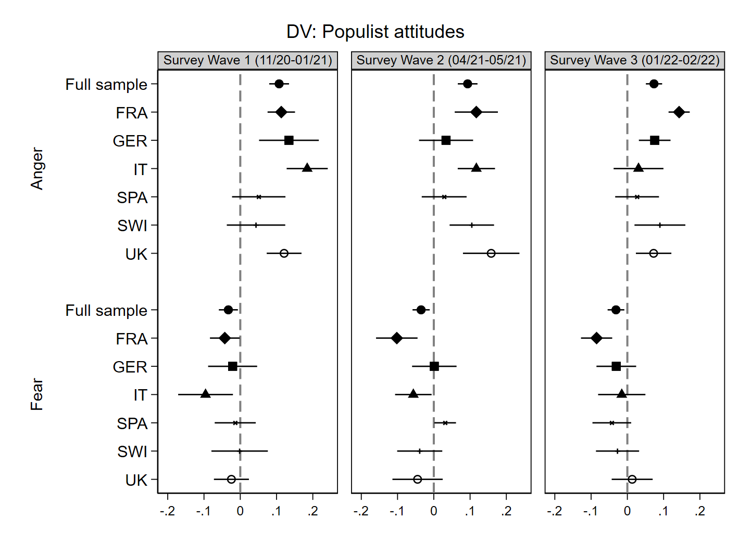 Notes: Marginal effects calculated from a linear regression model with region-clustered standard errors, 95% confidence intervals, N = 18,090. Source: Original survey data collected by SurveyEngine (survey wave 1: 24th November 2020 - 18th January 2021; survey wave 2: 22nd April and 21st May 2021; survey wave 3: 25th January and 8th March 2022)..

Figure S5 Marginal effects of pandemic-elicited emotions on people centrism by country-survey wave including personality traits as additional control variable
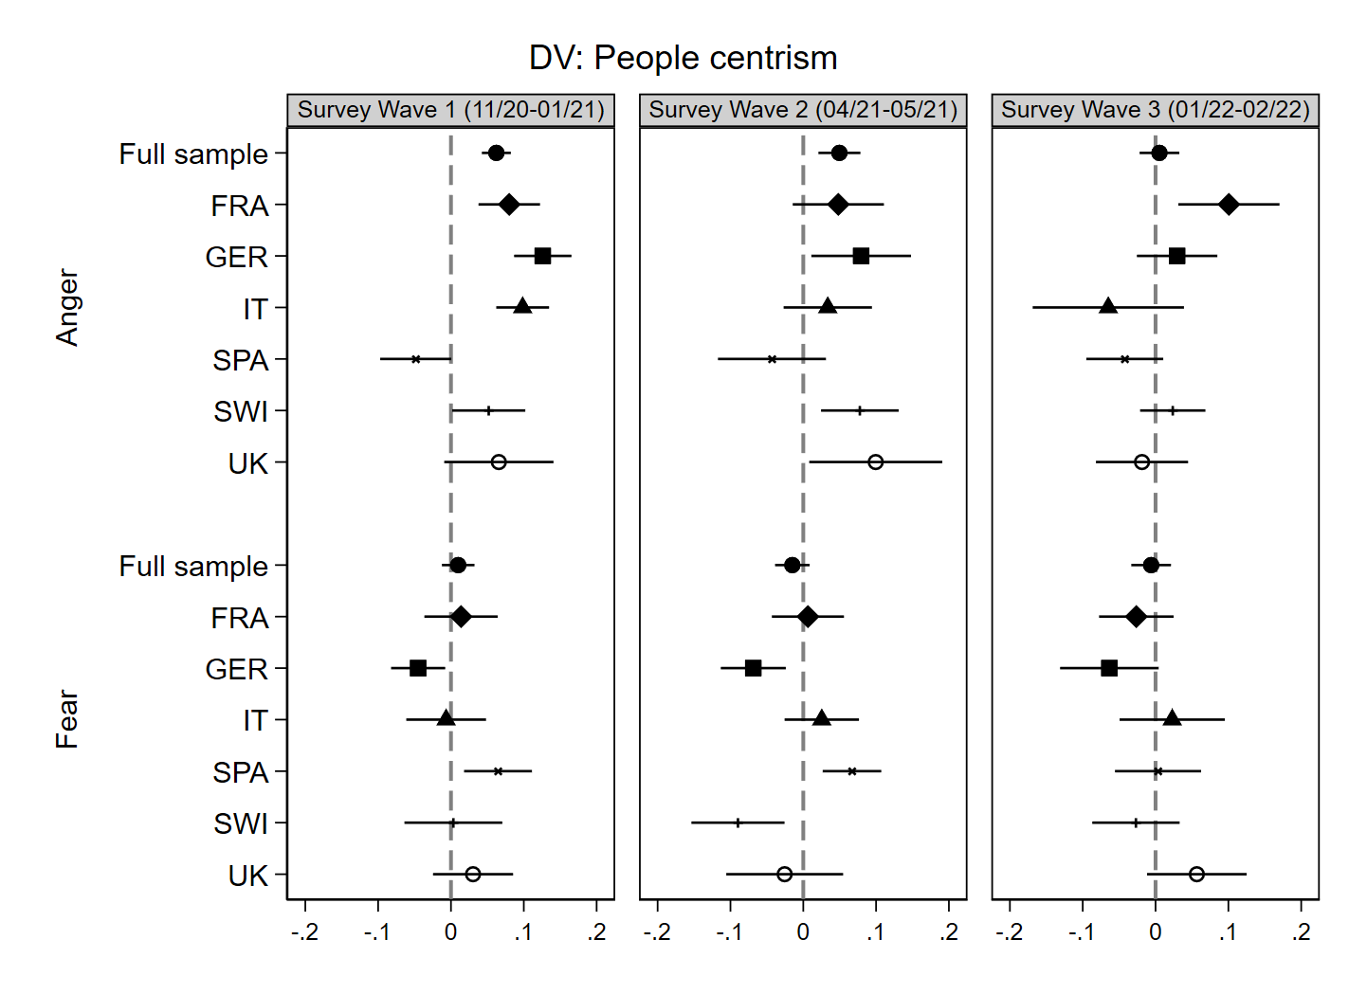Notes: Marginal effects calculated from a linear regression model with region-clustered standard errors, 95% confidence intervals, N = 18,090. Source: Original survey data collected by SurveyEngine (survey wave 1: 24th November 2020 - 18th January 2021; survey wave 2: 22nd April and 21st May 2021; survey wave 3: 25th January and 8th March 2022).

Figure S6 Marginal effects of pandemic-elicited emotions on people centrism by country-survey wave including threat perceptions as additional control variable
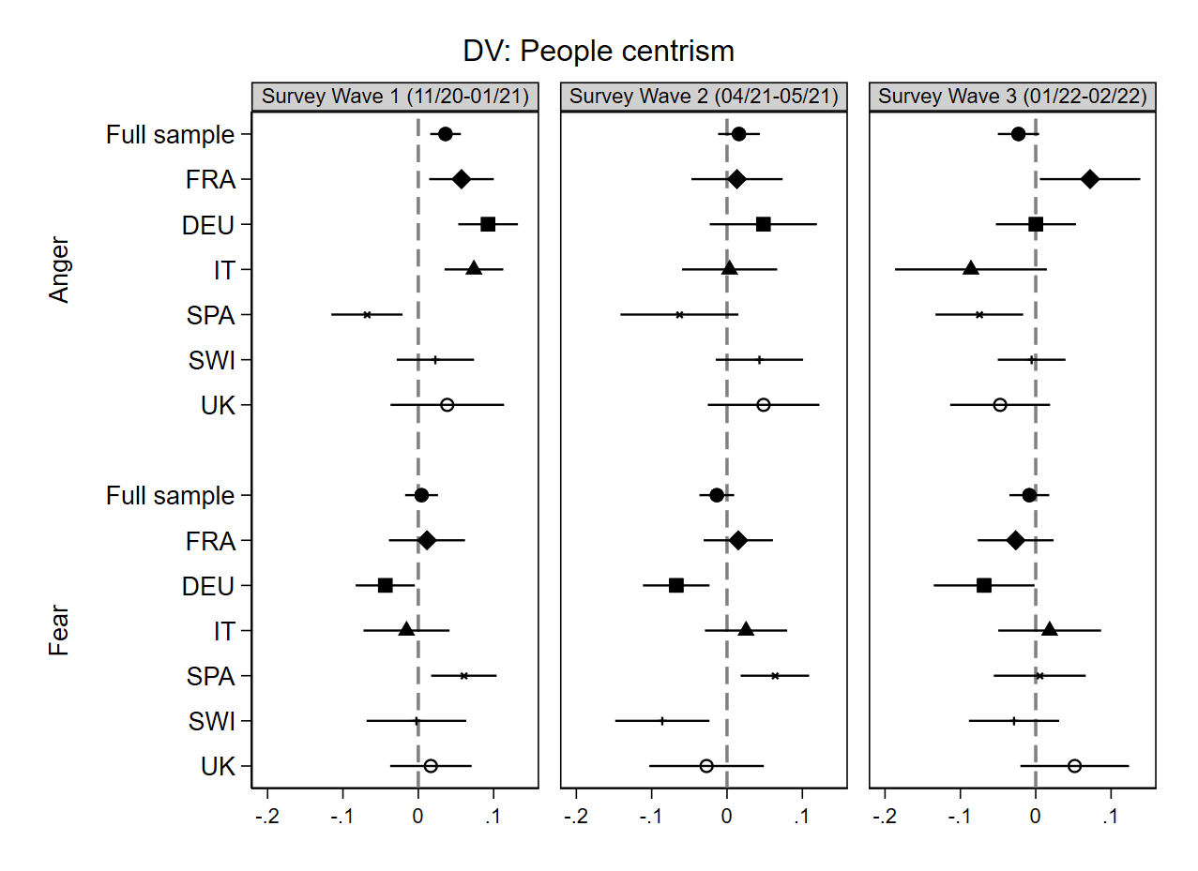 Notes: Marginal effects calculated from a linear regression model with region-clustered standard errors, 95% confidence intervals, N = 18,090. Source: Original survey data collected by SurveyEngine (survey wave 1: 24th November 2020 - 18th January 2021; survey wave 2: 22nd April and 21st May 2021; survey wave 3: 25th January and 8th March 2022).

Figure S7 Marginal effects of pandemic-elicited emotions on people centrism by country-survey wave including Covid-19 infection as additional control variable
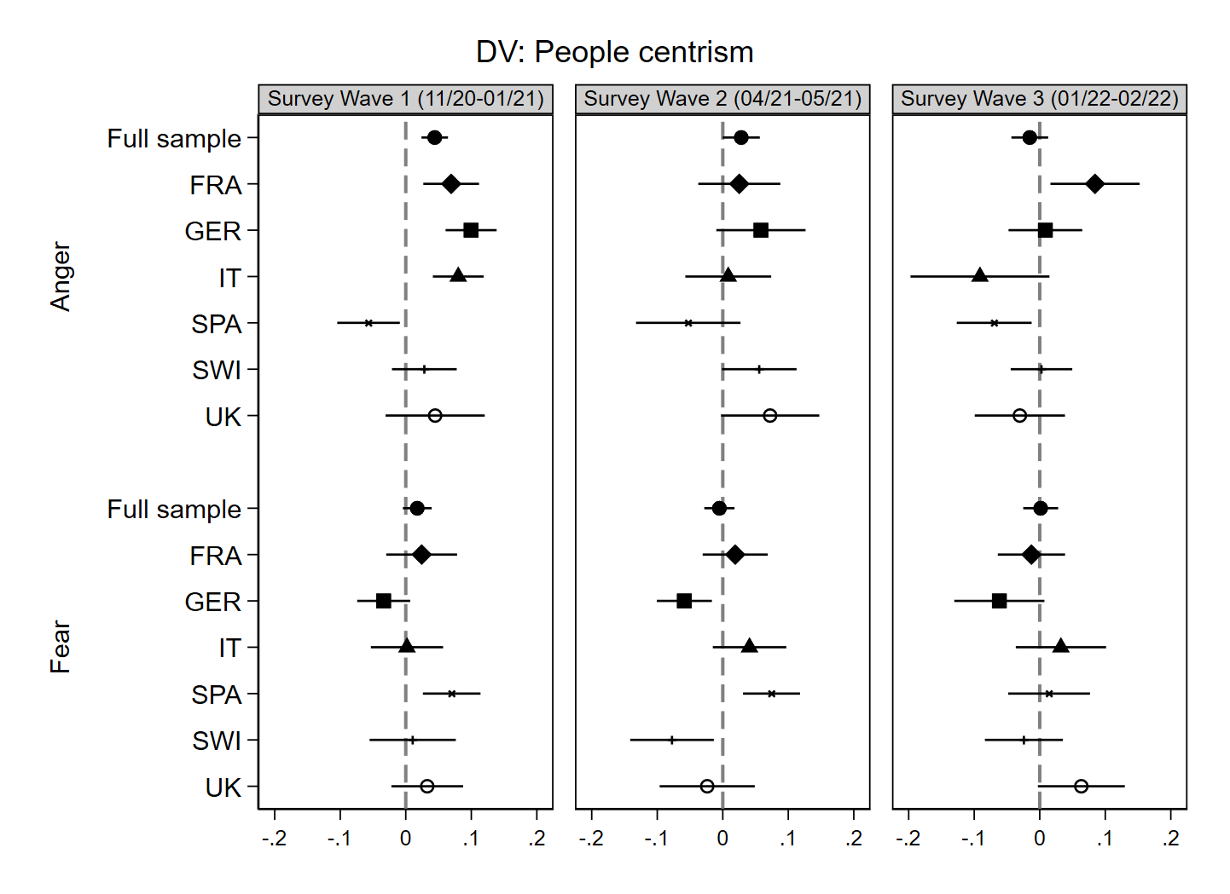Notes: Marginal effects calculated from a linear regression model with region-clustered standard errors, 95% confidence intervals, N = 18,090. Source: Original survey data collected by SurveyEngine (survey wave 1: 24th November 2020 - 18th January 2021; survey wave 2: 22nd April and 21st May 2021; survey wave 3: 25th January and 8th March 2022).

Figure S8 Marginal effects of pandemic-elicited emotions on anti-elitism by country-survey wave including personality traits as additional control variable
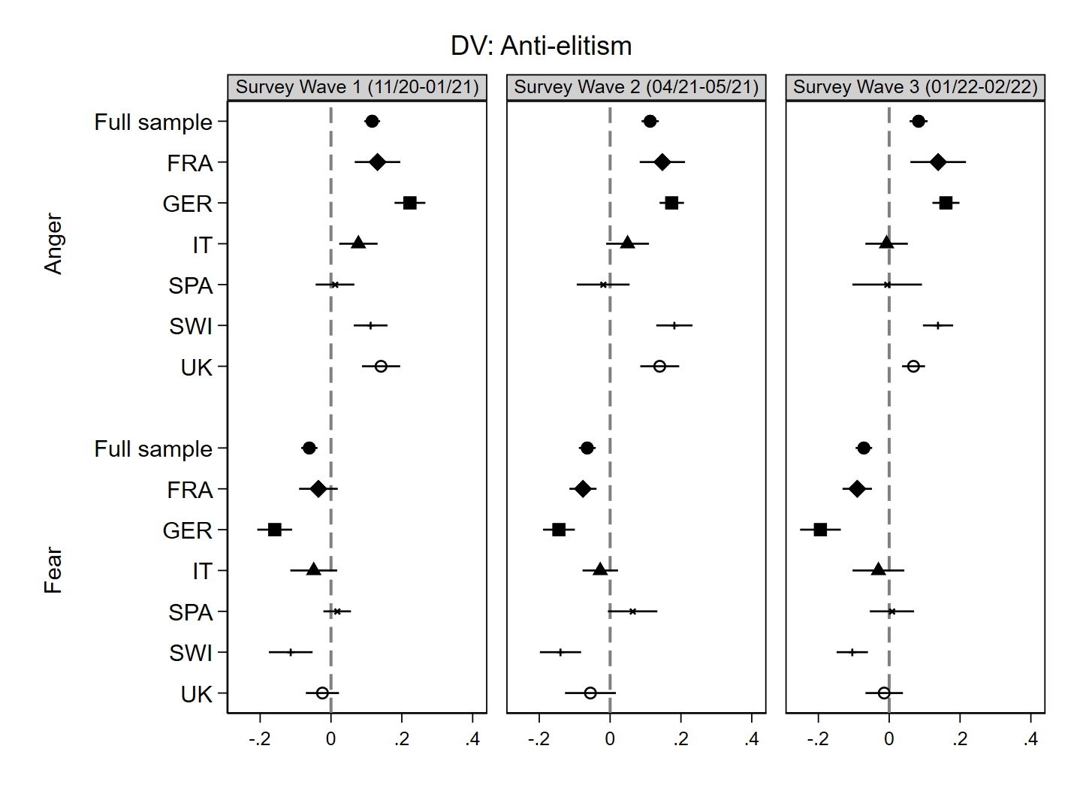Notes: Marginal effects calculated from a linear regression model with region-clustered standard errors, 95% confidence intervals, N = 18,090. Source: Original survey data collected by SurveyEngine (survey wave 1: 24th November 2020 - 18th January 2021; survey wave 2: 22nd April and 21st May 2021; survey wave 3: 25th January and 8th March 2022).

Figure S9 Marginal effects of pandemic-elicited emotions on anti-elitism by country-survey wave including threat perceptions as additional control variable
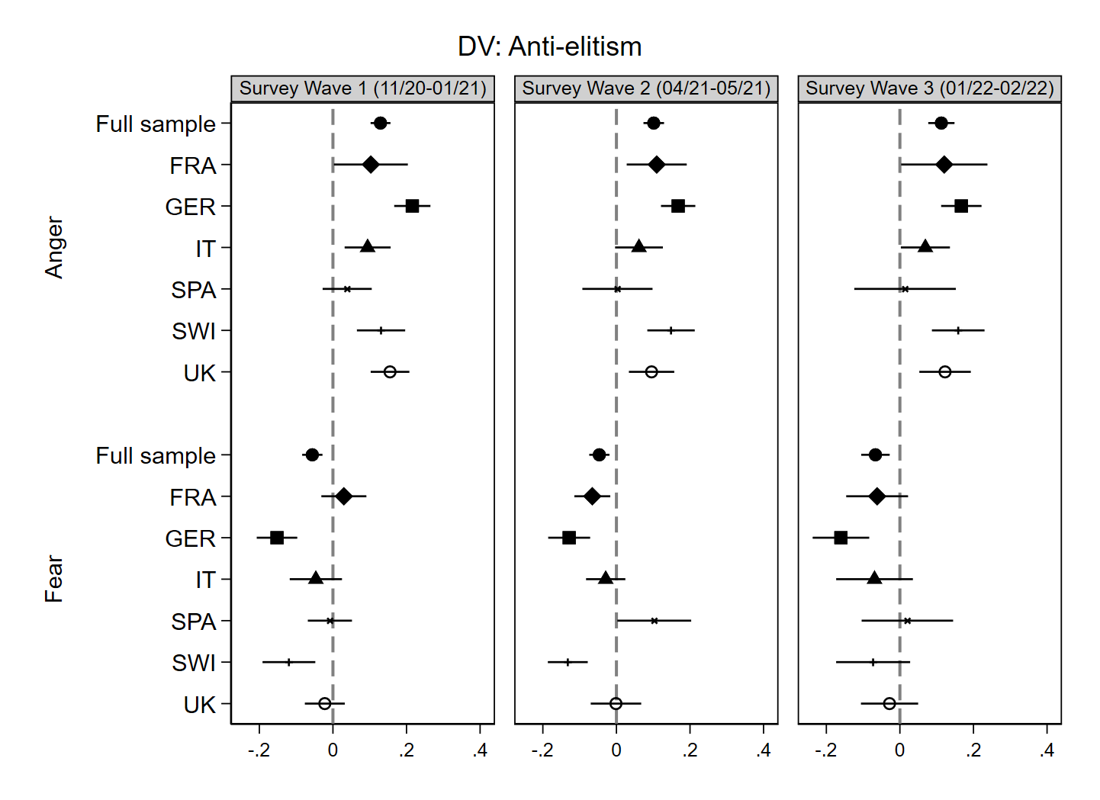Notes: Marginal effects calculated from a linear regression model with region-clustered standard errors, 95% confidence intervals, N = 18,090. Source: Original survey data collected by SurveyEngine (survey wave 1: 24th November 2020 - 18th January 2021; survey wave 2: 22nd April and 21st May 2021; survey wave 3: 25th January and 8th March 2022).
Figure S10 Marginal effects of pandemic-elicited emotions on anti-elitism by country-survey wave including Covid-19 infection as additional control variable
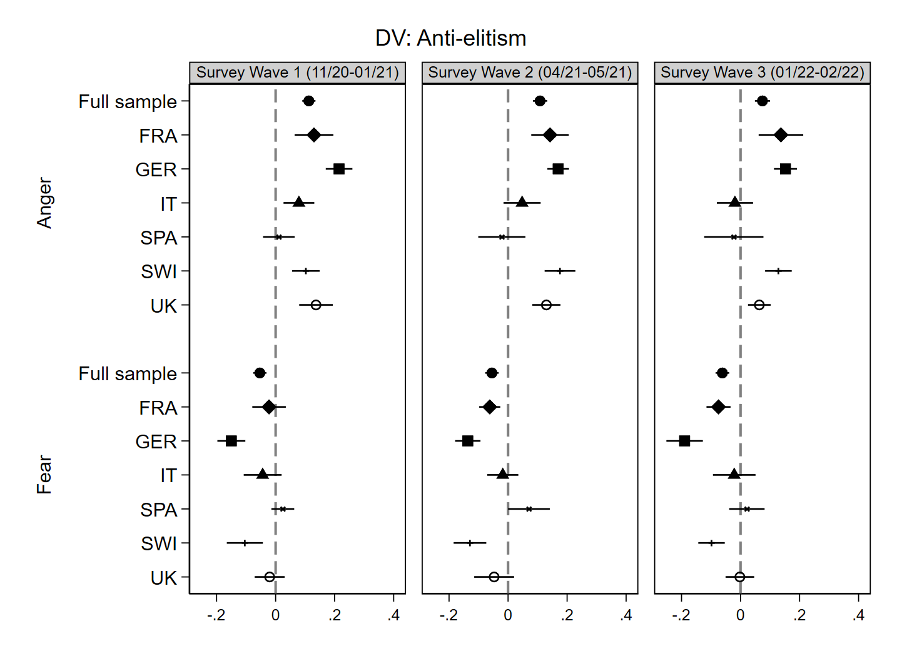Notes: Marginal effects calculated from a linear regression model with region-clustered standard errors, 95% confidence intervals, N = 18,090. Source: Original survey data collected by SurveyEngine (survey wave 1: 24th November 2020 - 18th January 2021; survey wave 2: 22nd April and 21st May 2021; survey wave 3: 25th January and 8th March 2022).

Figure S11 Marginal effects of pandemic-elicited emotions on Manichean outlook by country-survey wave including personality traits as additional control variable
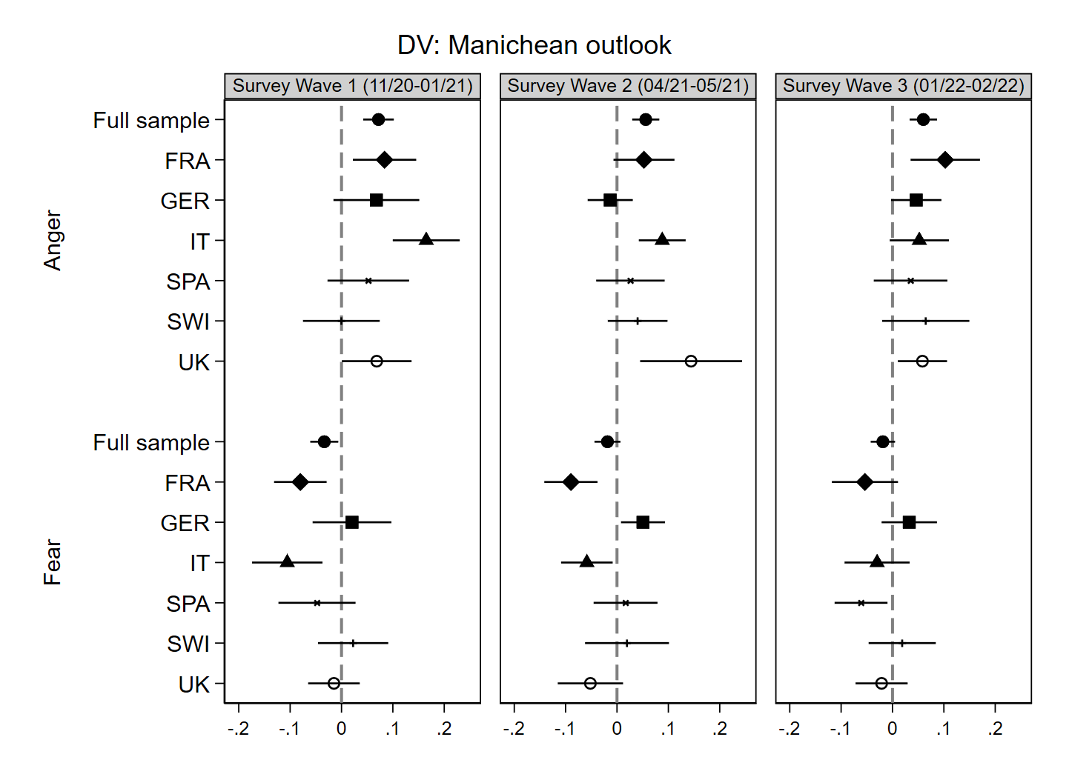Notes: Marginal effects calculated from a linear regression model with region-clustered standard errors, 95% confidence intervals, N = 18,090. Source: Original survey data collected by SurveyEngine (survey wave 1: 24th November 2020 - 18th January 2021; survey wave 2: 22nd April and 21st May 2021; survey wave 3: 25th January and 8th March 2022)..

Figure S12 Marginal effects of pandemic-elicited emotions on Manichean outlook by country-survey wave including threat perceptions as additional control variable
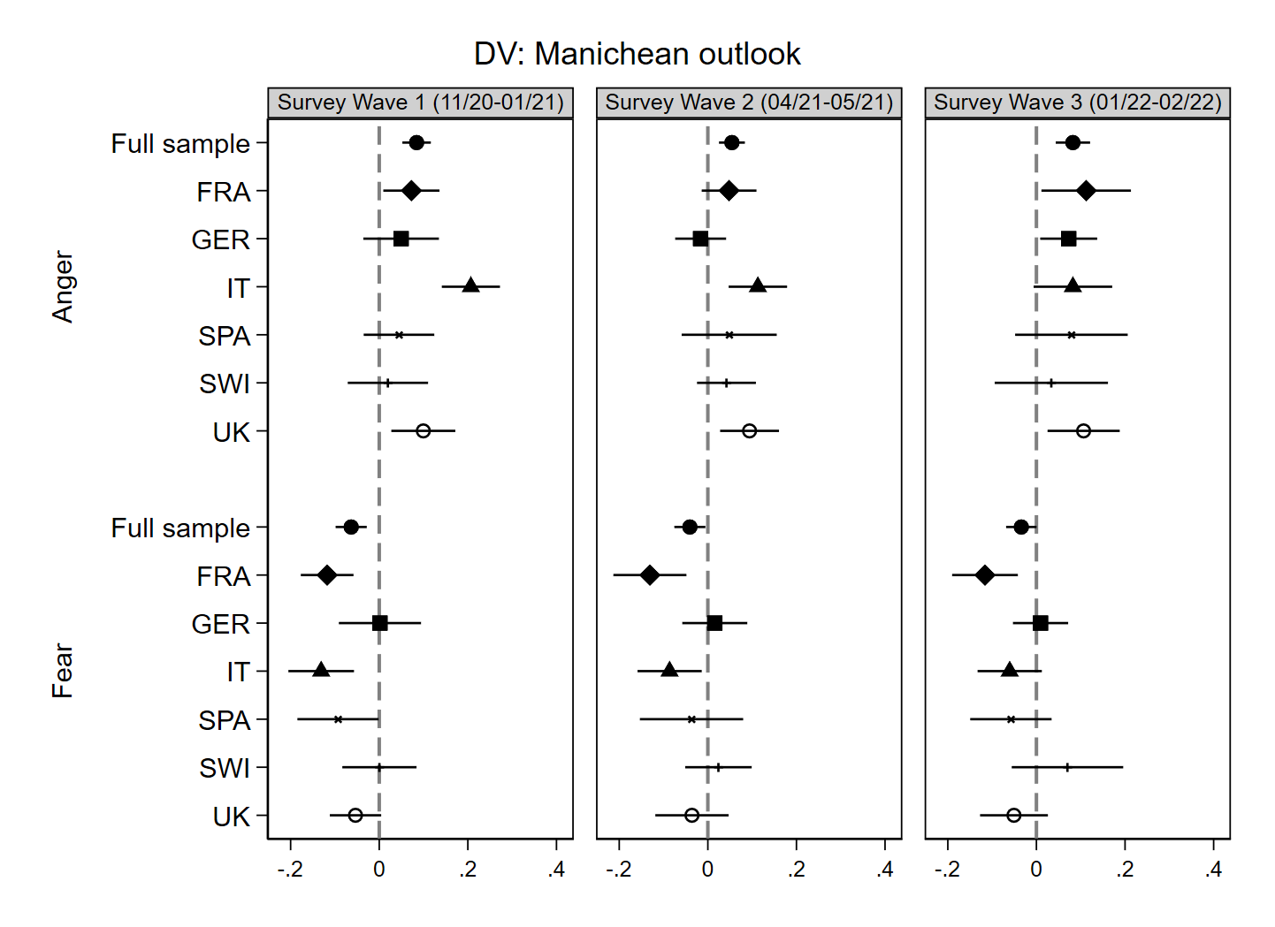Notes: Marginal effects calculated from a linear regression model with region-clustered standard errors, 95% confidence intervals, N = 18,090. Source: Original survey data collected by SurveyEngine (survey wave 1: 24th November 2020 - 18th January 2021; survey wave 2: 22nd April and 21st May 2021; survey wave 3: 25th January and 8th March 2022).

Figure S13 Marginal effects of pandemic-elicited emotions on Manichean outlook by country-survey wave including Covid-19 infection as additional control variable
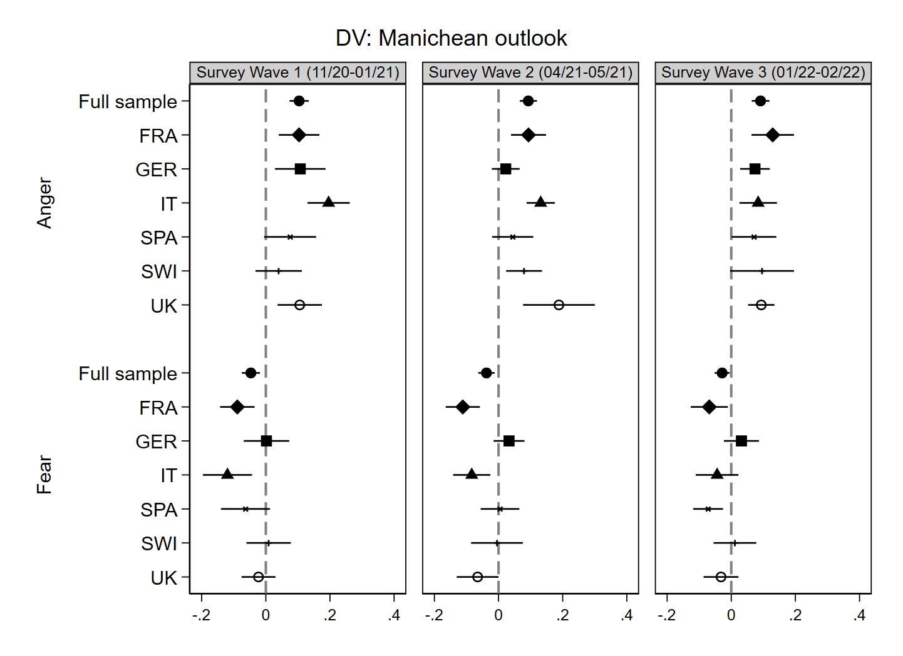Notes: Marginal effects calculated from a linear regression model with region-clustered standard errors, 95% confidence intervals, N = 18,090. Source: Original survey data collected by SurveyEngine (survey wave 1: 24th November 2020 - 18th January 2021; survey wave 2: 22nd April and 21st May 2021; survey wave 3: 25th January and 8th March 2022).

Figure S14 Marginal effects of pandemic-elicited emotions on POP 1 by country-survey

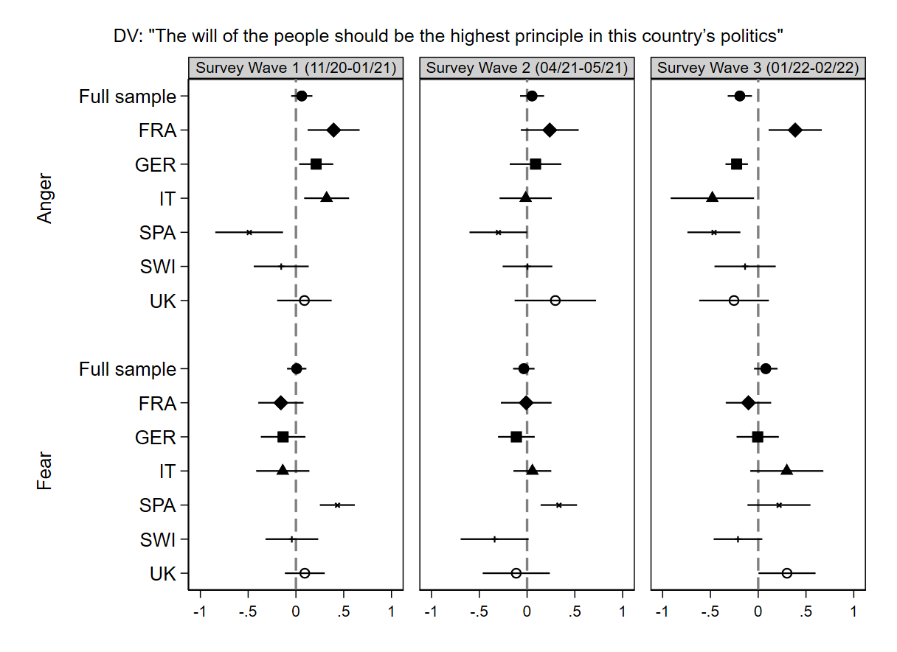Notes: Marginal effects calculated from a linear regression model with region-clustered standard errors, 95% confidence intervals, N = 18,090. Source: Original survey data collected by SurveyEngine (survey wave 1: 24th November 2020 - 18th January 2021; survey wave 2: 22nd April and 21st May 2021; survey wave 3: 25th January and 8th March 2022).
Figure S15 Marginal effects of pandemic-elicited emotions on POP 2 by country-survey wave
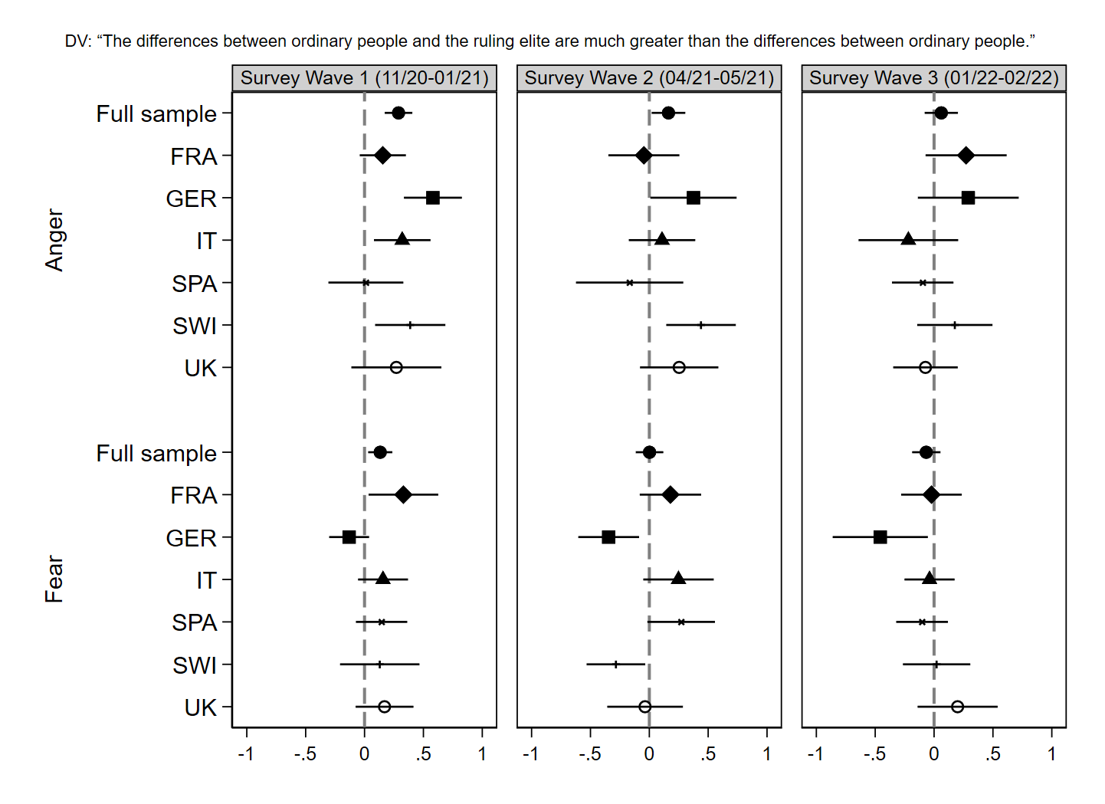Notes: Marginal effects calculated from a linear regression model with region-clustered standard errors, 95% confidence intervals, N = 18,090. Source: Original survey data collected by SurveyEngine (survey wave 1: 24th November 2020 - 18th January 2021; survey wave 2: 22nd April and 21st May 2021; survey wave 3: 25th January and 8th March 2022).

Figure S16 Marginal effects of pandemic-elicited emotions on POP 3 by country-survey wave
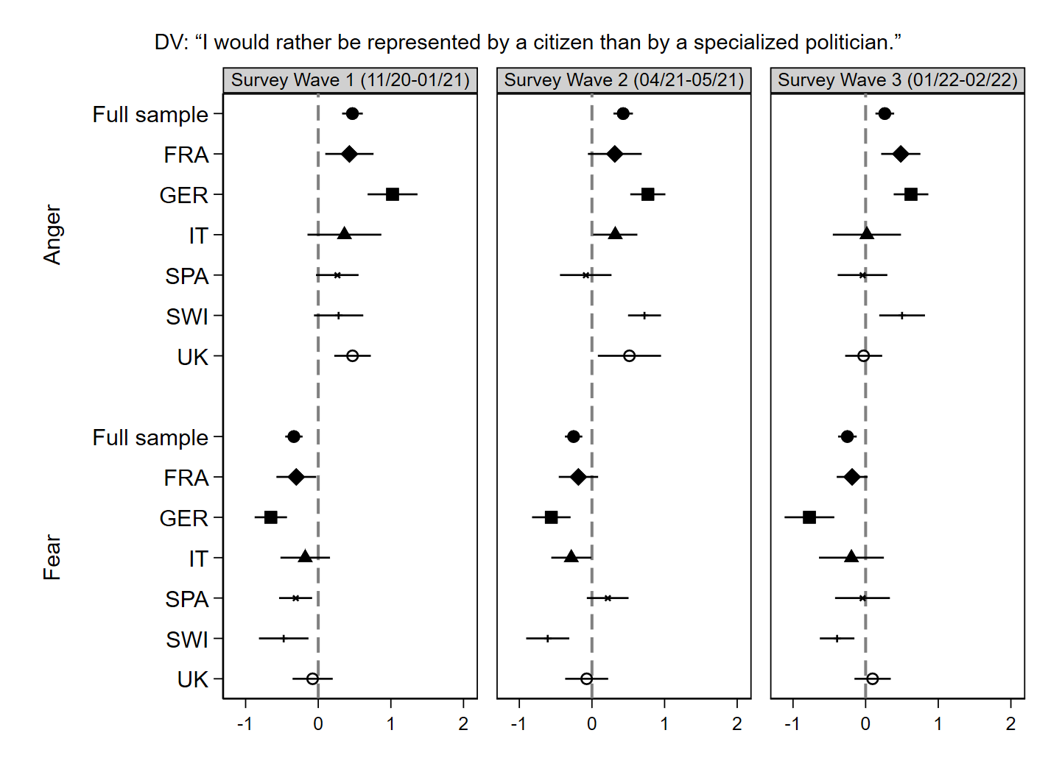Notes: Marginal effects calculated from a linear regression model with region-clustered standard errors, 95% confidence intervals, N = 18,090. Source: Original survey data collected by SurveyEngine (survey wave 1: 24th November 2020 - 18th January 2021; survey wave 2: 22nd April and 21st May 2021; survey wave 3: 25th January and 8th March 2022).

Figure S17 Marginal effects of pandemic-elicited emotions on POP 4 by country-survey wave
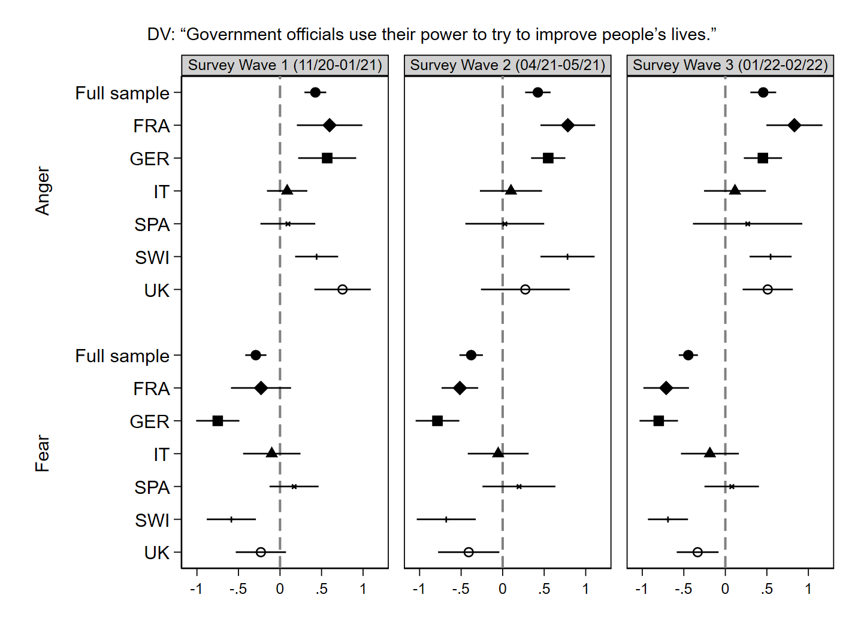Notes: Marginal effects calculated from a linear regression model with region-clustered standard errors, 95% confidence intervals, N = 18,090. Source: Original survey data collected by SurveyEngine (survey wave 1: 24th November 2020 - 18th January 2021; survey wave 2: 22nd April and 21st May 2021; survey wave 3: 25th January and 8th March 2022).

Figure S18 Marginal effects of pandemic-elicited emotions on POP 5 by country-survey wave
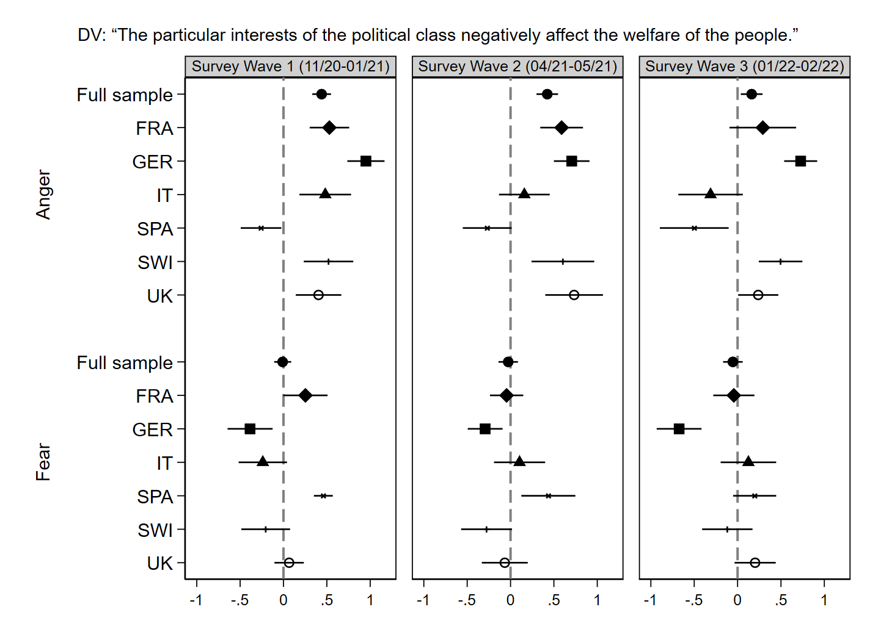Notes: Marginal effects calculated from a linear regression model with region-clustered standard errors, 95% confidence intervals, N = 18,090. Source: Original survey data collected by SurveyEngine (survey wave 1: 24th November 2020 - 18th January 2021; survey wave 2: 22nd April and 21st May 2021; survey wave 3: 25th January and 8th March 2022).

Figure S19 Marginal effects of pandemic-elicited emotions on POP 6 by country-survey wave
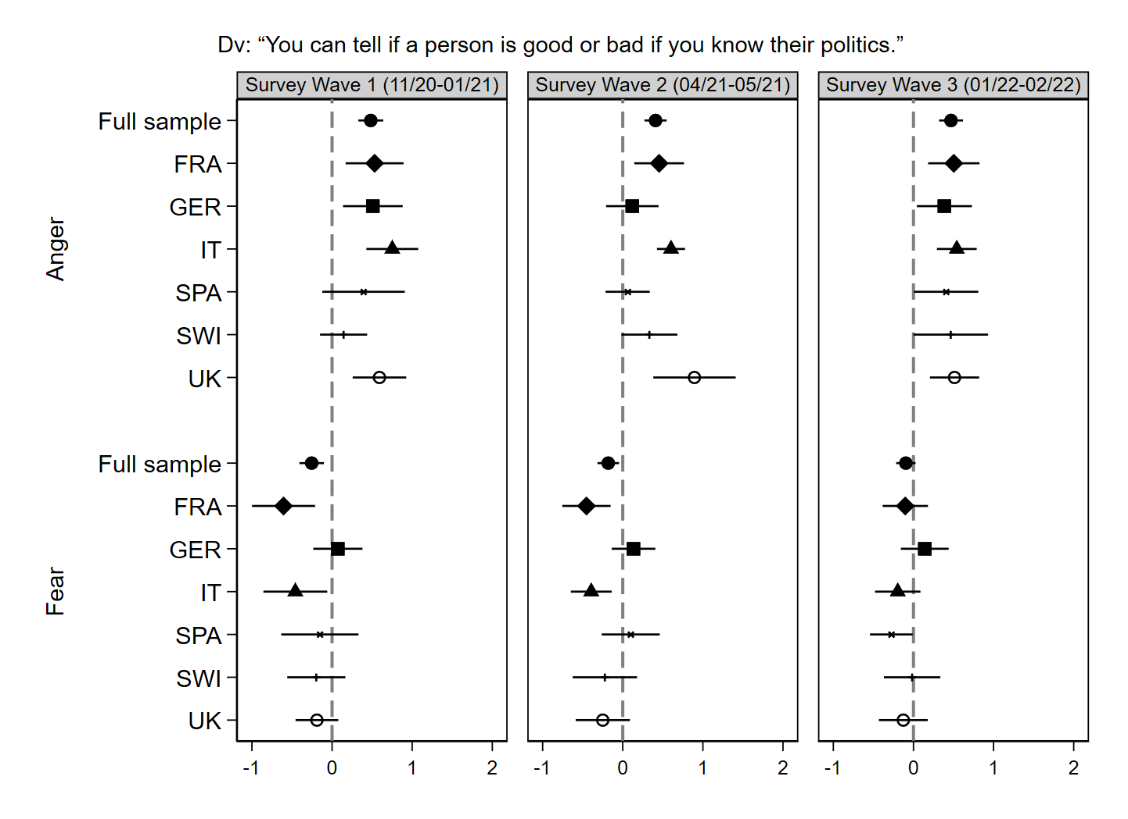Notes: Marginal effects calculated from a linear regression model with region-clustered standard errors, 95% confidence intervals, N = 18,090. Source: Original survey data collected by SurveyEngine (survey wave 1: 24th November 2020 - 18th January 2021; survey wave 2: 22nd April and 21st May 2021; survey wave 3: 25th January and 8th March 2022).

Figure S20 Marginal effects of pandemic-elicited emotions on POP 7 by country-survey wave
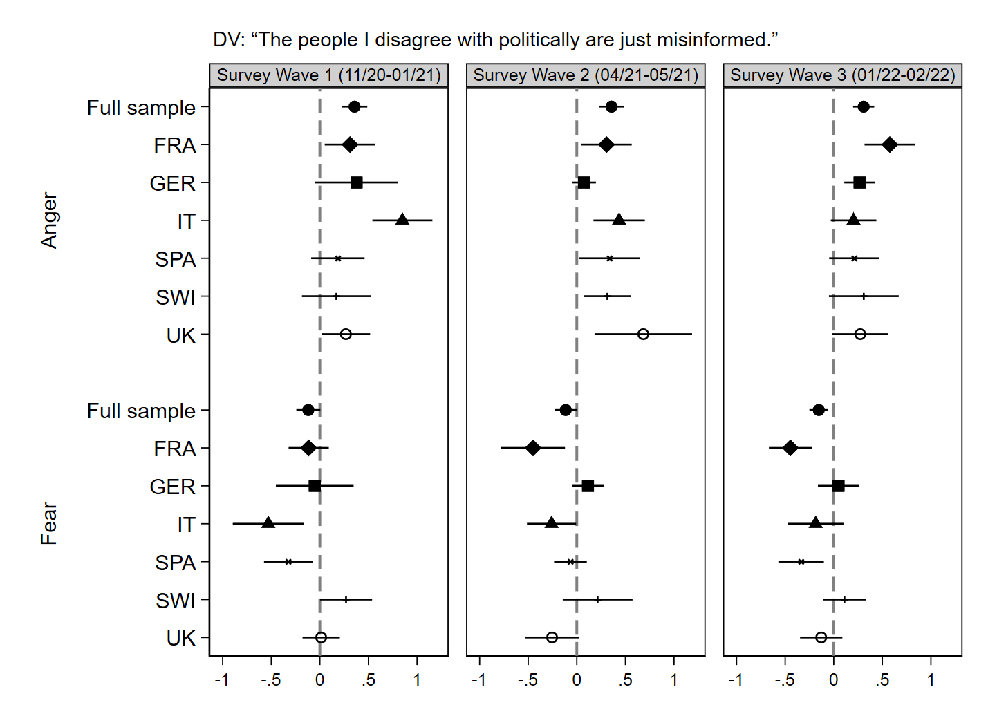Notes: Marginal effects calculated from a linear regression model with region-clustered standard errors, 95% confidence intervals, N = 18,090. Source: Original survey data collected by SurveyEngine (survey wave 1: 24th November 2020 - 18th January 2021; survey wave 2: 22nd April and 21st May 2021; survey wave 3: 25th January and 8th March 2022).

Table S18 Linear regression models for the relationship between threat perceptions and pandemic-elicited emotions
 | DV: Anger | DV: Fear | DV: Anger | DV: Fear
Perceived financial threat | 0.029***  (0.003) | 0.016***  (0.003) | 0.033***  (0.003) | 0.038***  (0.003)
Perceived infection threat | 0.026***  (0.003) | 0.116***  (0.005) | - | -
Perceived social threat | 0.040***  (0.003) | 0.035***  (0.003) | 0.047***  (0.003) | 0.054***  (0.003)
Covid-19 infection
Infection friends/family | - | - | 0.022***  (0.004) | 0.044***  (0.005)
Own infection | - | - | 0.056***  (0.007) | 0.044***  (0.006)
Age | -0.002***  (0.000) | -0.001**  (0.000) | -0.002***  (0.000) | -0.001***  (0.000)
Sex
Male | -0.025***  (0.005) | -0.064***  (0.006) | -0.018***  (0.004) | -0.068***  (0.005)
Education
Upper, post-secondary | 0.018*  (0.007) | 0.020**  (0.006) | 0.004  (0.006) | 0.012*  (0.005)
Tertiary | 0.016*  (0.007) | 0.029***  (0.007) | 0.008  (0.005) | 0.026***  (0.007)
Income situation | -0.006*  (0.003) | -0.005  (0.003) | -0.007**  (0.002) | -0.000  (0.003)
Left-right self-placement | 0.004**  (0.001) | -0.002*  (0.001) | 0.007***  (0.001) | -0.001  (0.001)
Self-rated health | -0.029***  (0.003) | -0.043***  (0.003) | -0.037***  (0.003) | -0.054***  (0.003)
Constant | 0.263***  (0.023) | 0.324***  (0.029) | 0.348***  (0.022) | 0.556***  (0.022)
Observations | 10610 | 10610 | 18008 | 18008
Country fixed-effects
Survey Wave fixed-effects
R² | 0.157 | 0.349 | 0.167 | 0.217
Adjusted R² | 0.156 | 0.348 | 0.166 | 0.217
Notes: Linear regression coefficients with region-clustered standard errors in parentheses, * p < 0.05, ** p < 0.01, *** p < 0.001. Reference Category (RF) for sex: female; RF Education: lower secondary or less; RF Covid-19 infection: No infection. Number of observations varies as the question about perceived infection threat was only presented to those that did not have a Covid-19 infection at the time of the survey. Source: Original survey data collected by SurveyEngine (survey wave 1: 24th November 2020 - 18th January 2021; survey wave 2: 22nd April and 21st May 2021; survey wave 3: 25th January and 8th March 2022).

Table S19 Linear Regression Model for the Relationship between Pandemic Elicited Emotions and Position on Countermeasures
 | DV: Measures go too far | DV: Priority on economy over public health
Anger | 0.302***  (0.023) | 1.080***  (0.072)
Fear | -0.354***  (0.026) | -1.244***  (0.089)
Age | -0.001***  (0.000) | -0.014***  (0.001)
Sex
Male | -0.029***  (0.008) | 0.026  (0.038)
Education
Upper, post-secondary | 0.010  (0.008) | -0.041  (0.036)
Tertiary | 0.017  (0.009) | -0.002  (0.040)
Income situation | -0.018***  (0.003) | -0.032*  (0.015)
Left-right self-placement | -0.013**  (0.005) | 0.215***  (0.023)
Left-right self-placement (squared) | 0.003***  (0.000) | -0.005*  (0.002)
Political interest | 0.000  (0.003) | 0.057***  (0.015)
Self-rated health | 0.017***  (0.004) | 0.050**  (0.019)
Constant | 0.329***  (0.032) | 2.990***  (0.160)
Country fixed-effects
Survey Wave fixed-effects
Observations | 18090 | 18090
R² | 0.106 | 0.119
Adjusted R² | 0.105 | 0.118
Notes: Linear regression coefficients with region-clustered standard errors in parentheses, * p < 0.05, ** p < 0.01, *** p < 0.001. Reference Category (RF) for sex: female; RF Education: lower secondary or less. Source: Original survey data collected by SurveyEngine (survey wave 1: 24th November 2020 - 18th January 2021; survey wave 2: 22nd April and 21st May 2021; survey wave 3: 25th January and 8th March 2022).

Table S20 Linear Regression Model for the Relationship between Populist Attitudes and Populist Party Support
 | DV: RRWP Party | DV: RLWP Party
Populist attitudes | 0.114***  (0.017) | 0.074**  (0.026)
Age | 0.001**  (0.000) | -0.000  (0.000)
Sex
Male | -0.000  (0.010) | 0.004  (0.008)
Education
Upper, post-secondary | 0.033**  (0.010) | 0.019  (0.010)
Tertiary | -0.025*  (0.011) | 0.030**  (0.010)
Income situation | -0.015***  (0.003) | -0.007  (0.005)
Left-right self-placement | -0.021***  (0.006) | -0.105***  (0.012)
Left-right self-placement (squared) | 0.008***  (0.001) | 0.007***  (0.001)
Political interest | 0.003  (0.003) | 0.015***  (0.004)
Constant | -0.033  (0.039) | 0.298***  (0.039)
Observations | 15553 | 7683
Country fixed-effects
Survey Wave fixed-effects
R² | 0.272 | 0.158
Adjusted R² | 0.271 | 0.157
Notes: Linear regression coefficients with region-clustered standard errors in parentheses, * p < 0.05, ** p < 0.01, *** p < 0.001. RRWP Party: Radical right-wing populist party; RLWP: Radical left-wing populist party; Reference Category (RF) for sex: female; RF Education: lower secondary or less. Source: Original survey data collected by SurveyEngine (survey wave 1: 24th November 2020 - 18th January 2021; survey wave 2: 22nd April and 21st May 2021; survey wave 3: 25th January and 8th March 2022).

Figure S21 Marginal effects of pandemic-elicited emotions on radical right-wing populist party support by country-survey wave
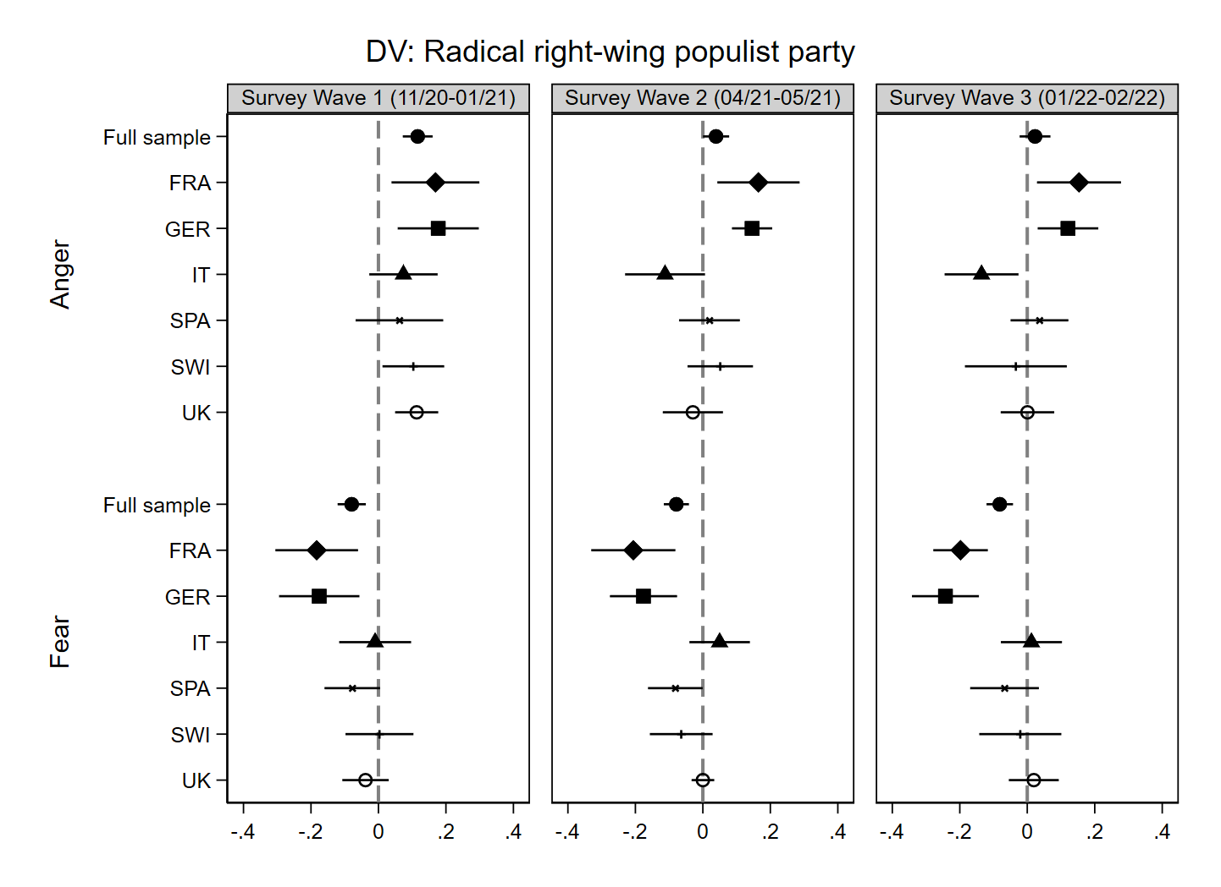 Notes: Marginal effects calculated from a linear regression model with region-clustered standard errors, 95% confidence intervals. Source: Original survey data collected by SurveyEngine (survey wave 1: 24th November 2020 - 18th January 2021; survey wave 2: 22nd April and 21st May 2021; survey wave 3: 25th January and 8th March 2022).

Figure S22 Marginal effects of pandemic-elicited emotions on radical left-wing populist party support by country-survey wave
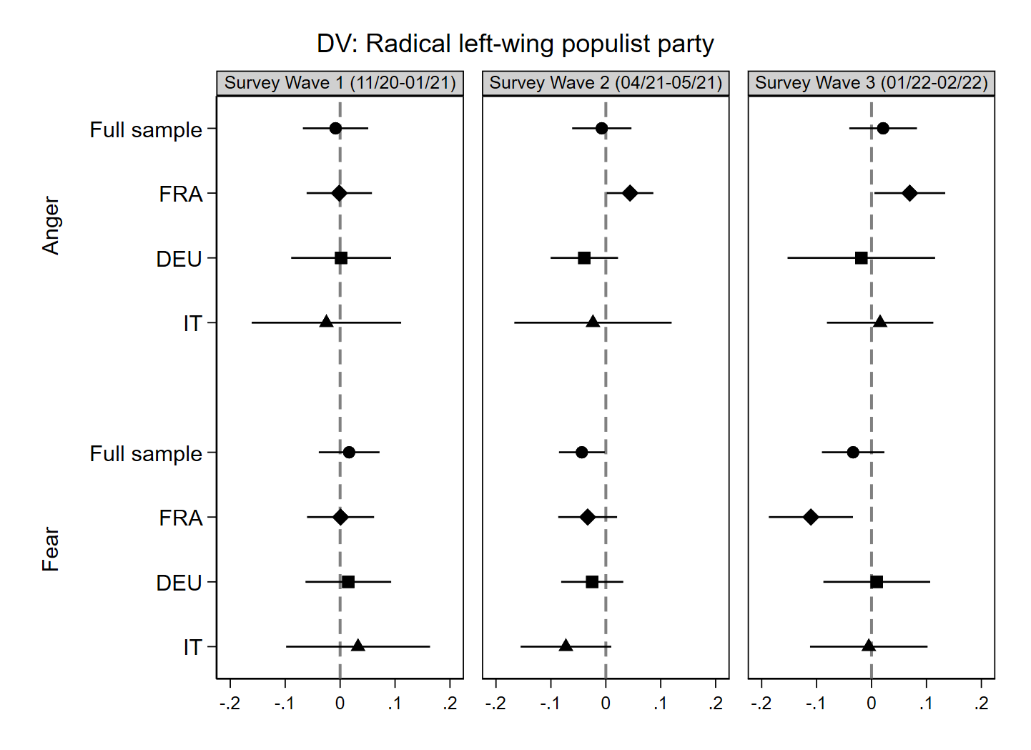 Notes: Marginal effects calculated from a linear regression model with region-clustered standard errors, 95% confidence intervals. Source: Original survey data collected by SurveyEngine (survey wave 1: 24th November 2020 - 18th January 2021; survey wave 2: 22nd April and 21st May 2021; survey wave 3: 25th January and 8th March 2022).

