Online Appendix:
How Governance Shaped Military Responses to the Covid-19 Pandemic

Appendix 1: Countries included

Afghanistan, Albania, Algeria, Andorra, Angola, Antigua & Barbuda, Argentina, Armenia, Australia, Austria, Azerbaijan, Bahamas, Bahrain, Bangladesh, Barbados, Belarus, Belgium, Belize, Benin, Bhutan, Bolivia, Bosnia and Herzegovina, Botswana, Brazil, Brunei, Bulgaria, Burkina Faso, Burundi, Cambodia, Cameroon, Canada, Cape Verde, Central African Republic, Chad, Chile, China, Colombia, Comoros, Congo, Costa Rica, Croatia, Cuba, Cyprus, Czech Republic, Democratic Republic of the Congo, Denmark, Djibouti, Dominica, Dominican Republic, East Timor, Ecuador, Egypt, El Salvador, Equatorial Guinea, Eritrea, Estonia, Ethiopia, Federated States of Micronesia, Fiji, Finland, France, Gabon, Gambia, Georgia, Germany, Ghana, Greece, Grenada, Guatemala, Guinea, Guinea-Bissau, Guyana, Haiti, Honduras, Hungary, Iceland, India, Indonesia, Iran, Iraq, Ireland, Israel, Italy, Ivory Coast, Jamaica, Japan, Jordan, Kazakhstan, Kenya, Kiribati, Korea, Kosovo, Kuwait, Kyrgyzstan, Laos, Latvia, Lebanon, Lesotho, Liberia, Libya, Liechtenstein, Lithuania, Luxembourg, Macedonia, Madagascar, Malawi, Malaysia, Maldives, Mali, Malta, Marshall Islands, Mauritania, Mauritius, Mexico, Moldova, Monaco, Mongolia, Montenegro, Morocco, Mozambique, Myanmar, Namibia, Nauru, Nepal, Netherlands, New Zealand, Nicaragua, Niger, Nigeria, North Korea, Norway, Oman, Pakistan, Palau, Panama, Papua New Guinea, Paraguay, Peru, Philippines, Poland, Portugal, Qatar, Republic of Vietnam, Romania, Russia, Rwanda, Samoa, Sao Tome and Principe, Saudi Arabia, Senegal, Seychelles, Sierra Leone, Singapore, Slovakia, Slovenia, Solomon Islands, Somalia, South Africa, South Korea, South Sudan, Spain, Sri Lanka, St. Kitts and Nevis, St. Lucia, St. Vincent and the Grenadines, Sudan, Suriname, Swaziland, Sweden, Switzerland, Syria, Taiwan, Tajikistan, Tanzania, Thailand, Togo, Tonga, Trinidad and Tobago, Tunisia, Turkey, Turkmenistan, Tuvalu, Uganda, Ukraine, United Arab Emirates, United Kingdom, United States of America, Uruguay, Uzbekistan, Vanuatu, Venezuela, Vietnam, Yemen, Zambia, Zanzibar, Zimbabwe.

Appendix 2: Alternative Model Specifications

In this appendix, we explore alternative model specifications to those presented in the main text. In particular, we investigate the sensitivity of our models to changes in the way that regime type and military deployments are measured. We discuss each in turn.

Regime Type
We use a binary measure of regime type (democracy or non-democracy) in the main text. Readers may be concerned, however, that the democracy variable is really capturing a relationship between military deployment and consolidated regimes. We therefore provide versions of our models that use a continuous democracy score ranging from -10 (consolidated autocracy) to 10 (consolidated democracy). These scores are derived from the same source as the binary democracy measure in the main text (Marshall, Gurr and Jaggers 2016).

We also include a squared version of the democracy score. This squared polity term is highest when a regime is on the extremes of the democracy scale (-10 or 10) and lowest when a regime is in the middle of the democracy scale. Higher values of this variable indicate a more consolidated regime. This variable represents a nonlinear “U-shaped” relationship between regime type and military deployment.

The results of this test are displayed in Table A, which reproduces the model in Table 2 from the main text. The substantive conclusions from these tables are largely the same as those presented in the main text, although the statistical uncertainty around our estimates are increased due to the additional model parameter. The association between polity squared and military deployment is statistically significant only for domestic protection, which was less common in consolidated regimes, both democratic and autocratic.

We additionally report a model of military deployments in countries with scheduled elections that includes a continuous measure of democracy. (Because every country in this sample is democratic, we do not include the squared polity term in this test—higher values of polity indicate more consolidated democracies.) This test is reported in Table B, which reproduces the model in Table 3 of the main text. These results are substantively unchanged from those in the main text.
Table A. Covid Military Action, All Countries (Logistic Regression)
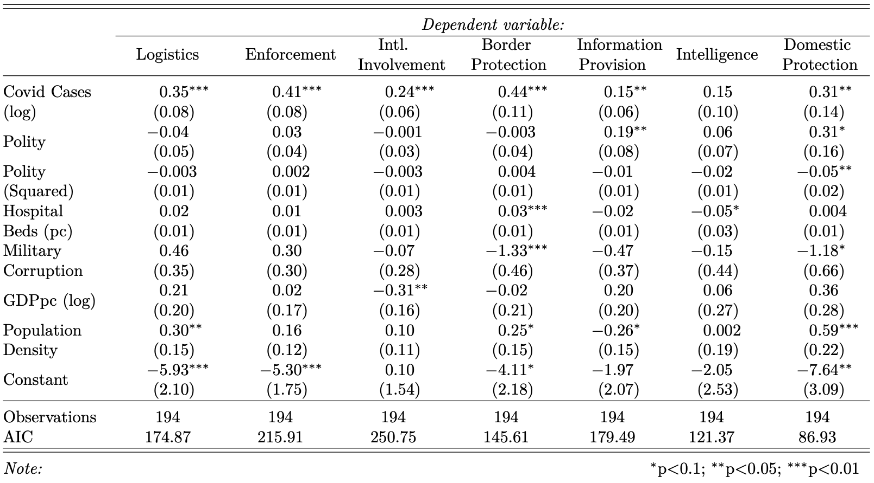

Table B. Covid Military Action, Countries with Scheduled Elections (Logistic Regression)
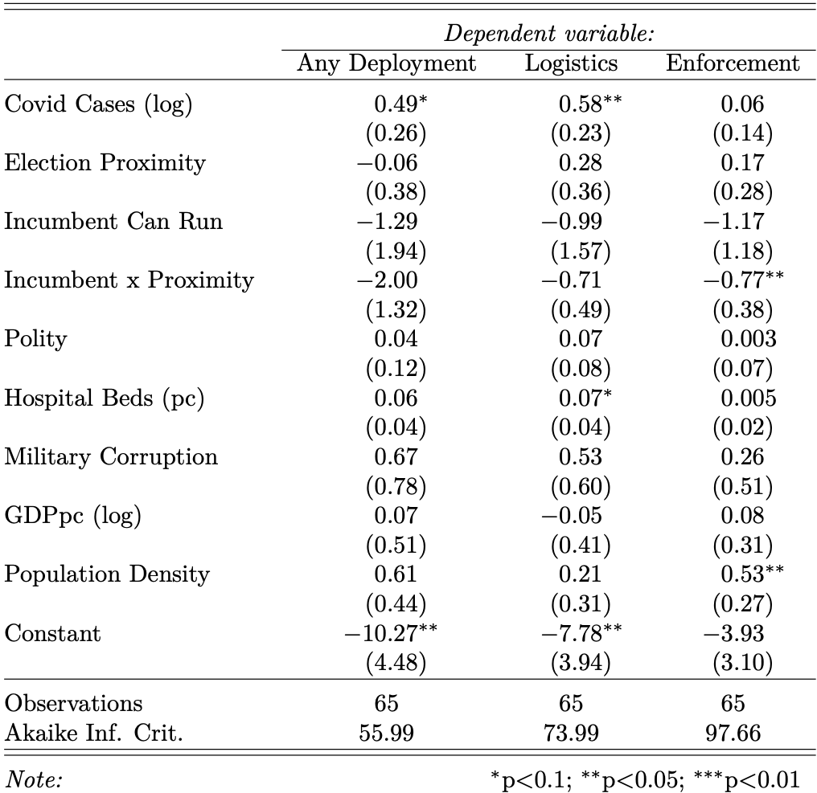
Deployment Categories
Our data capture seven distinct categories of military deployment. Some of these deployment types share similarities and might be aggregated into larger categories. We create two such categories here.

Some categories of deployment—enforcement, domestic protection, and intelligence operations—are domestic and civilian-facing. These deployments have consequences for the rights of civilians. We refer to this category of deployments as “boots on the ground” deployment.

Other categories of deployment—logistics, information provision, and border protection—are domestically visible, but do not directly impact the rights of civilians. (Note that we do not include international mobilization in either category because it is not domestically visible.) We refer to this category of deployments as “behind the scenes” deployment.

We recreate our main results from the text using these aggregate measures of military deployment. Table C reproduces the model from Table 2 in the text using these aggregate categories as the dependent variable, while Table D reproduces the model from Table 3 in the text using these aggregate categories as the dependent variable.

The results of these additional tests are substantively similar to the results for logistic operations and enforcement from the main text.

Table C. Covid Military Action, All Countries (Logistic Regression)
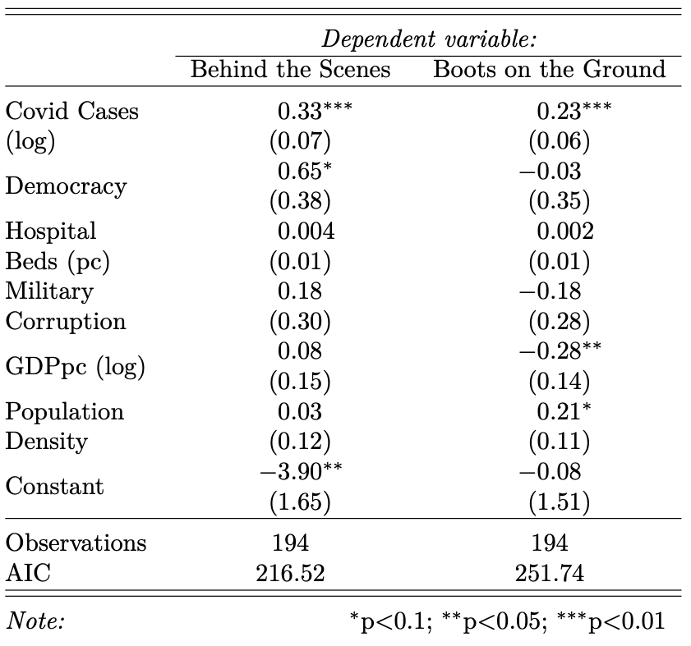
Table D. Covid Military Action, Countries with Scheduled Elections (Logistic Regression)
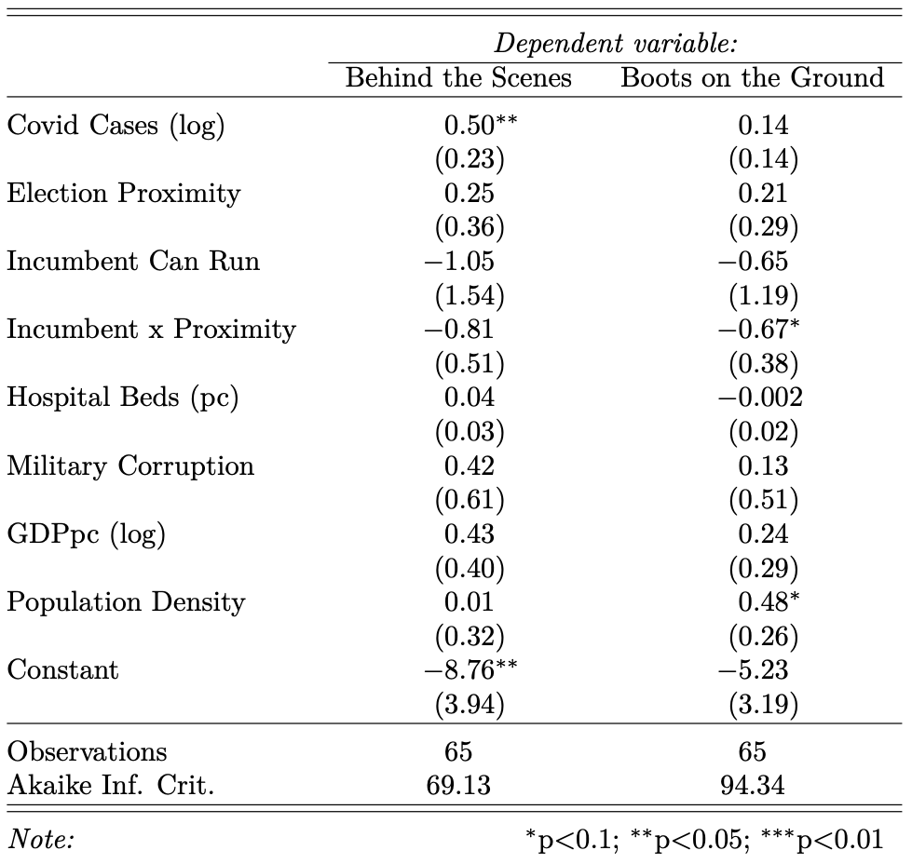

Appendix 3: Qualitative Appendix

In this Appendix, we perform a deep dive into some qualitative illustrations from some key cases. Our objective is to illustrate qualitatively how complex these dynamics are, and to acknowledge the existence of potentially consequential latent variables. Political culture and public support for the military are particularly significant to understand the complex relations between capacity, severity of the pandemic, and proximity to the elections. In the remainder of this Appendix, we illustrate how the variables we focus on—notably, severity of the pandemic, capacity and proximity to elections—are nested in complex dynamics, which vary across countries. Of particular significance are the political culture and military’s standing in society, which shapes dynamics, such as the willingness of the political leaders to ‘pull’ the military covid-related functions to increase their political capital for instance (Levy 2021; Bove, Rivera, and Ruffa 2020; Kuehn and Levy 2021).

For our illustrations, we focus on democracies that were the least likely cases to deploy the military: countries in which the military has had a controversial past, notably a military dictatorship (Germany, Italy, Japan and Spain). We find that in those countries, not only the military was deployed but also in a variety of forms, ranging from logistics to enforcement. This suggests that specific contextual factors broadly revolving around political culture influence the process and mechanisms that we observed. We also include two countries with a particular history, culture, and baseline level of civil-military relations: Israel and South Africa. Israel looks like an interesting outlier because even though the severity of the pandemic was never very high in the country, the military was deployed extensively (Levy 2021). South Africa is another interesting case because the military was deployed to a certain extent, notwithstanding its poor track-record of human rights violations, sadly confirmed also during the covid-19 pandemic (Esterhuyse 2019; Heinecken 2021). This is surprising given the controversial past of its military.

Germany used the military in logistical operations, international involvement, and border protection, but not enforcement, information provision, intelligence operations, or domestic protection. For instance, it was asked to build hospitals and distribute protective material. This activism is surprising because Germany severely restricts domestic deployments for historical reasons of totalitarianism and militarism (Friesendorf 2018; Duffield 1999; Longhurst 2004). Some of those restrictions were lifted in the early ´90s to participate in specific non-domestic operations, notably peacekeeping missions (Friesendorf 2018; King 2011). Those restrictions are particularly strong when it comes to domestic deployments; and yet the military was used, and used extensively, to respond to the pandemic in Germany. Allegedly, the use of the readily-available capacity and expertise of the Bundeswehr played an important role at a time in which it was perceived to be crucial to respond quickly.

Japan displays similar—if not stronger—limitations on the use of force as Germany (Berger,1993). As Ben-Ari writes, “Japan is still marked by a lingering antimilitarist ethos, suspicious about overseas deployment and legal restrictions on the use of the country’s Self-Defense Forces (SDF)” (Ben-Ari 2021: 37). Its totalitarian past deeply affected the kind of deployment that we observe in that case. During the pandemic, Japan deployed the military in domestic functions, specifically logistic and enforcement functions. This is in line with Ben-Ari’s argument that “the armed forces of Japan are more restricted and have more freedom than in the past” (ibidem, 53) and in general the public and the political culture allowed for both the use of SDF in a wide variety of missions and the allocation of more resources for the country’s overall militarization.

Similar to Germany and Japan, Italy is also a country with a totalitarian past and a profound collusion between the Fascist dictatorship and its military, which have traditionally made the public skeptical of the armed forces (Ruffa 2018; Coticchia 2014). Like in the other two countries, strong antimilitaristic and pacifist narratives persist together with restrictions against the use of force domestically. Yet, notwithstanding that situation, the military was extensively used during the pandemic, albeit mostly in support functions. Italian soldiers announced the lockdown, built a field hospital and dealt extensively with logistics and transportation.

Spain was a dictatorship under Franco until 1975 (Martinez and Jaime 2021). During the pandemic, Spain declared a state of emergency and made use of the military in logistical and border protection operations, notwithstanding the government’s reticence to use the military in domestic function. Spain deployed the military very extensively during the pandemic in logistic support, enforcement, international involvement, border protection, information provision, intelligence operations, and domestic protection. In domestic debates, the issue was framed widely as a direct and needed immediate response to the pandemic that hit the country very severely. This is somewhat surprising given the dictatorship's past and the restrictive measures regulating the use of the military in domestic contexts (Ibidem, 2021). Two observations are in order here. The first is that even countries that impose severe restrictions to the use of the military employed the military in domestic functions, which seem to be a growing general trend in Western democracies, including but not limited to the US, the Netherlands, the United Kingdom, Sweden, France, and Belgium among others (Kuehn and Levy 2021). Second, that the (real and perceived) severity of the pandemic seems to have enabled military deployment even in those countries with more severe restrictions against the use of force. Both Spain and Italy were deeply affected by the pandemic with Italy being hit first and Spain shortly thereafter. Notwithstanding those limitations, the severity pushed the military into roles that they had hitherto never performed before.

A specific aspect of political culture to be explored is the public support of the military. Israel is, for instance, an interesting case. Notwithstanding its mid-level severity, the military was deployed extensively. To illustrate, soldiers delivered food and hygiene kits to families, the Israeli Defence Force supported the police to implement restrictions and created an Epidemiological Investigation Task Force, to which over two thousand soldiers were enlisted (Levy 2021: 110). Levy suggests that because the military is popular its deployment could enhance securitization within a crisis (Levy 2021). He finds that securitization legitimized the deployment of the military and in turn, this deployment further legitimized securitization.

In South Africa, the military has a bad record of human rights violations during (and after) the Apartheid era, which, however, did not prevent the military from being mobilized during covid (Heinecken 2021). The military was amply used in support functions and the President “appeared on national television dressed in combat gear, symbolizing his role as Commander in Chief of the SANDF and explained to the public that this decision was taken to save lives and to defend South Africa against the invisible covid enemy. At the same time, however, the President also addressed them to warn them against the use of excessive force (Heinecken, 2022: 60). The South African military deployed 2820 service members across South Africa. The deployment served mainly as a force for good during the pandemic, leaving experts wondering whether they had been properly prepared and fit for purpose as soldiers were found guilty of a range of human rights abuses. “Those included shooting, baton and gun beatings, tear-gassing” among many others (Heinecken, 2022: 65). So the capacity of the healthcare system—which was perceived to be under strain—may have pushed the President of South Africa to pull the military into those domestic functions, even if he was fully aware of the cost. Ultimately, “While the military served in various roles to help and save lives, its involvement in law enforcement tasks, where it used excessive force, tarnishes its efforts as a force for good” (Heineken, 58; see also (Heinecken 2021). In this case, the need for popularity was possibly weighted against the unpopularity of the means taken to fight the virus, probably regardless of the healthcare infrastructure.

Taken together, as Table 1 summarizes, these examples suggest that even the least likely cases have deployed the military during covid, surpassing reticence and restriction against the use of force domestically. Context-specific factors—such as reputation and political culture—do matter and more work should be done to investigate their relations to severity of the pandemic threat, capacity of the health care system, and proximity to elections.

 | Political culture | Severity of the pandemic | Capacity of capacity of the healthcare system | Proximity to elections | Was the military  deployed during covid-19? | What kind of deployment?
Germany | Totalitarian past, limitations on the possibility to use the military domestically | Medium-Low | High |  | Yes | Very limited deployments (2)
Spain | Franco dictatorship, little support for domestic deployment | High | High |  | Yes | Boots on the ground (6)
Italy | Totalitarian past, limitations on the possibility to use the military domestically | High | High |  | Yes | Limited deployment (4)
Japan | Totalitarian past, limitations on the possibility to use the military domestically | Medium-low | High |  | Yes | Limited deployment (2)
South Africa | Heritage of human rights´abuse by the military during the apartheid |  | Medium- High | Yes |  | Quite extensive deployment (4) allegations of police and military brutality in enforcing quarantine
Israel | High popularity of the military |  | High |  |  | Extensive deployment (6)
Table 1: Summary of variation of the six illustrative cases under investigation.

Reference

Ben-Ari, Eyal. 2021. “Japan: ‘Normalizing’ the Japan Self-Defence Forces.” In Mobilizing Force, edited by David Kuehn and Yagil Levy. New York: Lynne Rienner Publisher.
Berger, Thomas. 1993 “From Sword to Chrysanthemum: Japan’s Military Culture of Anti-Militarism.” International Security 17 (4): 119–50.
Bove, Vincenzo, Mauricio Rivera, and Chiara Ruffa. 2020. “Beyond Coups: Terrorism and Military Involvement in Politics.” European Journal of International Relations 26 (1): 263–88. https://doi.org/10.1177/1354066119866499.
Coticchia, Fabrizio. 2014. La Guerra Che Non c’era. Opinione Pubblica e Interventi Militari Italiani Dall’Afghanistan Alla Libia. Milano: UBE Egea.
Duffield, John S. 1999. “Political Culture and State Behavior: Why Germany Confounds Neorealism.” International Organization 53 (04): 765–803. https://doi.org/10.1162/002081899551066.
Esterhuyse, Abel. 2019. “The Domestic Deployment of the Military in a Democratic South Africa: Time for a Debate.” African Security Review 28 (1): 3–18. https://doi.org/10.1080/10246029.2019.1650787.
Friesendorf, C. 2018. How Western Soldiers Fight: Organizational Routines in Multinational Missions. Cambridge University Press. https://books.google.se/books?id=EgpaDwAAQBAJ.
Heinecken, Lindy. 2021. “South Africa: From Militarization to Demilitarization Remilitarization.” In Mobilizing Force, edited by David Kuehn, 181–98. New York: Lynne Rienner Publisher.
———. 2022 “Combatting Covid-19: Roles and Challenges Associated with the Deployment of the South African Military.” IRSEM/EGMONT Report No. 91.
King, Anthony. 2011. The Transformation of European Armed Forces. Cambridge: Cambridge University Press.
Kuehn, David, and Yagil Levy. 2021. “Militarization: The Missing Link Between Threats and Civilian Control.” In Mobilizing Force. Linking Security Threats, Militarization and Civilian Control. New York: Lynne Rienner.
Levy, Yagil. 2021. “The People’s Army ‘Enemising’ the People: The COVID-19 Case of Israel.” European Journal of International Security, 1–20. https://doi.org/10.1017/eis.2021.33.
Longhurst, Kelly. 2004. Germany and the Use of Force. Manchester: Manchester University Press.
Martinez, Rafa, and Oscar Jaime. 2021. “Spain: A War without an Army.” In Mobilizing Force, edited by David Kuehn and Yagil Levy, 199–222. New York: Lynne Rienner Publisher.
Ruffa, Chiara. 2018. Military Cultures in Peace and Stability Operations. Philadelphia, PA: University of Pennsylvania Press.

https://www.dw.com/en/how-the-german-military-is-fighting-coronavirus/a-52931817
https://www.dw.com/en/coronavirus-the-german-armys-fight-on-the-homefront/a-56553467
https://theconversation.com/japans-capricious-response-to-coronavirus-could-dent-its-international-reputation-136737
https://lerubicon.org/publication/la-mobilisation-des-militaires-dans-la-crise-sanitaire/
https://www.aa.com.tr/en/europe/with-81-000-infections-in-14-days-spain-brings-in-army/1952981

