‘The perceived legitimacy of deliberative minipublics: Taking the perspective of polarised citizens’

Appendix A: Sample description
Table A1: Socio-demographic distributions of respondents (n = 932) and the Northern Ireland population
 |  | Sample (%) | Population (%)
Sex
 | Male | 47.4 | 48.3
 | Female | 52.4 | 51.7
 | Other | 0.2 | -
Age group
 | 18-34 years old | 30.5 | 30.4
 | 35-54 years old | 36.8 | 36.4
 | 55+ years old | 32.7 | 33.1
Educational level
 | No higher education | 60.1 | 63.3
 | Higher education | 38.4 | 36.7
 | Other | 1.5 | -
Community background
 | Catholic | 33.3 | 39.7
 | Protestant | 47.3 | 43.1
 | Other religion | 2.9 | 0.8
 | No religion | 14.9 | 9.9
 | Prefer not to say/not stated | 1.6 | 6.5
Ethno-national identity
 | Unionist | 35.7 | 32.8
 | Nationalist | 22.1 | 22.8
 | Neither | 42.3 | 39.4
Population data sources: Northern Ireland 2011 Census (for sex, age and religious/community background); Northern Ireland 2019 Labour Force Survey (for educational level among working age population); Northern Ireland Life and Times Survey 2019 (for ethno-national identity).

We fielded our survey with Survation, a major survey company based in the UK which is registered with the Market Research Society (MRS) and is a member of the British Polling Council (BPC). Fieldwork took place between 8 August and 12 September 2019, during which time there were no major political developments in the region. Participants were recruited by email from Survation’s online panel of over one million UK residents, with the incentive of earning points towards a cash reward (equalling approximately £0.50 per five minutes of survey participation time).

From our total sample of 1,018 participants, we are able to include 932 respondents in our main analysis. This analytical sample thus consists of respondents who have answered at least one of the dependent variables (general evaluation of the minipublic and/or outcome acceptance), one of the independent variables (ideological and/or affective polarisation) as well as the control variables.

Appendix B: Survey design

Figure B1: Infographic shown to survey respondents on the minipublic procedure
Note: In constructing the infographic, every effort was made to communicate as clearly and concisely as possible the key information that respondents were likely to need in order to make a basic evaluation, such as regarding the nature of the minipublic participants and the deliberative process.

The participants were not explicitly asked to provide a collective recommendation on whether Northern Ireland should stay in the UK or join a united Ireland. Instead, at the end of the deliberative process the participants were asked in a post-survey to indicate their level of support or opposition for each of the three constitutional options (see Figure 1 in main text). The status quo received the highest level of support, an integrated united Ireland received the next highest level of support – around the mid-point of the scale – and the option of a devolved united Ireland received the lowest level of support.

While the basic issue of Northern Ireland’s constitutional future is widely understood in broad terms, the precise nature of a united Ireland has not been explored in significant detail. Traditionally Irish unity has been understood as the effective integration of Northern Ireland into a unitary state. However, Northern Ireland could also continue to exist as a devolved region within a united Ireland, hence the rationale for the minipublic to deliberate on the relative merits and drawbacks of these different possibilities.

The purpose of this minipublic was to provide participants with relevant information about the possible options as well as the space to discuss them freely with one another in structured discussion. Yet, any change to Northern Ireland’s constitutional status can only take place with the support of a majority of voters in a referendum, as per the 1998 Belfast/Good Friday Agreement. The organisers deliberately avoided generating media attention prior to the event, noting that the minipublic was “not designed to predict exactly how a real world [referendum] campaign would unfold, but rather to show what happens in a reasoned deliberative setting” (Garry et al., 2020, p. 445).

Table B1: Dependent variables
Item | Question formulation
General evaluation of the minipublic | On a scale of 0-10 where 0 means not at all and 10 means completely, to what extent do you believe that this citizens’ assembly was… Just / Trustworthy / Inefficient / Transparent / A waste of money / Unnecessary [randomized order]  Answer options: 0 = Not at all; 10 = Completely; Don't know  ---> After reverse coding the negatively phrased items, we combined them into one ‘general evaluation’ variable by summing their scores and dividing this by the number of items. Cronbach’s alpha = 0.816.
Outcome acceptance | On a scale of 0-10, how willing are you to accept the outcome of the citizens’ assembly?  Answer options: 0 = Not at all willing; 10 = Completely willing; Don't know
Note: ‘Don’t know’ answers are coded as missing values.

Table B2: Independent variables
Item | Question formulation
Issue positions  [used for ideological polarisation] | On a scale of 1-7, where 1 means strongly opposed and 7 means strongly in favour, to what extent would you be opposed or in favour of the following options?  - An integrated united Ireland  - A devolved united Ireland  - Northern Ireland stays in the UK  Answer options: 1 = Strongly opposed; 7 = Strongly in favour; Don't know
Ethno-national identity [used for affective polarisation] | Generally speaking, do you usually think of yourself as a unionist, a nationalist, or neither? Answer options: Unionist; Nationalist; Neither unionist nor nationalist; Don’t know

Feeling thermometer [used for affective polarisation] | We’d like you to rate how you feel towards different groups in society on a scale of 0 to 100, which we call a ‘feeling thermometer’.  On this feeling thermometer, ratings between 0 and 49 degrees mean that you feel unfavourable and cold (with 0 being the most unfavourable/coldest). Ratings between 51 and 100 degrees mean that you feel favourable and warm (with 100 being the most favourable/warmest). A rating of 50 means that you have neutral feelings.  How would you rate your feelings towards each of the following groups in society?  - People from a unionist background  - People from a nationalist background  - People from neither a unionist nor a nationalist background  Slider from 0 = Most unfavourable/coldest; 100 = Most favourable/warmest; No default value
Note: ‘Don’t know’ answers are coded as missing values.

Table B3: Control variables
Item | Question formulation
Sex | What is your sex? 0 = Male; 1 = Female; 2 = Other
Age | What is your age? Recoded to 0 = 18-34 years old; 1 = 35-54 years old; 2 = 55+ years old
Education level | What is the highest level of education that you have completed? Recoded to  0 = No university education [GCSE/O-Level/CSE; Vocational qualification; A-Level or equivalent; No formal qualifications; Still studying];  1 = University education [Bachelor degree or equivalent; Masters/PhD or equivalent]; 2 = Other; Don’t know
Community background | What is your community background? 0 = Catholic; 1 = Protestant; 2 = Other religion; 3 = No religion; 4 = Prefer not to say
Satisfaction with democracy | On a scale of 0-10, where 0 means not at all satisfied and 10 means completely satisfied, to what extent are you satisfied with how democracy works in Northern Ireland? Answer options: 0 = Not at all satisfied; 10 = Completely satisfied; Don't know
Political interest | On a scale of 0-10, where 0 means not at all and 10 means very, how interested are you in politics? Answer options: 0 = Not at all interested; 10 = Very interested; Don't know
Note: ‘Don’t know’ answers are coded as missing values.

Table B4: Mediating variables
Item | Question formulation
Aversion to compromise | To what extent do you agree or disagree with the following statements? What people call compromise in politics is really just selling out on one's principles.  Answer options: 1 = Totally disagree; 5 = Totally agree; Don't know
Willingness to participate | Members of the citizens’ assembly were selected from the Northern Ireland population at random. If you had been selected, how likely is it that you would have accepted the invitation to participate in the citizens’ assembly?  Answer options: 1 = Not at all likely; 4 = Very likely; Don't know
Trust in other citizens | Here are some statements about the participation of citizens in politics in general. Can you indicate to what extent you agree or disagree with these statements? (Cronbach’s alpha = 0.841)  - I trust ordinary citizens to make good political decisions.  - I trust ordinary citizens to make political decisions that are in the public interest.  Answer options: 1 = Totally disagree; 5 = Totally agree; Don't know
Note: ‘Don’t know’ answers are coded as missing values.

Appendix C: Main analyses

Table C1: Means and standard deviation for the perceived legitimacy of the minipublic across different levels of polarised attitudes
 | General evaluation of minipublic |  |  |  | Outcome acceptance
 | N | Mean | 95% CI (lower) | 95% CI (higher) | N | Mean | 95% CI (lower) | 95% CI (higher)
Analytical sample | 776 | 6.005 | 5.858 | 6.151 | 894 | 5.821 | 5.627 | 6.015
Ideological polarisation
Low (0-1) | 159 | 6.108 | 5.844 | 6.372 | 169 | 6.000 | 5.639 | 6.361
Middle (2-4) | 205 | 6.269 | 6.007 | 6.531 | 235 | 6.136 | 5.820 | 6.453
High (5-6) | 393 | 5.798 | 5.570 | 6.025 | 462 | 5.528 | 5.222 | 5.834
Affective polarisation
Low (0-3.33) | 434 | 6.093 | 5.897 | 6.289 | 512 | 6.049 | 5.799 | 6.298
Middle (3.34-6.67) | 189 | 6.143 | 5.854 | 6.431 | 216 | 5.833 | 5.450 | 6.217
High (6.68-10) | 86 | 5.442 | 4.931 | 5.953 | 95 | 4.916 | 4.208 | 5.624
Note: Splits in subgroups are scale-based as indicated in the first column.
Table C2: OLS Regression of the perceived legitimacy of minipublics
 | General evaluation |  | Outcome acceptance
 | Model 1 | Model 2 | Model 3 | Model 4
Ideological polarisation | -0.097** |  | -0.134**
 | (0.036) |  | (0.049)
Affective polarisation |  | -0.047 |  | -0.108**
 |  | (0.028) |  | (0.037)
Satisfaction with democracy | 0.028 | 0.027 | 0.086* | 0.073
 | (0.029) | (0.031) | (0.040) | (0.041)
Political interest | 0.142*** | 0.134*** | 0.115** | 0.084*
 | (0.027) | (0.029) | (0.037) | (0.038)
Sex (ref = Male)
Female | -0.004 | 0.121 | 0.078 | 0.171
 | (0.157) | (0.164) | (0.213) | (0.218)
Other | 0.282 | 0.434 | -0.932 | -1.316
 | (2.052) | (2.087) | (2.097) | (2.099)
Age group (ref = 18-34 years old)
35-54 years old | 0.218 | 0.217 | -0.005 | -0.013
 | (0.181) | (0.192) | (0.246) | (0.254)
55+ years old | 0.200 | 0.143 | -0.222 | -0.274
 | (0.200) | (0.208) | (0.271) | (0.276)
Education level (ref = no university education)
University education | -0.160 | -0.200 | -0.272 | -0.297
 | (0.157) | (0.166) | (0.210) | (0.216)
Other | -0.799 | -1.055 | -1.201 | -1.672
 | (0.653) | (0.741) | (0.800) | (0.860)
Community background (ref = Catholic)
Protestant | -0.199 | -0.268 | 0.161 | -0.030
 | (0.177) | (0.176) | (0.240) | (0.233)
Other | -0.233 | 0.065 | 0.288 | 1.223
 | (0.449) | (0.538) | (0.631) | (0.716)
No religion | -0.488* | -0.420 | -0.339 | -0.135
 | (0.235) | (0.241) | (0.318) | (0.319)
Prefer not to say | -1.131 | -0.916 | -1.256 | -1.187
 | (0.629) | (0.862) | (0.906) | (0.952)
Constant | 5.529*** | 5.338*** | 5.536*** | 5.633***
 | (0.299) | (0.314) | (0.407) | (0.412)
R² | 0.065 | 0.055 | 0.035 | 0.036
Adj. R² | 0.048 | 0.037 | 0.020 | 0.021
N | 757 | 709 | 866 | 823
* p<0.05; ** p<0.01; *** p<0.001; Note: Unstandardised regression coefficients, standard errors between parentheses.

Appendix D: Exploratory analyses

For the purpose of the exploratory analyses, we normalised all variables to range from 0 to 1. This allows us to compare effect sizes of the different variables (which were initially measured on different scales).

Figure D1: Mediation analyses with ideological polarisation and general evaluations of the minipublic (using bootstrapped standard errors with 10,000 replications)
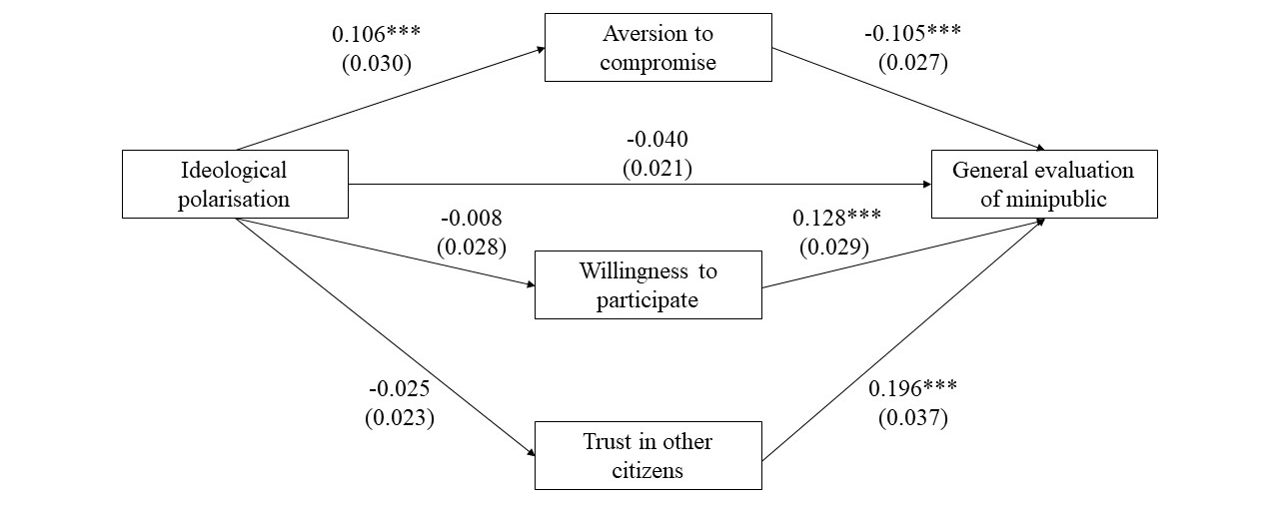
* p<0.05; ** p<0.01; *** p<0.001; Note: Unstandardized estimates and standard errors in parentheses. Mediation analyses using gsem with bootstrapped standard errors (10,000 replications). Models include controls for sex, age, education level, community background, political interest and satisfaction with democracy – which are not displayed for reasons of readability. Corresponding tables can be found in the replication materials and are available upon request.

Figure D2: Mediation analyses with affective polarisation and general evaluations of the minipublic (using bootstrapped standard errors with 10,000 replications)
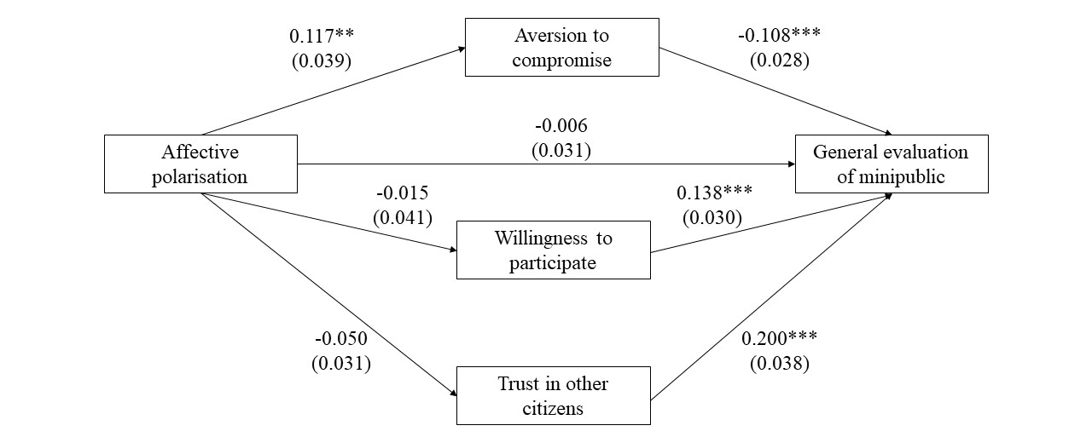
* p<0.05; ** p<0.01; *** p<0.001; Note: Unstandardized estimates and standard errors in parentheses. Mediation analyses using gsem with bootstrapped standard errors (10,000 replications). Models include controls for sex, age, education level, community background, political interest and satisfaction with democracy – which are not displayed for reasons of readability. Corresponding tables can be found in the replication materials and are available upon request.

Figure D3: Mediation analyses with ideological polarisation and outcome acceptance (using bootstrapped standard errors with 10,000 replications)
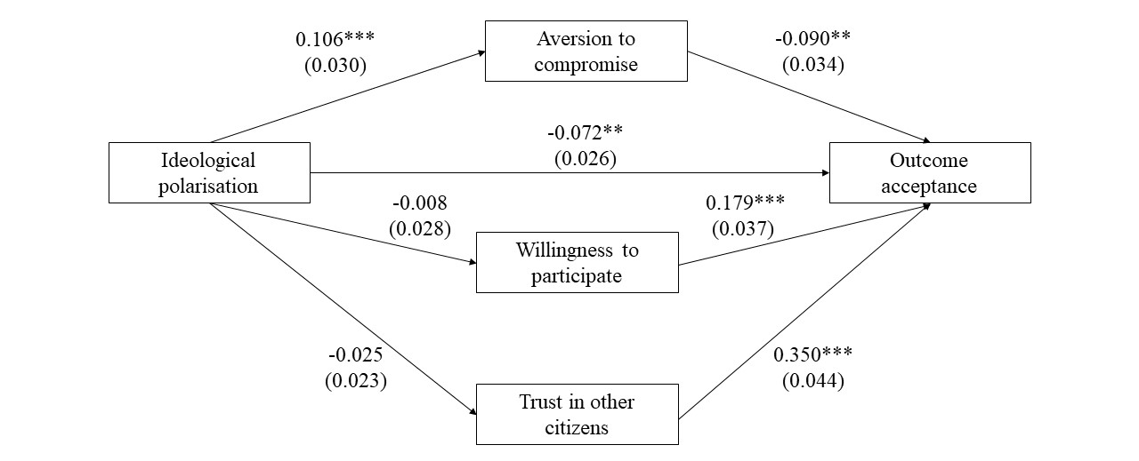
* p<0.05; ** p<0.01; *** p<0.001; Note: Unstandardized estimates and standard errors in parentheses. Mediation analyses using gsem with bootstrapped standard errors (10,000 replications). Models include controls for sex, age, education level, community background, political interest and satisfaction with democracy – which are not displayed for reasons of readability. Corresponding tables can be found in the replication materials and are available upon request.

Figure D4: Mediation analyses with affective polarisation and outcome acceptance (using bootstrapped standard errors with 10,000 replications)
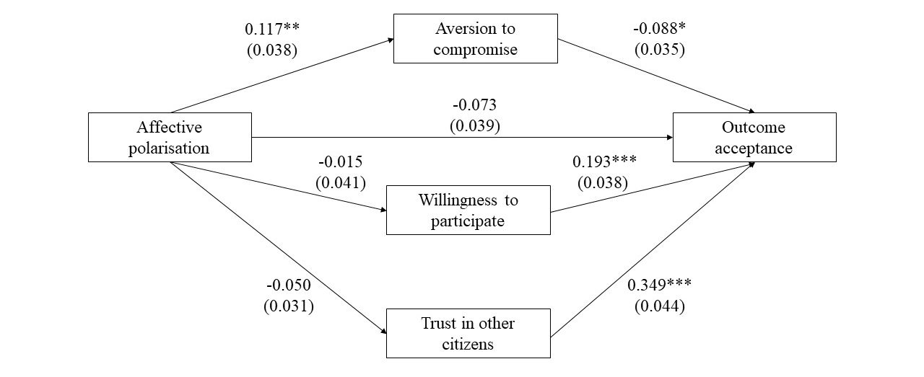
* p<0.05; ** p<0.01; *** p<0.001; Note: Unstandardized estimates and standard errors in parentheses. Mediation analyses using gsem with bootstrapped standard errors (10,000 replications). Models include controls for sex, age, education level, community background, political interest and satisfaction with democracy – which are not displayed for reasons of readability. Corresponding tables can be found in the replication materials and are available upon request.

Appendix E: Robustness checks

Another approach to measuring ideological polarisation is to look at respondents’ ideological extremity, either in absolute or relative terms (Abramowitz & Saunders, 2008; Luttig, 2018; Mason, 2015). To denote the extremity of respondents’ answers towards the constitutional options, we first recoded their issue positions on Northern-Ireland staying in the UK or joining a united integrated Ireland as follows: The midpoint (4) was assigned a value of 0, the values closest to that (3 and 5) a value of 1, and so on, so that the extreme ends (1 and 7) were given a value of 3. We then calculated their absolute extremity score by taking the sum of the two values. Relative extremity was assessed not by looking at respondents’ extremity in relation to the scale midpoint, but rather by their distance to the sample mean in terms of z-scores. These measurements of ideological extremity are used to assess the robustness of our findings.

In a first robustness check, we repeat our analysis using two alternative measures of ideological polarisation, namely absolute and relative ideological extremity. Here, it is important to clarify the differences between these and our measurement of ideological polarisation used in the main analysis (ideological constraint). We illustrate the difference between ideological constraint and absolute extremity below.

 | (a) Position on ‘Northern Ireland staying in the UK’ | (b) Position on ‘Northern Ireland joining an integrated Ireland’ | Ideological constraint  = absolute difference between (a) and (b) | Ideological extremity absolute  = summed extremity of opinions from midpoint
Respondent 1 | 5 | 1 | 4 | 4
Respondent 2 | 2 | 3 | 1 | 3
Respondent 3 | 2 | 7 | 5 | 5
Respondent 4 | 7 | 5 | 2 | 4
Respondent 5 | 7 | 1 | 6 | 6

As can be seen in this illustration with fictional respondents, the measurement of ideological constraint and ideological extremity (in absolute terms) is sometimes identical. This is the case when respondents’ issue positions on the two options on the constitutional future of Northern-Ireland fall on different sides of the midpoint (that is, for respondents 1, 3 and 5). When their issue positions, however, fall on the same side of the midpoint, the measurements for ideological constraint and extremity are different. This is because the extremity does not take into account whether one’s opinion is on one side or the other (e.g. both a totally agree and totally disagree are assigned an extremity score of 3).

For our relative score of ideological extremity, we look at how far respondents’ issue positions are away from the sample mean in standard deviations (z-scores).

The different measurements of ideological polarisation are highly correlated.
 | Ideological constraint | Ideological extremity (absolute) | Ideological extremity (standardised)
Ideological constraint | 1.000
Ideological extremity (absolute) | 0.873 | 1.000
Ideological extremity (standardised) | 0.483 | 0.568 | 1.000

Table E1: OLS Regression of the perceived legitimacy of minipublics using ideological extremity
 | General evaluation |  | Outcome acceptance
Ideological extremity (absolute) | -0.129** |  | -0.166**
 | (0.042) |  | (0.058)
Ideological extremity (standardised) |  | -0.277** |  | -0.336*
 |  | (0.097) |  | (0.130)
Satisfaction with democracy | 0.029 | 0.024 | 0.087* | 0.081*
 | (0.029) | (0.029) | (0.040) | (0.040)
Political interest | 0.141*** | 0.148*** | 0.113** | 0.121**
 | (0.027) | (0.028) | (0.037) | (0.037)
Sex (ref = Male)
Female | 0.021 | 0.034 | 0.103 | 0.112
 | (0.156) | (0.156) | (0.213) | (0.213)
Other | 0.106 | 0.417 | -1.033 | -0.885
 | (2.052) | (2.048) | (2.097) | (2.098)
Age group (ref = 18-34 years old)
35-54 years old | 0.227 | 0.213 | 0.002 | -0.029
 | (0.180) | (0.180) | (0.246) | (0.246)
55+ years old | 0.217 | 0.153 | -0.206 | -0.287
 | (0.200) | (0.199) | (0.271) | (0.270)
Education level (ref = no university education)
University education | -0.179 | -0.167 | -0.297 | -0.276
 | (0.157) | (0.157) | (0.211) | (0.210)
Other | -0.850 | -0.898 | -1.273 | -1.332
 | (0.652) | (0.652) | (0.799) | (0.801)
Community background (ref = Catholic)
Protestant | -0.175 | -0.453** | 0.182 | -0.167
 | (0.178) | (0.173) | (0.241) | (0.233)
Other | -0.206 | -0.311 | 0.326 | 0.210
 | (0.449) | (0.450) | (0.630) | (0.631)
No religion | -0.459 | -0.610* | -0.310 | -0.467
 | (0.236) | (0.237) | (0.318) | (0.320)
Prefer not to say | -1.037 | -1.172 | -1.147 | -1.303
 | (0.629) | (0.628) | (0.908) | (0.906)
Constant | 5.678*** | 5.756*** | 5.706*** | 5.771***
 | (0.314) | (0.332) | (0.429) | (0.453)
R² | 0.067 | 0.066 | 0.036 | 0.034
Adj. R² | 0.051 | 0.050 | 0.021 | 0.019
N | 757 | 757 | 866 | 866
* p<0.05; ** p<0.01; *** p<0.001; Note: Unstandardised regression coefficients, standard errors between parentheses.
In a second robustness check, we repeat our analysis using two further measures of affective polarisation. We re-run our analysis including all respondents, that is, also those who have negative score on the affective polarisation measurement. Furthermore, for those who identify as ‘neithers’ we take their average feeling towards unionists and nationalists as their out-group score (rather than their least-liked score). Here, we again leave out the negative values. This measurement of affective polarisation is highly correlated to the one used in our main analysis. For the ‘neithers’, the correlation is r = 0.970.

Table E2: OLS Regression of the perceived legitimacy of minipublics using alternative measurements of affective polarisation
 | General evaluation |  | Outcome acceptance
Affective polarisation (with negative values) | -0.041 |  | -0.088*
 | (0.026) |  | (0.035)
Affective polarisation (average for ‘neithers’) |  | -0.043 |  | -0.104**
 |  | (0.029) |  | (0.038)
Satisfaction with democracy | 0.032 | 0.030 | 0.071 | 0.072
 | (0.030) | (0.031) | (0.040) | (0.041)
Political interest | 0.129*** | 0.130*** | 0.107** | 0.085*
 | (0.028) | (0.029) | (0.037) | (0.038)
Sex (ref = Male)
Female | 0.107 | 0.123 | 0.164 | 0.196
 | (0.157) | (0.165) | (0.211) | (0.220)
Other | 0.467 | 0.460 | -1.074 | -1.251
 | (2.074) | (2.088) | (2.095) | (2.104)
Age group (ref = 18-34 years old)
35-54 years old | 0.240 | 0.242 | 0.060 | 0.012
 | (0.183) | (0.193) | (0.244) | (0.256)
55+ years old | 0.180 | 0.170 | -0.187 | -0.266
 | (0.199) | (0.209) | (0.267) | (0.278)
Education level (ref = no university education)
University education | -0.165 | -0.165 | -0.283 | -0.266
 | (0.159) | (0.168) | (0.209) | (0.218)
Other | -0.909 | -1.077 | -1.335 | -1.707*
 | (0.660) | (0.741) | (0.798) | (0.862)
Community background (ref = Catholic)
Protestant | -0.325 | -0.291 | -0.037 | -0.056
 | (0.169) | (0.177) | (0.225) | (0.234)
Other | -0.161 | 0.200 | 0.664 | 1.173
 | (0.483) | (0.554) | (0.653) | (0.717)
No religion | -0.456 | -0.441 | -0.123 | -0.163
 | (0.234) | (0.244) | (0.312) | (0.323)
Prefer not to say | -0.970 | -0.992 | -1.323 | -1.246
 | (0.793) | (0.862) | (0.906) | (0.955)
Constant | 5.338*** | 5.334*** | 5.352*** | 5.595***
 | (0.298) | (0.314) | (0.393) | (0.412)
R² | 0.052 | 0.054 | 0.032 | 0.035
Adj. R² | 0.036 | 0.036 | 0.017 | 0.020
N | 761 | 700 | 880 | 815
* p<0.05; ** p<0.01; *** p<0.001;
Note: Unstandardised regression coefficients, standard errors between parentheses.
Table E3: OLS Regression of the perceived legitimacy of minipublics among different subgroups of ideologically polarised respondents
 | Respondents preferring Northern Ireland to staying in the UK  (≥ an integrated Ireland) |  | Respondents preferring an integrated Ireland (≥ staying in the UK)
 | General evaluation | Outcome acceptance | General evaluation | Outcome acceptance
Ideological polarisation | -0.049 | -0.058 | -0.036 | -0.073
 | (0.046) | (0.062) | (0.054) | (0.070)
Satisfaction with democracy | 0.042 | 0.073 | -0.064 | 0.073
 | (0.034) | (0.047) | (0.048) | (0.063)
Political interest | 0.146*** | 0.085 | 0.110* | 0.168**
 | (0.033) | (0.045) | (0.044) | (0.054)
Sex (ref = Male)
Female | 0.188 | 0.514 | -0.246 | -0.851**
 | (0.195) | (0.267) | (0.231) | (0.300)
Other | 0.685 | -0.696 | 0.300 | -1.915
 | -2.091 | -2.150 | -1.919 | -2.648
Age group (ref = 18-34 years old)
35-54 years old | 0.196 | -0.169 | 0.036 | 0.091
 | (0.225) | (0.308) | (0.252) | (0.332)
55+ years old | 0.149 | -0.271 | 0.239 | -0.242
 | (0.245) | (0.339) | (0.301) | (0.389)
Education level (ref = no university education)
University education | -0.063 | -0.215 | -0.297 | -0.236
 | (0.197) | (0.263) | (0.224) | (0.292)
Other | 0.080 | 0.001 | -4.645*** | -5.417***
 | (0.743) | (0.927) | -1.365 | -1.543
Community background (ref = Catholic)
Protestant | -0.717** | -0.446 | 0.453 | 1.219**
 | (0.272) | (0.362) | (0.301) | (0.400)
Other | -0.524 | -0.226 | -0.182 | 0.265
 | (0.524) | (0.749) | (0.618) | (0.808)
No religion | -0.999** | -0.872* | -0.416 | -0.037
 | (0.324) | (0.436) | (0.312) | (0.396)
Prefer not to say | -1.813* | -1.718 | -0.737 | -1.035
 | (0.766) | -1.270 | (0.796) | -1.091
Constant | 5.585*** | 5.719*** | 5.812*** | 5.227***
 | (0.367) | (0.510) | (0.427) | (0.549)
R² | 0.080 | 0.033 | 0.112 | 0.149
Adj. R² | 0.056 | 0.011 | 0.072 | 0.115
N | 526 | 606 | 306 | 342
* p<0.05; ** p<0.01; *** p<0.001;
Note: Unstandardised regression coefficients, standard errors between parentheses.
Table E4: OLS Regression of the perceived legitimacy of minipublics among different subgroups of affectively polarised respondents
 | Unionists |  | Nationalists |  | Neithers
 | General evaluation | Outcome acceptance | General evaluation | Outcome acceptance | General evaluation | Outcome acceptance
Affective polarisation | -0.058 | -0.071 | -0.099* | -0.318*** | 0.032 | -0.020
 | (0.050) | (0.069) | (0.046) | (0.075) | (0.048) | (0.051)
Satisfaction with democracy | 0.024 | 0.091 | 0.025 | 0.129 | 0.046 | 0.062
 | (0.056) | (0.075) | (0.055) | (0.090) | (0.049) | (0.055)
Political interest | 0.074 | -0.025 | 0.114* | 0.128 | 0.185*** | 0.199***
 | (0.055) | (0.074) | (0.051) | (0.077) | (0.043) | (0.048)
Sex (ref = Male)
Female | 0.081 | 1.130* | -0.612* | -1.230** | 0.414 | -0.224
 | (0.321) | (0.446) | (0.265) | (0.419) | (0.256) | (0.285)
Other |  |  |  | 0.600 | 0.756 | -1.855
 |  |  |  | (3.053) | (2.135) | (2.490)
Age group (ref = 18-34 years old)
35-54 years old | 0.199 | -0.657 | 0.620 | -0.198 | -0.087 | 0.075
 | (0.385) | (0.542) | (0.315) | (0.496) | (0.290) | (0.318)
55+ years old | 0.024 | -0.617 | 0.204 | -0.255 | 0.258 | -0.211
 | (0.397) | (0.549) | (0.341) | (0.552) | (0.329) | (0.370)
Education level (ref = no university education)
University education | -0.088 | -0.408 | -0.437 | -0.327 | -0.262 | -0.420
 | (0.335) | (0.435) | (0.268) | (0.424) | (0.252) | (0.278)
Other | 0.786 | 1.070 |  | -7.664** | -2.225* | -2.492**
 | (1.327) | (1.955) |  | (2.748) | (0.966) | (0.893)
Community background (ref = Catholic)
Protestant | 0.000 | -3.028 | 0.520 | -1.986 | -0.037 | 0.723*
 | (.) | (2.419) | (0.925) | (1.377) | (0.298) | (0.330)
Other | -0.965 | -4.013 | -0.755 | 0.441 | 0.293 | 1.168
 | (1.638) | (3.377) | (0.942) | (1.614) | (0.675) | (0.722)
No religion | -0.510 | -3.317 | 0.134 | -1.019 | -0.560 | -0.027
 | (0.738) | -2.610 | (0.533) | (0.808) | (0.309) | (0.340)
Prefer not to say |  |  |  |  | -1.174 | -1.323
 |  |  |  |  | (0.894) | (0.822)
Constant | 5.293*** | 8.792*** | 5.686*** | 6.383*** | 4.943*** | 5.101***
 | (0.575) | (2.603) | (0.501) | (0.799) | (0.484) | (0.536)
R² | 0.024 | 0.066 | 0.177 | 0.210 | 0.124 | 0.125
Adj. R² | -0.018 | 0.029 | 0.121 | 0.154 | 0.086 | 0.091
N | 240 | 291 | 157 | 184 | 312 | 348
* p<0.05; ** p<0.01; *** p<0.001;
Note: Unstandardised regression coefficients, standard errors between parentheses.

Appendix F: Multiple imputation to deal with “don’t know” answers

As is common in the social sciences, our datasets contains respondents who have indicated “don’t know” to one or more of the items under study. This is particularly manifest in the creation of the general evaluation of the minipublic-index, which is comprised of six items; see Table F1). Overall, 69.7% of our respondents completed all items used in our main analyses (Table F2).

Multiple imputation methods replace missing values with a value obtained from the dataset for m times. The multiple imputed datasets which are analysed separately and the results are then pooled using Rubin’s rule (see van Buuren, 2018; White et al., 2011 for detailed explanations). We use multiple imputation by chained equations (MICE), because it does not assume normal distributions and, instead, allows each variable to be imputed using a separately specified method (see below). This allows to deal with categorical variables as well as with non-normality in continuous variable (Lee & Carlin, 2010; van Buuren, 2007, 2018).

We make use of the Stata Software Version 15 and, specifically, the mi impute chained command. Our imputation model includes all variables used in our main models, that is, our dependent, independent and control variables (Moons et al., 2006; see also Azur et al., 2011; van Buuren, 2018; White et al., 2011). For variables that constitute an index, we include the original variables that were used in the formation of the sum score (Azur et al., 2011; Plumpton et al., 2016; van Buuren, 2010). We additionally include: Socio-economic group, Satisfaction with policy, Internal efficacy, External efficacy and Vote choice (Azur et al., 2011; van Buuren, 2018; White et al., 2011). For the continuous variables, we use predictive mean matching (PMM) with the number of donors set to d = 5 (van Buuren, 2018; Vink et al., 2014; White et al., 2011) For our categorical variables, which are unordered, we use multinomial logistic regression and specify data augmentation as to circumvent the problem of perfect prediction (Plumpton et al., 2016; van Buuren, 2007, 2018; White et al., 2010, 2011). Overall, we do 20 iterations per imputed dataset and we create 25 multiply imputed datasets (m = 25; van Buuren, 2018). The convergence diagnostics as well as frequency tables and kernel distribution plots can be found in the replication materials (Azur et al., 2011; Stuart et al., 2009; van Buuren, 2018). We use a similar specification of our OLS regression models as in the main analysis. The results are reported in Table F3.

Azur, M. J., Stuart, E. A., Frangakis, C., & Philip, L. J. (2011). Multiple imputation by chained equations: what is it and how does it work? International Journal of Methods Is Psychiatric Research, 20(1), 40–49. https://doi.org/10.1002/mpr.329
Lee, K. J., & Carlin, J. B. (2010). Multiple imputation for missing data: Fully conditional specification versus multivariate normal imputation. American Journal of Epidemiology, 171(5), 624–632. https://doi.org/10.1093/aje/kwp425
Moons, K. G. M., Donders, R. A. R. T., Stijnen, T., & Harrell, F. E. (2006). Using the outcome for imputation of missing predictor values was preferred. Journal of Clinical Epidemiology, 59(10), 1092–1101. https://doi.org/10.1016/j.jclinepi.2006.01.009
Plumpton, C. O., Morris, T., Hughes, D. A., & White, I. R. (2016). Multiple imputation of multiple multi-item scales when a full imputation model is infeasible. BMC Res Notes, 9(45). https://doi.org/10.1186/s13104-016-1853-5
Stuart, E. A., Azur, M., Frangakis, C., & Leaf, P. (2009). Multiple Imputation With Large Data Sets: A Case Study of the Children’s MentalHealth Initiative. American Journal of Epidemiology, 169(9), 1133–1139. https://doi.org/10.1093/aje/kwp026
van Buuren, S. (2007). Multiple imputation of discrete and continuous data by fully conditional specification. Statistical Methods in Medical Research, 16(3), 219–242. https://doi.org/10.1177/0962280206074463
van Buuren, S. (2010). Item imputation without specifying scale structure. Methodology, 6(1), 31–36. https://doi.org/10.1027/1614-2241/a000004
van Buuren, S. (2018). Flexible Imputation of Missing Data (2nd Edition). CRC Press.
Vink, G., Frank, L. E., Pannekoek, J., & van Buuren, S. (2014). Predictive mean matching imputation of semicontinuous variables. Statistica Neerlandica, 68(1), 61–90. https://doi.org/10.1111/stan.12023
White, I. R., Daniel, R., & Royston, P. (2010). Avoiding bias due to perfect prediction in multiple imputation of incomplete categorical variables. Computational Statistics and Data Analysis, 54(10), 2267–2275. https://doi.org/10.1016/j.csda.2010.04.005
White, I. R., Royston, P., & Wood, A. M. (2011). Multiple imputation using chained equations: Issues and guidance for practice. Statistics in Medicine, 30(4), 377–399. https://doi.org/10.1002/sim.4067

Table F1: Missingness for each variable under study
Variable | Number of missings | Number of don’t know-responses | Total number of missings | Percent missing  (n = 1,018)
General evaluation |  |  | 235 | 23.08
Just | 1 | 133 | 134 | 13.16
Trustworthy | 1 | 104 | 105 | 10.31
Inefficient (rev) | 1 | 147 | 148 | 14.54
Transparent | 1 | 138 | 139 | 13.65
Waste of money (rev) | 1 | 70 | 71 | 6.97
Unnecessary (rev) | 1 | 72 | 73 | 7.17
Outcome acceptance | 1 | 111 | 112 | 11.0
Ideological polarisation |  |  | 62 | 6.09
Outcome: Stay in UK | 1 | 39 | 40 | 3.93
Outcome: Integrated Ireland | 1 | 45 | 46 | 4.52
Affective polarisation |  |  | 31 | 3.05
Ethno-national identity | 1 | 30 | 31 | 3.05
Feeling towards unionists | 1 | n/a | 1 | 0.10
Feeling towards nationalists | 1 | n/a | 1 | 0.10
Feelings towards neither | 1 | n/a | 1 | 0.10
Sex | 0 | n/a | 0 | 0
Age | 0 | n/a | 0 | 0
Education level | 1 | 2 | 3 | 0.29
Community background | 1 | n/a | 1 | 0.10
Satisfaction with democracy | 0 | 19 | 19 | 1.87
Political interest | 1 | 5 | 6 | 0.59
Socio-economic group (SEG) | 1 | n/a | 1 | 0.10
Satisfaction with policy | 0 | 24 | 24 | 2.36
Internal efficacy | 1 | 27 | 28 | 2.75
External efficacy | 0 | 30 | 30 | 2.95
Vote choice | 29 | n/a | 29 | 2.85

Table F2: Missingness in our observations
Number of missings | Frequency | Percent | Cumulative
0 | 710 | 69.74 | 69.74
1 | 199 | 19.55 | 89.29
2 | 77 | 7.56 | 96.86
3 | 19 | 1.87 | 98.72
4 | 8 | 0.79 | 99.51
5 | 4 | 0.39 | 99.90
7 | 1 | 0.10 | 100.0
Total | 1018 | 100.0
Note: This is based on the included variables in our main analysis – that is, general evaluation of the minipublic, outcome acceptance, ideological polarisation, affective polarisation, sex, age, education level, community background, satisfaction with democracy and political interest.
Table F3: Pooled results of OLS Regression of the perceived legitimacy of minipublics using multiply imputed datasets (m = 25)
 | General evaluation |  | Outcome acceptance
Ideological polarisation | -0.096** |  | -0.125**
 | (0.033) |  | (0.048)
Affective polarisation |  | -0.039 |  | -0.081*
 |  | (0.023) |  | (0.034)
Satisfaction with democracy | 0.031 | 0.030 | 0.078* | 0.072
 | (0.026) | (0.027) | (0.039) | (0.039)
Political interest | 0.105*** | 0.102*** | 0.096** | 0.092
 | (0.024) | (0.024) | (0.036) | (0.036)
Sex (ref = Male)
Female | 0.048 | 0.080 | 0.066 | 0.106
 | (0.143) | (0.143) | (0.211) | (0.211)
Other | 1.050 | 1.040 | -1.010 | -1.096
 | (1.518) | (1.525) | (2.089) | (2.092)
Age group (ref = 18-34 years old)
35-54 years old | 0.177 | 0.139 | 0.142 | 0.087
 | (0.163) | (0.163) | (0.234) | (0.234)
55+ years old | 0.068 | 0.013 | -0.150 | -0.225
 | (0.179) | (0.179) | (0.261) | (0.259)
Education level (ref = no university education)
University education | -0.204 | -0.217 | -0.257 | -0.286
 | (0.142) | (0.142) | (0.205) | (0.205)
Other | -0.753 | -0.792 | -1.208 | -1.260
 | (0.564) | (0.565) | (0.795) | (0.795)
Community background (ref = Catholic)
Protestant | -0.196 | -0.345* | 0.218 | -0.028
 | (0.161) | (0.154) | (0.230) | (0.219)
Other | -0.417 | -0.435 | 0.182 | 0.145
 | (0.391) | (0.392) | (0.582) | (0.580)
No religion | -0.390 | -0.416 | -0.235 | -0.264
 | (0.211) | (0.212) | (0.308) | (0.308)
Prefer not to say | -1.117* | -1.184* | -1.803* | -1.893*
 | (0.518) | (0.519) | (0.746) | (0.744)
Constant | 5.748*** | 5.578*** | 5.555*** | 5.429***
 | (0.270) | (0.261) | (0.400) | (0.388)
N | 1,018 | 1,018 | 1,018 | 1,018
* p<0.05; ** p<0.01; *** p<0.001; Note: Unstandardised regression coefficients, standard errors between parentheses.

More broadly, it is worth noting that Northern Ireland’s devolved power-sharing institutions collapsed in January 2017 due to intense disagreement between the main governing parties; they were not restored until January 2020. The survey took place in this context of a political vacuum at the regional level. By 2019, this was by no means a novel context from the perspective of the general public of Northern Ireland; it was also not without precedent: the devolved institutions had previously been dormant between 2002 and 2007. Indeed, political instability is often a feature of polarized societies..
Here we use our measurement of affective polarisation that does include negative values. These respondents did fill in the feeling thermometer, so we believe that it is not appropriate to consider them as missing values.
The main alternative of joint modelling (JM) is considered less appropriate for our purposes because our data contain non-normal distributions (see replication materials) and also include categorical variables (Lee & Carlin, 2010; van Buuren, 2018).
Vote choice was asked in two questions. First, respondents were asked how likely they would be to vote if there were elections tomorrow (0 = Would not vote; 10 = Certain to vote). Second, respondents were asked which political party they would vote for (except respondents having indicated ‘0’ on the first question. We combine these questions into one variable whereby we add a category ‘Would not vote’ to respondents’ self-indicated vote choice for those who indicated ‘0’ on the first question.

