Supplemental material

Annex A: Candidate weights to calculate weighted turnover.
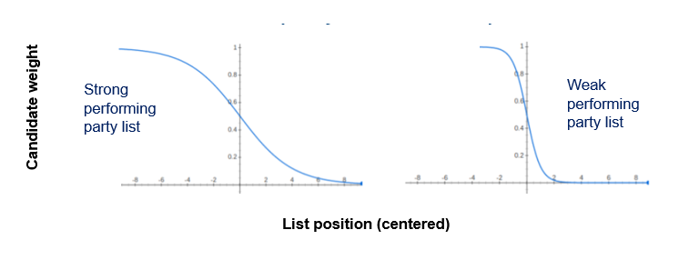
Note: The figure visualises the inverted S-shaped weights which were applied for each candidate (Sikk and Köker, 2015). Higher list positions, relative to the list magnitude, are deemed more important but the curve inclination depends on the candidate’s rank in comparison to the electoral results of the respective ballot list. When the relevant list is performing stronger, the curve becomes less steep and as a result more list positions are still considered relevant. Essentially we calculate weighted turnover whereby the weights are created by applying a sigmoid function
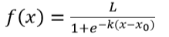
with x₀ being the sigmoid's mid-point, L the maximum value and K the steepness of the curve. In order to calculate weighted turnover the following modifications are required. In order to arrive at weights from 1 to 0, we subtract the equation from 1 with L set at 1 (since the values of the original logistic equation range from 0 to 1). Moreover, x₀ varies between parties, as a result of which the midpoint is always at the party's total vote share – e.g. at the 30 percent list position for a party which won 30 percent of the votes. In addition, the smoothness parameter K is set equal to 0.25 to generate a suitably inclined curve. As the smoothness parameter is negative, the curve decreases as K increases, therefore a slope coefficient of 1 would lead to an inverse S-shape which immediately falls back to 0. Given that it has been established that, even in non-ranked systems, higher list positions yield higher visibility (e.g. Söderlund et al., 2021), we applied these negative s-shaped functions to calculate weighted turnover in all country cases. Yet, we reran the analysis with .2 and .3 as respective alternative K-values. All substantial conclusions (direction of effects and significance levels) remained unaltered (Annex D.7). In other words, our results are robust against variation in how stringent top positions are identified and weighted accordingly.

To make the weights for a party in each district add up to 1, the weighted value for a candidate is to be divided by the sum of initial weights for all candidates on that list. Weighted candidate novelty is thus calculated as
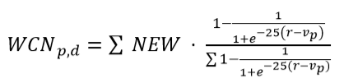 .

When it happens that two or more candidate lists from the same party are presented in the same district (Sweden), the S-shaped weight function have been applied to all lists separately. In a second step, one turnover measure has been calculated for each party-in-district-in-election combination.
Annex B: Operationalisation of independent variables.
Party variables | Operationalisation
Electoral swing | 1) swing at t-1: differentiating the respective party votes at t-1 and t-2  The typical way of operationalising electoral development. It is especially convenient to accommodate the demand dynamic. Indeed previous electoral success (or lack thereof) determines the number of ‘free’ spots on the list as well as the party’s decision to renew their image or not.  2) swing at t: differentiating the respective party votes at t and t-1  The electoral mood around a party can be measured more accurately by electoral swing at t, i.e. by comparing party votes at t vs. t-1. Candidate supply is indeed likely to be influenced by media coverage and information from polls in the run-up to the elections and this information can be approximated more correctly by a comparison of recent election results. For instance, during the 2019 campaign the Green parties were surfing on a positive wave due to the Youth for Climate movement. This positive vibe is more accurately captured by comparing the 2019 to the 2014 elections (which for example in Belgium results in a positive swing for the green party) rather than by comparing 2014 to 2010 (which results in a negative swing).  Both measures are group-mean centered at the election level since parties compare themselves with competitors within the same electoral context (André et al., 2017).
Party Members | The respective number of party members (Koskimaa et al., 2021).
Transformational party events | Dummy variables that indicate leadership change and name change. Based on ParlGov database.
Party candidacy requirements | Dummies that indicate (1) membership requirement and (2) the necessity to collect signatures from other party members as well as age and incompatibility with other mandates (i.e. other).  In addition (3) a continuous variable that specifies the number of months of required membership.  Based on the Political Party Database Working Group.
Covariates
Ideological position  (left/rights scales) | The ParlGov database (Döring et al., 2015) provides party positions in three major dimensions: left/right (i.e. general left-right), state/market (i.e. socio-economic left-right), liberty/authority (i.e. gal-tan). These positions are mean values of information from party expert surveys on a 0 to 10 scale. After we checked for multicollinearity, we excluded the general left-right dimension (VIF > 10).
Ideological position  (radical) | Dummy variable that distinguishes the most radical party to the left and right of the political spectrum in terms of ideological position, each time relative to the set of competing parties in the relevant election at hand.
Party Age | Party age (i.e. number of years since the party was founded) (Tavits, 2008).
Election variables | Operationalisation
Ballot type | Dummies with closed list-PR systems as reference category. Based on IDEA electoral system design database, Däubler and Hix (2018) and the European Parliament report (2009) on candidate selection.
legal gender quotas (LGQs) | Continuous variable that indicates the expressed share of women candidates on an electoral list.
Party system competitiveness | Level of electoral volatility, calculated as the Pedersen index (Powell and Tucker, 2014, 124):  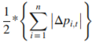  with with p_{i,t} being the vote share of party i at election _{t} and n being the total number of parties.
Party system competitiveness | The effective number of electoral parties (ENEP), calculated as (Schleiter and Voznaya, 2014):  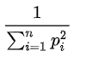  With n being the number of parties with at least one vote and p_{i}² the square of each party’s proportion of all votes. This measure accounts for the multiparty nature of electoral competition taking place in proportional systems.
Covariates
District Magnitude | Number of seats that are to be distributed in the respective district
Countrywide candidate requirements | Dummies to specify (ACE, 2021):  1) Prior registration requested or not;  2) Only national residents can run for a legislative mandate or not;  3) Other requirements in place or not (e.g. age).
Note: unless explicitly mentioned differently, continuous independent variables are standardised around their grand mean. Dummy variables are included in the model in their natural dichotomous metric.

Annex C: Descriptive analysis.
C.1 Univariate descriptive statistics.
 | mean | sd | median | Min | max | skew | kurtosis
General turnover | 0,6 | 0,2 | 0,6 | 0,1 | 1,0 | -0,1 | -0,2
Weighted turnover | 0,1 | 0,1 | 0,1 | 0,0 | 1,0 | 2,9 | 18,0
Swing at t | -0,5 | 6,0 | -0,1 | -39,1 | 30,3 | -0,7 | 4,2
Swing at t-1 | -0,6 | 5,9 | -0,4 | -39,1 | 28,9 | -0,5 | 3,7
Socio-eco L/R | 4,9 | 2,0 | 4,9 | 0,0 | 8,8 | -0,3 | -0,8
Gal/Tan | 4,7 | 2,3 | 3,6 | 0,0 | 9,8 | 0,4 | -1,0
PI_Extreme | 0,3 | 0,5 | 0,0 | 0,0 | 1,0 | 0,8 | -1,4
PartyInGov | 0,4 | 0,5 | 0,0 | 0,0 | 1,0 | 0,6 | -1,6
PartyMembers | 0,0 | 1,0 | -0,3 | 0,0 | 6,5 | 4,5 | 24,6
PartyAge | 60,9 | 4,4 | 46,0 | 0,0 | 149,0 | 0,5 | -1,1
LeaderChange | 0,4 | 0,5 | 0,0 | 0,0 | 1,0 | 0,6 | -1,6
Namechange | 0,0 | 0,2 | 0,0 | 0,0 | 1,0 | 5,3 | 26,6
PCR_member | 0,5 | 0,5 | 0,0 | 0,0 | 1,0 | 0,2 | -2,0
PCR_MonthsMember | 1,9 | 4,9 | 0,0 | 0,0 | 24,0 | 2,8 | 7,1
PCR_Other | 0,2 | 0,4 | 0,0 | 0,0 | 1,0 | 1,8 | 1,2
PVQ_share | 0,1 | 0,2 | 0,0 | 0,0 | 0,5 | 0,8 | -1,2
BallotType Flexible | 0,6 | 0,5 | 1,0 | 0,0 | 1,0 | -0,4 | -1,8
BallotType Open | 0,2 | 0,4 | 0,0 | 0,0 | 1,0 | 1,6 | 0,7
CCR_ Registration | 0,2 | 0,4 | 0,0 | 0,0 | 1,0 | 1,2 | -0,6
CCR_ Residence | 0,3 | 0,5 | 0,0 | 0,0 | 1,0 | 0,8 | -1,4
CCR_ Other | 0,6 | 0,5 | 1,0 | 0,0 | 1,0 | -0,3 | -1,9
ElecCycle | 0,0 | 1,0 | 0,2 | -3,5 | 1,3 | -2,3 | 5,6
LGQ_share | 0,1 | 0,2 | 0,0 | 0,0 | 0,5 | 1,2 | -0,5
LGQ_NotValidSanction | 0,2 | 0,4 | 0,0 | 0,0 | 1,0 | 1,5 | 0,1
ElVol | 0,0 | 1,0 | -0,2 | -1,8 | 4,7 | 1,1 | 1,9
ENEP | 0,0 | 1,0 | -0,1 | -1,8 | 7,2 | 2,1 | 9,4

C.2 Turnover rates per country.
Country | General turnover | Weighted turnover | N (lists)
Portugal | 84,4 | 4,9 | 188
Spain | 67,0 | 12,6 | 540
Norway | 65,1 | 9,0 | 590
Finland | 61,2 | 5,9 | 276
Netherlands | 61,1 | 6,4 | 409
Austria | 60,9 | 17,4 | 163
Denmark | 58,4 | 3,5 | 257
Luxembourg | 53,1 | 4,8 | 89
Sweden | 50,2 | 6,0 | 683
Belgium | 48,3 | 4,8 | 149
Total | 60,9 | 7,8 | 3344

C.3 Bivariate analysis, predictors country dashboard.
 | Party Members / 1000 | Leader Change | Ballot type | Elec Vol | LGQ share | Party Age | LegCycle Days
POR | 50,96 | 0,23 | 0 | 15,04 | 0,33 | 26,41 | 1478,49
SPN | 138,26 | 0,19 | 0 | 17,35 | 0,4 | 56,97 | 1057,87
NOR | 26,02 | 0,32 | 1 | 39,55 | 0 | 72,82 | 1460,86
FIN | 31,2 | 0,57 | 2 | 24,79 | 0 | 70,72 | 1496,91
NED | 28,24 | 0,39 | 1 | 40,81 | 0 | 41,5 | 1307,46
AUS | 75,94 | 0,41 | 1 | 24,74 | 0 | 49,82 | 1406,96
DEN | 23,2 | 0,37 | 2 | 31,4 | 0 | 76,49 | 1431,39
LUX | 26,08 | 0,71 | 2 | 16,97 | 0 | 45,09 | 1759,75
SWD | 37,78 | 0,3 | 1 | 18,81 | 0 | 73,66 | 1456,08
BEL | 37,1 | 0,69 | 1 | 28,39 | 0,5 | 42,93 | 1505,77
Notes: This table includes the independent variables and two covariates which were significant in the multivariate analysis (party age and the length of the legislative cycle in days). Scores are each time averaged over country. Ballot type is coded: 0= closed, 1= semi-open and 2= open. The colour coding is contingent on the observed effect direction for each variable, such that darker green is found to go along with higher turnover in the multivariate analysis.

Annex D: IGLS estimation and robustness checks (MCMC estimation for general and weighted turnover + list-pusher adapted weighted turnover).

D.1 Table summary of IGLS model (general turnover).
IGLS estimation | Model 0 |  | Model 1 |  | Model 2 |  | Model 3
 | Estimate | P-value | Estimate | P-value | Estimate | P-value | Estimate | P-value
Cons | 0,397*** | 0,000 | 0,276** | 0,009 | 0,272* | 0,031 | 2,038*** | 0,000
Swing (t) |  |  | 0,009*** | 0,000 | 0,010*** | 0,000 | 0,011*** | 0,000
Swing (t-1) |  |  | -0,002 | 0,466 | 0,000 | 0,974 | 0,000 | 0,977
ElectoralStrenght (% votes) |  |  | -0,009*** | 0,000 | -0,009*** | 0,000 | -0,009*** | 0,000
PartyMembers (# members) |  |  |  |  | 0,296*** | 0,000 | 0,274** | 0,001
LeaderChange |  |  |  |  | 0,138* | 0,014 | 0,153** | 0,009
Namechange |  |  |  |  | -0,011 | 0,950 | 0,018 | 0,925
PCR_Member |  |  |  |  | -0,142* | 0,034 | -0,124 | 0,080
PCR_MonthsMember |  |  |  |  | -0,007 | 0,294 | -0,006 | 0,359
PCR_Other |  |  |  |  | -0,006 | 0,951 | -0,012 | 0,909
PVQ_share |  |  |  |  | -0,030 | 0,862 | 0,002 | 0,990
PartyCovariates | included |  | included |  | included |  | included
Ballot type: Semi-open |  |  |  |  |  |  | -1,884*** | 0,000
Ballot type: Open |  |  |  |  |  |  | -1,759*** | 0,001
LGQ_share |  |  |  |  |  |  | -0,630 | 0,582
LGQ_NotValidSanction |  |  |  |  |  |  | -0,216 | 0,709
ElVol |  |  |  |  |  |  | 0,038* | 0,027
ENEP |  |  |  |  |  |  | 0,025 | 0,141
EU dummy | included |  | included |  | included |  | included
SystemicCovariates | included |  | included |  | included |  | included
Notes: Model 0 is the null model, model 1 also includes ballot list variables, model 2 incorporates party level variables as well, and model 3 is the full model with election level variables added. Notes: ElVol = electoral volatility; ENEP = effective number of electoral parties; LGQ = legislative gender quota; PVQ = party voluntary quota; PCR = party candidate requirements. Significance codes: 0 ‘***’ 0.001 ‘**’ 0.01 ‘*’ 0.05 ‘ ’ 1.
D.2 MCMC model with general turnover as dependent variable.
 | Model 3 (MCMC)
Response | General turnover
 | Estimate | Bayesian-P
Cons | 2,179 | 0,000
Swing (t) | 0,011*** | 0,000
Swing (t-1) | 0,000 | 0,488
ElectoralStrength (% votes) | -0,009*** | 0,000
PartyMembers (# members) | 0,307** | 0,002
LeaderChange | 0,168** | 0,002
Namechange | 0,042 | 0,430
PCR_Member | -0,123 | 0,053
PCR_MonthsMember | -0,008 | 0,118
PCR_Other | -0,039 | 0,359
PVQ_share | -0,007 | 0,505
PartyCovariates | included
Ballot type: Semi-open | -2,149*** | 0,000
Ballot type: Open | -1,864*** | 0,000
LGQ_share | -1,613 | 0,247
LGQ_NotValidSanction | 0,425 | 0,431
ElVol | 0,037* | 0,016
ENEP | 0,028 | 0,066
EU dummy | included
SystemicCovariates | included
Notes: ElVol = electoral volatility; ENEP = effective number of electoral parties; LGQ = legislative gender quota; PVQ = party voluntary quota; PCR = party candidate requirements. Significance codes: 0 ‘***’ 0.001 ‘**’ 0.01 ‘*’ 0.05 ‘ ’ 1.
The results of our main model 3 are overall robust to rerunning them within the Bayesian framework. If any, the Bayesian robustness check tends to be somewhat less conservative. If small differences occur we suggest, given our explorative research design (without informative priors) with relatively few higher-level units (implying that the lack of prior information actually plays an important role in the estimation of the posterior distribution), to focus primarily on interpreting RIGLS results. The Bayesian framework tends to be less strong as concerns coping with small sample sizes without informative priors. The running diagnostics for the Bayesian analyses can be consulted below. These confirm overall a good model estimation and decent fit.
D.3 Variance components trajectories (MCMC model: general turnover model 3)
Party level
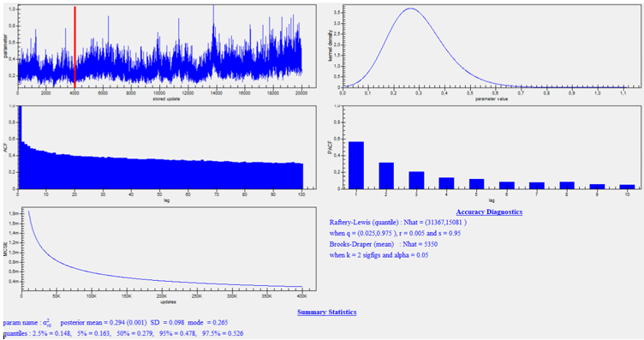
Election level
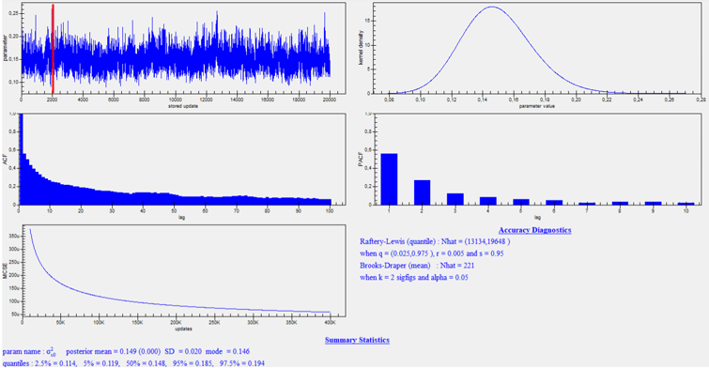

D.4 MCMC regression with weighted turnover as dependent variable.
MCMC estimation | Model 3 (MCMC)
Response | Weighted turnover
 | Estimate | Bayesian-p
Cons | -0,407 | 0,113
Swing (t) | -0,007* | 0,047
Swing (t-1) | -0,003 | 0,242
ElectoralStrength (% votes) | 0,047*** | 0,000
PartyMembers (# members) | 0,230* | 0,010
LeaderChange | -0,049 | 0,258
Namechange | -0,023 | 0,455
PCR_Member | -0,090 | 0,187
PCR_MonthsMember | -0,008 | 0,156
PCR_Other | -0,063 | 0,298
PVQ_share | 0,366 | 0,054
PartyCovariates | included
Ballot type: Semi-open | -2,045¨*** | 0,000
Ballot type: Open | -1,846*** | 0,000
LGQ_share | -2,108* | 0,046
LGQ_NotValidSanction | 0,899 | 0,109
ElVol | -0,012 | 0,331
ENEP | -0,012 | 0,354
EU dummy | included
SystemicCovariates | included
Notes: ElVol = electoral volatility; ENEP = effective number of electoral parties; LGQ = legislative gender quota; PVQ = party voluntary quota; PCR = party candidate requirements. Significance codes: 0 ‘***’ 0.001 ‘**’ 0.01 ‘*’ 0.05 ‘ ’ 1.
The results of our main model 3 are overall robust to rerunning them within the Bayesian framework. If any, the Bayesian robustness check tends to be somewhat less conservative. If small differences occur we suggest, given our explorative research design (without informative priors) with relatively few higher-level units (implying that the lack of prior information actually plays an important role in the estimation of the posterior distribution), to focus primarily on interpreting RIGLS results. The Bayesian framework tends to be less strong as concerns coping with small sample sizes without informative priors. The running diagnostics for the Bayesian analyses can be consulted below. These confirm overall a good model estimation and decent fit.
D.5 Variance components trajectories (MCMC model: weighted turnover model 3).
Party level
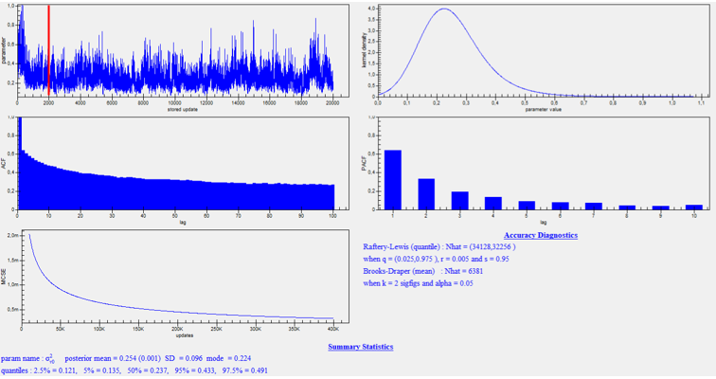
Election level
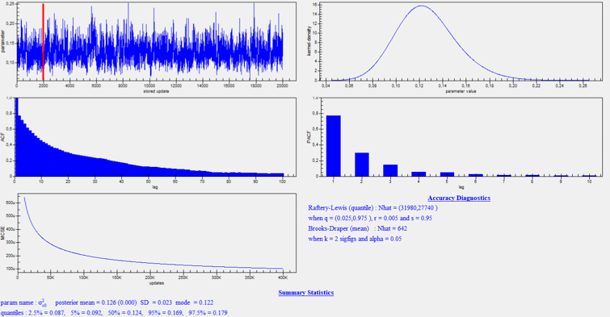

D.6 RIGLS regression with list pusher adapted weighted turnover as dependent variable.
RIGLS estimation | Model 3 (RIGLS)
Response | List pusher adapted weighted turnover
 | Estimate | P-value
Cons | -0,706 | 0,283
Swing (t) | -0,006 | 0,148
Swing (t-1) | -0,002 | 0,671
ElectoralStrength (% votes) | 0,045*** | 0,000
PartyMembers (# members) | -0,074 | 0,286
LeaderChange | 0,014 | 0,951
Namechange | 0,015 | 0,795
PCR_Member | -0,124 | 0,157
PCR_MonthsMember | -0,010 | 0,195
PCR_Other | -0,133 | 0,247
PVQ_share | 0,274 | 0,197
PartyCovariates | included
Ballot type: Semi-open | -1,667* | 0,011
Ballot type: Open | -1,500* | 0,029
LGQ_share | -2,927* | 0,020
LGQ_NotValidSanction | 1,328* | 0,037
ElVol | -0,016 | 0,559
ENEP | -0,006 | 0,830
EU dummy | included
SystemicCovariates | included
Notes: ElVol = electoral volatility; ENEP = effective number of electoral parties; LGQ = legislative gender quota; PVQ = party voluntary quota; PCR = party candidate requirements. Significance codes: 0 ‘***’ 0.001 ‘**’ 0.01 ‘*’ 0.05 ‘ ’ 1.

Table 4d: Main RIGLS models for weighted turnover with alternative smoothness parameter values as dependent variable.
RIGLS estimation | Model 3 (RIGLS) |  | Model 3 (RIGLS)
Response | Weighted (smoothness K = 0,20) |  | Weighted (smoothness K = 0,30)
 | Estimate | P-value | Estimate | P-value
Cons | -0,734 | 0,265 | -0,718 | 0,271
Swing (t) | -0,006 | 0,162 | -0,006 | 0,168
Swing (t-1) | -0,002 | 0,682 | -0,002 | 0,688
ElectoralStrength (% votes) | 0,047*** | 0,000 | 0,043*** | 0,000
PartySize (# members) | 0,232* | 0,014 | 0,208* | 0,016
LeaderChange | -0,082 | 0,251 | -0,068 | 0,302
Namechange | 0,008 | 0,918 | 0,008 | 0,990
PCR_Member | -0,133 | 0,149 | -0,111 | 0,178
PCR_MonthsMember | -0,011 | 0,174 | -0,009 | 0,212
PCR_Other | -0,129 | 0,260 | -0,127 | 0,264
PVQ_share | 0,293 | 0,183 | 0,255 | 0,209
PartyCovariates | included |  | included
Ballot type: Semi-open | -1,693* | 0,012 | -1,621* | 0,012
Ballot type: Open | -1,572* | 0,028 | -1,410* | 0,032
LGQ_share | -2,981* | 0,020 | -2,861* | 0,020
LGQ_NotValidSanction | 1,346* | 0,036 | 1,330* | 0,036
ElVol | -0,018 | 0,492 | -0,016 | 0,581
ENEP | -0,006 | 0,760 | -0,006 | 0,893
EU dummy | included |  | included
SystemicCovariates | included |  | included
Notes: ElVol = electoral volatility; ENEP = effective number of electoral parties; LGQ = legislative gender quota; PVQ = party voluntary quota; PCR = party candidate requirements. Significance codes: 0 ‘***’ 0.001 ‘**’ 0.01 ‘*’ 0.05 ‘ ’ 1.

Annex E: Variance partitioning based on full RIGLS models, weighted turnover.
Random part | Model 0  (Empty model) | Model 1  (+ list variables) | Model 2  (+ list & party variables) | Model 3  (+ list, party & election variables)
Election level variance | 0,002*** | 0,002*** | 0,002*** | 0,001***
Party level variance | 0,002*** | 0,001*** | 0,001*** | 0,001***
List level variance | 0,002*** | 0,001*** | 0,001*** | 0,001***
Notes: Variance components are tested via one-sided tests as negative values are excluded from the parameter space: significance codes: 0 ‘***’ 0.001 ‘**’ 0.01 ‘*’ 0.05 ‘.’ 0.1 ‘ ’ 1. We made use of the standard logistic link function for estimating beta parameters, but the variance component results above are reweighted to undo the model-implied constant first-level variance.

