Research Note
Political Parties, Issue Salience and the Appointment of Female Cabinet Members
Online Appendix

A1 Overview of states, time periods, and cabinets included in the analysis
Appendix A1 provides an overview of the time periods and cabinets included in the dataset. For each state, the period of investigation starts with the first government newly elected in or after 2006.
State | Period | Cabinets
Baden-Württemberg | 2010 - 2021 | Mappus; Kretschmann I; Kretschmann II
Bavaria | 2008 - 2018 | Seehofer I; Seehofer II; Söder I
Berlin | 2006 - 2021 | Wowereit III; Müller I; Müller II
Brandenburg | 2009 - 2019 | Platzeck III; Woidke I; Woidke II
Bremen | 2007 - 2019 | Böhrnsen II; Böhrnsen III; Sieling
Hamburg | 2010 - 2020 | Ahlhaus; Scholz I; Scholz II; Tschentscher I
Hesse | 2010 - 2021 | Bouffier I; Bouffier II; Bouffier III
Lower-Saxony | 2010 - 2021 | McAllister; Weil I; Weil II
Mecklenburg-West Pomerania | 2008 - 2021 | Sellering I; Sellering II; Sellering III; Schwesig I
North Rhine-Westphalia | 2010 - 2021 | Kraft I; Kraft II; Laschet
Rhineland-Palatinate | 2006 - 2021 | Beck IV; Beck V; Dreyer I; Dreyer II
Saarland | 2009 - 2021 | Müller III; Kramp-Karrenbauer I; Kramp-Karrenbauer II; Kramp-Karrenbauer III; Hans
Saxony | 2009 - 2019 | Tillich II; Tillich III; Kretschmer I
Saxony-Anhalt | 2006 - 2021 | Böhmer II; Haseloff I; Haseloff II
Schleswig-Holstein | 2009 - 2021 | Carstensen II; Albig; Günther I
Thuringia | 2009 - 2020 | Lieberknecht; Ramelow I
Notes: In Germany, sub-national governments are commonly referred to by the name of the respective Prime Minister (e.g. “Kretschmann I” for the first cabinet headed by Prime Minister Winfried Kretschmann in Baden-Württemberg).
A2 Average proportion of female ministers in the German states, 2006-2021
Figure A2 gives an overview of the average share of women in the German state cabinets between 2006 and 2021. The figure demonstrates that women were considerably under-represented in the executives of the German federal states. Across all states, only 39 percent of the ministries were headed by a female minister. The states with the highest representation of women in the government include Rhineland-Palatinate, Berlin, and Bremen. The cabinets with the lowest shares of female ministers include the governments in Saxony and Saxony-Anhalt.
Figure A2: Average proportion of female ministers in the German states, 2006-2021.
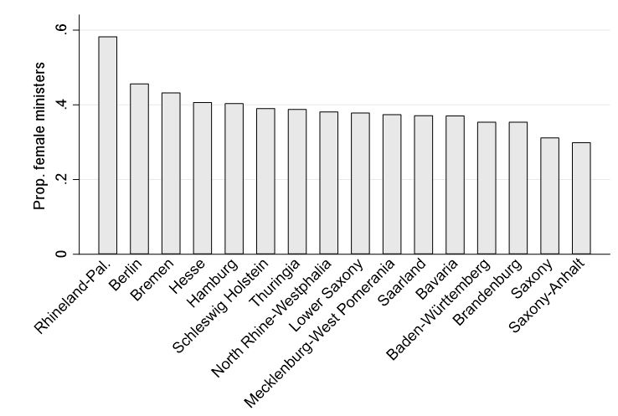

A3 Proportion of female ministers in the German states by ministries, 2006-2021
Figure A3 shows the share of women in the different ministries across the German state cabinets between 2006 and 2021. Since the composition of portfolios in the German states varies considerably, ministries were categorized into 11 broader policy fields (see Raabe and Linhart 2014). The highest shares of female ministers can be found in the ministries of Science and Research, Social Affairs (including the portfolios for women’s affairs, senior citizens, youth and children, family, and care) as well as Labor. Only very few women can be found among the ministers responsible for Finance, Economy, and the Interior.
Figure A3: Proportion of female ministers in the German states by ministries, 2006-2021.
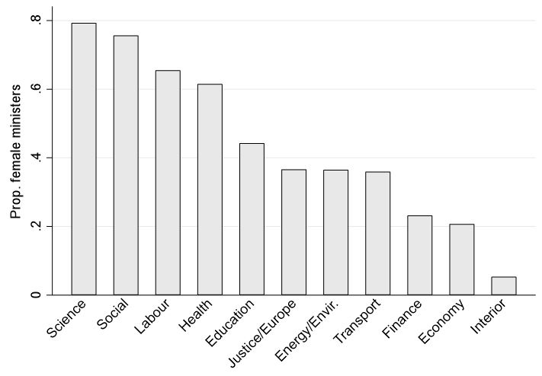

A4 Issue salience in the German states, 2006-2021
Figure A4 gives an overview of the issue salience that government parties on average attach to different portfolios. Since the composition of portfolios in the German states varies considerably, ministries were categorized into 11 broader policy fields (see Raabe and Linhart 2014). The most salient portfolio is social policy, including the portfolios for women’s affairs, senior citizens, youth and children, family, and care. On average, governing parties relate 24% of their manifestos to issues falling into this jurisdiction. Labour (23%) and Education (22%) are the second and third most salient portfolios. For governing parties in the German states, Justice and Finance are the least salient portfolios. Presumably, this can be explained by the limited legislative competence of the states in these policy areas.
Figure A4: Issue salience in the German states, 2006-2021.
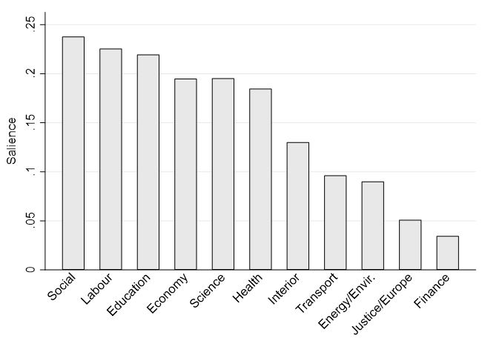

A5 Robustness Test – Correlation between salience and feminine portfolios
To further underpin the robustness of the main findings, I test whether the positive effect of salience might be driven by a correlation between salience and stereotypically feminine ministries. In fact, as can be seen in Figure A4 in the Appendix, government parties on the German sub-national level particularly emphasize social welfare policies in their manifestos. Since these portfolios are also often considered to be stereotypically feminine, this might be the main reason why women enjoy greater access to highly salient ministries on the sub-national level. Therefore, I re-run the main models of the analysis and exclude all ministries responsible for social and labor policies. The results in Table A5 demonstrate that the findings remain unchanged. Salience still has a significant and substantially important positive effect on the appointment of a female minister.

Table A5: Robustness Test - Salience and feminine portfolios
Variables | Model 1 | Model 2 | Model 3 | Model 4
Salience | 4.99**  (1.72) | 5.23**  (1.70) | 4.97**  (1.72) | 5.21**  (1.70)
Prestige of ministry | -0.01  (0.01) | -0.01  (0.01) | -0.01  (0.01) | -0.01  (0.01)
Feminine ministry | -0.11  (0.40) | 0.01  (0.40) | -0.11  (0.40) | 0.02  (0.40)
Party ideology | -0.08  (0.07) | -0.15  (0.16) | -0.08  (0.07) | -0.16  (0.16)
Female Prime Minister | 0.10  (0.20) | -0.13  (0.43) | 0.09  (0.21) | -0.13  (0.44)
Female party leader | -0.28  (0.17) | -0.12  (0.44) | -0.27  (0.18) | -0.07  (0.45)
Female MPs (share in PPG) | 1.76  (1.21) | 1.53  (2.35) | 1.78  (1.27) | 1.68  (2.43)
East Germany | -0.09  (0.15) |  | -0.11  (0.20)
Seats in parliament |  |  | -0.53  (1.00) | -1.34  (2.57)
No. ministries |  |  | 0.01  (0.05) | 0.07  (0.14)
Party fixed effects
Year (linear time trend)
State fixed effects
Constant | -76.51  (48.28) | -91.33  (80.12) | -71.90  (49.36) | -73.43  (86.38)
N | 381 | 381 | 381 | 381
Log-Pseudolikelihood | -226.25 | -221.82 | -226.22 | -221.67
Pseudo R² | 0.07 | 0.09 | 0.07 | 0.09
Notes: Logit regression. Dependent variable: Dummy variable coded 1 if a portfolio is headed by a woman. Excluding ministries for Social Affairs and Labour. Standard errors (in parentheses) are clustered by governments. * p<.10; ** p<.05; *** p<.001.

Literature
Raabe, Johannes and Eric Linhart. 2014. “Disentangling the Value of a Ministry: Party Leaders’ Evaluations of German State Ministries.” West European Politics 37(5): 1065-1086.

