online Supplementary material

Time is on my side?
The temporal proximity between elections and parties’ salience strategies

Table of Content

Figure S1: Average EU issue emphasis by Cycle position across all parties and elections in the sample 2
Figure S2: Distribution of dependent variable EU issue emphasis 3
Table S1: Elections and countries 4
Table S2: Descriptive statistics 9
Table S3: The example of the Swedish Social Democratic Labour Party 9
Table S4: Robustness check (excluding three outliers) 10
Table S5: Robustness check (excluding parties without EU issue emphasis) 11
Table S6: Robustness check (non-linear effect of Cycle position) 12
Table S7: Robustness check (using absolute difference in days between national parliamentary elections and the closest EP elections) 13
References 14

Figure S1: Average EU issue emphasis by Cycle position across all parties and elections in the sample
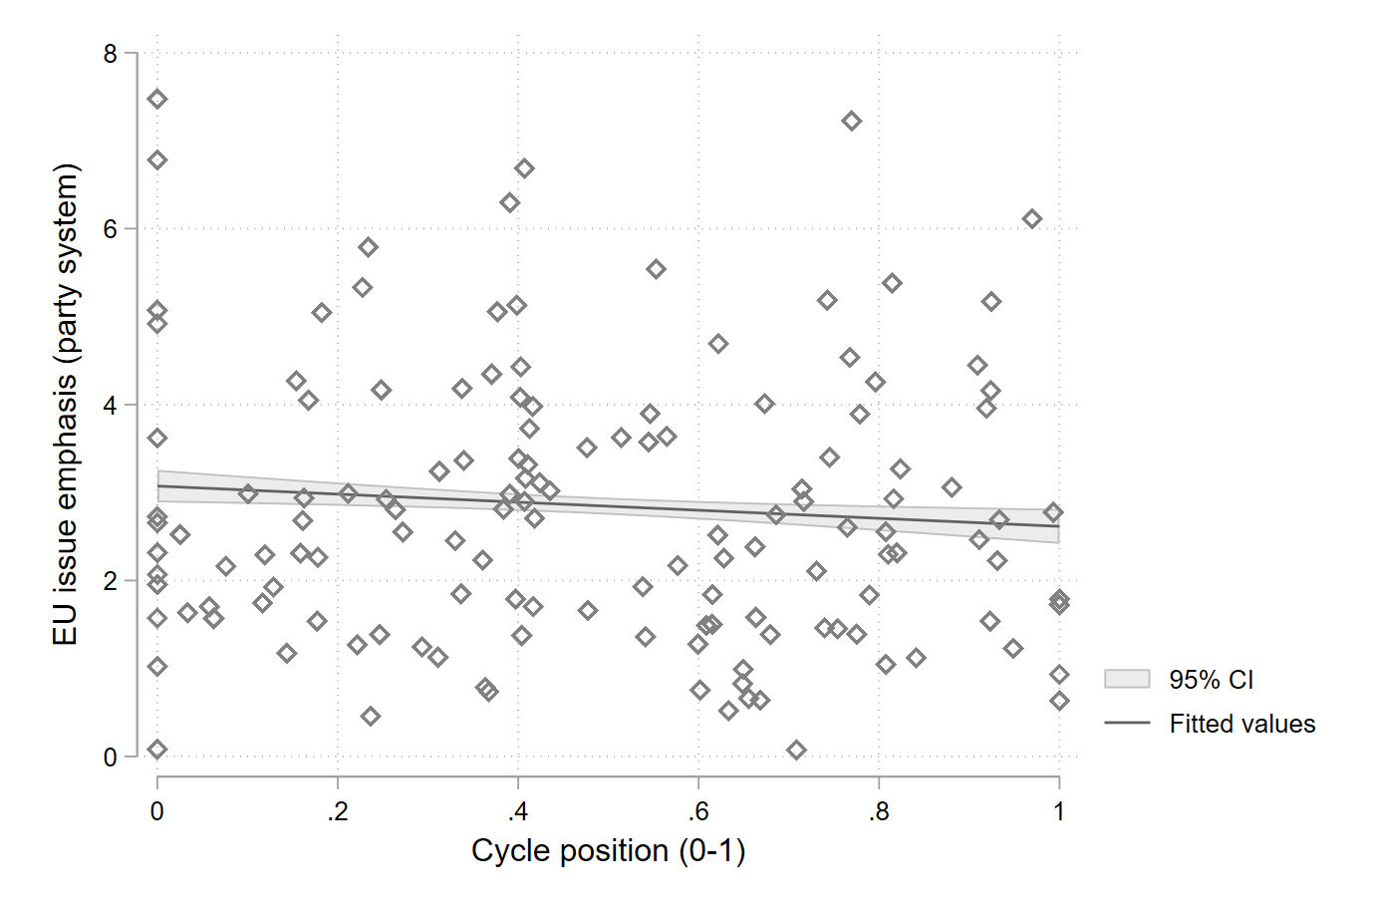
Notes: Line represents fitted values of 95 per cent confidence intervals; each dot indicates the average EU issue emphasis in national party manifestos at a given cycle position in a country (that is, the party system saliency of EU issue emphasis).

Figure S2: Distribution of dependent variable EU issue emphasis
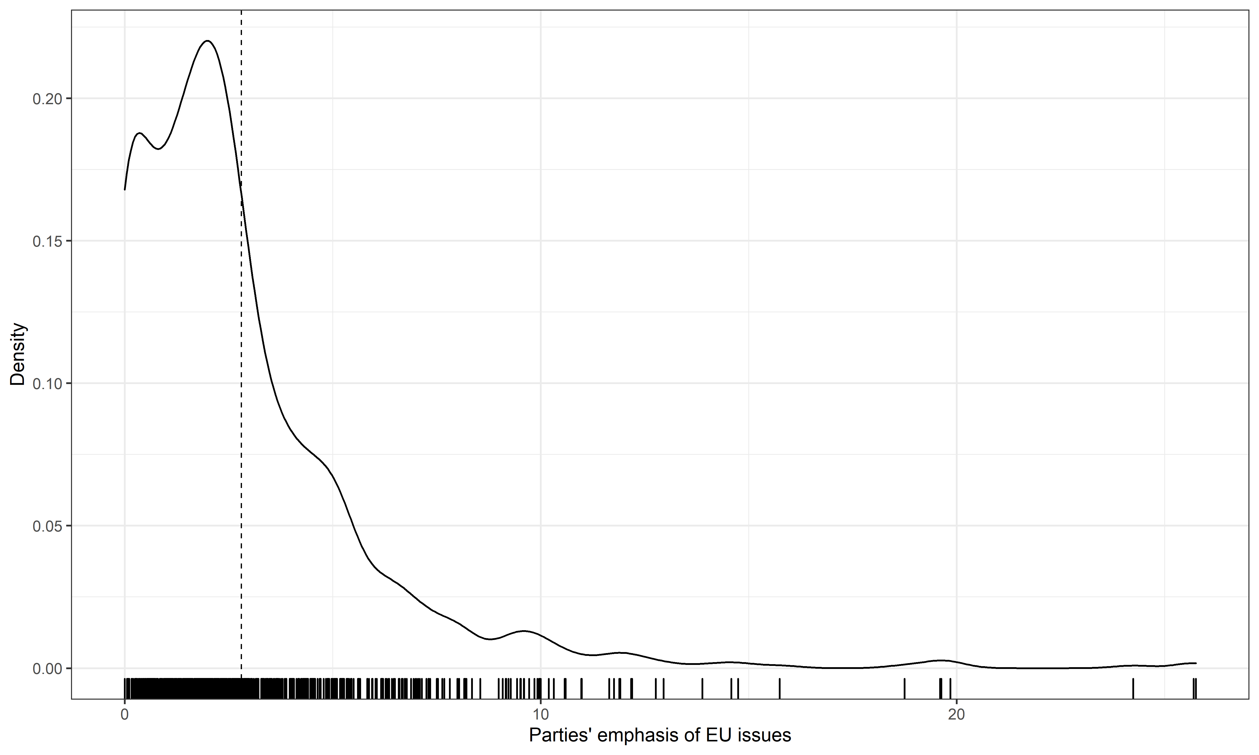
Notes: The figure plots national parties’ emphasis of EU issues in their national election manifestos (in percent). Mean value (indicated by the vertical dotted line) of national parties’ emphasis of EU issues is 2.81.

Table S1: Elections and countries
Country | Election date to the national parliament_{t} | Election date to the next European parliament | Election date to the national parliament_{t+1} | Eurosceptic party in national election_{t}
Austria | 24.11.2002 | 13.06.2004 | 01.10.2006 | Austrian Freedom Party
 | 28.09.2008 | 06.07.2009 | 29.09.2012 | Austrian Freedom Party; Alliance for the Future of Austria
 | 29.09.2013 | 25.05.2014 | 15.10.2017 | Austrian Freedom Party; Team Stronach for Austria
 | 15.10.2017 | 26.05.2019 | 29.09.2019 | Austrian Freedom Party
Belgium | 08.11.1981 | 17.06.1984 | 13.10.1985 | Flemish Bloc
 | 13.12.1987 | 18.06.1989 | 24.11.1991 | Flemish Bloc
 | 24.11.1991 | 12.16.1994 | 21.05.1995 | Flemish Bloc
 | 21.05.1995 | 13.06.1999 | 13.06.1999 | Flemish Bloc
 | 13.06.1999 | 13.06.1999 | 18.05.2003 | Flemish Bloc
 | 18.05.2003 | 13.06.2004 | 10.06.2007 | Flemish Bloc
 | 10.06.2007 | 07.06.2009 | 13.06.2010 | Flemish Interest
 | 13.06.2010 | 25.05.2014 | 25.05.2014 | Flemish Interest
 | 25.05.2014 | 25.05.2014 | 26.05.2019 | Workers’ Party of Belgium; Flemish Interest
Bulgaria | 12.05.2013 | 25.05.2014 | 05.10.2014 | National Union Attack
 | 26.03.2017 | 26.05.2019 | 04.04.2021 | United Patriots; Will
Croatia | 11.09.2016 | 26.05.2019 | 05.07.2020 | —
Cyprus | 21.05.2006 | 06.06.2009 | 22.05.2011 | Progressive Party of the Working People
 | 22.05.2011 | 25.05.2014 | 22.05.2016 | Progressive Party of the Working People
 | 22.05.2016 | 26.05.2019 | 30.05.2021 | Progressive Party of the Working People; National Popular Front
Czech Republic | 03.06.2006 | 05.06.2009 | 29.05.2010 | Communist Party of Bohemia and Moravia
 | 26.10.2013 | 23.05.2014 | 21.10.2017 | Communist Party of Bohemia and Moravia; Tomio Okamura’s Dawn of Direct Democracy
 | 21.10.2017 | 24.05.2019 | 09.10.2021 | Communist Party of Bohemia and Moravia; Freedom and Direct Democracy
Denmark | 10.01.1984 | 14.06.1984 | 08.09.1987 | Progress Party
 | 10.05.1988 | 15.06.1989 | 12.12.1990 | Progress Party
 | 12.12.1990 | 09.06.1994 | 21.09.1994 | Progress Party
 | 11.03.1998 | 10.06.1999 | 20.11.2001 | Red-Green Unity List; Danish People’s Party; Progress Party
 | 20.11.2001 | 13.06.2004 | 08.02.2005 | Red-Green Unity List; Danish People’s Party
 | 13.11.2007 | 07.06.2009 | 15.09.2011 | Red-Green Unity List; Danish People’s Party
 | 15.09.2011 | 25.05.2014 | 18.06.2015 | Red-Green Unity List; Danish People’s Party
 | 18.06.2015 | 26.05.2019 | 05.06.2019 | Red-Green Unity List; Danish People’s Party
Estonia | 04.03.2007 | 07.06.2009 | 06.03.2011 | Estonia People’s Union
 | 06.03.2011 | 25.05.2014 | 01.03.2015 | —
Finland | 19.03.1995 | 20.10.1996 | 21.03.1999 | Finnish Rural Party
 | 21.03.1999 | 13.06.1999 | 16.03.2003 | True Finns
 | 16.03.2003 | 13.06.2004 | 18.03.2007 | True Finns
 | 18.03.2007 | 07.06.2009 | 17.04.2011 | True Finns
 | 17.04.2011 | 25.05.2014 | 19.04.2015 | True Finns
France | 14.06.1981 | 17.06.1984 | 16.03.1986 | French Communist Party; Union for French Democracy
 | 05.06.1988 | 10.06.1989 | 21.03.1993 | French Communist Party; National Front
 | 21.03.1993 | 12.06.1994 | 25.05.1997 | French Communist Party
 | 25.05.1997 | 13.06.1999 | 09.06.2002 | French Communist Party; National Front
 | 09.06.2002 | 13.06.2004 | 10.06.2007 | French Communist Party
 | 10.06.2007 | 07.06.2009 | 10.06.2012 | French Communist Party
 | 10.06.2012 | 25.05.2014 | 11.06.2017 | Left Front; National Front
 | 11.06.2017 | 26.05.2019 | 12.06.2022 | French Communist Party; Indomitable France; National Front
Germany | 06.03.1983 | 17.06.1984 | 25.01.1987 | —
 | 25.01.1987 | 18.06.1989 | 02.12.1990 | —
 | 02.12.1990 | 12.06.1994 | 16.10.1994 | Party of Democratic Socialism
 | 27.09.1998 | 13.06.1999 | 22.09.2002 | Party of Democratic Socialism
 | 22.09.2002 | 13.06.2004 | 18.09.2005 | Party of Democratic Socialism
 | 18.09.2005 | 07.06.2009 | 27.09.2009 | The Left, Party of Democratic Socialism
 | 22.09.2013 | 25.05.2014 | 24.09.2017 | The Left
 | 24.09.2017 | 26.05.2019 | 26.09.2021 | The Left; Alternative for Germany
Greece | 18.10.1981 | 18.10.1981 | 02.06.1985 | Communist Party of Greece
 | 02.06.1985 | 18.06.1989 | 18.06.1989 | Communist Party of Greece
 | 18.06.1989 | 18.06.1989 | 05.11.1989 | Progressive Left Coalition
 | 10.10.1993 | 12.06.1994 | 22.09.1996 | Communist Party of Greece
 | 22.09.1996 | 13.06.1999 | 09.04.2000 | Communist Party of Greece; Progressive Left Coalition; Democratic Social Movement
 | 07.03.2004 | 13.06.2004 | 16.09.2007 | Coalition of the Radical Left; Communist Party of Greece
 | 16.09.2007 | 07.06.2009 | 04.10.2009 | Coalition of the Radical Left; Communist Party of Greece; Popular Orthodox Rally
 | 17.06.2012 | 25.05.2014 | 25.01.2015 | Communist Party of Greece; Coalition of the Radical Left – Unionist Social Front; Golden Dawn; Independent Greeks
 | 20.09.2015 | 26.05.2019 | 07.07.2019 | Communist Party of Greece; Coalition of the Radical Left
Hungary | 09.04.2006 | 07.06.2009 | 11.04.2010 | —
 | 06.04.2014 | 25.05.2014 | 08.04.2018 | Alliance of Federation of Young Democrats – Hungarian Civic Union – Christian Democratic People’s Party
Ireland | 24.11.982 | 14.06.1984 | 17.02.1987 | Workers’ Party
 | 17.02.1987 | 15.06.1989 | 15.06.1989 | Workers’ Party
 | 15.06.1989 | 15.06.1989 | 25.11.1992 | Workers’ Party
 | 25.11.1992 | 10.06.1994 | 06.06.1997 | —
 | 06.06.1997 | 11.06.1999 | 17.05.2002 | We Ourselves
 | 17.05.2002 | 11.06.2004 | 24.05.2007 | We Ourselves
 | 24.05.2007 | 05.06.2009 | 25.02.2011 | We Ourselves
 | 25.02.2011 | 25.05.2014 | 26.02.2016 | United Left Alliance; We Ourselves
 | 26.02.2016 | 24.05.2019 | 08.02.2020 | People Before Profit Alliance; We Ourselves
Italy | 26.06.1983 | 17.06.1984 | 14.06.1987 | Italian Communist Party
 | 14.06.1987 | 18.06.1989 | 06.04.1992 | Italian Communist Party
 | 28.03.1994 | 12.06.1994 | 21.04.1996 | Communist Refoundation Party; Northern League
 | 21.04.1996 | 13.06.1999 | 13.05.2001 | Communist Refoundation Party; Northern League
 | 13.05.2001 | 12.06.2004 | 10.04.2006 | Communist Refoundation Party; Party of Italian Communists; Northern League
 | 13.04.2008 | 07.06.2009 | 24.02.2013 | Northern League
 | 24.02.2013 | 25.05.2014 | 04.03.2018 | Brothers of Italy – National Centre-right; Northern League; Five Star Movement
 | 04.03.2018 | 26.05.2019 | 01.06.2023 | Brothers of Italy; League; Five Star Movement
Latvia | 07.10.2006 | 06.06.2009 | 02.10.2010 | —
 | 17.09.2011 | 24.05.2014 | 04.10.2014 | —
 | 06.10.2018 | 25.05.2019 | 01.10.2022 | Who owns the state?
Lithuania | 12.10.2008 | 07.06.2009 | 14.10.2012 | Order and Justice
 | 14.10.2012 | 25.05.2014 | 09.10.2016 | Order and Justice
 | 09.10.2016 | 26.05.2019 | 11.10.2020 | Order and Justice
Luxembourg | 10.06.1979 | 10.06.1979 | 17.06.1984 | Communist Party of Luxembourg
 | 17.06.1984 | 17.06.1984 | 18.06.1989 | Communist Party of Luxembourg
 | 18.06.1989 | 18.06.1989 | 12.06.1994 | Communist Party of Luxembourg; Action Committee for Democracy and Pension Justice
 | 12.06.1994 | 12.06.1994 | 13.06.1999 | Action Committee for Democracy and Pension Justice
 | 13.06.1999 | 13.06.1999 | 13.06.2004 | Action Committee for Democracy and Pension Justice
 | 13.06.2004 | 13.06.2004 | 07.06.2009 | Action Committee for Democracy and Pension Justice
 | 07.06.2009 | 07.06.2009 | 20.10.2013 | The Left; Alternative Democratic Reform Party
 | 20.10.2013 | 25.05.2014 | 14.10.2018 | The Left; Alternative Democratic Reform Party
Netherlands | 08.09.1982 | 14.06.1984 | 21.05.1986 | Reformed Political League; Reformed Political Party
 | 21.05.1986 | 15.06.1989 | 06.09.1989 | Reformed Political Party
 | 03.05.1994 | 09.06.1994 | 06.05.1998 | Socialist Party; Reformed Political League; Centre Democrats; Reformed Political Party
 | 06.05.1998 | 10.06.1999 | 15.05.2002 | Socialist Party; Reformed Political League; Reformed Political Party
 | 22.01.2003 | 10.06.2004 | 22.11.2006 | Socialist Party; List Pim Fortuyn
 | 22.11.2006 | 04.06.2009 | 09.06.2010 | Socialist Party; Party of Freedom; Party for the Animals; Reformed Political Party
 | 12.09.2012 | 25.05.2014 | 15.03.2017 | Socialist Party; Party of Freedom; Party for the Animals; Reformed Political Party; 50Plus
 | 15.03.2017 | 23.05.2019 | 17.03.2021 | Socialist Party; Party of Freedom; Forum for Democracy; Party for the Animals; Reformed Political Party; 50Plus
Poland | 21.10.2007 | 07.06.2009 | 09.10.2011 | Law and Justice
 | 09.10.2011 | 25.05.2014 | 25.10.2015 | Law and Justice
Portugal | 19.07.1987 | 19.07.1987 | 06.10.1991 | Portuguese Communist Party
 | 06.10.1991 | 12.06.1994 | 01.10.1995 | Unified Democratic Coalition
 | 01.10.1995 | 13.06.1999 | 10.10.1999 | Unified Democratic Coalition
 | 17.03.2002 | 13.06.2004 | 20.02.2005 | Left Bloc; Portuguese Communist Party
 | 20.02.2005 | 07.06.2009 | 27.09.2009 | Left Bloc; Portuguese Communist Party
 | 05.06.2011 | 25.05.2014 | 04.10.2015 | Left Bloc; Portuguese Communist Party
 | 04.10.2015 | 26.05.2019 | 06.10.2019 | Left Bloc; Portuguese Communist Party
Romania | 30.11.2008 | 07.06.2009 | 09.12.2012 | —
 | 09.12.2012 | 25.05.2014 | 11.12.2016 | —
 | 11.12.2016 | 26.05.2019 | 06.12.2020 | —
Slovakia | 17.06.2006 | 06.06.2009 | 12.06.2010 | Slovak National Party
 | 10.03.2012 | 24.05.2014 | 05.03.2016 | Freedom and Solidarity
 | 05.03.2016 | 25.05.2019 | 29.02.2020 | Freedom and Solidarity; Slovak National Party; Kotleba – People’s Party Our Slovakia; We Are Family
Slovenia | 21.09.2008 | 07.06.2009 | 04.12.2011 | Slovenian National Party
 | 04.12.2011 | 25.05.2014 | 13.07.2014 | —
Spain | 22.06.1986 | 10.07.1987 | 29.10.1989 | United Left
 | 06.06.1993 | 12.06.1994 | 03.03.1996 | United Left
 | 03.03.1996 | 13.06.1999 | 12.03.2000 | United Left; Galician Nationalist Bloc
 | 14.03.2004 | 13.06.2004 | 09.03.2008 | United Left; Galician Nationalist Bloc
 | 09.03.2008 | 07.06.2009 | 20.11.2011 | United Left; Galician Nationalist Bloc
 | 20.11.2011 | 25.05.2014 | 20.12.2015 | United Left; Galician Nationalist Bloc
Sweden | 21.09.1998 | 13.06.1999 | 15.09.2002 | Left Party
 | 15.09.2002 | 13.06.2004 | 17.09.2006 | Left Party
 | 17.09.2006 | 07.06.2009 | 19.09.2010 | Left Party
 | 19.09.2010 | 25.05.2014 | 14.09.2014 | Left Party; Sweden Democrats
 | 19.09.2018 | 26.05.2019 | 11.09.2022 | Left Party: Sweden Democrats
United Kingdom | 09.06.1983 | 14.06.1984 | 11.06.1987 | Labour Party; Conservative Party
 | 11.06.1987 | 15.06.1989 | 09.04.1992 | Conservative Party
 | 09.04.1992 | 06.09.1994 | 01.05.1997 | Conservative Party; Democratic Unionist Party
 | 01.05.1997 | 10.06.1999 | 07.06.2001 | We Ourselves; Conservative Party; Democratic Unionist Party
 | 07.06.2001 | 10.06.2004 | 05.05.2005 | We Ourselves; Conservative Party; Democratic Unionist Party
 | 05.05.2005 | 04.06.2009 | 06.05.2010 | Conservative Party
 | 06.05.2010 | 25.05.2014 | 07.05.2015 | Conservative Party
 | 08.06.2017 | 23.05.2019 | 12.12.2019 | We Ourselves; Conservative Party; Democratic Unionist Party
Notes: National elections are dropped when no EP election took place between two national elections. National election dates and names of Eurosceptic parties are taken from Manifesto Project Dataset (version 2019b) (Volkens et al., 2019). EP election dates have been collected by the authors. Concurrent elections at the beginning or at the end of the national electoral cycle are highlighted in bold.

Table S2: Descriptive statistics
Variables | N | Min. | Max. | Average | SD
EU issue emphasis | 956 | 0 | 25.75 | 2.81 | 3.01
EU issue emphasis (log) | 956 | -2.85 | 3.25 | 0.72 | 0.87
Cycle position | 956 | 0 | 1 | 0.48 | 0.29
Eurosceptic party | 956 | 0 | 1 | 0.22 | 0.41
Government party | 956 | 0 | 1 | 0.25 | 0.44
CEE party | 956 | 0 | 1 | 0.16 | 0.37
Southern European party | 956 | 0 | 1 | 0.25 | 0.43
Concurrent elections | 956 | 0 | 1 | 0.11 | 0.31
Pre-Maastricht | 956 | 0 | 1 | 0.23 | 0.42
Euro crisis | 956 | 0 | 1 | 0.32 | 0.47
Left-right position | 956 | -74.3 | 60 | -4.41 | 19.10
EU issue emphasis_{t-1} | 621 | 0 | 25.70 | 2.91 | 3.07

Table S3: The example of the Swedish Social Democratic Labour Party
Date of national election | In government? | Cycle position | EU issue emphasis
21.09.1998 | Yes | 0.18 | 4.69
15.09.2002 | Yes | 0.44 | 1.10
17.09.2006 | Yes | 0.68 | 1.02
19.09.2010 | No | 0.92 | 0.00
09.09.2018 | Yes | 0.18 | 2.58

Table S4: Robustness check (excluding three outliers)
 | Model 1 | Model 2 | Model 3
Hypothesis 1:
Cycle position | -0.2314* | -0.3929** | -0.3718**
 | (0.1131) | (0.1242) | (0.1391)
Hypothesis 2:
Eurosceptic party |  | -0.2948* | -0.1887
 |  | (0.1364) | (0.1627)
Cycle position X Eurosceptic party |  | 0.7531** | 0.5627*
 |  | (0.2457) | (0.2778)
Control variables:
Government party |  |  | 0.0493
 |  |  | (0.0774)
CEE party |  |  | -0.3342⁺
 |  |  | (0.1829)
Southern European party |  |  | -0.0875
 |  |  | (0.1672)
Concurrent elections |  |  | -0.2702*
 |  |  | (0.1324)
Pre-Maastricht |  |  | -0.0428
 |  |  | (0.0933)
Euro crisis |  |  | 0.0018
 |  |  | (0.0854)
Left-right position |  |  | 0.0015
 |  |  | (0.0019)
EU issue emphasis_{t-1} |  |  | 0.0688***
 |  |  | (0.0111)
Constant | 0.7002*** | 0.7675*** | 0.7641***
 | (0.0841) | (0.0873) | (0.1304)
Random effects:
Party manifesto level | 0.7736 | 0.7646 | 0.6351
 | (0.0446) | (0.0440) | (0.0441)
Country level | 0.0729 | 0.0667 | 0.0675)
 | (0.0322) | (0.0301) | (0.0334)
Observations | 953 | 953 | 620
Log Likelihood | -1160.3470 | -1155.3357 | -714.7244
Akaike Inf. Crit. | 2328.6940 | 2322.6715 | 1457.4488
Bayesian Inf. Crit. | 2348.1325 | 2351.8292 | 1519.4649
Notes: Dependent variable: EU issue emphasis (log). Multilevel mixed-effects Tobit regression. Standard errors are given in parentheses. Manifestos drafted by the Liberals in Denmark in 1990, by the Liberal Reformation Party in Belgium in 1999, and by the Social Democratic Center Party in Portugal in 1987 are excluded from the analysis. Significance levels: ⁺p < 0.10; *p < 0.05; **p < 0.01; ***p < 0.001.

Table S5: Robustness check (excluding parties without EU issue emphasis)
 | Model 1 | Model 2 | Model 3
Hypothesis 1:
Cycle position | -0.2920** | -0.4095*** | -0.3017*
 | (0.1027) | (0.1121) | (0.1264)
Hypothesis 2:
Eurosceptic party |  | -0.2541* | -0.1893
 |  | (0.1242) | (0.1498)
Cycle position X Eurosceptic party |  | 0.5692* | 0.4408⁺
 |  | (0.2229) | (0.2567)
Control variables:
Government party |  |  | 0.0017
 |  |  | (0.0708)
CEE party |  |  | -0.4060*
 |  |  | (0.1644)
Southern European party |  |  | -0.1376
 |  |  | (0.1482)
Concurrent elections |  |  | -0.1970
 |  |  | (0.1204)
Pre-Maastricht |  |  | 0.0389
 |  |  | (0.0860)
Euro crisis |  |  | 0.0147
 |  |  | (0.0778)
Left-right position |  |  | 0.0045*
 |  |  | (0.0018)
EU issue emphasis_{t-1} |  |  | 0.0507***
 |  |  | (0.0105)
Constant | 0.9253*** | 0.9788*** | 0.9876***
 | (0.0832) | (0.0856) | (0.1178)
Random effects:
Party manifesto level | 0.5624 | 0.5577 | 0.4888
 | (0.0315) | (0.0313) | (0.0334)
Country level | 0.0890 | 0.0840 | 0.0514
 | (0.0346) | (0.0330) | (0.0280)
Observations | 830 | 830 | 552
Log Likelihood | -952.3363 | -949.0556 | -599.1874
Akaike Inf. Crit. | 1912.6726 | 1910.1113 | 1226.3748
Bayesian Inf. Crit. | 1931.5583 | 1938.4398 | 1286.7645
Notes: Dependent variable: EU issue emphasis (log). Multilevel mixed-effects Tobit regression. Standard errors are given in parentheses. Significance levels: ⁺p < 0.10; *p < 0.05; **p < 0.01; ***p < 0.001.

Table S6: Robustness check (non-linear effect of Cycle position)
 | Model 1 | Model 2 | Model 3
Hypothesis 1:
Cycle position (squared) | -0.3051** | -0.4576*** | -0.3464*
 | (0.1132) | (0.1241) | (0.1349)
Hypothesis 2:
Eurosceptic party |  | -0.1774⁺ | -0.0753
 |  | (0.1064) | (0.1260)
Cycle position (squared) X Eurosceptic party |  | 0.7421** | 0.5081⁺
 |  | (0.2521) | (0.2744)
Control variables:
Government party |  |  | 0.0711
 |  |  | (0.0782)
CEE party |  |  | -0.3386⁺
 |  |  | (0.1833)
Southern European party |  |  | -0.0885
 |  |  | (0.1663)
Concurrent elections |  |  | -0.2228⁺
 |  |  | (0.1340)
Pre-Maastricht |  |  | -0.0230
 |  |  | (0.0943)
Euro crisis |  |  | 0.0007
 |  |  | (0.0864)
Left-right position |  |  | 0.0016
 |  |  | (0.0019)
EU issue emphasis_{t-1} |  |  | 0.0676***
 |  |  | (0.0112)
Constant | 0.6867*** | 0.7259*** | 0.6876***
 | (0.0744) | (0.0758) | (0.1187)
Random effects:
Party manifesto level | 0.7956 | 0.7872 | 0.6521
 | (0.0457) | (0.0452) | (0.0452)
Country level | 0.0765 | 0.0707 | 0.0656
 | (0.0336) | (0.0317) | (0.0335)
Observations | 956 | 956 | 621
Log Likelihood | -1173.4970 | -1168.9670 | -722.2199
Akaike Inf. Crit. | 2354.9941 | 2349.9340 | 1472.4399
Bayesian Inf. Crit. | 2374.4451 | 2379.1106 | 1534.4785
Notes: Dependent variable: EU issue emphasis (log). Multilevel mixed-effects Tobit regression. Standard errors are given in parentheses. Significance levels: ⁺p < 0.10; *p < 0.05; **p < 0.01; ***p < 0.001.

Table S7: Robustness check (using absolute difference in days between national parliamentary elections and the closest EP elections)
 | Model 1 | Model 2 | Model 3
Hypothesis 1:
|Days between elections| | -0.0000 | -0.0001 | -0.0001
 | (0.0001) | (0.0001) | (0.0002)
Hypothesis 2:
Eurosceptic party |  | -0.2053 | -0.0519
 |  | (0.1576) | (0.1916)
|Days between elections| X Eurosceptic party |  | 0.0005⁺ | 0.0003
 |  | (0.0003) | (0.0003)
Control variables:
Government party |  |  | 0.0641
 |  |  | (0.0791)
CEE party |  |  | -0.3520⁺
 |  |  | (0.1830)
Southern European party |  |  | -0.1028
 |  |  | (0.1642)
Concurrent elections |  |  | -0.2812⁺
 |  |  | (0.1489)
Pre-Maastricht |  |  | -0.0119
 |  |  | (0.0952)
Euro crisis |  |  | -0.0019
 |  |  | (0.0872)
Left-right position |  |  | 0.0017
 |  |  | (0.0019)
EU issue emphasis_{t-1} |  |  | 0.0698***
 |  |  | (0.0113)
Constant | 0.6139*** | 0.6610*** | 0.6368***
 | (0.0929) | (0.0976) | (0.1472)
Random effects:
Party manifesto level | 0.8026 | 0.7993 | 0.6606
 | (0.0461) | (0.0460) | (0.0458)
Country level | 0.0717 | 0.0666 | 0.0636
 | (0.0324) | (0.0309) | (0.0331)
Observations | 956 | 956 | 621
Log Likelihood | -1177.0790 | -1175.1731 | -725.4954
Akaike Inf. Crit. | 2362.1580 | 2362.3462 | 1478.9908
Bayesian Inf. Crit. | 2381.6090 | 2391.5227 | 1541.0294
Notes: Dependent variable: EU issue emphasis (log). Multilevel mixed-effects Tobit regression. Standard errors are given in parentheses. Significance levels: ⁺p < 0.10; *p < 0.05; **p < 0.01; ***p < 0.001.

References
Volkens, A., Krause, W., Lehmann, P., Matthieß, T., Merz, N., Regel, S., & Weßels, B. (2019). The Manifesto Data Collection. Manifesto Project (MRG/CMP/MARPOR). Version 2019b. Wissenschaftszentrum Berlin für Sozialforschung (WZB).

