Supplementary Material

Tables
Table A1. The full database of forty-five attempts at pacts
Country | Year | Negotiations failed | Democratization (raw) | Democratization (fuzzy value) | Сombined success of negotiations and democratization (raw) | Сombined success of negotiations and democratization (fuzzy value) | Trade union | The Catholic Church | Party/military dictatorship | Established Opposition Party (age, fuzzy value) | The age of the oldest party (raw) | Share of population in the trade union
Albania | 1992 | 0 | 0 | 0 | .75 | .53 | 0 | 0 | 0 | .10 | 2 | 2.46
Albania | 1997 | 0 | .05 | .07 | .75 | .53 | 0 | 0 | 0 | .64 | 6 | 2.54
Argentina | 1983 | 0 | .57 | 1 | 1 | .97 | 1 | 0 | 1 | 1 | 53 | 8.48
Bangladesh | 1990 | 1 | .10 | .51 | 0 | .01 | 0 | 0 | 0 | 1 | 41 | 1.10
Benin | 1991 | 0 | .16 | .98 | 1 | .97 | 1 | 1 | 0 | 1 | 17 | 5.82
Bolivia | 1982 | 0 | .36 | 1 | 1 | .97 | 1 | 1 | 1 | 1 | 46 | 8.56
Brazil | 1985 | 0 | .29 | 1 | 1 | .97 | 1 | 1 | 1 | 1 | 20 | 2.57
Bulgaria | 1990 | 0 | .31 | 1 | 1 | .97 | 1 | 0 | 1 | 1 | 101 | 3.32
Chechoslovakia | 1990 | 0 | .49 | 1 | 1 | .97 | 0 | 1 | 1 | .05 | 1 | 0
Comoros | 2001 | 0 | .15 | .94 | .75 | .53 | 0 | 0 | 0 | .32 | 4 | 0
Congo DRC | 1992 | 1 | 0 | 0 | 0 | .01 | 0 | 1 | 0 | .10 | 2 | 0
Dominican Rep. | 1978 | 0 | .16 | .98 | 1 | .97 | 0 | 1 | 0 | 1 | 39 | 0
Ecuador | 1979 | 0 | .35 | 1 | 1 | .97 | 1 | 0 | 1 | 1 | 110 | 3.34
Egypt | 2013 | 1 | .05 | .06 | 0 | .01 | 0 | 0 | 1 | 1 | 85 | 0
Georgia | 2003 | 0 | .19 | 1 | 1 | .97 | 0 | 0 | 0 | .10 | 2 | 0
Greece | 1974 | 0 | .64 | 1 | 1 | .97 | 0 | 0 | 1 | 1 | 18 | 0
Hungary | 1989 | 0 | .52 | 1 | 1 | .97 | 1 | 1 | 1 | 1 | 59 | .47
Iran | 1979 | 0 | .02 | .01 | .75 | .53 | 0 | 0 | 0 | .02 | 0 | 0
Ivory Coast | 2000 | 1 | .16 | .97 | .25 | .05 | 0 | 1 | 0 | 1 | 18 | 0
Ivory Coast | 2011 | 1 | .03 | .01 | 0 | .01 | 0 | 0 | 0 | 1 | 24 | 0
Kenya | 2008 | 0 | .06 | .07 | .75 | .53 | 0 | 0 | 0 | .19 | 3 | 0
Madagascar | 1992 | 0 | .22 | 1 | 1 | .97 | 1 | 1 | 0 | .10 | 2 | 0
Malawi | 1994 | 0 | .28 | 1 | 1 | .97 | 0 | 1 | 0 | 1 | 35 | 0
Mali | 1991 | 0 | .32 | 1 | 1 | .97 | 1 | 0 | 0 | 1 | 28 | 5.50
Mongolia | 1993 | 0 | .42 | 1 | 1 | .97 | 0 | 0 | 1 | .19 | 3 | 0
Myanmar | 1988 | 1 | 0 | 0 | 0 | .01 | 0 | 0 | 1 | .02 | 0 | 0
Nepal | 2006 | 0 | .21 | 1 | .75 | .53 | 0 | 0 | 0 | .98 | 12 | 0
Nepal | 1990 | 0 | .09 | .38 | .75 | .53 | 0 | 0 | 0 | .02 | 0 | 0
Nicaragua | 1990 | 0 | .17 | .98 | 1 | .97 | 0 | 0 | 1 | .85 | 8 | 0
Peru | 1980 | 0 | .39 | 1 | 1 | .97 | 1 | 0 | 0 | 1 | 56 | 4.03
Poland | 1989 | 0 | .57 | 1 | 1 | .97 | 1 | 1 | 1 | .91 | 9 | 13.17
Slovenia | 1990 | 0 | .47 | 1 | 1 | .97 | 1 | 1 | 1 | .05 | 1 | 0
South Africa | 1994 | 0 | .27 | 1 | 1 | .97 | 0 | 0 | 1 | 1 | 82 | 2.04
South Korea | 1987 | 0 | .32 | 1 | 1 | .97 | 1 | 1 | 1 | 1 | 41 | 3.55
Spain | 1977 | 0 | .65 | 1 | 1 | .97 | 0 | 0 | 1 | 1 | 54 | 0
Sudan | 1985 | 0 | .09 | .42 | .75 | .53 | 0 | 0 | 0 | 1 | 40 | 9.71
Taiwan | 1990 | 0 | .06 | .12 | .75 | .53 | 0 | 0 | 1 | .32 | 4 | 0
Togo | 1991 | 1 | .04 | .03 | 0 | .01 | 0 | 0 | 0 | .02 | 0 | 0
Togo | 2006 | 1 | .04 | .02 | 0 | .01 | 0 | 0 | 0 | .05 | 1 | 0
Tunisia | 2011 | 0 | .43 | 1 | 1 | .97 | 1 | 0 | 1 | 1 | 68 | 4.80
Ukraine | 2004 | 0 | .17 | .98 | 1 | .97 | 0 | 0 | 0 | .19 | 3 | 0
Ukraine | 2014 | 1 | -.04 | 0 | 0 | .01 | 0 | 0 | 0 | 1 | 23 | 0
Uruguay | 1984 | 0 | .70 | 1 | 1 | .97 | 1 | 0 | 1 | .02 | 0 | 7.22
Yemen | 2011 | 0 | -.08 | 0 | .75 | .53 | 0 | 0 | 0 | 1 | 42 | 0
Zambia | 1991 | 0 | .15 | .95 | 1 | .97 | 1 | 1 | 1 | 1 | 27 | 4.85

Table A2. Analysis of necessity for the (non-)failure of an attempt at negotiations with consistency, coverage, and relevance of necessity values, all conditions are included. The outcome is a crisp failure of negotiations. Notes: FAIL—a failed attempt at negotiations; ~FAIL—a successful attempt at negotiations
 | Consistency |  | Coverage |  | RoN
Conditions | FAIL | ~FAIL | FAIL | ~FAIL | FAIL | ~FAIL
TU is present | 0 | .47 | 0 | 1 | .62 | 1
TU is not present | 1 | .53 | .47 | .68 | .47 | .67
Party dictatorship | .22 | .53 | .10 | .92 | .56 | .92
Personalistic dictatorship | .78 | .47 | .29 | .70 | .55 | .75
The Catholic Church is present | .22 | .33 | .14 | .86 | .72 | .94
The Catholic Church is not present | .78 | .67 | .23 | .77 | .37 | .67
Established opp. party is present (fuzzy) | .58 | .67 | .18 | .82 | .40 | .75
Established opp. party is not present (fuzzy) | .42 | .33 | .29 | .76 | .71 | .89

Table A3. Analysis of necessity for the (non-)occurrence of democratization as a result of a pact with consistency, coverage, and relevance of necessity values, the outcome is a fuzzy increase in democracy score. Notes: DEM—democratization
 | Consistency |  | Coverage |  | RoN
Conditions | DEM | ~DEM | DEM | ~DEM | DEM | ~DEM
TU is present | .55 | .04 | .96 | .04 | .98 | .63
TU is not present | .45 | .96 | .47 | .56 | .53 | .53
Party dictatorship | .58 | .25 | .81 | .19 | .86 | .58
Personalistic dictatorship | .42 | .75 | .51 | .49 | .64 | .63
The Catholic Church is present | .44 | .07 | .92 | .08 | .97 | .70
The Catholic Church is not present | .56 | .93 | .54 | .47 | .49 | .46
Established opp. party is present (fuzzy) | .77 | .44 | .78 | .24 | .78 | .41
Established opp. party is not present (fuzzy) | .24 | .58 | .45 | .55 | .78 | .81

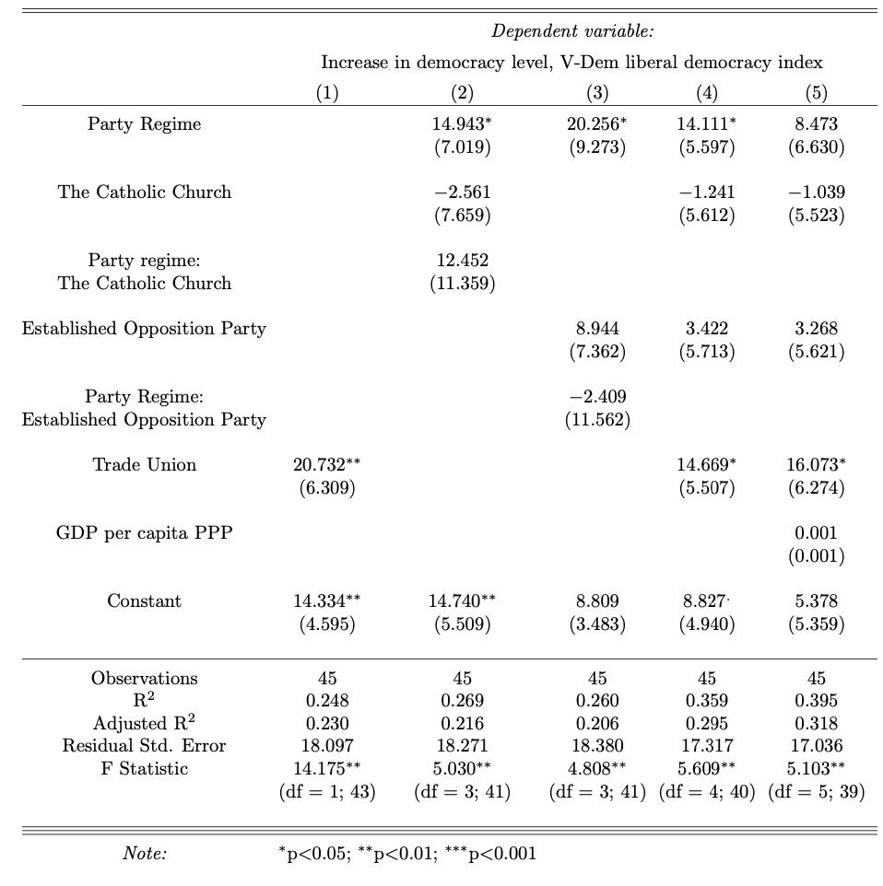
Table A4. The regression table with OLS parameters and standard errors with the increase in the level of democracy, the share of the population with membership in trade unions that participate in pacts (cases without trade unions in negotiations are coded as 0), and GDP per capita

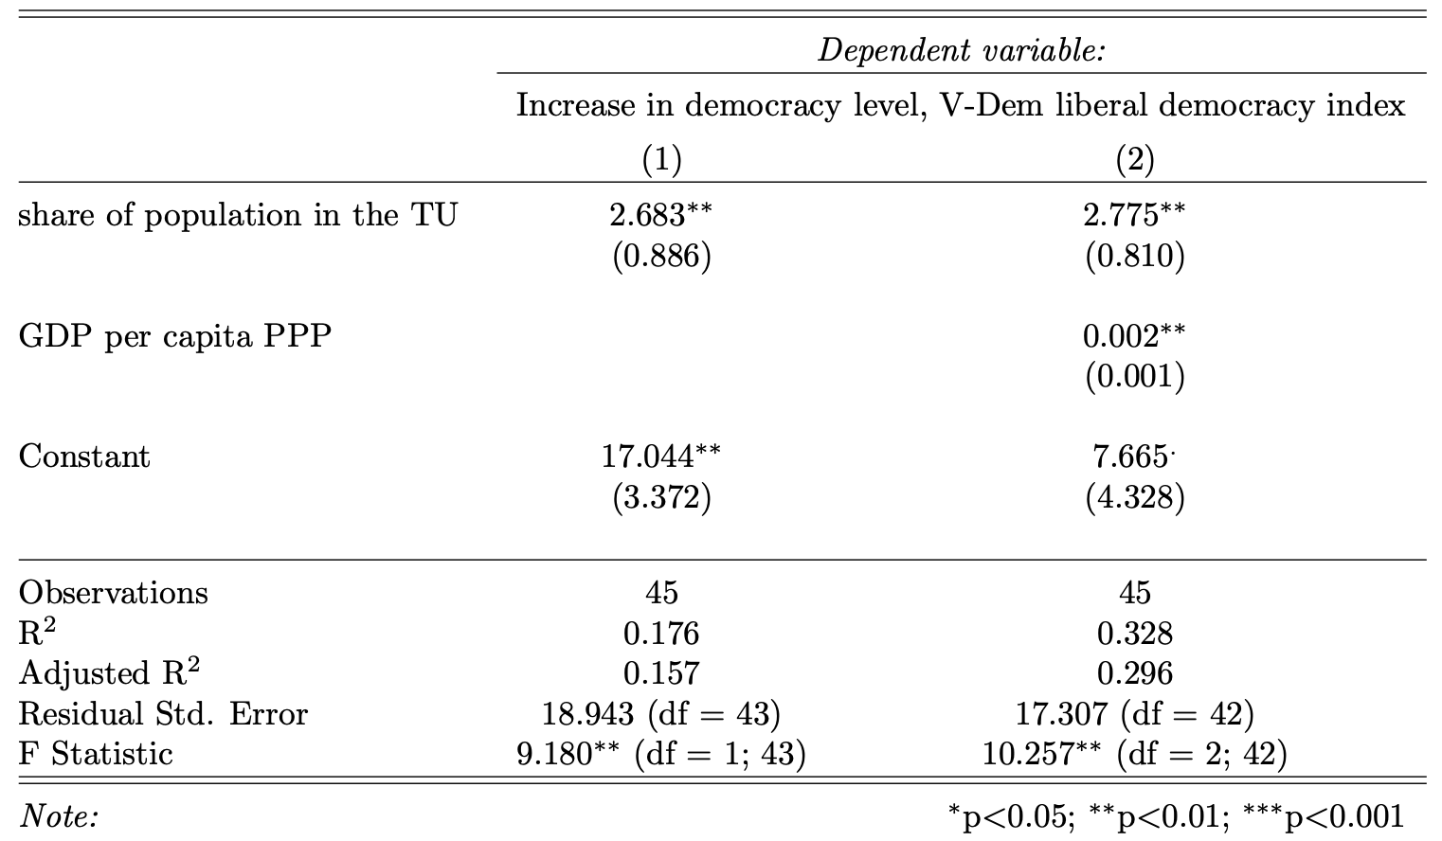
Table A5. The regression table with OLS parameters and standard errors indicating the covariates of democratization as a result of a pact

Post-QCA statistical tests on trade unions
Continuing the findings of the QCA analysis, this section will unpack the possible reasons why trade unions are associated with successful pacts. Namely, it will test the effect of the presence of the trade unions on democratization while controlling for economic development. As the QCA analysis has shown, the presence of a trade union in negotiations is sufficient both for successful negotiations and subsequent democratization. However, the cause and the character of this effect remain uncertain. Is it the presence of trade unions per se fostering democratization, or is there a confounding variable (namely, economic development)? The following section tests this argument.
I offer and test two possible explanations for why trade unions lead to democratic outcomes. My hypothesis suggests that countries with trade unions participating in pacts are more economically developed and therefore are structurally more likely to democratize, which, in turn, explains the democratic gain from the presence of a trade union. My hypothesis 4 is that the larger the membership of a trade union (union density) that participates in the pact, the greater the subsequent increase in the level of democracy. This echoes the proletarianization argument of Rueschemeyer and colleagues (1992), which contends that democratization is more likely when organized labor is strong. In contrast, I argue that the agency mechanism can explain the democratizing effect—trade unions always pose a credible threat and provide a credible commitment to their counterparts in negotiations. If the presence of a trade union in negotiations causes a fixed increase in the level of democracy, but this gain does not gradually increase with the size of the trade union, then it means that this effect stems from the actor level.
First and foremost, the quantitative methods are useful in testing these hypotheses because of their correlational, probabilistic logic as opposed to the deterministic logic of QCA. This logic allows better testing of the hypotheses that address differences in degree as opposed to differences in kind, which is the precise question raised in this section. In addition, the variables GDP per capita and between the size of membership of the negotiating trade union lack clear, logical categories. Hence, they are hard, albeit not impossible, to calibrate. More than that, multiple regression allows us to control for particular variables to rule out their effects, as I do in Table A3.5 and, especially, in Table 3.6. Finally, supporting the findings of the QCA with the different family method (Table 3.6) serves as a robustness test.
To elaborate further on the results of the QCA analysis, I use the following statistical methods. First, I employ a t-test to check the economic difference between the countries that have and do not have a trade union included in negotiations. Second, I perform a regression analysis to test whether there is a linear connection between the size of membership of the negotiating trade union and the increase in democratization.
Economic development differences do not explain the success of negotiations and subsequent democratization in countries with a trade union involved. The t-test shows a lack of statistically significant difference between the means of the two groups of countries. Although, on average, countries in which trade unions are present during the negotiations are slightly more developed economically (US$4,420 versus US$3,905 GDP per capita), the standard deviation is considerable, especially within the countries with trade unions. Therefore, this difference between the two samples is statistically non-significant, with a p-value as high as .65 (t = -.46; df = 33.73). In any event, the slight difference of US$500 hardly explains the strong effect of the presence of trade unions.
The regression analysis shows almost a perfect linear relation between the membership in trade unions represented in a pact and an increase in the level of democracy (see Table 3.6). Each additional 1% of the population involved in trade unions increases the level of democracy by 2.8% in the first three years after the negotiations alone. Furthermore, the trade union effect caused does not decrease when the control variable—GDP per capita—is introduced to the model, which demonstrates that the presence of a trade union produces an effect that is not dependent on economic development.
Regression analysis (see Table A5) on the extent of democratization in three years after the negotiations copies the QCA model except for controlling for GDP and not dichotomizing the increase in the level of democracy. Model 1 copies Pathway I in the QCA analysis, while Models 2 and 3 copy Pathway II in the QCA analysis. Moreover, Model 4 copies the entire solution formula, and Model 5 adds controls for GDP to Model 4. Regression analysis confirms the previous argument based on QCA. The presence of a trade union or a preceding party regime almost guarantees further democratization. At the same time, the trade union variable explains democratization better than the incumbent regime one. The presence of the latter adds 20% to democratization in three years (p=.0005) (see Models 3, 4, 5), as opposed to a preceding party/military regime, which also adds 20%, albeit with lower statistical significance (p=.039) (see Models 2, 3, 4, and 5). In addition, the model that uses the TU variable has a lower AIC (392 as opposed to 395). The effect of economic development that is fully statistically significant in Table A4 is not statistically significant in Table A5 (p=.13). The other variables in the database produce a very small positive effect, which is statistically insignificant; they even have no effect when aggregated into an index. Estimates of these models are relatively strong, with R² ranging from 25 to 40% and low p-values.
To sum up, the countries that bring trade unions into the negotiations are not richer than those that do not. The effect caused by their presence is not dependent on the country’s economic development. At the same time, the share of a country`s population involved in a trade union that participates in the negotiations has a positive linear relationship with the degree of democratization in the subsequent three years (see Table A5). Therefore, the effect of trade unions has no direct connection with a “modernization” explanation and is caused by the direct influence of these organizations. In addition, although the scope of countries that have a trade union partially overlaps with those that derive from a party/military regime, the regression models have shown that the explanation through a trade union explains the further democratization better.
The regression analysis generally supports the results of the QCA analysis. At the same time, it helps control for economic development and check the character of the connection between the variables—and thus, to investigate the findings even further. The first difference between the two methods is that according to the regression analysis, the configurative logic of the party/military regime condition—namely, that negotiations should lead to democratization when either the established opposition party or the Catholic Church is present during the pact—is not important. Second, the regression analysis allowed to show that not only the presence of trade unions but also their strength is important. The larger trade unions are, the larger increase in the level of democracy that follows.
The variation between pacted transitions
The attempts at pacted transitions in my data vary by the extent to which the incumbent and the opposition control the situation, by the extent the incumbent and the opposition are represented in negotiations, by the extent of what is discussed, by the extent of how the foreign powers intervened, and by the scale of violence and contention. This section introduces the borderline cases of the maximum extent of the deviation from my understandings.
Albania in 1990 is an example of negotiations that were controlled entirely by the incumbent. In this case, Ramiz Alia, Albanian authoritarian leader, completed a round of negotiations with students, acceding to almost all their demands, but nevertheless maintained full control of the situation in the country. The opposite situation where it is difficult to say whether the incumbent had already entirely lost by the time negotiations began is Georgia in 2003. After a day of severe anti-government protests and Russia’s sudden decision to withdraw its support for (then president) Eduard Shevardnadze, Igor Ivanov, the Russian minister of foreign affairs, gave an encouraging speech to the protesters. After that, Ivanov deliberately brought Shevardnadze and then opposition leader Mikhail Saakashvili to negotiate the terms of exit. In this case, with the Kremlin openly supporting the opposition, one could say that Shevardnadze was effectively on the way out. The Polish case in 1989 is most neutral in this regard. Had the character of contention between the Solidarity movement and the ruling party become completely noncooperative and violent, it is impossible to guess which side would have prevailed. One case that has been excluded from the database because the incumbent did not control the situation is Kyrgyzstan in 2010. The ousted President Bakiev started the negotiations only after he had fled the country.
The scope of the issues negotiated during a pact varies from complete constitution-making to the mere clarification of the terms of exit. In the Visegrad countries in 1989, the number of matters discussed was all-embracing, in some cases even covering detailed aspects of the new institutional structure down to the rules for municipal elections. On the other extreme, the failed negotiations in Ivory Coast in 2011 merely included the terms of President Laurent Gbagbo’s exit. Besides, this case is on my borderline of the tolerated foreign influence. Although the pressure by the UN was severe and the country eventually ended up with direct military intervention, Gbagbo still managed to behave independently.
Although both the opposition and the incumbent should be present during the negotiations, they can be represented unevenly. In 1989, the negotiations in Czechoslovakia were heavily dominated by the opposition, with the prime minister, Ladislav Adamec, being present only briefly four days out of ten. There is no direct evidence that Togo’s dictator—Gnassingbé Eyadema— showed up to an (eventually failed) attempt at negotiations in 2006, but he sent delegates. However, there is the other extreme of an underrepresented opposition. In Spain in 1977, the ruling Adolfo Suarez seemed to have had a perfect grip on the selection of organizations that participated in pacting. As a result, Spanish trade unions, although extremely strong, did not participate in the Spain`s main event of negotiations known as the Moncloa pact.
The amount of contention resolved by pacts varies drastically from a very comfortable coexistence to mass violence with thousands of victims. In 1993, bottom-up pressure was almost absent in Mongolia, but a pact was still negotiated between the established Communist Party and a newborn opposition with almost no contention involved. In Ukraine in 2014, by the time negotiations had started, not only was Kyiv, the country’s capital, but also the main squares in the large cities in the west of the country, were covered with thick smoke as the protesters that occupied them were burning tires and throwing firebombs at the police.

Vignette: the case of Tunisia
The Tunisian case in the years 2011-2013 is typical for the QCA model presented above. Tunisian political regime shared characteristics of military, personalistic, and party dictatorships; the secular opposition parties did not have enough organizational capacity and resources to negotiate. The presence and the participation of an independent trade union, the Union Générale Tunisienne du Travail (UGTT), was decisive to the success of negotiations. The UGTT facilitated a compromise by organizing two platforms for negotiations with the ruling elites—the ISROR (High Authority for Realization of the Objectives of the Revolution, Political Reform, and Democratic Transition) in 2011 and the National Dialogue in 2013. At the same time, it had enough power to force an autocrat to agree when they did not want to.
Before Zine El Abidine Ben Ali, Tunisian leader from 1987 to 2011, left the country without any negotiations, the participation of the trade union did not make much difference: mostly the most militant local branches participated (Warkotsch, 2014, p. 176), and they did not mobilize a significant number of people (Pilati et al., 2019).
Hovewer, the UGTT played a crucial role after Ben Ali left the country. Initially, the UGTT was underrepresented, and had to fight for its guiding role in a transition organizing the so-called Kasbah I and Kasbah II protests (Omri, 2015, p. 22; Yousfi, 2018). In addition, the UGTT organized a collective decision-making platform that united the opposition at the time, the CNPR (the Council for the Protection of the Revolution) (Stepan, 2012).
In January and February 2011, it succeeded in dismissing the first government dominated by the ruling elites, and organized what Stepan (2012) calls “one of the most effective consensus-building bodies in the history of ‘crafted’ democratic transitions”, the ISROR. It enjoyed legal power to organize elections and electoral laws (Stepan, 2012; Yousfi, 2018). Its work yielded two main fruits: a new electoral design, and a roadmap for a further transition (Stepan, 2012, pp. 92–94). In April 2011, this body agreed to call elections for the Constitutional Assembly that would draft a new constitution later approved by a referendum.
Two years later, the UGTT resolved the crisis connected with the protracted constitution writing on one hand and the rise of Salafism-driven violence on the other. Similarly, it organized an opposition alliance called Quartet, forced the government to resign, and provided a platform for negotiations called the National Dialogue in November 2013.

However, one should bear in mind that p-statistics are prone to show low significances when applied to small samples, such as the one of this paper with 45 cases.
For the sake of similarity with my QCA models, I violate the assumption on multicollinearity and use variables that control for a political regime and a trade union in the same models, even though they are associated with each other (Chisq=4.59, p=.03). Thus, the R-square estimates in Models 4 and 5 should be treated with caution.

