Appendix

Table A.1: Descriptive statistics
 | N | Mean | SD | Min | Max
Level of Agreement (Difference to 50%) | 1440 | 25.253 | 14.337 | 0.065 | 50
Assembly (=1) | 1463 | 0.308 | 0.462 | 0 | 1
Turnout in Merger Decision (%) | 1298 | 56.896 | 18.090 | 0.054 | 98
Population Size | 1481 | 1593 | 4102 | 11 | 58381
Size/Coalition Size | 1481 | 0.284 | 0.272 | 0.001 | 0.994
Δ Tax Rate | 1458 | 0.024 | 0.108 | -0.639 | 0.568
Previous Merger
None | 1541 | 0.826 | 0.379 | 0 | 1
Failed | 1541 | 0.125 | 0.331 | 0 | 1
Succeeded | 1541 | 0.049 | 0.215 | 0 | 1
Name Change
New Name | 1527 | 0.748 | 0.434 | 0 | 1
Compound Name | 1527 | 0.099 | 0.299 | 0 | 1
Old Name | 1527 | 0.153 | 0.360 | 0 | 1
Parliament (=1) | 1399 | 0.242 | 0.428 | 0 | 1
Time Period
1999-2005 | 1541 | 0.225 | 0.417 | 0 | 1
2006-2012 | 1541 | 0.437 | 0.496 | 0 | 1
2013-2019 | 1541 | 0.338 | 0.473 | 0 | 1
Canton
AG | 1541 | 0.057 | 0.232 | 0 | 1
BE | 1541 | 0.114 | 0.318 | 0 | 1
FR | 1541 | 0.166 | 0.372 | 0 | 1
GR | 1541 | 0.117 | 0.321 | 0 | 1
JU | 1541 | 0.045 | 0.207 | 0 | 1
LU | 1541 | 0.043 | 0.203 | 0 | 1
NE | 1541 | 0.047 | 0.211 | 0 | 1
SG | 1541 | 0.019 | 0.136 | 0 | 1
SH | 1541 | 0.010 | 0.101 | 0 | 1
SO | 1541 | 0.028 | 0.165 | 0 | 1
TI | 1541 | 0.171 | 0.377 | 0 | 1
VD | 1541 | 0.120 | 0.325 | 0 | 1
VS | 1541 | 0.046 | 0.210 | 0 | 1
ZH | 1541 | 0.017 | 0.129 | 0 | 1

Figure A.1: Correlation between reported and approximated turnout
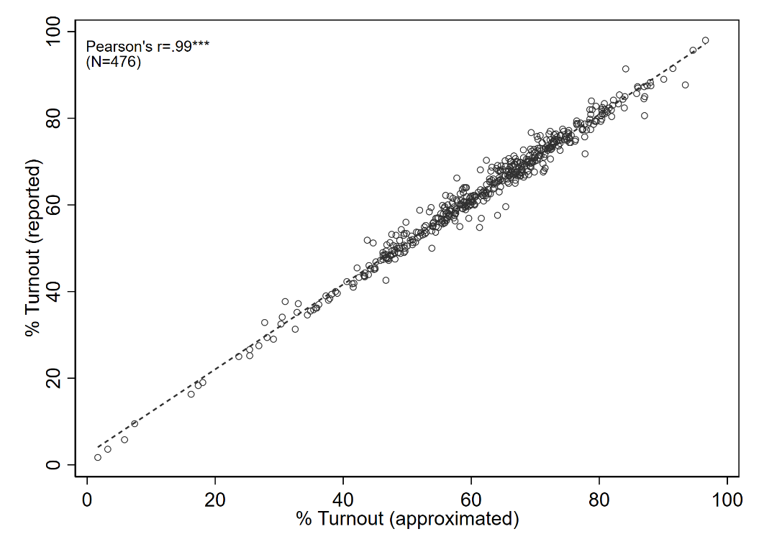

Figure A.2: Abstention (Cantons of Grisons and Ticino)
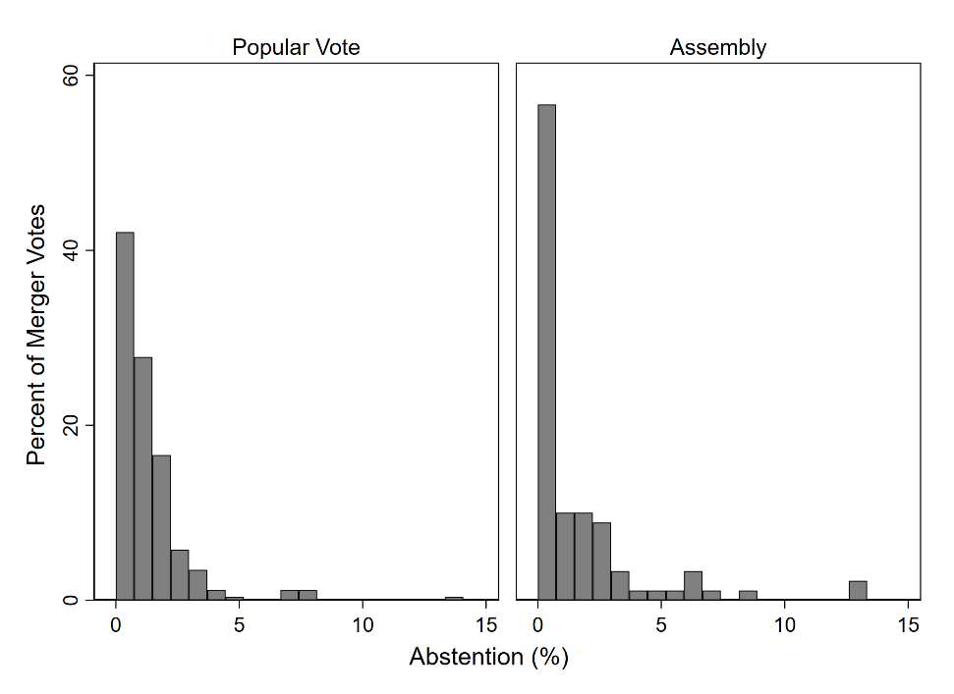

Figure A.3: Difference in level of agreement between decision procedures in same municipality
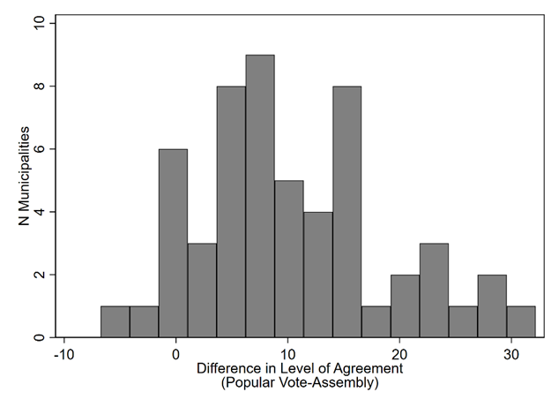

Figure A.4: Level of agreement in assemblies taking final decision and assemblies prior to popular votes
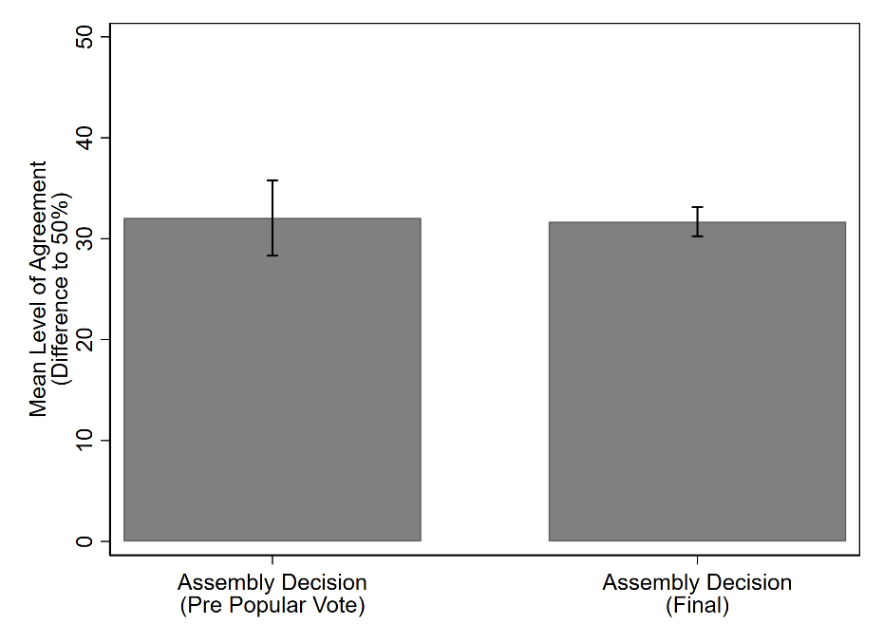

Figure A.5: Level of agreement in popular votes with/without prior assemblies
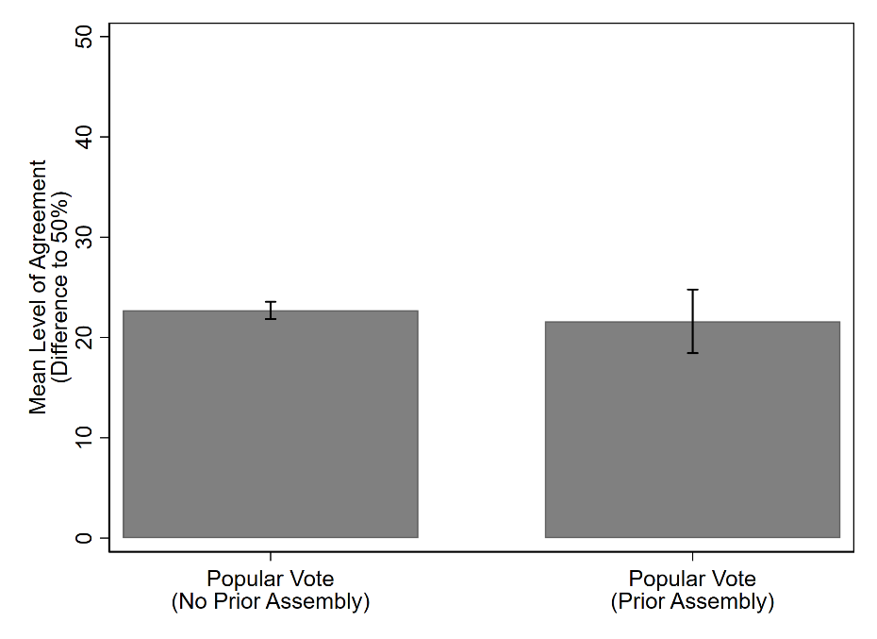

Table A.2: Multilevel Regression Model: Random-Effects ANOVA
 | Level of Agreement |  |  | Intra-Class Correlation
 | Estimate | SE |  | Estimate | SE
Constant | 24.81 | (1.04)
Level-1 Variance (Merger Decisions) | 141.71 | (6.32)
Level-2 Variance (Merger Projects) | 57.84 | (8.07) |  | 0.05 | (0.02)
Level-3 Variance (Cantons) | 10.06 | (5.35) |  | 0.32 | (0.03)
N Merger Decisions | 1440
N Merger Projects | 415
N Cantons | 14
LR test (X²) | 174.59
p>X² | 0.000
Note. Results obtained through -mixed- command in Stata; standard errors in parentheses.

Table A.3. Robustness, level of agreement: municipalities with assembly followed by popular vote
 | (1) | (2) | (3)
Assembly (B=Popular Vote) | 10.44*** | 10.44*** | -1.05
 | (1.11) | (1.11) | (3.78)
Turnout (%) |  |  | -0.35**
 |  |  | (0.11)
Previous Merger (B=None)
Merger Attempt Failed |  | 5.91 | 2.81
 |  | (4.95) | (4.45)
Name Change (B=New Name)
Compound Name |  | 8.30 | 9.35
 |  | (6.22) | (5.49)
Old Name |  | 10.90 | 10.89
 |  | (10.51) | (9.36)
Log(Population Size) |  | -4.01 | -6.24*
 |  | (2.67) | (2.45)
Size/Coalition Size |  | 6.28 | 1.14
 |  | (16.84) | (15.08)
Δ Tax Rate |  | 38.97* | 39.37*
 |  | (18.41) | (16.19)
Time Period (B=1999-2005)
2006-2012 |  | 4.09 | 2.82
 |  | (5.81) | (5.12)
2013-2020 |  | 2.88 | 0.86
 |  | (6.36) | (5.63)
Canton (B=AG)
LU |  | -5.34 | 5.46
 |  | (9.61) | (9.20)
SH |  | -6.09 | -3.11
 |  | (6.75) | (6.01)
Constant | 21.61*** | 37.17* | 76.39***
 | (1.73) | (16.42) | (18.76)
Level-1 Variance (Merger Decision) | 34.06*** | 34.06*** | 38.22***
 | (6.49) | (6.49) | (8.08)
Level-2 Variance (Municipality) | 125.43*** | 103.32*** | 73.89***
 | (36.08) | (23.18) | (20.23)
Level-3 Variance (Merger Project) | 1.48 | 0.00 | 0.00
 | (24.17) | (0.00) | (.)
N (Merger Decisions) | 110 | 110 | 107
N (Municipalities) | 55 | 55 | 55
N (Merger Projects) | 23 | 23 | 23
Log. Lik. | -409 | -404 | -390
Wald X² | 88.03 | 98.81 | 102.65
p>X² | 0.000 | 0.000 | 0.000
AIC | 828 | 838 | 809
BIC | 841 | 878 | 849
Note. *<.05 **<.01 ***<.001. Coefficients are obtained through -mixed- command in Stata; standard errors in parentheses.

Table A.4. Robustness, level of agreement: municipalities involved in 1 merger project only
 | (1) | (2) | (3)
Assembly (B=Popular Vote) | 8.66*** | 5.37*** | -3.12*
 | (1.14) | (1.13) | (1.50)
Turnout (%) |  |  | -0.31***
 |  |  | (0.04)
Name Change (B=New Name)
Compound Name |  | 0.34 | 0.68
 |  | (1.56) | (1.53)
Old Name |  | 4.24* | 2.22
 |  | (1.89) | (1.93)
Log(Population Size) |  | -3.95*** | -5.28***
 |  | (0.49) | (0.51)
Size/Coalition Size |  | 16.37*** | 11.78***
 |  | (3.02) | (3.04)
Δ Tax Rate |  | 24.16*** | 23.48***
 |  | (3.68) | (3.61)
Parliament (B=Assembly) |  | 0.41 | 0.82
 |  | (1.25) | (1.23)
Time Period (B=1999-2005)
2006-2012 |  | -1.34 | 0.02
 |  | (1.19) | (1.18)
2013-2020 |  | -1.50 | -1.32
 |  | (1.33) | (1.31)
Constant | 22.55*** | 43.17*** | 73.34***
 | (0.67) | (2.87) | (4.46)
Level-1 Variance (Merger Decision) | 140.84*** | 142.64*** | 128.09***
 | (7.15) | (7.68) | (7.28)
Level-2 Variance (Merger Project) | 53.44*** | 19.33*** | 18.19***
 | (8.57) | (5.90) | (5.68)
Level-3 Variance (Canton) | 0.00 | 0.00** | 0.00
 | (0.00) | (0.00) | (0.00)
N (Merger Decisions) | 1138 | 979 | 888
N (Merger Projects) | 353 | 317 | 296
N (Cantons) | 14 | 14 | 14
Log. Lik. | -4561 | -3870 | -3465
Wald X² | 57.85 | 221.63 | 291.45
p>X² | 0.000 | 0.000 | 0.000
AIC | 9132 | 7766 | 6957
BIC | 9158 | 7829 | 7024
Note. *<.05 **<.01 ***<.001. Coefficients are obtained through -mixed- command in Stata; standard errors in parentheses.

Table A.5. Robustness, level of agreement: multicollinearity test
 | Without Turnout |  |  | With Turnout
Variable | Variance Inflation Factor | 1/Variance Inflaction Factor |  | Variance Inflation Factor | 1/Variance Inflaction Factor
Assembly (B=Popular Vote) | 2.72 | 0.37 |  | 4.37 | 0.23
% Turnout |  |  |  | 2.99 | 0.33
Previous Merger (B=None)
Failed Merger | 1.13 | 0.88 |  | 1.15 | 0.87
Successful Merger | 1.15 | 0.87 |  | 1.17 | 0.86
Name Change (B=New Name)
Compound Name | 1.37 | 0.73 |  | 1.37 | 0.73
Old Name | 2.8 | 0.36 |  | 2.86 | 0.35
log(Population Size) | 2.96 | 0.34 |  | 3.32 | 0.30
Size/Coalition Size | 4.08 | 0.25 |  | 4.23 | 0.24
Δ Tax Rate | 1.11 | 0.90 |  | 1.12 | 0.89
Parliament (B=Assembly) | 3.32 | 0.30 |  | 3.47 | 0.29
Time Period (B=1999-2005)
2006-2012 | 2.75 | 0.36 |  | 2.74 | 0.36
2013-2020 | 2.96 | 0.34 |  | 2.93 | 0.34
Canton (B=AG)
BE | 2.35 | 0.43 |  | 2.19 | 0.46
FR | 3.92 | 0.26 |  | 3.94 | 0.25
GR | 4.02 | 0.25 |  | 4.09 | 0.24
JU | 1.7 | 0.59 |  | 1.37 | 0.73
LU | 1.72 | 0.58 |  | 1.62 | 0.62
NE | 2.17 | 0.46 |  | 2.24 | 0.45
SG | 1.36 | 0.73 |  | 1.33 | 0.75
SH | 1.21 | 0.82 |  | 1.24 | 0.81
SO | 1.43 | 0.70 |  | 1.44 | 0.69
TI | 4.84 | 0.21 |  | 4.93 | 0.20
VD | 1.71 | 0.59 |  | 1.65 | 0.61
VS | 1.66 | 0.60 |  | 1.75 | 0.57
ZH | 1.23 | 0.81 |  | 1.27 | 0.79
Mean VIF | 2.32 |  |  | 2.43
Note. Coefficients are obtained through -estat vif- command in Stata, after -regress-.

Table A.6. Turnout: multilevel regression models
 | (1) | (2)
Assembly (B=Popular Vote) | -23.05*** | -27.13***
 | (1.41) | (1.40)
Previous Merger (B=None)
Merger Attempt Failed |  | -1.85
 |  | (1.20)
Merger Attempt |  | -1.30
Succeeded |  | (1.38)
Name Change (B=New Name)
Compound Name |  | -0.07
 |  | (1.22)
Old Name |  | -5.30***
 |  | (1.35)
Log(Population Size) |  | -3.58***
 |  | (0.43)
Size/Coalition Size |  | -17.64***
 |  | (2.38)
Δ Tax Rate |  | -2.82
 |  | (2.64)
Parliament (B=Assembly) |  | 6.92***
 |  | (1.22)
Time Period (B=1999-2005)
2006-2012 |  | -1.76
 |  | (1.43)
2013-2020 |  | -1.66
 |  | (1.50)
Constant | 63.40*** | 95.85***
 | (1.51) | (3.17)
Level-1 Variance (Merger Decision) | 153.73*** | 74.19***
 | (7.08) | (3.75)
Level-2 Variance (Merger Project) | 31.21*** | 39.21***
 | (6.05) | (5.15)
Level-3 Variance (Canton) | 25.59*** | 41.10***
 | (11.50) | (17.93)
N (Merger Decisions) | 1273 | 1097
N (Merger Projects) | 380 | 343
N (Cantons) | 14 | 14
Log. Lik. | -5118 | -4094
Wald X² | 267.78 | 1232.92
p>X² | 0.000 | 0.000
AIC | 10247 | 8218
BIC | 10272 | 8293
Note. *<.05 **<.01 ***<.001. Coefficients are obtained through -mixed- command in Stata; standard errors in parentheses.

Table A.7. Level of agreement: mediation analysis
 | Turnout (%) |  |  | Level of Agreement
 | B | SE |  | B | SE
Assembly (B=Popular Vote) | -26.86*** | (1.98) |  | -3.89 | (2.01)
Turnout (%) |  |  |  | -0.35*** | (0.04)
Previous Merger (B=None)
Merger Attempt Failed | -1.82 | (1.37) |  | 2.65* | (1.06)
Merger Attempt Succeeded | -1.69 | (1.28) |  | -1.72 | (1.87)
Name Change (B=New Name)
Compound Name | 0.35 | (1.37) |  | -0.77 | (1.41)
Old Name | -6.30*** | (1.57) |  | 2.14 | (1.67)
Log(Population Size) | -4.03*** | (.58) |  | -5.56*** | (.51)
Size/Coalition Size | -14.20*** | (2.95) |  | 10.88*** | (2.83)
Δ Tax Rate | -0.74 | (3.72) |  | 23.26*** | (5.23)
Parliament (B=Assembly) | 8.92*** | (1.54) |  | 3.29* | (1.66)
Time Period (B=1999-2005)
2006-2012 | -1.06 | (1.65) |  | -.25 | (1.50)
2013-2020 | -1.64 | (1.65) |  | -1.43 | (1.53)
Canton (B=AG)
BE | -1.69 | (2.46) |  | 1.77 | (1.94)
FR | 0.79 | (1.89) |  | 2.73 | (1.89)
GR | 5.47* | (2.52) |  | 3.54 | (2.26)
JU | 8.44* | (3.73) |  | .47 | (2.93)
LU | 13.22*** | (2.06) |  | 3.95 | (2.45)
NE | -9.04*** | (2.36) |  | -3.29 | (2.40)
SG | 6.22* | (2.69) |  | 4.44 | (2.53)
SH | 11.86* | (4.70) |  | 3.43 | (3.25)
SO | -1.71 | (3.53) |  | 2.75 | (2.51)
TI | -3.14 | (2.21) |  | 1.70 | (1.98)
VD | -7.11*** | (2.72) |  | 2.09 | (2.93)
VS | 14.07*** | (2.31) |  | 8.61*** | (2.16)
ZH | 12.97*** | (2.61) |  | 5.20* | (2.44)
Constant | 93.17*** | (4.05) |  | 75.28*** | (4.95)
Average Causal Mediation Effect (ACME) | 9.56***
(Assembly -> Turnout -> Level of Agreement) | [7.14, 12.08]
Direct Effect | -3.85
(Assembly -> Level of Agreement) | [-7.73,0.16]
Total Effect (=ACME+Direct Effect) | 5.71***
 | [2.27,9.25]
N (Merger Decisions) | 1096 |  |  | 1096
N Clusters (Merger Projects) | 343 |  |  | 343
F (24, 342) | 72.53 |  |  | 16.73
p>F | 0.000 |  |  | 0.000
R² | .67 |  |  | .31
Note. *<.05 **<.01 ***<.001. Coefficients are obtained through -medeff- command in Stata; clustered standard errors in parentheses, 95% confidence intervals in square brackets.

Table A.8. Unanimous decisions: multilevel logistic regression models
 | (1) | (2) | (3)
Assembly (B=Popular Vote) | 3.79*** | 4.13*** | 2.49*
 | (0.53) | (0.95) | (1.11)
Turnout (%) |  |  | -0.07***
 |  |  | (0.02)
Previous Merger (B=None)
Merger Attempt Failed |  | 0.50 | 0.55
 |  | (0.53) | (0.55)
Merger Attempt Succeeded |  | 0.53 | -1.11
 |  | (0.73) | (1.16)
Name Change (B=New Name)
Compound Name |  | 0.43 | 0.38
 |  | (0.59) | (0.62)
Old Name |  | 0.16 | -0.29
 |  | (0.68) | (0.79)
Log(Population Size) |  | -1.81*** | -2.22***
 |  | (0.29) | (0.37)
Size/Coalition Size |  | 6.42*** | 5.31***
 |  | (1.31) | (1.40)
Δ Tax Rate |  | 2.26 | 3.27*
 |  | (1.40) | (1.52)
Parliament (B=Assembly) |  | -12.91 | -12.06
 |  | (921.82) | (1227.04)
Time Period (B=1999-2005)
2006-2012 |  | 0.32 | -0.41
 |  | (0.63) | (0.77)
2013-2020 |  | 0.13 | -0.30
 |  | (0.71) | (0.74)
Constant | -5.80*** | 2.00 | 9.07***
 | (0.57) | (1.43) | (2.36)
Level-2 Variance | 1.69 | 0.30 | 0.17
 | (0.83) | (0.50) | (0.51)
Level-3 Variance | 0.11 | 1.18 | 0.33
 | (0.17) | (0.99) | (0.43)
N (Merger Decisions) | 1400 | 1199 | 1096
N (Merger Projects) | 407 | 368 | 343
N (Cantons) | 14 | 14 | 14
Log. Lik. | -219 | -152 | -115
Wald X² | 51.02 | 53.30 | 47.92
p>X² | 0.000 | 0.000 | 0.000
AIC | 446 | 332 | 259
BIC | 467 | 404 | 334
Note. *<.05 **<.01 ***<.001. Coefficients are obtained through -meqrlogit- command in Stata; standard errors in parentheses.

