Supplementary Material for
“Non-citizen Voting Rights and Political Participation of Citizens: Evidence from Switzerland”

Table of Contents

Table A1: Summary statistics of variables used in the analyses (SHP) 3
Table A2: Question items used in the analysis from the Swiss Household Panel (SHP) 4
Figure A1: Map of municipalities with and without non-citizen voting rights (NCV) across Switzerland (2020) 5
Table A3: Non-citizen enfranchisement efforts in Switzerland 6
Table A4: Introduction of non-citizen voting rights and constitutional changes across cantons 7
Note on the distribution and characteristics of immigrant populations across Switzerland 9
Table A5: Distribution of groups across Swiss municipalities with and without non-citizen voting (NCV) rights in our sample in 2014 9
Table A6: Top five countries of origin with the highest shares of immigrant stock in Switzerland 9
Table A7: Respondents by region of origin and municipal residence with or without non-citizen voting rights (NCV) 10
Note on the measurement of political participation 11
Table A8: Distribution of political participation in federal polls frequency across vote intention 12
Table A9: Interest in local and national politics, by type of canton 13
Table A10: The effect of non-citizen voting rights on electoral participation, alternative DV 14
Figure A2: Total participation rate in federal polls (OFS), over time 15
Figure A3: Mean participation rate in federal polls reported in SHP, by electoral group 16
Figure A4 : Mean participation rate in federal polls reported in SHP, by group (NC, CIB) and NCV rights in municipality 16
Figure A5: Participation rates in federal polls (OFS and reported in SHP), by canton 17
Note on SHP sampling strategy and checks for attrition 18
Table A11: Stratification method of SHP in the sample (I, II, III sampling waves) 18
Table A12: Participation in the SHP waves (1999-2016 across three sampling waves) 19
Table A13: Predicting below median participation rate in the SHP 21
Table A14: Full estimation results of models presented in Table 2 22
Table A15: Full estimation results of models presented in Table 3 24
Figure A6: Replication of Figure 2 with 90% CIs 26
Figure A7: Replication of Figure 3 with 90% CIs 26
Robustness with alternative categories of status variable 27
Figure A8: Mean reported participation by more disaggregated categories of electoral groups 27
Table A16: Replication of models presented in Table 2 28
Table A17: Replication of Table 3 with the more detailed categorical variable 28
Robustness checks by concentrating on four cantons with canton-wide non-citizen voting rights legislation 29
Figure A9: Political participation trends over time, by group in 4 cantons 30
Table A18: Average treatment effect on the treated (ATT) predicted in two-way fixed effects with 4 cantons 31
Table A19: Political participation models with lagged DV estimation 31
Table A20: Political participation models with forwards lagged IV by one-year 32
Table A21: Political participation models controlling for region of origin and employment status 33
Table A22: Political participation models controlling for partisanship, union membership, and religiosity 34
Table A23: Political participation models controlling for political interest 35
Table A24: Political participation models removing respondents that move between municipalities (random effects models) 36
Table A25: Political participation models removing respondents that move between municipalities (fixed effects models) 36
Table A26: Political participation models controlling for the share % vote of SVP in each municipality 37
Table A27: Political participation models controlling for the share % of foreigners residing in each municipality 38
Analysis of the attitudes towards NCV in CH 39
Table A28: Summary statistics of the variables used in MOSAiCH 39
Table A29: Table of results from MOSAiCH survey data, 2015 wave 40
Table A30: Predicting political participation, excluding 1999 wave 41
Table A31: Predicting political participation, excluding 1999 and 2000 waves 42
Table A32: Linear multi-level model estimations 43

Table A1: Summary statistics of variables used in the analyses (SHP)

 | N | Mean | Sd. Dev. | Min | Max
Citizens with immigration background (CIB) | 52,670 | 0.144 | .351 | 0 | 1
Civic and immigration group status | 53,670 |  |  | 1 | 3
Native citizens | 45,957 | .8563
Native citizens with immigration background | 2,911 | .0542
Naturalized immigrants | 4,802 | .0895
Participation in federal polls (number) | 53,670 | 7.654 | 3.070 | 0 | 10
Female | 53,670 | 1.546 | .498 | 1 | 2
Age | 53,670 | 47.976 | 16.631 | 18 | 99
Education | 53,670 | 13.380 | 2.9464 | 8 | 21
Income (deciles) | 53,670 | 5.670 | 2.799 | 1 | 10
Additional variables used | N | Mean | Std. Dev. | Min | Max
Left-right placement | 48,413 | 4.776 | 2.101 | 0 | 10
Political interest | 53,646 | 5.798 | 2.671 | 0 | 10
Religious event attendance (frequency) | 42,329 | 4.061 | 2.126 | 1 | 9
Union membership | 53,621 |  |  | 1 | 3
Active member | 3,547 | .066
Passive member | 6,286 | .117
Not a member | 43,788 | .817
Labour market status | 53,670 |  |  | 1 | 3
Employed (in occupation) | 39,304 | .732
Unemployed | 666 | .012
Not in labour force | 13,700 | .255

Note: All descriptive data is from the sample used in the analysis in the SHP 1999, 2000, 2001, 2002, 2003, 2004, 2005, 2007, 2008, 2009, 2011, 2014 waves.

Table A2: Question items used in the analysis from the Swiss Household Panel (SHP)

Variable | Operationalization in SHP | Variable
Immigration status | Birth in Switzerland (yes/no) | d160_
Citizenship status | Nationality (first, second, or third in case of multiple nationalities identifying citizens with an immigration background) | nat_1_  nat_2_  nat_3_
 | Swiss since birth (yes/no)  Reception of Swiss citizenship (yes/no) | d161_  d162_
Non-citizen voting rights (NCV) | Coded by authors from https://www.bfs.admin.ch/ | mvoting
Canton of residence | Canton of residence (each wave) | canton
Municipality of residence* | Community numbers of residence (each wave) | ofs_
Political participation | "Let's suppose that there are 10 federal polls in a year. How many do you usually take part in?" | p06_
Sex | Sex (man/woman) | sex
Age | Age (in years) – post-coded | age
Education | Years of education attainment (post-coded based on ISCED classification) | edyear
Income (P) | Yearly net income at the person level (recoded to 10 quintiles by authors for the analysis) | ptotn_
Additional variables used in the analyses
Political interest | Generally, how interested are you in politics, if 0 means "not at all interested" and 10 "very interested"? | p01_
Left-right ideological placement | When they talk about politics, people mention left and right. Personally, where do you position yourself 0 means "left" and 10 means "right" | p10_
Union membership | Could you tell me for "Syndicate, employees association" whether you are an active member, a passive member or not a member? | n42_
Religiosity (Frequency of participating in religious events) | Choice options: "never", "only for family ceremonies", "only for religious celebrations", "both family and religious celebrations", "a few times year", "once a month", "every two weeks", "once a week", "several times a week" | r04_
Work status | Working/professional status (post-coded); actively occupied, not employed, not in the labour force | wstat
Region of origin | First nationality reported by respondents post-coded into either being Swiss or other 12 geographical regions | reg_1_
Income (H) | Yearly net income at the household level (recoded to 10 quintiles by authors for the analysis) | htyn_
*All SHP data waves are publicly available upon contract agreement online at FORS database https://forscenter.ch/projects/swiss-household-panel/data/ This is except for identifiers that link households to their residence at the communal (Gemeinde/commune) level. The ofs_ variable is also available upon reasonable request for academic researchers by contacting swisspanel@fors.unil.ch.
Canton and municipality of residence variables are from household-level data (H) whereas all others are from person-level (P) datasets. We merged individual year waves of the SHP by creating a long format panel data. Therefore, each variable comes from the specific wave that they are administered. Using the variable naming conventions in SHP, we create one variable that contains the data and information on a particular question for the repeated observations in our panel structure.

Figure A1: Map of municipalities with and without non-citizen voting rights (NCV) across Switzerland (2020)
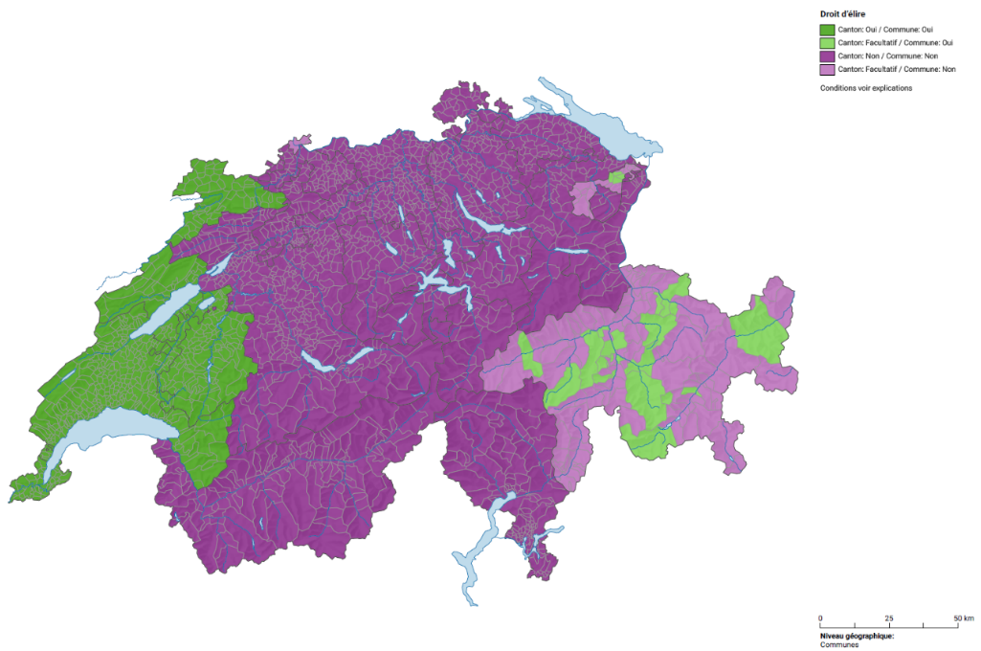
Source: Atlas Statistique de la Suisse & Zentrum für Demokratie Aarau
https://www.bfs.admin.ch/bfs/fr/home/statistiques/population/migration-integration/indicateurs-integration/indicateurs/communes-cantons-droit.html
https://www.bfs.admin.ch/bfs/fr/home/statistiques/population/migration-integration/indicateurs-integration/indicateurs/communes-cantons-droit.htmlLight green: Non-citizen voting rights at the municipal level, cantonal level legislation allows opting in Dark green: Non-citizen voting rights at both municipal and cantonal level Light purple: No non-citizen voting rights, cantonal level legislation allows opting-in Dark purple: No non-citizen voting rights

Table A3: Non-citizen enfranchisement efforts in Switzerland
Canton | Non-citizen voting rights (NCV) efforts (type/level/year) | Conditions for eligibility | Percentage yes vote accepting the policy
Jura | NCV at the municipal level: voting rights since 1977; limited to parliament until 2014, extended to the executive (except for the position of the mayor) | Minimum ten years of residency in Switzerland, thereof min. one year in the canton | 70.0% (introduction of NCV rights at the moment of the foundation of the canton through the acceptance of the cantonal constitution)
Neuchâtel | NCV in all municipalities since 2000 | Minimum one year of residency in the canton | 76,6 % (when accepting full revised cantonal constitution)
Appenzell-Ausserrhoden | Since 1995, municipalities can introduce NCV rights at the municipal level (4/20 municipalities have introduced such political rights). | Minimum ten years of residency in Switzerland, thereof min. five years in the canton | Municipal assembly  (Landsgemeinde) for each municipality holds own opt-in referendum
Vaud | NCV rights at the municipal level since 2002 | Minimum ten years of continuous residency in Switzerland, thereof min. three years continuously in the canton | 55.9%
Grisons/ Graubünden | Since 2004, municipalities can introduce NCV rights at the municipal level (23/105 municipalities have introduced such political rights) | No cantonal regulations on criteria of eligibility | 59.7% (result of the 2004 vote)
Geneva | NCV rights at the municipal level since 2005 | Minimum eight years of residency in the canton | 52.3%
Fribourg | NCV rights at the municipal level since 2006 | Residence permit, minimum five years of residency in the canton | 58.0%
Basel-Stadt | Since 2005, municipalities can introduce NCV rights at the municipal level. | No cantonal regulations on criteria of eligibility | 76.%
Notes: While only seven out of 26 cantons foresee NCV rights at the municipal or cantonal levels, the introduction of non-citizen voting rights has been the subject of political debates in a large variety of cantons in the last decades. From 1977 to 2015, citizens voted on 31 cantonal initiatives to introduce some type of electoral rights for non-citizens (Adler et al. 2016). It is striking that initiatives that aimed at introducing cantonal voting rights or passive voting rights face particularly significant obstacles to be accepted through a public vote. For instance, in 2005 citizens in Geneva rejected a legal project that intended to introduce active and passive voting rights on communal matters, while at the same time accepting a similar project that was, however, restricted to the introduction of active voting rights only. Importantly, cantons sometimes need to go to through several attempts of introducing voting rights, such as in Geneva where a constitutional amendment to enfranchisement non-citizens was rejected in 2001. Similarly, the proposition of expanding active and passive NCV rights from municipal to cantonal matters in the canton of Vaud in 2011 was rejected by 69% of the electorate (Adler et al. 2016). Even though many attempts at introducing some form of NCV rights remained unsuccessful, it is worth noting that there are currently several initiatives. For instance, the canton of Zurich and the city of Basel are in the process of trying to introduce these reforms.

Table A4: Introduction of non-citizen voting rights and constitutional changes across cantons

Canton | Way of introducing non-citizen voting rights | Additional constitutional changes (if applicable)
Jura | Establishment of canton in 1979 by adoption of a cantonal constitution. | First cantonal constitution.
Neuchatel | Active voting rights introduced in the context of full revision of the cantonal constitution.  Passive voting rights introduced through popular initiative. | Full editorial revision of cantonal constitution to clarify the role of cantonal authorities and the rights and obligations between citizens and canton.  No other changes occurred when passive voting rights were adopted.
Appenzell Ausserrhoden | Voting rights introduced in the context of a full revision of the cantonal constitution. | Editorial revision of the constitution. The changes further include an expansion of fundamental and social rights, clarifications about the obligations to provide information by the cantonal institutions, the separation of religion and state, and regulations about environmental protection.
Vaud | Voting rights introduced in the context of a full revision of the cantonal constitution. | Full editorial revision clarified the general principles of the public service, reinforcement of the Grand Conseil (cantonal parliament), financial coordination among municipalities, introduction of a Cour des comptes (court of Auditors), and minor changes in the naturalization procedures in the canton.
Graubünden | Voting rights introduced in the context of a full revision of the cantonal constitution. | Editorial revision. Other, minor changes include the institutionalization of the cantonal constitutional court, the replacement of the mandatory by a facultative referendum and the constitutional confession to the trilingual characteristic of the canton.
Geneva | Popular initiative. | Specific popular initiative referendum on the voting rights of non-citizens.
Fribourg | Voting rights introduced in the context of a full revision of the cantonal constitution. | A comprehensive revision of the cantonal constitution including sensitive issues such as the non-citizen voting rights, maternity insurance, Council of the Judiciary, on a system guaranteeing the balance of finances, on the maintenance of districts, revision of the preamble.

While several cantons have adopted non-citizen voting (NCV) rights in the context of a general revision of the cantonal constitution, enlargement of enfranchisement to non-citizens was not linked to any other policy change that aimed particularly at enhancing political turnout among. In most cases, constitutional changes were minor and addressed editorial revisions of outdated constitutions and clarified responsibility of cantonal and municipal authorities (see table below for further details).
Sources: Adler et al. 2016; Historisches Lexikon der Schweiz (see https://hls-dhs-dss.ch/); Canton of Vaud (2008). Rapport du Conseil d'Etat au Grand Conseil, présentant le bilan de la mise en œuvre de la Constitution du 14 avril 2003 du Canton de Vaud, cinq ans après son entrée en vigueur : See https://www.vd.ch/fileadmin/user_upload/themes/etat_droit/lois/constitution/fichiers_pdf/RapportCst0908.pdf)

Note on the distribution and characteristics of immigrant populations across Switzerland

Table A5: Distribution of groups across Swiss municipalities with and without non-citizen voting (NCV) rights in our sample in 2014
Living in a municipality… | …without NCV rights | …with NCV rights | Total
Native citizens | 7,469 | 1,798 | 9,267
 | (75.71) | (61.79) | (72.54)
Native citizens with immigration background (Second generation immigrants and dual citizens)ª | 429  (4.35) | 272  (9.35) | 701  (5.49)
Naturalised immigrants (First generation immigrants) | 868 | 386 | 1,254
 | (8.80) | (13.26) | (9.82)
Non-naturalised immigrants (Non-Swiss) | 1,099  (11.14) | 454  (15.60) | 1,553  (12.16)
Total | 9,865 | 2,910 | 12,775
 | (100.00) | (100.00) | (100.00)
Source: SHP 2014 wave. Authors' own calculations. Column percentages in parentheses.
a: Includes Swiss-born and those who hold Swiss citizenship by birth.

Table A6: Top five countries of origin with the highest shares of immigrant stock in Switzerland

Origin | Population in Switzerland (2014/2015) | Share % of foreigners in Switzerland | Median income | % with a tertiary degree
Italy | 300,577 | 15.5 | 70, 022 | 20.1
Germany | 292,742 | 15.1 | 81,982 | 53.3
Portugal | 259,032 | 13.4 | 64,470 | 9.3
France | 111,994 | 5.8 | 80,000 | 60.0
Turkey | 69, 148 | 3.6 | 51,722 | 10.9
Northern America | 24,874 | 1.3 | 112,164 | 82.0
Total (all immigrants) | 8,066,570 |  | 78,000 | 28.6
Source: Data from register data STATPOP as of 31.12.2014 (Zufferey and Wanner 2020, p. 5)
Looking at the distribution of immigrants by origin reveals that the residential area of choice amongst immigrants is primarily economically driven, followed by language proximity and potential networks effects from earlier immigrations. For instance, unsurprisingly, most immigrants from Italy reside in Ticino, one of two Italian speaking cantons of Switzerland. Besides, they are spread out in cantons with large cities or close to large urban areas such as Zurich, Vaud, Aargau, Geneva, and Bern. On the other hand, German immigrants are mostly clustered in the German-speaking cantons Zurich, Aargau, Bern, Thurgau, Luzern, and Basel-City. Following this pattern, immigrants from France are primarily located in the French-speaking cantons Vaud, Geneva, Valais, Fribourg, and Neuchatel. The two non-neighbour countries of origin with the highest levels of immigrant stocks from Europe also seem to be divided along the lines representing earlier guest-worker dynamics from the 70s and 80s. While the Portuguese immigrants are, in majority, resident in the French-speaking cantons of Vaud, Geneva, and Valais, the Turkish population is concentrated in Zurich, Aargau, Bern, and Basel-City and some part in St. Gallen and Solothurn. Turning to the highly skilled Northern American immigrants, the trend quite visibly reflects the clear economic motivations behind the residential area choices where immigrants are overwhelmingly clustered around the three big cities Zurich, Geneva, and Lausanne (Zufferey and Wanner 2020, pp. 9-10).

Table A7: Respondents by region of origin and municipal residence with or without non-citizen voting rights (NCV)
Year: 2005
Region of origin (share % of residents) | Municipalities with NCV rights | Municipalities without NCV rights
Switzerland | 87.71 | 95.06
Northern Europe | 0.08 | 0.06
Eastern Europe | 0.59 | 0.04
Central Europe | 4.75 | 1.13
Western Europe | 1.27 | 0.38
South-West Europe | 3.47 | 0.17
Southern Europe | 0.42 | 1.73
South-East Europe | 0.76 | 0.61
Africa | 0.25 | 0.19
Latin America | 0.25 | 0.31
Northern America | 0.42 | 0.17
Asia | 0.30 | 0.10
Oceania | 0.00 | 0.04
Year: 2010
Switzerland | 89.33 | 94.94
Northern Europe | 0.13 | 0.07
Eastern Europe | 0.00 | 0.02
Central Europe | 0.57 | 1.01
Western Europe | 3.81 | 0.44
South-West Europe | 0.76 | 0.15
Southern Europe | 2.60 | 1.90
South-East Europe | 0.70 | 0.68
Africa | 0.89 | 0.15
Latin America | 0.51 | 0.18
Northern America | 0.32 | 0.13
Asia | 0.38 | 0.30
Oceania | 0.00 | 0.02
Year: 2015
Switzerland | 87.89 | 94.12
Northern Europe | 0.18 | 0.14
Eastern Europe | 0.13 | 0.04
Central Europe | 0.45 | 1.24
Western Europe | 3.62 | 0.62
South-West Europe | 1.74 | 0.15
Southern Europe | 2.77 | 2.09
South-East Europe | 0.85 | 0.94
Africa | 0.80 | 0.11
Latin America | 0.85 | 0.24
Northern America | 0.22 | 0.08
Asia | 0.49 | 0.20
Oceania | 0.00 | 0.03
Source: Sample calculated using the Swiss Household Panel 2005, 2010, and 2015. Authors' own calculations using the SHP data.

Note on the measurement of political participation
One advantage of the question item we use in our primary analysis is its overtime variation. In Switzerland, due to direct democracy, citizens participate in polls four times per year, where often several initiatives and referenda are voted on simultaneously. For instance, 14 federal polls were held in 2021. Given our framework, such a time-variant question item within individuals is more desirable and empirically relevant than national legislative elections, which occur only every four years. This characteristic is a crucial benefit of our measurement strategy allowing the outcome to vary both between respondents and within individuals over time as a behaviour measure. Given the frequency of such polls each year, our dependent variable differs substantially from one wave (t) to the following (t+1).
The only other alternative question in SHP for our DV would be the following "if there were an election for the National Council tomorrow, for which party would you vote?" Among the answer options, there is the possibility of reporting "would not vote". A critical drawback of using this measure is its formulation towards future federal legislative elections meaning that some of the responses in the survey refer to potential prospective voting behaviour as far as 3-4 years into the future. This makes it difficult to reconcile with our theoretical interest in observing the short-term impact of non-citizen voting rights dynamically and the differences between voters living in enfranchised or non-enfranchised municipalities. Instead, this measure is expected to be slow-moving and likely to be prone to more measurement error than the DV measure we use, referring to the participation of federal polls in the same year of the survey wave implementation. In addition, due to its stability from wave t-1 to t, it is, thus, very much open to potential threats of Type II errors – particularly in the 2-way FE models. This risk is especially high considering the smaller cells sizes for citizens with an immigration background when looking at the conditioned impact of non-citizen voting rights.
There are several additional empirical concerns about the answer options and the construction of the legislative turnout question. Importantly, answer options such as "would not vote for a political party" and "would vote for persons but not a party" constitute a non-negligible and a large percentage of respondents who are ambiguous electoral choices for turnout or whether the respondents indeed wish to take part in the elections. More importantly, the option for "don't know" arguably also relates to distance from politics and indicates an unlikely electoral participation. Yet, it is uncertain what part of the "don't know" options we can count and consider as actual non-turnout cases as it is not reported behaviour. Nevertheless, we confirm that the higher number of reported participations in federal polls negatively correlates with choosing the "would not vote" response. Those who say as not likely to vote also self-report as having participated in federal polls 0 times and vice versa, adding to the internal validity of the item we use, see Table A8 below.

Table A8: Distribution of political participation in federal polls frequency across vote intention

 | Frequency of participation in federal polls
Vote choice | 0 | 1 | 2 | 3 | 4 | 5 | 6 | 7 | 8 | 9 | 10 | Total
Radical-Democrats | 138 | 70 | 165 | 150 | 116 | 479 | 254 | 401 | 894 | 557 | 4,123 | 7,347
Christian-Democrats | 85 | 53 | 120 | 134 | 93 | 398 | 228 | 289 | 678 | 383 | 2,661 | 5,122
Socialist Party | 274 | 139 | 310 | 303 | 218 | 907 | 417 | 784 | 1,752 | 1,097 | 7,184 | 13,385
UDC/SVP | 293 | 108 | 255 | 219 | 193 | 676 | 319 | 464 | 948 | 457 | 3,943 | 7,875
PLS Liberal Party | 26 | 14 | 18 | 19 | 18 | 67 | 39 | 61 | 94 | 54 | 597 | 1,007
AdI Independent Alli. | 0 | 0 | 2 | 1 | 0 | 4 | 3 | 1 | 7 | 8 | 11 | 37
PEV Pop. Evang Party | 6 | 8 | 13 | 16 | 16 | 56 | 44 | 70 | 144 | 70 | 316 | 759
PCS Christian S | 2 | 0 | 2 | 2 | 2 | 18 | 9 | 6 | 27 | 14 | 83 | 165
PST Labour Party | 7 | 3 | 3 | 6 | 3 | 11 | 4 | 7 | 8 | 20 | 146 | 218
AVF Socialist Green Alli. | 3 | 0 | 5 | 1 | 0 | 11 | 3 | 3 | 22 | 11 | 104 | 163
PES Ecology Party | 113 | 58 | 78 | 70 | 51 | 221 | 136 | 231 | 475 | 403 | 1,994 | 3,830
DS Swiss Democrats | 6 | 2 | 1 | 4 | 1 | 7 | 5 | 4 | 6 | 8 | 62 | 106
UDF Federal Democ. | 3 | 7 | 6 | 6 | 4 | 28 | 11 | 23 | 69 | 45 | 185 | 387
PSL Swiss Freedom Party | 4 | 0 | 4 | 2 | 0 | 1 | 0 | 4 | 1 | 6 | 27 | 49
Lega dei ticinesi | 2 | 3 | 2 | 4 | 4 | 2 | 1 | 0 | 4 | 1 | 23 | 46
Other Party | 10 | 4 | 9 | 4 | 4 | 23 | 20 | 17 | 49 | 24 | 194 | 358
Green Party | 14 | 17 | 27 | 22 | 15 | 78 | 51 | 74 | 209 | 140 | 629 | 1,276
G-Liberal (21) | 16 | 3 | 14 | 10 | 13 | 43 | 25 | 47 | 100 | 54 | 260 | 585
Vote for a candidate not party | 215 | 152 | 385 | 337 | 281 | 1,006 | 483 | 725 | 1,681 | 957 | 6,323 | 12,545
Vote for no party | 585 | 159 | 249 | 207 | 120 | 431 | 163 | 208 | 435 | 194 | 1,188 | 3,939
Would not vote | 1,543 | 256 | 322 | 236 | 133 | 349 | 100 | 137 | 176 | 58 | 249 | 3,559
Total | 3,345 | 1,056 | 1,990 | 1,753 | 1,285 | 4,816 | 2,315 | 3,556 | 7,779 | 4,561 | 30,302 | 62,758
Source: SHP 1999-2015.
Next, as we noted in our measurement discussion section in the manuscript, there are no question items that refer to electoral participation at the local level, which would be ideal for capturing such outcomes at the level of the enfranchisement policy. Nevertheless, federal polls are implemented together with the cantonal and municipal polls, for which we can reasonably assume high correlation and potential channels of influence through non-citizen voting rights policy. This assumption, for instance, cannot be held in the same way if we consider federal legislative elections. The mechanisms we talk about at the local level are not so easily reconcilable with the federal legislative election participatory behaviour, where ideological and partisanship patterns are arguably far more strongly at play than participation dynamics. Instead, our DV measure of participation at the polls is arguably more directly influenced by local electoral institutions and electoral dynamics in line with our theoretical framework.
In Switzerland, federal, cantonal, and municipal level polls are almost always held at the same time (the very few exceptions to such cases exist only in certain municipalities). This means that, in the case of voting by mail, voters receive their ballots for the polls at the different levels at the same time and even submit using the same envelope. Likewise, the same principle also applies those who cast their ballot in person, meaning that all polls at the different governance levels are cast at the same time. Based on this, we hold that the SHP item we use is the best available question available that fits the empirical analysis we conduct in the paper. To the best of our knowledge, there is no previous studies or extant dataset where respondents are asked about their participation in federal and local polls. However, Baglioni’s study shows that there is a strong congruence of political interest in different levels of politics in Switzerland (2007), further strengthening our justification for the use of our DV measurement, see Table A9 below.

Table A9: Interest in local and national politics, by type of canton
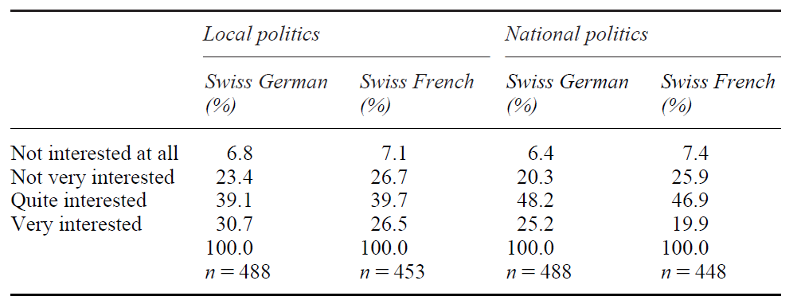
Source: Baglioni 2007, p.95 (Table 5.2).

Next, despite the empirical and theoretical reservations we noted here about the question item referring to the federal legislative elections, as an alternative measure, we recode the question and binarize it to indicate 1, meaning respondents that state “would not vote” and 0 otherwise. Estimating random-effects and fixed-effects logistic linear models to assess the impact of non-citizen voting rights reveal that our conclusions remain robust when our models are estimated using this alternative dependent variable measure showing a negative relationship between non-citizen voting rights and reporting to not going to vote in the next federal election. This result, of course, comes with the caveat regarding statistical power due to the concerns we noted above. Regardless, we note this aspect and conclude that our results indeed refer to participation in federal polls rather than federal legislative elections held every 4 years. The substantive findings from our main analysis are not challenged by replication with the federal election turnout measurement. We also check that ideological partisanship differences do not alter the relationship we study using respondents' subjective left-right placement. The models return substantively the same results as in our main models when the partisanship factor is included in our models, see Table A22.

Table A10: The effect of non-citizen voting rights on electoral participation, alternative DV
 | (1) | (2) | (3) | (4) | (5)
 | Random Effects |  | 2-way Fixed Effects
NCV | 0.00 | -0.00 | -0.01*** | -0.01* | -0.01*
 | (0.003) | (0.004) | (0.004) | (0.004) | (0.004)
Citizen with Immigration Background (CIB) | 0.03*** | 0.02*** | -0.00 | -0.02 | -0.02
 | (0.005) | (0.005) | (0.036) | (0.042) | (0.042)
Age |  | -0.00*** |  | -0.00*** | -0.00***
 |  | (0.000) |  | (0.000) | (0.000)
Female |  | 0.04***
 |  | (0.004)
Education |  | -0.01*** |  | -0.00 | 0.00
 |  | (0.000) |  | (0.001) | (0.001)
Income |  | 0.00 |  | -0.00 | -0.00
 |  | (0.000) |  | (0.000) | (0.000)
Constant | 0.09*** | 0.14*** | 0.06*** | 0.09*** | 0.09***
 | (0.003) | (0.011) | (0.005) | (0.012) | (0.016)
Year FE | Y | Y | Y | Y | Y
Canton FE | N | Y | N | N | Y
Individual FE | N | N | Y | Y | Y
Observations | 99,867 | 88,913 | 99,867 | 88,913 | 88,913
Number of individuals | 15,520 | 14,856 | 15,520 | 14,856 | 14,856
RMSE | 0.172 | 0.168 | 0.173 | 0.169 | 0.169
Note: DV (“Would not vote”=1). This alternative turnout measure is available in every wave of SHP so, the analysis from all waves 1999-2014. Standard errors in parentheses.
*** p<0.001, ** p<0.01, * p<0.05, t p<0.1

Finally, we also note that much like in other survey projects (Holbrook and Krosnick 2010), there is an average over-reporting of the federal poll participation in the SHP. The potential reasons for such an over-reporting in social and political survey is likely to be driven by a social desirability bias in reporting as participative as well as the likelihood that survey participants, overall, are more political and socially engaged citizens when compared to the average citizen. Figure A2 plots the average total participation rates in federal polls in Switzerland reported from the Swiss Federal Statistics Office (OFS). As the figure shows, on average, the participation rates in the polls oscillates between 40-50% across our observation period. This is lower, when we consider the about 6-7 polls, on average, that is reported by the SHP sample respondents. Yet, despite such an over reporting, the trends of the participation rates reported are remarkably parallel when comparing the OFS reported statistics with the average participation rates, we calculate using the SHP sample over time for the native citizen and citizen with immigration background groups, see Figure A3 and Figure A4. In this respect, our empirical strategy of within-individual estimations over time is robust to such an overall sample based higher political engagement. Since, such analyses do not rely on the level of participation but the change of such participation, the higher baseline among the sample participants are less concerning when observing changes in participation predicted by non-citizen voting rights.

Figure A2: Total participation rate in federal polls (OFS), over time
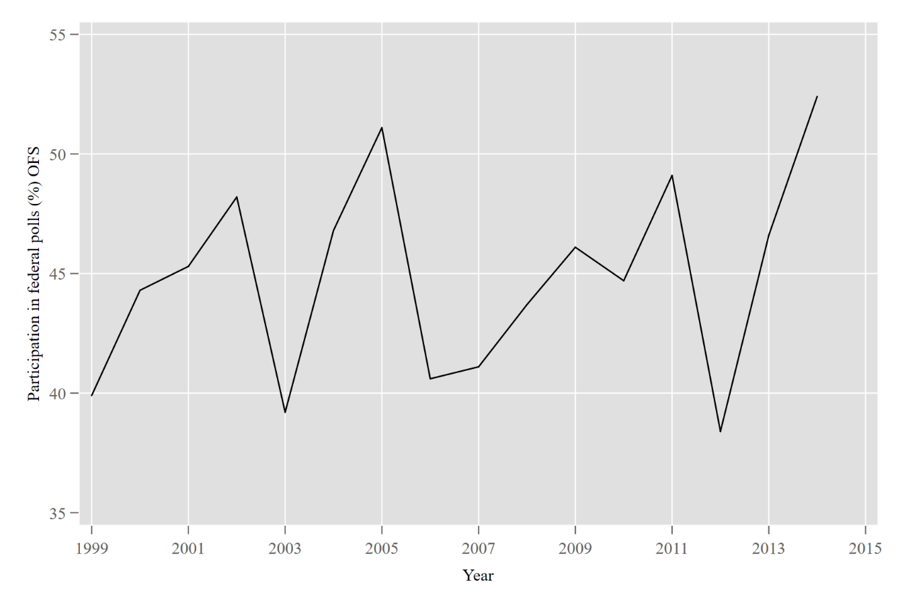
Source : Office fédéral de la statistique (OFS)

Figure A3: Mean participation rate in federal polls reported in SHP, by electoral group
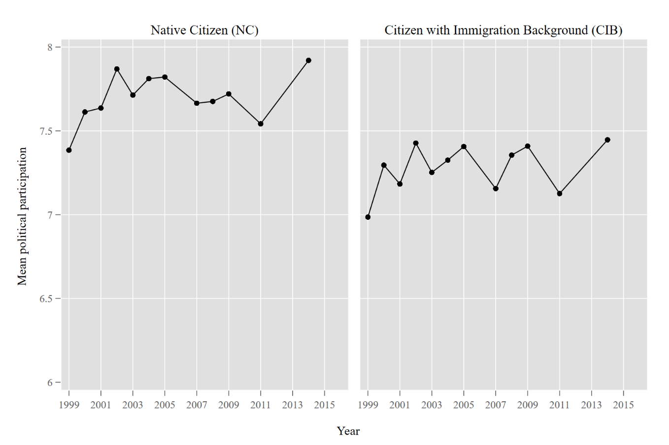

Figure A4 : Mean participation rate in federal polls reported in SHP, by group (NC, CIB) and NCV rights in municipality
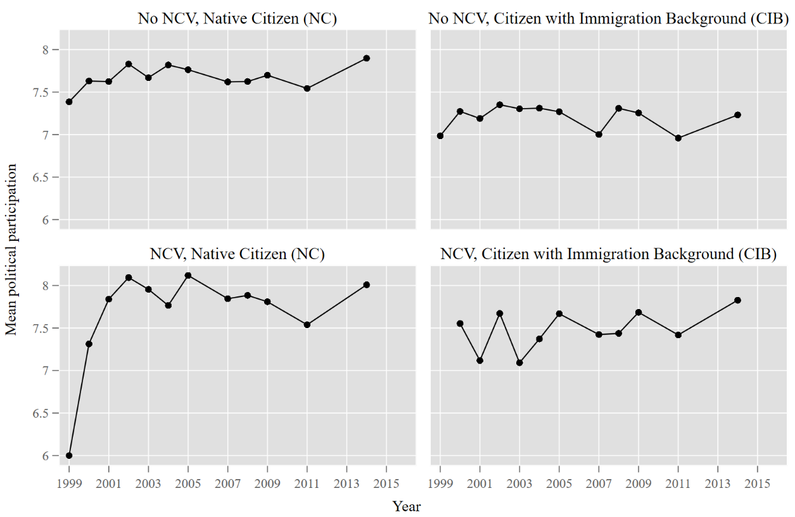
Figure A4 (above) also shows, as expected, the lower average participation rates among citizens with immigration background when compared to native citizens. In line with the empirical findings of the paper, such differences seem to be small among those living in municipalities with non-citizen voting rights. We also note that in 1999, the only canton with non-citizen voting rights was Jura. The exceptionally low average participation among native citizens in NCV rights contexts in 1999 is likely to be driven by the lower participation rates in this canton. To check that our findings are not sensitive to this, we exclude observations from 1999 and 2000 from our sample and re-estimate our models, revealing no changes in our results, see Table A30 and A31.

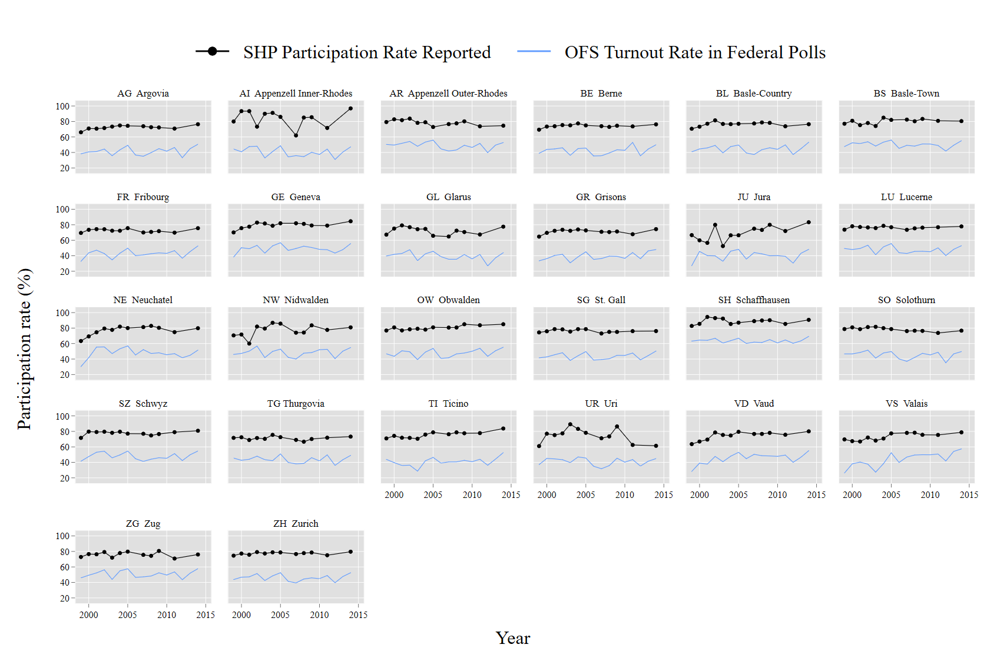
Figure A5: Participation rates in federal polls (OFS and reported in SHP), by canton

Figure A5 (above) plots the average reported participation rates in each canton over time and the OFS data reported for each canton, revealing that NCV positive cantons such as Vaud, Geneva, Fribourg, and Neuchatel are in line with the similar trends of over-reporting when compared to other cantons. For an intuitive comparison of the rates, we multiple the average reported participation rates we calculate using the SHP with ten in order have a comparable percentage point interpretation vis-à-vis the OFS reported rates. One potential important issue linked to over-reporting could be if there is systematic over-reporting of participation among citizens with immigration background living in municipalities with non-citizen voting rights. While some may argue that citizens with immigration background could potentially be more prone to overreporting to sustain an idea of the “ideal citizen”, we contend that if such over-reporting is systematic over time, then, our estimations within individuals is robust to this issue. Importantly, the concerns related to over-reporting would challenge our findings in the case that the over-reporting is indeed specific to the CIBs in the non-citizen enfranchised contexts. Since the OFS does not report official reports of participation in different groups, we are unable to check and compare the specific dynamics of the participation in OFS with SHP reports. However, we confirm that cantons which give voting rights to non-citizens do not seem to be linked to specifically higher over-reporting when compared to the OFS data.

Note on SHP sampling strategy and checks for attrition

The Swiss Household Panel’s sampling strategy is based on a stratified random sampling of private households whose members represent the non-institutional resident population in Switzerland. The SHP project started in 1999 with the first wave of survey respondents (SHP_I) where the “methodology section of the Swiss Federal Statistical Office drew a simple random sample in each of the seven major statistical regions of Switzerland from the Swiss telephone directory” (Voorpostel, et al. 2021, p.10). In 2004 (SHP_II) and 2013 (SHP_III) two additional refreshment random samples of households were added to the panel where the former was incorporated using the same methodology as in SHP_I and the latter sample was drawn from the data coming from the cantonal and communal register of residents at the individual level. All three samples in the SHP are stratified by the NUTS-II level seven major geographic regions in Switzerland. This means that the selection was proportional to the number of households per major region without overrepresentation of smaller regions. Within one major region, each household (SHP_I and SHP_II) or individual (SHP_III) had the same inclusion probability. Table A11 presents the stratification method of the gross sample in the SHP in the three sampling waves.

Table A11: Stratification method of SHP in the sample (I, II, III sampling waves)
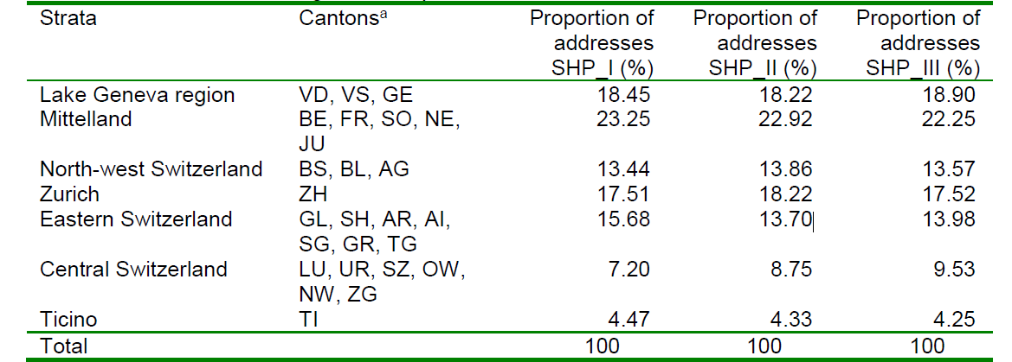
Source: Voorpostel, et al. 2021, p.11

In our analyses we use these stratified random samples of the SHP samples. Since we need the household residential information to match the individuals to their municipality to operationalise our key non-citizen voting rights indicator, we use data both at the individual and household level, merging the reported SHP files. Importantly, while SHP has other projects where the panel incorporates an over-sampling of certain groups such as the residents of Vaud, higher-income households etc. in the data sample we use, we only analyse the core SHP sample households and individuals, sampled in the method as described above.
As with all survey and longitudinal panel projects, the quality of the data relies on the continuous participation and response rate quality in the data collection. In this respect, SHP is considered a high quality scientifically appropriate data source for which analyses of attrition rates and composition are like household panel projects such as British Household Panel and European Community Household Panel. Lipps reports that, even though attrition is relatively higher in the SHP when compared to these projects that “it is not particularly selective with respect to important socio-demographic or economic variables” (Lipps 2007, p. 63). The difficulty of the attrition seems to be to track and keep the younger respondents in the panel and the tracking of the respondents who do not have Swiss citizenship. Table A12 below reports the participation rates and attrition across the three sampling waves of the SHP reported by FORS - the Swiss Centre of Expertise in the Social Science data which is responsible for the management of the SHP data collection.

Table A12: Participation in the SHP waves (1999-2016 across three sampling waves)

Participation rates for the first wave sample (SHP_I) recruited in 1999
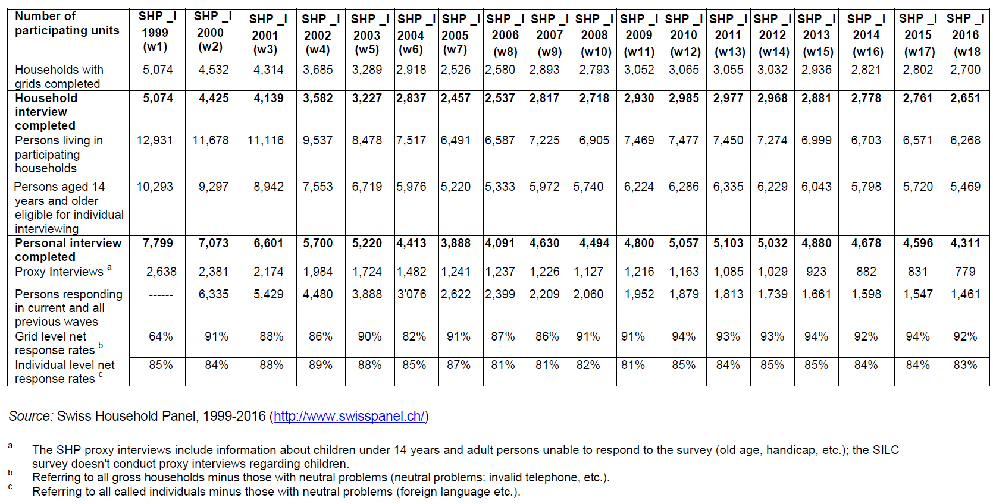

Participation rates for the second wave sample (SHP_II) recruited in 2004 and the third wave sample (SHP_III) recruited in 2013

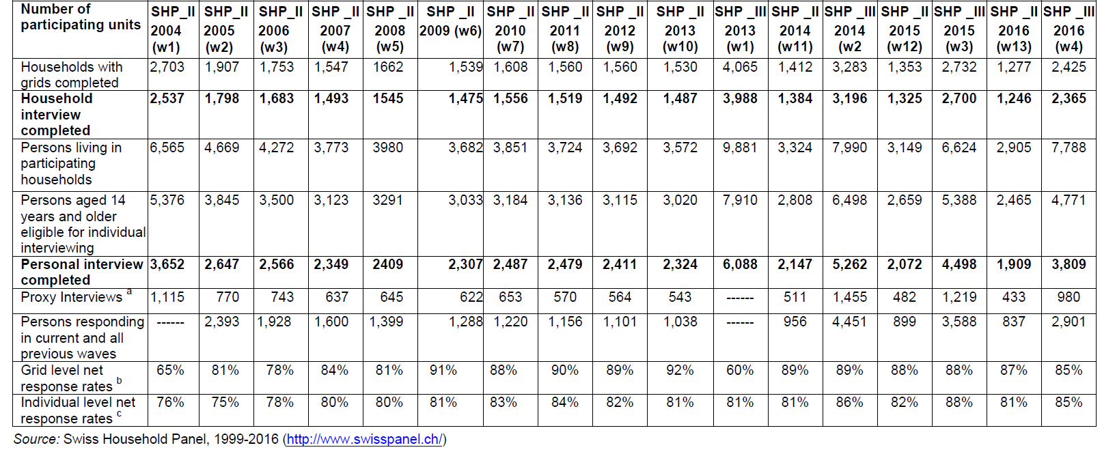

While the attrition sensitive groups are less relevant for the citizen and adult population for which our study refers to, we nevertheless also evaluate the sensitivity of the key dependent variable and the non-citizen voting rights distribution vis-à-vis such dynamics. To check for this, first, we calculate the participation rate of each individual respondent in the SHP panel. Since our analysis observes the respondents in the 1999-2014 period, for instance, an individual can be in the panel for a minimum of 1 and a maximum of 16 times. We are unable to use the SHP waves after 2014 because the more precise municipality of resident information for households is only available up to 2014. As an initial check, we report that the participation rate does not correlate highly with reported political participation variable (R= 0.1425).
Next, we see that the median number of participations is about 7 waves. Using this, we create a binary variable indicating individuals who are in the panel above or below the median participation rate. We, then, estimate the probability of low participation using a logistic regression with individual clustered errors in a model specification of potential covariates that are likely predictors of such participation rate in the panel such as age, gender, education level, income, employment status, and whether the respondent is a native citizen or a citizen with an immigration background. Table A13, below, reports the results from this estimation. Using this prediction, we calculate the predicted probability of the low attrition rate for our observations and report that the probability does not correlate highly either with the reported political participation, i.e., our DV, (R= -0.1935) or living in a municipality with non-citizen voting rights (R=-0.0145).

Table A13: Predicting below median participation rate in the SHP
 | (1)
Pr (Low participation rate)
Age | -0.11***
 | (0.003)
Female | -1.12***
 | (0.089)
Education | -0.22***
 | (0.015)
Income | -0.12***
 | (0.019)
Employment status (Ref: Employed)
Unemployed | 0.92**
 | (0.293)
Not in labour force | 0.97***
 | (0.108)
Ref: Native citizen
Citizen with an immigration background (CIB) | 0.76***
 | (0.111)
Constant | 11.09***
 | (0.327)
Canton FE | Y
Year FE | Y
Observations | 53,670
Number of individuals | 10,351
Log likelihood | -5783
Note: Logistic regression predicting the probability of individuals participating in less than 7 waves of the SHP. Clustered standard errors in parentheses *** p<0.001, ** p<0.01, * p<0.05, t p<0.1

Table A14: Full estimation results of models presented in Table 2

 | (M1) | (M2) | (M3) | (M4)
Non-citizen voting rights (NCV) | 0.36*** | 0.45*** | 0.44*** | 0.48***
 | (0.050) | (0.063) | (0.062) | (0.064)
Ref: Native Citizens (NCs)
Citizens with immigration background (CIB) | -0.56*** | -0.45*** | 0.77 | 0.77
 | (0.083) | (0.084) | (0.852) | (0.851)
Age |  | 0.03*** | 0.02*** | 0.02***
 |  | (0.002) | (0.003) | (0.003)
Female |  | -0.54***
 |  | (0.057)
Education |  | 0.08*** | -0.02 | -0.02
 |  | (0.008) | (0.012) | (0.012)
Income |  | -0.03*** | -0.02** | -0.02**
 |  | (0.006) | (0.007) | (0.007)
Canton (REF: Aargau )
AI Appenzell Inner-Rhodes |  | 0.81* |  | 0.10
 |  | (0.324) |  | (0.399)
AR Appenzell Outer-Rhodes |  | 0.13 |  | -0.14
 |  | (0.299) |  | (0.570)
BE Berne |  | -0.03 |  | -0.32
 |  | (0.123) |  | (0.307)
BS Basel-Town |  | 0.20 |  | -0.23
 |  | (0.138) |  | (0.241)
BL Basel-Country |  | 0.18 |  | -0.23
 |  | (0.131) |  | (0.238)
FR Fribourg |  | -0.40* |  | -0.58
 |  | (0.167) |  | (0.359)
GE Geneva |  | 0.25 |  | -0.07
 |  | (0.161) |  | (0.399)
GL Glarus |  | 0.05 |  | 1.36
 |  | (0.421) |  | (0.944)
GR Grisons |  | -0.22 |  | -0.25
 |  | (0.209) |  | (0.441)
JU Jura |  | -0.87* |  | -0.86
 |  | (0.414) |  | (0.562)
LU Lucerne |  | 0.24t |  | -0.07
 |  | (0.135) |  | (0.275)
NE Neuchatel |  | -0.19 |  | -0.97*
 |  | (0.162) |  | (0.397)
NW Nidwalden |  | 0.34 |  | -0.09
 |  | (0.385) |  | (0.656)
OW Obwalden |  | 0.33t |  | 0.15
 |  | (0.199) |  | (0.331)
SG St. Gall |  | 0.11 |  | 0.04
 |  | (0.161) |  | (0.388)
SH Schaffhausen |  | 0.86*** |  | 0.40
 |  | (0.227) |  | (0.400)
SO Solothurn |  | 0.02 |  | -0.53
 |  | (0.177) |  | (0.344)
SZ Schwyz |  | 0.25 |  | -0.02
 |  | (0.242) |  | (0.555)
TG Thurgovia |  | 0.06 |  | 0.41
 |  | (0.224) |  | (0.474)
TI Ticino |  | 0.04 |  | -0.63*
 |  | (0.163) |  | (0.318)
UR Uri |  | -0.45 |  | -1.58
 |  | (0.486) |  | (1.491)
VD Vaud |  | -0.34** |  | -0.60*
 |  | (0.133) |  | (0.295)
VS Valais |  | 0.06 |  | -0.22
 |  | (0.166) |  | (0.335)
ZG Zug |  | 0.20 |  | -0.05
 |  | (0.253) |  | (0.481)
ZH Zurich |  | 0.16 |  | -0.03
 |  | (0.110) |  | (0.236)
Constant | 7.06*** | 5.69*** | 6.90*** | 7.16***
 | (0.044) | (0.184) | (0.218) | (0.287)
Canton FE | N | Y | N | Y
Year FE | Y | Y | Y | Y
Individual FE | N | N | Y | Y
Observations | 61,870 | 53,670 | 53,670 | 53,670
Number of individuals | 10,820 | 10,351 | 10,351 | 10,351
RMSE | 1.587 | 1.567 | 1.409 | 1.408
Note: Robust standard errors in parentheses 1999, 2000, 2001, 2002, 2003, 2004, 2005, 2007, 2008, 2009, 2011, 2014 *** p<0.001, ** p<0.01, * p<0.05, t p<0.1

Table A15: Full estimation results of models presented in Table 3

 | (M5) | (M6) | (M7) | (M8)
Non-citizen voting rights (NCV) | 0.30*** | 0.38*** | 0.38*** | 0.41***
 | (0.056) | (0.067) | (0.068) | (0.070)
Ref: Native Citizens (NCs)
Citizens with immigration background (CIB) | -0.63*** | -0.54*** | 0.58 | 0.57
 | (0.088) | (0.089) | (0.841) | (0.839)
Ref: NCV*Native Citizen
NCV*CIB | 0.26* | 0.33** | 0.33* | 0.34*
 | (0.119) | (0.127) | (0.151) | (0.151)
Age |  | 0.03*** | 0.02*** | 0.02***
 |  | (0.002) | (0.003) | (0.003)
Female |  | -0.54***
 |  | (0.057)
Education |  | 0.08*** | -0.02 | -0.02
 |  | (0.008) | (0.012) | (0.012)
Income |  | -0.03*** | -0.02** | -0.02**
 |  | (0.006) | (0.007) | (0.007)
Canton (REF: Aargau )
AI Appenzell Inner-Rhodes |  | 0.80* |  | 0.10
 |  | (0.323) |  | (0.399)
AR Appenzell Outer-Rhodes |  | 0.13 |  | -0.14
 |  | (0.300) |  | (0.573)
BE Berne |  | -0.03 |  | -0.31
 |  | (0.123) |  | (0.308)
BS Basel-Town |  | 0.20 |  | -0.23
 |  | (0.138) |  | (0.241)
BL Basel-Country |  | 0.18 |  | -0.24
 |  | (0.131) |  | (0.238)
FR Fribourg |  | -0.40* |  | -0.58
 |  | (0.167) |  | (0.360)
GE Geneva |  | 0.23 |  | -0.07
 |  | (0.161) |  | (0.399)
GL Glarus |  | 0.04 |  | 1.35
 |  | (0.421) |  | (0.944)
GR Grisons |  | -0.22 |  | -0.26
 |  | (0.209) |  | (0.442)
JU Jura |  | -0.85* |  | -0.87
 |  | (0.412) |  | (0.554)
LU Lucerne |  | 0.24t |  | -0.07
 |  | (0.135) |  | (0.275)
NE Neuchatel |  | -0.20 |  | -1.00*
 |  | (0.163) |  | (0.402)
NW Nidwalden |  | 0.33 |  | -0.09
 |  | (0.385) |  | (0.656)
OW Obwalden |  | 0.33 |  | 0.15
 |  | (0.199) |  | (0.331)
SG St. Gall |  | 0.11 |  | 0.04
 |  | (0.161) |  | (0.388)
SH Schaffhausen |  | 0.86*** |  | 0.40
 |  | (0.227) |  | (0.400)
SO Solothurn |  | 0.02 |  | -0.52
 |  | (0.177) |  | (0.343)
SZ Schwyz |  | 0.25 |  | -0.03
 |  | (0.242) |  | (0.556)
TG Thurgovia |  | 0.06 |  | 0.41
 |  | (0.225) |  | (0.474)
TI Ticino |  | 0.05 |  | -0.63*
 |  | (0.164) |  | (0.319)
UR Uri |  | -0.45 |  | -1.59
 |  | (0.487) |  | (1.492)
VD Vaud |  | -0.35** |  | -0.60*
 |  | (0.133) |  | (0.298)
VS Valais |  | 0.06 |  | -0.24
 |  | (0.166) |  | (0.336)
ZG Zug |  | 0.20 |  | -0.05
 |  | (0.254) |  | (0.481)
ZH Zurich |  | 0.16 |  | -0.03
 |  | (0.110) |  | (0.236)
Constant | 7.07*** | 5.70*** | 6.93*** | 7.19***
 | (0.044) | (0.184) | (0.217) | (0.286)
Canton FE | Y | N | Y | N
Year FE | Y | Y | Y | Y
Individual FE | N | N | Y | Y
Observations | 61,870 | 53,670 | 53,670 | 53,670
Number of individuals | 10,820 | 10,351 | 10,351 | 10,351
RMSE | 1.587 | 1.567 | 1.408 | 1.408
Note: Robust standard errors in parentheses 1999, 2000, 2001, 2002, 2003, 2004, 2005, 2007, 2008, 2009, 2011, 2014 *** p<0.001, ** p<0.01, * p<0.05, t p<0.1

Figure A6: Replication of Figure 2 with 90% CIs
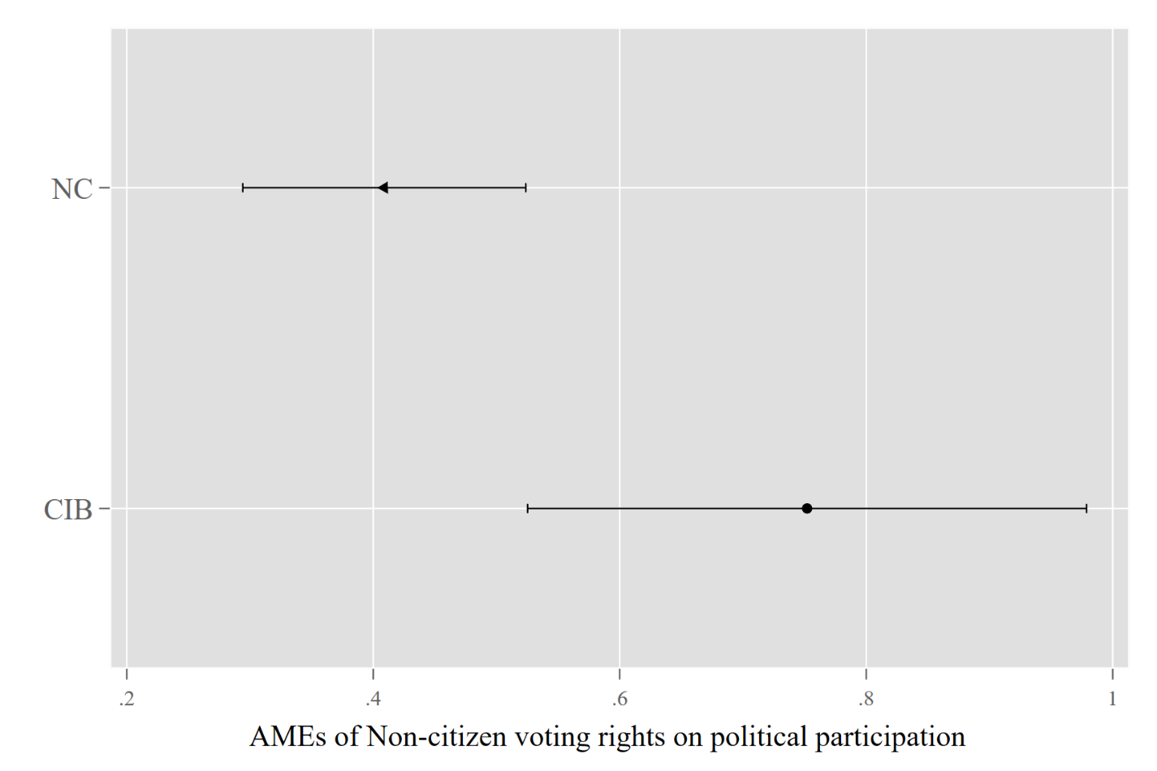

Figure A7: Replication of Figure 3 with 90% CIs
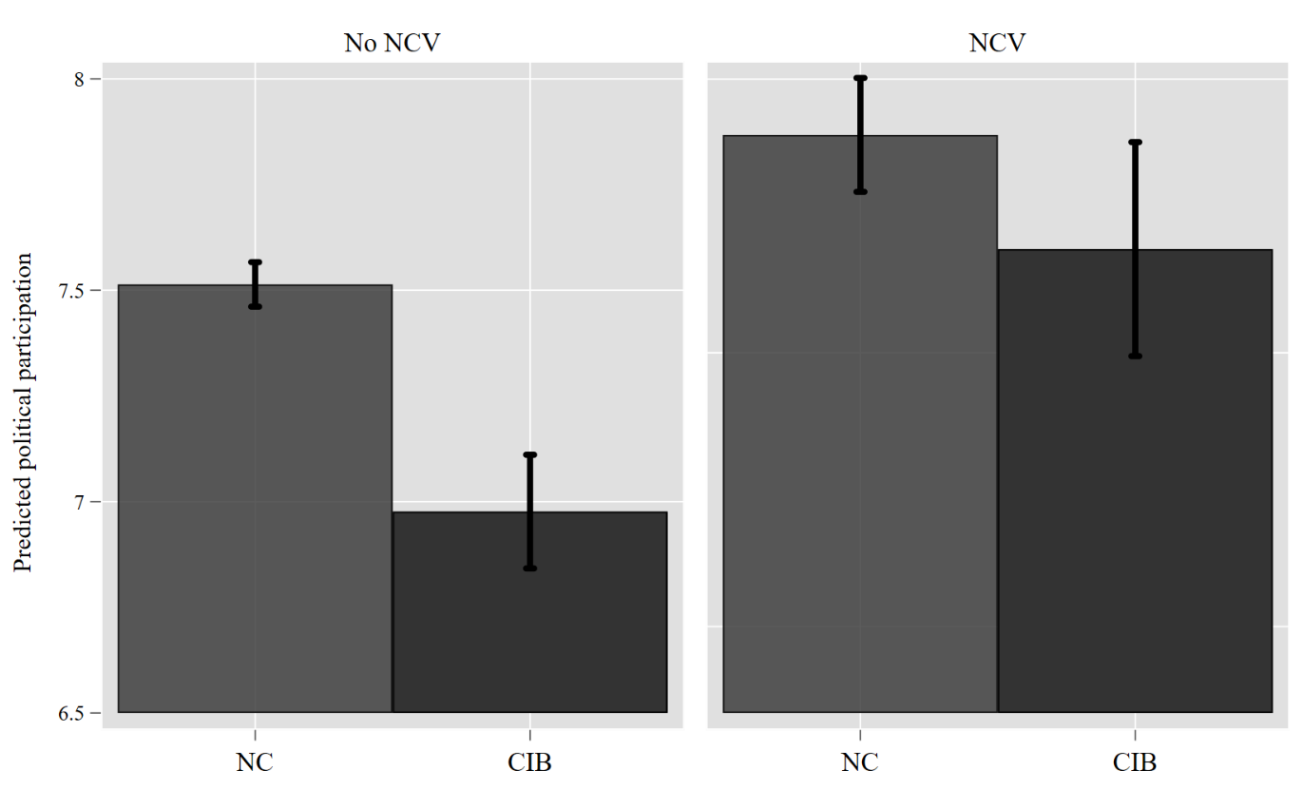

Robustness with alternative categories of status variable

Figure A8: Mean reported participation by more disaggregated categories of electoral groups
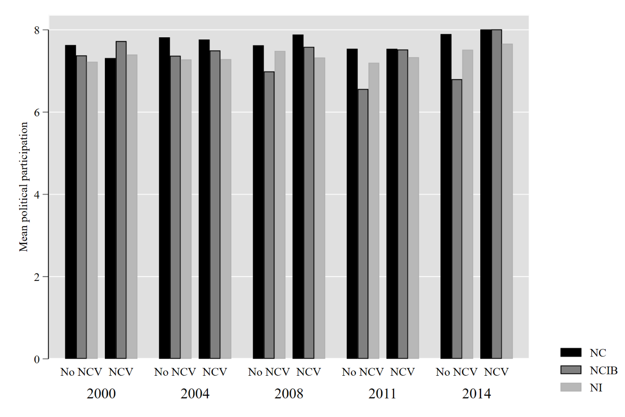
Note: NC: Native citizens; NCIB: Native citizens with immigration background (Swiss citizens from birth); NI: Naturalised immigrants. NCV: Non-citizen voting rights.

Our operationalisation of the two electoral groups among citizens consisted of native citizens and citizens with immigration backgrounds. Yet, the citizens with immigration background are themselves a heterogeneous group, meaning that first and second-generation immigrants are arguably distinct between each other as well. Figure A8, for instance, shows that while these groups are by and large lower in participation than NCs, there is indeed some descriptive differences in the group average between these groups as well. To ensure that our results are not driven by the way we measure our groups, we also re-estimate our models accounting for a more disaggregated conceptualisation of electoral groups that takes into consideration being born in Switzerland and having the Swiss citizenship by birth vs. first generation immigrants and those who personally go through the process of naturalisation themselves. We report our results in Table A16 and Table A17 below showing that the main findings in the paper hold.

Table A16: Replication of models presented in Table 2
 | (M1) | (M3) | (M4) | (M5)
NCV | 0.36*** | 0.45*** | 0.44*** | 0.48***
 | (0.050) | (0.063) | (0.062) | (0.064)
Ref: Native Citizen (NC)
NCIB | -0.61*** | -0.20 | 0.77 | 0.77
 | (0.128) | (0.130) | (0.852) | (0.851)
NI | -0.52*** | -0.63*** | omitted
 | (0.101) | (0.100)
Age |  | 0.03*** | 0.02*** | 0.02***
 |  | (0.002) | (0.003) | (0.003)
Female |  | -0.53*** | omitted
 |  | (0.057)
Education |  | 0.08*** | -0.02 | -0.02
 |  | (0.008) | (0.012) | (0.012)
Income |  | -0.03*** | -0.02** | -0.02**
 |  | (0.006) | (0.007) | (0.007)
Constant | 7.06*** | 5.65*** | 7.33*** | 7.60***
 | (0.044) | (0.184) | (0.179) | (0.259)
Canton FE | N | Y | N | Y
Year FE | Y | Y | Y | Y
Individual FE | N | N | Y | Y
Observations | 61,870 | 53,670 | 53,670 | 53,670
Number of individuals | 10,820 | 10,351 | 10,351 | 10,351
RMSE | 1.587 | 1.567 | 1.409 | 1.408
Note: Linear regression coefficients are displayed. Robust individual clustered standard errors in parentheses. *** p<0.001, ** p<0.01, * p<0.05, t p<0.1

Table A17: Replication of Table 3 with the more detailed categorical variable
 | (M5) | (M6) | (M7) | (M8)
NCV | 0.30*** | 0.39*** | 0.38*** | 0.41***
 | (0.056) | (0.067) | (0.068) | (0.070)
Ref: Native Citizen (NC)
NCIB | -0.69*** | -0.33* | 0.55 | 0.53
 | (0.134) | (0.136) | (0.839) | (0.836)
NI | -0.58*** | -0.69***
 | (0.109) | (0.108)
Ref: NC*NCV
NCIB*NCV | 0.25 | 0.40* | 0.38t | 0.41*
 | (0.166) | (0.175) | (0.209) | (0.209)
NI*NCV | 0.27t | 0.26 | 0.30 | 0.30
 | (0.153) | (0.163) | (0.195) | (0.195)
Age |  | 0.03*** | 0.02*** | 0.02***
 |  | (0.002) | (0.003) | (0.003)
Female |  | -0.53***
 |  | (0.057)
Education |  | 0.08*** | -0.02 | -0.02
 |  | (0.008) | (0.012) | (0.012)
Income |  | -0.03*** | -0.02** | -0.02**
 |  | (0.006) | (0.007) | (0.007)
Constant | 7.07*** | 5.66*** | 6.98*** | 7.25***
 | (0.044) | (0.184) | (0.188) | (0.265)
Year FE | Y | Y | Y | Y
Individual FE | N | N | Y | Y
Canton FE | N | Y | N | Y
Observations | 61,870 | 53,670 | 53,670 | 53,670
Number of individuals | 10,820 | 10,351 | 10,351 | 10,351
RMSE | 1.587 | 1.567 | 1.408 | 1.408
Note: Linear regression coefficients are displayed. Robust individual clustered standard errors in parentheses. *** p<0.001, ** p<0.01, * p<0.05, t p<0.1

Robustness checks by concentrating on four cantons with canton-wide non-citizen voting rights legislation

Among the positive cases of NCV in our sample and observation period one canton (Jura) has had NCV across all surveyed years and two cantons had opt-in regimes (Grisons and Appenzell-Ausserrhoden), meaning that the municipalities that have NCVs have selected into an electoral regime which gives NCV rights once the cantonal constitutional legislation has been changed into allowing such rights. While our findings are robust to removing all between canton variation, in the latter two cases, it is more difficult to hold the assumption of the NCV rights policy regulations as an external introduction and it is plausible to critique the design on such grounds. Therefore, to narrow our investigation of the effect of NCV as an external policy intervention to the municipalities more precisely we concentrate on the four cantons Neuchatel, Vaud, Fribourg, and Geneva which implemented NCV. In this respect, following earlier research studying the impact of NCV on political and social policy outcomes, we hold that for each canton each legislation can be plausibly characterised as an “exogenous temporal shock” (Ferwerda 2021, p.328). Figure A9 below plots the reported political participation trends over time in these four cantons for the two groups we concentrate on. For the four cantons, the two groups seem to follow a roughly parallel trends in participation. However, for the case of Neuchatel, the only pre-policy introduction observation year we have is from 1999.

Figure A9: Political participation trends over time, by group in 4 cantons

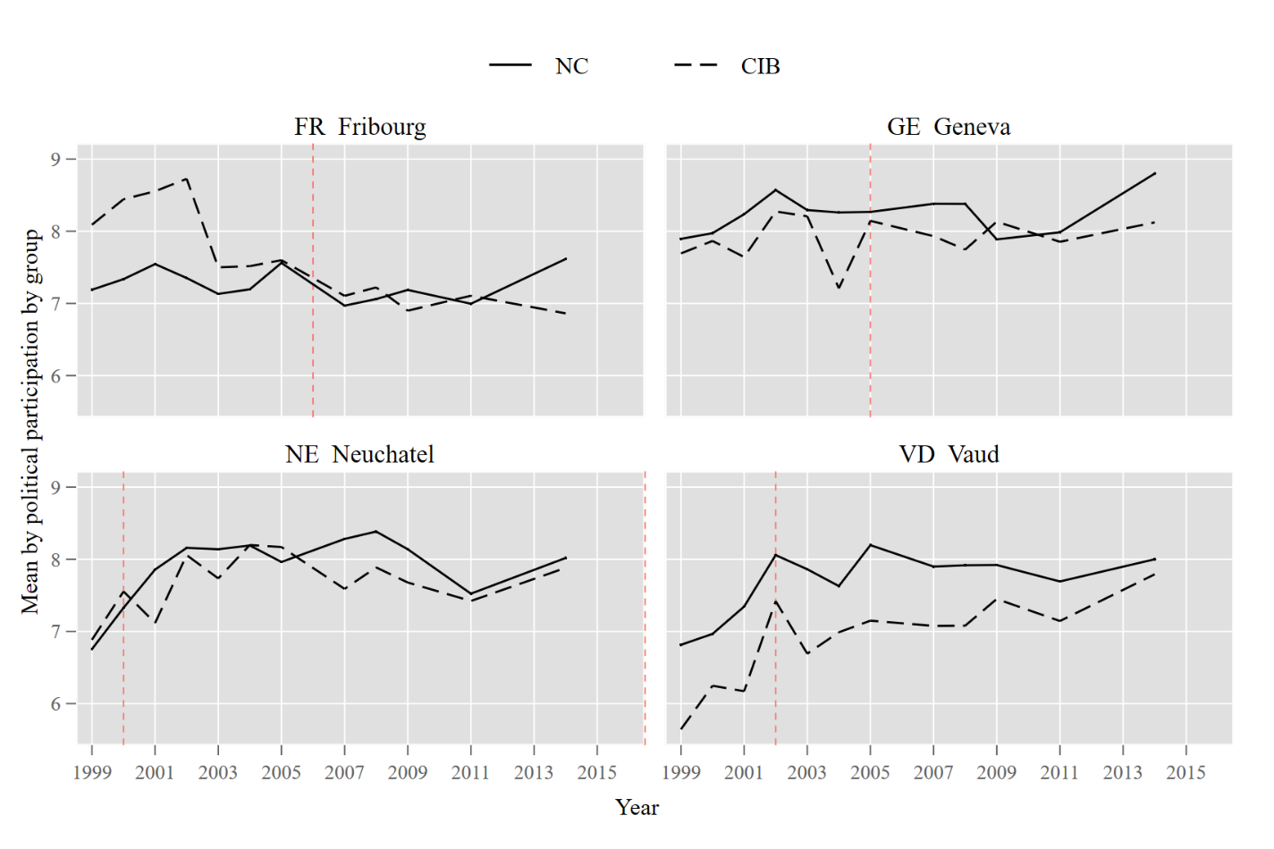
For an additional test of the findings in our analysis, we employ a difference-in-differences design strategy and assign citizens with immigration background in non-citizen enfranchised municipalities as our treated respondents. In this way, we obtain a point estimate of the Average Treatment Effect on the Treated (ATT), which indicates the effect of NCV rights in the “treatment group” which in this case implies citizens with immigration background after the introduction of non-citizen enfranchisement. To estimate the ATT, we use the following equation;
Y_{it}= NCV_{it} + S_{it} + (NCV_{it} * S_{it}) + X_{it} + u_{i} + v_{t} +ε_{it}
Y measures the political participation reported by an individual at a given year, NCV is the binary variable indicative of the presence or absence of NCV in the municipality that the respondent i lives in at t. S is the binary indicator of whether the individual is CIB or NC. X demonstrates the vector of alternative explanations that we control for in our model estimations, age, education, and income. We estimate a two-way fixed effects accounting for between individual (u_{i} ) and between year differences (v_{t}). Our specification also includes a linear time trend control with wave dummies. The coefficient of ATT reported in Table A18 display the estimated change in political participation among citizens with immigration background following the extension of NCV. The first model presents the ATT without the additional controls and the second one is the result of the fully specified equation model as above. Lastly, since we do not have sufficient pre-treatment information for Neuchatel, we also re-estimate our ATT with the exclusion of this case and reveal that our results support the main findings reported in the paper. Our findings strongly relate to our previous results that included between-municipality variation and were based on the full dataset. The ATT suggests that receiving the treatment, i.e. being exposed to NCV rights, results in higher participation rates.

Table A18: Average treatment effect on the treated (ATT) predicted in two-way fixed effects with 4 cantons
 | (1) | (2) | (3)
 |  |  | Excluding Neuchatel
ATT | 0.31* | 0.40** | 0.41**
 | (0.133) | (0.146) | (0.156)
Age |  | 0.08*** | 0.08***
 |  | (0.008) | (0.009)
Education |  | -0.01 | -0.01
 |  | (0.028) | (0.032)
Income |  | -0.00 | 0.00
 |  | (0.017) | (0.019)
Constant | 6.70*** | 3.64*** | 3.86***
 | (0.064) | (0.472) | (0.536)
Observations | 15,730 | 13,627 | 10,505
R-squared | 0.033 | 0.033 | 0.029
Number of individuals | 3,107 | 2,946 | 2,303
RMSE | 1.605 | 1.567 | 1.549
Note: All models estimated with individual clustered robust standard errors and two-way linear fixed effect specifications. Linear estimation coefficients are presented.
*** p<0.001, ** p<0.01, * p<0.05, t p<0.1

Table A19: Political participation models with lagged DV estimation
 | (1) | (2) | (3)
Lagged DV: Political participation (t-1) | 0.62*** | 0.60*** | 0.60***
 | (0.007) | (0.008) | (0.008)
Non-citizen voting (NCV) | 0.14*** | 0.15*** | 0.08t
 | (0.035) | (0.037) | (0.041)
Ref: Native Citizen
Citizen with Immigration Background (CIB) | -0.15*** | -0.13** | -0.17***
 | (0.044) | (0.046) | (0.052)
Ref: NCV*Native Citizen
NCV*CIB |  |  | 0.19*
 |  |  | (0.094)
Age |  | 0.02*** | 0.01***
 |  | (0.001) | (0.001)
Female |  | -0.21*** | -0.22***
 |  | (0.035) | (0.035)
Education |  | 0.06*** | 0.06***
 |  | (0.005) | (0.005)
Income |  | -0.01 | -0.01t
 |  | (0.006) | (0.006)
Constant | 3.00*** | 1.99*** | 1.96***
 | (0.067) | (0.121) | (0.119)
Year FE | Y | Y | Y
Observations | 32,806 | 28,505 | 28,505
Number of individuals | 7,588 | 7,233 | 7,233
RMSE | 1.664 | 1.628 | 1.630
Note: Linear regression coefficients are displayed. Robust individual clustered standard errors in parentheses. *** p<0.001, ** p<0.01, * p<0.05, t p<0.1

Table A20: Political participation models with forwards lagged IV by one-year

 | (1) | (2) | (3) | (4)
Non-citizen voting (NCV) rights (t+1) | 0.25*** | 0.20** | 0.36*** | 0.30***
 | (0.056) | (0.062) | (0.046) | (0.051)
Ref: Native Citizen (NC)
CIB | -0.46*** | -0.54*** | 0.54 | 0.36
 | (0.084) | (0.091) | (0.508) | (0.513)
Ref: NCV*Native Citizen
NCV*CIB |  | 0.26t |  | 0.29*
 |  | (0.137) |  | (0.114)
Age | 0.03*** | 0.03*** | 0.02*** | 0.02***
 | (0.002) | (0.002) | (0.002) | (0.002)
Female | -0.52*** | -0.52***
 | (0.058) | (0.058)
Education | 0.08*** | 0.08*** | -0.01 | -0.01
 | (0.009) | (0.009) | (0.009) | (0.009)
Income | -0.02*** | -0.02*** | -0.02*** | -0.02***
 | (0.007) | (0.007) | (0.006) | (0.006)
Constant | 5.65*** | 5.66*** | 6.75*** | 6.77***
 | (0.167) | (0.167) | (0.152) | (0.152)
Observations | 50,440 | 50,440 | 50,440 | 50,440
Year FE | Y | Y | Y | Y
Individual FE | N | N | Y | Y
Number of individuals | 9,748 | 9,748 | 9,748 | 9,748
RMSE | 1.549 | 1.549 | 1.550 | 1.550
Note: By allowing the effect of NCV to be tested in t+1, we can relax the assumption with respect when the impact of this legislation should be expected to be observed. Linear regression coefficients are displayed. Robust individual clustered standard errors in parentheses.
*** p<0.001, ** p<0.01, * p<0.05, t p<0.1

Table A21: Political participation models controlling for region of origin and employment status

 | (1) | (2) | (3) | (4)
Non-citizen voting (NCV) | 0.35*** | 0.28*** | 0.35*** | 0.28***
 | (0.054) | (0.058) | (0.052) | (0.058)
Ref: Native Citizen (NC)
CIB | -0.22t | -0.36** | -0.46*** | -0.55***
 | (0.129) | (0.133) | (0.083) | (0.088)
Ref: NCV*Native Citizen
NCV*CIB |  | 0.42** |  | 0.34**
 |  | (0.141) |  | (0.127)
Origin (Ref: Swiss)
N.Europe | 0.54 | 0.60
 | (0.961) | (0.965)
E.Europe | -0.12 | -0.07
 | (1.377) | (1.360)
C.Europe | -0.45 | -0.37
 | (0.302) | (0.303)
W.Europe | 0.16 | 0.10
 | (0.259) | (0.262)
SW.Europe | -0.54 | -0.61
 | (0.507) | (0.506)
S.Europe | -0.15 | -0.12
 | (0.234) | (0.234)
SE. Europe | -1.64*** | -1.57***
 | (0.406) | (0.406)
Africa | -1.31** | -1.39***
 | (0.420) | (0.421)
L.America | -0.86 | -0.84
 | (0.602) | (0.602)
N.America | -0.69 | -0.66
 | (0.890) | (0.887)
Asia | -1.63** | -1.63**
 | (0.502) | (0.511)
Oceania | -2.04 | -1.91
 | (2.059) | (2.059)
Employment status (Ref: Employed)
Unemployed |  |  | 0.06 | 0.06
 |  |  | (0.090) | (0.090)
Not in labour force |  |  | 0.08* | 0.08*
 |  |  | (0.034) | (0.034)
Age | 0.03*** | 0.03*** | 0.03*** | 0.03***
 | (0.002) | (0.002) | (0.002) | (0.002)
Female | -0.53*** | -0.53*** | -0.53*** | -0.53***
 | (0.058) | (0.058) | (0.057) | (0.057)
Education | 0.08*** | 0.08*** | 0.08*** | 0.08***
 | (0.009) | (0.009) | (0.008) | (0.008)
Income | -0.03*** | -0.03*** | -0.02** | -0.02***
 | (0.007) | (0.007) | (0.007) | (0.007)
Constant | 5.73*** | 5.74*** | 5.67*** | 5.68***
 | (0.165) | (0.165) | (0.163) | (0.163)
Year FE | Y | Y | Y | Y
Observations | 51,673 | 51,673 | 53,670 | 53,670
Number of individuals | 10,023 | 10,023 | 10,351 | 10,351
RMSE | 1.568 | 1.568 | 1.568 | 1.568
Note: Linear regression coefficients are displayed. Robust individual clustered standard errors in parentheses. *** p<0.001, ** p<0.01, * p<0.05, t p<0.1

Table A22: Political participation models controlling for partisanship, union membership, and religiosity

 | (1) | (2) | (3) | (4) | (5) | (6)
Non-citizen voting (NCV) | 0.32*** | 0.25*** | 0.35*** | 0.28*** | 0.36*** | 0.30***
 | (0.053) | (0.059) | (0.052) | (0.058) | (0.054) | (0.060)
Ref: Native Citizen (NC)
CIB | -0.39*** | -0.48*** | -0.45*** | -0.55*** | -0.43*** | -0.51***
 | (0.083) | (0.088) | (0.083) | (0.088) | (0.087) | (0.092)
Ref: AE*Native Citizen
NCV*CIB |  | 0.35** |  | 0.34** |  | 0.32*
 |  | (0.127) |  | (0.126) |  | (0.131)
Left-right placement | -0.00 | -0.00
 | (0.007) | (0.007)
Union membership (Ref: Active member)
Passive member |  |  | -0.09* | -0.09*
 |  |  | (0.036) | (0.036)
Not a member |  |  | -0.12** | -0.12**
 |  |  | (0.037) | (0.037)
Religiosity |  |  |  |  | 0.04*** | 0.04***
 |  |  |  |  | (0.008) | (0.008)
Age | 0.04*** | 0.04*** | 0.03*** | 0.03*** | 0.04*** | 0.04***
 | (0.002) | (0.002) | (0.002) | (0.002) | (0.002) | (0.002)
Female | -0.42*** | -0.42*** | -0.53*** | -0.53*** | -0.53*** | -0.53***
 | (0.056) | (0.056) | (0.057) | (0.057) | (0.062) | (0.062)
Education | 0.07*** | 0.07*** | 0.08*** | 0.08*** | 0.09*** | 0.09***
 | (0.008) | (0.008) | (0.008) | (0.008) | (0.010) | (0.010)
Income | -0.03*** | -0.03*** | -0.03*** | -0.03*** | -0.02* | -0.02*
 | (0.006) | (0.006) | (0.006) | (0.006) | (0.007) | (0.007)
Constant | 5.88*** | 5.89*** | 5.82*** | 5.82*** | 5.30*** | 5.31***
 | (0.167) | (0.167) | (0.167) | (0.167) | (0.186) | (0.186)
Year FE | Y | Y | Y | Y | Y | Y
Observations | 48,413 | 48,413 | 53,621 | 53,621 | 42,329 | 42,329
Number of individuals | 9,918 | 9,918 | 10,348 | 10,348 | 9,024 | 9,024
RMSE | 1.481 | 1.481 | 1.568 | 1.568 | 1.527 | 1.526
Note: Linear regression coefficients are displayed. Robust individual clustered standard errors in parentheses. *** p<0.001, ** p<0.01, * p<0.05, t p<0.1

Table A23: Political participation models controlling for political interest

 | (1) | (2) | (3) | (4)
Political interest | 0.32*** | 0.32*** | 0.21*** | 0.21***
 | (0.007) | (0.007) | (0.008) | (0.008)
Non-citizen voting (NCV) | 0.36*** | 0.30*** | 0.39*** | 0.33***
 | (0.048) | (0.054) | (0.060) | (0.067)
Ref: Native Citizen (NC)
CIB | -0.38*** | -0.45*** | 0.87 | 0.69
 | (0.072) | (0.078) | (0.836) | (0.825)
Ref: NCV*Native Citizen
NCV*CIB |  | 0.27* |  | 0.31*
 |  | (0.118) |  | (0.146)
Age | 0.02*** | 0.02*** | 0.04*** | 0.04***
 | (0.001) | (0.001) | (0.003) | (0.003)
Female | -0.18*** | -0.18*** | -0.38*** | -0.36***
 | (0.050) | (0.050) | (0.031) | (0.032)
Education | 0.06*** | 0.06*** | -0.02 | -0.02
 | (0.008) | (0.008) | (0.012) | (0.012)
Income | -0.02*** | -0.02*** | -0.02* | -0.02*
 | (0.006) | (0.006) | (0.007) | (0.007)
Constant | 4.04*** | 4.04*** | 5.33*** | 5.33***
 | (0.147) | (0.147) | (0.237) | (0.236)
Individual FE | N | N | Y | Y
Year FE | Y | Y | Y | Y
Observations | 53,646 | 53,646 | 53,646 | 53,646
Number of individuals | 10,349 | 10,349 | 10,349 | 10,349
RMSE | 1.558 | 1.558 | 1.382 | 1.382
Note: Linear regression coefficients are displayed. Robust individual clustered standard errors in parentheses. *** p<0.001, ** p<0.01, * p<0.05, t p<0.1

Table A24: Political participation models removing respondents that move between municipalities (random effects models)
 | (1) | (2) | (3) | (4)
Non-citizen voting (NCV) | 0.27*** | 0.35*** | 0.20** | 0.28***
 | (0.055) | (0.069) | (0.061) | (0.072)
Ref: Native Citizen (NC)
CIB | -0.42*** | -0.43*** | -0.52*** | -0.53***
 | (0.085) | (0.086) | (0.092) | (0.093)
Ref: NCV*Native Citizen
NCV*CIB |  |  | 0.38** | 0.37**
 |  |  | (0.139) | (0.140)
Age | 0.03*** | 0.03*** | 0.03*** | 0.03***
 | (0.002) | (0.002) | (0.002) | (0.002)
Female | -0.49*** | -0.50*** | -0.49*** | -0.50***
 | (0.061) | (0.061) | (0.061) | (0.061)
Education | 0.09*** | 0.09*** | 0.09*** | 0.09***
 | (0.009) | (0.009) | (0.009) | (0.009)
Income | -0.02** | -0.02** | -0.02** | -0.02**
 | (0.007) | (0.007) | (0.007) | (0.007)
Constant | 5.60*** | 5.56*** | 5.61***
 | (0.189) | (0.208) | (0.189)
Canton FE | N | Y | N | Y
Year FE | Y | Y | Y | Y
Observations | 43,172 | 43,172 | 43,172 | 43,172
Number of individuals | 9,070 | 9,070 | 9,070 | 9,070
RMSE | 1.474 | 1.474 | 1.474 | 1.474
Note: Linear regression coefficients are displayed. Robust individual clustered standard errors in parentheses. *** p<0.001, ** p<0.01, * p<0.05, t p<0.1

Table A25: Political participation models removing respondents that move between municipalities (fixed effects models)

 | (1) | (2) | (3) | (4)
Non-citizen voting (NCV) | 0.33*** | 0.35*** | 0.25*** | 0.27***
 | (0.069) | (0.070) | (0.075) | (0.076)
Ref: Native Citizen (NC)
CIB | 0.89 | 0.88 | 0.61 | 0.60
 | (0.747) | (0.748) | (0.721) | (0.723)
Ref: NCV*Native Citizen
NCV*CIB |  |  | 0.45** | 0.45**
 |  |  | (0.173) | (0.173)
Age | 0.03*** | 0.03*** | 0.03*** | 0.03***
 | (0.003) | (0.003) | (0.003) | (0.003)
Female | -0.26*** | -0.26*** | -0.26*** | -0.26***
 | (0.035) | (0.035) | (0.035) | (0.035)
Education | -0.03* | -0.03* | -0.03* | -0.03*
 | (0.013) | (0.013) | (0.013) | (0.013)
Income | -0.01t | -0.01 | -0.01t | -0.01t
 | (0.008) | (0.008) | (0.008) | (0.008)
Constant | 7.15*** | 7.30*** | 7.19*** | 7.34***
 | (0.244) | (0.322) | (0.242) | (0.321)
Individual FE | Y | Y | Y | Y
Canton FE | N | Y | N | Y
Year FE | Y | Y | Y | Y
Observations | 43,172 | 43,172 | 43,172 | 43,172
R-squared | 0.008 | 0.009 | 0.008 | 0.009
Number of individuals | 9,070 | 9,070 | 9,070 | 9,070
RMSE | 1.307 | 1.307 | 1.307 | 1.307
Note: Linear regression coefficients are displayed. Robust individual clustered standard errors in parentheses. *** p<0.001, ** p<0.01, * p<0.05, t p<0.1

Table A26: Political participation models controlling for the share % vote of SVP in each municipality

 | (1) | (2) | (3) | (4)
Non-citizen voting (NCV) | 0.33*** | 0.25*** | 0.36*** | 0.28***
 | (0.054) | (0.060) | (0.044) | (0.048)
Ref: Native Citizen (NC)
CIB | -0.48*** | -0.58*** | 0.21 | 0.00
 | (0.081) | (0.088) | (0.432) | (0.435)
Ref: NCV*Native Citizen
NCV*CIB |  | 0.38** |  | 0.39***
 |  | (0.130) |  | (0.100)
SVP vote share (%) | 0.00 | 0.00 | 0.01*** | 0.01***
 | (0.002) | (0.002) | (0.002) | (0.002)
Age | 0.03*** | 0.03*** | 0.02*** | 0.02***
 | (0.002) | (0.002) | (0.002) | (0.002)
Female | -0.53*** | -0.53***
 | (0.057) | (0.057)
Education | 0.08*** | 0.08*** | -0.01 | -0.01
 | (0.008) | (0.008) | (0.009) | (0.009)
Income | -0.03*** | -0.03*** | -0.02** | -0.02***
 | (0.007) | (0.007) | (0.006) | (0.006)
Constant | 5.70*** | 5.71*** | 6.92*** | 6.94***
 | (0.176) | (0.176) | (0.150) | (0.151)
Year FE | Y | Y | Y | Y
Individual FE | N | N | Y | Y
Observations | 51,680 | 51,680 | 51,680 | 51,680
Number of individuals | 10,260 | 10,260 | 10,260 | 10,260
RMSE | 1.556 | 1.556 | 1.556 | 1.556
Note: Linear regression coefficients are displayed. Robust individual clustered standard errors in parentheses. *** p<0.001, ** p<0.01, * p<0.05, t p<0.1

Table A27: Political participation models controlling for the share % of foreigners residing in each municipality

 | (1) | (2) | (3) | (4)
Non-citizen voting (NCV) | 0.27*** | 0.20** | 0.34*** | 0.26***
 | (0.059) | (0.066) | (0.050) | (0.056)
Ref: Native Citizen (NC)
CIB | -0.43*** | -0.54*** | 1.22** | 0.96*
 | (0.087) | (0.094) | (0.459) | (0.465)
Ref: NCV*Native Citizen
NCV*CIB |  | 0.38** |  | 0.42***
 |  | (0.142) |  | (0.122)
Share % of foreigners in municipality | 0.00 | 0.00 | 0.00 | 0.00
 | (0.002) | (0.002) | (0.003) | (0.003)
Age | 0.03*** | 0.03*** | 0.02*** | 0.02***
 | (0.002) | (0.002) | (0.002) | (0.002)
Female | -0.57*** | -0.57***
 | (0.060) | (0.060)
Education | 0.09*** | 0.09*** | -0.01 | -0.01
 | (0.009) | (0.009) | (0.010) | (0.010)
Income | -0.03*** | -0.03*** | -0.02*** | -0.02***
 | (0.007) | (0.007) | (0.007) | (0.007)
Constant | 5.73*** | 5.74*** | 6.74*** | 6.77***
 | (0.175) | (0.175) | (0.165) | (0.165)
Year FE | Y | Y | Y | Y
Individual FE | N | N | Y | Y
Observations | 40,566 | 40,566 | 40,566 | 40,566
Number of individuals | 9,429 | 9,429 | 9,429 | 9,429
RMSE | 1.543 | 1.543 | 1.541 | 1.541
Note: Foreigners indicate residents in any municipality who do not hold Swiss citizenship. The data comes from the national statistics office of Switzerland (OFS).
Considering the data availability, our sample here is limited 2000-2014. We use data from 2000, 2007, 2010, and 2014 and match these values lagging forward 3 years maximum. Linear regression coefficients are displayed. Robust individual clustered standard errors in parentheses. *** p<0.001, ** p<0.01, * p<0.05, t p<0.1

Analysis of the attitudes towards NCV in CH

To assess the attitudes towards the NCV rights among Swiss residents, we turn to the Measurement and Observation of Social Attitudes in Switzerland (MOSAiCH) survey (Stähli Stähli, et al. 2015), see Table A28 for details of the variables used. In the 2015 wave, the MOSAiCH project included a question on attitudes towards granting long-term resident immigrants in Switzerland the right to participate in elections. The question is as follows: "There are different opinions about people's rights in a democracy. On a scale of 1 to 7 going from 'being not at all important' to 'very important', how important is that long-term residents of a country, who are not citizens, have the right to vote in that country's national elections." Using this question, we achieve better internal validity to the concept of sharing political rights and triangulate our results, finding strong robustness across these different data sources. Table A29 displays the results of linear regressions with canton-clustered standard errors replicating our main model specifications. These results suggest that naturalised immigrants (citizens with an immigration background) significantly differ in their attitudes towards sharing politics rights with foreigners, in line with previous evidence (Michel and Blatter 2020). In this respect, citizens with an immigration background seem to be more positive towards sharing political rights with non-citizens when compared to native citizens.

Table A28: Summary statistics of the variables used in MOSAiCH

Summary statistics for the full sample (N+NI+NNI) | N | Mean | Std. Dev. | Min | Max
Status and immigration background
Native citizens | 1,115 | .6493274 | .4773947 | 0 | 1
Naturalized citizens | 1,115 | .1408072 | .3479786 | 0 | 1
Non-naturalized immigrants (non-citizens) | 1,115 | .2098655 | .4073951 | 0 | 1
Non-citizen voting (NCV)support | 1,210 | 4.52314 | 1.946737 | 1 | 7
Female | 1,235 | 0.5109312 | .500083 | 0 | 1
Age | 1,235 | 48.85992 | 17.87483 | 18 | 94
Education | 1,228 | 11.20684 | 3.585657 | 0 | 33
Income (deciles) | 1,014 | 5.464497 | 2.66938 | 1 | 10
Left-right ideology | 1,111 | 5.213321 | 1.971062 | 0 | 10
Religiosity | 876 | 4.898402 | 3.072078 | 1 | 10
MOSAiCH: Measurement and Observation of Social Attitudes in Switzerland survey data is publicly available from the FORS data repository: https://forscenter.ch/projects/mosaich/

Table A29: Table of results from MOSAiCH survey data, 2015 wave

DV: Non-citizen enfranchisement support | 1 | 2 | 3 | 4 | 5 | 6
Immigration status (Ref. Natives)
Naturalized immigrants | 0.845*** | 0.742*** | 0.784*** | 0.518* | 0.356 | 0.423
 | (0.166) | (0.189) | (0.191) | (0.227) | (0.325) | (0.335)
Non-naturalized immigrants | 1.469*** | 1.348*** | 1.138*** | 1.011*** | 0.764* | 0.679
 | (0.142) | (0.164) | (0.172) | (0.212) | (0.358) | (0.370)
Female |  | 0.314* | 0.145 | 0.241 | 0.246 | 0.168
 |  | (0.133) | (0.136) | (0.161) | (0.163) | (0.170)
Age |  | -0.0068 | -0.0052 | -0.00050 | 0.00021 | 0.00041
 |  | (0.00365) | (0.00368) | (0.0044) | (0.00446) | (0.0046)
Education |  | 0.0175 | 0.00519 | 0.00614 | 0.0108 | 0.0137
 |  | (0.0175) | (0.0178) | (0.0212) | (0.0218) | (0.0227)
Income |  | 0.0201 | 0.0160 | -0.00394 | 0.00195 | -0.00970
 |  | (0.0256) | (0.0259) | (0.0297) | (0.0302) | (0.0316)
Left-right ideology |  |  | -0.268*** | -0.264*** | -0.264*** | -0.257***
 |  |  | (0.0330) | (0.0396) | (0.0404) | (0.0410)
Religiosity |  |  |  | -0.0137 | -0.0158 | -0.0139
 |  |  |  | (0.0253) | (0.0257) | (0.0263)
Region of origin (Ref. Switzerland)
Italy |  |  |  |  | 0.192 | 0.212
 |  |  |  |  | (0.503) | (0.524)
France |  |  |  |  | 0.0301 | -0.0592
 |  |  |  |  | (0.547) | (0.570)
Germany |  |  |  |  | 0.0215 | 0.150
 |  |  |  |  | (0.443) | (0.460)
Austria |  |  |  |  | -0.343 | -0.489
 |  |  |  |  | (0.964) | (0.975)
Other Europe |  |  |  |  | 0.593 | 0.590
 |  |  |  |  | (0.376) | (0.383)
Africa |  |  |  |  | -0.400 | -0.678
 |  |  |  |  | (1.103) | (1.135)
America |  |  |  |  | -1.399 | -1.479
 |  |  |  |  | (0.944) | (0.960)
Asia |  |  |  |  | 0.822 | 0.559
 |  |  |  |  | (0.712) | (0.725)
Oceania |  |  |  |  | 1.177 | 0.429
 |  |  |  |  | (1.832) | (1.879)
Canton dummies | NO | NO | NO | NO | NO | YES
Constant | 4.090*** | 4.046*** | 5.645*** | 5.511*** | 5.379*** | 5.237***
 | (0.0698) | (0.309) | (0.364) | (0.461) | (0.473) | (0.531)
Observations | 1091 | 896 | 821 | 605 | 597 | 597
Adjusted R2 | 0.095 | 0.093 | 0.149 | 0.121 | 0.115 | 0.111
Note: Higher values on our dependent variable indicate more positive attitudes towards giving political rights with non-citizens. Linear estimation coefficients are presented. Standard errors in parentheses. *** p<0.001, ** p<0.01, * p<0.05

Table A30: Predicting political participation, excluding 1999 wave

 | (1) | (2) | (3) | (4)
Non-citizen voting (NCV) | 0.35*** | 0.27*** | 0.34*** | 0.25***
 | (0.066) | (0.071) | (0.067) | (0.073)
Ref: Native Citizen (NC)
CIB | -0.47*** | -0.57*** | 0.75 | 0.50
 | (0.083) | (0.089) | (0.789) | (0.780)
Ref: NCV*Native Citizen
NCV*CIB |  | 0.38** |  | 0.42**
 |  | (0.132) |  | (0.163)
Age | 0.03*** | 0.03*** | 0.01*** | 0.01***
 | (0.002) | (0.002) | (0.003) | (0.003)
Female | -0.54*** | -0.54***
 | (0.057) | (0.057)
Education | 0.08*** | 0.08*** | -0.02t | -0.02t
 | (0.008) | (0.008) | (0.012) | (0.012)
Income | -0.02*** | -0.02*** | -0.02* | -0.02*
 | (0.007) | (0.007) | (0.007) | (0.007)
Constant | 5.72*** |  | 7.37*** | 7.40***
 | (0.190) |  | (0.276) | (0.276)
Canton FE | Y | Y | Y | Y
Year FE | Y | Y | Y | Y
Individual FE | N | N | Y | Y
Observations | 50,487 | 50,487 | 50,487 | 50,487
Number of individuals | 10,331 | 10,331 | 10,331 | 10,331
RMSE | 1.544 | 1.544 | 1.376 | 1.376
Note: Linear regression coefficients are displayed. Robust individual clustered standard errors in parentheses. *** p<0.001, ** p<0.01, * p<0.05, t p<0.1

Table A31: Predicting political participation, excluding 1999 and 2000 waves

 | (1) | (2) | (3) | (4)
Non-citizen voting (NCV) | 0.26*** | 0.17* | 0.24*** | 0.16*
 | (0.069) | (0.073) | (0.069) | (0.075)
Ref: Native Citizen (NC)
CIB | -0.49*** | -0.60*** | 0.53 | 0.28
 | (0.082) | (0.089) | (0.712) | (0.711)
Ref: NCV*Native Citizen
NCV*CIB |  | 0.39** |  | 0.44**
 |  | (0.132) |  | (0.168)
Age | 0.03*** | 0.03*** | 0.01*** | 0.01***
 | (0.002) | (0.002) | (0.003) | (0.003)
Female | -0.54*** | -0.54***
 | (0.057) | (0.057)
Education | 0.08*** | 0.08*** | -0.03* | -0.03*
 | (0.008) | (0.008) | (0.012) | (0.012)
Income | -0.02*** | -0.02*** | -0.01* | -0.01*
 | (0.007) | (0.007) | (0.008) | (0.008)
Constant |  | 5.77*** | 7.54*** | 7.57***
 |  | (0.192) | (0.278) | (0.279)
Canton FE | Y | Y | Y | Y
Year FE | Y | Y | Y | Y
Individual FE | N | N | Y | Y
Observations | 46,974 | 46,974 | 46,974 | 46,974
Number of individuals | 10,279 | 10,279 | 10,279 | 10,279
RMSE | 1.519 | 1.519 | 1.342 | 1.341
Note: Linear regression coefficients are displayed. Robust individual clustered standard errors in parentheses. *** p<0.001, ** p<0.01, * p<0.05, t p<0.1

Table A32: Linear multi-level model estimations

 | (1) | (2) | (3) | (4) | (5)
Non-citizen voting (NCV) | 0.44*** | 0.44*** | 0.46*** | 0.36*** | 0.38***
 | (0.038) | (0.041) | (0.042) | (0.045) | (0.045)
Ref: Native Citizen (NC)
Citizen with Immigration Background (CIB) | -0.54*** | -0.47*** | -0.47*** | -0.57*** | -0.57***
 | (0.073) | (0.073) | (0.073) | (0.076) | (0.076)
Ref: NCV*Native Citizen
NCV*CIB |  |  |  | 0.38*** | 0.37***
 |  |  |  | (0.087) | (0.087)
Age |  | 0.03*** | 0.03*** | 0.03*** | 0.03***
 |  | (0.001) | (0.001) | (0.001) | (0.001)
Education |  | 0.09*** | 0.09*** | 0.09*** | 0.09***
 |  | (0.007) | (0.007) | (0.007) | (0.007)
Income |  | -0.01* | -0.01* | -0.01* | -0.01**
 |  | (0.005) | (0.005) | (0.005) | (0.005)
Canton FE | N | N | Y | N | Y
Year FE | Y | Y | Y | Y | Y
N Observations | 61,870 | 53,670 | 53,670 | 53,670 | 53,670
N groups: cantons | 26 | 26 | 26 | 26 | 26
N groups: individuals | 11,798 | 11,235 | 11,235 | 11,235 | 11,235
Intercept (constant) | 7.09*** | 4.80*** | 4.59*** | 4.80*** | 4.60***
 | (0.079) | (0.120) | (0.134) | (0.120) | (0.134)
Canton intercept variance | 0.32 | 0.26 | 0.00 | 0.26 | 0.00
 | (0.066) | (0.060) | (0.000) | (0.060) | (0.000)
Individual intercept variance | 2.74 | 2.62 | 2.62 | 2.62 | 2.62
 | (0.020) | (0.020) | (0.020) | (0.020) | (0.020)
Log likelihood | -131098 | -113546 | -113513 | -113536 | -113504
Note: Multi-level models estimated using observations clustered in individuals within cantons and with year fixed effects. Standard errors in parentheses.
*** p<0.001, ** p<0.01, * p<0.05, t p<0.1.

References
Adler, T., H. Moret, N. Pomezny, T. Schlegel, G. Schwarz, and A. Müller. 2016. "Passives Wahlrecht Für Aktive Ausländer: Möglichkeiten Für Politisches Engagement Auf Gemeindeebene." Zürich: Avenir Suisse.
Baglioni, S. 2007. "The Effects of Direct Democracy and City Size on Political Participation: The Swiss Case " In Participatory Democracy and Political Participation Can Participatory Engineering Bring Citizens Back In?, eds. T. Zittel and D. Fuchs. Abingdon: Routledge. 91-107.
Ferwerda, J. 2021. "Immigration, Voting Rights, and Redistribution: Evidence from Local Governments in Europe." Journal of Politics 81: 321-39.
Holbrook, A. L., and J. A. Krosnick. 2010. "Social Desirability Bias in Voter Turnout Reports: Tests Using the Item Count Technique." Public Opinion Quarterly 74: 37-67.
Lipps, O. 2007. "Attrition in the Swiss Household Panel." Methoden, Daten, Analysen 1: 45-68.
Michel, E. and J. Blatter. 2020. "Enfranchising Immigrants and/or Emigrants? Attitudes Towards Voting Rights Expansion among Sedentary Nationals in Europe." Ethnic and Racial Studies Forthcoming.
Stähli, M. E., D. Joye, M. Sapin, A. Pollien, M. Ochsner, K. Nisple, and A. van den Hende. 2015. "Mosaich-Issp: Befragung Zur Staatsbürgerschaft Und Zum Sinn Der Arbeit." Lausanne: FORS-UNIL.
Voorpostel, M. , R. Tillmann, F. Lebert, U. Kuhn, O. Lipps, V.-A. Ryser, E. Antal, G.-A. Monsch, N. Dasoki, H.S. Klaas, and B. Wernli. 2021. "Swiss Household Panel Userguide (1999-2019) " Lausanne: FORS-UNIL.
Zufferey, J. and P. Wanner. 2020. "La Distribution Spatiale De La Population Étrangère En Suisse." Lausanne: FORS-UNIL.

Neuchâtel had introduced NCV rights policies on the municipal level in 1849. However, the policy was removed in 1861, then reintroduced in 1874, and again removed in 1888. During the full revision of the cantonal constitution, active voting rights for non-citizens were re-introduced on the cantonal and municipal level in 2000, with the policy being implemented 2001. In 2007, two initiatives were proposed to introduce passive voting rights of non-citizens on the municipal and cantonal level, whereof only the initiative regarding passive voting rights on the municipal level was accepted with 54.4% of the votes in favour.
https://www.letemps.ch/suisse/constituante-fribourgeoise-troisieme-derniere-lecture (Le Temps 15 January 2004).
https://www.bfs.admin.ch/bfs/fr/home/statistiques/politique/votations/participation.assetdetail.15884903.html

