Online Appendix to ‘Setting the Terms of State Intervention: Employers, Unions and the Politics of Inclusiveness in Austrian and Danish Vocational Education Institutions’

List of interviewees
Denmark (interviews conducted in February and March 2015 by anonymized)
Austria (interviews conducted in October 2018 by anonymized)

Denmark - Interviewees (anonymized):
Representative of the Social Democratic Party
Representative of Danish Vocational Schools and Gymnasiums
Representative of Danish Trade Union Confederation
Representative A of Confederation of Danish Industry
Representative B of Confederation of Danish Industry
Representative of Danish Agency for Labour Market and Recruitment
Representative of Confederation of Danish Employers

Austria – Interviewees (anonymized)
Independent expert and policy evaluator A
Independent expert and policy evaluator B
Representative of Austrian Chamber of Labor
Representative of Austrian Economic Chamber
Representative of Ministry of Social Affairs

Developments in upper-secondary VET and state-led apprenticeships

Figure 1: Crisis of the Austrian apprenticeship market that led to introduction of public training workshops (Source: Schneeberger 2009)

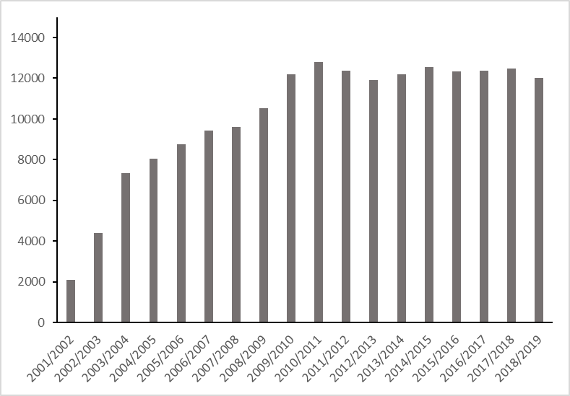
Figure 2: Number of participants in Austrian public training workshops according to AMS data, 2001-2019 (Source: AMS 2020)

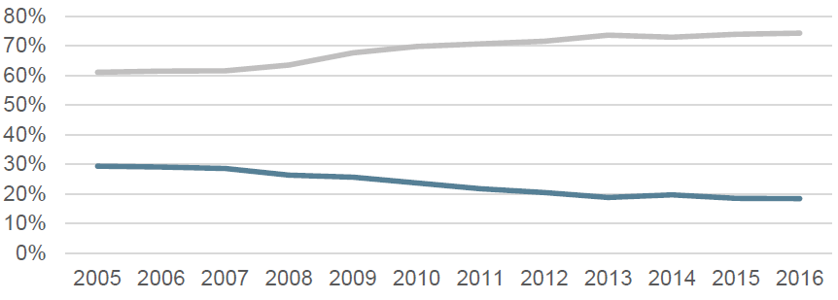
Figure 3: Percentage students applying for Danish VET (blue line) and gymnasium (grey line) directly after completion of primary school, 2005-2016 (Source: Expert Group on Youth Education 2017: 50).

 | 2016 | 2017 | 2018 | 2019 | 2020
Students with regular apprenticeship agreement | 67304 | 65031 | 66876 | 69564 | 73348
Students enrolled in school-based apprenticeship | 7818 | 7338 | 6085 | 5230 | 5799
Table 1: Students according to type of apprenticeship in Danish VET: school-based or regular (Source: Ministry of Education 2021: 7)

References
AMS (2020). Anzahl Personen im Programm. Überbetriebliche Lehrausbildung durch das AMS [In-house dataset]. Wien, AMS.
Expert Group on Youth Education (2017). Bedre veje til en ungdomsuddannelse – anbefalinger til regeringen. Copenhagen: Expert Group on Youth Education.
Ministry of Education (2021) Praktikpladsområdet 2020: Årsstatistik. Copenhagen: Ministry of Education. Retrieved on December 1 2021 via https://www.uvm.dk/-/media/filer/uvm/stat/pdf21/sep/210929-praktikpladsomraadet-2020.pdf
Schneeberger, A. (2009). Bildungsgarantie bis zum 18./19. Lebensjahr. Entwicklungen und Perspektiven in der Berufsbildung. In: Spechtl, W. (ed.) Nationaler Bildungsbericht Österreich 2009 - Band 2 - Fokussierte Analysen bildungspolitischer Schwerpunktthemen. Graz: Leykam.

