Appendix 1: Factor analysis for each election
Figure A1. Screeplot of Eigenvalues for the unrotated factor analysis for each election

Table A1. Eigenvalues and proportion of explained variance for unrotated solutions
 | 2009 |  |  | 2014 |  |  | 2019
Factor | Eigenvalue | Proportion |  | Eigenvalue | Proportion |  | Eigenvalue | Proportion
1 | 4.807 | 0.516 |  | 5.698 | 0.574 |  | 6.440 | 0.678
2 | 3.138 | 0.337 |  | 2.819 | 0.284 |  | 2.226 | 0.235
3 | 0.898 | 0.096 |  | 0.804 | 0.081 |  | 0.713 | 0.075
4 | 0.554 | 0.059 |  | 0.570 | 0.057 |  | 0.426 | 0.045
5 | 0.382 | 0.041 |  | 0.338 | 0.034 |  | 0.260 | 0.027
6 | 0.199 | 0.021 |  | 0.255 | 0.026 |  | 0.149 | 0.016
7 | 0.126 | 0.014 |  | 0.136 | 0.014 |  | 0.073 | 0.008
8 | 0.034 | 0.004 |  | 0.061 | 0.006 |  | 0.004 | 0.000
9 | -0.020 | -0.002 |  | 0.007 | 0.001 |  | -0.032 | -0.003
10 | -0.036 | -0.004 |  | -0.044 | -0.005 |  | -0.061 | -0.007
11 | -0.069 | -0.007 |  | -0.089 | -0.009 |  | -0.092 | -0.010
12 | -0.102 | -0.011 |  | -0.119 | -0.012 |  | -0.116 | -0.012
13 | -0.170 | -0.018 |  | -0.139 | -0.014 |  | -0.131 | -0.014
14 | -0.197 | -0.021 |  | -0.163 | -0.016 |  | -0.160 | -0.017
15 | -0.222 | -0.024 |  | -0.203 | -0.020 |  | -0.203 | -0.021

Table A2. Pattern matrix of factor analysis with oblique (promax) rotation for each election, plus correlations between factors
 | 2009 |  |  |  | 2014 |  |  |  | 2019
Variable | Factor1 | Factor2 | Uniqueness |  | Factor1 | Factor2 | Uniqueness |  | Factor1 | Factor2 | Uniqueness
Gay marriage | 0.674 | 0.075 | 0.530 |  | 0.654 | 0.235 | 0.443 |  | 0.628 | 0.180 | 0.499
Soft drugs | 0.712 | 0.039 | 0.486 |  | 0.604 | 0.067 | 0.611 |  | 0.637 | 0.078 | 0.556
Euthanasia | 0.557 | 0.175 | 0.640 |  | 0.492 | 0.275 | 0.617 |  | 0.544 | 0.139 | 0.635
Criminality | -0.782 | -0.034 | 0.383 |  | -0.741 | -0.092 | 0.410 |  | -0.635 | -0.204 | 0.471
Immigration restriction | -0.697 | -0.133 | 0.479 |  | -0.647 | -0.185 | 0.490 |  | -0.788 | -0.092 | 0.323
Immigrant assimilation | -0.800 | 0.169 | 0.357 |  | -0.754 | 0.140 | 0.462 |  | -0.827 | 0.199 | 0.385
Renewables | 0.498 | 0.062 | 0.743 |  | 0.661 | -0.060 | 0.579 |  | 0.731 | 0.066 | 0.430
Public transport | 0.550 | 0.175 | 0.649 |  | 0.615 | -0.004 | 0.623 |  | 0.681 | 0.103 | 0.480
Social programmes | 0.614 | -0.295 | 0.571 |  | 0.781 | -0.093 | 0.417 |  | 0.763 | -0.196 | 0.477
Government spending | -0.602 | 0.171 | 0.628 |  | -0.724 | 0.393 | 0.459 |  | -0.766 | 0.244 | 0.477
EU foreign policy | 0.037 | 0.836 | 0.294 |  | -0.122 | 0.923 | 0.188 |  | -0.019 | 0.895 | 0.210
EU security | -0.256 | 0.839 | 0.270 |  | -0.230 | 0.928 | 0.188 |  | -0.294 | 0.887 | 0.297
EU integration | 0.047 | 0.869 | 0.235 |  | 0.203 | 0.818 | 0.210 |  | 0.161 | 0.793 | 0.262
EU members’ veto | 0.121 | 0.800 | 0.327 |  | 0.261 | 0.696 | 0.361 |  | 0.369 | 0.517 | 0.471
Correlation between factors | .094 |  |  |  | .241 |  |  |  | .328

Appendix 2: Results of multilevel regression models

Table A3.Results of multilevel regression models on EU integration position including the time-varying effects of economic left-right position, with observations (N=625) nested in parties (N=334) and countries (N=28)
 | 1a |  | 2a |  | 3a |  | 4a
 | B | SE | B | SE | B | SE | B | SE
Economic left-right | 0.035 | 0.034 | 0.098* | 0.041 | 0.038 | 0.034 | 0.100* | 0.041
2009 | Ref. |  | Ref. |  | Ref. |  | Ref.
2014 | -0.067 | 0.040 | -0.073 | 0.039 | -0.068 | 0.040 | -0.053 | 0.066
2019 | -0.121** | 0.040 | -0.131** | 0.039 | -0.123** | 0.040 | -0.042 | 0.064
NWE | Ref. |  | Ref. |  | Ref. |  | Ref.
SE | -0.017 | 0.111 | -0.021 | 0.111 | -0.017 | 0.111 | -0.023 | 0.111
CEE | 0.232* | 0.103 | 0.230* | 0.103 | 0.228* | 0.103 | 0.221* | 0.103
2014 X Econ. L-R |  |  | -0.052 | 0.044 |  |  | -0.051 | 0.044
2019 X Econ. L-R |  |  | -0.138** | 0.044 |  |  | -0.139** | 0.044
Econ. L-R² |  |  |  |  | -0.020 | 0.032 | 0.020 | 0.048
2014 X Econ. L-R² |  |  |  |  |  |  | -0.023 | 0.061
2019 X Econ. L-R² |  |  |  |  |  |  | -0.107 | 0.058
Intercept | 0.002 | 0.075 | 0.009 | 0.075 | 0.021 | 0.081 | -0.007 | 0.087
Var. _{intercept country} | 0.000 | 0.000 | 0.000 | 0.011 | 0.000 | 0.000 | 0.001 | 0.013
Var. _{intercept party} | 0.579 | 0.051 | 0.576 | 0.052 | 0.574 | 0.053 | 0.572 | 0.052
Var. _{residual} | 0.116 | 0.010 | 0.113 | 0.010 | 0.117 | 0.010 | 0.112 | 0.010
Model comparison |  |  | VS | χ² | VS | χ² | VS | χ²
Likelihood ratio test |  |  | 1a | 9.93** | 1a | 0.38 | 3a | 14.28**
 |  |  |  |  |  |  | 2a | 4.72
* p < 0.05, ** p < 0.01; NWE = reference category; 2009 = reference category; Var. = variance

Table A4.Results of multilevel regression models on EU integration position including the time-varying effects of anti-immigration position, with observations (N=625) nested in parties (N=334) and countries (N=28)
 | 1b |  | 2b |  | 3b |  | 4b
 | B | SE | B | SE | B | SE | B | SE
Anti-immigration | -0.089** | 0.034 | -0.014 | 0.045 | -0.103** | 0.034 | -0.036 | 0.045
2009 | Ref. |  | Ref. |  | Ref. |  | Ref.
2014 | -0.079 | 0.041 | -0.077 | 0.040 | -0.071 | 0.042 | -0.168** | 0.064
2019 | -0.113** | 0.040 | -0.107** | 0.040 | -0.095* | 0.041 | -0.140* | 0.066
NWE | Ref. |  | Ref. |  | Ref. |  | Ref.
SE | -0.018 | 0.113 | -0.023 | 0.113 | -0.002 | 0.111 | 0.001 | 0.114
CEE | 0.251* | 0.103 | 0.260* | 0.104 | 0.228* | 0.102 | 0.244* | 0.104
2014 X Anti-imm. |  |  | -0.050 | 0.046 |  |  | -0.049 | 0.048
2019 X Anti-imm. |  |  | -0.134** | 0.046 |  |  | -0.120* | 0.047
Anti-imm.² |  |  |  |  | -0.114** | 0.036 | -0.167** | 0.053
2014 X Anti-imm.² |  |  |  |  |  |  | 0.122* | 0.062
2019 X Anti-imm.² |  |  |  |  |  |  | 0.066 | 0.064
Intercept | -0.004 | 0.076 | -0.005 | 0.076 | 0.085 | 0.080 | 0.120 | 0.086
Var. _{intercept country} | 0.003 | 0.014 | 0.004 | 0.014 | 0.006 | 0.013 | 0.007 | 0.014
Var. _{intercept party} | 0.549 | 0.051 | 0.551 | 0.051 | 0.498 | 0.050 | 0.502 | 0.050
Var. _{residual} | 0.119 | 0.010 | 0.116 | 0.010 | 0.126 | 0.011 | 0.121 | 0.011
Model comparison |  |  | VS | χ² | VS | χ² | VS | χ²
Likelihood ratio test |  |  | 1b | 8.77* | 1b | 8.98** | 3b | 10.77*
 |  |  |  |  |  |  | 2b | 10.98*
* p < 0.05, ** p < 0.01; NWE = reference category; 2009 = reference category; Var. = variance

Table A5.Results of multilevel regression models on EU integration position including the time-varying effects of green position, with observations (N=625) nested in parties (N=334) and countries (N=28)
 | 1c |  | 2c |  | 3c |  | 4c
 | B | SE | B | SE | B | SE | B | SE
Green | 0.143** | 0.029 | 0.076 | 0.046 | 0.115** | 0.032 | 0.075 | 0.047
2009 | Ref. |  | Ref. |  | Ref. |  | Ref.
2014 | -0.024 | 0.041 | -0.034 | 0.041 | -0.020 | 0.041 | 0.021 | 0.058
2019 | -0.083* | 0.041 | -0.090* | 0.041 | -0.073 | 0.041 | -0.094 | 0.058
NWE | Ref. |  | Ref. |  | Ref. |  | Ref.
SE | -0.057 | 0.112 | -0.049 | 0.111 | -0.058 | 0.113 | -0.052 | 0.111
CEE | 0.236* | 0.102 | 0.237* | 0.101 | 0.221* | 0.103 | 0.229* | 0.102
2014 X Green |  |  | 0.071 | 0.051 |  |  | 0.009 | 0.058
2019 X Green |  |  | 0.093 | 0.050 |  |  | 0.086 | 0.055
Green² |  |  |  |  | -0.058* | 0.026 | -0.032 | 0.047
2014 X Green² |  |  |  |  |  |  | -0.068 | 0.057
2019 X Green² |  |  |  |  |  |  | 0.012 | 0.056
Intercept | -0.012 | 0.075 | -0.005 | 0.075 | 0.035 | 0.079 | 0.021 | 0.082
Var. _{intercept country} | 0.005 | 0.013 | 0.004 | 0.013 | 0.007 | 0.013 | 0.005 | 0.013
Var. _{intercept party} | 0.510 | 0.049 | 0.510 | 0.049 | 0.499 | 0.048 | 0.499 | 0.048
Var. _{residual} | 0.121 | 0.010 | 0.120 | 0.010 | 0.121 | 0.011 | 0.120 | 0.010
Model comparison |  |  | VS | χ² | VS | χ² | VS | χ²
Likelihood ratio test |  |  | 1c | 3.48 | 1c | 4.80* | 3c | 4.82
 |  |  |  |  |  |  | 2c | 6.15
* p < 0.05, ** p < 0.01; NWE = reference category; 2009 = reference category; Var. = variance

Table A6.Results of multilevel regression models on EU integration position including the cross-regional time-varying effects of economic and anti-immigration positions, with observations (N=625) nested in parties (N=334) and countries (N=28)
 | 5 |  | 6 |  | 7
 | B | SE | B | SE | B | SE
Economic left-right | 0.133* | 0.057
2014 | -0.085 | 0.052 | -0.071 | 0.056 | -0.170* | 0.083
2019 | -0.096 | 0.052 | -0.073 | 0.053 | -0.179* | 0.084
2014 X Econ. LR | -0.096 | 0.057
2019 X Econ. LR | -0.158** | 0.058
SE | 0.011 | 0.124 | 0.009 | 0.125 | -0.100 | 0.176
CEE | 0.312** | 0.119 | 0.264* | 0.117 | 0.202 | 0.148
SE X Econ. LR | 0.044 | 0.100
CEE X Econ. LR | -0.229* | 0.103
2014 X SE | 0.100 | 0.098 | 0.133 | 0.100 | 0.114 | 0.193
2014 X CEE | -0.099 | 0.095 | -0.082 | 0.096 | 0.004 | 0.145
2019 X SE | -0.155 | 0.097 | -0.158 | 0.097 | -0.040 | 0.178
2019 X CEE | -0.069 | 0.094 | 0.033 | 0.101 | 0.140 | 0.155
2014 X SE X Econ. LR | 0.141 | 0.103
2014 X CEE X Econ. LR | 0.112 | 0.112
2019 X CEE X Econ. LR | 0.208 | 0.116
Anti-immigration |  |  | 0.029 | 0.068 | -0.020 | 0.070
2014 X Anti-imm. |  |  | -0.036 | 0.062 | -0.043 | 0.067
2019 X Anti-imm. |  |  | -0.143* | 0.062 | -0.112 | 0.063
SE X Anti-imm. |  |  | -0.034 | 0.105 | 0.001 | 0.106
2014 X SE X Anti-imm. |  |  | 0.049 | 0.101 | 0.066 | 0.105
2014 X CEE X Anti-imm. |  |  | -0.189 | 0.131 | -0.214 | 0.138
2019 X SE X Anti-imm. |  |  | 0.033 | 0.102 | 0.006 | 0.105
2019 X CEE X Anti-imm. |  |  | -0.047 | 0.131 | -0.051 | 0.141
Anti-imm2 |  |  |  |  | -0.223** | 0.075
2014 X Anti-imm² |  |  |  |  | 0.135 | 0.081
2019 X Anti-imm² |  |  |  |  | 0.168* | 0.083
SE X Anti-imm² |  |  |  |  | 0.179 | 0.126
CEE X Anti-imm² |  |  |  |  | 0.048 | 0.148
2014 X SE X Anti-imm² |  |  |  |  | -0.037 | 0.156
2014 X CEE X Anti-imm² |  |  |  |  | -0.086 | 0.187
2019 X SE X Anti-imm² |  |  |  |  | -0.179 | 0.150
2019 X CEE X Anti-imm² |  |  |  |  | -0.144 | 0.195
Intercept | 0.002 | 0.078 | -0.018 | 0.078 | 0.140 | 0.095
Var. _{intercept country} | 0.000 | 0.000 | 0.002 | 0.131 | 0.007 | 0.014
Var. _{intercept party} | 0.580 | 0.050 | 0.553 | 0.051 | 0.513 | 0.052
Var. _{residual} | 0.104 | 0.008 | 0.109 | 0.009 | 0.111 | 0.010
Model comparison | VS | χ² | VS | χ² | VS | χ²
Likelihood ratio test | 2a | 23.66** | 2b | 19.54* | 6 | 13.75
 |  |  |  |  | 4b | 22.31
* p < 0.05, ** p < 0.01; NWE = reference category; 2009 = reference category; Var. = variance
Appendix 3: Results of robustness checks

Table A7.Results of multilevel regression models on EU integration position including the time-varying effects of all issue positions, with observations (N=625) nested in parties (N=334) and countries (N=28)
 | A1 |  | A2 |  | A3 |  | A4
 | B | SE | B | SE | B | SE | B | SE
Economic left-right | 0.101** | 0.035 | 0.135** | 0.045 | 0.103** | 0.035 | 0.133** | 0.045
Anti-immigration | -0.025 | 0.038 | 0.046 | 0.057 | -0.037 | 0.039 | 0.024 | 0.058
Green | 0.129** | 0.031 | 0.089 | 0.052 | 0.106** | 0.034 | 0.095 | 0.053
Permissive | 0.175** | 0.046 | 0.204** | 0.063 | 0.176** | 0.046 | 0.200** | 0.063
2009 | Ref. |  | Ref. |  | Ref. |  | Ref.
2014 | -0.051 | 0.043 | -0.059 | 0.043 | -0.041 | 0.044 | -0.093 | 0.074
2019 | -0.102* | 0.042 | -0.114** | 0.043 | -0.078 | 0.044 | -0.146 | 0.076
NWE | Ref. |  | Ref. |  | Ref. |  | Ref.
SE | -0.059 | 0.110 | -0.057 | 0.110 | -0.039 | 0.111 | -0.029 | 0.111
CEE | 0.259* | 0.101 | 0.271** | 0.101 | 0.224* | 0.102 | 0.253* | 0.103
2014XEcon. LR |  |  | -0.027 | 0.056 |  |  | -0.000 | 0.057
2019XEcon. LR |  |  | -0.072 | 0.057 |  |  | -0.065 | 0.058
2014XAnti-imm. |  |  | -0.057 | 0.068 |  |  | -0.057 | 0.070
2019XAnti-imm. |  |  | -0.113 | 0.068 |  |  | -0.093 | 0.070
2014XGreen |  |  | 0.050 | 0.061 |  |  | -0.009 | 0.068
2019XGreen |  |  | 0.016 | 0.062 |  |  | 0.003 | 0.069
2014XPermiss. |  |  | -0.024 | 0.072 |  |  | -0.012 | 0.074
2019XPermiss. |  |  | -0.020 | 0.073 |  |  | -0.013 | 0.074
Anti-imm.² |  |  |  |  | -0.111** | 0.036 | -0.205** | 0.054
Green² |  |  |  |  | -0.051 | 0.027 | 0.019 | 0.048
Permissive² |  |  |  |  | -0.011 | 0.047
2014XAnti-imm.² |  |  |  |  |  |  | 0.161* | 0.064
2019XAnti-imm.² |  |  |  |  |  |  | 0.110 | 0.068
2014XGreen² |  |  |  |  |  |  | -0.116* | 0.059
2019XGreen² |  |  |  |  |  |  | -0.046 | 0.058
Intercept | -0.016 | 0.074 | -0.010 | 0.074 | 0.120 | 0.085 | 0.131 | 0.088
Var. _{intercept country} | 0.007 | 0.013 | 0.007 | 0.013 | 0.011 | 0.013 | 0.012 | 0.013
Var. _{intercept party} | 0.457 | 0.045 | 0.462 | 0.046 | 0.402 | 0.044 | 0.405 | 0.044
Var. _{residual} | 0.124 | 0.011 | 0.119 | 0.010 | 0.132 | 0.012 | 0.124 | 0.012
Model comparison |  |  | VS | χ² | VS | χ² | VS | χ²
Likelihood ratio test |  |  | A1 | 11.81 | A1 | 13.24** | A3 | 18.52
 |  |  |  |  |  |  | A2 | 19.96**
* p < 0.05, ** p < 0.01; NWE = reference category; 2009 = reference category; Var. = variance

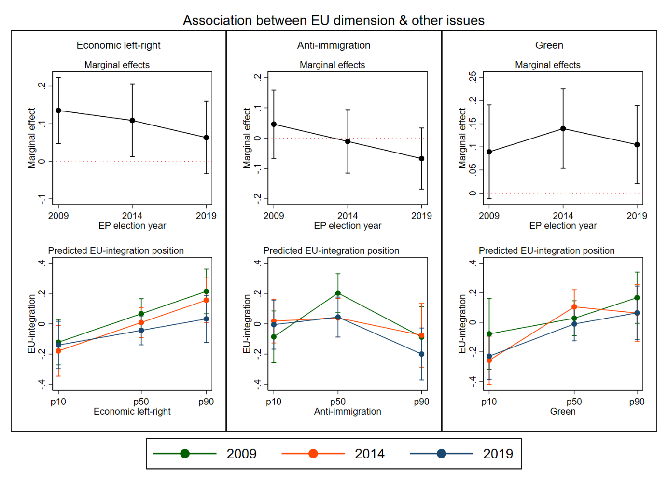Figure A2. Marginal effects on economic, anti-immigration and green issues on EU integration positions, and predicted EU integration position as function of these issues, by election year, controlled for other issues. Note: p10 = 10th percentile, p50 = 50th percentile, p90 = 90th percentile in the distribution of the independent variable.

Table A8.Results of multilevel regression models on EU integration position including the cross-regional time-varying effects of all issues, with observations (N=625) nested in parties (N=334) and countries (N=28)
 | A5
 | B | SE
Anti-immigration | 0.008 | 0.081
2014 | -0.068 | 0.059
2019 | -0.074 | 0.056
2014 X Anti-immigration | 0.039 | 0.087
2019 X Anti-immigration | -0.037 | 0.088
SE | -0.073 | 0.132
CEE | 0.306* | 0.124
SE X Anti-immigration | 0.248 | 0.168
CEE X Anti-immigration | 0.079 | 0.136
2014 X SE | 0.089 | 0.115
2014 X CEE | -0.091 | 0.112
2019 X SE | -0.206 | 0.115
2019 X CEE | 0.003 | 0.109
2014 X SE X Anti-immigration | -0.414* | 0.192
2014 X CEE X Anti-immigration | -0.343* | 0.174
2019 X SE X Anti-immigration | 0.066 | 0.205
2019 X CEE X Anti-immigration | -0.241 | 0.171
Green | 0.027 | 0.068
2014 X Green | 0.074 | 0.077
2019 X Green | 0.155 | 0.085
SE X Green | 0.090 | 0.135
CEE X Green | 0.304* | 0.140
2014 X SE X Green | -0.081 | 0.178
2014 X CEE X Green | -0.190 | 0.154
2019 X SE X Green | -0.398* | 0.165
2019 X CEE X Green | -0.377* | 0.163
Economic left-right | 0.143* | 0.059
2014 X Economic left-right | -0.085 | 0.073
2019 X Economic left-right | -0.032 | 0.075
SE X Economic left-right | 0.149 | 0.118
CEE X Economic left-right | -0.124 | 0.106
2014 X SE X Economic left-right | 0.171 | 0.156
2014 X CEE X Economic left-right | 0.015 | 0.126
2019 X SE X Economic left-right | -0.324* | 0.154
2019 X CEE X Economic left-right | -0.028 | 0.134
Permissive | 0.143 | 0.092
2014 X Permissive | 0.031 | 0.089
2019 X Permissive | -0.013 | 0.089
SE X Permissive | 0.393* | 0.180
CEE X Permissive | 0.082 | 0.150
2014 X SE X Permissive | -0.395 | 0.217
2014 X CEE X Permissive | -0.253 | 0.191
2019 X SE X Permissive | 0.070 | 0.234
2019 X CEE X Permissive | -0.121 | 0.181
Intercept | -0.008 | 0.075
Var. _{intercept country} | 0.005 | 0.012
Var. _{intercept party} | 0.450 | 0.044
Var. _{residual} | 0.103 | 0.009
Model comparison | VS | χ²
Likelihood ratio test | 5 | 78.63**
 | 6 | 78.52**
* p < 0.05, ** p < 0.01; NWE = reference category; 2009 = reference category; Var. = variance

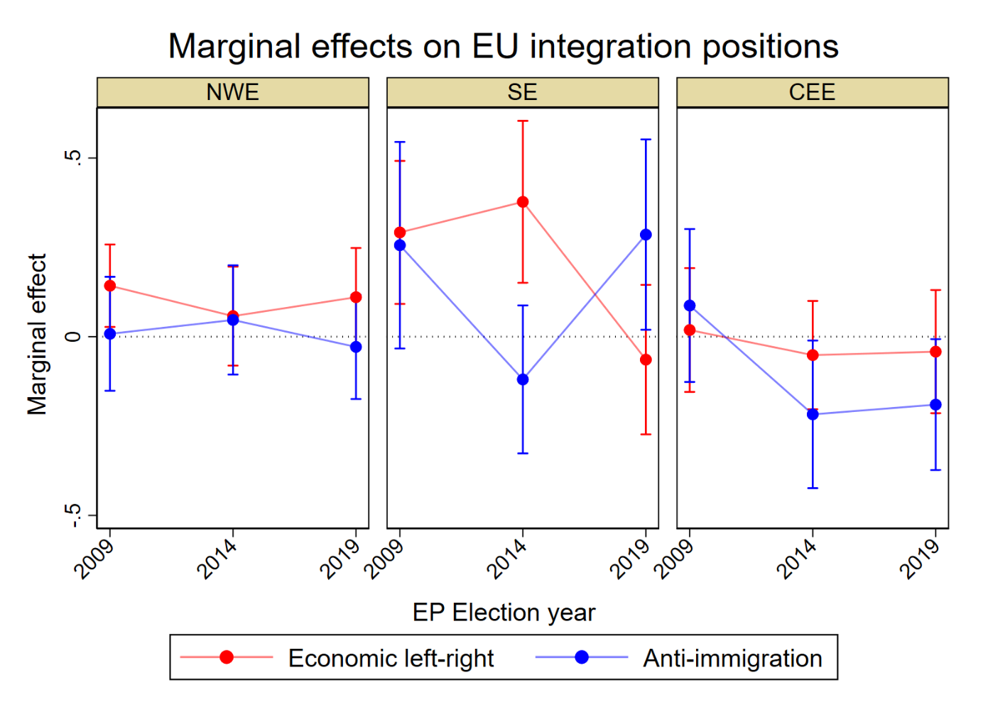
Figure A3. Marginal effects of parties’ positions on economic and anti-immigration issues on parties’ EU-integration position, by region and election, controlled for positions on other issues based on Model A5

