Supplementary Material (to be published online)
Tables
Table S1: Overview of items, coding and data sources
Variable | Items | Coding
Level of politicians
Dependent variable:
Transnational solidarity ª | The EU should continue to support all current members of the Eurozone facing major financial crises. | Average of items; high values indicate stronger support for transnational solidarity; values have been grand-mean centered; alpha = 0.63
 | The EU and/or IMF should provide funds for more investment to stimulate economic growth.
Independent Variables
Socio-economic issue position ª | Governments should abstain from intervening in the economy. | Factor scores; high values indicate left-wing positions; alpha = 0.71
 | Providing a stable network of social security should be the prime goal of government.
 | The government should take measures to reduce differences in income levels.
EU issue position ª | Some say European unification should be pushed further. Others say it already has gone too far. What is your opinion? Please indicate your views using a scale from 0 to 10, where 0 means unification 'has already gone too far' and 10 means it 'should be pushed further'. What number on this scale best describes your position? | Average of rescaled items; high values indicate pro-EU positions; alpha = 0.77
 | Generally speaking, do you think that [country’s] membership of the European Union is a good thing, a bad thing, or neither good nor bad? (Tick one box only.)
Ascribed national responsibility ª | Following the international financial crisis that started in 2007, the economy in many countries has experienced serious problems. How responsible for the crisis in these countries would you say each of the following is? | Average of items; high values indicate more ascribed national responsibility, alpha = 0.47
 | …the governments and politicians in the countries suffering from the economic crises
 | …the people/everybody in these countries
Politician’s gender ª | Gender of the politician | 1 = male; 2 = female
Education ª | Educational attainment (school) based on ISCED | 1 = low; 2 = medium;  3 = high
Age ª | Age measured in years at time of election | High values indicate older politicians
Member of parliament ª | Was the politician elected to parliament? | 0 = politician is not a MP; 1 = politician is a MP
Level of parties
Socio-economic position (party)^{b} | Left-wing categories: per403, per404, per412, per413, per504, per701, per409 | Positions are calculated based on Lowe et al. (2011); high values indicate socio-economically more left-wing positions
 | Right-wing categories: per401, per402, per505, per702, per414
EU issue position (party)^{b} | Pro-EU categories: per108, per107, per602 | Positions are calculated based on Lowe et al. (2011); high values indicate more pro-EU positions
 | Anti-EU categories: per110, per109, per601
Government party ^{c} | Was the politician’s party part of the government after the surveyed election? | 0 = no; 1 = yes
Level of elections
Economic misery index ^{d} | Has the politician’s country suffered economic misery (high unemployment and high inflation) in the last two to four years before the survey? | Sum of unemployment rate and inflation; high values indicate stronger economic misery
Public opinion: transnational solidarity ^{e} | To what extent do you agree or disagree with the following statement: In times of crisis, it is desirable for (OUR COUNTRY) to give financial help to another EU Member State facing severe economic and financial difficulties. | Country means; rescaled item; high values indicate stronger public support for transnational solidarity
EP election candidacy ª | Was the politician surveyed as a candidate in a national of European parliament election? | 0 = politician was surveyed as a candidate in national election; 1 = politician was surveyed as a candidate in EP elections
Note: Items were reverse-coded for calculating combined measures if necessary.
Sources: ª = CCS/EECS; ^{b} = MARPOR; ^{c} = GovElec; ^{d} = Eurostat; ^{e} = EES 2014.
Table S2: Descriptive statistics of main variables
Level | Continuous Variables | min | max | mean | sd
Individual | DV: Transnational solidarity | -2.70 | 1.30 | -0.05 | 0.91
 | Socio-economic issue position | -1.33 | 0.62 | -0.02 | 0.50
 | EU issue position | 0.41 | 2.13 | 1.64 | 0.52
 | National responsibility | 0.64 | 3.22 | 2.10 | 0.53
 | Age (in years) | 0.68 | 3.32 | 1.90 | 0.52
Party | Socio-economic position (party) | -0.71 | 3.82 | 0.49 | 0.66
 | EU issue position (party) | -1.25 | 1.20 | 0.19 | 0.56
Election | Economic misery index | 0.60 | 2.74 | 1.29 | 0.59
 | Public opinion: transn. solidarity | 3.42 | 4.92 | 4.10 | 0.54
Level | Categorical Variables | Coding and distribution
Individual | Member of parliament | 0 = no (79.93%); 1 = yes (20.07%)
 | Politician’s gender | 1 = male (63.52%); 2 = female (36.48%)
 | Education | 1 = low (1.79%); 2 = medium (20.61%);  3 = high (77.60%)
Party | Government party | 0 = no (52.15%); 1 = yes (47.85%)
Election | EP election data | 0 = no (54.57%); 1 = yes (45.43%)
Descriptive statistics are limited to cases used in the analysis. Values have been calculated after the standardization outlined in the main text. Post-stratification weights have been applied.

Table S3: Overview of elections, parties and number of politicians
Election | Party Name | Initials | N
CZ 2017 | Christian Democratic Union - Czech People’s Party | KDU-CSL | 29
 | Civic Democratic Party | ODS | 33
 | Communist Party of Bohemia and Moravia | KSCM | 40
 | Czech Pirate Party | Piráti | 44
 | Tradition Responsibility Prosperity 09 | TOP 09 | 32
DK 2014 (EP) | Conservative People's Party | KF | 5
 | Danish People's Party | DF | 3
 | Danish Social Liberal Party | RV | 4
 | Left, Denmark's Liberal Party | Venstre | 5
 | Liberal Alliance | LA | 2
 | Social Democrats | SD | 4
 | Socialist People's Party | SF | 9
FI 2015 | Centre Party of Finland | Kesk | 34
 | Christian Democrats | KD | 37
 | Finnish Social Democratic Party | SSDP | 37
 | Finns Party | PS | 28
 | Green League | Vihr | 45
 | Left-Wing Alliance | VAS | 61
 | National Coalition | KK | 27
 | Swedish People's Party | SFP/RKP | 23
DE 2013 | Alliance 90/Greens | B’90/Grüne | 161
 | Alternative for Germany | AfD | 117
 | Christian Democratic Union | CDU | 135
 | Free Democratic Party | FDP | 131
 | Pirate Party Germany | PIRATEN | 165
 | Social Democratic Party of Germany | SPD | 174
 | The Left | L | 134
DE 2014 (EP) | Alliance 90/Greens | B’90/Grüne | 11
 | Alternative for Germany | AfD | 8
 | Christian Democratic Union | CDU | 63
 | Free Democratic Party | FDP | 43
 | Pirate Party Germany | PIRATEN | 4
 | Social Democratic Party of Germany | SPD | 58
 | The Left | L | 6
GR 2015 | Coalition of the Radical Left | SYRIZA | 46
 | Independent Greeks | ANEL | 45
 | New Democracy | ND | 56
 | Pan-Hellenic Socialist Movement | PASOK | 63
 | The River | Potami | 80
PT 2014 (EP) | Portuguese Communist Party | PCP | 1
 | Portuguese Socialist Party | PSP | 15
 | Social Democratic Center - Popular Party | CDS-PP | 2
 | Social Democratic Party | PSD | 7

Table S3: Overview of elections, parties and number of politicians (continued)
Election | Party Name | Initials | N
PT 2015 | Left Bloc | BE | 51
 | People-Animals-Nature | PAN | 26
 | Portuguese Communist Party | PCP | 40
 | Portuguese Socialist Party | PSP | 66
RO 2016 | Alliance of Liberals and Democrats | ALDE | 30
 | Hungarian Democratic Alliance of Romania | UDMR | 112
 | National Liberal Party | PNL | 56
 | People's Movement Party | PMP | 31
 | Save Romania Union | USR | 80
 | Social Democratic Party | PSD (2001) | 42
SW 2014 (EP) | Centre Party | CP | 83
 | Christian Democrats | KD | 131
 | Green Ecological Party | MPG | 205
 | Left Party | VP | 236
 | Liberal People's Party | FP | 193
 | Moderate Party | MP | 228
 | Social Democratic Labour Party | SdAP | 202
 | Sweden Democrats | SD | 15
SW 2014 | Centre Party | CP | 18
 | Christian Democrats | KD | 17
 | Left Party | VP | 15
 | Liberal People's Party | FP | 9
 | Moderate Party | MP | 23
 | Social Democratic Labour Party | SdAP | 11
 | Sweden Democrats | SD | 3
UK 2014 (EP) | Conservative Party | Cons | 10
 | Labour Party | Lab | 12
 | Liberal Democrats | LibDem | 18
Party names and initials are taken from the MARPOR dataset.

Table S4: Additional multi-level regression results
 | MODEL 1 | MODEL 2 | MODEL 3 | MODEL 4 | MODEL 5
Socio-economic issue position |  | 0.22  [0.29] | 0.05  [0.36] | -0.26  [0.31] | 0.84***  [0.13]
EU issue position |  | 0.47⁺  [0.27] | 0.81***  [0.16] | 0.15  [0.33] | 1.24***  [0.23]
National responsibility |  | -0.56***  [0.14] | -0.44*  [0.21] | -0.49⁺  [0.26] | -0.19⁺  [0.10]
Economic misery index |  | 1.20***  [0.29] | 1.02**  [0.32] | 0.37***  [0.06] | 1.25***  [0.36]
Socio-economic issue position # National responsibility |  | 0.25*  [0.11] | 0.32*  [0.16] | 0.35*  [0.16]
EU issue position # National responsibility |  | 0.29***  [0.06] | 0.18*  [0.09] | 0.21⁺  [0.12]
Socio-economic issue position # Economic misery index |  | -0.28*  [0.11] | -0.22*  [0.11] |  | -0.29*  [0.11]
EU issue position # Economic misery index |  | -0.49**  [0.16] | -0.46**  [0.17] |  | -0.51**  [0.19]
Socio-economic position (party) |  | 0.21**  [0.08] | 0.21*  [0.09] | 0.25*  [0.11] | 0.20*  [0.08]
EU position (party) |  | 0.13⁺  [0.07] | 0.12*  [0.06] | 0.13⁺  [0.07] | 0.14⁺  [0.08]
Education (base: low)
medium |  | -0.08  [0.13] | -0.07  [0.13] | -0.06  [0.13] | -0.06  [0.14]
high |  | -0.10  [0.14] | -0.10  [0.13] | -0.08  [0.13] | -0.09  [0.15]
Female politician |  | 0.05  [0.04] | 0.04  [0.04] | 0.04  [0.04] | 0.04  [0.04]
Age (in years) |  | 0.09  [0.05] | 0.09⁺  [0.05] | 0.08  [0.05] | 0.10⁺  [0.06]
Politician is MP |  | 0.02  [0.06] | 0.02  [0.06] | 0.02  [0.06] | 0.02  [0.06]
Party is in government |  | 0.06  [0.10] | 0.07  [0.10] | 0.10  [0.10] | 0.08  [0.11]
Public opinion: transn. solidarity |  | -0.06  [0.10] | 0.02  [0.12] | -0.02  [0.11] | -0.01  [0.11]
EP election data |  | 0.22*  [0.09] | 0.27***  [0.08] | 0.25**  [0.09] | 0.18*  [0.09]
Debtor country |  |  | 0.23⁺  [0.13]
Intercept | 0.05  [0.16] | -1.13⁺  [0.65] | -1.80**  [0.60] | -0.66  [0.66] | -2.45**  [0.80]
var(individual); N = 3990 | 0.52***  [0.05] | 0.45***  [0.04] | 0.45***  [0.04] | 0.45***  [0.04] | 0.46***  [0.04]
var(party); N = 71 | 0.34***  [0.11] | 0.02***  [0.01] | 0.02**  [0.01] | 0.03*  [0.01] | 0.02**  [0.01]
var(election); N = 12 | 0.06  [0.07] | 0.01  [0.01] | 0.01  [0.00] | 0.01  [0.01] | 0.01  [0.01]
Note: Dv: Transnational solidarity. Standard errors in brackets; post-stratification weights are applied; model results are used to calculate values for Figures S3, S4 and S5.
⁺ p < 0.1, * p < 0.05, ** p < 0.01, *** p < 0.001

Figures
Figure S1: Distribution of preferences for transnational solidarity (histogram, N = 3990)
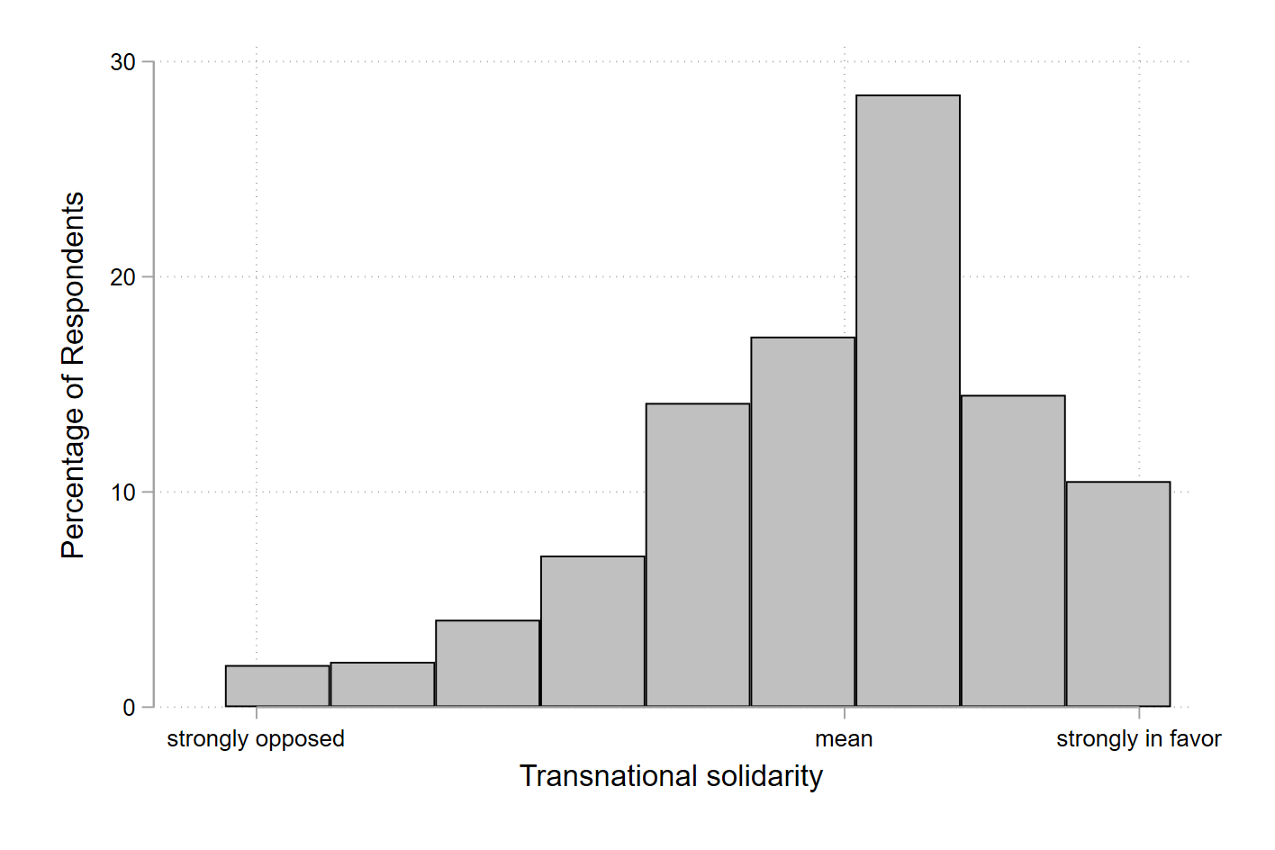

Figure S2: Standard deviation of preferences for transnational solidarity per party
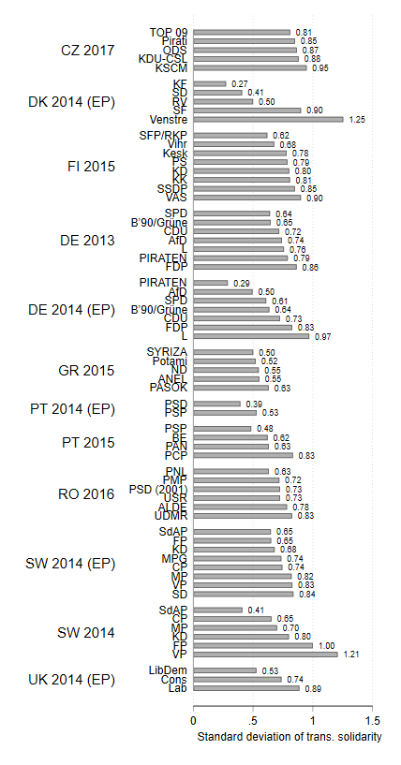
Note: The figure only presents standard deviations for parties with four or more respondents.

Figure S3: Conditioning the effects of attitudes on preferences (Model 2, Table S4), different measure of ascribed national responsibility

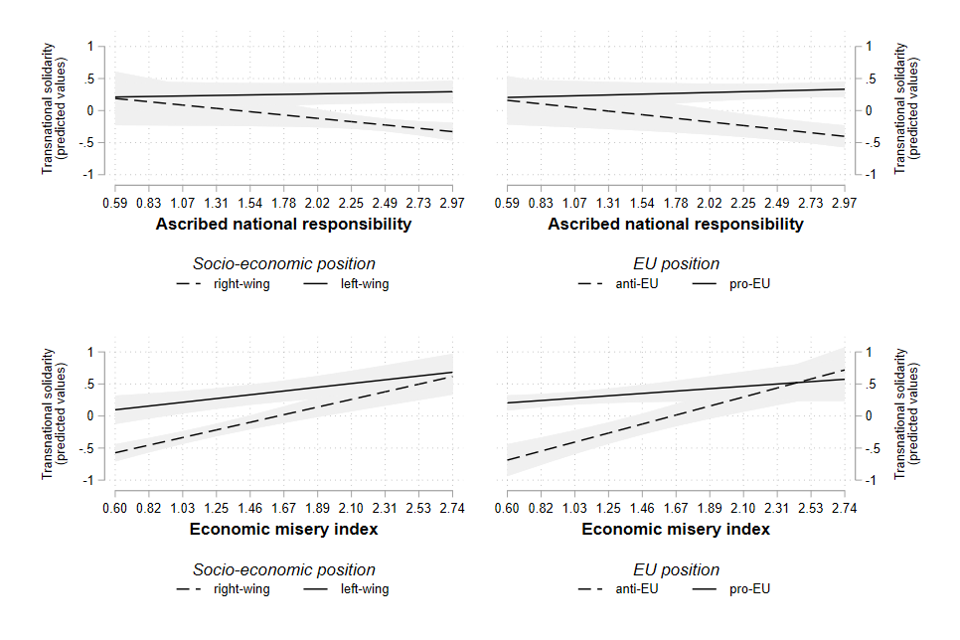
Note: Dv: Transnational solidarity. Estimations represent predicted values with 95 per cent confidence intervals. The solid line refers to an attitudinal value equal to the empirical mean plus one standard deviation, while the dashed line refers to an attitudinal value equal to the empirical mean minus one standard deviation.

Figure S4: Conditioning the effects of attitudes on preferences (Model 3, Table S4), adding debtor variable

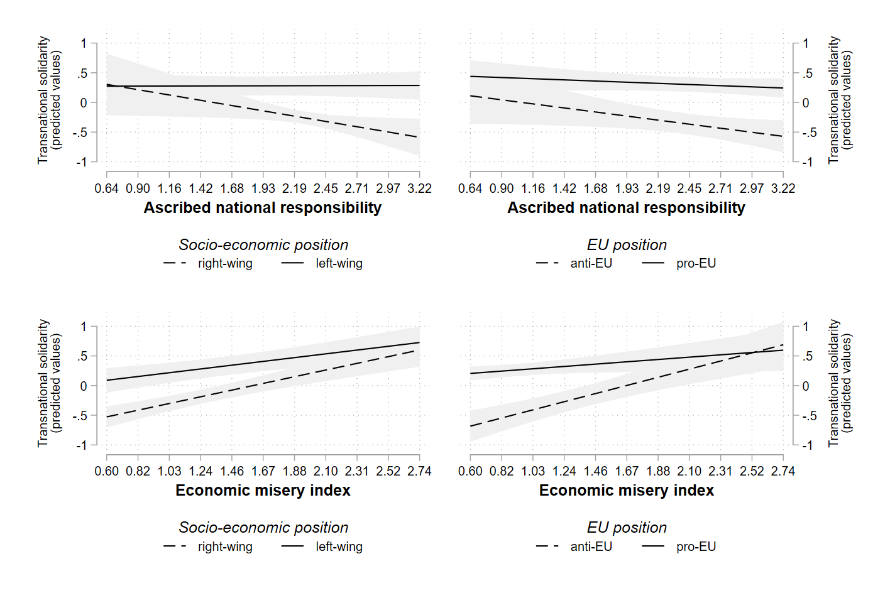
Note: Dv: Transnational solidarity. Estimations represent predicted values with 95 per cent confidence intervals. The solid line refers to an attitudinal value equal to the empirical mean plus one standard deviation, while the dashed line refers to an attitudinal value equal to the empirical mean minus one standard deviation.

Figure S5: Conditioning the effects of attitudes on preferences (Model 4 and 5, Table S4), separated interactions
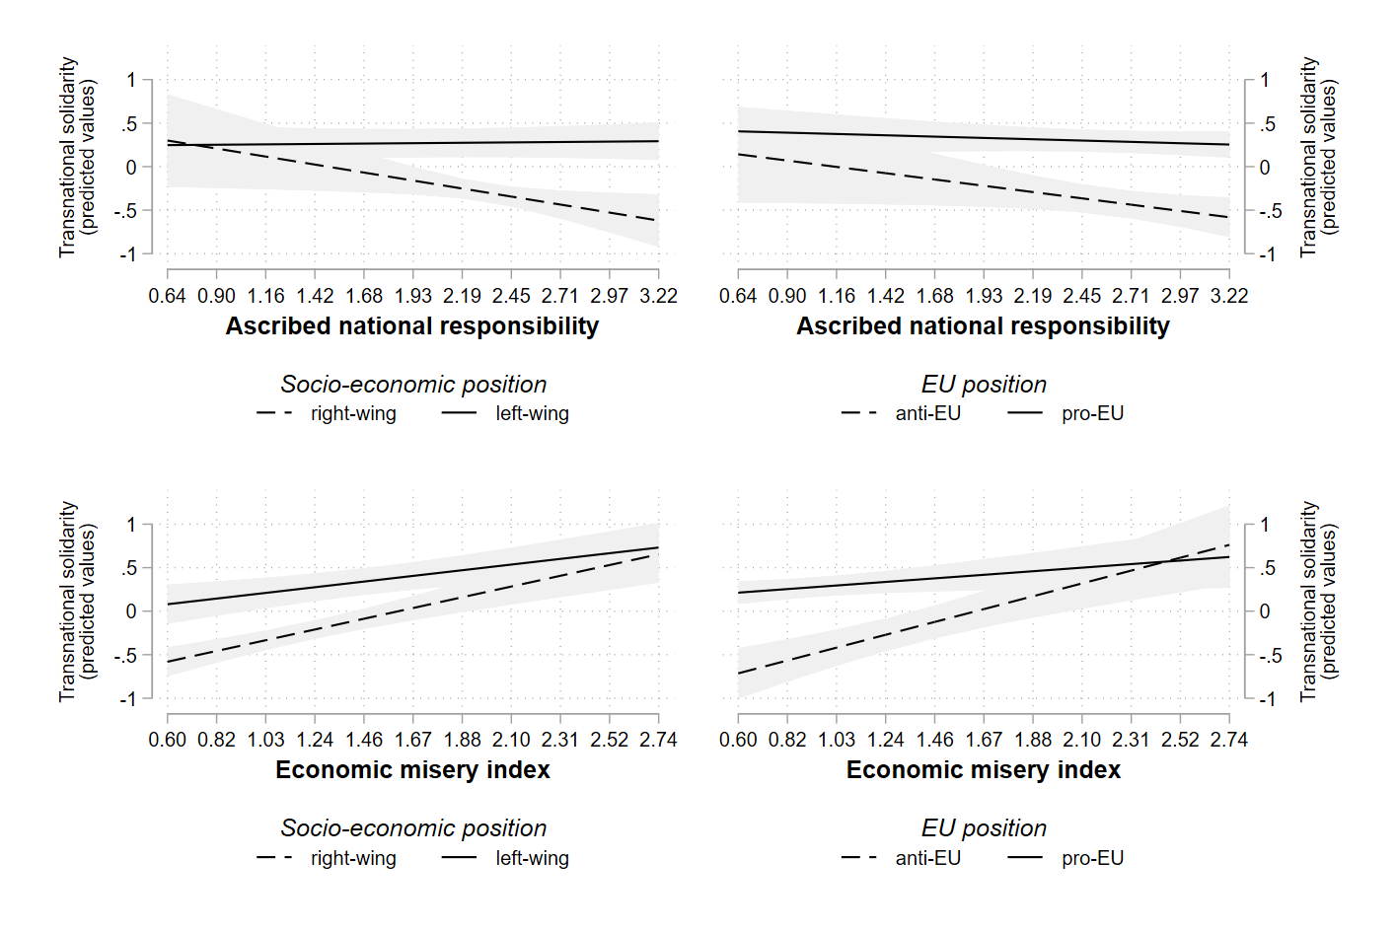
Note: Dv: Transnational solidarity. Estimations represent predicted values with 95 per cent confidence intervals. The solid line refers to an attitudinal value equal to the empirical mean plus one standard deviation, while the dashed line refers to an attitudinal value equal to the empirical mean minus one standard deviation.

