Online Supplementary Material
APPENDIX A Examples of a Measure of Presidential Influences over Cabinet Survival through a Proposed Motion of No-confidence by Parties in the Parliament
This online appendix contains two examples of a measure of how parties in the parliament exercise the power to terminate the cabinet by a vote of no-confidence. For example, in Bulgaria at least one-fifth of MPs (Art. 89, that is, 48 of total 240 MPs, Art. 63) can submit an interpellation in order to measure confidence in the government. To be passed, the motion requires a majority of more than half of the votes of all MPs (Art. 89). No conditionality applies to this case. For Dimitrov’s cabinet (1991-1992) where a single ruling party SDS (110 seats) faces two opposition parties, DL (106 seats) and DPS (24 seats), the probability is,
$$Initial actor \left(parliament\right),P\left(I_{parl}\right)=\frac{2 (two possible combinations: \{DL\}, \{DL, DPS\})}{4(four possible combinations: \{none\}, \{DL\}, \{DPS\}, \{DL, DPS\})}=.5$$
$$Trigger \left(parliament\right),P\left(T_{parl}\right)=1$$
$$Collective action rule \left(parliament\right),P\left(R_{parl}\right)=\frac{1(DL and DPS must cooperate, \{DL, DPS\})}{4(four possible combinations: \{none\}, \{DL\}, \{DPS\}, \{DL, DPS\})}=.25$$
$$No conditionality$$
$$P\left(I_{parl}\right)*P\left(T_{parl}\right)*P\left(R_{parl}\right)=.5*1*.25=.125$$
In Slovenia, the National Assembly may pass a vote of no confidence in the government only by electing a new PM on the proposal of at least 10 deputies and by a majority vote of all deputies (Art. 116, that is, 10 of total 90 MPs, and 45 of total 90 MPs, Art. 80). It is a case of a constructive vote of no confidence, which requires an absolute majority of MPs to withdraw confidence in current government and an absolute majority for a prospective successor. For Drnovšek’s cabinet (1996-1997) where a two-party coalition (37 seats) faces eight opposition parties, SDP (14 seats), SNS (12 seats), SLS (10 seats), DS (6 seats), ZS (5 seats), SDS (4 seats), Mad (1 seats), Ita (1 seats), the probability is, thus,
$$Initial actor \left(parliament\right),P\left(I_{parl}\right)=\frac{239(\left\{SDP\right\}, \left\{SNS\right\},\{SLS\},\left\{SDP, SNS\right\},……,\left\{SDP,SNS, SLS, DS, ZS, SDS, Mad, Ita\right\})}{256}=.934$$
$$Trigger \left(parliament\right),P\left(T_{parl}\right)=1$$
$$Collective action rule \left(parliament\right),P\left(R_{parl}\right)=\frac{16(\left\{SDP, SNS, SLS, DS, ZS\right\},\left\{SDP, SNS, SLS, DS, SDS\right\},……,\left\{SDP,SNS, SLS, DS, ZS, SDS, Mad, Ita\right\})}{256}=.063$$
$$Conditionality \left(parliament\right),P\left(C_{parl}\right)=.063(an absolute majority for a prospective successor)$$
$$P\left(I_{parl}\right)*P\left(T_{parl}\right)*P\left(R_{parl}\right)*P\left(C_{parl}\right)=.934*.063*.063=.004$$
APPENDIX B The Level of Intra-executive Conflict in Semi-presidential Regimes, 1990-2015
Country | President | Prime Minister | Date In | Date Out | Conflict
Austria | Kurt Waldheim | Franz Vranitzky | 1990/12/17 | 1992/07/08 | Low
Austria | Thomas Klestil | Franz Vranitzky | 1992/07/08 | 1994/11/29 | Low
Austria | Thomas Klestil | Franz Vranitzky | 1994/11/29 | 1996/03/12 | Low
Austria | Thomas Klestil | Franz Vranitzky | 1996/03/12 | 1997/01/28 | Low
Austria | Thomas Klestil | Viktor Klima | 1997/01/28 | 1999/10/03 | Low
Austria | Thomas Klestil | Viktor Klima | 1999/10/03 | 2000/02/04 | Caretaker
Austria | Thomas Klestil | Wolfgang Schüssel | 2000/02/04 | 2002/11/24 | Low
Austria | Thomas Klestil | Wolfgang Schüssel | 2002/11/24 | 2003/02/28 | Caretaker
Austria | Thomas Klestil | Wolfgang Schüssel | 2003/02/28 | 2004/07/06 | Low
Austria | Heinz Fischer | Wolfgang Schüssel | 2004/07/06 | 2005/04/05 | Low
Austria | Heinz Fischer | Wolfgang Schüssel | 2005/04/05 | 2007/01/11 | Low
Austria | Heinz Fischer | Alfred Gusenbauer | 2007/01/11 | 2008/12/02 | Low
Austria | Heinz Fischer | Werner Faymann | 2008/12/02 | 2013/12/16 | Low
Austria | Heinz Fischer | Werner Faymann | 2013/12/16 | 2016/05/17 | Low
Bulgaria | Zhelyu Zhelev | Philip Dimitrov | 1991/11/18 | 1992/12/30 | High
Bulgaria | Zhelyu Zhelev | Lyuben Berov | 1992/12/30 | 1994/10/17 | High
Bulgaria | Zhelyu Zhelev | Reneta Indzhova | 1994/10/17 | 1995/01/25 | Caretaker
Bulgaria | Zhelyu Zhelev | Zhan Videnov | 1995/01/25 | 1997/02/13 | High
Bulgaria | Petar Stoyanov | Stefan Sofiyanski | 1997/02/13 | 1997/05/21 | Caretaker
Bulgaria | Petar Stoyanov | Ivan Kostov | 1997/05/21 | 2001/07/24 | Low
Bulgaria | Petar Stoyanov | Simeon Borisov Sakskoburggotski | 2001/07/24 | 2002/01/22 | Low
Bulgaria | Georgi Parvanov | Simeon Borisov Sakskoburggotski | 2002/01/22 | 2005/08/17 | Low
Bulgaria | Georgi Parvanov | Sergei Stanishev | 2005/08/17 | 2009/07/27 | Low
Bulgaria | Georgi Parvanov | Boyko Borissov | 2009/07/27 | 2012/01/22 | High
Bulgaria | Rosen Plevneliev | Boyko Borissov | 2012/01/22 | 2013/03/13 | Low
Bulgaria | Rosen Plevneliev | Marin Raykov | 2013/03/13 | 2013/05/29 | Caretaker
Bulgaria | Rosen Plevneliev | Plamen Oresharski | 2013/05/29 | 2014/08/06 | Caretaker
Bulgaria | Rosen Plevneliev | Georgi Bliznashki | 2014/08/06 | 2014/11/07 | Caretaker
Croatia | Stjepan Mesić | Ivica Račan | 2000/01/27 | 2001/06/04 | High
Croatia | Stjepan Mesić | Ivica Račan | 2001/06/04 | 2002/07/30 | High
Croatia | Stjepan Mesić | Ivica Račan | 2002/07/30 | 2003/12/23 | Low
Croatia | Stjepan Mesić | Ivo Sanader | 2003/12/23 | 2006/02/11 | Low
Croatia | Stjepan Mesić | Ivo Sanader | 2006/02/11 | 2008/01/12 | Low
Croatia | Stjepan Mesić | Ivo Sanader | 2008/01/12 | 2009/07/06 | Low
Croatia | Stjepan Mesić | Jadranka Kosor | 2009/07/06 | 2010/02/18 | Low
Croatia | Ivo Josipović | Jadranka Kosor | 2010/02/18 | 2010/07/10 | High
Croatia | Ivo Josipović | Jadranka Kosor | 2010/07/10 | 2011/12/23 | High
Croatia | Ivo Josipović | Zoran Milanović | 2011/12/23 | 2015/02/15 | Low
Czech Rep. | Miloš Zeman | Petr Nečas | 2013/03/08 | 2013/07/10 | High
Czech Rep. | Miloš Zeman | Jiří Rusnok | 2013/07/10 | 2014/01/17 | Caretaker
Czech Rep. | Miloš Zeman | Bohuslav Sobotka | 2014/01/17 | - | High
Finland | Mauno Koivisto | Esko Tapani Aho | 1991/04/26 | 1994/03/01 | Low
Finland | Martti Ahtisaari | Esko Tapani Aho | 1994/03/01 | 1994/06/26 | Low
Finland | Martti Ahtisaari | Esko Tapani Aho | 1994/06/26 | 1995/04/13 | Low
Finland | Martti Ahtisaari | Paavo Tapio Lipponen | 1995/04/13 | 1999/04/15 | Low
Finland | Martti Ahtisaari | Paavo Tapio Lipponen | 1999/04/15 | 2000/03/01 | Low
Finland | Tarja Halonen | Paavo Tapio Lipponen | 2000/03/01 | 2002/05/31 | Low
Finland | Tarja Halonen | Paavo Tapio Lipponen | 2002/05/31 | 2003/04/17 | Low
Finland | Tarja Halonen | Anneli Tuulikki Jäätteenmäki | 2003/04/17 | 2003/06/24 | Low
Finland | Tarja Halonen | Matti Taneli Vanhanen | 2003/06/24 | 2007/04/19 | Low
Finland | Tarja Halonen | Matti Taneli Vanhanen | 2007/04/19 | 2010/06/22 | High
Finland | Tarja Halonen | Mari Johanna Kiviniemi | 2010/06/22 | 2011/06/22 | Low
Finland | Tarja Halonen | Jyrki Tapani Katainen | 2011/06/22 | 2012/03/01 | Low
Finland | Sauli Niinisto | Jyrki Tapani Katainen | 2012/03/01 | 2014/03/25 | Low
Finland | Sauli Niinisto | Jyrki Tapani Katainen | 2014/03/25 | 2014/06/24 | Low
Finland | Sauli Niinisto | Cai-Goran Alexander Stubb | 2014/06/24 | 2014/09/20 | Low
Finland | Sauli Niinisto | Cai-Goran Alexander Stubb | 2014/09/20 | 2015/05/29 | Low
France | François Mitterrand | Édith Cresson | 1991/05/16 | 1992/04/02 | Low
France | François Mitterrand | Pierre Bérégovoy | 1992/04/02 | 1993/03/29 | Low
France | François Mitterrand | Édouard Balladur | 1993/03/29 | 1995/05/17 | High
France | Jacques Chirac | Alain Juppé | 1995/05/17 | 1995/11/07 | Low
France | Jacques Chirac | Alain Juppé | 1995/11/07 | 1997/06/02 | Low
France | Jacques Chirac | Lionel Jospin | 1997/06/02 | 2002/05/07 | High
France | Jacques Chirac | Jean-Pierre Raffarin | 2002/05/07 | 2002/06/17 | n.a.
France | Jacques Chirac | Jean-Pierre Raffarin | 2002/06/17 | 2004/03/30 | Low
France | Jacques Chirac | Jean-Pierre Raffarin | 2004/03/30 | 2005/05/31 | Low
France | Jacques Chirac | Dominique de Villepin | 2005/05/31 | 2007/05/18 | Low
France | Nicolas Sarkozy | François Fillon | 2007/05/18 | 2007/06/18 | n.a.
France | Nicolas Sarkozy | François Fillon | 2007/06/18 | 2010/11/14 | Low
France | Nicolas Sarkozy | François Fillon | 2010/11/14 | 2012/05/15 | Low
France | François Hollande | Jean-Marc Ayrault | 2012/05/15 | 2012/06/18 | n.a.
France | François Hollande | Jean-Marc Ayrault | 2012/06/18 | 2014/03/31 | Low
France | François Hollande | Manuel Valls | 2014/03/31 | 2014/08/26 | Low
France | François Hollande | Manuel Valls | 2014/08/26 | 2016/02/11 | Low
Iceland | Vigdís Finnbogadóttir | Davíð Oddsson | 1991/04/30 | 1995/04/13 | Low
Iceland | Vigdís Finnbogadóttir | Davíð Oddsson | 1995/04/13 | 1996/08/01 | Low
Iceland | Ólafur Ragnar Grímsson | Davíð Oddsson | 1996/08/01 | 1999/05/28 | Low
Iceland | Ólafur Ragnar Grímsson | Davíð Oddsson | 1999/05/28 | 2003/05/23 | Low
Iceland | Ólafur Ragnar Grímsson | Davíð Oddsson | 2003/05/23 | 2004/09/15 | Low
Iceland | Ólafur Ragnar Grímsson | Halldór Ásgrímsson | 2004/09/15 | 2006/06/15 | Low
Iceland | Ólafur Ragnar Grímsson | Geir Hilmar Haarde | 2006/06/15 | 2007/05/24 | Low
Iceland | Ólafur Ragnar Grímsson | Geir Hilmar Haarde | 2007/05/24 | 2009/02/01 | Low
Iceland | Ólafur Ragnar Grímsson | Jóhanna Sigurðardóttir | 2009/02/01 | 2009/04/25 | Caretaker
Iceland | Ólafur Ragnar Grímsson | Jóhanna Sigurðardóttir | 2009/04/25 | 2013/05/23 | High
Iceland | Ólafur Ragnar Grímsson | Sigmundur Davíð Gunnlaugsson | 2013/05/23 | 2016/04/07 | High
Ireland | Mary Robinson | Albert Reynolds | 1992/02/11 | 1993/01/12 | Low
Ireland | Mary Robinson | Albert Reynolds | 1993/01/12 | 1994/12/15 | Low
Ireland | Mary Robinson | John Gerard Bruton | 1994/12/15 | 1997/06/26 | Low
Ireland | Mary Robinson | Bartholomew P. Ahern | 1997/06/26 | 1997/09/12 | Low
Ireland | Mary McAleese | Bartholomew P. Ahern | 1997/09/12 | 2002/06/06 | Low
Ireland | Mary McAleese | Bartholomew P. Ahern | 2002/06/06 | 2007/06/14 | Low
Ireland | Mary McAleese | Bartholomew P. Ahern | 2007/06/14 | 2008/05/07 | Low
Ireland | Mary McAleese | Brian Cowen | 2008/05/07 | 2011/03/09 | Low
Ireland | Mary McAleese | Enda Kenny | 2011/03/09 | 2011/11/10 | Low
Ireland | Michael Higgins | Enda Kenny | 2011/11/10 | 2016/05/06 | Low
Ireland | Michael Higgins | Enda Kenny | 2016/05/06 | 2017/06/14 | Low
Lithuania | Algirdas Brazauskas | Bronislovas Lubys | 1992/12/02 | 1993/03/10 | Low
Lithuania | Algirdas Brazauskas | Adolfas Šleževičius | 1993/03/10 | 1996/02/23 | Low
Lithuania | Algirdas Brazauskas | Laurynas Stankevičius | 1996/02/23 | 1996/12/10 | Low
Lithuania | Algirdas Brazauskas | Gediminas Vagnorius | 1996/12/10 | 1998/02/25 | Low
Lithuania | Valdas Adamkus | Gediminas Vagnorius | 1998/02/26 | 1999/05/18 | High
Lithuania | Valdas Adamkus | Rolandas Paksas | 1999/05/18 | 1999/10/29 | Low
Lithuania | Valdas Adamkus | Andrius Kubilius | 1999/10/29 | 2000/10/26 | Low
Lithuania | Valdas Adamkus | Rolandas Paksas | 2000/10/26 | 2001/07/03 | High
Lithuania | Valdas Adamkus | Algirdas Brazauskas | 2001/07/03 | 2003/02/26 | Low
Lithuania | Rolandas Paksas | Algirdas Brazauskas | 2003/02/26 | 2004/04/06 | High
Lithuania | Valdas Adamkus | Algirdas Brazauskas | 2004/07/12 | 2004/12/14 | High
Lithuania | Valdas Adamkus | Algirdas Brazauskas | 2004/12/14 | 2006/04/11 | High
Lithuania | Valdas Adamkus | Algirdas Brazauskas | 2006/04/11 | 2006/07/04 | High
Lithuania | Valdas Adamkus | Gediminas Kirkilas | 2006/07/04 | 2008/11/27 | Low
Lithuania | Valdas Adamkus | Andrius Kubilius | 2008/11/27 | 2009/07/12 | Low
Lithuania | Dalia Grybauskaitė | Andrius Kubilius | 2009/07/12 | 2010/09/21 | Low
Lithuania | Dalia Grybauskaitė | Andrius Kubilius | 2010/09/21 | 2012/11/22 | Low
Lithuania | Dalia Grybauskaitė | Algirdas Butkevičius | 2012/11/22 | 2016/12/13 | Low
Moldova | Mircea Snegur | Andrei Sangheli | 1994/04/05 | 1997/01/24 | High
Moldova | Petru Lucinschi | Ion Ciubuc | 1997/01/24 | 1998/05/22 | Low
Moldova | Petru Lucinschi | Ion Ciubuc | 1998/05/22 | 1999/03/03 | Low
Moldova | Petru Lucinschi | Ion Sturza | 1999/03/03 | 1999/12/21 | Low
Moldova | Petru Lucinschi | Dumitru Braghiș | 1999/12/21 | 2001/04/19 | Low
Poland | Lech Wałęsa | Jan Krzysztof Bielecki | 1991/01/12 | 1991/12/23 | Low
Poland | Lech Wałęsa | Jan Olszewski | 1991/12/23 | 1992/06/05 | High
Poland | Lech Wałęsa | Waldemar Pawlak | 1992/06/05 | 1992/07/11 | Caretaker
Poland | Lech Wałęsa | Hanna Suchocka | 1992/07/11 | 1993/10/26 | Low
Poland | Lech Wałęsa | Waldemar Pawlak | 1993/10/26 | 1995/03/06 | High
Poland | Lech Wałęsa | Józef Oleksy | 1995/03/06 | 1995/12/22 | High
Poland | Aleksander Kwaśniewski | Józef Oleksy | 1995/12/22 | 1996/02/07 | n.a.
Poland | Aleksander Kwaśniewski | Włodzimierz Cimoszewicz | 1996/02/07 | 1997/10/31 | Low
Poland | Aleksander Kwaśniewski | Jerzy Buzek | 1997/10/31 | 2000/06/07 | Low
Poland | Aleksander Kwaśniewski | Jerzy Buzek | 2000/06/07 | 2001/10/19 | Low
Poland | Aleksander Kwaśniewski | Leszek Miller | 2001/10/19 | 2003/03/01 | High
Poland | Aleksander Kwaśniewski | Leszek Miller | 2003/03/01 | 2004/05/02 | High
Poland | Aleksander Kwaśniewski | Marek Belka | 2004/05/02 | 2005/10/31 | Low
Poland | Aleksander Kwaśniewski | Kazimierz Marcinkiewicz | 2005/10/31 | 2006/05/05 | Low
Poland | Lech Kaczyński | Kazimierz Marcinkiewicz | 2006/05/05 | 2006/07/14 | n.a.
Poland | Lech Kaczyński | Jaroslaw Kaczyński | 2006/07/14 | 2007/11/16 | Low
Poland | Lech Kaczyński | Donald Tusk | 2007/11/16 | 2010/04/10 | High
Poland | Bronisław Komorowski | Donald Tusk | 2010/04/10 | 2011/11/18 | Low
Poland | Bronisław Komorowski | Donald Tusk | 2011/11/18 | 2014/09/22 | Low
Poland | Bronisław Komorowski | Ewa Kopacz | 2014/09/22 | 2015/08/06 | Low
Portugal | Mário Soares | Aníbal Cavaco Silva | 1991/10/31 | 1995/10/28 | Low
Portugal | Mário Soares | António Guterres | 1995/10/28 | 1996/03/09 | Low
Portugal | Jorge Sampaio | António Guterres | 1996/03/09 | 1999/10/25 | Low
Portugal | Jorge Sampaio | António Guterres | 1999/10/25 | 2002/04/06 | Low
Portugal | Jorge Sampaio | José Manuel Barroso | 2002/04/06 | 2004/07/23 | Low
Portugal | Jorge Sampaio | Pedro Santana Lopes | 2004/07/23 | 2005/03/12 | High
Portugal | Jorge Sampaio | José Sócrates | 2005/03/12 | 2006/03/09 | Low
Portugal | Aníbal Cavaco Silva | José Sócrates | 2006/03/09 | 2009/10/26 | Low
Portugal | Aníbal Cavaco Silva | José Sócrates | 2009/10/26 | 2011/06/15 | High
Portugal | Aníbal Cavaco Silva | Pedro Passos Coelho | 2011/06/15 | 2015/10/30 | Low
Portugal | Aníbal Cavaco Silva | Pedro Passos Coelho | 2015/10/30 | 2015/11/26 | Low
Romania | Emil Constantinescu | Victor Ciorbea | 1996/12/11 | 1998/04/15 | Low
Romania | Emil Constantinescu | Radu Vasile | 1998/04/15 | 1999/12/21 | High
Romania | Emil Constantinescu | Mugur Isarescu | 1999/12/21 | 2000/12/20 | Low
Romania | Ion Iliescu | Adrian Nastase | 2000/12/20 | 2003/06/19 | Low
Romania | Ion Iliescu | Adrian Nastase | 2003/06/19 | 2004/12/29 | Low
Romania | Traian Băsescu | Călin Popescu-Tăriceanu | 2004/12/29 | 2006/12/07 | High
Romania | Traian Băsescu | Călin Popescu-Tăriceanu | 2006/12/07 | 2007/04/05 | High
Romania | Traian Băsescu | Călin Popescu-Tăriceanu | 2007/04/05 | 2008/12/22 | High
Romania | Traian Băsescu | Emil Boc | 2008/12/22 | 2009/12/23 | Low
Romania | Traian Băsescu | Emil Boc | 2009/12/23 | 2010/05/19 | Low
Romania | Traian Băsescu | Emil Boc | 2010/05/19 | 2012/02/09 | Low
Romania | Traian Băsescu | Mihai Razvan Ungureanu | 2012/02/09 | 2012/05/07 | n.a.
Romania | Traian Băsescu | Victor Ponta | 2012/05/07 | 2012/12/21 | High
Romania | Traian Băsescu | Victor Ponta | 2012/12/21 | 2014/03/04 | High
Romania | Traian Băsescu | Victor Ponta | 2014/03/04 | 2014/12/15 | High
Russia | Vladimir Putin | Mikhail Kasyanov | 2000/05/07 | 2004/02/24 | Low
Russia | Vladimir Putin | Mikhail Fradkov | 2004/03/05 | 2007/09/14 | Low
Slovakia | Rudolf Schuster | Mikuláš Dzurinda | 1999/06/15 | 2002/10/16 | High
Slovakia | Rudolf Schuster | Mikuláš Dzurinda | 2002/10/16 | 2004/06/15 | Low
Slovakia | Ivan Gašparovič | Mikuláš Dzurinda | 2004/06/15 | 2006/02/08 | Low
Slovakia | Ivan Gašparovič | Mikuláš Dzurinda | 2006/02/08 | 2006/07/04 | Caretaker
Slovakia | Ivan Gašparovič | Robert Fico | 2006/07/04 | 2010/07/08 | Low
Slovakia | Ivan Gašparovič | Iveta Radičová | 2010/07/08 | 2011/10/20 | High
Slovakia | Ivan Gašparovič | Iveta Radičová | 2011/10/20 | 2012/04/04 | Caretaker
Slovakia | Ivan Gašparovič | Robert Fico | 2012/04/04 | 2014/06/15 | Low
Slovakia | Andrej Kiska | Robert Fico | 2014/06/15 | 2016/03/23 | Low
Slovenia | Milan Kučan | Janez Drnovšek | 1992/04/22 | 1993/01/12 | Low
Slovenia | Milan Kučan | Janez Drnovšek | 1993/01/12 | 1994/04/08 | Low
Slovenia | Milan Kučan | Janez Drnovšek | 1994/04/08 | 1996/01/26 | Low
Slovenia | Milan Kučan | Janez Drnovšek | 1996/01/26 | 1997/02/27 | Low
Slovenia | Milan Kučan | Janez Drnovšek | 1997/02/27 | 2000/06/07 | Low
Slovenia | Milan Kučan | Andrej Bajuk | 2000/06/07 | 2000/11/30 | Low
Slovenia | Milan Kučan | Janez Drnovšek | 2000/11/30 | 2002/12/19 | Low
Slovenia | Janez Drnovšek | Anton Rop | 2002/12/19 | 2004/04/08 | Low
Slovenia | Janez Drnovšek | Anton Rop | 2004/04/08 | 2004/12/03 | Low
Slovenia | Janez Drnovšek | Janez Janša | 2004/12/03 | 2007/12/22 | High
Slovenia | Danilo Türk | Janez Janša | 2007/12/22 | 2008/11/21 | High
Slovenia | Danilo Türk | Borut Pahor | 2008/11/21 | 2011/06/27 | Low
Slovenia | Danilo Türk | Borut Pahor | 2011/06/27 | 2012/01/28 | Low
Slovenia | Danilo Türk | Janez Janša | 2012/01/28 | 2012/12/22 | Low
Slovenia | Borut Pahor | Janez Janša | 2012/12/22 | 2013/03/20 | n.a.
Slovenia | Borut Pahor | Alenka Bratušek | 2013/03/20 | 2014/08/25 | Low
Ukraine | Leonid Kuchma | Pavlo Lazarenko | 1996/05/28 | 1997/07/02 | High
Ukraine | Leonid Kuchma | Valeriy Pustovoitenko | 1997/07/16 | 1998/03/29 | Low
Ukraine | Leonid Kuchma | Valeriy Pustovoitenko | 1998/03/29 | 1999/12/22 | Low
Ukraine | Leonid Kuchma | Viktor Yushchenko | 1999/12/22 | 2001/05/29 | High
Ukraine | Leonid Kuchma | Anatoliy Kinakh | 2001/05/29 | 2002/03/31 | Low
Ukraine | Leonid Kuchma | Anatoliy Kinakh | 2002/03/31 | 2002/11/21 | Low
Ukraine | Leonid Kuchma | Viktor Yanukovych | 2002/11/21 | 2005/01/05 | Low
Ukraine | Victor Yushchenko | Yulia Tymoshenko | 2005/01/24 | 2005/09/08 | High
Ukraine | Victor Yushchenko | Yuriy Yekhanurov | 2005/09/08 | 2006/08/04 | Caretaker
Ukraine | Victor Yushchenko | Viktor Yanukovych | 2006/08/04 | 2006/10/17 | High
Ukraine | Victor Yushchenko | Viktor Yanukovych | 2006/10/17 | 2007/09/30 | High
Ukraine | Victor Yushchenko | Viktor Yanukovych | 2007/09/30 | 2007/12/18 | Caretaker
Ukraine | Victor Yushchenko | Yulia Tymoshenko | 2007/12/18 | 2008/09/04 | High
Ukraine | Victor Yushchenko | Yulia Tymoshenko | 2008/09/04 | 2008/12/09 | High
Ukraine | Victor Yushchenko | Yulia Tymoshenko | 2008/12/09 | 2010/03/04 | High
Ukraine | Viktor Yanukovych | Mykola Azarov | 2010/03/11 | 2012/12/24 | Low
Source: for the list of presidents, prime ministers, date in and date out, see Parliaments and Governments Database. For the level of intra-executive conflict, see Appendix C.
APPENDIX C Issues of Intra-executive Conflict in Semi-presidential Regimes, 1990-2015
Country | President/Cabinet | Issues of intra-executive conflict, some examples
Bulgaria | Parvanov/Borissov  (2009-2012) | Energy policies  Appointments or dismissal issues (Conflict on recalling the country’s ambassadors to Turkey and the United States; Impeachment attempts against the president by right-wing coalition government)  Political Scandal (The government criticized the president received oil payoffs from Saddam Hussein in exchange for support; Clash between Wiretapping scandal)  Personal Clash (Prime Minister Boyko Borisov has accused President Georgi Parvanov of outright lying about pressure on the media in the wake of an article of “The Economist” which said Bulgaria might be becoming a police state)
Croatia | Josipović /Kosor (2010-2011) | Economic policies (Josipović announced the members of his Economic Council, where business groups participated, regarded as challenge for anti-recession measures imposed by Kosor)  Foreign policies (Josipović intended to establish autonomous foreign policy, in which much more attention on the European Union, the United States and neighboring countries should be paid)  Personal Clash (Josipović condemned Kosor for sending a public greeting to Croatian generals, which had expelled Serbians in independent war)
Czech | Zeman/ Nečas  (2013) | Personal Clash (Nečas criticized Zeman over his remarks over the post-war expulsion of ethnic Germans from Czechoslovakia)
Czech | Zeman/ Sobotka  (2014-) | Foreign Policies (Zeman criticized Sobotka, who committed more troops to Central and Eastern Europe in response to tensions in Ukraine and the Russian annexation of Crimea. Sobotka took opposite stance to Zeman, who pledged NATO troops should enter into Ukraine if Russia extended its military operation outside Crimea)  Social Policies (Veto and overriding the veto on the civil service, and the children group bills)
Finland | Halonen/Vanhanen  (2007-2010) | Foreign Policies (Vanhanen said the media that only the prime minister will represent Finland in EU summits while Halonen will stick to her summit plate whenever possible, indicating the prime minister should not break the constitution outright)  Appointments or dismissal issues (Halonen was unsatisfied with some heavy ministerial posts to men from National Coalition Party; Halonen appointed the women permanent undersecretary, a Social Democrat in the Interior Ministry, accused of cronyism by the ruling coalition)
Iceland | Grimsson/ Sigurðardóttir  (2009-2013) | Economic policies (Icesave dispute: Grimsson vetoed a measure of the Icelandic government to repay the governments of Britain and the Netherlands for their bailouts of customers of private Icelandic banks and instead called for a referendum in 2010; Grimsson again refused to sign any new deal and called for referendum in 2011, and Sigurðardóttir stated that the worst option had been chosen)
Iceland | Grimsson/ Gunnlaugsson  (2013-2016) | Appointments or dismissal issues (Gunnlaugsson asked Grimsson to dissolve parliament and call new elections. Grimsson refused this request on the grounds that Gunnlaugsson had not consulted his coalition partner on this issue and it was inappropriate to drag him into disputes between political parties)
Poland | Kaczyński/Tusk  (2007-2010) | EU integration (Tusk has strongly supported greater political and economic integration within the EU and backed the implementation of the Lisbon Treaty, in contrast to Kaczyński’s stance)  Foreign policies (Kaczyński ran his own foreign policy without consulting the government, such as in favor of Mikhail Saakashvili in Georgian Crisis)  Social Policies (Kaczyński veto legislation drafted by the Tusk government, including pension reform and Health Service Institution)  Constitutional power (Tusk said he aimed to strip the country’s president of his veto powers; Ruling coalition, Civic Platform, wanted to overhaul the constitution, in which changes include a concentration of executive power in the hands of the Prime Minister, and making the government exclusively responsible for foreign policy so as to avoid rows between the President and the Prime Minister, thus defining who should represent Poland at EU summits, among other high-profile events)
Portugal | Sampaio/Santana Lopez  (2004-2005) | Appointments or dismissal issues (Sampaio wanted Santana to remove Rui Gomes da Silva, Minister for Parliamentary Affairs, who intervened on behalf of the government against the weekly commentaries of party member Marcelo Rebelo de Sousa on the independent television channel TVI, from government. Instead, Santana wanted to keep the minister by putting him in a less visible position within the government; The request of Santana to reshuffle cabinet due to the resignation of Henrique Chaves was not granted by Sampaio)  Personal Clash (Santana lashed out at Sampaio, saying that the circumstances behind parliament’s dissolution were unparalleled in any other country as his coalition held a majority in parliament)
Portugal | Silva/Sócrates  (2009-2011) | Economic policies (Silva vetoed a decree law regarding austerity measures approved by the government, expressing unwillingness to rescue the plan from rejection on the grounds that the presidency had been prevented from using its influence owing to the lack of information given by the government on the new austerity package)
Romania | Băsescu/ Tăriceanu  (2004-2008) | Appointments or dismissal issues (Băsescu refused to accept Tăriceanu’s nomination of Adrian Cioroianu as the country’s new Minister of Foreign Affairs)  Personal Clash (Băsescu refused to meet with Tăriceanu in the days following the announced reversal of resignation; Tăriceanu made allegations of Băsescu’s past membership in the Securitate during Communist Romania)  Lawsuit (Tăriceanu was accused by Băsescu of interfering with justice in lawsuit of Dinu Patriciu, who transacted with Tăriceanu based on secret information)  Foreign policies (Tăriceanu and the Defense Minister announced that they sought to withdraw Romania’s troops from Iraq, in contrast to Băsescu, who claimed troops should stay in Iraq because of the resolution of the Supreme Defense Council)
Romania | Băsescu/ Ponta  (2012-2014) | Constitutional power (Băsescu and Ponta became locked in a constitutional judicial conflict over Romania’s representation at the meeting of the European Council; Ruling leftist alliance and parliament suspended Băsescu, ruling that he had overstepped his powers, but the referendum was invalid)  Appointments or dismissal issues (Băsescu denounced the cohabitation pact following a controversial removal of a leading prosecutor with the National Anti-corruption Department (DNA), Lucian Papici, who participated in investigation of Ponta’s deputy scandal, warning he might break the cohabitation pact with Ponta)  Economic policies (Ponta asked Băsescu to stop his attacks aimed at foreign investors, and pledged Government support for them)
Slovakia | Schuster/Dzurinda  (1999-2002) | Personal Clash (Schuster in his “state of the nation” speech to Parliament said the ruling coalition was preoccupied with the mistakes of the previous government, accused Dzurinda of ignoring him, and said the coalition parties were guilty of egotism; Schuster criticized the tardiness of the government in assuming his powers, leading to ill-prepared political and medical establishments, during his emergency hospitalization)
Slovakia | Gašparovič/ Radičová  (2010-2011) | Appointments or dismissal issues (Gašparovič refused to appoint Jozef Čentéš in the post of Attorney General named by the ruling coalition)
Slovenia | Drnovšek/ Janša  (2004-2007) | Foreign policies (Janša criticized Drnovšek’s attempt to intervene in the Darfur conflict and the solution of Kosovo crisis)  Appointments or dismissal issues (Clashes between the appointment of the Governor of the bank and Constitutional Court judges)  Personal Clash (Drnovšek accused Janša and the ruling coalition of abusing power to investigate his affairs on secret service funds)
Slovenia | Türk/ Janša  (2007-2008) | Appointments or dismissal issues (Clashes between the nomination of new ambassadors, Türk had only appointed a few of the ambassadors proposed by Janša)
Note: other examples of issues of intra-executive conflict, see Sedelius and Mashtaler (2013, 133-134). Source: East European Constitutional Review, Freedom House’s Nations in Transit, Parliaments and Governments Database, The Political Data Yearbook of the European Journal of Political Research, Elgie’s two blogs (The Semi-Presidential One and Presidential Power), DELFI by the Lithuania Tribune, Dziennik Związkowy-Polish Daily News, Independent Balkan News Agency, Nacional.hr-Dnevno online izdanje, Novinite.com-Sofia News Agency, Prague Post Magazine, Radio Free Europe/Radio Liberty, The Daily Slovakia, The Slovenia Times.
APPENDIX D Descriptive Statistics
VARIABLES | N | mean | Sd. | min | max
Intra-executive conflict | 187* | 0.262 | 0.441 | 0 | 1
Cohabitation | 228 | 0.228 | 0.421 | 0 | 1
Cabinet dismissal power | 228 | 0.171 | 0.377 | 0 | 1
Assembly dissolution power | 228 | 0.467 | 0.321 | 0 | 1
Censure (motion of no-confidence) | 227 | 0.045 | 0.101 | 0 | 0.544
Prime ministerial autonomy | 227 | 0.416 | 0.313 | 0 | 1
Experience as a party leader | 228 | 0.539 | 0.500 | 0 | 1
First term presidency | 228 | 0.404 | 0.492 | 0 | 1
Late term presidency | 225 | 0.387 | 0.488 | 0 | 1
Age of democracy | 228 | 29.272 | 25.026 | 0 | 95
Log (age of democracy) | 228 | 2.962 | 1.070 | 0☆ | 4.564
Transition | 228 | 0.070 | 0.256 | 0 | 1
ENLP | 228 | 4.283 | 1.857 | 2.2 | 13.3
The number of parties in the government | 228 | 2.596 | 1.329 | 0 | 7
Note: *no record of the levels of intra-executive conflict for caretaker cabinet; ☆ coded as 0 if the age of democracy is less than one year. ENLP: the effective number of legislative parties.
APPENDIX E Supplementary Tables
TABLE 1 Prime Ministerial Autonomy and Intra-executive Conflicts
 | Model (1)  No control | Model (2)  Control | Model (3)  Aus./Ice. | Model (4)  Adj. Index | Model (5)  Adj. Cases | Model (6)  Excl. Russia
Prime ministerial autonomy | 5.081*** | 4.777** | 4.114* | 4.769** | 5.997** | 4.484**
 | (1.891) | (2.264) | (2.355) | (2.332) | (2.362) | (2.287)
Prime ministerial autonomy² | -5.436*** | -6.045** | -4.665** | -5.991** | -7.711*** | -5.852**
 | (2.055) | (2.440) | (2.236) | (2.482) | (2.633) | (2.482)
Previous party chair |  | 1.112** | 1.134*** | 1.114** | 1.158*** | 1.128***
 |  | (0.434) | (0.433) | (0.434) | (0.433) | (0.435)
Transition |  | -0.722 | -0.544 | -0.704 | -1.463* | -0.809
 |  | (0.780) | (0.753) | (0.779) | (0.792) | (0.790)
First term presidency |  | -0.371 | -0.358 | -0.374 | -0.255 | -0.347
 |  | (0.389) | (0.382) | (0.388) | (0.389) | (0.389)
Late term presidency |  | -0.469 | -0.454 | -0.470 | -0.083 | -0.435
 |  | (0.393) | (0.389) | (0.392) | (0.390) | (0.394)
ENLP |  | 0.154 | 0.169 | 0.143 | 0.107 | 0.147
 |  | (0.115) | (0.117) | (0.114) | (0.114) | (0.115)
Number of government parties |  | -0.052 | -0.073 | -0.048 | -0.049 | -0.054
 |  | (0.155) | (0.153) | (0.155) | (0.155) | (0.155)
Age of democracy |  | -0.646*** | -0.538** | -0.640*** | -0.784*** | -0.687***
 |  | (0.245) | (0.222) | (0.246) | (0.249) | (0.253)
Constant | -1.739*** | -0.448 | -0.859 | -0.452 | -0.100 | -0.238
 | (0.394) | (1.340) | (1.321) | (1.346) | (1.350) | (1.371)
No. of subjects | 186 | 186 | 186 | 186 | 186 | 185
LR chi² | 8.25 | 32.57 | 30.28 | 32.27 | 34.97 | 32.82
Prob> chi² | 0.0162 | 0.0002 | 0.0004 | 0.0002 | 0.0001 | 0.0001
Log likelihood | -103.12746 | -90.96737 | -92.114108 | -91.117503 | -90.779543 | -90.537373
Note: standard error in parentheses, * p < 0.1, ** p < 0.05, *** p < 0.01. Regression coefficients of prime ministerial autonomy and its squared form within a univariate regression: 3.659*, -4.290** (model 3), 5.260***, -5.592*** (model 4), 5.959***, -6.490*** (model 5), 4.992***, -5.363*** (model 6). The results still hold under country-clustered effects.
APPENDIX F csQCA
F-1
The Truth Table
CO | PD | CD | NC | O | Distribution | Cases
0 | 0 | 0 | 0 | C | H:22  L:72 | Dimitrov, Berov, Kostov, Stanishev, Borissov II, Račan I, Račan II, Račan III, Sanader I, Sanader II, Sanader III, Kosor I, Milanović, Lipponen I, Lipponen II, Lipponen III, Lipponen IV, Jäätteenmäki,Vanhanen I, Katainen I, Katainen II, Katainen III, Stubb I, Stubb II, Reynolds II, Ahern III, Ahern IV, Cowen, Kenny II, Lubys, Šleževičius, Stankevičius, Vagnorius II, Paksas I, Kubilius I, Paksas II, Brazauskas I, Brazauskas III, Brazauskas IV, Brazauskas V, Kirkilas, Kubilius II, Kubilius III, Kubilius IV, Butkevičius, Sangheli, Ciubuc I, Ciubuc II, Sturza, Braghiș, Bielecki, Cimoszewicz, Miller I, Miller II, Belka, Marcinkiewicz, Kaczyński, Tusk II, Tusk III, Kopacz, Ciorbea, Vasile, Isarescu, Nastase I, Nastase II, Popescu-Tăriceanu I, Popescu-Tăriceanu II, Boc I, Boc II, Boc III, Dzurinda I, Dzurinda II, Fico I, Radicova, Fico II, Fico III, Drnovšek I, Drnovšek II, Drnovšek III, Drnovšek IV, Drnovšek V, Bajuk, Drnovšek VI, Rop I, Rop II, Janša II, Pahor I, Pahor II, Janša III, Bratušek, Tymoshenko I, Yanukovych II, Tymoshenko II, Tymoshenko IV
0 | 1 | 0 | 0 | 0 | L:18 | Cresson, Bérégovoy, Juppé I, Juppé II, Raffarin I, Raffarin II, Villepin, Fillon I, Fillon II, Ayrault, Valls I, Valls II, Guterres I, Guterres II, Guterres III, Sócrates I, Coelho I, Coelho II
0 | 0 | 1 | 0 | C | H:2  L:8 | Kasyanov, Fradkov, Lazarenko, Pustovoitenko I, Pustovoitenko II, Yushchenko, Kinakh I, Kinakh II, Yanukovych I, Azarov
0 | 0 | 0 | 1 | 0 | L:2 | Bruton, Ahern II
0 | 1 | 1 | 0 | C | H:2  L:17 | Vranitzky I, Vranitzky II, Vranitzky III, Vranitzky IV, Klima, Schüssel I, Schüssel II, Gusenbauer, Faymann I, Faymann II, Oddsson I, Oddsson II, Oddsson IV, Oddsson V, Ásgrímsson, Haarde I, Haarde II, Sigurðardóttir, Gunnlaugsson
1 | 0 | 0 | 0 | C | H:19  L:12 | Videnov, Gotha I, Gotha II, Borissov I, Kosor II, Kosor III, Nečas, Sobotka, Aho I, Aho II, Aho III, Vanhanen II, Kiviniemi, Kenny I, Vagnorius I, Brazauskas II, Olszewski, Suchocka, Pawlak, Oleksy I, Buzek I, Buzek II, Tusk I, Popescu-Tăriceanu III, Ponta I, Ponta II, Ponta III, Dzurinda III, Janša I, Yanukovych III, Tymoshenko III
1 | 0 | 0 | 1 | 0 | L:3 | Reynolds I, Ahern I, Kenny III
1 | 1 | 0 | 0 | C | H:4  L:3 | Balladur, Jospin, Silva, Barroso, Santana Lopes, Sócrates II, Sócrates III
1 | 1 | 1 | 0 | 0 | L:2 | Schüssel III, Oddsson III
1 | 1 | 1 | 1 | 0 | L:1 | Schüssel IV
Note: CO: COHABIT, PD: DISPARL, CD: DISCAB, NC: NOCONF, O: CONFLICT, C: contradictory configuration. Cabinets labeled by bold are cases of high level of intra-executive conflict.
Venn Diagram Corresponding to the Truth Table
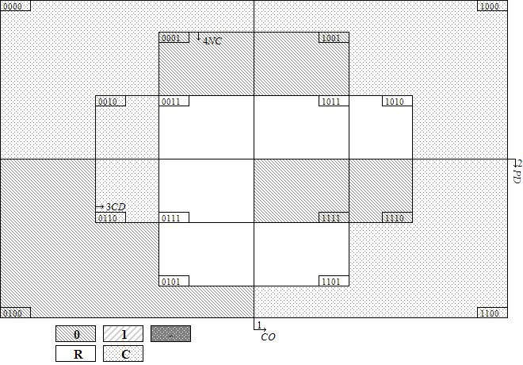
Note: CO: COHABIT, PD: DISPARL, CD: DISCAB, NC: NOCONF, O: CONFLICT, C: contradictory configuration. 0000: CO {0}* PD{0} * CD {0}* NC{0}.
Resolving Contradictory Configurations
CO | PD | CD | NC | O | Total cases | Distribution | Percentage | Mean ratio | Outcome
0 | 0 | 0 | 0 | C | 94 | H:22  L:72 | 23.40% | 0.806 | C
0 | 1 | 0 | 0 | 0 | 18 | L:18 | 0.00% | 0.000 | 0
0 | 0 | 1 | 0 | C | 10 | H:2  L:8 | 20.00% | 0.753 | C
0 | 0 | 0 | 1 | 0 | 2 | L:2 | 0.00% | 0.000 | 0
0 | 1 | 1 | 0 | C | 19 | H:2  L:17 | 10.53% | 0.376 | C
1 | 0 | 0 | 0 | C | 31 | H:19  L:12 | 61.29% | 3.187*** | 1
1 | 0 | 0 | 1 | 0 | 3 | L:3 | 0.00% | 0.000 | 0
1 | 1 | 0 | 0 | C | 7 | H:4  L:3 | 57.14% | 2.286* | 1
1 | 1 | 1 | 0 | 0 | 2 | L:2 | 0.00% | 0.000 | 0
1 | 1 | 1 | 1 | 0 | 1 | L:1 | 0.00% | 0.000 | 0
Note: * p < 0.1, ** p < 0.05, *** p < 0.01, Pearson’s chi-squared test checks statistically significant difference between configuration mean and mean of cases not falling into this specific configuration.
1. 50% threshold is used to determine the outcome of contradictory configuration
Minimization of the [1] Configurations
CO{1} * CD{0} * NC{0}= O {1} complex
CO{1} * CD{0} * NC{0}= O {1} parsimonious
(Simplifying Assumptions: -)
Minimization of the [0] Configurations
CO {0} * NC{0} +CO{1} * PD{1} * CD {1} +PD{0} * CD{0} * NC{1} = O {0} complex
CO {0}+CD{1}+NC{1}= O {0} parsimonious
(Simplifying Assumptions: CO{0}PD{0}CD{1}NC{1} +CO{0}PD{1}CD{0}NC{1} +CO{0}PD{1}CD{1}NC{1} +CO{1}PD{0}CD{1}NC{0} +CO{1}PD{0}CD{1}NC{1} +CO{1}PD{1}CD{0}NC{1}= O {0})
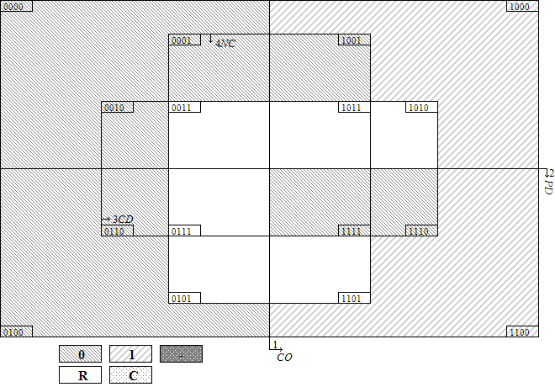
2. 60% threshold is used to determine the outcome of contradictory configuration
Minimization of the [1] Configurations
CO{1} * PD{0} *CD{0} * NC{0}= O {1} complex
CO{1} * PD{0} * NC{0}= O {1} parsimonious
(Simplifying Assumptions: CO{1}PD{0}CD{1}NC{0}= O {1})
Minimization of the [0] Configurations
CO {0} * NC{0} + CO{1} * PD{1} * CD {1} + PD{1}* NC{0}+PD{0} * CD{0} * NC{1} = O {0} complex
CO {0}+PD{1}+NC{1}= O {0} parsimonious
(Simplifying Assumptions: CO{0}PD{0}CD{1}NC{1} +CO{0}PD{1}CD{0}NC{1} +CO{0}PD{1}CD{1}NC{1} + CO{1}PD{0}CD{1}NC{1} +CO{1}PD{1}CD{0}NC{1}= O {0})
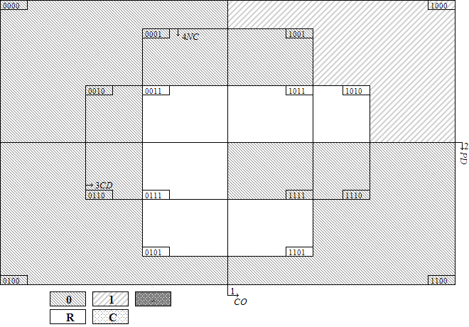
3. Ratios of configuration percentages to non-configuration percentages is used to determine the outcome of contradictory configuration
Minimization of the [1] Configurations
CO{1} * CD{0} * NC{0}= O {1} complex
CO{1} * CD{0} * NC{0}= O {1} parsimonious
(Simplifying Assumptions: -)
Minimization of the [0] Configurations
CO{1} * PD{1} * CD{1} +PD{0} * CD{0} * NC{1} +CO{0} * PD{1} * CD{0} * NC{0}=O {0} complex
NC{1}+CO{1}*CD{1}+CO{0}*PD{1}*CD{0}=O {0} parsimonious
(Simplifying Assumptions: CO{0}PD{0}CD{1}NC{1} +CO{0}PD{1}CD{0}NC{1} +CO{0}PD{1}CD{1}NC{1} +CO{1}PD{0}CD{1}NC{0} +CO{1}PD{0}CD{1}NC{1} +CO{1}PD{1}CD{0}NC{1}= O {0})
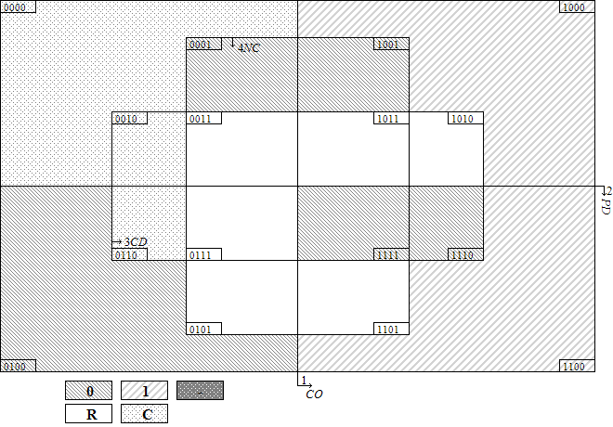
F-2 Assessing the Robustness of csQCA
1. Addition of explanatory condition: LONGDEMO
The Truth Table
CO | PD | CD | NC | LD | O | Distribution | Cases
0 | 0 | 0 | 0 | 0 | C | H:22  L:56 | Dimitrov, Berov, Kostov, Stanishev, Borissov II, Račan I, Račan II, Račan III, Sanader I, Sanader II, Sanader III, Kosor I, Milanović, Lubys, Šleževičius, Stankevičius, Vagnorius II, Paksas I, Kubilius I, Paksas II, Brazauskas I, Brazauskas III, Brazauskas IV, Brazauskas V, Kirkilas, Kubilius II, Kubilius III, Kubilius IV, Butkevičius, Sangheli, Ciubuc I, Ciubuc II, Sturza, Braghiș, Bielecki, Cimoszewicz, Miller I, Miller II, Belka, Marcinkiewicz, Kaczyński, Tusk II, Tusk III, Kopacz, Ciorbea, Vasile, Isarescu, Nastase I, Nastase II, Popescu-Tăriceanu I, Popescu-Tăriceanu II, Boc I, Boc II, Boc III, Dzurinda I, Dzurinda II, Fico I, Radicova, Fico II, Fico III, Drnovšek I, Drnovšek II, Drnovšek III, Drnovšek IV, Drnovšek V, Bajuk, Drnovšek VI, Rop I, Rop II, Janša II, Pahor I, Pahor II, Janša III, Bratušek, Tymoshenko I, Yanukovych II, Tymoshenko II, Tymoshenko IV
0 | 0 | 0 | 0 | 1 | 0 | L:16 | Lipponen I, Lipponen II, Lipponen III, Lipponen IV, Jäätteenmäki,Vanhanen I, Katainen I, Katainen II, Katainen III, Stubb I, Stubb II, Reynolds II, Ahern III, Ahern IV, Cowen, Kenny II
0 | 1 | 0 | 0 | 1 | 0 | L:18 | Cresson, Bérégovoy, Juppé I, Juppé II, Raffarin I, Raffarin II, Villepin, Fillon I, Fillon II, Ayrault, Valls I, Valls II, Guterres I, Guterres II, Guterres III, Sócrates I, Coelho I, Coelho II
0 | 0 | 1 | 0 | 0 | C | H:2  L:8 | Kasyanov, Fradkov, Lazarenko, Pustovoitenko I, Pustovoitenko II, Yushchenko, Kinakh I, Kinakh II, Yanukovych I, Azarov
0 | 0 | 0 | 1 | 1 | 0 | L:2 | Bruton, Ahern II
0 | 1 | 1 | 0 | 1 | C | H:2  L:17 | Vranitzky I, Vranitzky II, Vranitzky III, Vranitzky IV, Klima, Schüssel I, Schüssel II, Gusenbauer, Faymann I, Faymann II, Oddsson I, Oddsson II, Oddsson IV, Oddsson V, Ásgrímsson, Haarde I, Haarde II, Sigurðardóttir, Gunnlaugsson
1 | 0 | 0 | 0 | 0 | C | H:18  L:7 | Videnov, Gotha I, Gotha II, Borissov I, Kosor II, Kosor III, Nečas, Sobotka, Vagnorius I, Brazauskas II, Olszewski, Suchocka, Pawlak, Oleksy I, Buzek I, Buzek II, Tusk I, Popescu-Tăriceanu III, Ponta I, Ponta II, Ponta III, Dzurinda III, Janša I, Yanukovych III, Tymoshenko III
1 | 0 | 0 | 0 | 1 | C | H:1  L:5 | Aho I, Aho II, Aho III, Vanhanen II, Kiviniemi, Kenny I,
1 | 0 | 0 | 1 | 1 | 0 | L:3 | Reynolds I, Ahern I, Kenny III
1 | 1 | 0 | 0 | 1 | C | H:4  L:3 | Balladur, Jospin, Silva, Barroso, Santana Lopes, Sócrates II, Sócrates III
1 | 1 | 1 | 0 | 1 | 0 | L:2 | Schüssel III, Oddsson III
1 | 1 | 1 | 1 | 1 | 0 | L:1 | Schüssel IV
Note: CO: COHABIT, PD: DISPARL, CD: DISCAB, NC: NOCONF, LD: LONGDEMO, O: CONFLICT, C: contradictory configuration. Cabinets labeled by bold are cases of high level of intra-executive conflict.
Resolving Contradictory Configurations
CO | PD | CD | NC | LD | O | Total cases | Distribution | Percentage | Mean ratio | Outcome
0 | 0 | 0 | 0 | 0 | C | 78 | H:22  L:56 | 28.21% | 1.139 | C
0 | 0 | 0 | 0 | 1 | 0 | 16 | L:16 | 0.00% | 0.000 | 0
0 | 1 | 0 | 0 | 1 | 0 | 18 | L:18 | 0.00% | 0.000 | 0
0 | 0 | 1 | 0 | 0 | C | 10 | H:2  L:8 | 20.00% | 0.753 | C
0 | 0 | 0 | 1 | 1 | 0 | 2 | L:2 | 0.00% | 0.000 | 0
0 | 1 | 1 | 0 | 1 | C | 19 | H:2  L:17 | 10.53% | 0.376 | C
1 | 0 | 0 | 0 | 0 | C | 25 | H:18  L:7 | 72.00% | 3.763*** | 1
1 | 0 | 0 | 0 | 1 | C | 6 | H:1  L:5 | 16.67% | 0.629 | C
1 | 0 | 0 | 1 | 1 | 0 | 3 | L:3 | 0.00% | 0.000 | 0
1 | 1 | 0 | 0 | 1 | C | 7 | H:4  L:3 | 57.14% | 2.286* | 1
1 | 1 | 1 | 0 | 1 | 0 | 2 | L:2 | 0.00% | 0.000 | 0
1 | 1 | 1 | 1 | 1 | 0 | 1 | L:1 | 0.00% | 0.000 | 0
Note: * p < 0.1, ** p < 0.05, *** p < 0.01, Pearson’s chi-squared test checks statistically significant difference between configuration mean and mean of cases not falling into this specific configuration.
1. 50% threshold is used to determine the outcome of contradictory configuration
Minimization of the [1] Configurations
CO{1} * PD{0} * CD{0} * NC{0} * LD{0} +CO{1} * PD{1} * CD{0} * NC{0} * LD{1}= O {1} complex
CO{1} * PD{0} * CD{0} * NC{0} * LD{0}+CO{1} * PD{1} * CD{0} * LD{1}= O {1} intermediate
(Simplifying Assumptions: using logical remainders including LD{1} = O {1})
CO{1}*LD{0}+CO{1}*PD{1}*CD{0}= O {1} parsimonious
(Simplifying Assumptions: CO{1}PD{0}CD{0}NC{1}LD{0} + CO{1}PD{0}CD{1}NC{0}LD{0} + CO{1}PD{0}CD{1}NC{1}LD{0} + CO{1}PD{1}CD{0}NC{0}LD{0} + CO{1}PD{1}CD{0}NC{1}LD{0} + CO{1}PD{1}CD{0}NC{1}LD{1} + CO{1}PD{1}CD{1}NC{0}LD{0} + CO{1}PD{1}CD{1}NC{1}LD{0}= O {1})
Minimization of the [0] Configurations
PD{0} * CD{0} * LD{1} +CO{0} * PD{1} * NC{0} * LD{1} +CO{1} * PD{1} * CD{1} * LD{1} +CO{0} * PD{0} * NC{0} * LD{0} = O {0} complex
PD{0} * CD{0} * LD{1} +CO{0} * PD{1} * NC{0} +CO{1} * PD{1} * CD{1} + CO{0} * NC{0} * LD{0}+ CO{0}* PD{0}* LD{0} = O {0} intermediate
(Simplifying Assumptions: using logical remainders including LD{0} = O {0})
CO{0}+CD{1}+PD{0}*LD{1}= O {0} parsimonious
(Simplifying Assumptions: CO{0}PD{0}CD{0}NC{1}LD{0} + CO{0}PD{0}CD{1}NC{0}LD{1} + CO{0}PD{0}CD{1}NC{1}LD{0} + CO{0}PD{0}CD{1}NC{1}LD{1} + CO{0}PD{1}CD{0}NC{0}LD{0} + CO{0}PD{1}CD{0}NC{1}LD{0} + CO{0}PD{1}CD{0}NC{1}LD{1} + CO{0}PD{1}CD{1}NC{0}LD{0} + CO{0}PD{1}CD{1}NC{1}LD{0} + CO{0}PD{1}CD{1}NC{1}LD{1} + CO{1}PD{0}CD{1}NC{0}LD{0} + CO{1}PD{0}CD{1}NC{0}LD{1} + CO{1}PD{0}CD{1}NC{1}LD{0} + CO{1}PD{0}CD{1}NC{1}LD{1} + CO{1}PD{1}CD{1}NC{0}LD{0} + CO{1}PD{1}CD{1}NC{1}LD{0}= O {0})
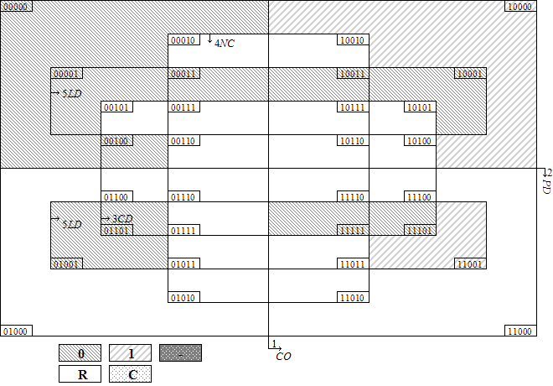
2. 60% threshold is used to determine the outcome of contradictory configuration
Minimization of the [1] Configurations
CO{1} * PD{0} * CD{0} * NC{0} * LD{0} = O {1} complex
CO{1} * PD{0} * CD{0} * NC{0} * LD{0} = O {1} intermediate
(Simplifying Assumptions: -)
CO{1}*LD{0}= O {1} parsimonious
(Simplifying Assumptions: CO{1}PD{0}CD{0}NC{1}LD{0} + CO{1}PD{0}CD{1}NC{0}LD{0} + CO{1}PD{0}CD{1}NC{1}LD{0} + CO{1}PD{1}CD{0}NC{0}LD{0} + CO{1}PD{1}CD{0}NC{1}LD{0} + CO{1}PD{1}CD{1}NC{0}LD{0} + CO{1}PD{1}CD{1}NC{1}LD{0}= O {1})
Minimization of the [0] Configurations
PD{1} * NC{0} * LD{1} + PD{0} * CD{0} * LD{1} +CO{1} * PD{1} * CD{1} * LD{1} +CO{0} * PD{0} * NC{0} * LD{0} = O {0} complex
PD{1} * NC{0}+ PD{0} * CD{0} * LD{1} + CO{1} * PD{1} * CD{1} + CO{0} * NC{0} * LD{0}+ CO{0}* PD{0}* LD{0} = O {0} intermediate
(Simplifying Assumptions: using logical remainders including LD{0} = O {0})
CO{0}+LD{1}= O {0} parsimonious
(Simplifying Assumptions: CO{0}PD{0}CD{0}NC{1}LD{0} + CO{0}PD{0}CD{1}NC{0}LD{1} + CO{0}PD{0}CD{1}NC{1}LD{0} + CO{0}PD{0}CD{1}NC{1}LD{1} + CO{0}PD{1}CD{0}NC{0}LD{0} + CO{0}PD{1}CD{0}NC{1}LD{0} + CO{0}PD{1}CD{0}NC{1}LD{1} + CO{0}PD{1}CD{1}NC{0}LD{0} + CO{0}PD{1}CD{1}NC{1}LD{0} + CO{0}PD{1}CD{1}NC{1}LD{1} + CO{1}PD{0}CD{1}NC{0}LD{1} + CO{1}PD{0}CD{1}NC{1}LD{1} + CO{1}PD{1}CD{0}NC{1}LD{1}= O {0})
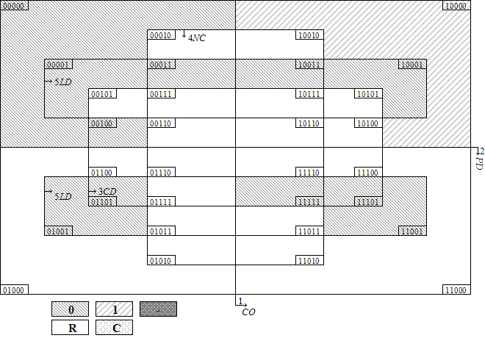
3. Ratios of configuration percentages to non-configuration percentages is used to determine the outcome of contradictory configuration
Minimization of the [1] Configurations
CO{1} * PD{0} * CD{0} * NC{0} * LD{0} = O {1} complex
CO{1} * PD{0} * CD{0} * NC{0} * LD{0} = O {1} intermediate
(Simplifying Assumptions: -)
CO{1}*LD{0}= O {1} parsimonious
(Simplifying Assumptions: CO{1}PD{0}CD{0}NC{1}LD{0} + CO{1}PD{0}CD{1}NC{0}LD{0} + CO{1}PD{0}CD{1}NC{1}LD{0} + CO{1}PD{1}CD{0}NC{0}LD{0} + CO{1}PD{1}CD{0}NC{1}LD{0} + CO{1}PD{1}CD{1}NC{0}LD{0} + CO{1}PD{1}CD{1}NC{1}LD{0}= O {1})
Minimization of the [0] Configurations
CO{1} * PD{1} * CD{1} * LD{1} +CO{0} * CD{0} * NC{0} * LD{1} +PD{0} * CD{0} * NC{1} * LD{1} =O {0} complex
CO{1} * PD{1} * CD{1}+ CO{0} * CD{0} * NC{0} * LD{1} + PD{0} * CD{0} * NC{1}=O {0} intermediate
(Simplifying Assumptions: using logical remainders including LD{0} = O {0})
NC{1}+CO{1}*CD{1}+CO{0}*CD{0}*LD{1}=O {0} parsimonious
(Simplifying Assumptions: CO{0}PD{0}CD{0}NC{1}LD{0} + CO{0}PD{0}CD{1}NC{1}LD{0} + CO{0}PD{0}CD{1}NC{1}LD{1} + CO{0}PD{1}CD{0}NC{1}LD{0} + CO{0}PD{1}CD{0}NC{1}LD{1} + CO{0}PD{1}CD{1}NC{1}LD{0} + CO{0}PD{1}CD{1}NC{1}LD{1} + CO{1}PD{0}CD{0}NC{1}LD{0} + CO{1}PD{0}CD{1}NC{0}LD{0} + CO{1}PD{0}CD{1}NC{0}LD{1} + CO{1}PD{0}CD{1}NC{1}LD{0} + CO{1}PD{0}CD{1}NC{1}LD{1} + CO{1}PD{1}CD{0}NC{1}LD{0} + CO{1}PD{1}CD{0}NC{1}LD{1} + CO{1}PD{1}CD{1}NC{0}LD{0} + CO{1}PD{1}CD{1}NC{1}LD{0}= O {0})
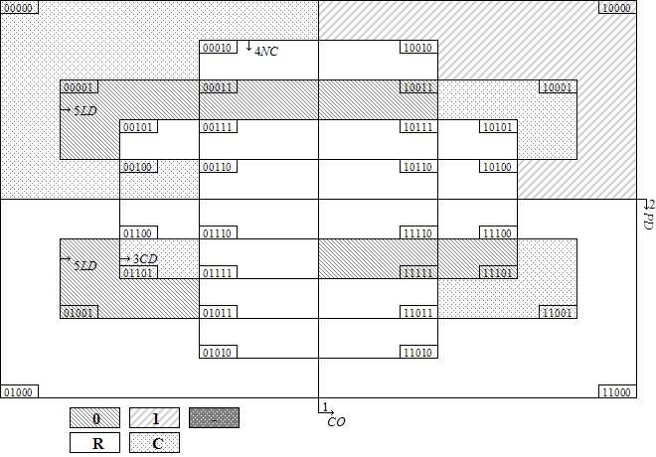
2. Change the Calibration Thresholds: DISPARL
The Truth Table
CO | PD | CD | NC | O | Distribution | Cases
0 | 0 | 0 | 0 | C | H:15  L:37 | Dimitrov, Berov, Kostov, Stanishev, Borissov II, Račan I, Račan II, Račan III, Sanader I, Sanader II, Sanader III, Kosor I, Milanović, Sangheli, Ciubuc I, Ciubuc II, Sturza, Braghiș, Ciorbea, Vasile, Isarescu, Nastase I, Nastase II, Popescu-Tăriceanu I, Popescu-Tăriceanu II, Boc I, Boc II, Boc III, Dzurinda I, Dzurinda II, Fico I, Radicova, Fico II, Fico III, Drnovšek I, Drnovšek II, Drnovšek III, Drnovšek IV, Drnovšek V, Bajuk, Drnovšek VI, Rop I, Rop II, Janša II, Pahor I, Pahor II, Janša III, Bratušek, Tymoshenko I, Yanukovych II, Tymoshenko II, Tymoshenko IV
0 | 1 | 0 | 0 | C | H: 7  L:53 | Lipponen I, Lipponen II, Lipponen III, Lipponen IV, Jäätteenmäki,Vanhanen I, Katainen I, Katainen II, Katainen III, Stubb I, Stubb II, Cresson, Bérégovoy, Juppé I, Juppé II, Raffarin I, Raffarin II, Villepin, Fillon I, Fillon II, Ayrault, Valls I, Valls II, Reynolds II, Ahern III, Ahern IV, Cowen, Kenny II, Lubys, Šleževičius, Stankevičius, Vagnorius II, Paksas I, Kubilius I, Paksas II, Brazauskas I, Brazauskas III, Brazauskas IV, Brazauskas V, Kirkilas, Kubilius II, Kubilius III, Kubilius IV, Butkevičius, Bielecki, Cimoszewicz, Miller I, Miller II, Belka, Marcinkiewicz, Kaczyński, Tusk II, Tusk III, Kopacz, Guterres I, Guterres II, Guterres III, Sócrates I, Coelho I, Coelho II
0 | 0 | 1 | 0 | C | H:2  L:6 | Lazarenko, Pustovoitenko I, Pustovoitenko II, Yushchenko, Kinakh I, Kinakh II, Yanukovych I, Azarov
0 | 1 | 0 | 1 | 0 | L:2 | Bruton, Ahern II
0 | 1 | 1 | 0 | C | H:2  L:19 | Vranitzky I, Vranitzky II, Vranitzky III, Vranitzky IV, Klima, Schüssel I, Schüssel II, Gusenbauer, Faymann I, Faymann II, Oddsson I, Oddsson II, Oddsson IV, Oddsson V, Ásgrímsson, Haarde I, Haarde II, Sigurðardóttir, Gunnlaugsson, Kasyanov, Fradkov
1 | 0 | 0 | 0 | C | H:13  L:3 | Videnov, Gotha I, Gotha II, Borissov I, Kosor II, Kosor III, Nečas, Sobotka, Popescu-Tăriceanu III, Ponta I, Ponta II, Ponta III, Dzurinda III, Janša I, Yanukovych III, Tymoshenko III
1 | 1 | 0 | 1 | 0 | L:3 | Reynolds I, Ahern I, Kenny III
1 | 1 | 0 | 0 | C | H:10  L:12 | Aho I, Aho II, Aho III, Vanhanen II, Kiviniemi, Balladur, Jospin, Kenny I, Vagnorius I, Brazauskas II, Olszewski, Suchocka, Pawlak, Oleksy I, Buzek I, Buzek II, Tusk I, Silva, Barroso, Santana Lopes, Sócrates II, Sócrates III
1 | 1 | 1 | 0 | 0 | L:2 | Schüssel III, Oddsson III
1 | 1 | 1 | 1 | 0 | L:1 | Schüssel IV
Note: CO: COHABIT, PD: DISPARL, CD: DISCAB, NC: NOCONF, O: CONFLICT, C: contradictory configuration. Cabinets labeled by bold are cases of high level of intra-executive conflict.
Resolving Contradictory Configurations
CO | PD | CD | NC | O | Total cases | Distribution | Percentage | Mean ratio | Outcome
0 | 0 | 0 | 0 | C | 52 | H:15  L:37 | 28.85% | 1.145 | C
0 | 1 | 0 | 0 | C | 60 | H: 7  L:53 | 11.67% | 0.353*** | 0
0 | 0 | 1 | 0 | C | 8 | H:2  L:6 | 25.00% | 0.952 | C
0 | 1 | 0 | 1 | 0 | 2 | L:2 | 0.00% | 0.000 | 0
0 | 1 | 1 | 0 | C | 21 | H:2  L:19 | 9.52% | 0.336* | 0
1 | 0 | 0 | 0 | C | 16 | H:13  L:3 | 81.25% | 3.860*** | 1
1 | 1 | 0 | 1 | 0 | 3 | L:3 | 0.00% | 0.000 | 0
1 | 1 | 0 | 0 | C | 22 | H:10  L:12 | 45.45% | 1.923** | 1
1 | 1 | 1 | 0 | 0 | 2 | L:2 | 0.00% | 0.000 | 0
1 | 1 | 1 | 1 | 0 | 1 | L:1 | 0.00% | 0.000 | 0
Note: * p < 0.1, ** p < 0.05, *** p < 0.01, Pearson’s chi-squared test checks statistically significant difference between configuration mean and mean of cases not falling into this specific configuration.
1. 50%(=60%) threshold is used to determine the outcome of contradictory configuration
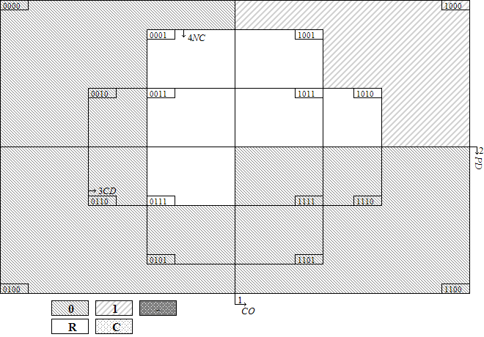
Minimization of the [1] Configurations
CO{1} * PD{0} * CD{0} * NC{0}= O {1} complex
CO{1} * PD{0}= O {1} parsimonious
(Simplifying Assumptions: CO{1}PD{0}CD{0}NC{1} + CO{1}PD{0}CD{1}NC{0} + CO{1}PD{0}CD{1}NC{1}= O {1})
Minimization of the [0] Configurations
CO{0} * NC{0} + CO{1} * PD{1} + PD{1} * CD{0} = O {0} complex
CO{0}+ PD{1}= O {0} parsimonious
(Simplifying Assumptions: CO{0}PD{0}CD{0}NC{1} + CO{0}PD{0}CD{1}NC{1} + CO{0}PD{1}CD{1}NC{1}= O {0})
2. Ratios of configuration percentages to non-configuration percentages is used to determine the outcome of contradictory configuration
Minimization of the [1] Configurations
CO{1} * CD{0} * NC{0}= O {1} complex
CO{1} * CD{0} * NC{0}= O {1} parsimonious
(Simplifying Assumptions: -)
Minimization of the [0] Configurations
PD{1} * CD{1} * NC{0} + CO{1} * PD{1} * NC{1} + CO{0} * PD{1} * CD{0} =O {0} complex
CO{0} * PD{1} * NC{0} + CO{1} * PD{1} * CD{1} + PD{1} * CD{0} * NC{1}=O {0} complex
NC{1}+CO{0}*PD{1}+CO{1}*CD{1} =O {0} parsimonious
(Simplifying Assumptions: CO{0}PD{0}CD{0}NC{1} + CO{0}PD{0}CD{1}NC{1} + CO{0}PD{1}CD{1}NC{1} + CO{1}PD{0}CD{0}NC{1} + CO{1}PD{0}CD{1}NC{0} + CO{1}PD{0}CD{1}NC{1}= O {0})
NC{1}+CO{0}*PD{1}+PD{1}*CD{1}=O {0} parsimonious
(Simplifying Assumptions: CO{0}PD{0}CD{0}NC{1} + CO{0}PD{0}CD{1}NC{1} + CO{0}PD{1}CD{1}NC{1} + CO{1}PD{0}CD{0}NC{1} + CO{1}PD{0}CD{1}NC{1}= O {0})
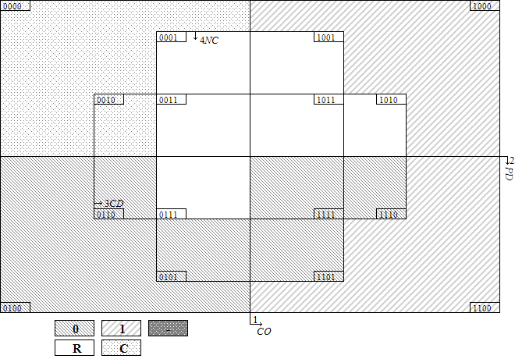
3. Change the Frequency Thresholds: at least Two Cases
The Truth Table
CO | PD | CD | NC | O | Distribution | Cases
0 | 0 | 0 | 0 | C | H:22  L:72 | Dimitrov, Berov, Kostov, Stanishev, Borissov II, Račan I, Račan II, Račan III, Sanader I, Sanader II, Sanader III, Kosor I, Milanović, Lipponen I, Lipponen II, Lipponen III, Lipponen IV, Jäätteenmäki,Vanhanen I, Katainen I, Katainen II, Katainen III, Stubb I, Stubb II, Reynolds II, Ahern III, Ahern IV, Cowen, Kenny II, Lubys, Šleževičius, Stankevičius, Vagnorius II, Paksas I, Kubilius I, Paksas II, Brazauskas I, Brazauskas III, Brazauskas IV, Brazauskas V, Kirkilas, Kubilius II, Kubilius III, Kubilius IV, Butkevičius, Sangheli, Ciubuc I, Ciubuc II, Sturza, Braghiș, Bielecki, Cimoszewicz, Miller I, Miller II, Belka, Marcinkiewicz, Kaczyński, Tusk II, Tusk III, Kopacz, Ciorbea, Vasile, Isarescu, Nastase I, Nastase II, Popescu-Tăriceanu I, Popescu-Tăriceanu II, Boc I, Boc II, Boc III, Dzurinda I, Dzurinda II, Fico I, Radicova, Fico II, Fico III, Drnovšek I, Drnovšek II, Drnovšek III, Drnovšek IV, Drnovšek V, Bajuk, Drnovšek VI, Rop I, Rop II, Janša II, Pahor I, Pahor II, Janša III, Bratušek, Tymoshenko I, Yanukovych II, Tymoshenko II, Tymoshenko IV
0 | 1 | 0 | 0 | 0 | L:18 | Cresson, Bérégovoy, Juppé I, Juppé II, Raffarin I, Raffarin II, Villepin, Fillon I, Fillon II, Ayrault, Valls I, Valls II, Guterres I, Guterres II, Guterres III, Sócrates I, Coelho I, Coelho II
0 | 0 | 1 | 0 | C | H:2  L:8 | Kasyanov, Fradkov, Lazarenko, Pustovoitenko I, Pustovoitenko II, Yushchenko, Kinakh I, Kinakh II, Yanukovych I, Azarov
0 | 0 | 0 | 1 | 0 | L:2 | Bruton, Ahern II
0 | 1 | 1 | 0 | C | H:2  L:17 | Vranitzky I, Vranitzky II, Vranitzky III, Vranitzky IV, Klima, Schüssel I, Schüssel II, Gusenbauer, Faymann I, Faymann II, Oddsson I, Oddsson II, Oddsson IV, Oddsson V, Ásgrímsson, Haarde I, Haarde II, Sigurðardóttir, Gunnlaugsson
1 | 0 | 0 | 0 | C | H:19  L:12 | Videnov, Gotha I, Gotha II, Borissov I, Kosor II, Kosor III, Nečas, Sobotka, Aho I, Aho II, Aho III, Vanhanen II, Kiviniemi, Kenny I, Vagnorius I, Brazauskas II, Olszewski, Suchocka, Pawlak, Oleksy I, Buzek I, Buzek II, Tusk I, Popescu-Tăriceanu III, Ponta I, Ponta II, Ponta III, Dzurinda III, Janša I, Yanukovych III, Tymoshenko III
1 | 0 | 0 | 1 | 0 | L:3 | Reynolds I, Ahern I, Kenny III
1 | 1 | 0 | 0 | C | H:4  L:3 | Balladur, Jospin, Silva, Barroso, Santana Lopes, Sócrates II, Sócrates III
1 | 1 | 1 | 0 | 0 | L:2 | Schüssel III, Oddsson III
Note: CO: COHABIT, PD: DISPARL, CD: DISCAB, NC: NOCONF, O: CONFLICT, C: contradictory configuration. Cabinets labeled by bold are cases of high level of intra-executive conflict.
Resolving Contradictory Configurations
CO | PD | CD | NC | O | Total cases | Distribution | Percentage | Mean ratio | Outcome
0 | 0 | 0 | 0 | C | 94 | H:22  L:72 | 23.40% | 0.797 | C
0 | 1 | 0 | 0 | 0 | 18 | L:18 | 0.00% | 0.000 | 0
0 | 0 | 1 | 0 | C | 10 | H:2  L:8 | 20.00% | 0.749 | C
0 | 0 | 0 | 1 | 0 | 2 | L:2 | 0.00% | 0.000 | 0
0 | 1 | 1 | 0 | C | 19 | H:2  L:17 | 10.53% | 0.374 | C
1 | 0 | 0 | 0 | C | 31 | H:19  L:12 | 61.29% | 3.167*** | 1
1 | 0 | 0 | 1 | 0 | 3 | L:3 | 0.00% | 0.000 | 0
1 | 1 | 0 | 0 | C | 7 | H:4  L:3 | 57.14% | 2.273* | 1
1 | 1 | 1 | 0 | 0 | 2 | L:2 | 0.00% | 0.000 | 0
Note: * p < 0.1, ** p < 0.05, *** p < 0.01, Pearson’s chi-squared test checks statistically significant difference between configuration mean and mean of cases not falling into this specific configuration.
1. 50% threshold is used to determine the outcome of contradictory configuration
Minimization of the [1] Configurations
CO{1} * CD{0} * NC{0}= O {1} complex
CO{1} * CD{0} * NC{0}= O {1} parsimonious
(Simplifying Assumptions: -)
Minimization of the [0] Configurations
CO {0} * NC{0} + PD{1} * CD{1} * NC{0} +PD{0} * CD{0} * NC{1} = O {0} complex
CO {0}+CD{1}+NC{1}= O {0} parsimonious
(Simplifying Assumptions: CO{0}PD{0}CD{1}NC{1} + CO{0}PD{1}CD{0}NC{1} + CO{0}PD{1}CD{1}NC{1} + CO{1}PD{0}CD{1}NC{0} + CO{1}PD{0}CD{1}NC{1} + CO{1}PD{1}CD{0}NC{1} + CO{1}PD{1}CD{1}NC{1}= O {0})
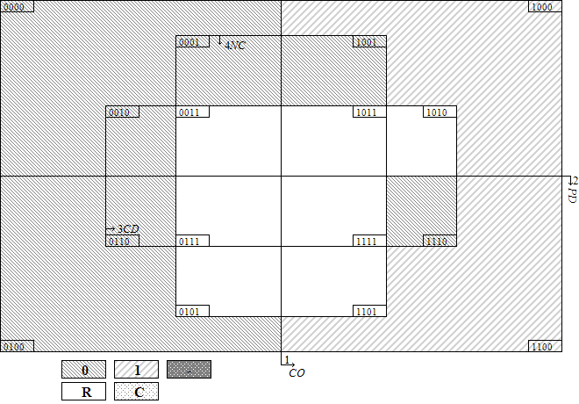
2. 60% threshold is used to determine the outcome of contradictory configuration
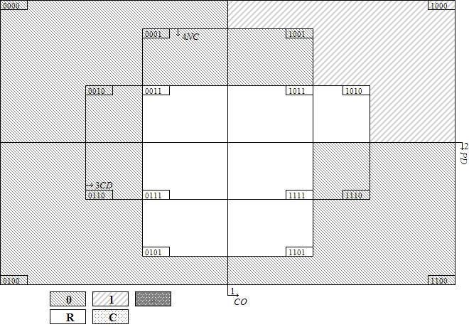
Minimization of the [1] Configurations
CO{1} * PD{0} *CD{0} * NC{0}= O {1} complex
CO{1} * PD{0} * NC{0}= O {1} parsimonious
(Simplifying Assumptions: CO{1}PD{0}CD{1}NC{0}= O {1})
Minimization of the [0] Configurations
CO {0} * NC{0} + PD{1}* NC{0}+PD{0} * CD{0} * NC{1} = O {0} complex
CO {0}+PD{1}+NC{1}= O {0} parsimonious
(Simplifying Assumptions: CO{0}PD{0}CD{1}NC{1} + CO{0}PD{1}CD{0}NC{1} + CO{0}PD{1}CD{1}NC{1} + CO{1}PD{0}CD{1}NC{1} + CO{1}PD{1}CD{0}NC{1} + CO{1}PD{1}CD{1}NC{1}= O {0})
3. Ratios of configuration percentages to non-configuration percentages is used to determine the outcome of contradictory configuration
Minimization of the [1] Configurations
CO{1} * CD{0} * NC{0}= O {1} complex
CO{1} * CD{0} * NC{0}= O {1} parsimonious
(Simplifying Assumptions: -)
Minimization of the [0] Configurations
CO{1} * PD{1} * CD{1} +PD{0} * CD{0} * NC{1} +CO{0} * PD{1} * CD{0} * NC{0}=O {0} complex
NC{1}+CO{1}*CD{1}+CO{0}*PD{1}*CD{0}=O {0} parsimonious
(Simplifying Assumptions: CO{0}PD{0}CD{1}NC{1} + CO{0}PD{1}CD{0}NC{1} + CO{0}PD{1}CD{1}NC{1} + CO{1}PD{0}CD{1}NC{0} + CO{1}PD{0}CD{1}NC{1} + CO{1}PD{1}CD{0}NC{1} + CO{1}PD{1}CD{1}NC{1}= O {0})
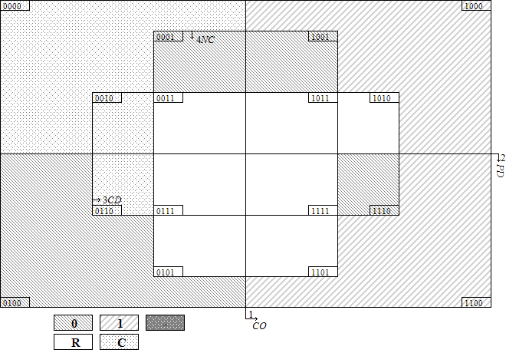

F-3 Testing the Competing Theories
Alternative Motivational Conditions: the president with experience as a party leader
Assumption: prior experience as party leaders makes it more likely for the president to intervene in executive affairs
Condition: CH{1}: the president with experience as a party leader
The Truth Table
CH | PD | CD | NC | O | Distribution | Cases
0 | 0 | 0 | 0 | C | H:13  L:50 | Kostov, Gotha I, Borissov II, Račan I, Račan II, Račan III, Sanader I, Sanader II, Sanader III, Kosor I, Kosor II, Kosor III, Milanović, Aho I, Aho II, Aho III, Lipponen I, Lipponen II, Lipponen III, Lipponen IV, Jäätteenmäki,Vanhanen I, Vanhanen II, Kiviniemi, Katainen I, Reynolds II, Ahern III, Ahern IV, Cowen, Kenny I, Kenny II, Vagnorius II, Paksas I, Kubilius I, Paksas II, Brazauskas I, Brazauskas II, Brazauskas III, Brazauskas IV, Brazauskas V, Kirkilas, Kubilius II, Kubilius III, Kubilius IV, Butkevičius, Tusk II, Tusk III, Kopacz, Ciorbea, Vasile, Isarescu, Fico III, Drnovšek I, Drnovšek II, Drnovšek III, Drnovšek IV, Drnovšek V, Bajuk, Drnovšek VI, Janša II, Pahor I, Pahor II, Janša III
0 | 0 | 1 | 0 | C | H:2  L:5 | Lazarenko, Pustovoitenko I, Pustovoitenko II, Yushchenko, Kinakh I, Kinakh II, Yanukovych I
0 | 0 | 0 | 1 | 0 | L:5 | Reynolds I, Bruton, Ahern I, Ahern II, Kenny III
0 | 1 | 1 | 0 | 0 | L:13 | Vranitzky I, Vranitzky II, Vranitzky III, Vranitzky IV, Klima, Schüssel I, Schüssel II, Schüssel III, Gusenbauer, Faymann I, Faymann II, Oddsson I, Oddsson II
0 | 1 | 1 | 1 | 0 | L:1 | Schüssel IV
1 | 0 | 0 | 0 | C | H:28  L:34 | Dimitrov, Berov, Videnov, Gotha II, Stanishev, Borissov I, Nečas, Sobotka, Katainen II, Katainen III, Stubb I, Stubb II, Lubys, Šleževičius, Stankevičius, Vagnorius I, Sangheli, Ciubuc I, Ciubuc II, Sturza, Braghiș, Bielecki, Olszewski, Suchocka, Pawlak, Oleksy I, Cimoszewicz, Buzek I, Buzek II, Miller I, Miller II, Belka, Marcinkiewicz, Kaczyński, Tusk I, Nastase I, Nastase II, Popescu-Tăriceanu I, Popescu-Tăriceanu II, Popescu-Tăriceanu III, Boc I, Boc II, Boc III, Ponta I, Ponta II, Ponta III, Dzurinda I, Dzurinda II, Dzurinda III, Fico I, Radicova, Fico II, Rop I, Rop II, Janša I, Bratušek, Tymoshenko I, Yanukovych II, Yanukovych III, Tymoshenko II, Tymoshenko III, Tymoshenko IV
1 | 0 | 1 | 0 | 0 | L:3 | Kasyanov, Fradkov, Azarov
1 | 1 | 0 | 0 | C | H:4  L:21 | Cresson, Bérégovoy, Balladur, Juppé I, Juppé II, Jospin, Raffarin I, Raffarin II, Villepin, Fillon I, Fillon II, Ayrault, Valls I, Valls II, Silva, Guterres I, Guterres II, Guterres III, Barroso, Santana Lopes, Sócrates I, Sócrates II, Sócrates III, Coelho I, Coelho II
1 | 1 | 1 | 0 | C | H:2  L:6 | Oddsson III, Oddsson IV, Oddsson V, Ásgrímsson, Haarde I, Haarde II, Sigurðardóttir, Gunnlaugsson
Note: CH: CHAIR, PD: DISPARL, CD: DISCAB, NC: NOCONF, O: CONFLICT, C: contradictory configuration. Cabinets labeled by bold are cases of high level of intra-executive conflict.
Venn Diagram Corresponding to the Truth Table
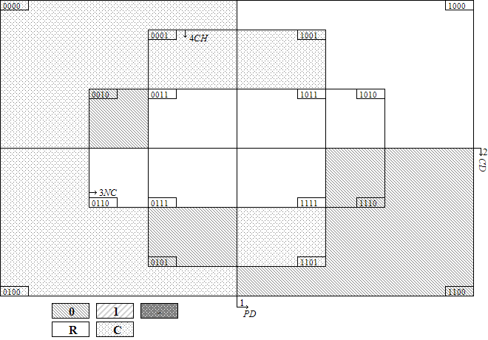
Note: CH: CHAIR, PD: DISPARL, CD: DISCAB, NC: NOCONF, O: CONFLICT, C: contradictory configuration. 0000: PD{0} * CD {0}* NC{0}* CH{0}.
Resolving Contradictory Configurations
CH | PD | CD | NC | O | Total cases | Distribution | Percentage | Mean ratio | Outcome
0 | 0 | 0 | 0 | C | 63 | H:13  L:50 | 20.63% | 0.711 | C
0 | 0 | 1 | 0 | C | 7 | H:2  L:5 | 28.57% | 1.094 | C
0 | 0 | 0 | 1 | 0 | 5 | L:5 | 0.00% | 0.000 | 0
0 | 1 | 1 | 0 | 0 | 13 | L:13 | 0.00% | 0.000 | 0
0 | 1 | 1 | 1 | 0 | 1 | L:1 | 0.00% | 0.000 | 0
1 | 0 | 0 | 0 | C | 62 | H:28  L:34 | 45.16% | 2.688*** | 1
1 | 0 | 1 | 0 | 0 | 3 | L:3 | 0.00% | 0.000 | 0
1 | 1 | 0 | 0 | C | 25 | H:4  L:21 | 16.00% | 0.576 | C
1 | 1 | 1 | 0 | C | 8 | H:2  L:6 | 25.00% | 0.952 | C
Note: * p < 0.1, ** p < 0.05, *** p < 0.01, Pearson’s chi-squared test checks statistically significant difference between configuration mean and mean of cases not falling into this specific configuration.
1. 50% threshold is used to determine the outcome of contradictory configuration
Minimization of the [1] Configurations
Complex: no logical configuration
Parsimonious: no logical configuration
(Simplifying Assumptions: -)
Minimization of the [0] Configurations
CD{1} * NC{0} +NC{0} * CH{1} +PD{1} * CD{1} * CH{0} + PD{0} * CD{0} * CH{0}= O {0} complex
Parsimonious: all logical configuration
(Simplifying Assumptions: -)
2. 60% threshold is used to determine the outcome of contradictory configuration
Minimization of the [1] Configurations
Complex: no logical configuration
Parsimonious: no logical configuration
(Simplifying Assumptions: -)
Minimization of the [0] Configurations
CD{1} * NC{0} +NC{0} * CH{1} +PD{1} * CD{1} * CH{0} + PD{0} * CD{0} * CH{0}= O {0} complex
Parsimonious: all logical configuration
(Simplifying Assumptions: -)
3. Ratios of configuration percentages to non-configuration percentages is used to determine the outcome of contradictory configuration
Minimization of the [1] Configurations
CH{1} * PD{0} *CD{0} * NC{0}= O {1} complex
CH{1} * PD{0} *CD{0}= O {1} parsimonious
(Simplifying Assumptions: CH{1}PD{0}CD{0}NC{1}= O {1})
Minimization of the [0] Configurations
PD{1} * CD{1} * CH{0} +PD{0} * CD{0} * NC{1} * CH{0} +PD{0} * CD{1} * NC{0} * CH{1} = O {0} complex
NC{1}+PD{1}*CH{0}+PD{0}*CD{1}*CH{1}= O {0} parsimonious
(Simplifying Assumptions: PD{0}CD{0}NC{1}CH{1} +PD{0}CD{1}NC{1}CH{0} +PD{0}CD{1}NC{1}CH{1} +PD{1}CD{0}NC{0}CH{0} +PD{1}CD{0}NC{1}CH{0} +PD{1}CD{0}NC{1}CH{1} +PD{1}CD{1}NC{1}CH{1}= O {0})
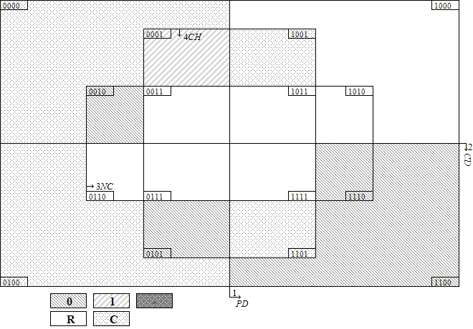

Alternative Motivational Conditions: long-lived democracy
Assumption: the president in a nascent democracy is likely to intervene in executive affairs
Condition: LD{0}: the president in a nascent democracy
The Truth Table
LD | PD | CD | NC | O | Distribution | Cases
0 | 0 | 0 | 0 | C | H:40  L:63 | Dimitrov, Berov, Videnov, Kostov, Gotha I, Gotha II, Stanishev, Borissov I, Borissov II, Račan I, Račan II, Račan III, Sanader I, Sanader II, Sanader III, Kosor I, Kosor II, Kosor III, Milanović, Nečas, Sobotka, Lubys, Šleževičius, Stankevičius, Vagnorius I, Vagnorius II, Paksas I, Kubilius I, Paksas II, Brazauskas I, Brazauskas II, Brazauskas III, Brazauskas IV, Brazauskas V, Kirkilas, Kubilius II, Kubilius III, Kubilius IV, Butkevičius, Sangheli, Ciubuc I, Ciubuc II, Sturza, Braghiș, Bielecki, Olszewski, Suchocka, Pawlak, Oleksy I, Cimoszewicz, Buzek I, Buzek II, Miller I, Miller II, Belka, Marcinkiewicz, Kaczyński, Tusk I, Tusk II, Tusk III, Kopacz, Ciorbea, Vasile, Isarescu, Nastase I, Nastase II, Popescu-Tăriceanu I, Popescu-Tăriceanu II, Popescu-Tăriceanu III, Boc I, Boc II, Boc III, Ponta I, Ponta II, Ponta III, Dzurinda I, Dzurinda II, Dzurinda III, Fico I, Radicova, Fico II, Fico III, Drnovšek I, Drnovšek II, Drnovšek III, Drnovšek IV, Drnovšek V, Bajuk, Drnovšek VI, Rop I, Rop II, Janša I, Janša II, Pahor I, Pahor II, Janša III, Bratušek, Tymoshenko I, Yanukovych II, Yanukovych III, Tymoshenko II, Tymoshenko III, Tymoshenko IV
0 | 0 | 1 | 0 | C | H:2  L:8 | Kasyanov, Fradkov, Lazarenko, Pustovoitenko I, Pustovoitenko II, Yushchenko, Kinakh I, Kinakh II, Yanukovych I, Azarov
1 | 0 | 0 | 0 | C | H:1  L:21 | Aho I, Aho II, Aho III, Lipponen I, Lipponen II, Lipponen III, Lipponen IV, Jäätteenmäki,Vanhanen I, Vanhanen II, Kiviniemi, Katainen I, Katainen II, Katainen III, Stubb I, Stubb II, Reynolds II, Ahern III, Ahern IV, Cowen, Kenny I, Kenny II
1 | 0 | 0 | 1 | 0 | L:5 | Reynolds I, Bruton, Ahern I, Ahern II, Kenny III
1 | 1 | 0 | 0 | C | H:4  L:21 | Cresson, Bérégovoy, Balladur, Juppé I, Juppé II, Jospin, Raffarin I, Raffarin II, Villepin, Fillon I, Fillon II, Ayrault, Valls I, Valls II, Silva, Guterres I, Guterres II, Guterres III, Barroso, Santana Lopes, Sócrates I, Sócrates II, Sócrates III, Coelho I, Coelho II
1 | 1 | 1 | 0 | C | H:2  L:19 | Vranitzky I, Vranitzky II, Vranitzky III, Vranitzky IV, Klima, Schüssel I, Schüssel II, Schüssel III, Gusenbauer, Faymann I, Faymann II, Oddsson I, Oddsson II, Oddsson III, Oddsson IV, Oddsson V, Ásgrímsson, Haarde I, Haarde II, Sigurðardóttir, Gunnlaugsson
1 | 1 | 1 | 1 | 0 | L:1 | Schüssel IV
Note: LD: LONG-DEMO, PD: DISPARL, CD: DISCAB, NC: NOCONF, O: CONFLICT, C: contradictory configuration. Cabinets labeled by bold are cases of high level of intra-executive conflict.
Venn Diagram Corresponding to the Truth Table
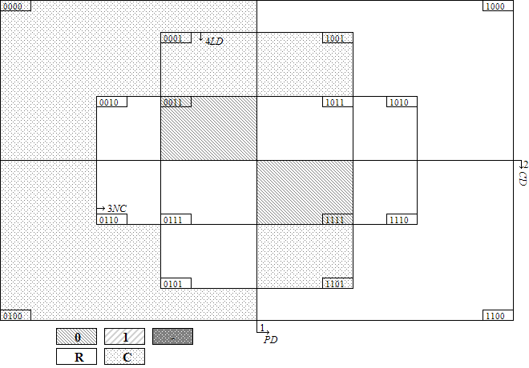
Note: LD: LONG-DEMO, PD: DISPARL, CD: DISCAB, NC: NOCONF, O: CONFLICT, C: contradictory configuration. 0000: PD{0} * CD {0}* NC{0}* LD{0}.
Resolving Contradictory Configurations
LD | PD | CD | NC | O | Total cases | Distribution | Percentage | Mean ratio | Outcome
0 | 0 | 0 | 0 | C | 103 | H:40  L:63 | 38.83% | 3.625*** | 1
0 | 0 | 1 | 0 | C | 10 | H:2  L:8 | 20.00% | 0.753 | C
1 | 0 | 0 | 0 | C | 22 | H:1  L:21 | 4.55% | 0.156** | 0
1 | 0 | 0 | 1 | 0 | 5 | L:5 | 0.00% | 0.000 | 0
1 | 1 | 0 | 0 | C | 25 | H:4  L:21 | 16.00% | 0.576 | C
1 | 1 | 1 | 0 | C | 21 | H:2  L:19 | 9.52% | 0.336* | 0
1 | 1 | 1 | 1 | 0 | 1 | L:1 | 0.00% | 0.000 | 0
Note: * p < 0.1, ** p < 0.05, *** p < 0.01, Pearson’s chi-squared test checks statistically significant difference between configuration mean and mean of cases not falling into this specific configuration.
1. 50% threshold is used to determine the outcome of contradictory configuration
Minimization of the [1] Configurations
Complex: no logical configuration
Parsimonious: no logical configuration
(Simplifying Assumptions: -)
Minimization of the [0] Configurations
PD{1} * CD{1} * LD{1} +PD{1} * NC{0} * LD{1} +PD{0} * NC{0} * LD{0} +PD{0} * CD{0} * LD{1}= O {0} complex
Parsimonious: all logical configuration
(Simplifying Assumptions: -)
2. 60% threshold is used to determine the outcome of contradictory configuration
Minimization of the [1] Configurations
Complex: no logical configuration
Parsimonious: no logical configuration
(Simplifying Assumptions: -)
Minimization of the [0] Configurations
PD{1} * CD{1} * LD{1} +PD{1} * NC{0} * LD{1} +PD{0} * NC{0} * LD{0} +PD{0} * CD{0} * LD{1}= O {0} complex
Parsimonious: all logical configuration
(Simplifying Assumptions: -)
3. Ratios of configuration percentages to non-configuration percentages is used to determine the outcome of contradictory configuration
Minimization of the [1] Configurations
LD{0} * PD{0} *CD{0} * NC{0}= O {1} complex
LD{0} * CD{0} = O {1} parsimonious
(Simplifying Assumptions: PD{0}CD{0}NC{1}LD{0} +PD{1}CD{0}NC{0}LD{0} +PD{1}CD{0}NC{1}LD{0}= O {1})
Minimization of the [0] Configurations
PD{1} *CD{1} *LD{1} +PD{0} *CD{0} *LD{1} = O {0} complex
PD{0} *LD{1}+PD{1} *CD{1}= O {0} parsimonious (Simplifying Assumptions: PD{0}CD{1}NC{0}LD{1} +PD{0}CD{1}NC{1}LD{1} +PD{1}CD{1}NC{0}LD{0} +PD{1}CD{1}NC{1}LD{0}= O {0})
PD{0} *LD{1}+CD{1} *LD{1}= O {0} parsimonious (Simplifying Assumptions: PD{0}CD{1}NC{0}LD{1} +PD{0}CD{1}NC{1}LD{1}= O {0})
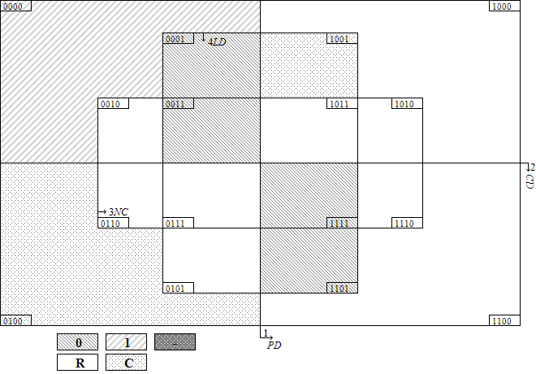
F-4 Tackling Deviant Cases of Consistency: adding more motivational conditions
Original model
CO{1} * CD{0} * NC{0}= O {1} (H:23, L:15)
Cabinets: Videnov, Gotha I, Gotha II, Borissov I, Kosor II, Kosor III, Nečas, Sobotka, Aho I, Aho II, Aho III, Vanhanen II, Kiviniemi, Balladur, Jospin, Kenny I, Vagnorius I, Brazauskas II, Olszewski, Suchocka, Pawlak, Oleksy I, Buzek I, Buzek II, Tusk I, Silva, Barroso, Santana Lopes, Sócrates II, Sócrates III, Popescu-Tăriceanu III, Ponta I, Ponta II, Ponta III, Dzurinda III, Janša I, Yanukovych III, Tymoshenko III
- The president with experience as a party leader
CO{1} * CD{0} * NC{0} * CH{1}= O {1} (H:18, L:9)
Cabinets: Videnov, Gotha II, Borissov I, Nečas, Sobotka, Balladur, Jospin, Vagnorius I, Olszewski, Suchocka, Pawlak, Oleksy I, Buzek I, Buzek II, Tusk I, Silva, Barroso, Santana Lopes, Sócrates II, Sócrates III, Popescu-Tăriceanu III, Ponta I, Ponta II, Ponta III, Dzurinda III, Janša I, Yanukovych III, Tymoshenko III
- Long-lived democracy
CO{1} * CD{0} * NC{0} * LD{0}= O {1} (H:18, L:7)
Cabinets: Videnov, Gotha I, Gotha II, Borissov I, Kosor II, Kosor III, Nečas, Sobotka, Vagnorius I, Brazauskas II, Olszewski, Suchocka, Pawlak, Oleksy I, Buzek I, Buzek II, Tusk I, Popescu-Tăriceanu III, Ponta I, Ponta II, Ponta III, Dzurinda III, Janša I, Yanukovych III, Tymoshenko III
Note: Cabinets labeled by bold are cases of high level of intra-executive conflict.

