Appendix

Figure A1. Mean levels of nativism by wave & country
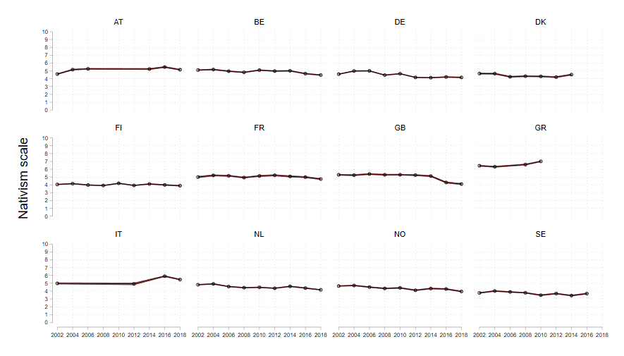
Source: European Social Survey (ESS).
Note: Composite scale of three items, rescaled 0 to 10.
Figure A2. Share of people who (strongly) agree that immigration undermines culture
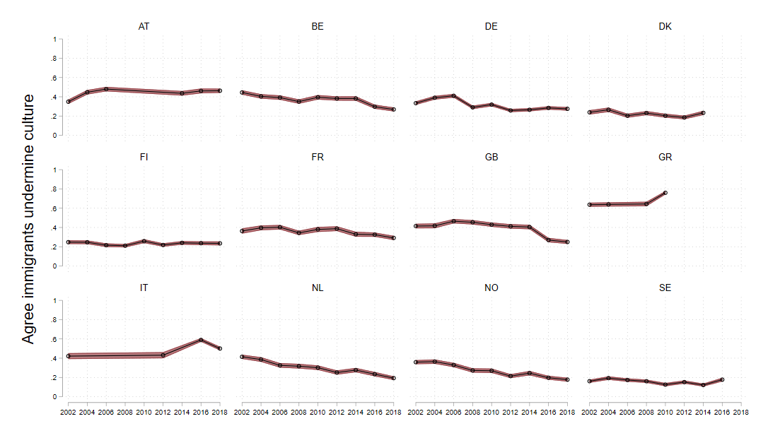 Source: European Social Survey (ESS).
Figure A3. Satisfaction with democracy and government in the Netherlands 2007–2013
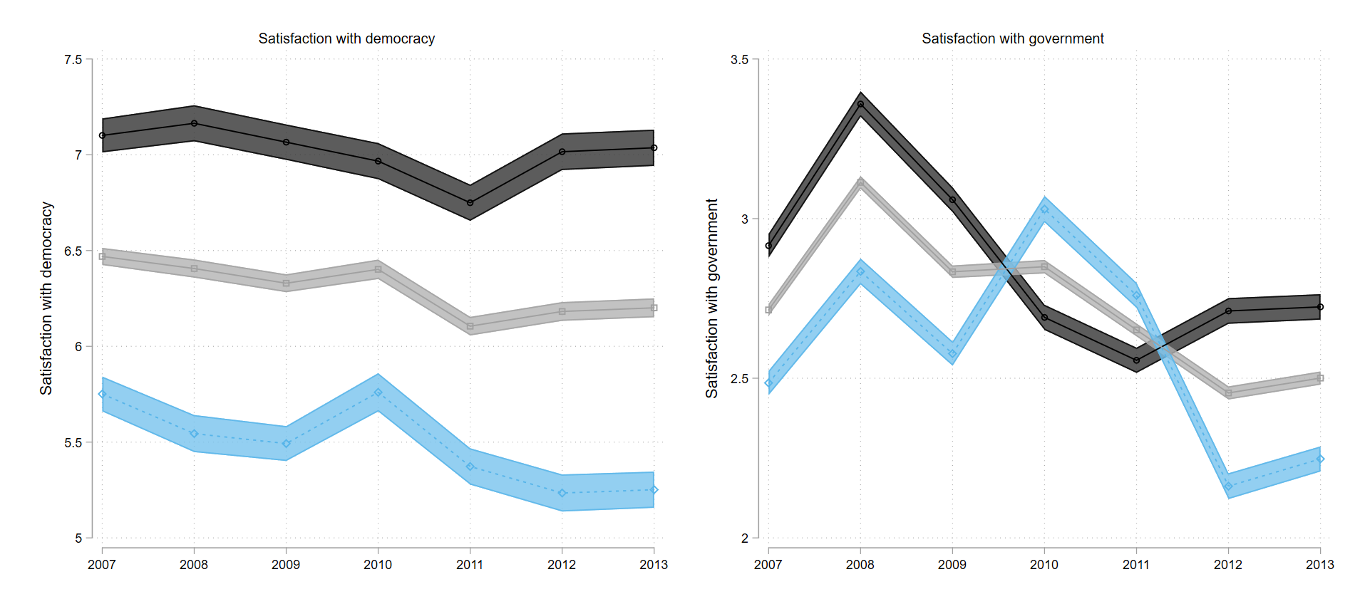
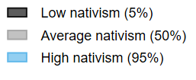
Source: LISS.

Figure A4. The effect of inclusion (2010 only) on satisfaction with democracy and government in the Netherlands

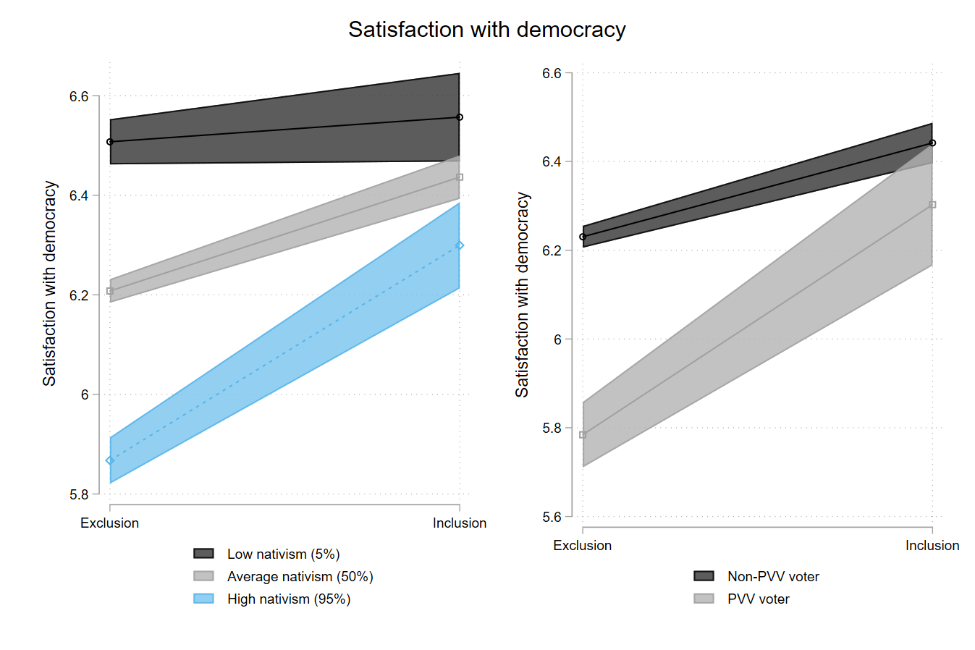

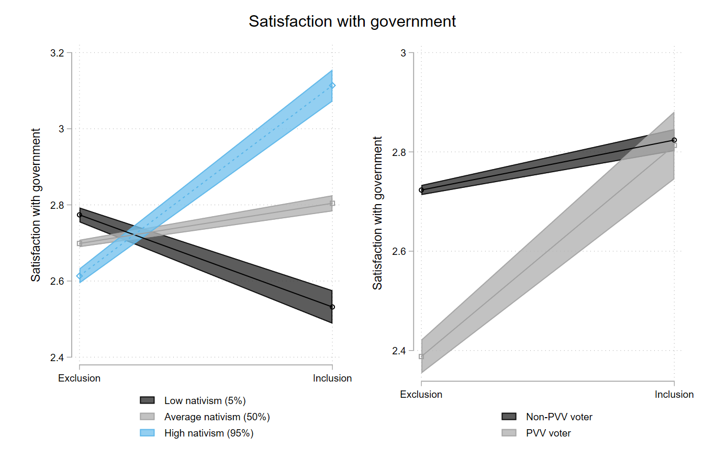
Source: LISS.
Figure A5. Marginal effects of inclusion over nativism scale
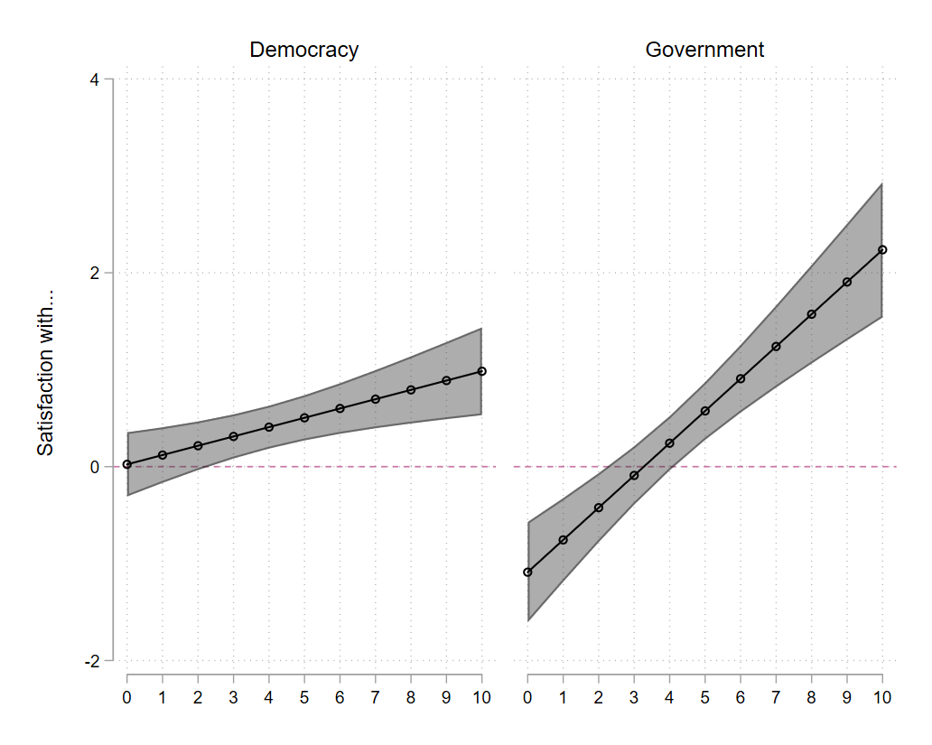
Source: European Social Survey (ESS).
Table A1. Descriptive statistics
Table A1a European Social Survey (ESS)
Variable | N | Mean | Std. Dev. | Min | Max
Satisfaction with democracy | 173,975 | 5.71 | 2.38 | 0 | 10
Satisfaction with government | 173,870 | 4.50 | 2.35 | 0 | 10
PRR vote | 139,655 | 0.06 | 0.23 | 0 | 1
Voted for winner | 122,027 | 0.50 | 0.50 | 0 | 1
Nativism (scale) | 177,163 | 4.76 | 2.12 | 0 | 10
Female (vs male) | 177,947 | 0.48 | 0.50 | 0 | 1
Age | 177,378 | 49.56 | 17.89 | 18 | 123
Education in years | 176,583 | 12.96 | 4.02 | 0 | 56

Table A1b LISS
Variable |  | Mean | Std. Dev. | Min | Max | Observations
Satisfaction with democracy | overall | 6.26 | 1.91 | 0 | 10 | N = 40274
 | between |  | 1.70 | 0 | 10 | n = 10924
 | within |  | 1.04 | -.88 | 13.66 | T bar = 3.69
Satisfaction with government | overall | 2.72 | .83 | 1 | 5 | N = 41982
 | between |  | .65 | 1 | 5 | n = 11095
 | within |  | .58 | .01 | 6.06 | T bar = 3.78
Nativism | overall | .51 | .14 | 0 | 1 | N = 64834
 | between |  | .13 | .02 | 1 | n = 11058
 | within |  | .05 | .11 | .99 | T bar = 5.86
Vote for PVV | overall | .08 | .27 | 0 | 1 | N = 61692
 | between |  | .23 | 0 | 1 | n = 10458
 | within |  | .15 | -.78 | .93 | T bar = 5.90

Table A2. Additional interaction models on the effect of inclusion on satisfaction with democracy and government
Satisfaction with democracy
LSDV approach |  |  |  |  |  | cFES model with (extended) FE transformations
 | lsdv1 | lsdv2 | lsdv3 | lsdv4 | lsdv5 |  | fet1 | fet2 | fet3 | fet4 | fet5
 | b/se | b/se | b/se | b/se | b/se |  | b/se | b/se | b/se | b/se | b/se
Nativism | -0.303*** | -0.339*** | -0.242*** | -0.325*** | -0.225*** | Nativism | -0.303*** | -0.327*** | -0.302*** | -0.326*** | -0.302***
 | (0.021) | (0.017) | (0.031) | (0.017) | (0.028) |  | (0.021) | (0.017) | (0.021) | (0.017) | (0.021)
Inclusion | 0.308* | -0.423 | -0.224 | -0.312 | -0.041 | Inclusion | 0.308* | -0.436 | -0.192 | 0.325* | 0.318*
 | (0.118) | (0.208) | (0.215) | (0.210) | (0.212) |  | (0.118) | (0.206) | (0.206) | (0.120) | (0.116)
Nativism X inclusion |  | 0.168*** | 0.119* | 0.148** | 0.096* | Nativism X inclusion |  | 0.158**
 |  | (0.037) | (0.042) | (0.037) | (0.036) |  |  | (0.037)
 |  |  |  |  |  | Nativism X inclusion (demeaned) |  |  | 0.111*
 |  |  |  |  |  |  |  |  | (0.039)
 |  |  |  |  |  | Nativism (demeaned) X inclusion |  |  |  | 0.147**
 |  |  |  |  |  |  |  |  |  | (0.036)
 |  |  |  |  |  | Nativism (demeaned) X inclusion (demeaned) |  |  |  |  | 0.088*
 |  |  |  |  |  |  |  |  |  |  | (0.032)
Satisfaction with government
LSDV approach |  |  |  |  |  | cFES model with (extended) FE transformations
 | lsdv1 | lsdv2 | lsdv3 | lsdv4 | lsdv5 |  | fet1 | fet2 | fet3 | fet4 | fet5
 | b/se | b/se | b/se | b/se | b/se |  | b/se | b/se | b/se | b/se | b/se
Nativism | -0.214*** | -0.263*** | -0.309*** | -0.255*** | -0.298*** | Nativism | -0.214*** | -0.256*** | -0.212*** | -0.255*** | -0.213***
 | (0.023) | (0.018) | (0.030) | (0.017) | (0.034) |  | (0.023) | (0.017) | (0.023) | (0.017) | (0.023)
Inclusion | 0.39 | -0.923** | -1.001** | -1.092*** | -1.184*** | Inclusion | 0.39 | -0.930** | -0.959** | 0.413 | 0.411
 | (0.212) | (0.247) | (0.244) | (0.218) | (0.238) |  | (0.212) | (0.246) | (0.244) | (0.210) | (0.205)
Nativism X Inclusion |  | 0.281*** | 0.300*** | 0.263*** | 0.280*** | Nativism X inclusion |  | 0.275***
 |  | (0.039) | (0.040) | (0.039) | (0.042) |  |  | (0.039)
 |  |  |  |  |  | Nativism X inclusion (demeaned) |  |  | 0.291***
 |  |  |  |  |  |  |  |  | (0.040)
 |  |  |  |  |  | Nativism (demeaned) X inclusion |  |  |  | 0.264***
 |  |  |  |  |  |  |  |  |  | (0.038)
 |  |  |  |  |  | Nativism (demeaned) X inclusion (demeaned) |  |  |  |  | 0.275***
 |  |  |  |  |  |  |  |  |  |  | (0.037)
Note: *** p<0.001, ** p<0.01, * p<0.05.

Comment: The relevant interaction between nativism and inclusion is highlighted in bold. All models contain controls for gender, education and age and a dummy for voting for the winning party, as well as an PRR vote dummy interacted with inclusion (and the same additional interaction terms as used in the nativism X inclusion interaction). All LSDV models include country dummies. The LSDV3 model includes interactions between nativism and country dummies. LSDV 4 includes interactions between inclusion and country dummies. LSDV5 includes both interactions between nativism and country dummies and interactions between inclusion and country dummies.

Source: European Social Survey (ESS).

