**Online Appendix**

**Claiming the Right to Rule: Regime Legitimation Strategies, 1900 to 2019**

**1, Additional convergent validity checks**

*Legitimation claims and continuous measures of democracy*

The scatter diagrams in Figure 10 plot the four legitimation claims against V-Dem’s Electoral Democracy Index (EDI) for a cross-section of all countries in the V-Dem dataset in 2019. Including all country years the correlation between the claims and the EDI are: Ideology -0.33, Leader -0.42, Performance 0.44, Rational-legal 0.52. This reiterates the pattern of associations already visible in the previous plots in section 3, but also highlights that the four legitimation measures are not mere proxy measures of democracy. They carry additional information.

*Figure 10: Relationship Between Claims and Democracy in 2019*



*Authoritarian regime types (Wahman, Teorell, and Hadenius, 2013)*

Breaking down legitimation claims according to the regime categorization proposed by Wahman, Teorell, and Hadenius (2013) offers some further nuance with regards to differences between one-party and multi-party regimes (see Figure 3). As expected, One-party regimes rely to a greater extent on ideology than any other regime type, and rely on the person of the leader more than do multi-party authoritarian regimes. While indistinguishable in terms of performance claims, one-party dictatorship, on average, relies less on rational-legal claims than do their multi-party cousins.

*Figure 11: Distributions of Claims by Regime Type*

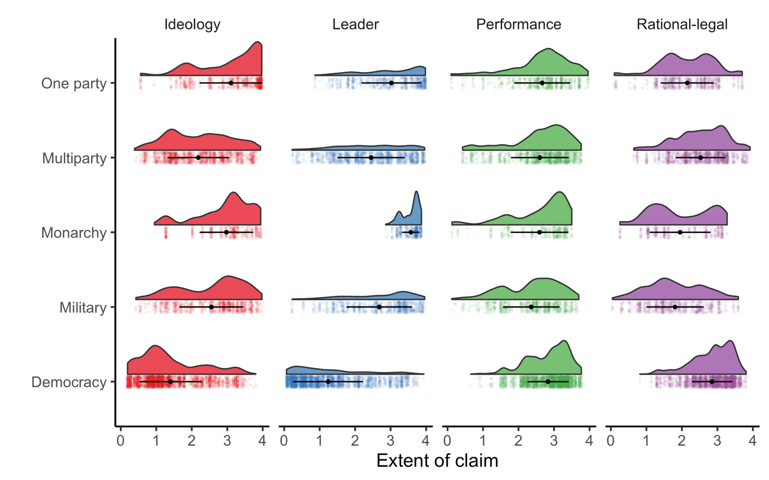

*Different Types of Ideology*

In addition to asking the country experts “*To what extent does the current government promote a specific ideology […] in order enhance the legitimacy of the regime in place”*, we also ask about the *character* of that ideology. Specifically; “*How would you characterize the ideology/ideologies identified in the previous question?”*, giving the coder the option to signify whether any of the five types of ideology were present (1 = yes, 0 = no): *Nationalist*; *Socialist or communist*; *Restorative or conservative*; *Separatist or autonomist*; *Religious*. These answers are then aggregated via averaging, taking on values between 0 [No] and 1 [Yes]. These are not mutually exclusive as a government may well promote, for example, both religion and nationalism in order to justify the regime, which, for example, is the case in both democratic Israel and autocratic Iran. In order to make the different types of ideology claim comparable to, for example personalistic claims, we simply assign the full value from the Ideology claim variable to each ideology type that half, or more, of the experts agreed was present, allowing a regime to claim legitimacy based on more than one ideology.[1] To illustrate, out of the 9 coders for Russia in 2018, 6 reported that the ideology was *nationalist*, 6 that it was *restorative or conservative*, and 1 coder reported that the ideology was *socialist or communist.* In this case we assign the full value from the ideology claim question (in this case 2.8) to both *nationalist* and *restorative or conservative* but not to *socialist or communist.*

If we look at the average level of specific ideologies in regions during specific time periods we see certain patterns which we would expect given what we know about history. For instance, in Africa and Asia we see increases rise in nationalism after decolonization. In Eastern Europe, as expected, we see sharp rise in Socialist and Communist ideology following World War II, and then its collapse at the end of the Cold War. We see a similar pattern in Africa when Chinese and Russian influence was widespread during the Cold War and its diminution with the collapse of European communism.

*Figure 12: The Changing Nature of Ideological Claims Across Time and Space*



Figure 13 breaks down the distributions of the ideological claims character by regimes according to the Wahman, Teorell, and Hadenius (2013) regime types and gives us further confidence that the coders have managed to capture important differences between the type of ideology that different regimes promote. For example, democracies, though not very ideological, are more prone to promote nationalism, a conservative or restorative ideology. One-party states, more often than not, promote a socialist or communist ideology. Military regimes promote nationalism more than do other types, and among the monarchies, most promote a conservative or restorative ideology.

Figure 13: *Distributions of Claims by Regime Type*

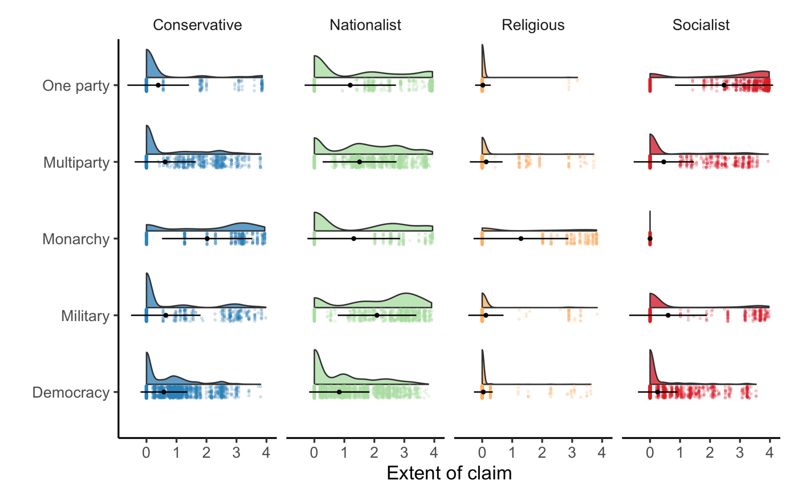

**2. Difference in means tests for the construct validity tests**

Figure 14 and Table 1, 2 and 3 below offer additional references to the construct validity tests. While the three other legitimation claims (Ideology, Performance and Rational-legal) are not employed to asses construct validity, their relationship with populism may be of interest in relation to the Leader-based claims, but also independently in an exploratory analysis.

*Figure 14: Distribution of Claims by Populists and Non-populists in Latin America and Europe (1995-2018).*

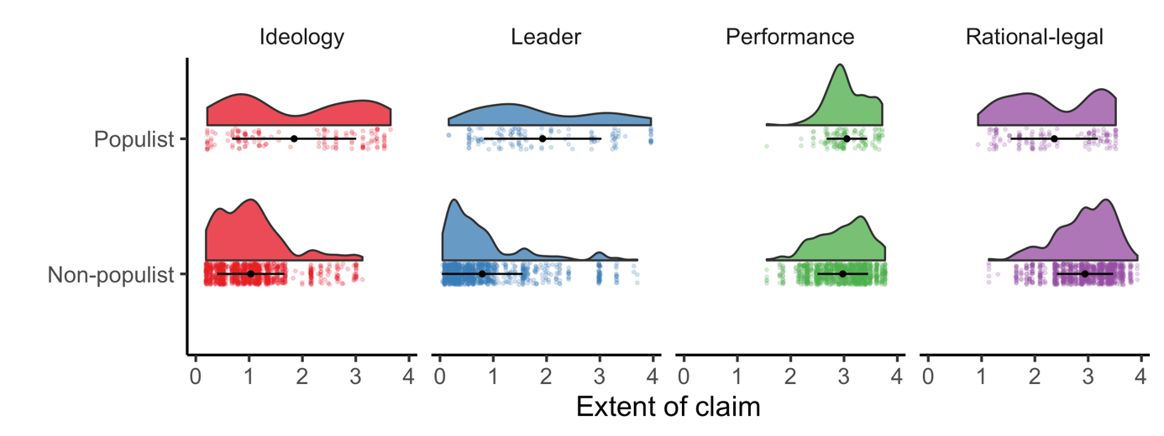

*Table 1 – DiM Estimates of Populists and Non-populists’ Legitimation Claims*

|  |  |  |  |  |  |
| --- | --- | --- | --- | --- | --- |
|  | | | | | |
| Strategy | | Difference  in Mean | | Non  Populist | Populist |
| Ideology | | -0.813*** | | 1.031 | 1.844 |
| **Leader** | | **-1.133\*\*\*** | | **0.793** | **1.926** |
| Performance | | -0.077 | | 2.977 | 3.054 |
| Rational-legal | | 0.576*** | | 2.94 | 2.364 |
|  |  | |  |  |  |
| *Note: DiM estimates based on two-tailed t-tests with Bonferroni adjusted p-values (k=12):*  *p<0.1, **p<0.05, ***p<0.01 | | | | | |

*Table 2 –DiM Estimates of Populists and Non-populists’ Legitimation Claims (Europe)*

|  |  |  |  |  |  |  |  |
| --- | --- | --- | --- | --- | --- | --- | --- |
|  | | | | | | | |
| Strategy | | Difference in Mean | | Non Populist | | Populist | |
| Ideology | | -0.269 | | 0.932 | | 1.201 | |
| **Leader** | | **-0.558\*\*\*** | | **0.637** | | **1.195** | |
| Performance | | -0.211*** | | 2.985 | | 3.196 | |
| Rational-legal | | -0.025 | | 2.980 | | 3.005 | |
|  |  | |  | |  | |  |
| *Note: DiM estimates based on two-tailed t-tests with Bonferroni adjusted p-values (k=12):*  *p<0.1, **p<0.05, ***p<0.01 | | | | | | | |

*Table 3 – DiM Estimates of Populists and Non-populists’ Legitimation Claims (Latin America)*

|  |  |  |  |  |  |  |  |
| --- | --- | --- | --- | --- | --- | --- | --- |
|  | | | | | | | |
| Strategy | | Difference in Mean | | Non Populist | | Populist | |
| Ideology | | -0.93*** | | 1.233 | | 2.163 | |
| **Leader** | | **-1.187\*\*\*** | | **1.101** | | **2.288** | |
| Performance | | -0.022 | | 2.961 | | 2.983 | |
| Rational-legal | | 0.814*** | | 2.861 | | 2.047 | |
|  |  | |  | |  | |  |
| *Note: DiM estimates based on two-tailed t-tests with Bonferroni adjusted p-values (k=12):*  *p<0.1, **p<0.05, ***p<0.01 | | | | | | | |

**2. Regression tables for the construct validity tests**

In addition to the relationship with Leader-based claims detailed in the manuscript, we also see positive effects for populist governments on the use of ideological claims consistently across all model specifications (see Table 4). When we drill down into this, we find that the direction of the populist variable takes with regard to ideological legitimation claims is contingent on the character of the ideology. Over a sample as whole, populists are more likely invoke a socialist or nationalist claims compared to non-populists, and less likely to rely on a conservative ideology compared to non-populists (see Figure 15 for further details). Statistically, there is no difference between the two on religious ideological claims.

We also see that populists are less likely to make rational-legal legitimation claims (Table 7). This is as we would expect as populists given their focus on substantive outcomes over adherence to procedures. Outcomes should reflect the will of the people and the extent to which legal procedures obstructs those outcomes are often seen by populists as evidence of corrupt practices that favour the preferences of elites. With regard to performance-based legitimation claims we do not see a significant difference between populist and non-populist governments (Table 6).

These exploratory findings may provide insight into the nature of populist rule based on the legitimation claims that they make. First, while there is great variance in the degree to which populist rulers make ideological legitimation claims, there is a subset for which this is a strong part of their identity. Furthermore, they are more likely to make claims of an ideological nature in pursuit of legitimacy in comparison to non-populists. These findings raise questions about the contemporary characterization of populists as having thin ideologies (Mudde 2004). Yes, their ideologies may be thin in comparison to the highly ideological party-states that formally codified ideological orthodoxy in the twentieth century, but in comparison to their party and movement competitors nowadays, they are ideologically thick.

*Table 4 - Estimated Effect of Populist Government on Ideology Based Legitimation Claims*

|  |  |  |  |  |  |
| --- | --- | --- | --- | --- | --- |
|  | | | | | |
|  | *Dependent variable:* | | | | |
|  |  | | | | |
|  | Ideology | | | | |
|  | (1) | (2) | (3) | (4) | (5) |
|  | | | | | |
| Populist | 0.81*** | 0.41*** | 0.38*** | 0.40*** | 0.41*** |
|  | (0.06) | (0.06) | (0.06) | (0.04) | (0.06) |
|  |  |  |  |  |  |
| GDP pc (log) |  | 0.05 | 0.001 | 0.29*** | 0.04 |
|  |  | (0.04) | (0.04) | (0.05) | (0.04) |
|  |  |  |  |  |  |
| Level of Democracy |  | -3.02*** | -2.89*** | -3.02*** | -3.04*** |
|  |  | (0.19) | (0.20) | (0.18) | (0.20) |
|  |  |  |  |  |  |
| Regional dummy (LA) |  |  |  |  | -0.03 |
|  |  |  |  |  | (0.06) |
|  |  |  |  |  |  |
| Constant | 1.03*** | 2.97*** | 3.15*** | 0.72 | 3.13*** |
|  | (0.02) | (0.28) | (0.29) | (0.50) | (0.39) |
|  |  |  |  |  |  |
|  | | | | | |
| Year FE | no | no | yes | no | no |
| Country FE | no | no | no | yes | no |
| Observations | 1,173 | 1,153 | 1,153 | 1,153 | 1,153 |
| R2 | 0.12 | 0.35 | 0.37 | 0.84 | 0.35 |
|  | | | | | |
| *Note:* | *p<0.1; **p<0.05; ***p<0.01 | | | | |

*Table 5 – Estimated Effect of Populist Government on Leader Based Legitimation Claims*

|  |  |  |  |  |  |
| --- | --- | --- | --- | --- | --- |
|  | | | | | |
|  | *Dependent variable:* | | | | |
|  |  | | | | |
|  | Leader | | | | |
|  | (1) | (2) | (3) | (4) | (5) |
|  | | | | | |
| Populist | 1.13*** | 0.83*** | 0.83*** | 0.43*** | 0.81*** |
|  | (0.07) | (0.06) | (0.06) | (0.05) | (0.06) |
|  |  |  |  |  |  |
| GDP pc (log) |  | -0.08** | -0.07* | -0.16*** | 0.07* |
|  |  | (0.04) | (0.04) | (0.06) | (0.04) |
|  |  |  |  |  |  |
| Level of Democracy |  | -2.25*** | -2.33*** | -2.46*** | -1.99*** |
|  |  | (0.21) | (0.22) | (0.22) | (0.21) |
|  |  |  |  |  |  |
| Regional dummy (LA) |  |  |  |  | 0.39*** |
|  |  |  |  |  | (0.06) |
|  |  |  |  |  |  |
| Constant | 0.79*** | 3.35*** | 3.29*** | 5.19*** | 1.47*** |
|  | (0.02) | (0.29) | (0.31) | (0.61) | (0.41) |
|  |  |  |  |  |  |
|  | | | | | |
| Year FE | no | no | yes | no | no |
| Country FE | no | no | no | yes | no |
| Observations | 1,192 | 1,166 | 1,166 | 1,166 | 1,166 |
| R2 | 0.17 | 0.37 | 0.37 | 0.80 | 0.39 |
|  | | | | | |
| *Note:* | *p<0.1; **p<0.05; ***p<0.01 | | | | |

*Table 6 – Estimated Effect of Populist Government on Performance Based Legitimation Claims*

|  |  |  |  |  |  |
| --- | --- | --- | --- | --- | --- |
|  | | | | | |
|  | *Dependent variable:* | | | | |
|  |  | | | | |
|  | Performance | | | | |
|  | (1) | (2) | (3) | (4) | (5) |
|  | | | | | |
| Populist | 0.08* | 0.08* | 0.07 | -0.003 | 0.08* |
|  | (0.04) | (0.04) | (0.04) | (0.02) | (0.04) |
|  |  |  |  |  |  |
| GDP pc (log) |  | 0.05* | 0.03 | 0.15*** | 0.04 |
|  |  | (0.03) | (0.03) | (0.02) | (0.03) |
|  |  |  |  |  |  |
| Level of Democracy |  | -0.18 | -0.14 | -0.69*** | -0.20 |
|  |  | (0.14) | (0.15) | (0.09) | (0.15) |
|  |  |  |  |  |  |
| Regional dummy (LA) |  |  |  |  | -0.03 |
|  |  |  |  |  | (0.04) |
|  |  |  |  |  |  |
| Constant | 2.98*** | 2.63*** | 2.69*** | 2.38*** | 2.78*** |
|  | (0.01) | (0.20) | (0.22) | (0.24) | (0.29) |
|  |  |  |  |  |  |
|  | | | | | |
| Year FE | no | no | yes | no | no |
| Country FE | no | no | no | yes | no |
| Observations | 1,186 | 1,166 | 1,166 | 1,166 | 1,166 |
| R2 | 0.003 | 0.01 | 0.01 | 0.89 | 0.01 |
|  | | | | | |
| *Note:* | *p<0.1; **p<0.05; ***p<0.01 | | | | |

*Table 7 – Estimated Effect of Populist Government on Rational-legal Based Legitimation Claims*

|  |  |  |  |  |  |
| --- | --- | --- | --- | --- | --- |
|  | | | | | |
|  | *Dependent variable:* | | | | |
|  |  | | | | |
|  | Rational-legal | | | | |
|  | (1) | (2) | (3) | (4) | (5) |
|  | | | | | |
| Populist | -0.58*** | -0.34*** | -0.35*** | -0.16*** | -0.33*** |
|  | (0.05) | (0.05) | (0.05) | (0.02) | (0.05) |
|  |  |  |  |  |  |
| GDP pc (log) |  | -0.20*** | -0.22*** | -0.05* | -0.27*** |
|  |  | (0.03) | (0.03) | (0.03) | (0.04) |
|  |  |  |  |  |  |
| Level of Democracy |  | 2.32*** | 2.43*** | 1.71*** | 2.21*** |
|  |  | (0.16) | (0.17) | (0.10) | (0.17) |
|  |  |  |  |  |  |
| Regional dummy (LA) |  |  |  |  | -0.17*** |
|  |  |  |  |  | (0.05) |
|  |  |  |  |  |  |
| Constant | 2.94*** | 3.03*** | 3.16*** | 1.00*** | 3.84*** |
|  | (0.02) | (0.23) | (0.24) | (0.28) | (0.32) |
|  |  |  |  |  |  |
|  | | | | | |
| Year FE | no | no | yes | no | no |
| Country FE | no | no | no | yes | no |
| Observations | 1,186 | 1,166 | 1,166 | 1,166 | 1,166 |
| R2 | 0.10 | 0.24 | 0.25 | 0.92 | 0.25 |
|  | | | | | |
| *Note:* | *p<0.1; **p<0.05; ***p<0.01 | | | | |

**3. Supplemental analysis. Ideological claims of populist governments (convergent validity tests)**

Figure 15, below highlights the diverging approach populist take towards the four different ideology characters: controlling for level of democracy, economic development, regional-dummy and time trends, populist incumbents do rely on nationalism and a socialist ideology to a larger extent than do non populists. The reverse is true for conservative ideology.

*Figure* ***15****: Estimated Effect of Populist Incumbent on Extent of Ideological Legitimation Claim*

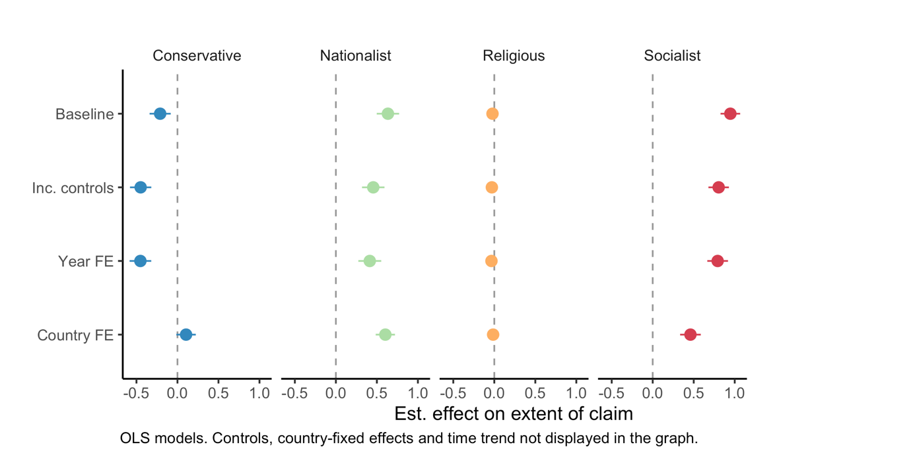

**4. RLS questionnaire**

*Table 8: Question Battery (including vignettes)*

**X. Legitimation introduction**

*Clarification*: Governments make legitimacy claims – provide justifications for the form of rule under which they govern. In the following section we are interested in the nature of the legitimacy claims made by the sitting government. **Please note that the government’s claims to legitimacy - their legitimation strategies - are the object of inquiry here. We are not asking you to assess how ordinary people judge the legitimacy of their rulers.** Do not assume that governments make legitimacy claims on only one basis. We are interested in multi-track and hybrid legitimation strategies.

**The regime** is understood as a set of formal and/or informal rules that govern the choice of political leaders and their exercise of power. **The government** is understood as the chief executive along with the cabinet, ministries, and top civil servants.

**X.1 Performance legitimation**

*Question:*To what extent does the government refer to performance (such as providing economic growth, poverty reduction, effective and non-corrupt governance, and/or providing security) in order to justify the regime in place?

*Responses:*

0: Not at all.

1: To a small extent.

2: To some extent but it is not the most important component.

3: To a large extent but not exclusively.

4: Almost exclusively.

*Vignettes:*

**0-1** The economy in Country X has fluctuated in the recent decade, and although the government takes credit for improvements when the economy is improving, they seldom connect the economic situation of the country to the political regime.

**1-2** The incumbent government in Country X often claims that their policies are more conducive for economic growth and lead to lower rates of unemployment, and that the proposed platform of the opposition would set the country on course to recession. However, the incumbent does not describe the opposition as an illegitimate alternative because of this, nor suggest that the existing rules for leadership selection be set aside in order to secure continued economic progress.

**2-3** Country X has had a turbulent history of civil unrest and a previous regime that was overthrown, following allegations of grand corruption. The current political leadership and state-owned news media often portray the current government a bulwark to civil conflict, and as doing their best at cleaning up a corrupt political system and bureaucracy.

**3-4** Country X has seen sustained economic growth and widespread poverty reduction in the previous two decades. State owned media frequently attribute the rise in living standards to the stability of the political system and government policies. The government in Country X routinely dismisses calls for political reforms by referring to the absence of economic development and widespread corruption in a neighboring country since it introduced multi-party elections ten years ago, as a contrast to the successful and stable development of country X.

**X.2 Rational-legal legitimation**

*Question:*To what extent does the current government refer to the legal norms and regulations in order to justify the regime in place?

*Clarification:* This question pertains to legal norms and regulations as laid out for instance in the constitution regarding access to power (e.g. elections) as well as exercise of power (e.g. rule of law). Electoral regimes may score high on this question as well as non-electoral regimes that emphasize their rule-boundedness.

*Responses:*

0: Not at all.

1: To a small extent.

2: To some extent but it is not the most important component.

3: To a large extent but not exclusively.

4: Almost exclusively.

*Vignettes:*

**0-1** Country X does not hold competitive elections and the rules governing access to political power are not made transparent in Country X. Yet the government may proclaim that they have gained office through intra-party rules and regulations.

**1-2** While the military government in Country X came to power through violent means, the junta often portray themselves as the only guarantors of rule of law, and the only one who can uphold a predictable climate for businesses to operate.

**2-3** The president in Country X was elected by popular vote in an election tainted by accusations of widespread voter fraud in benefit of the incumbent. The key opposition leaders have called for new elections to be held, but these calls have been dismissed by the national election committee. The president proclaims that he is democratically elected, by a majority the people of Country X, and as such is the rightful ruler of the country for the upcoming 4 years.

**3-4** Country X is a highly democratic country where freedom of expression and liberal principles are respected, and where horizontal accountability is institutionalized. The government clearly derive their right to rule from the electoral process and rules based on the procedures laid out in the constitution.

**X.3 Person of the Leader**

*Question:* To what extent is the Chief Executive portrayed as being endowed with an extraordinary personal characteristics and/or leadership skills (e.g. as father or mother of the nation, exceptionally heroic, moral, pious, or wise, or any other extraordinary attribute valued by the society)?

*Clarification:* TheChief Executive refers to the Head of State or the Head of Government, depending on the relative power of each office. We are interested in the key leadership Figure.

*Responses:*

0: Not at all.

1: To a small extent.

2: To some extent but it is not the most important component.

3: To a large extent but not exclusively.

4: Almost exclusively.

*Vignettes:*

**0-1** The president of Country X dresses indistinguishably from the rest of his cabinet. Save for a stellar academic record, little is publicized about the president’s life and extraordinary personal achievements before ascending to the top political position of the country.

**1-2** The government in Country X often makes a point of the president’s excellent leadership in stewarding the country through the ongoing economic crisis, but at the same time also give credit to the finance minister’s work on managing the budget.

**2-3** The president of Country X makes frequent media appearances in which he addresses the nation population as his family. Government communication promotes his capabilities as a skilled international negotiator and an excellent military commander. However, the life and political accomplishments of political leaders, including the president are not taught in school in Country X.

**3-4** History books in Country X typically devote more than one chapter to the early life and political accomplishments of the country’s president, one of which include swimming across a raging river at age 60. The portrait of the president hangs in every school classroom and public building throughout the country. The philosophy and political thought of the president is mandatory teaching in the education system of Country X.

**X.4 Ideology**

*Question:*To what extent does the current government promote a specific ideology or societal model (an officially codified set of beliefs used to justify a particular set of social, political, and economic relations; for example socialism, nationalism, religious traditionalism, etc.) in order to justify the regime in place?

*Responses:*

0: Not at all.

1: To a small extent.

2: To some extent but it is not the most important component.

3: To a large extent but not exclusively.

4: Almost exclusively.

*Vignettes*

**0-1** Country X ensures freedom of expression and religion both de-jure and de-facto. In school liberalism is promoted as the foundation of Country X.

**1-2** The government in Country X often preaches the virtues of Christian values and promote themselves as realizing the core interest of the Nation of Country X, which they proclaim is under threat from globalization, immigration and international businesses. The president recently stated that by the mandate of the people of Country X, he is obliged to close the boarders to immigrants who do not share Country X’s values and traditions.

**2-3** Islam is the official religion in Country X. Throughout the modern history of Country X, all political leaders have portrayed themselves as devout Sunni Muslims, who frequently claim that political decisions are made in order to safeguard the standing of their religion in the region. While freedom of religion is enshrined in Country X’s constitution there are only a few followers of different faith traditions, and none of whom are central in the state apparatus.

**3-4** Communism is the official ideology of Country X. Marxist and Leninist teachings are compulsory throughout the educational system and are featured in university entry exams. Most public spaces are decorated with banners and posters carrying ideological slogans promoting communism and egalitarian values.

**X.5 Ideology character**

*Question*: How would you characterize the ideology/ideologies identified in the previous question?

*Clarification*: Check all that apply.

*Responses*:

0: Nationalist (0=No, 1=Yes)

1: Socialist or communist. (0=No, 1=Yes)

2: Restorative or conservative. (0=No, 1=Yes)

3: Separatist or autonomist. (0=No, 1=Yes)

4: Religious. (0=No, 1=Yes)

**5. Coders per question per country**

*Figure 15: Number of coders – Ideology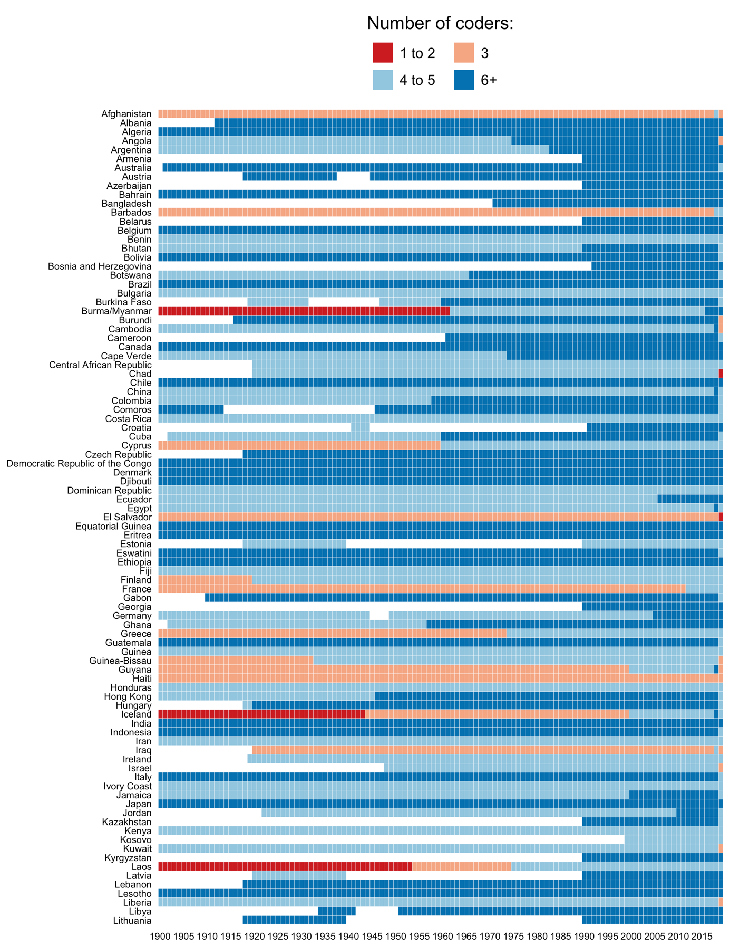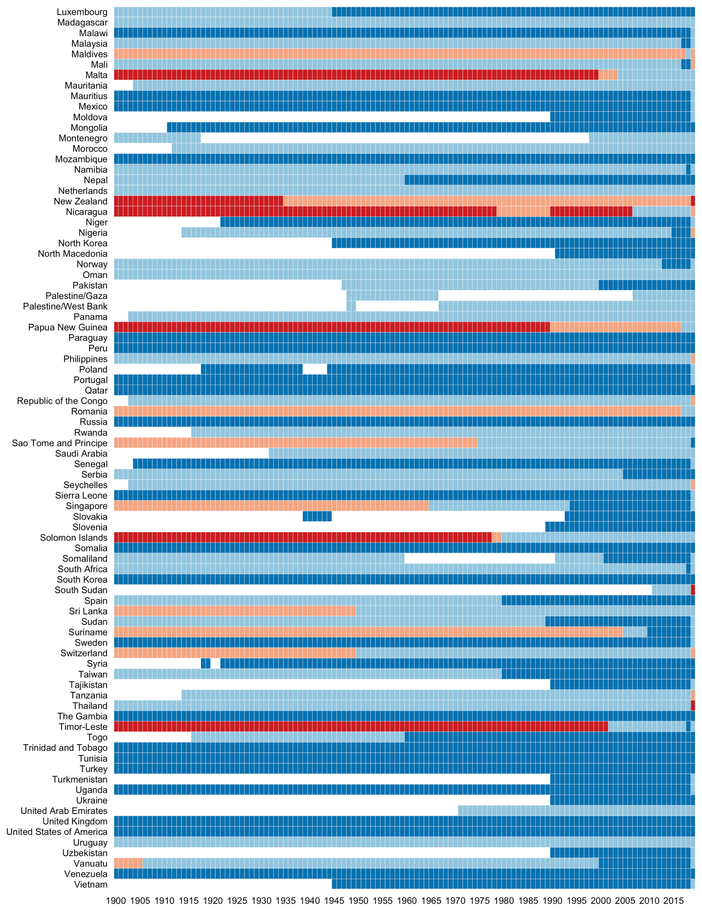*

*Figure 16: Number of coders – Leader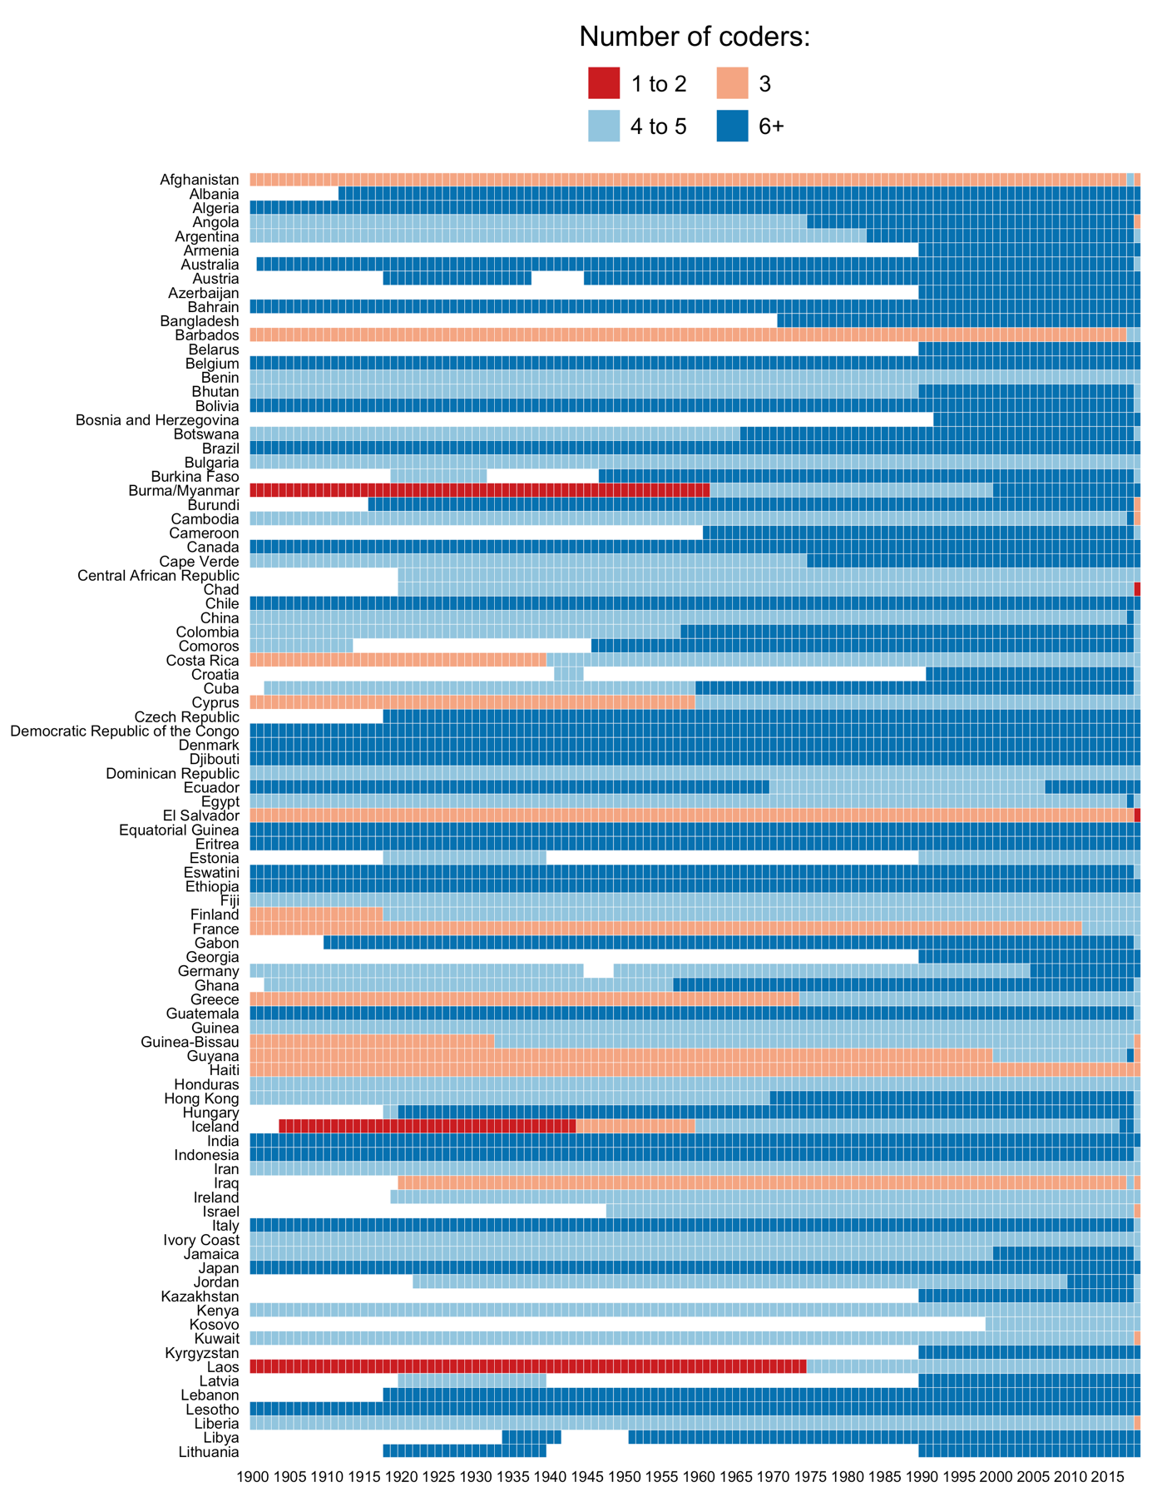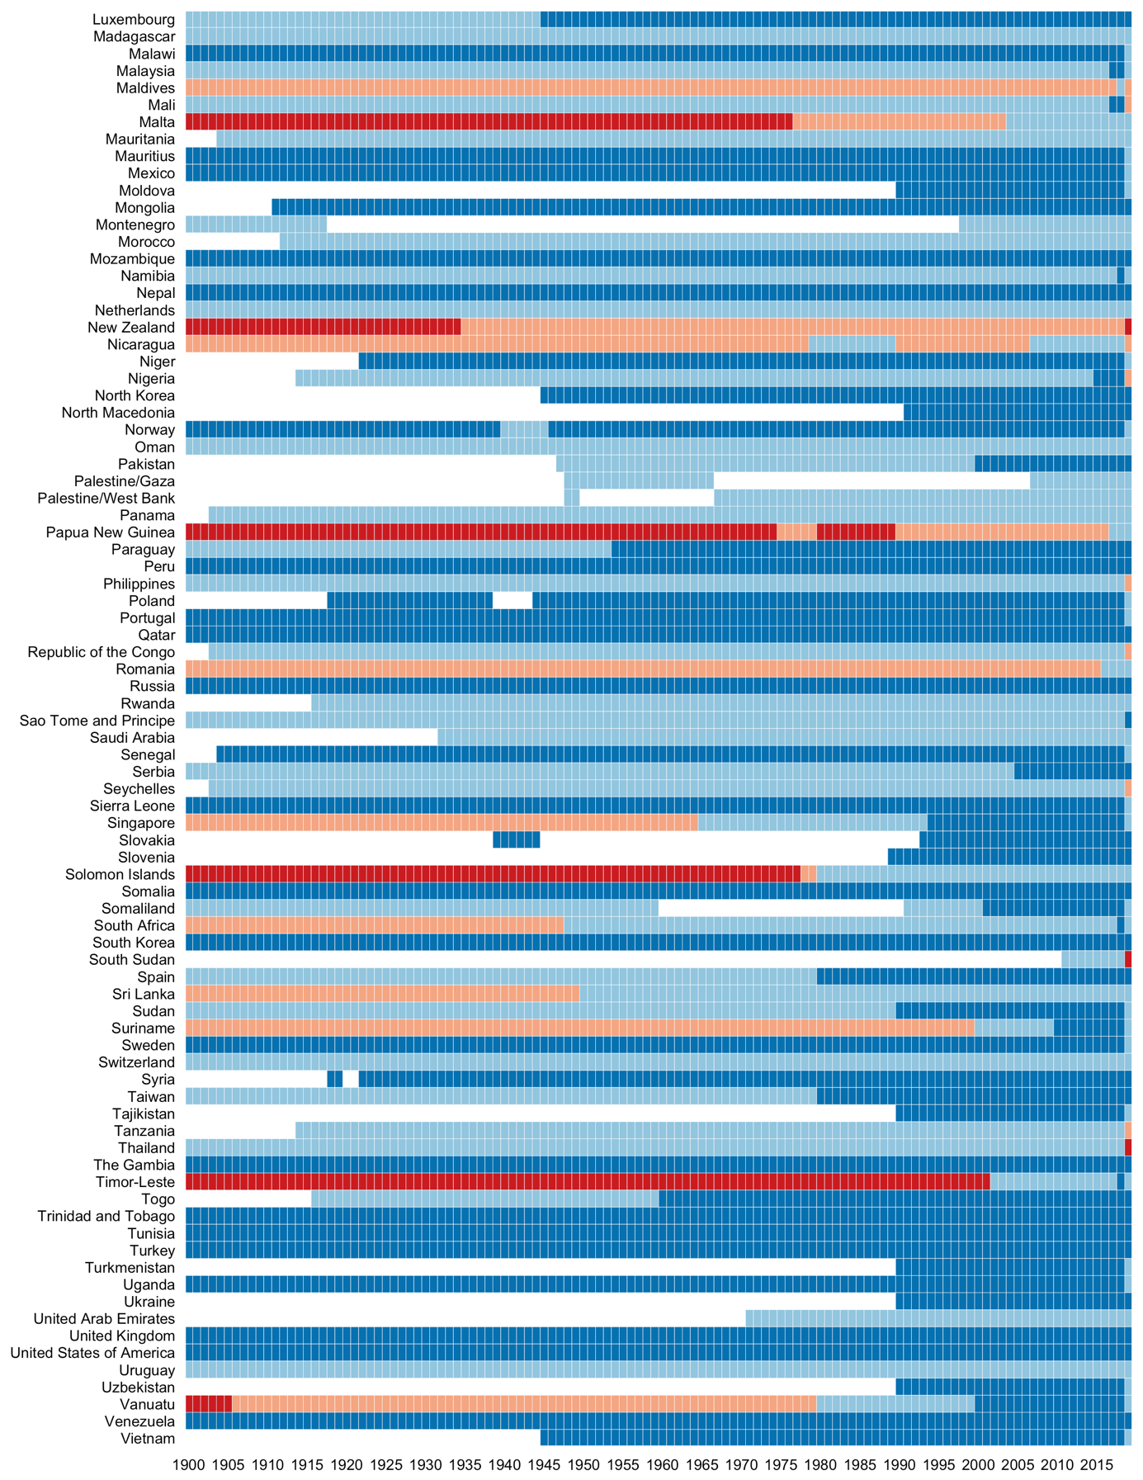*

*Figure 17: Number of coders – Performance 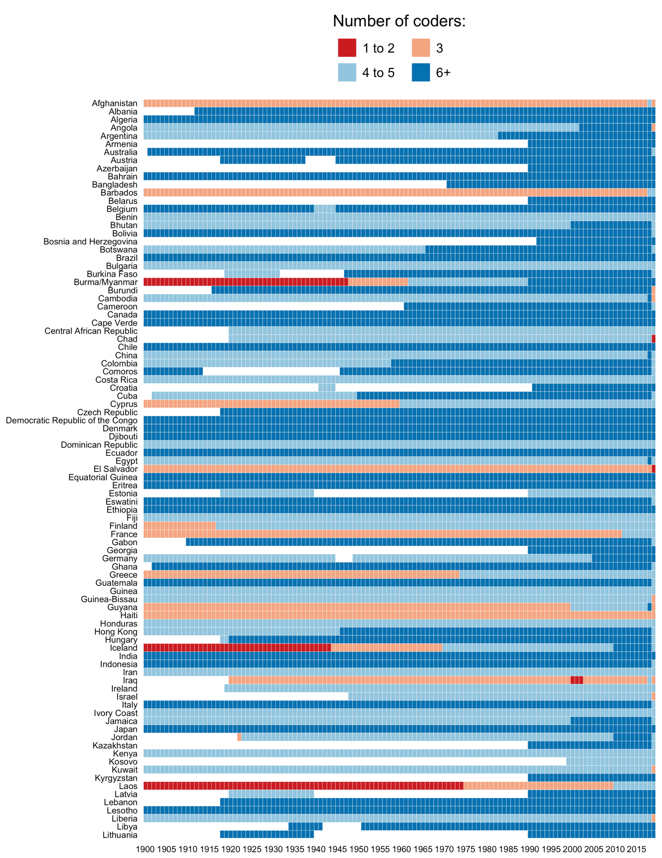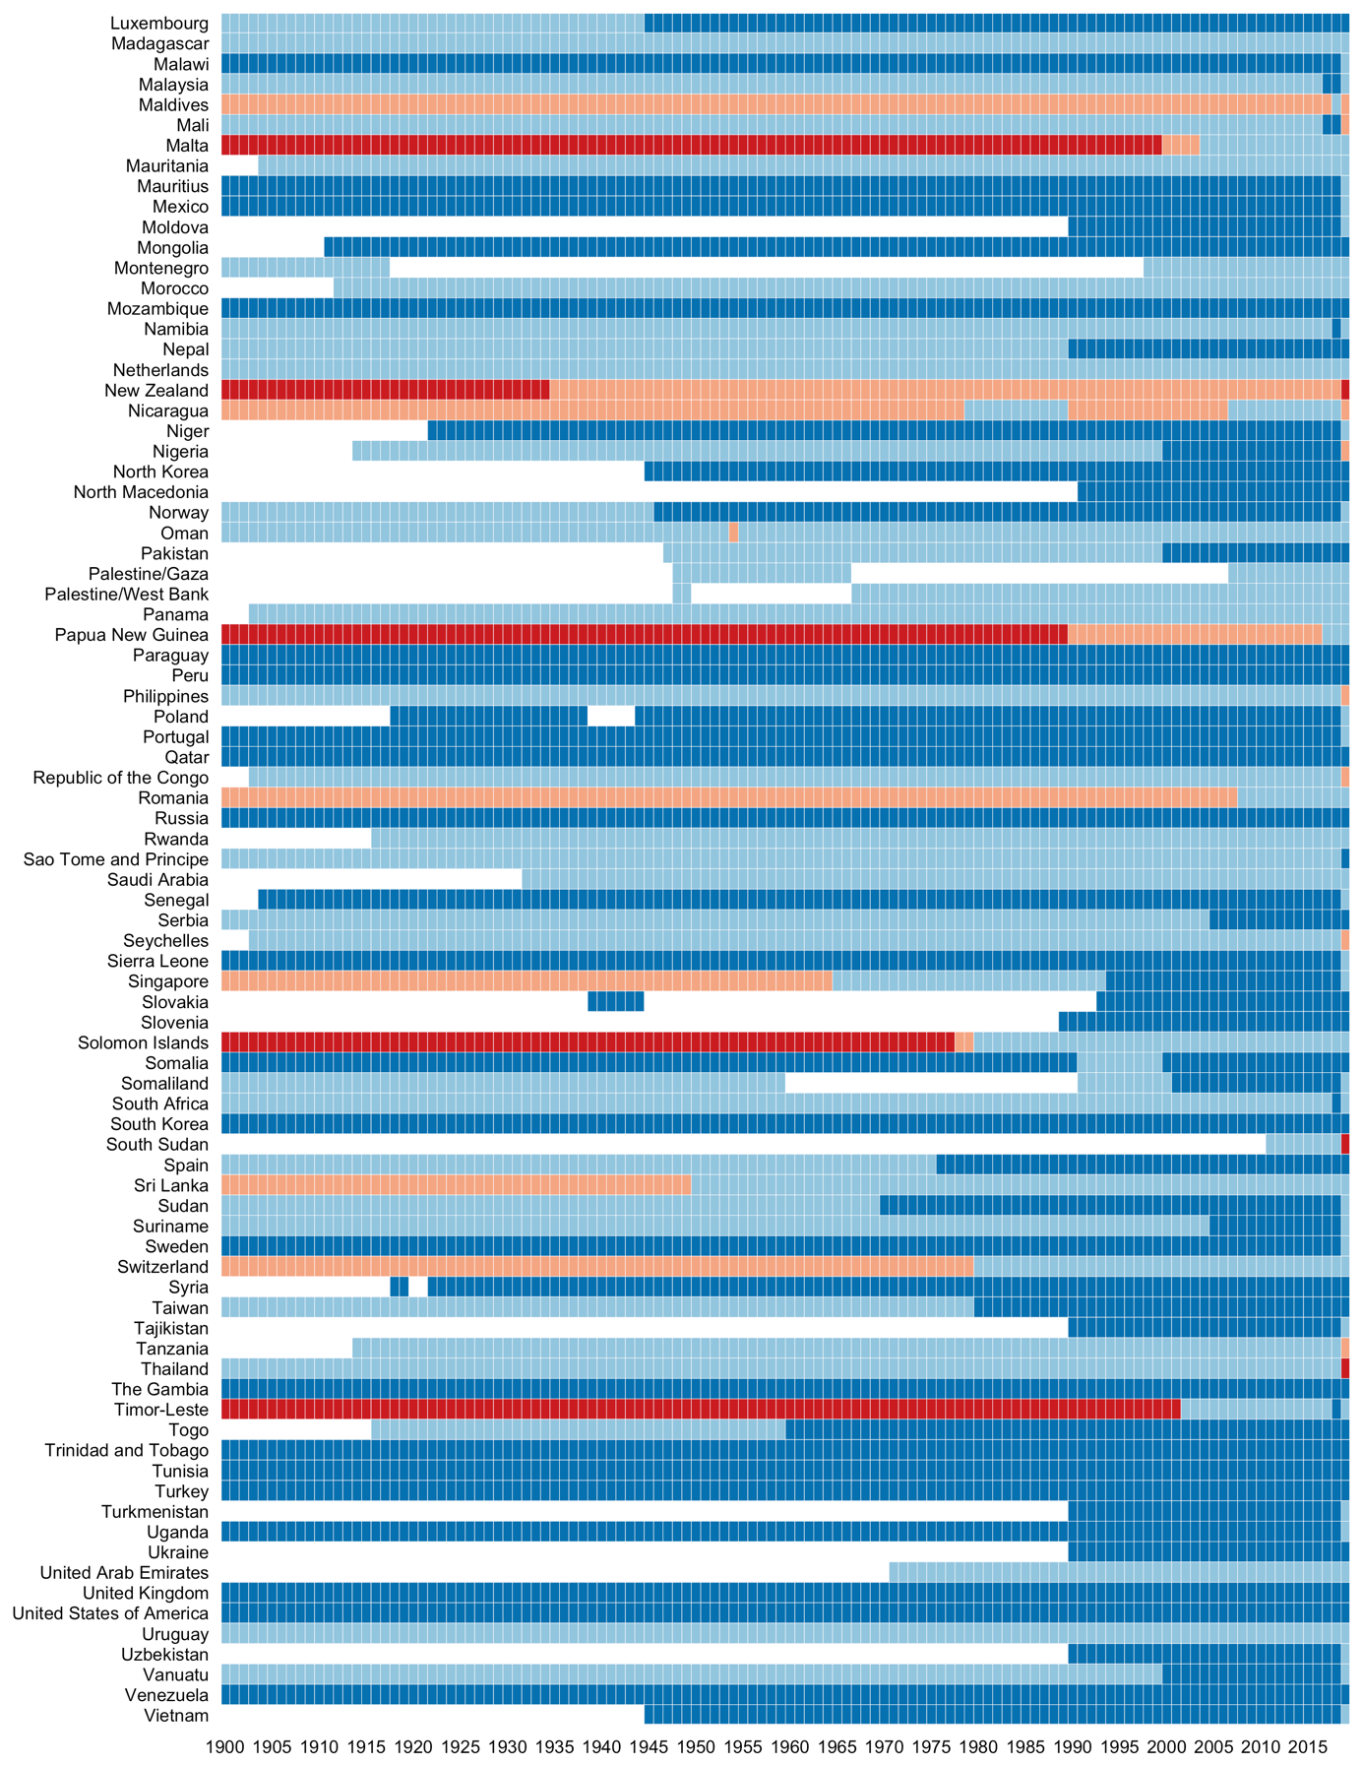*

*Figure 18: Number of coders – Rational-legal 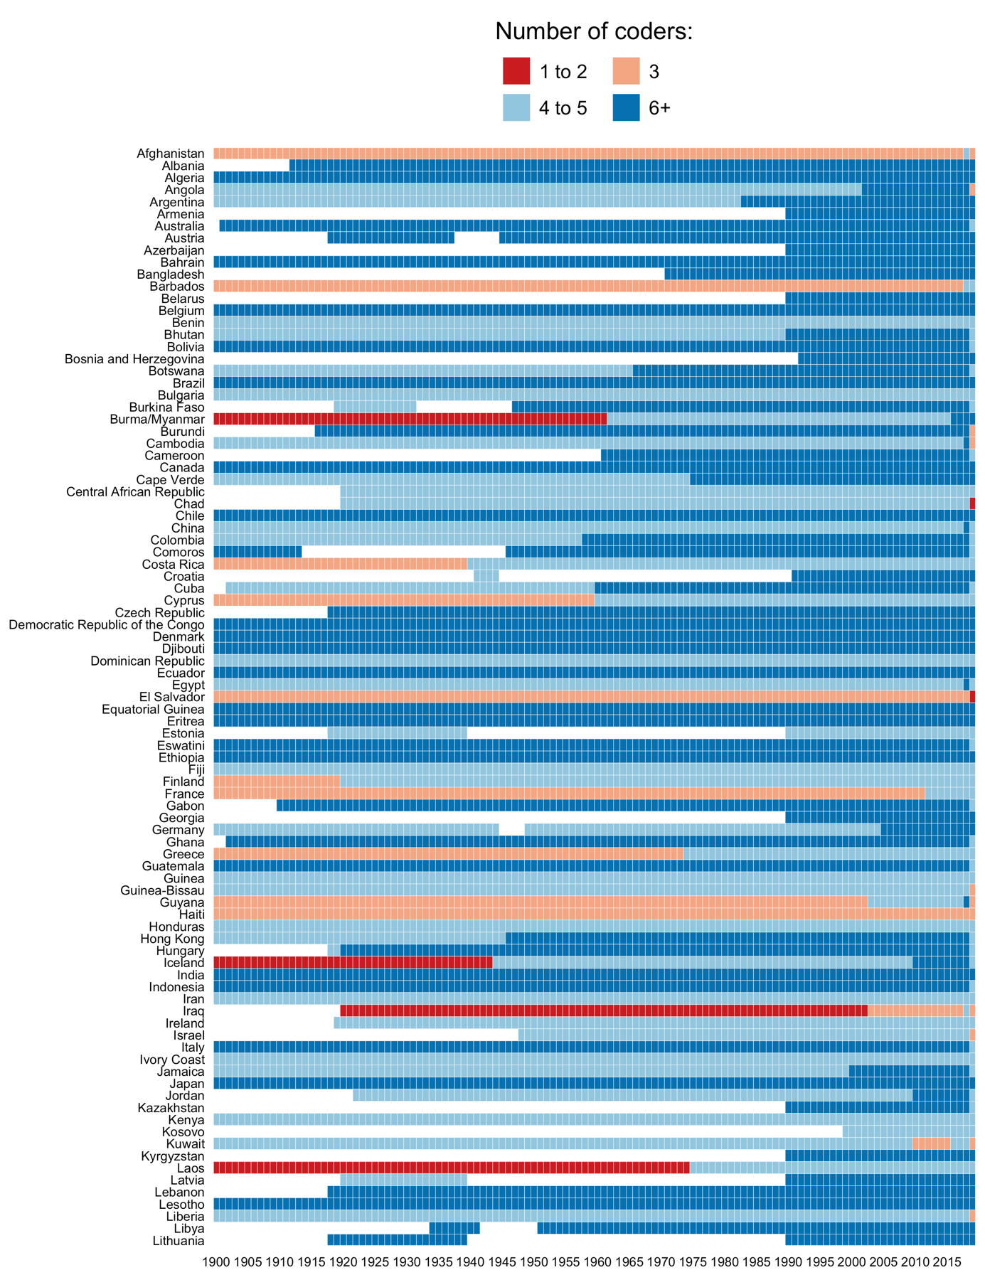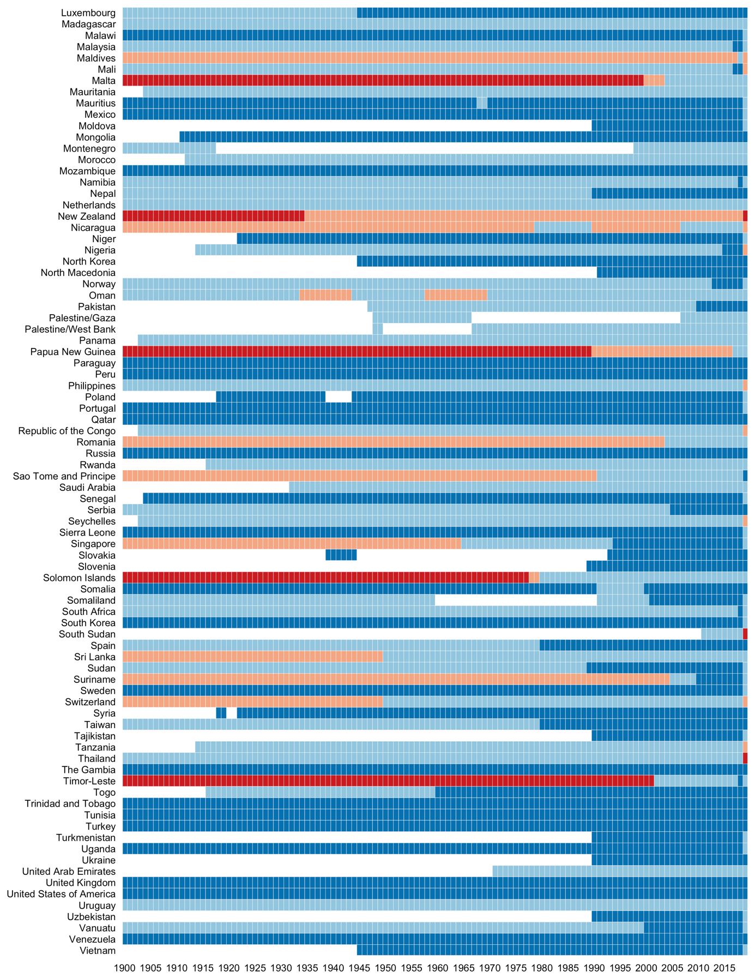*

1. An alternative approach, which is suitable for comparing the different ideology types to each other, would be to weigh the *ideology* measure with by the mean of each *ideology character* coding.