Supplementary Material
Full regression tables
Table A1: Tax-Spend in Britain, BES (APC models)
 | Model 1: APC | Model 2: with socio-demographics
Generation. Reference: pre-war
Post-war generation | 0.002 | 0.131
 | (0.116) | (0.117)
Neoliberal generation | -0.213 | -0.041
 | (0.138) | (0.139)
Third way generation | -0.368** | -0.229
 | (0.170) | (0.174)
Gender (female) | 0.095 | 0.190
 | (0.132) | (0.135)
Post-war generation*gender | 0.239* | 0.144
 | (0.143) | (0.143)
Neoliberal*gender | 0.179 | 0.050
 | (0.147) | (0.148)
Third way*gender | 0.026 | -0.180
 | (0.174) | (0.175)
Age. Reference: 18-34
Aged 35-59 | 0.156** | 0.118*
 | (0.061) | (0.061)
Aged 60+ | 0.287*** | 0.023
 | (0.090) | (0.100)
Year of survey. Reference: 1987
1992 | 0.336*** | 0.362***
 | (0.076) | (0.075)
1997 | 0.810*** | 0.836***
 | (0.063) | (0.063)
2001 | 0.079 | 0.052
 | (0.065) | (0.068)
2005 | -0.359*** | -0.374***
 | (0.063) | (0.065)
2015 | -0.176** | -0.204**
 | (0.080) | (0.082)
Owns house |  | -0.201***
 |  | (0.047)
Marital status. Reference: married/cohabiting
Widowed |  | -0.196**
 |  | (0.082)
Divorced/separated |  | -0.082
 |  | (0.071)
Never married |  | -0.083
 |  | (0.057)
Union membership |  | 0.319***
 |  | (0.046)
Income. Reference: low
Middle |  | -0.146***
 |  | (0.054)
High |  | -0.196***
 |  | (0.061)
White |  | 0.358***
 |  | (0.080)
Social class. Reference: none
Working class |  | 0.272***
 |  | (0.043)
Middle class |  | 0.031
 |  | (0.050)
Degree |  | 0.131***
 |  | (0.041)
Employment status. Reference: in work
In FT education |  | 0.353***
 |  | (0.133)
Unemployed |  | 0.152
 |  | (0.095)
Disabled or retired |  | 0.384***
 |  | (0.072)
Looking after home |  | 0.195***
 |  | (0.071)
Other |  | 0.277
 |  | (0.180)
Constant | 6.300 | 5.869***
 | (0.131)*** | (0.163)
R² | 0.05 | 0.06
N | 13,865 | 13,865
NB: * p<0.1; ** p<0.05; *** p<0.01. Standard errors are in parentheses

Table A2: Tax-Spend in the United States, ANES (APC models)

 | Model 1: APC | Model 2: with socio-demographics
Generation. Reference: pre-war
Post-war generation | -0.228 | -0.133
 | (0.105)** | (0.103)
Neoliberal generation | -0.041 | -0.042
 | (0.127) | (0.126)
Third way generation | -0.041 | -0.102
 | (0.175) | (0.172)
Gender (female) | 0.043 | 0.030
 | (0.103) | (0.103)
Post-war*gender | 0.407 | 0.349
 | (0.111)*** | (0.109)***
Neoliberal*gender | 0.400 | 0.378
 | (0.128)*** | (0.125)***
Third way*gender | 0.425 | 0.400
 | (0.178)** | (0.174)**
Age. Reference: 18-34
Aged 35-59 | -0.184 | -0.120
 | (0.046)*** | (0.046)***
Aged 60+ | -0.257 | -0.352
 | (0.084)*** | (0.087)***
Year of Survey. Reference: 1982
1984 | 0.153 | 0.121
 | (0.067)** | (0.065)*
1986 | 0.541 | 0.481
 | (0.067)*** | (0.064)***
1988 | 0.320 | 0.278
 | (0.070)*** | (0.067)***
1990 | 0.540 | 0.479
 | (0.070)*** | (0.068)***
1992 | 0.204 | 0.197
 | (0.080)** | (0.077)**
2004 | 0.624 | 0.602
 | (0.086)*** | (0.084)***
2008 | 0.700 | 0.511
 | (0.091)*** | (0.090)***
Employment status. Reference: in work
In FT education |  | 0.139
 |  | (0.113)
Unemployed |  | 0.238
 |  | (0.069)***
Disabled/retired |  | 0.225
 |  | (0.065)***
Looking after the home |  | 0.041
 |  | (0.060)
Other |  | 0.400
 |  | (0.882)
Owns house |  | -0.201
 |  | (0.039)***
Marital status. Reference: married/cohabiting
Widowed |  | 0.247
 |  | (0.073)***
Divorced/separated |  | 0.106
 |  | (0.050)**
Never married |  | -0.002
 |  | (0.050)
Union membership |  | 0.258
 |  | (0.053)***
Race. Reference: white
Black |  | 0.858
 |  | (0.051)***
Hispanic |  | 0.341
 |  | (0.068)***
Other |  | 0.156
 |  | (0.080)*
Income. Reference: low
Middle |  | -0.139
 |  | (0.045)***
High |  | -0.229
 |  | (0.052)***
Social class. Reference: none
Working class |  | 0.140
 |  | (0.042)***
Middle class |  | -0.029
 |  | (0.042)
Religion. Reference: Protestant
Catholic |  | 0.294
 |  | (0.040)***
Jewish |  | 0.722
 |  | (0.120)***
Other/none |  | 0.207
 |  | (0.051)***
Education. Reference: Grade school or less
High school |  | -0.120
 |  | (0.083)
Some college |  | -0.255
 |  | (0.087)***
College or advanced degree |  | -0.345
 |  | (0.090)***
Constant | 3.942 | 4.018
 | (0.117)*** | (0.142)***
R² | 0.05 | 0.13
N | 9,137 | 9,137
NB: * p<0.1; ** p<0.05; *** p<0.01. Standard errors are in parentheses

Table A3: Education Spending in Britain, ISSP (APC models)
 | Model 1: APC | Model 2: with socio-demographics
Generation. Reference: pre-war
Post-war generation | -0.028 | -0.027
 | (0.073) | (0.073)
Neoliberal generation | 0.074 | 0.082
 | (0.096) | (0.097)
Third way generation | 0.037 | 0.025
 | (0.118) | (0.119)
Gender(female) | 0.008 | 0.021
 | (0.088) | (0.088)
Post-war*gender | 0.103 | 0.099
 | (0.093) | (0.093)
Neoliberal*gender | -0.039 | -0.057
 | (0.097) | (0.097)
Third way*gender | 0.056 | 0.046
 | (0.109) | (0.110)
Year of Survey. Reference: 1985
1990 | 0.087 | 0.099
 | (0.034)** | (0.035)***
1996 | 0.129 | 0.097
 | (0.053)** | (0.055)*
2006 | -0.006 | -0.015
 | (0.054) | (0.055)
2016 | -0.026 | -0.048
 | (0.050) | (0.053)
Age. Reference: 18-34
Aged 35-59 | -0.025 | -0.027
 | (0.039) | (0.039)
Aged 60+ | -0.156 | -0.144
 | (0.066)** | (0.068)**
Marital Status. Reference: married/cohabiting
Widowed |  | -0.006
 |  | (0.046)
Divorced |  | 0.003
 |  | (0.041)
Separated |  | -0.016
 |  | (0.083)
Never married |  | -0.053
 |  | (0.032)*
Education. Reference: no secondary qualification
Secondary |  | -0.051
 |  | (0.031)
A-Level |  | 0.004
 |  | (0.040)
High education below degree |  | -0.062
 |  | (0.038)
Degree |  | 0.058
 |  | (0.039)
Other |  | 0.003
 |  | (0.110)
Employment status. Reference: unemployed
Employed |  | -0.114
 |  | (0.050)**
Not in labour force |  | -0.114
 |  | (0.057)**
Religion. Reference: Catholic
Protestant |  | -0.232
 |  | (0.041)***
Other Christian |  | -0.056
 |  | (0.057)
Other non-Christian |  | -0.040
 |  | (0.070)
Religious |  | -0.146
 |  | (0.040)***
Constant | 3.967 | 4.254
 | (0.087)*** | (0.104)***
R² | 0.02 | 0.04
N | 4,250 | 4,250
NB: * p<0.1; ** p<0.05; *** p<0.01. Standard errors are in parentheses

Table A4: Education Spending in the US, ISSP (APC models)
 | Model 1: APC | Model 2: with socio-demographics
Generation. Reference: pre-war
Post-war generation | -0.039 | -0.035
 | (0.088) | (0.088)
Neoliberal generation | -0.036 | -0.046
 | (0.113) | (0.113)
Third way generation | -0.010 | -0.033
 | (0.126) | (0.127)
Gender(female) | 0.005 | -0.034
 | (0.100) | (0.103)
Post-war*gender | 0.044 | 0.067
 | (0.106) | (0.108)
Neoliberal*gender | 0.066 | 0.118
 | (0.116) | (0.119)
Third way*gender | 0.167 | 0.214
 | (0.116) | (0.118)*
Year of Survey. Reference: 1985
1990 | 0.159 | 0.169
 | (0.047)*** | (0.048)***
1996 | 0.190 | 0.170
 | (0.070)*** | (0.072)**
2006 | 0.374 | 0.368
 | (0.067)*** | (0.068)***
2016 | 0.201 | 0.176
 | (0.064)*** | (0.066)***
Age. Reference: 18-34
Aged 35-59 | -0.125 | -0.115
 | (0.043)*** | (0.044)***
Aged 60+ | -0.253 | -0.247
 | (0.069)*** | (0.071)***
Marital Status. Reference: married/cohabiting
Widowed |  | 0.097
 |  | (0.054)*
Divorced |  | 0.133
 |  | (0.040)***
Separated |  | 0.066
 |  | (0.073)
Never married |  | 0.102
 |  | (0.037)***
Education. Reference: less than high school
High School |  | -0.023
 |  | (0.039)
College education |  | 0.009
 |  | (0.043)
Employment status. Reference: unemployed
Employed |  | -0.058
 |  | (0.078)
Not in labour force |  | -0.056
 |  | (0.082)
Religion. Reference: Catholic
Protestant |  | -0.028
 |  | (0.034)
Other Christian |  | -0.115
 |  | (0.063)*
Other non-Christian |  | 0.159
 |  | (0.074)**
Religious |  | 0.061
 |  | (0.045)
Constant | 3.934 | 3.960
 | (0.100)*** | (0.130)***
R² | 0.04 | 0.05
N | 3,682 | 3,682
NB: * p<0.1; ** p<0.05; *** p<0.01. Standard errors are in parentheses

Table A5: Health Spending in Britain, ISSP (APC models)
 | Model 1: APC | Model 2: with socio-demographics
Generation. Reference: pre-war
Post-war generation | 0.023 | 0.014
 | (0.067) | (0.067)
Neoliberal generation | 0.061 | 0.049
 | (0.087) | (0.088)
Third way generation | -0.024 | -0.046
 | (0.108) | (0.109)
Gender(female) | -0.034 | -0.057
 | (0.079) | (0.080)
Post-war*gender | 0.155 | 0.172
 | (0.084)* | (0.084)**
Neoliberal*gender | 0.065 | 0.085
 | (0.088) | (0.088)
Third way*gender | 0.207 | 0.228
 | (0.099)** | (0.100)**
Year of Survey. Reference: 1985
1990 | 0.039 | 0.052
 | (0.031) | (0.032)
1996 | 0.058 | 0.059
 | (0.048) | (0.051)
2006 | -0.150 | -0.126
 | (0.049)*** | (0.050)**
2016 | -0.064 | -0.025
 | (0.046) | (0.048)
Age. Reference: 18-34
Aged 35-59 | -0.034 | -0.041
 | (0.035) | (0.036)
Aged 60+ | 0.005 | -0.040
 | (0.060) | (0.062)
Marital Status. Reference: married/cohabiting
Widowed |  | 0.013
 |  | (0.041)
Divorced |  | -0.004
 |  | (0.038)
Separated |  | 0.051
 |  | (0.075)
Never married |  | 0.007
 |  | (0.029)
Education. Reference: no secondary qualification
Secondary |  | -0.114
 |  | (0.029)***
A-Level |  | -0.099
 |  | (0.037)***
High education below degree |  | -0.189
 |  | (0.035)***
Degree |  | -0.188
 |  | (0.036)***
Other |  | -0.185
 |  | (0.098)*
Employment status. Reference: unemployed
Employed |  | -0.097
 |  | (0.046)**
Not in labour force |  | -0.078
 |  | (0.052)
Religion. Reference: Catholic
Protestant |  | -0.156
 |  | (0.038)***
Other Christian |  | -0.095
 |  | (0.052)*
Other non-Christian |  | -0.143
 |  | (0.064)**
Religious |  | -0.096
 |  | (0.036)***
Constant | 4.168 | 4.472
 | (0.079)*** | (0.095)***
R² | 0.01 | 0.03
N | 4,281 | 4,281
NB: * p<0.1; ** p<0.05; *** p<0.01. Standard errors are in parentheses

Table A6: Health Spending in the US, ISSP (APC models)
 | Model 1: APC | Model 2: with socio-demographics
Generation. Reference: pre-war
Post-war generation | -0.083 | -0.067
 | (0.092) | (0.092)
Neoliberal generation | -0.164 | -0.181
 | (0.118) | (0.118)
Third way generation | -0.137 | -0.201
 | (0.132) | (0.132)
Gender(female) | -0.138 | -0.114
 | (0.105) | (0.107)
Post-war*gender | 0.184 | 0.163
 | (0.112) | (0.112)
Neoliberal*gender | 0.224 | 0.222
 | (0.122)* | (0.124)*
Third way*gender | 0.318 | 0.316
 | (0.121)*** | (0.123)**
Year of Survey. Reference: 1985
1990 | 0.333 | 0.355
 | (0.050)*** | (0.050)***
1996 | 0.272 | 0.244
 | (0.073)*** | (0.076)***
2006 | 0.495 | 0.518
 | (0.070)*** | (0.071)***
2016 | 0.154 | 0.177
 | (0.067)** | (0.069)***
Age. Reference: 18-34
Aged 35-59 | -0.042 | -0.017
 | (0.045) | (0.046)
Aged 60+ | -0.057 | -0.032
 | (0.073) | (0.074)
Marital Status. Reference: married/cohabiting
Widowed |  | -0.027
 |  | (0.057)
Divorced |  | 0.093
 |  | (0.042)**
Separated |  | 0.090
 |  | (0.077)
Never married |  | 0.177
 |  | (0.039)***
Education. Reference: less than high school
High School |  | -0.143
 |  | (0.041)***
College education |  | -0.202
 |  | (0.045)***
Employment status. Reference: unemployed
Employed |  | -0.126
 |  | (0.082)
Not in labour force |  | -0.152
 |  | (0.086)*
Religion. Reference: Catholic
Protestant |  | -0.069
 |  | (0.035)**
Other Christian |  | -0.096
 |  | (0.066)
Other non-Christian |  | 0.306
 |  | (0.078)***
Religious |  | 0.040
 |  | (0.047)
Constant | 3.668 | 3.874
 | (0.105)*** | (0.135)***
R² | 0.04 | 0.06
N | 3,670 | 3,670
NB: * p<0.1; ** p<0.05; *** p<0.01. Standard errors are in parentheses

Robustness Check: GAMs

Fig. A1. Generational trends in Britain in support for tax-spend scale for men and women, BES (GAMs)

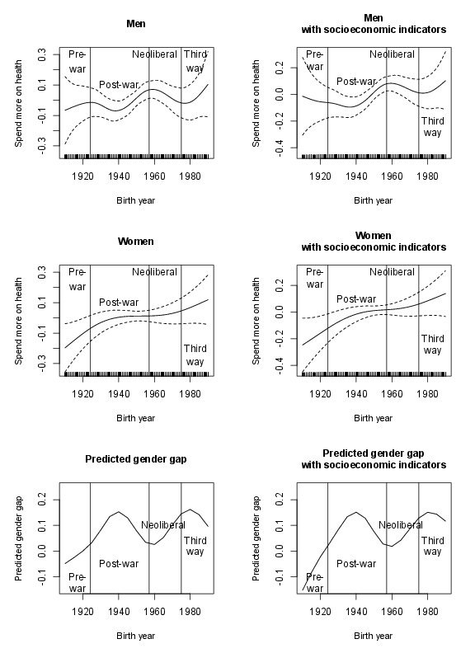

Fig. A2. Generational trends in Britain in support for health spending for men and women, ISSP (GAMs)

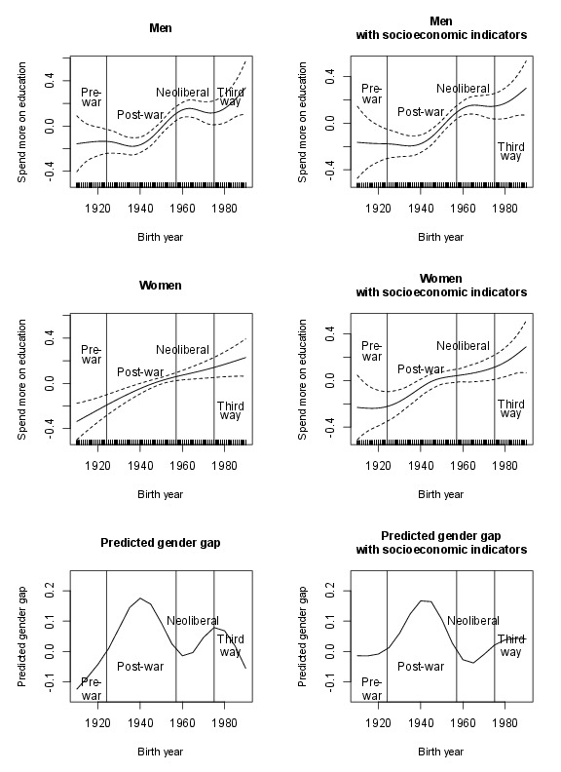
Fig. A3. Generational trends in Britain in support for education spending for men and women, ISSP (GAMs)

Fig. A4. Generational trends in the US in support for spending on social services for men and women, ANES (GAMs)

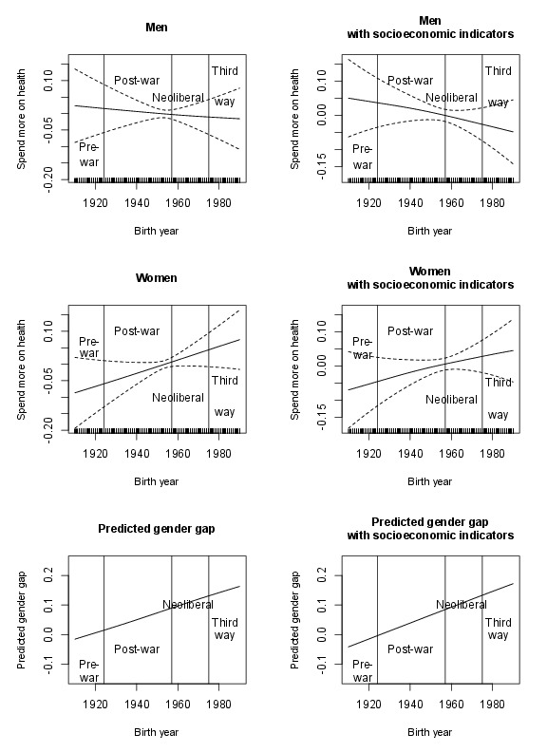

Fig. A5. Generational trends in the US in support for health spending for men and women, ISSP (GAMs)

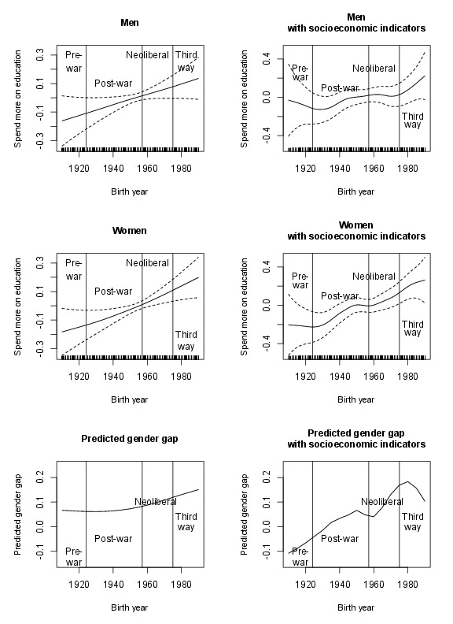
Fig. A6. Generational trends in the US in support for education spending for men and women, ISSP (GAMs)

Figures A1-A6 show the results from the GAMs for the various dependent variables, for models with and without the socioeconomic variables. The models for the categorical dependent variables from the ISSP are modelled in a linear way in order to aid computation of the GAMs. The GAMs cannot test whether the generational and gender differences are statistically significant, but can be used to assess whether the coding of the generation variable is valid, by visually inspecting the smoothed birth year function and comparing it to the generation categorisation. Figures A1-A3 show that this is broadly the case in Britain, with high/increasing support for spending/redistribution for the post-war generation, and then flattening/decreasing support for the neoliberal generation. The bottom panel of the figure shows the predicted gender gap calculated from the GAMs, with other variables held at the same means and medians as for the marginal effects calculated from the OLS/ordered logit models. This shows a very similar pattern to the regression models for each dependent variable.
The GAMs for the ANES in figures A4-A6 show that the generational distinctions are less relevant in the US than in Britain. There appears to be gradual change across all birth years, with no noticeable distinctions between generations of the kind seen in Britain. However, the GAMs do support the conclusions reached about the gender gap from the age-period-cohort models: the gender gap remains fairly stable for all generations born in the post-war generation and after in the ANES, and grows in size for younger generations in the ISSP.

