WHAT IS A CAREER POLITICIAN? THEORIES, CONCEPTS AND MEASURES
ONLINE APPENDIX

Standardized Composite Index

Summary table of composite index

Table 1: Summary statistics of the Standardized Composite Index
Min | 1st Qu. | Median | Mean | 3rd Qu. | Max | Variance | Kurtosis | Skewness
-2.57 | -0.65 | 0.025 | 0 | 0.68 | 2.5 | 1 | -0.41 | -0.19

Cross-Correlation Table between the Standardized Index and the Sub-Categories

Table 2: Cross-Correlations between Individual Dimensions of the Composite Career Politician Index
 | Commitment | Occupational Background | Life experience
Commitment
Occupational Background | 0.06
Life experience | 0.18* | 0.58*
Ambition | 0.17* | 0.26* | 0.34*
* = p<0.05

Histogram, Density Plot, and QQ-Plot of the Composite Career Politician index
Figure 1: Standardized Composite Career Politician Index Histogram with Superimposed Density Plot
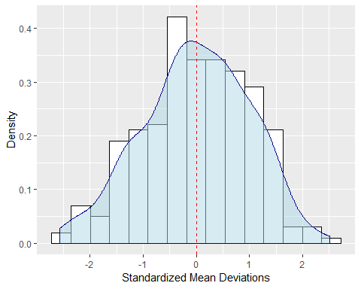

Figure 2: Quantile Comparison Plot for the Standardized Composite Career Politician Index
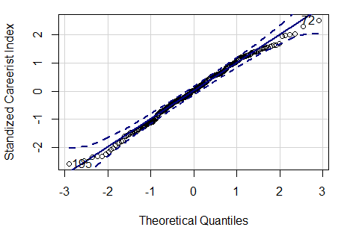

R-Output for Shapiro-Wilk test of normality on Composite Career Politician Index:
Shapiro-Wilk normality test
Data: Standardized Career Politician Index
W = 0.99204, p-value = 0.1455, n=275

Weighted Career Politician indices (additional robustness tests)

Table 3: T-test calculations on difference between Ministers and Backbenchers and Listed Career Politicians by either King or Riddell for composite indicator under different component weightings. Columns denoted with "x1.5" list the results for a composite index whose Occupation and Life Experience components have been multiplied by 1.5. Similarly, "x2" denotes tests performed on an index with doubled influence of Occupation and Life Experience.
Metrics | Ministers/Backbenchers |  | Listed Career Politicians
Weightings applied to Occupation & Experience | x1.5 | x2 | x1.5 | x2
Mean Backbenchers | -0.137 | -0.13 | -0.153 | -0.149
Mean Ministers | 0.699 | 0.666 | 0.873 | 0.85
T-Statistic | -6.554 | -6.254 | -8.229 | -8.098
P-Value | <0.001 | <0.001 | <0.001 | <0.001
N Backbenchers/Not listed | 230 | 230 | 234 | 234
N Ministers/ Listed career politician | 45 | 45 | 41 | 41

Statistical Detail on principal-component-derived career-politician indicator:

Correlation test between PCA and Standardized Indices
Pearson's product-moment correlation estimate between standardized composite index and PCA-derived score weights (1st dimension)

Correlation: 0.95657
t = 54.22, df = 273, p-value < 2.2e-16
Alternative hypothesis: True correlation is not equal to 0
95 percent confidence interval: [0.94523, 0.9656]

Eigenvalue plot of principal components extracted from raw data
Figure 3: Eigenvalue Plot per Principal Component - Only 1st PC provides meaningful reduction in variance
