Online Appendix
The Making of Four Ideologies of Globalization

Table 1 provides an additional overview of descriptive statistics on the justification and moral foundation variables in Table 1.
Table 1: Descriptive Statistics of Justification and Moral Foundation
 |  | Frequency | Percent | Moral Justification | Frequency | Percent
Moral | Equality | 610 | 5.2 | Individual - Needs | 51 | 2,7
 | Freedom | 392 | 3.3 | Individual - Rights | 490 | 25.7
 | Justice | 560 | 4.7 | Other Collective - Needs | 161 | 8.5
 | Democracy | 341 | 2.9 | Other Collective - Rights | 242 | 12.7
 |  |  |  | Own Collective - Needs | 106 | 5.6
 |  |  |  | Own Collective - Rights | 89 | 4.7
 |  |  |  | Unclear | 764 | 40.1
 | subtotal | 1903 | 16.1 |  | 1903 | 100.0
Ethical | Tolerance | 180 | 1.5
 | Solidarity | 215 | 1.8
 | Culture | 296 | 2.5
 | Patriotism | 55 | .5
 | Safety | 1005 | 8.5
 | Dignity | 162 | 1.4
 | Sovereignty | 197 | 1.7
 | subtotal | 2110 | 17.9
Instrumental | Necessity | 761 | 6.4
 | Economic Prosperity | 1481 | 12.5
 | Efficiency/Effectiveness | 472 | 4.0
 | Consistency | 455 | 3.9
 | Sustainable Development | 545 | 4.6
 | Progress | 265 | 2.2
 | subtotal | 3979 | 33.6
Other Justification |  | 233 | 2.0
None |  | 3585 | 30.4
Total |  | 11810 | 100.0

Table 2: Bivariate Correlations on the Four Interval Components of Globalization Ideology
 |  | Position | Addressee Scope | Problem Scope | Object Scope
Position | Pearson Correlation | 1
 | Sig. (2-tailed)
 | N | 11810
Addressee Scope | Pearson Correlation | .09** | 1
 | Sig. (2-tailed) | .00
 | N | 2376 | 2376
Problem Scope | Pearson Correlation | .05** | .42** | 1
 | Sig. (2-tailed) | .00 | .00
 | N | 11810 | 2376 | 11810
Object Scope | Pearson Correlation | .11** | .35** | .69** | 1
 | Sig. (2-tailed) | .00 | .00 | .00
 | N | 6038 | 1143 | 6038 | 6038
**. Correlation is significant at the 0.01 level (2-tailed).

Table 2 contains the results of the preliminary bivariate correlation between the four dimensional components of globalization. It reports unweighted results including all claims.
To find out how decontested each of these values and justifications is. I ran a Kruskal-Wallis H test to determine if there were differences in scores on the first and second dimension depending on the justification provided. This test of group differences is appropriate given unequal variance among groups. Distributions of the scores on both variables were statistically significantly different between justifications, Position H(18) = 774.224, p < .001; globality H(18) = 323.455, p < .001. Given the results of the Kruskal-Wallis H test, I subsequently performed a one-way ANOVA assuming unequal variances within groups. For the mean position, Welch's F(18, 1811.3) = 54.674, p < .001. For globality, Welch’s F(18, 1793.4) = 19.736, p < .001. For both dimensions, the null hypothesis that the means of the different groups are equal thus needs to be rejected.
A similar test was conducted for the moral foundations. Distributions of the scores on both variables were statistically significantly different between moral foundations, position H(6) = 196.210, p < .001; globality H(6) = 39.791, p < .001. Given these results of the Kruskal-Wallis H test, I subsequently performed the one-way ANOVA assuming unequal variances within groups. For the mean position, Welch's F(6, 308.454) = 85.135, p < .001. For globality, Welch’s F(6,304.488) = 6.927, p < .001. For both position and globality variables, the null hypothesis that the means of the different groups are equal again needs to be rejected.

Tables 3 and 4 report the details of the PostHoc significant differences tests for justifications and moral foundations.

Table 3: Games-Howell PostHoc test of significant pairwise mean differences of justification I on position and globality. All justifications compared to the means of claims with no justifications.
Justification (I) | Globality |  | Position
 | Mean Difference (I-None) | Std. Error | Mean Difference (I-None) | Std. Error
Equality | -.38* | .076 | .26* | .027
Freedom | .05 | .092 | .35* | .031
Justice | -.36* | .077 | .30* | .029
Democracy | -.85* | .094 | .08 | .043
Tolerance | -.36 | .135 | .38* | .040
Solidarity | .31 | .121 | .33* | .044
Culture | -.29 | .092 | -.39* | .052
Patriotism | -.85* | .213 | -.49* | .123
Safety | .35* | .055 | -.14* | .028
Dignity | -.20 | .148 | .47* | .033
Sovereignty | .56* | .087 | -.73* | .062
Necessity | -.23* | .065 | .11* | .030
Economic Prosperity | .10 | .046 | -.01 | .024
Efficiency/Effectiveness | -.15 | .077 | .08 | .038
Consistency | -.14 | .079 | .17* | .035
Sustainable Development | .20 | .064 | .29* | .026
Progress | -.25 | .096 | .30* | .037
Other Justification | .55* | .099 | .08 | .048
(*= p < .05)

Table 4: Games-Howell PostHoc test of significant pairwise mean differences of specification on position and globality. All justifications compared to the means of claims with no specifications.
Specification (I) | Globality |  | Position
 | Mean Difference (I-None) | Std. Error | Mean Difference (I-None) | Std. Error
Individual Needs | -.55 | .288 | .16 | .098
Individual Rights | -.32* | .084 | .43* | .020
Other Collective’s Needs | -.10 | .139 | .15 | .052
Other Collective’s Rights | .038 | .121 | .27* | .035
Own Collective Needs | -.75* | .155 | -.22 | .086
Own Collective Rights | -.23 | .187 | .16 | .098
(*= p < .05)

In line with Freeden’s analytical morphological approach, this paper analyzes ideology at the level of arguments. Hence, each claim is weighted equally. However, there are unequal amounts of claims on different issues and in different geographical contexts. To check whether specific issues and/or contexts influence the ideological spectrum disproportionally, I conducted a robustness check for the analysis presented in Figure 1. The first figure below presents the unweighted analysis. It is identical to the one in the main text. Figure 1a presents the findings weighted by origin. In other words, it visualizes means of means of justifications. Figure 1b presents the means of means by issue and Figure 1c presents the means of means of means by issue and origin.
Figure 1: Justification unweighted
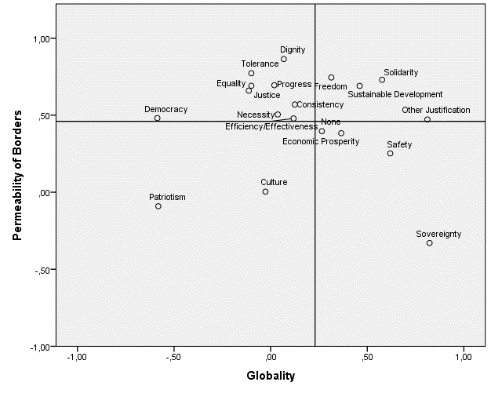

Figure 1a: Justification weighted by Origin (Germany, EU, Mexico, Poland, US and UN)
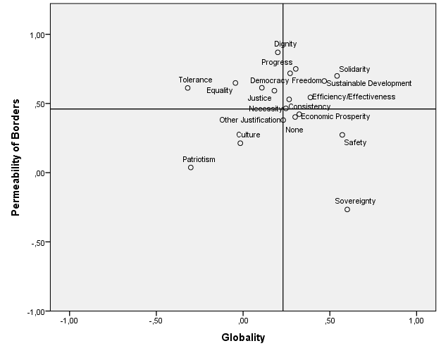
Figure 1b: Justification weighted by Issue (Human Rights, Migration, Climate Change, Trade, Regional Integration and Globalization)
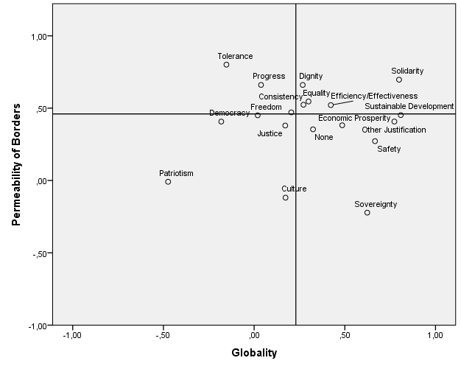
Figure 1c: Justification weighted by Issue and Origin
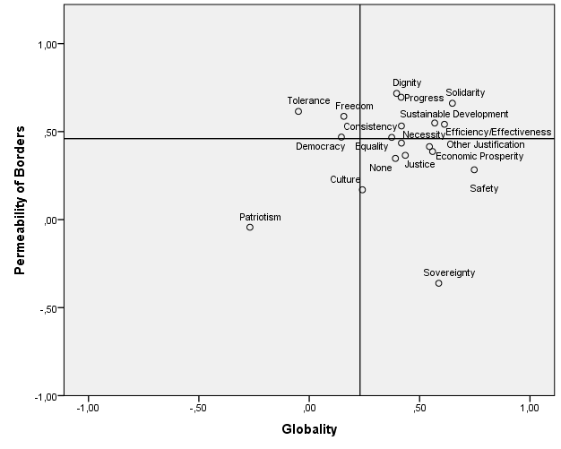

Figure 2: Moral Foundations unweighted
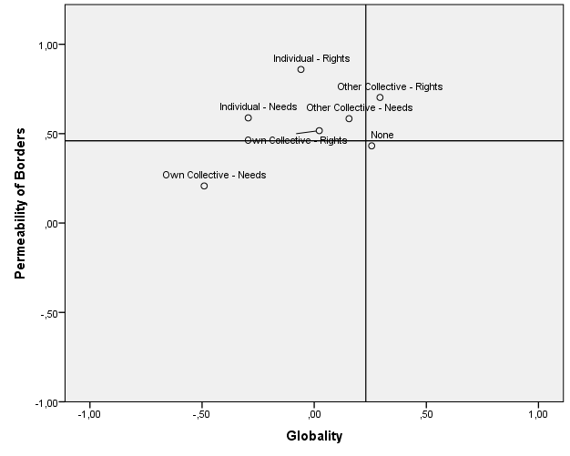

Figure 2a: Moral Foundations weighted by Issue
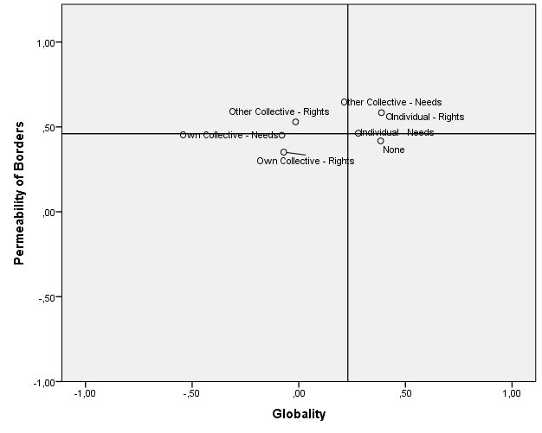

Figure 2b: Moral Foundations weighted by Origin
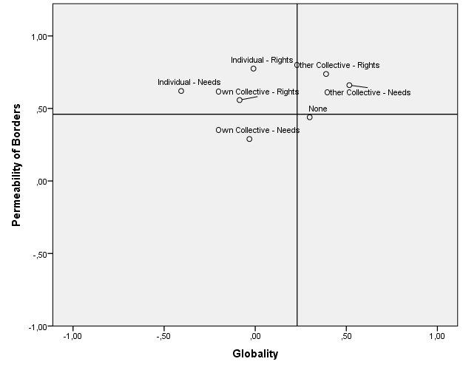

Figure 2c: Moral Foundations weighted by Issue and Origin
