Appendix: Conditions of civilian control in new democracies: an empirical analysis of 28 ‘third wave’ democracies

Appendix 1: Areas and indicators of civilian control
Area | Dimension | Indicator | Degree of Civilian Control
 |  |  | High | Medium | Low
Elite Recruitment | Competition for public office | Reserved representation for military personnel | No formal or informal guarantees for military representation in political bodies | Some privileged access to political office | Majority of decisive political positions are reserved for the military
 |  | Military influence on the rules of political competition | Military has no influence on the selection of political decision-makers | Some authority over the process of selecting political decision-makers but cannot dominate procedures or outcomes of the process | Military dominates rule-setting, process and outcomes of elite selection.
 | Political participation | Eligibility of active duty military officers | Active duty officers are not eligible for political office | Active duty officers are eligible in a few individual cases. | Regular eligibility of military officers or existing rules of non-eligibility are regularly ignored
 |  | Military veto power over formation and dissolution of governments | No military influence on the making and breaking of governments | Occasional and isolated de facto influence | Formal regulations establish military as veto actor or military systematically demands a tutelary role
Public Policy | Policy-making | Military influence on state budget | No military participation in the allocation of state expenditures | Institutionalized military prerogatives or de facto capture of some budget items | Military dominance over budgetary process
 |  | Military influence on public policy-making | No institutionalized prerogatives or informal intervention | Some isolated institutionalized or informal military participation | Systematic exclusion of civilians from at least one policy field
 | Policy implementation | Military authority over public administration | No military-dominated state-in-state structures and no military oversight of civilian administrative authorities | Military replaces civilian administration in certain (functional or geographical) areas | Civilian administrative authorities are under military oversight, or significant militarized parallel structures
Internal Security | Policy-making | Military influence on internal security policy-making | No institutionalized prerogatives or informal intervention | Some institutionalized or informal military authority | Systematic exclusion of civilians from internal security decision making
 | Control over security agents | Separation of police/other security agents and military | Strict separation; no military command over internal security agents except in clearly defined emergencies | Subordination of police or other agencies in limited specified geographic areas or missions | Police or other security agents subordinate to military command, or no separate civilian police
 |  | Civilian oversight over military internal security operations | Institutional framework for monitoring military operations; military accepts civilian oversight | Civilian capability to monitor military internal security operations is limited | No effective civilian oversight; military autonomous in the conduct of operations
National Defense | Policy-making | Civilian influence on defense policy making | Institutionalized civilian dominance over defense policy and active day-to-day participation of civilians in defense policy-making; military accepts civilians’ policy prerogative | Lacking or ambiguous legal regulations; military personnel dominates defense bureaucracy; occasional instances of ad hoc military contestation against civilian authority | Civilians are systematically excluded from defense policy decision-making
 | Policy implementation | Civilian oversight over military defense activities | Civilians in all branches of government are able to monitor military activities | Military has the ability to selectively withdraw itself from effective oversight | Military’s defense operations are not subject to civilian monitoring
Military Organization | Policy-making | Civilian influence on decision-making about military ‘hardware’ and ‘software’ | Civilians have full authority over decisions about military organization the rules of conduct, and the limits of military autonomy, and provide the guidelines for the armed forces’ corporate identity | Civilian decision making is limited to certain aspects of military organization due to lack of institutionalized channels, or the military exerts veto power over decisions. | The military alone defines military organization and determines the scope of its professional autonomy.
 | Policy implementation | Military compliance with and civilian monitoring of decisions on ‘hardware’ and ‘software’ | Civilians are able to monitor and audit military activities to guarantee the implementation of their decisions. | Military does not implement civilian decisions, or civilians lack institutionalized oversight mechanisms. | No civilian oversight; military completely autonomous in internal affairs
Source: XXX

Appendix 2: Countries of the Third Wave of democratization
Africa | Asia | Europe | Latin America
Benin | Bangladesh | Albania | Argentina
Burundi | Indonesia* | Belarus | Bolivia
Ghana | Korea, South* | Bulgaria | Brazil*
Guinea-Bissau | Lebanon | Croatia | Chile
Kenya | Mongolia | Czech Republic* | Dominican Republic
Lesotho | Nepal* | Estonia | Ecuador
Liberia* | Pakistan | Georgia | El Salvador
Madagascar | Philippines* | Greece* | Guatemala
Malawi | Sri Lanka* | Hungary | Honduras*
Mali* | Taiwan* | Latvia | Mexico*
Namibia* | Thailand* | Lithuania | Nicaragua*
Niger |  | Macedonia | Paraguay
Nigeria* |  | Moldova | Peru*
Senegal* |  | Poland* | Uruguay
Sierra Leone |  | Portugal*
South Africa* |  | Romania*
Sudan* |  | Russia*
Zambia* |  | Slovak Republic
 |  | Slovenia
 |  | Spain
 |  | Turkey*
 |  | Ukraine
 |  | Yugoslavia/Serbia
Notes: Asterisks (*) marks the 28 countries that are included in this study.

Appendix 3: Summary of the cases
label | id | case | Civ Con | ER | PP | IS | ND | MO | inthreat | intif | autinst | civsoc | age
BRA1 | 1 | Brazil 1, 1985-1987 | 0.13 | 0.2 | 0.2 | 0 | 0 | 0 | 0.3 | 0.3 | 0.7 | 0.2 | 0.0
BRA2 | 2 | Brazil 2, 1988-1998 | 0.65 | 0.85 | 0.85 | 0.4 | 0 | 0.4 | 0.3 | 0.3 | 0.7 | 0.6 | 0.7
BRA3 | 3 | Brazil 3, 1999-2010 | 0.95 | 1 | 0.85 | 1 | 1 | 0.7 | 0.7 | 0.3 | 0.7 | 1.0 | 1.0
CZE1 | 4 | Czech Republic 1, 1993-2010 | 1 | 1 | 1 | 1 | 1 | 1 | 0 | 1 | 1 | 0.9 | 0.9
CZK1 | 5 | Czechoslovakia 1, 1990-1992 | 1 | 1 | 1 | 1 | 1 | 1 | 0.3 | 1 | 1 | 0.3 | 0.0
GRC1 | 6 | Greece 1, 1974-2010 | 0.97 | 1 | 1 | 1 | 0.7 | 1 | 0.7 | 1 | 0.7 | 0.7 | 1.0
HND1 | 7 | Honduras 1, 1980-1984 | 0.18 | 0.4 | 0 | 0 | 0 | 0 | 0 | 0.7 | 0.7 | 0.0 | 0.0
HND2 | 8 | Honduras 2, 1989-1993 | 0.18 | 0.4 | 0 | 0 | 0 | 0 | 0 | 0.7 | 0.7 | 0.0 | 0.0
HND3 | 9 | Honduras 3, 1994-1997 | 0.25 | 0.4 | 0.1 | 0.1 | 0 | 0.4 | 0 | 0.7 | 0.7 | 0.1 | 0.2
HND4 | 10 | Honduras 4, 1998-2008 | 0.44 | 0.6 | 0.4 | 0.2 | 0.2 | 0.4 | 0 | 0.7 | 0.7 | 0.1 | 0.9
HND5 | 11 | Honduras 5, 2009-2010 | 0.42 | 0.6 | 0.2 | 0.3 | 0.2 | 0.4 | 0 | 0.7 | 0.7 | 0.1 | 1.0
IDN1 | 12 | Indonesia 1, 1999-2000 | 0.25 | 0.4 | 0.4 | 0 | 0 | 0 | 1 | 0.7 | 0 | 0.4 | 0.0
IDN2 | 13 | Indonesia 2, 2001-2004 | 0.33 | 0.4 | 0.4 | 0.4 | 0 | 0 | 1 | 0.7 | 0 | 0.6 | 0.1
IDN3 | 14 | Indonesia 3, 2005-2010 | 0.78 | 1 | 1 | 0.4 | 0.4 | 0.4 | 0.7 | 0.7 | 0 | 0.7 | 0.6
KOR1 | 15 | Korea South 1, 1987-1994 | 0.33 | 0.4 | 0.4 | 0.4 | 0 | 0 | 0 | 0.7 | 0.7 | 0.1 | 0.1
KOR2 | 16 | Korea South 2, 1995-2002 | 0.89 | 1 | 1 | 1 | 0.4 | 0.4 | 0 | 0.7 | 0.7 | 0.5 | 0.8
KOR3 | 17 | Korea South 3, 2003-2010 | 1 | 1 | 1 | 1 | 1 | 1 | 0 | 0.7 | 0.7 | 0.8 | 1.0
LBR1 | 18 | Liberia 1, 2003-2010 | 0.73 | 0.85 | 1 | 0.7 | 0.2 | 0.2 | 1 | 0.7 | 0.3 | 0.0 | 0.0
MLI1 | 19 | Mali 1, 1992-2001 | 0.95 | 1 | 1 | 0.85 | 1 | 0.7 | 0.7 | 0.7 | 0 | 0.0 | 0.4
MLI2 | 20 | Mali 2, 2002-2010 | 0.85 | 0.85 | 1 | 0.7 | 1 | 0.7 | 1 | 0.7 | 0 | 0.1 | 0.9
MEX1 | 21 | Mexico 1, 1997-2010 | 0.59 | 0.7 | 0.85 | 0.45 | 0.4 | 0 | 1 | 0.7 | 1 | 0.9 | 0.7
NAM1 | 22 | Namibia 1, 1990-2010 | 0.89 | 1 | 1 | 0.85 | 0.7 | 0.4 | 0.7 | 0.3 | 1 | 0.0 | 1.0
NPL1 | 23 | Nepal 1, 1999-2001 | 0.74 | 1 | 0.85 | 0.6 | 0 | 0.2 | 1 | 0.7 | 1 | 0.1 | 0.0
NPL2 | 24 | Nepal 2, 2006-2010 | 0.86 | 1 | 1 | 0.55 | 0.4 | 1 | 0.7 | 0.7 | 1 | 0.1 | 0.0
NIC1 | 25 | Nicaragua 1, 1990-1994 | 0.51 | 0.7 | 0.85 | 0.2 | 0 | 0 | 1 | 0.7 | 1 | 0.0 | 0.0
NIC2 | 26 | Nicaragua 2, 1995-2010 | 0.54 | 0.85 | 0.55 | 0.3 | 0 | 0 | 1 | 0.7 | 1 | 0.1 | 1.0
NGA1 | 27 | Nigeria 1, 1978-1979 | 0 | 0 | 0 | 0 | 0 | 0 | 0.7 | 0.3 | 0.7 | 0.0 | 0.0
NGA2 | 28 | Nigeria 2, 1980-1983 | 0.67 | 0.75 | 1 | 0.7 | 0.2 | 0 | 0.7 | 0.3 | 0.7 | 0.0 | 0.0
PAK1 | 29 | Pakistan 1, 1988-1996 | 0.33 | 0.4 | 0.4 | 0.4 | 0 | 0 | 1 | 0.3 | 0 | 0.1 | 0.2
PAK2 | 30 | Pakistan 2, 1997-1998 | 0.32 | 0.3 | 0.4 | 0.4 | 0.4 | 0 | 1 | 0.3 | 0 | 0.2 | 0.5
PER1 | 31 | Peru 1, 1978-1982 | 0.34 | 0.7 | 0.1 | 0 | 0 | 0 | 0.7 | 0.3 | 0.7 | 0.0 | 0.0
PER2 | 32 | Peru 2, 1983-1989 | 0.34 | 0.7 | 0.1 | 0 | 0 | 0 | 1 | 0.3 | 0.7 | 0.1 | 0.4
PER3 | 33 | Peru 3, 1990-1991 | 0.41 | 0.7 | 0.1 | 0.3 | 0 | 0.2 | 1 | 0.3 | 0.7 | 0.2 | 0.6
PER4 | 34 | Peru 4, 2001-2010 | 0.6 | 0.85 | 0.4 | 0.3 | 0.5 | 0.5 | 0.7 | 0.3 | 0.3 | 0.7 | 0.4
PHL1 | 35 | Philippines 1, 1986-2000 | 0.36 | 0.4 | 0.4 | 0.4 | 0.4 | 0 | 1 | 0.7 | 0.3 | 0.2 | 0.7
PHL2 | 36 | Philippines 2, 2001-2010 | 0.4 | 0.4 | 0.4 | 0.4 | 0.4 | 0.4 | 1 | 0.7 | 0.3 | 0.8 | 1.0
POL1 | 37 | Poland 1, 1991-1998 | 0.89 | 1 | 1 | 1 | 0.4 | 0.4 | 0 | 0.7 | 0.7 | 0.7 | 0.1
POL2 | 38 | Poland 2, 1999-2010 | 1 | 1 | 1 | 1 | 1 | 1 | 0 | 1 | 0.7 | 1.0 | 0.9
PRT1 | 39 | Portugal 1, 1974-1975 | 0 | 0 | 0 | 0 | 0 | 0 | 0.7 | 0.7 | 0.3 | 0.0 | 0.0
PRT2 | 40 | Portugal 2, 1976-1982 | 0.08 | 0.1 | 0.2 | 0 | 0 | 0 | 0.3 | 0.7 | 0.3 | 0.1 | 0.1
PRT3 | 41 | Portugal 3, 1983-2010 | 1 | 1 | 1 | 1 | 1 | 1 | 0 | 1 | 0.3 | 0.9 | 1.0
ROU1 | 42 | Romania 1, 1996-2010 | 1 | 1 | 1 | 1 | 1 | 1 | 0.3 | 1 | 0.3 | 0.8 | 0.8
RUS1 | 43 | Russia 1, 2000-2006 | 0.79 | 0.85 | 1 | 0.75 | 0.5 | 0.4 | 1 | 0.7 | 0.3 | 0.9 | 0.1
SEN1 | 44 | Senegal 1, 2000-2010 | 0.84 | 1 | 0.55 | 0.85 | 0.4 | 1 | 1 | 0.7 | 1 | 0.2 | 0.5
ZAF1 | 45 | South Africa 1, 1992-1993 | 0.8 | 1 | 1 | 0.3 | 0.5 | 0.7 | 1 | 0.3 | 1 | 0.3 | 0.0
ZAF2 | 46 | South Africa 2, 1994-2010 | 0.92 | 1 | 1 | 1 | 0.4 | 0.7 | 1 | 0.7 | 1 | 0.9 | 0.9
LKA1 | 47 | Sri Lanka 1, 2001-2002 | 0.76 | 1 | 1 | 0.3 | 0.4 | 0.4 | 1 | 0.7 | 1 | 0.3 | 0.0
LKA2 | 48 | Sri Lanka 2, 2006-2009 | 0.75 | 1 | 1 | 0.2 | 0.4 | 0.4 | 1 | 0.7 | 1 | 0.4 | 0.0
SDN1 | 49 | Sudan 1, 1985-1988 | 0.41 | 0.5 | 0.55 | 0.45 | 0 | 0 | 1 | 0.3 | 0 | 0.0 | 0.0
TWN1 | 50 | Taiwan 1, 1992-2001 | 0.89 | 1 | 1 | 1 | 0.4 | 0.4 | 0.3 | 0.3 | 1 | 0.2 | 0.4
TWN2 | 51 | Taiwan 2, 2002-2010 | 1 | 1 | 1 | 1 | 1 | 1 | 0.3 | 0.3 | 1 | 0.6 | 0.9
THA1 | 52 | Thailand 1, 1992-2000 | 0.75 | 1 | 1 | 0.4 | 0.4 | 0 | 1 | 0.7 | 0.7 | 0.2 | 0.2
THA2 | 53 | Thailand 2, 2001-2005 | 0.67 | 0.75 | 1 | 0.4 | 0.4 | 0.4 | 1 | 0.7 | 0.7 | 0.7 | 0.7
TUR1 | 54 | Turkey 1, 1983-1997 | 0.3 | 0.5 | 0.3 | 0.1 | 0 | 0 | 1 | 0.7 | 0.7 | 0.1 | 0.8
TUR2 | 55 | Turkey 2, 1998-2003 | 0.53 | 0.85 | 0.4 | 0.3 | 0.2 | 0 | 1 | 0.7 | 0.7 | 0.7 | 1.0
TUR3 | 56 | Turkey 3, 2004-2010 | 0.62 | 0.7 | 0.85 | 0.4 | 0.4 | 0.4 | 1 | 0.7 | 0.7 | 0.9 | 1.0
ZMB1 | 57 | Zambia 1, 1991-1995 | 0.67 | 1 | 0.7 | 0.3 | 0.2 | 0.2 | 0 | 0.7 | 1 | 0.1 | 0.0

Appendix 4: Distribution of Conditions (raw data)
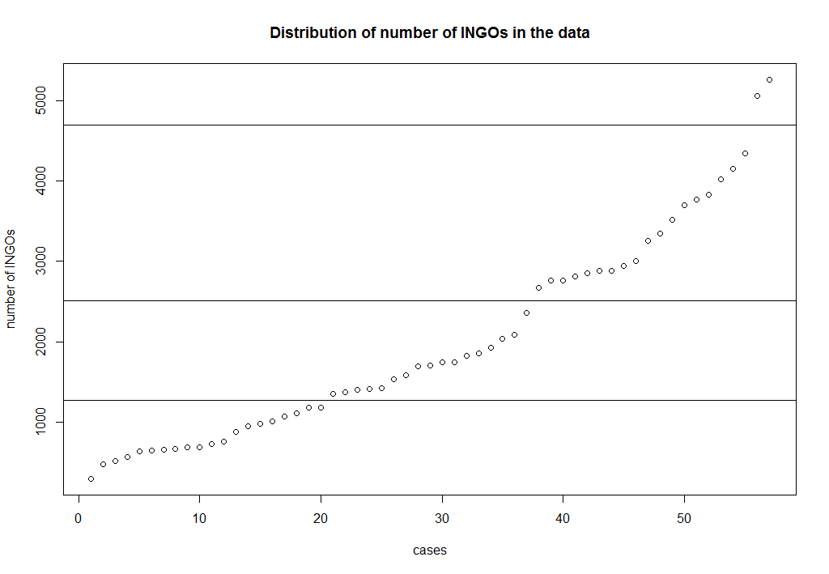
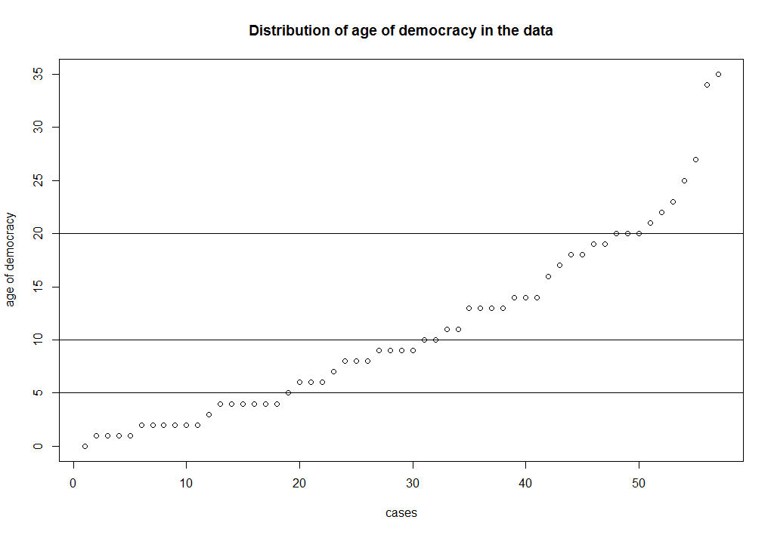

Appendix 5: Histograms of the distribution of the outcome and conditions
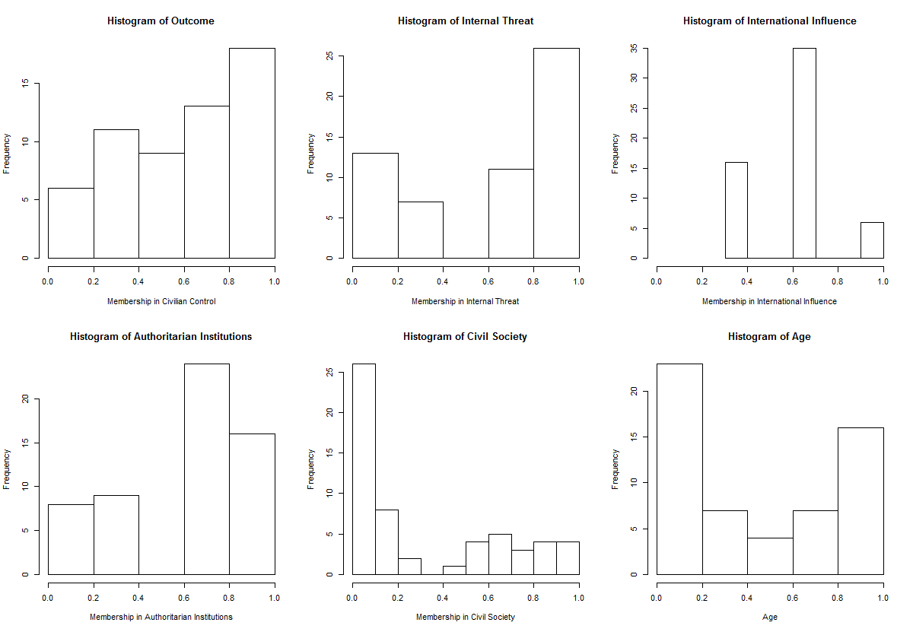

Appendix 6: XY-Plots of the outcome and the individual conditions
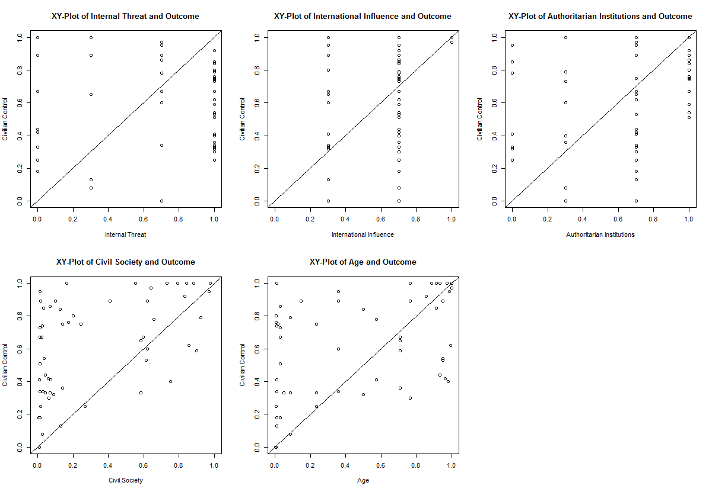

Appendix 7: Solutions of Boolean minimization procedure

Table A: Sufficiency of the outcome civilian control: Complex Solution
n OUT = 1/0/C: 35/20/0
Total : 55

Number of multiple-covered cases: 14

M1: AUTINST*AGE*INTIF + AUTINST*CIVSOC*AGE + CIVSOC*AGE*INTIF + INTHREAT*AGE*INTIF +
INTHREAT*AUTINST*AGE + INTHREAT*autinst*CIVSOC*age + inthreat*AUTINST*CIVSOC*INTIF +
INTHREAT*AUTINST*civsoc*INTIF => CC_SCORE

incl cov.r cov.u cases
-------------------------------------------------------------------------------------------------
1 AUTINST*AGE*INTIF 0.901 0.393 0.039 CZE1,KOR3,POL2; GRC1,MEX1,ZAF2,THA2,TUR2,TUR3; NIC2,TUR1; HND4,HND5,KOR2
2 AUTINST*CIVSOC*AGE 0.974 0.311 0.015 CZE1,KOR3,POL2; BRA3; BRA2,TWN2; GRC1,MEX1,ZAF2,THA2,TUR2,TUR3
3 CIVSOC*AGE*INTIF 0.954 0.342 0.036 CZE1,KOR3,POL2; PRT3,ROU1; GRC1,MEX1,ZAF2,THA2,TUR2,TUR3; IDN3,PHL2
4 INTHREAT*AGE*INTIF 0.877 0.328 0.042 GRC1,MEX1,ZAF2,THA2,TUR2,TUR3; MLI2; IDN3,PHL2; NIC2,TUR1
5 INTHREAT*AUTINST*AGE 0.878 0.291 0.016 BRA3; NAM1,PER3; GRC1,MEX1,ZAF2,THA2,TUR2,TUR3; NIC2,TUR1
6 INTHREAT*autinst*CIVSOC*age 0.928 0.116 0.041 PER4; IDN2,RUS1
7 inthreat*AUTINST*CIVSOC*INTIF 0.997 0.176 0.014 CZE1,KOR2,POL2; POL1
8 INTHREAT*AUTINST*civsoc*INTIF 0.872 0.340 0.147 NIC2,TUR1; NPL1,NPL2,NIC1,LKA1,LKA2,THA1
-------------------------------------------------------------------------------------------------
M1 0.867 0.755

Table B: Sufficiency of the outcome civilian control: Parsimonious Solution
n OUT = 1/0/C: 35/20/0
Total : 55

Number of multiple-covered cases: 18

M1: AGE + CIVSOC + INTHREAT*AUTINST*INTIF <=> CC_SCORE

incl cov.r cov.u
----------------------------------------------
1 AGE 0.826 0.599 0.141
2 CIVSOC 0.919 0.470 0.053
3 INTHREAT*AUTINST*INTIF 0.873 0.421 0.129
----------------------------------------------
M1 0.821 0.815

cases
--------------------------------
1 AGE CZE1,KOR3,POL2; BRA3; PRT3,ROU1; BRA2,TWN2; NAM1,PER3; GRC1,MEX1,ZAF2,THA2,TUR2,TUR3; MLI2,PHL1; IDN3,PHL2; NIC2,TUR1; HND4,HND5,KOR2
2 CIVSOC CZE1,KOR3,POL2; BRA3; PRT3,ROU1; BRA2,TWN2; POL1; PER4; GRC1,MEX1,ZAF2,THA2,TUR2,TUR3; IDN3,PHL2; IDN3,PHL2
3 INTHREAT*AUTINST*INTIF GRC1,MEX1,ZAF2,THA2,TUR2,TUR3; NIC2,TUR1; NPL1,NPL2,NIC1,LKA1,LKA2,THA1

Table C: Sufficiency of the outcome NO civilian control: Complex Solution
n OUT = 1/0/C: 15/40/0
Total : 55

Number of multiple-covered cases: 0

M1: autinst*civsoc*age*INTIF + AUTINST*civsoc*age*intif + INTHREAT*autinst*age*intif => cc_score

incl cov.r cov.u cases
------------------------------------------------------------------------
1 autinst*civsoc*age*INTIF 0.836 0.415 0.060 IDN1,LBR1,MLI1,PRT1; PRT2
2 AUTINST*civsoc*age*intif 0.801 0.448 0.176 BRA1,TWN1; NGA1,NGA2,PER1,PER2,ZAF1
3 INTHREAT*autinst*age*intif 0.894 0.336 0.049 PAK1,SDN1; PER4
------------------------------------------------------------------------
M1 0.767 0.641

Table D: Sufficiency of the outcome civilian control: Parsimonious Solution
n OUT = 1/0/C: 15/40/0
Total : 55

Number of multiple-covered cases: 2

M1: age*intif + autinst*civsoc*age => cc_score

incl cov.r cov.u cases
---------------------------------------------------------------------------
1 age*intif 0.800 0.590 0.192 PAK1,SDN1; PER4; BRA1,TWN1; NGA1,NGA2,PER1,PER2,ZAF1
2 autinst*civsoc*age 0.816 0.459 0.061 PAK1,SDN1; IDN1,LBR1,MLI1,PRT1; PRT2
---------------------------------------------------------------------------
M1 0.755 0.651

Appendix 8: XY-Plots of partial solution: outcome = Civilian Control

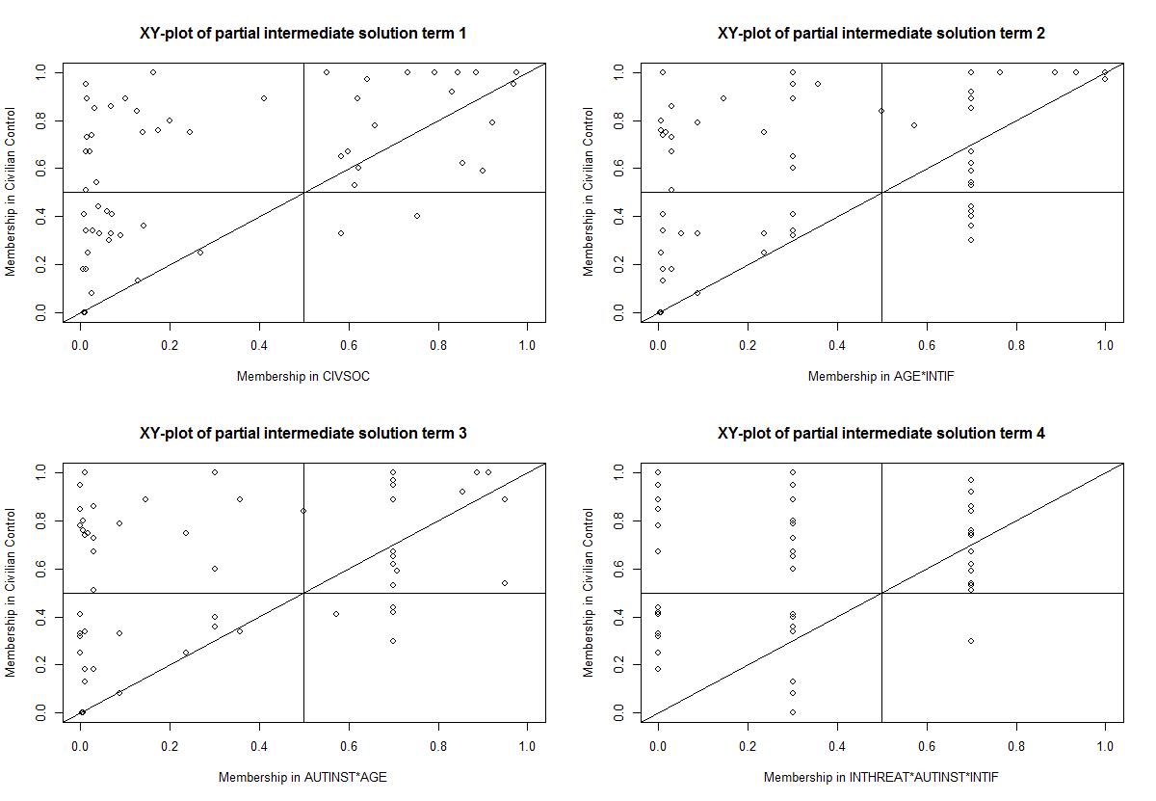
Appendix 9: XY-Plots of partial solution: outcome = No Civilian Control
