Table A: Summary Statistics and associations (mean differences and correlations) between objective and subjective IVs
 | Subjective deprivation | Globalization as opportunity | (sub)national identification | Supranational identification
Categorical control variables | Mean difference
Gender | T=6.40*** | T=3.01** | T=-2.51* | T=8.49***
Male (44.58%) | 2.63 | 3.45 | 5.41 | 3.96
Female (55.42%) | 2.69 | 3.38 | 5.44 | 3.79
Internet Use | T=-42.93*** | T=-21.69*** | T=9.64*** | T=-27.63***
Non-Daily (59.02%) | 2.50 | 3.20 | 5.47 | 3.65
Daily (40.98%) | 2.89 | 3.67 | 5.35 | 4.19
Residence Size | F*=124*** | F*=4.23** | F*=35.87*** | F*=43.48***
Rural (37.29% | 2.65 | 3.36 | 5.51 | 3.83
Small (34.46%) | 2.68 | 3.42 | 5.41 | 3.85
Large (28.26%) | 2.65 | 3.46 | 5.34 | 3.94
Immigrant Background | F*=175.11*** | F*=3.35* | F*=252.56*** | F*=63.82***
National (88.00%) | 2.66 | 3.42 | 5.50 | 3.85
EU Migrant (6.35%) | 2.76 | 3.42 | 4.85 | 4.20
Non-EU Migrant (5.65%) | 2.57 | 3.29 | 4.84 | 3.86
SES | F*= 338.83*** | F*= 40.96*** | F*=12.01*** | F*= 72.00***
Unemployed (11.50%) | 2.17 | 3.12 | 5.35 | 3.63
Student (7.63%) | 2.81 | 3.77 | 5.29 | 4.24
Unskilled Manual (8.63) | 2.39 | 3.24 | 5.42 | 3.45
Skilled Manual (21.25%) | 2.52 | 3.24 | 5.50 | 3.70
Office Worker (27.60%) | 2.78 | 3.38 | 5.45 | 3.89
Professional Workers (5.50%) | 2.93 | 3.79 | 5.38 | 4.22
Self-Employed (3.77%) | 2.69 | 3.15 | 5.40 | 3.93
Company Owner (2.43%) | 2.96 | 3.73 | 5.32 | 4.11
Mid-Range Manager (9.71%) | 2.98 | 3.67 | 5.47 | 4.19
Top Manager (1.97%) | 3.12 | 3.82 | 5.31 | 4.25
Ordinal control variables | Correlation
Age (centered) (SD: 18.18) | -0.007 | -0.046 | 0.104 | -0.115
Age end Education (centered) (SD: 4.91) | 0.206 | 0.122 | -0.035 | 0.147
Note: for the categorical control variables, F* statistics take into account heterogeneity of variance.
* p < 0.05, ** p < 0.01, *** p < 0.001
Table B. Coefficients of association of the 14 EU meaning categories (range from -1 to +1)
 | (1) | (2) | (3) | (4) | (5) | (6) | (7) | (8) | (9) | (10) | (11) | (12) | (13)
(1) Peace | 1
(2) Democracy | ,219 | 1
(3) Travel | ,096 | ,107 | 1
(4) Cult diversity | ,140 | ,167 | ,208 | 1
(5) Stronger world | ,147 | ,148 | ,150 | ,170 | 1
(6) Euro | ,083 | ,067 | ,131 | ,123 | ,089 | 1
(7) Eco prosperity | ,121 | ,146 | ,055 | ,092 | ,118 | ,037 | 1
(8) Soc protection | ,128 | ,164 | ,045 | ,117 | ,121 | ,021 | ,195 | 1
(9) Bureaucracy | ,028 | -,034 | ,008 | ,043 | -,006 | ,065 | -,062 | -,052 | 1
(10) Waste of money | -,039 | -,093 | -,100 | -,045 | -,080 | -,010 | -,121 | -,065 | ,288 | 1
(11) Unemployment | -,035 | -,051 | -,092 | -,024 | -,075 | ,024 | -,057 | ,000 | ,106 | ,201 | 1
(12) Loss cult identity | -,047 | -,060 | -,057 | -,014 | -,043 | ,002 | -,068 | -,022 | ,121 | ,168 | ,139 | 1
(13) Crime | ,011 | -,024 | -,002 | ,018 | -,022 | ,071 | -,059 | -,005 | ,155 | ,221 | ,277 | ,198 | 1
(14) Not enough border control | ,001 | -,028 | ,005 | ,008 | -,005 | ,061 | -,048 | -,005 | ,136 | ,167 | ,151 | ,185 | ,291

Table C. The four EU-meaning dimensions (cosmopolitan, utilitarian, libertarian, communitarian) and attitudes toward immigrants regressed on socio-demographic characteristics, by controlling for between-country variation.
 | (1) | (2) | (3) | (4) | (5)
 | Cosmopolitan  EU Meaning | Utilitarian  EU Meaning | Libertarian  EU Meaning | Communitarian  EU Meaning | Tolerance toward immigrants
Office worker (ref)
Unemployed | -0.055*** (-7.11) | -0.008 (-1.76) | 0.013* (2.35) | 0.035*** (5.93) | -0.357*** (-5.38)
Student | 0.072*** (7.58) | 0.007 (1.13) | -0.049*** (-7.59) | -0.043*** (-5.92) | 0.342*** (4.20)
Unskilled manual workers | -0.061*** (-6.82) | -0.015** (-2.72) | 0.007 (1.08) | 0.049*** (7.22) | -0.536*** (-6.99)
Skilled manual workers | -0.034*** (-5.19) | 0.007(1.67) | 0.009 (1.91) | 0.011* (2.12) | -0.262*** (-4.68)
Professional | 0.027** (2.67) | 0.011 (1.74) | -0.013 (-1.81) | -0.033*** (-4.32) | 0.309*** (3.62)
Self-employed | -0.021 (-1.76) | 0.008(1.06) | 0.007 (0.83) | 0.002 (0.25) | -0.236* (-2.39)
Company owner | 0.003 (0.20) | 0.009 (1.08) | -0.005 (-0.52) | -0.011 (-1.06) | 0.051 (0.43)
Mid manager | 0.046*** (5.73) | -0.002 (-0.33) | -0.008 (-1.51) | -0.035*** (-5.71) | 0.454*** (6.70)
Top manager | 0.041** (2.59) | 0.034*** (3.54) | -0.007 (-0.63) | -0.057*** (-4.77) | 0.594*** (4.56)
Education | 0.004*** (7.20) | -0.0002 (-0.61) | -0.0001 (-0.24) | -0.003*** (-6.49) | 0.056*** (12.64)
Age | -0.0005*** (-3.38) | -0.0003** (-2.92) | 0.0007*** (6.50) | 0.0004*** (3.60) | -0.0014 (-1.08)
Female | 0.015*** (3.37) | -0.009** (-3.26) | -0.020*** (-6.66) | 0.008* (2.52) | 0.012 (0.32)
Internet | 0.027*** (5.05) | 0.004 (1.36) | -0.012** (-3.23) | -0.026*** (-6.47) | 0.369*** (8.11)
Rural (ref)
Small town | 0.012* (2.28) | 0.0002 (0.08) | -0.0016 (-0.46) | -0.008* (-2.03) | 0.126** (2.90)
Large town | 0.019*** (3.38) | 0.002 (0.51) | -0.009* (-2.27) | -0.012** (-2.82) | 0.283*** (5.92)
Non EU migrant | 0.009(0.93) | 0.018**(3.16) | -0.014*(-2.19) | -0.012(-1.68) | 0.931***(11.57)
EU migrant | 0.018(1.91) | 0.004(0.73) | -0.014*(-2.23) | -0.010(-1.49) | 0.644***(8.28)
_cons | 0.455*** 30.02) | 0.107*** (11.54) | 0.149*** (12.16) | 0.182*** (15.17) | 4.437*** (21.74)
ICC | 0.0434 | 0.0447 | 0.0627 | 0.0482 | 0.1278
R² | 0.0291 | 0.0044 | 0.0116 | 0.0337 | 0.0777
Note. Table reports multilevel regression maximum likelihood estimates. t statistics in parentheses; R² values were calculated following the formula proposed by Snijders and Bosker (1999:102).
* p < 0.05, ** p < 0.01, *** p < 0.001

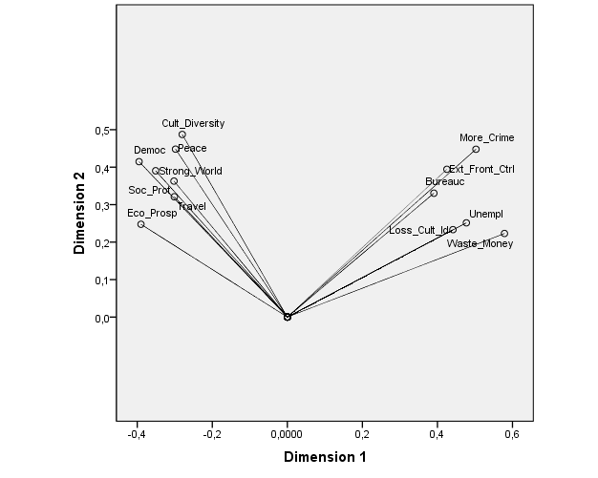

Graph A: dimension 1 against dimension 2 of the Cat PCA

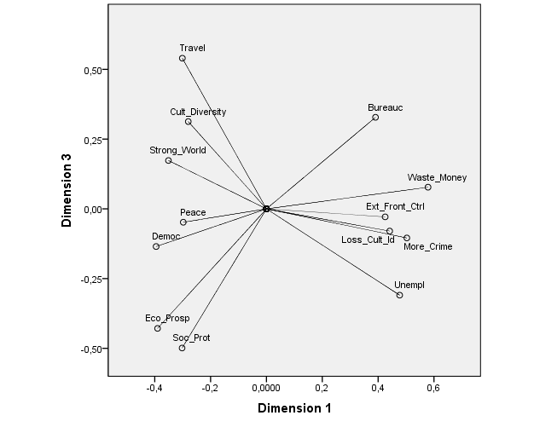

Graph B: dimension 1 against dimension 3 of the Cat PCA

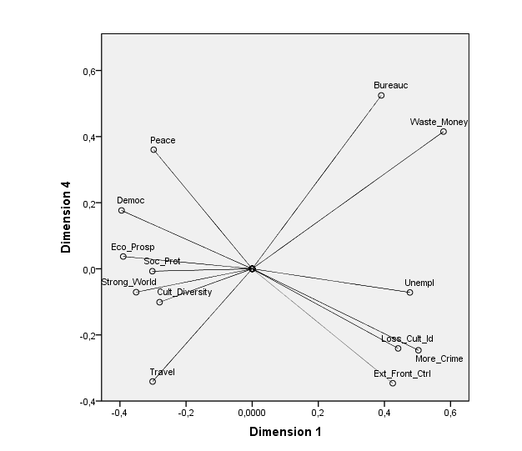

Graph C: dimension 1 against dimension 4 of the Cat PCA

