Supplementary material

Table S1 Selected properties of unmodified biochar and Mg/Fe-LDH-biochar
Adsorbent | Elemental composition (%) |  |  |  |  |  | pH |  | EC* |  | CEC** |  | Surface area
 | C | H | N | Mg | Fe |  |  |  | dS m⁻¹ |  | Cmol_{c} kg⁻¹ |  | m² g⁻¹
Unmodified biochar | 69 | 2.7 | 0.75 | 0.9 | 0.04 |  | 9.5 |  | 0.12 |  | 25 |  | 266
Mg/Fe-LDH-biochar | 48 | 2.5 | 0.48 | 6.2 | 7.8 |  | 8.5 |  | 0.53 |  | 6.5 |  | 50
* Electrical conductivity
** Cation exchange capacity

Figure S1 Point of zero charge for unmodified biochar and Mg/Fe-LDH-biochar.

Figure S2 Arsenate speciation as a function of pH simulated by Visual MINTEQ, (ionic strength = 0.01 M, arsenate concentration = 10 mg L⁻¹, temperature = 19ºC)

Figure S3 Main effect of background solution ionic strength on arsenate adsorption the Mg/Fe-LDH-biochar (pH = 7, arsenate concentration = 10 mg L⁻¹, adsorbent weight = 30 mg, solution volume = 40 mL, contact time = 16 h), bars denote ± standard errors of the means.

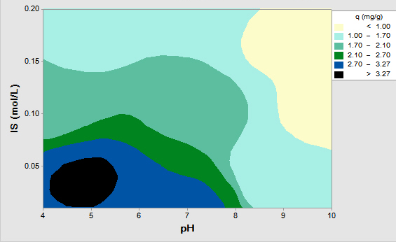
Figure S4 Interaction of ionic strength (IS) and pH on arsenate adsorption on the Mg/Fe-LDH-biochar (adsorbent weight = 30 mg, solution volume = 40 mL, contact time = 16 h).

Figure S5 Removal efficiency of arsenate by Mg/Fe-LDH-biochar over successive adsorption-desorption cycles (pH = 7, adsorbent weight = 30 mg, solution volume = 40 mL, contact time = 16 h), bars denote ± standard errors of the means

