Appendix
Divine Attribution? The Interaction of Religious and Secular Beliefs on Climate Change Attitudes
Variable Coding
Dominion <described in full in the text>
End times imminent “Do you think that the end of the world, as predicted in the Book of Revelation, will happen in your lifetime, or don't you think so?” 0=no, 1=yes.
Providential view of God Averages responses to three items, each coded 1=completely disagree, 2=mostly disagree, 3=mostly agree, and 4=completely agree. The statements were: “God is in control of everything that happens in the world;” “God sometimes punishes nations for the political decisions that their citizens make;” “Earthquakes, hurricanes, floods and other natural disasters are a sign from God.”
Human attribution Combines responses to two questions. First, respondents were asked, “From what you've read and heard, do you believe there is solid evidence that the average temperature on earth has been getting warmer over the past few decades, or not?” Responses included yes, no, and mixed/some evidence. Then respondents were asked, “Which statement comes closest to your view about the causes of climate change ...?” Responses included “Climate change is caused mostly by human activity such as burning fossil fuels.” And “Climate change is caused mostly by natural patterns in the earth’s environment.” Human attribution (=1) means that respondents replied yes to the first question and adopted the first statement of the second question and equals 0 otherwise.
Extreme weather “From what you know, over the last few years do you think that the weather has been getting more extreme, getting less extreme or has it not really changed?” 1=less extreme, 2=not changed, 3=more extreme.
Evangelical asked only of self-identified Protestants, Protestant denominations, Baptists, Christians, and non-denominational Christians: “Would you describe yourself as a 'born-again' or 'Evangelical Christian', or not?” 0=no, 1=yes.
Tea party ID “Do you consider yourself part of the Tea Party movement, or not?” 0=no, 1=yes
Male =1, female=0.
Education “What is the last grade of school you completed?” 1=Less than high school graduate, 2=High school graduate, 3=Some college or Technical school, 4=Graduated college, 5=Graduate school or more.
Black “Black Non-Hispanic”=1, 0=otherwise
Hispanic “Black Hispanic,” “White Hispanic,” or “Unspecified Hispanic” =1, 0=otherwise.
South=1, 0=otherwise.
Democrat/Republican “Generally speaking, do you usually think of yourself as:” Democrat/Republican=1, otherwise=0.

Table A1 – Descriptive Statistics of the Sample
Variable | N | Mean | SD | Min | Max
The U.S. government needs to do more to address the issue of climate change | 986 | 2.13 | 1.06 | 1 | 4
Dominion belief | 1,018 | 0.38 | 0.49 | 0 | 1
Providential view of God | 1,009 | 0.44 | 0.32 | 0 | 1
Human attribution | 1,018 | 0.46 | 0.50 | 0 | 1
Evangelical identifier | 1,018 | 0.27 | 0.44 | 0 | 1
Catholic | 1,018 | 0.22 | 0.42 | 0 | 1
Non-evangelical Protestant | 1,018 | 0.21 | 0.41 | 0 | 1
Religion ‘nothing in particular’ | 1,018 | 0.19 | 0.39 | 0 | 1
End times imminent | 1,018 | 0.15 | 0.36 | 0 | 1
Extreme weather | 1,018 | 2.58 | 0.60 | 1 | 3
Age | 1,018 | 55.81 | 19.57 | 18 | 99
Male | 1,018 | 0.48 | 0.50 | 0 | 1
Education | 1,016 | 2.83 | 1.19 | 1 | 5
Hispanic | 1,018 | 0.14 | 0.35 | 0 | 1
Black | 1,018 | 0.12 | 0.33 | 0 | 1
Other race | 1,018 | 0.09 | 0.28 | 0 | 1
South | 1,018 | 0.37 | 0.48 | 0 | 1
Democrat | 1,018 | 0.39 | 0.49 | 0 | 1
Tea Party | 1,018 | 0.06 | 0.23 | 0 | 1
Republican | 1,018 | 0.21 | 0.40 | 0 | 1
Source: Public Religion Research Institute, PRRI/RNS Religion News Survey, December 2012.

Table A2 – Question Order Effects on Dominion Beliefs (logistic regression estimates)
 | Coeff | SE | p
Dominion given second | 2.05 | (.18) | .00
Evangelical | .52 | (.24) | .03
Order * Evangelical | -1.42 | (.31) | .00
Tea party ID | 1.17 | (.37) | .00
Order * Tea party | -1.42 | (.50) | .00
Male | -.16 | (.14) | .27
Education | .03 | (.06) | .66
Black | .39 | (.26) | .13
South | .15 | (.15) | .33
Democrat | -.17 | (.17) | .31
Republican | -.04 | (.19) | .83
Age | .00 | (.00) | .23
Constant | -1.35 | (.33) | .00
Source: Public Religion Research Institute, PRRI/RNS Religion News Survey, December 2012. N=1016, χ²=169.97***, % correctly predicted=69.9 (61.7 modal), % reduction in error=21.3

Table A3 – Ordered Logistic Estimates of Whether the US Needs to Do More to Address the Issue of Climate Change
 | Minus Secular Beliefs |  | Full Model |  | Full Model w/ Interactions
 | B | p | B | p | B | p
End times imminent | .13 | .50 | .29 | .14 | -.36 | .66
Providential view of God | .38 | .10 | .17 | .48 | .20 | .40
Dominion | -.10 | .41 | .08 | .56 | .48 | .02
Statement order |  |  |  |  | .71 | .00
Dominion * order |  |  |  |  | -.96 | .00
Evangelical | .47 | .00 | .45 | .00 | .66 | .00
Human attribution |  |  | -1.56 | .00 | -1.43 | .00
Human attribution * evangelical |  |  |  |  | -.56 | .06
Extreme weather |  |  | -.73 | .00 | -.79 | .00
End times * extreme |  |  |  |  | .26 | .38
Male | -.05 | .68 | -.11 | .39 | -.10 | .44
Education | -.08 | .16 | .00 | .99 | .00 | .98
Hispanic | -.45 | .06 | -.30 | .22 | -.35 | .15
Black | .02 | .93 | .01 | .98 | -.15 | .55
Other race | -.25 | .31 | -.19 | .47 | .06 | .79
Southern state | .08 | .53 | -.03 | .84 | -.02 | .88
Democrat | -1.05 | .00 | -.75 | .00 | -.77 | .00
Tea Party identifier | 1.08 | .00 | .82 | .00 | .77 | .00
Republican | .65 | .00 | .37 | .02 | .40 | .01
Cut 1 | -.98 | .26 | -3.41 | (.38) | -3.39 | .40
Cut 2 | .60 | .25 | -1.47 | (.36) | -1.44 | .38
Cut 3 | 1.58 | .26 | -.30 | (.36) | -.26 | .38
Model Statistics | N=985, χ²=225.95*** |  | N=979, χ²=468.39*** |  | N=979, χ²=475.20***
Source: Public Religion Research Institute, PRRI/RNS Religion News Survey, December 2012.

Figure A1 – Marginal Effect of Dominion Belief on Climate Change Attitudes Conditional on Statement Order and Evangelical Identity
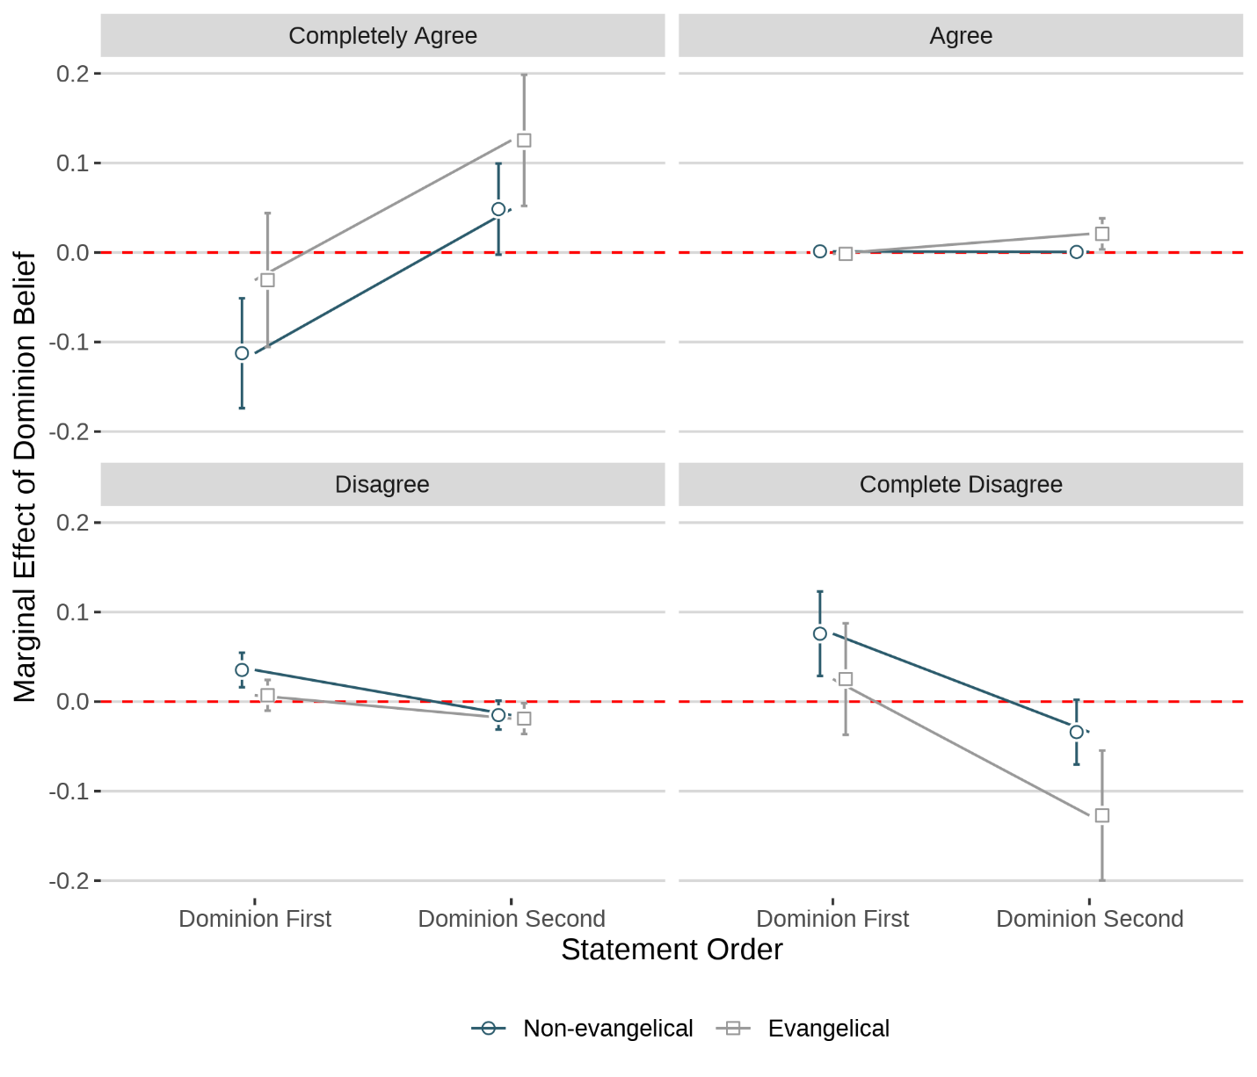
Source: Public Religion Research Institute, PRRI/RNS Religion News Survey, December 2012.
Note: 95% confidence intervals are displayed.

Figure A2 – The Contingent Effects of Human Culpability and Weather Extremity on Climate Change Attitudes
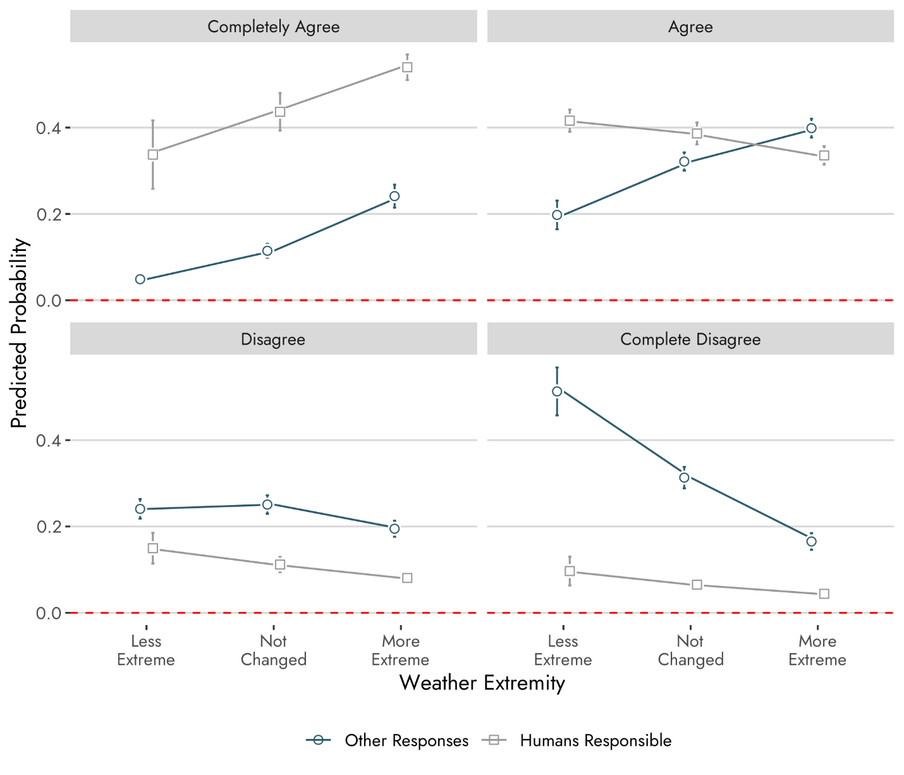
Source: Public Religion Research Institute, PRRI/RNS Religion News Survey, December 2012.
Note: Comparing any two confidence intervals is the equivalent of a 90% (p=.10) test at the point of overlap.

