Online appendix: Additional results

Results for authoritarian regimes

Detailed results for 2000
Regarding the total level of regulation (4-variable clustering), the results of the three-cluster solution can be found in Figure A.1 (dendrogram) and Figure A.4 (description of the average levels of regulation in each cluster). Information about the average silhouette widths and the number of countries in each cluster is provided in Table 5 of the paper. To summarize the results, in Cluster 1 we find 32 countries, many of which are located in the MENA-region or its close proximity. The mean value of support for religion and social regulation of religion are the highest in this cluster. Further, the average level of regulation for majority and all other religions is high as well as is the level of discrimination. The second cluster is formed by 38 countries. The geographic focus of this cluster is Sub Saharan Africa. In comparison to the other two clusters, the mean levels of regulation in this cluster are low. The third cluster consists of 12 countries. A majority of these countries is located on the Asian continent. Moreover, all countries in this cluster, with the exception of Tunisia and Singapore, have been or currently are ruled by a communist regime. Interestingly, the mean levels of regulation of majority religion or all religions, as well as discrimination are at high levels, whereas the mean level for support and in particular for social regulation are low. In other words, the countries in this cluster regulate religion via negative restrictions.
The silhouette analysis shows that the largest cluster (cluster 2) has the highest average silhouette width and thus the strongest internal coherence. Further, the third cluster has a moderately strong internal coherence, although altogether three countries in this cluster (Macedonia, Kazakhstan, Singapore) have negative silhouette widths and cluster 2 could almost equally well represent these countries. Regarding the first cluster, the average silhouette width is very low, which suggests a poor cluster coherence. It is also noteworthy that as many as 13 of the 32 countries in the cluster have negative silhouette widths. In case of Iraq, Laos, Libya, Maldives and Syria, cluster 3 may also be an alternative cluster to describe them. In case of Armenia, Bhutan, Comoros, Georgia, Lebanon, Mauritania, Morocco and Somalia, cluster 2 is relatively close (for countries with negative silhouette widths, see Table A.1).
Regarding government regulation of religion (3-variable clustering), the three-cluster solution (Figures A.2 and A.4) shows many similarities, as well as some notable differences in comparison to the above discussed results. In general, it appears that when social regulation of religion is excluded from the cluster analysis, clusters 1 and 3 are smaller (21 and 5 countries respectively), whereas the number of countries in cluster 2 is higher (56 countries). The geographical focus and regulatory profile of the clusters stays, however, similar to the above discussed clustering. The silhouette analysis (Table 5 in the paper) shows that cluster 3 is the most cohesive cluster, followed by cluster 2 and cluster 1, which both have a moderately strong internal coherence. Further, the negative silhouette widths for individual countries suggest that Iraq and Myanmar are borderline cases between cluster 1 and 3; Laos and Russia are borderline cases between cluster 1 and 2; and Azerbaijan, Cuba and Tunisia are borderline cases between clusters 2 and 3 (for countries with negative silhouette widths, see Table A.2).
When the clustering is performed with the 15 variables on the specific type of government regulation, the results (Figure A.3) are relatively similar to the results, which were gained from the clustering on total regulation of religion. Only the following differences between the clustering of the countries can be observed. Firstly, Bhutan, Comoros, Mauritania and Somalia, which in the clustering for total regulation of religion belonged to cluster 1 (but had negative silhouette widths, and thus were understood as borderline cases between clusters 1 and 2) now belong to cluster 2. Secondly, Armenia, Belarus, Georgia, Laos, Myanmar and Russia, which in the 4-variable clustering likewise belonged to cluster 1 now belong to cluster 3. Finally, Kazakhstan and Singapore, which in the 4-variable clustering were found in cluster 3 (but had negative silhouette widths and thus were borderline cases between clusters 2 and 3) now belong to cluster 2. Some countries also experienced negative silhouette widths, namely Morocco and Lebanon in cluster 1 as well as Armenia, Macedonia, Tajikistan and Georgia in cluster 3. All these countries may be better described by cluster 2 (for countries with negative silhouette widths, see Table A.3).
Some further interesting differences between the clusters emerge when the mean levels of specific types of regulation are observed (Figure A.5). As for the regulation of majority religion or all religions, the average levels of restrictions on religion’s political role and religious institutions, as well as other restrictions on religion are at high levels in cluster 1 and cluster 3. In cluster 1, however, religious practices are regulated to a much lower rate than in cluster 3. Moreover, it is of interest that while in the second cluster the average levels of regulation are in general at low levels, the average levels of restrictions on religion’s political role are somewhat higher than the average levels of the other types of restrictions. Regarding the specific types of support for religion, the mean levels in cluster 1 are high independently from the type of such support. This can be contrasted with clusters 2 and 3, where religious support is more selective. Indeed, in cluster 2 the mean levels of laws on relationships, sex and reproduction are higher than the support for other types. In cluster 3, in turn, the mean levels for funding of religion; entanglement of government and religious institutions and other forms of support for religion are at higher levels. Finally, as for the discrimination against minority religions, the mean levels are high both in cluster 1 and 3, but lower in cluster 2. The clearest difference between cluster 1 and cluster 3 is that in cluster 3 the mean levels of restrictions on religious institutions and the clergy are higher than the other restrictions, whereas in cluster 1 it is especially restrictions on conversion and proselytizing, which are high.

Figure A.1: Dendrogram of autocracies – total regulation, 2000
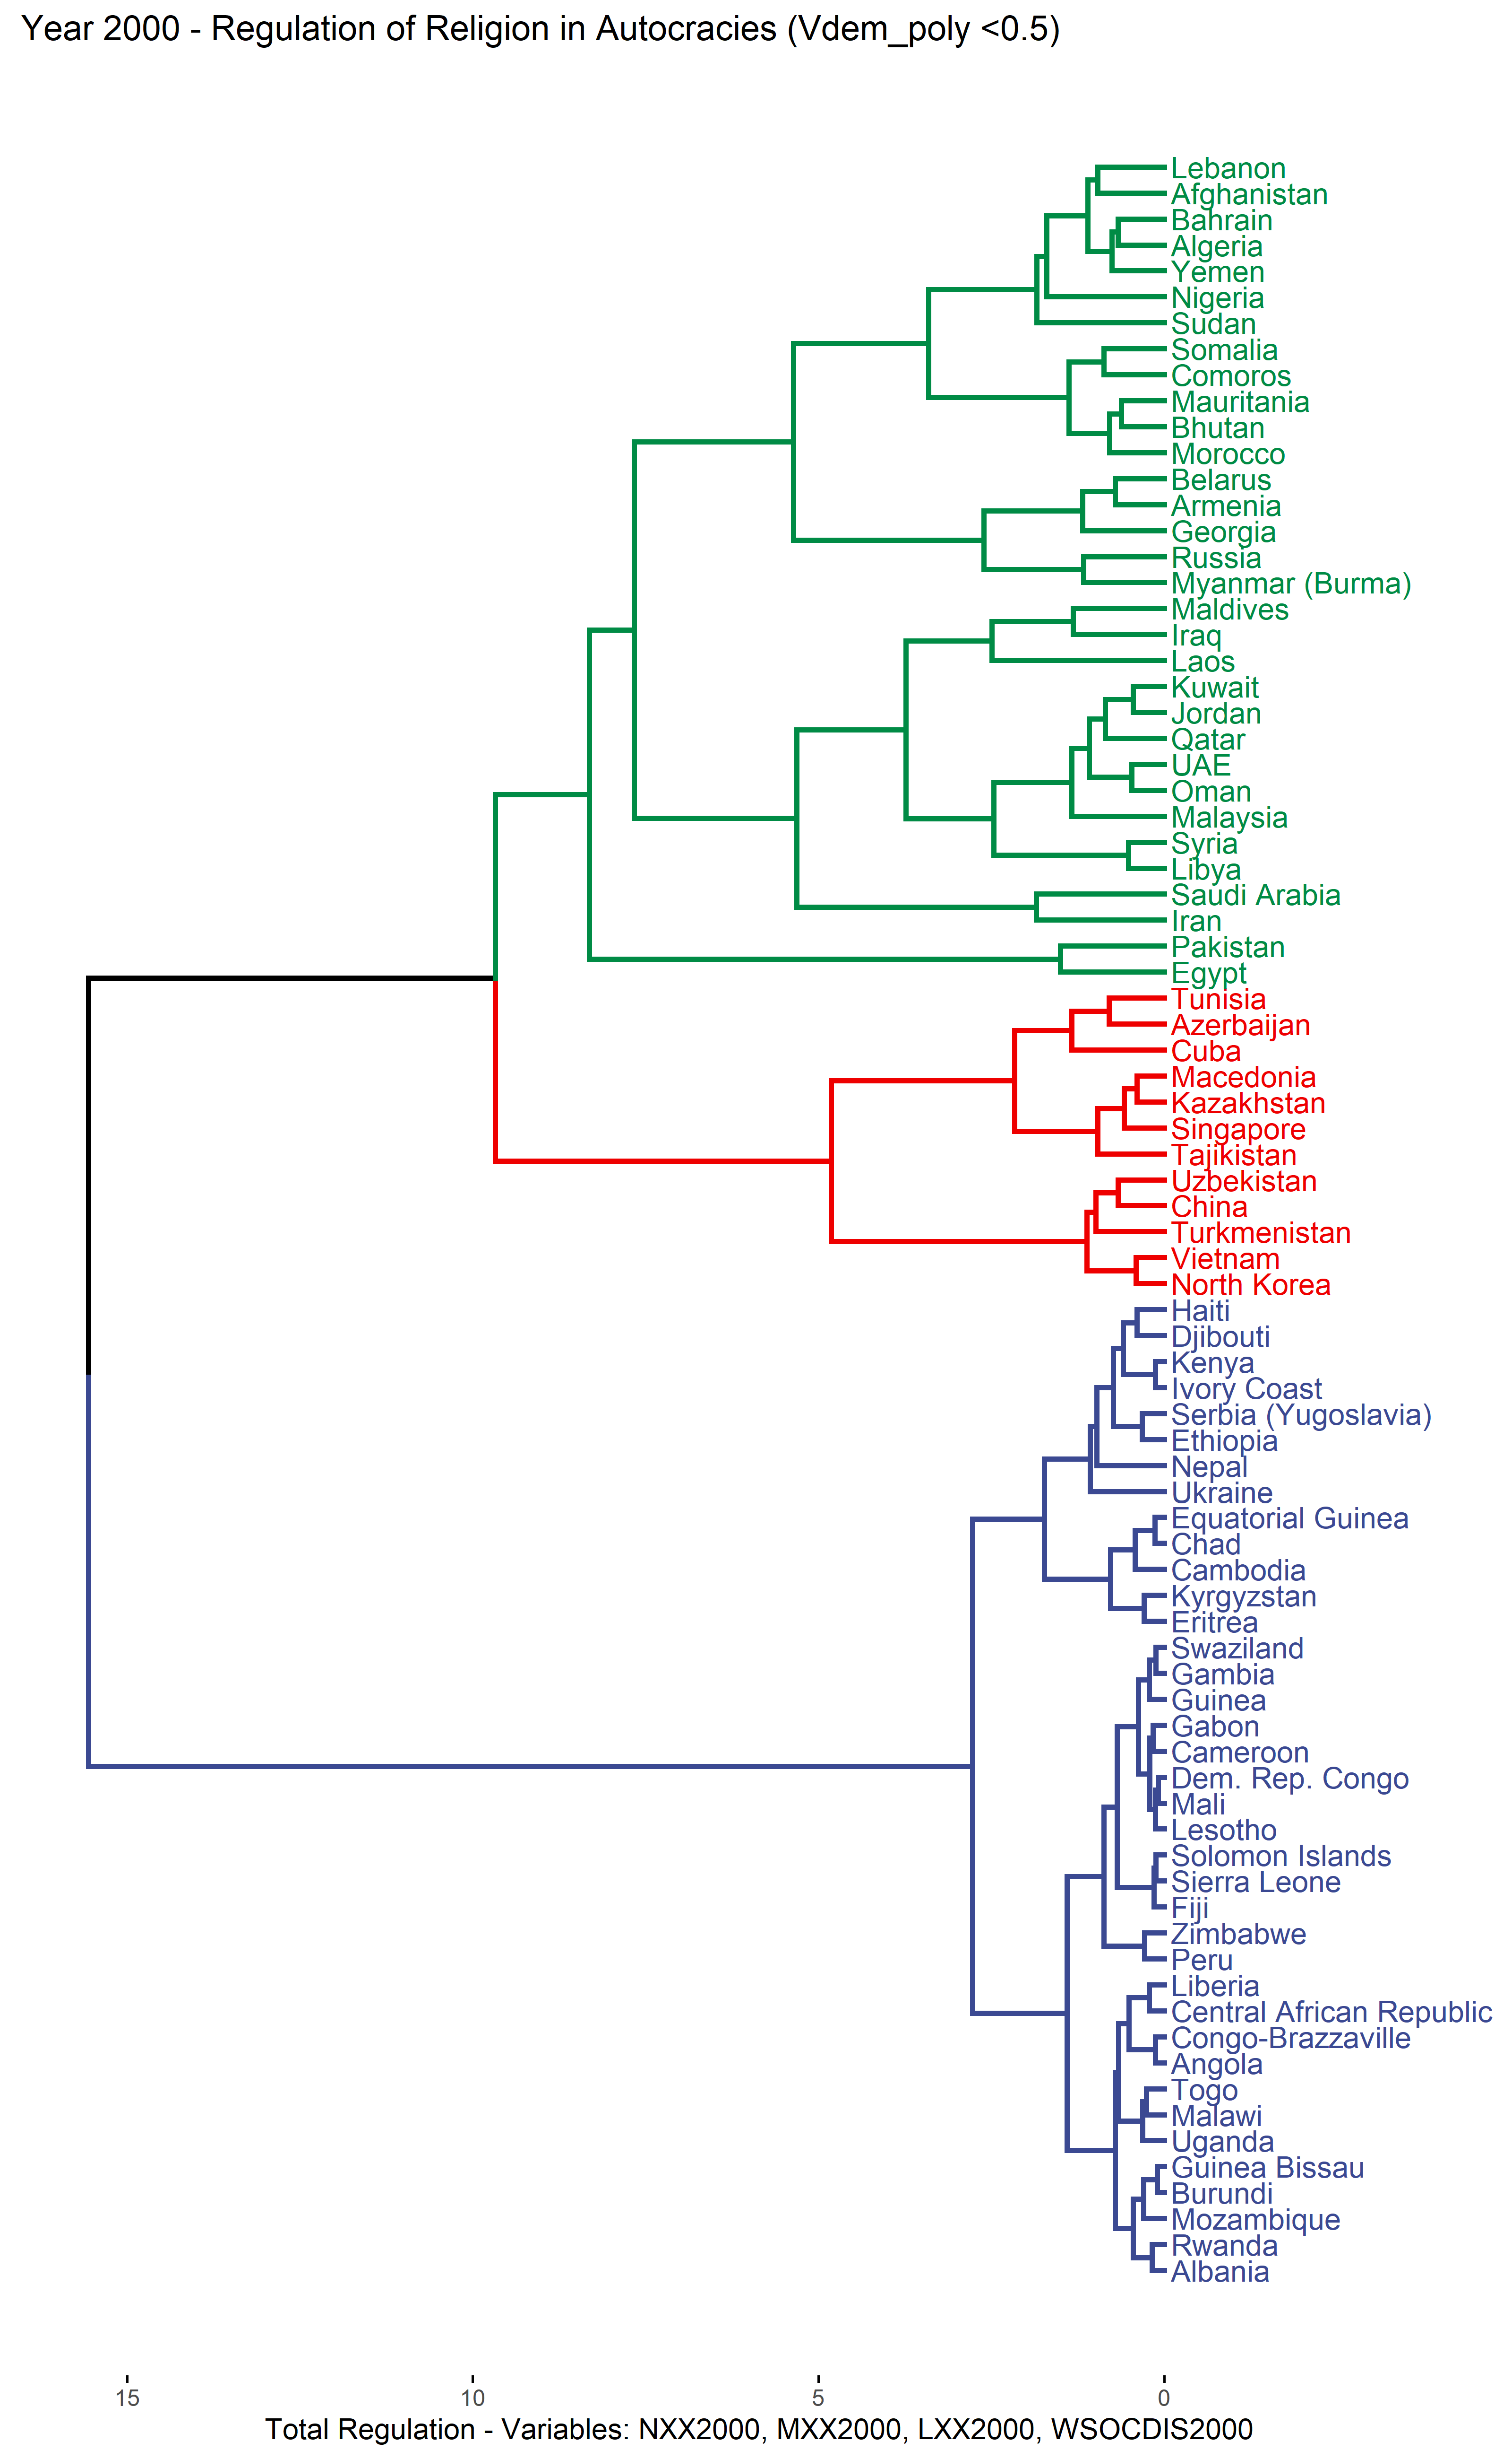
Figure A.2: Dendrogram of autocracies - government regulation of religion, 2000
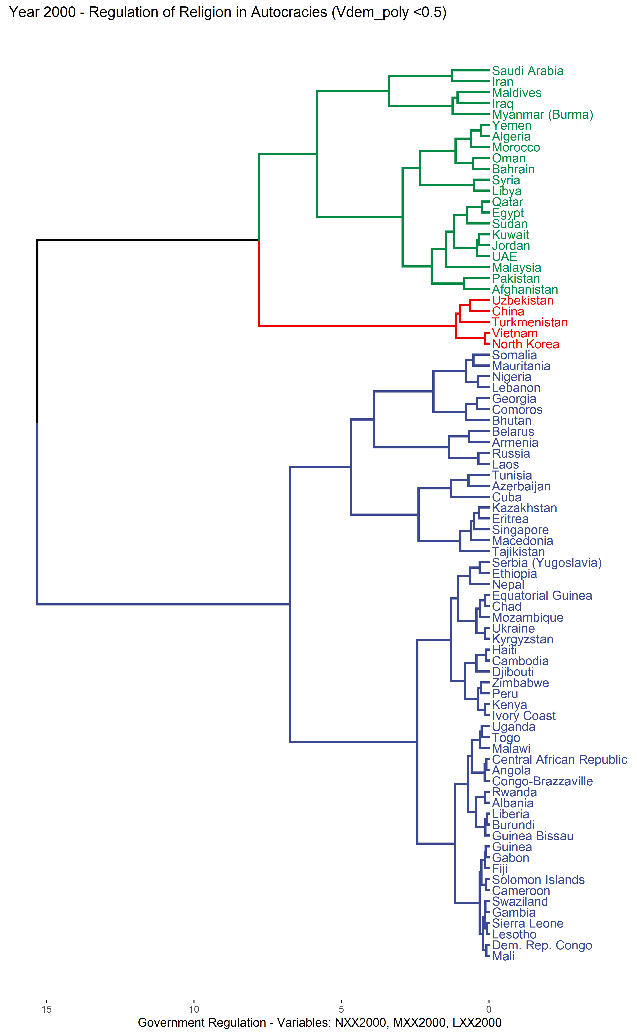
Figure A.3: Dendrogram of autocracies – specific types of regulation, 2000
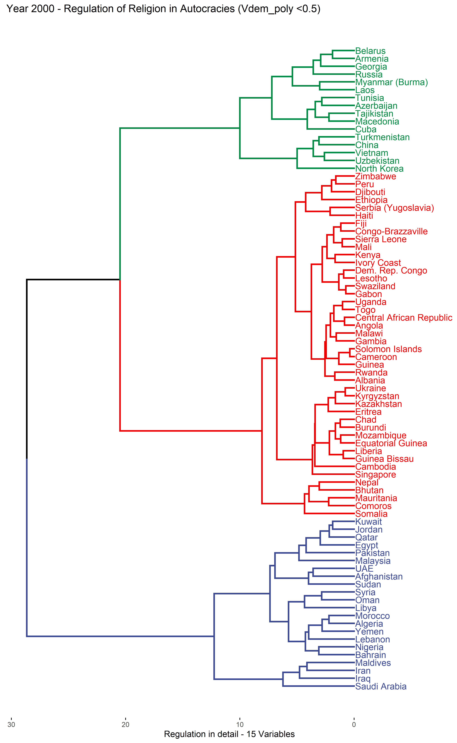
Figure A.4: Cluster mean levels of regulation in 2000: Total level of regulation and government regulation of religion
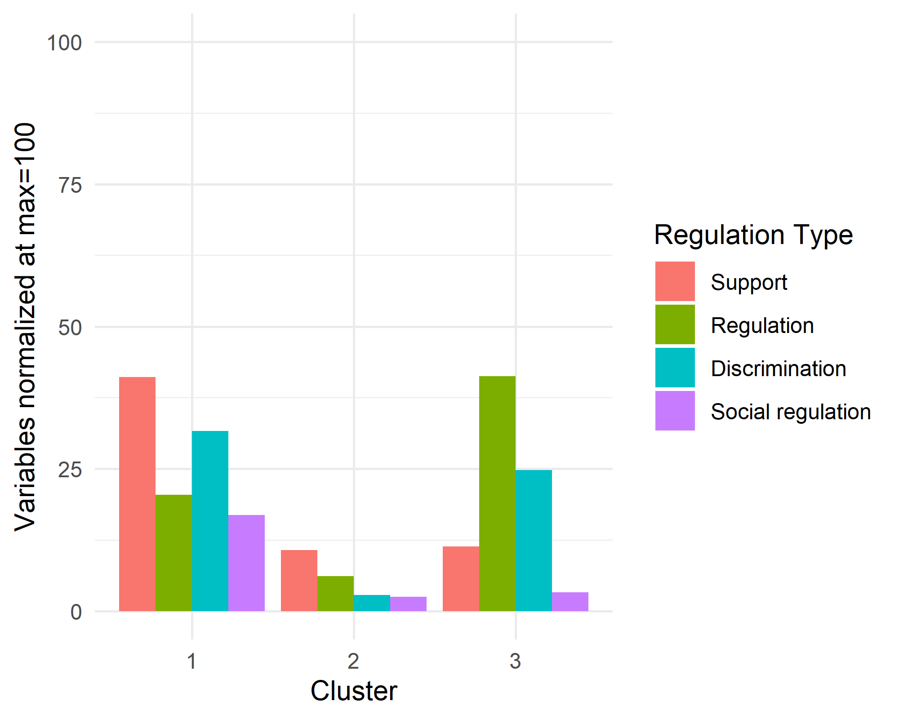 | 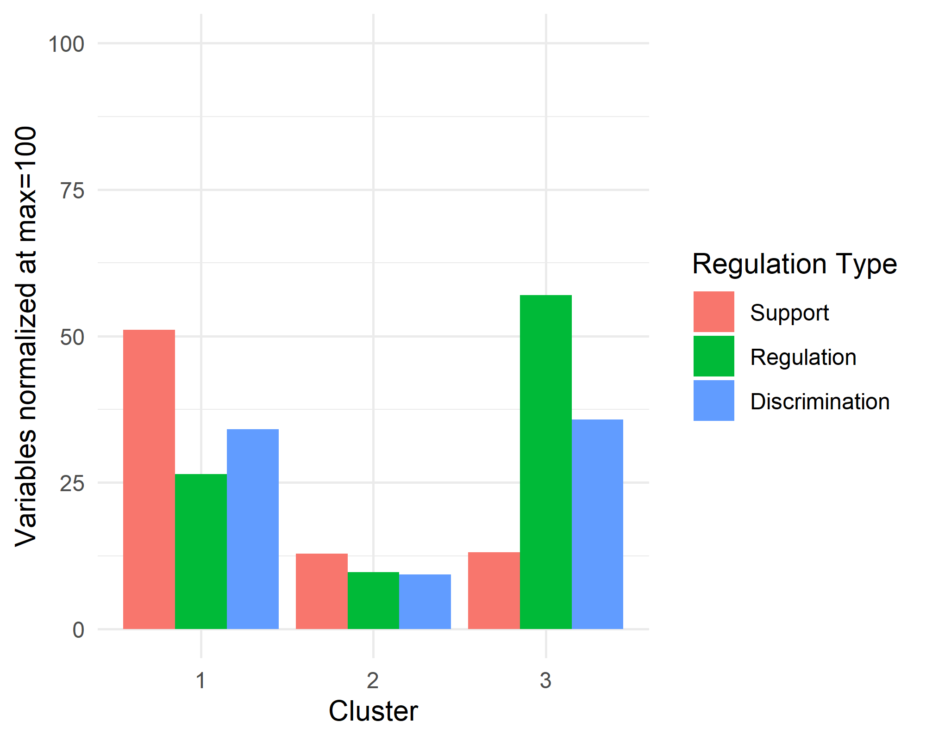
(a) Average level of total regulation | (b) Average level of government regulation

Figure A.5: Cluster mean levels of regulation in 2000: Specific types of regulation
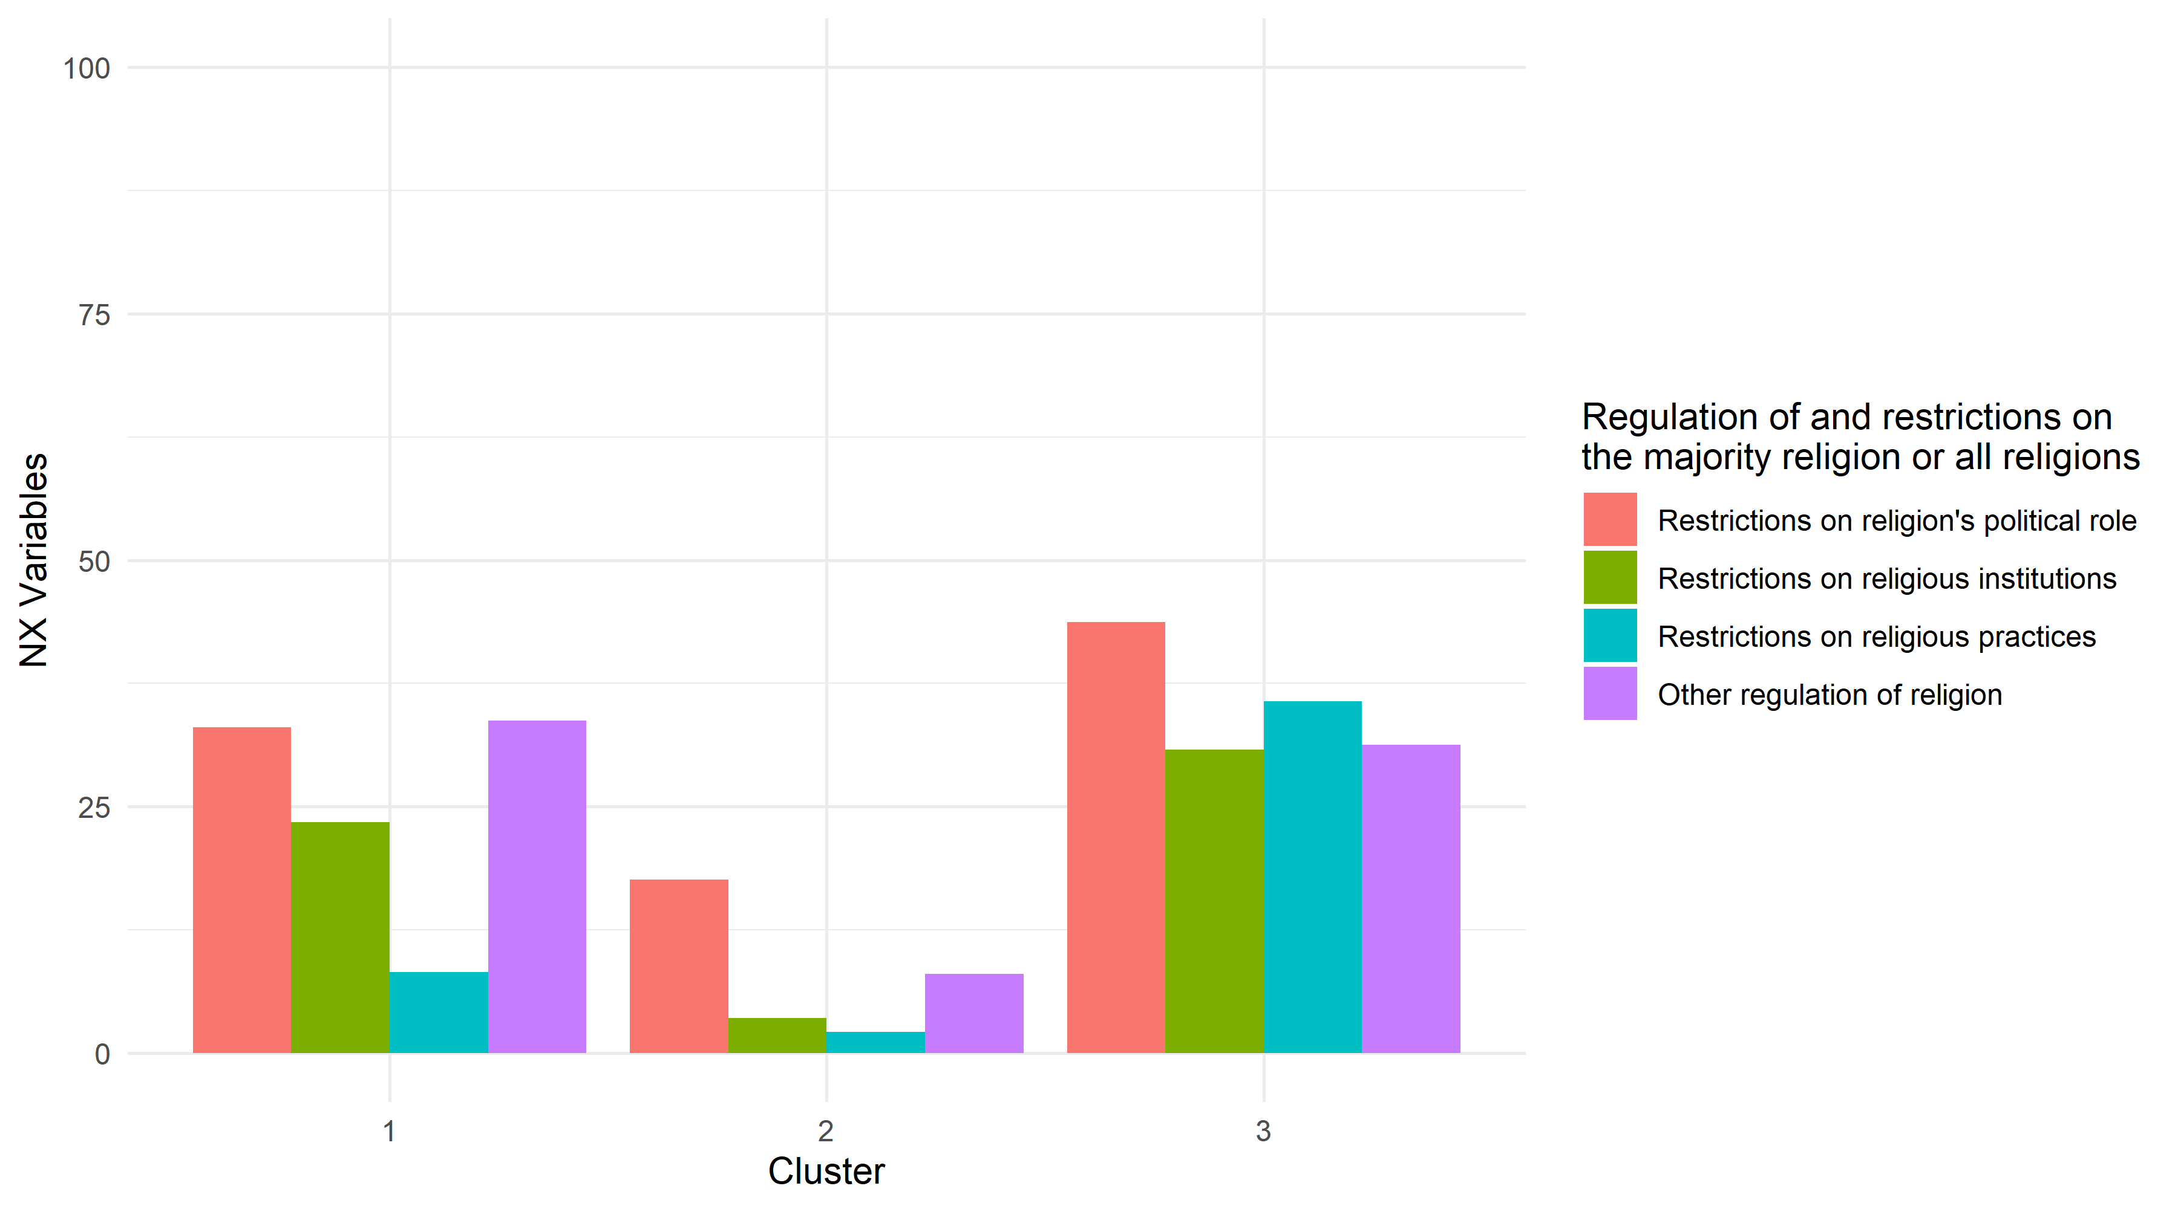
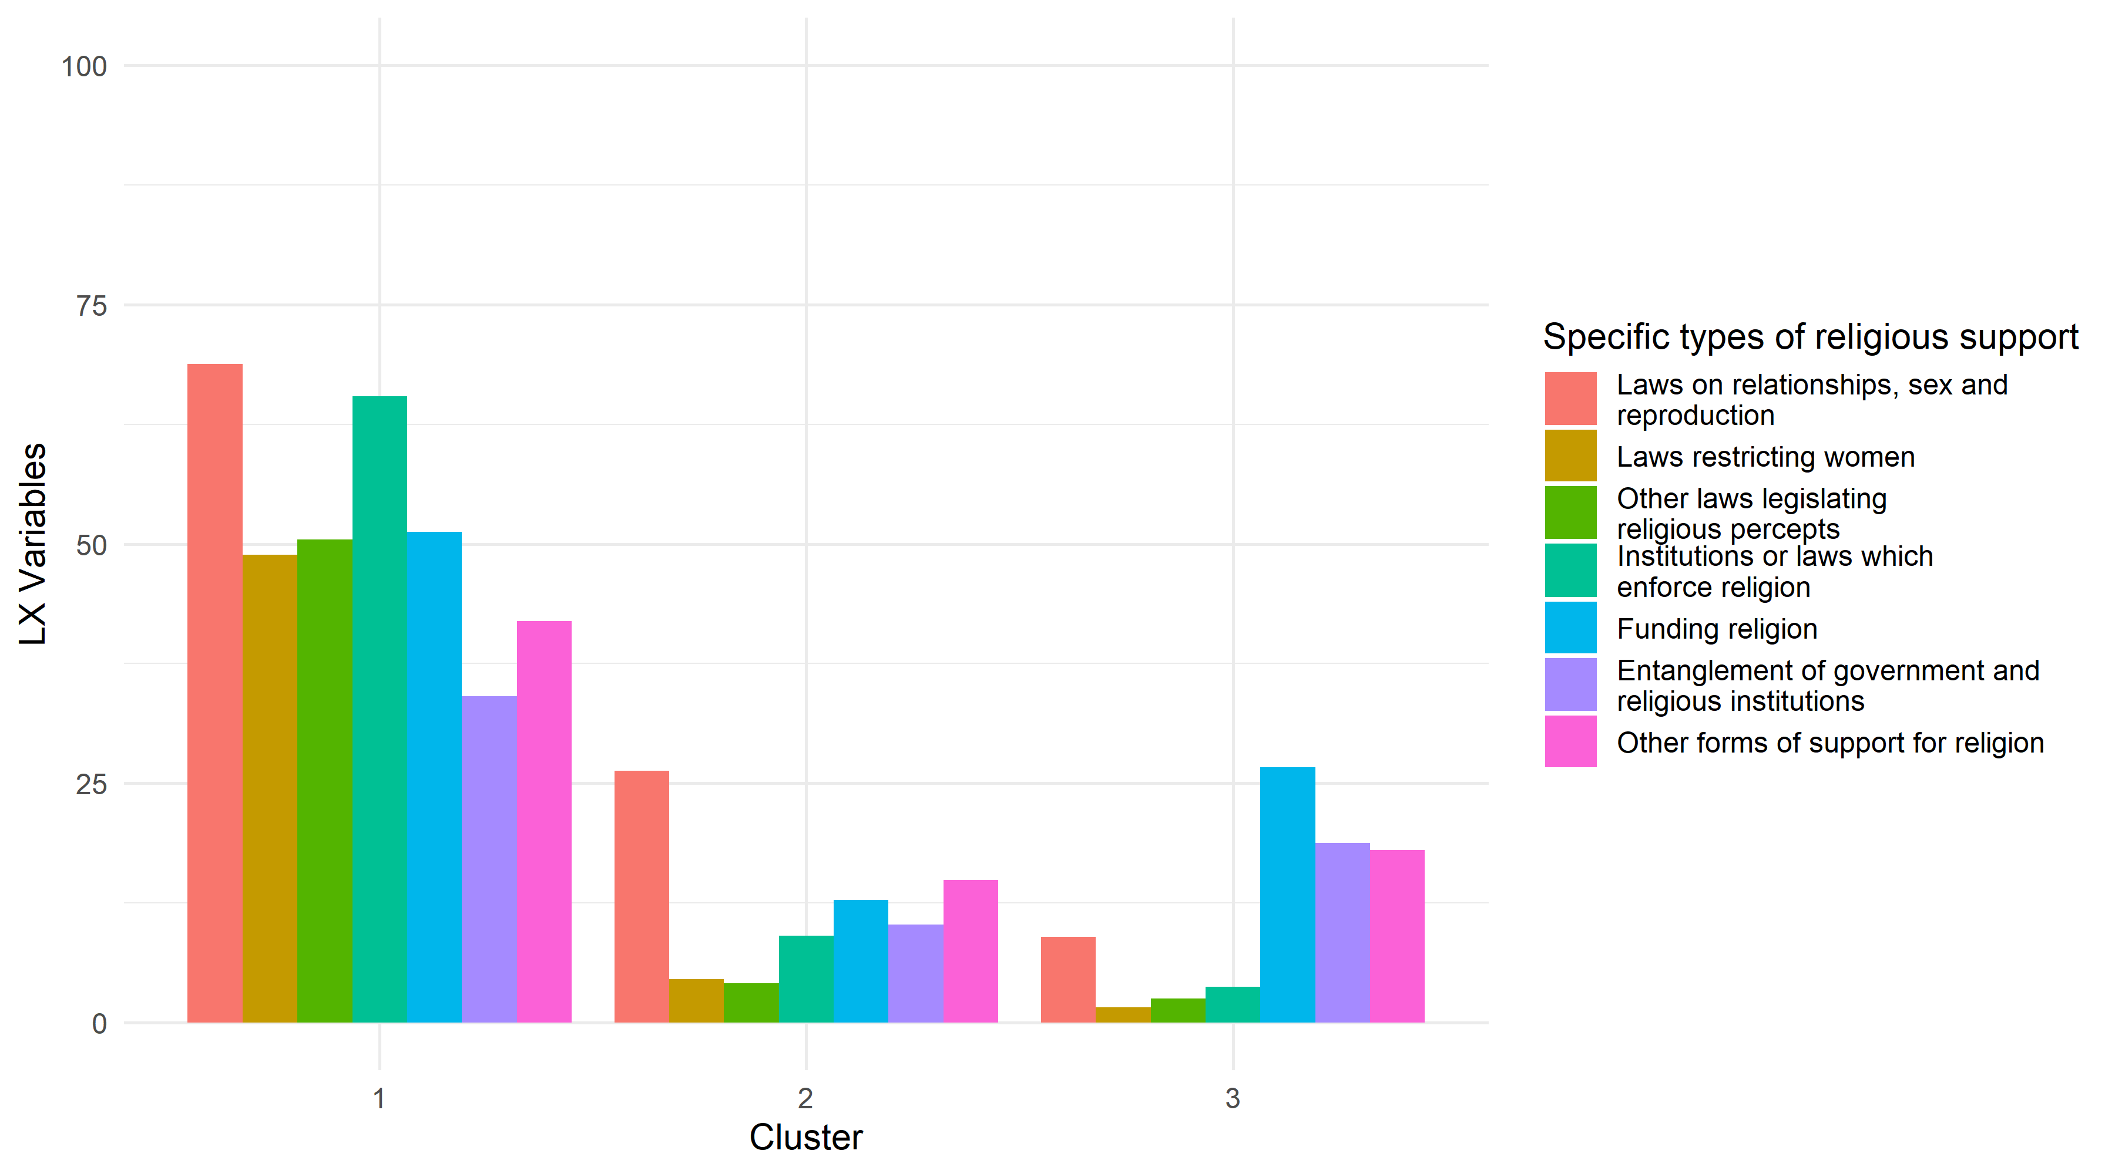
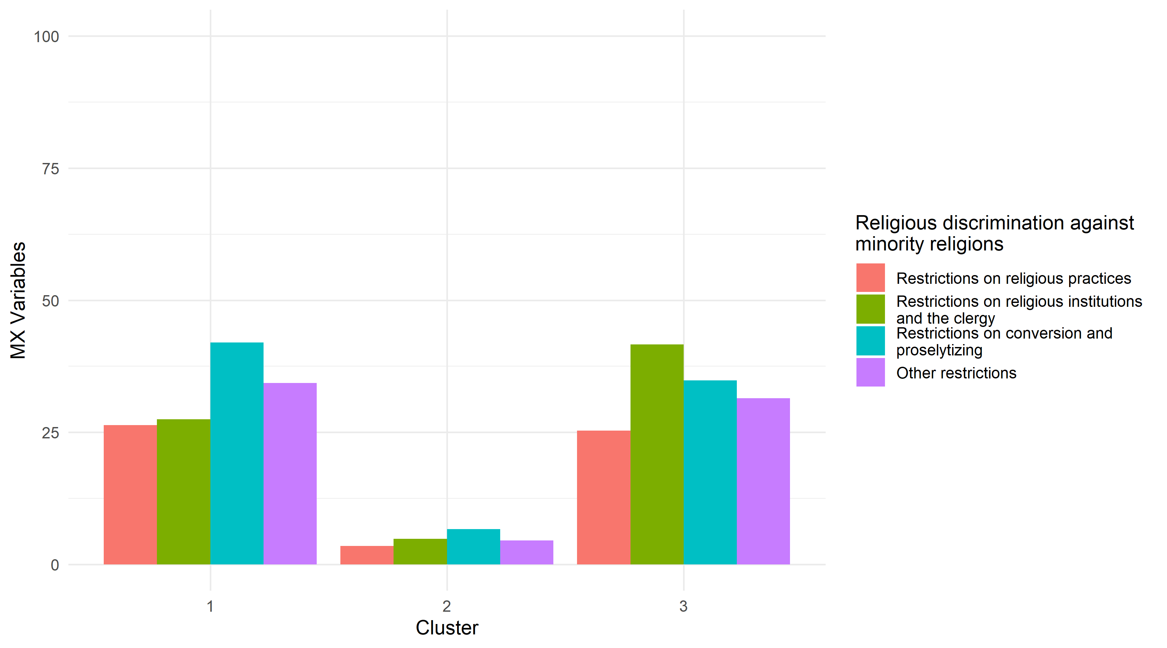

Table A.1: Negative silhouette widths in clustering for total regulation (4-variable clustering) for authoritarian regimes, 2000
Cluster | Neighbor | Silhouette width | Country
1 | 3 | -0.001240241 | Maldives
1 | 2 | -0.042340242 | Georgia
1 | 2 | -0.066990871 | Armenia
1 | 3 | -0.069895380 | Iraq
1 | 2 | -0.086111922 | Morocco
1 | 3 | -0.128657221 | Libya
1 | 2 | -0.158941064 | Lebanon
1 | 3 | -0.160104533 | Laos
1 | 3 | -0.205210583 | Syria
1 | 2 | -0.311664545 | Comoros
1 | 2 | -0.411441267 | Bhutan
1 | 2 | -0.438817472 | Mauritania
1 | 2 | -0.480240580 | Somalia
3 | 2 | -0.009218586 | Macedonia
3 | 2 | -0.305782038 | Kazakhstan
3 | 2 | -0.402797685 | Singapore

Table A.2: Negative silhouette widths in clustering for government regulation of regulation (3-variable clustering) for authoritarian regimes, 2000
Cluster | Neighbor | Silhouette width | Country
1 | 3 | -0.006900544 | Iraq
1 | 3 | -0.170852948 | Myanmar (Burma)
2 | 1 | -0.034284699 | Russia
2 | 1 | -0.040662556 | Laos
2 | 3 | -0.214395328 | Tunisia
2 | 3 | -0.267119762 | Cuba
2 | 3 | -0.330296388 | Azerbaijan

Table A.3: Negative silhouette widths in clustering for specific types of regulation (15-variable clustering) for authoritarian regimes, 2000
Cluster | Neighbor | Silhouette width | Country
1 | 2 | -0.04863662 | Morocco
1 | 2 | -0.09108895 | Lebanon
3 | 2 | -0.10207076 | Armenia
3 | 2 | -0.12090341 | Macedonia
3 | 2 | -0.17501667 | Tajikistan
3 | 2 | -0.26713127 | Georgia

Additional results for 2014 (silhouette widths)
Table A.4: Negative silhouette widths in clustering for total regulation (4-variable clustering) for authoritarian regimes, 2014
Cluster | Neighbor | Silhouette width | Country
3 | 1 | -0.005934121 | Russia
3 | 2 | -0.127476279 | Eritrea
3 | 2 | -0.193990125 | Armenia

Table A.5: Negative silhouette widths in clustering for government regulation of regulation (3-variable clustering) for authoritarian regimes, 2014
Cluster | Neighbor | Silhouette width | Country
1 | 2 | -0.18793119 | Thailand
1 | 2 | -0.30593656 | Somalia
1 | 2 | -0.50231999 | Sri Lanka
3 | 2 | -0.03239305 | Eritrea
3 | 1 | -0.04276982 | Syria
3 | 2 | -0.29560367 | Armenia

Table A.6: Negative silhouette widths in clustering for specific types of regulation (15-variable clustering) for authoritarian regimes, 2014
Cluster | Neighbor | Silhouette width | Country
1 | 2 | -0.02142562 | Mauritania
1 | 2 | -0.13190192 | Somalia
3 | 1 | -0.04538994 | Syria
3 | 2 | -0.07733955 | Eritrea
3 | 2 | -0.19802357 | Armenia

Results for democratic countries

Detailed results for 2000
Regarding the total level of regulation in 2000 (4-variable clustering), the two-cluster solution divides the countries into a cluster of 69 countries with low levels of regulation and 16 countries with high levels of regulation (Figures A.6 and A.9). The silhouette analysis (Table 7 in the paper) shows that the first cluster, despite of its large size, has a quite strong cluster structure. In the second cluster, however, the cluster structure is relatively weak. Further, as many as four countries in cluster 2 (Bangladesh, Denmark, France and Thailand) have negative average silhouette widths (see Table A.7). All this points towards the conclusion that the countries in cluster 2 are not very similar to each other when it comes to regulation of religion. Rather, they are joined together as they are distinguished from the countries in cluster 1 due to higher levels of regulation in at least one of the four regulatory categories.
As for the clustering based on government regulation of religion, the results (Figures A.7 and A.9) are rather similar to the results obtained for clustering with total regulation of religion. The first cluster consists of a majority of the countries (66 countries), has relatively low average levels of regulation (but somewhat elevated levels of support) and strong cluster structure. The second cluster consists of 19 countries with higher average levels of regulation and weak cluster structure. Moreover, four countries in the second cluster (Iceland, Lithuania, Poland and the UK) have negative silhouette widths (Table A.8).
Finally, as to the clustering of the countries based on the 15 sub-categories of regulation, the countries were forced into three clusters based on the results from NbClust (Figures A.8 and A.10). The first cluster consists of 37 countries. The average silhouette width for the cluster is, however, negative and as many as 22 countries have negative silhouette widths (Table A.9). In other words, the cluster is not internally coherent, which renders the interpretation of the cluster mean values as meaningless. Again, it appears that countries, which have somewhat higher levels of regulation in some categories, are clustered together in this cluster. The second cluster consists of 46 countries. The levels of various types of regulation in this cluster are low, although somewhat elevated in the categories of “restrictions on religion’s political role”, “other restrictions of religion”, “funding of religion” and “other forms of support for religion”. Finally, Indonesia and Israel form a cluster of their own, where the levels of regulation in several categories are relatively high.

Figure A.6: Dendrogram of democracies - total regulation, 2000
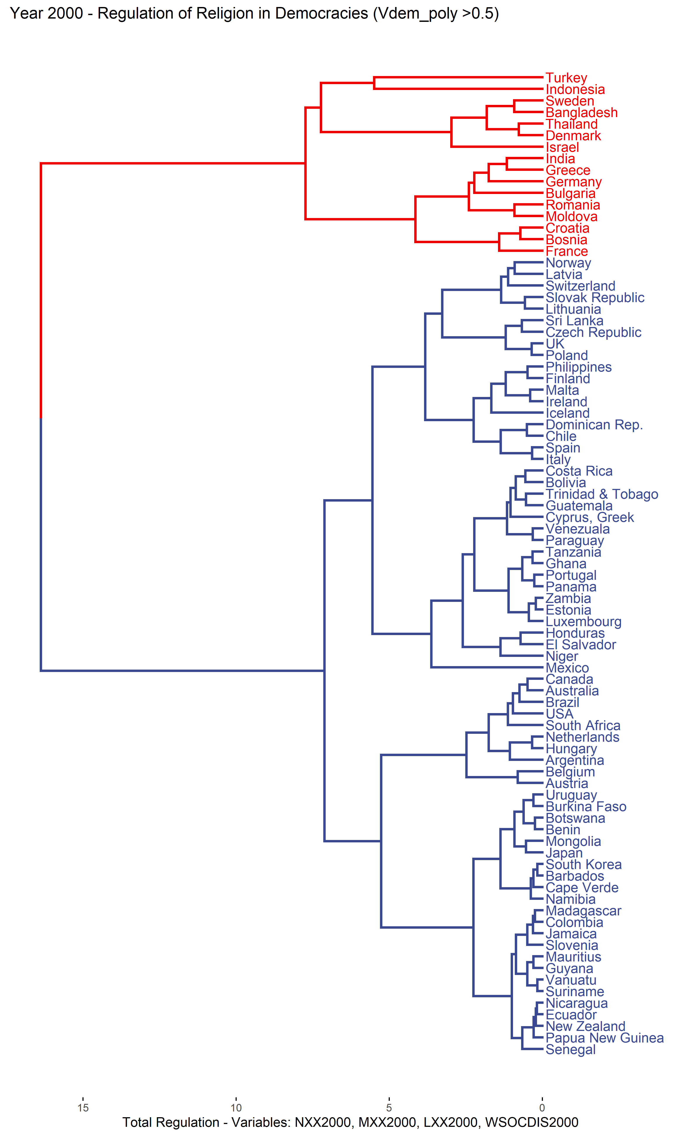
Figure A.7: Dendrogram of democracies - government regulation of religion, 2000
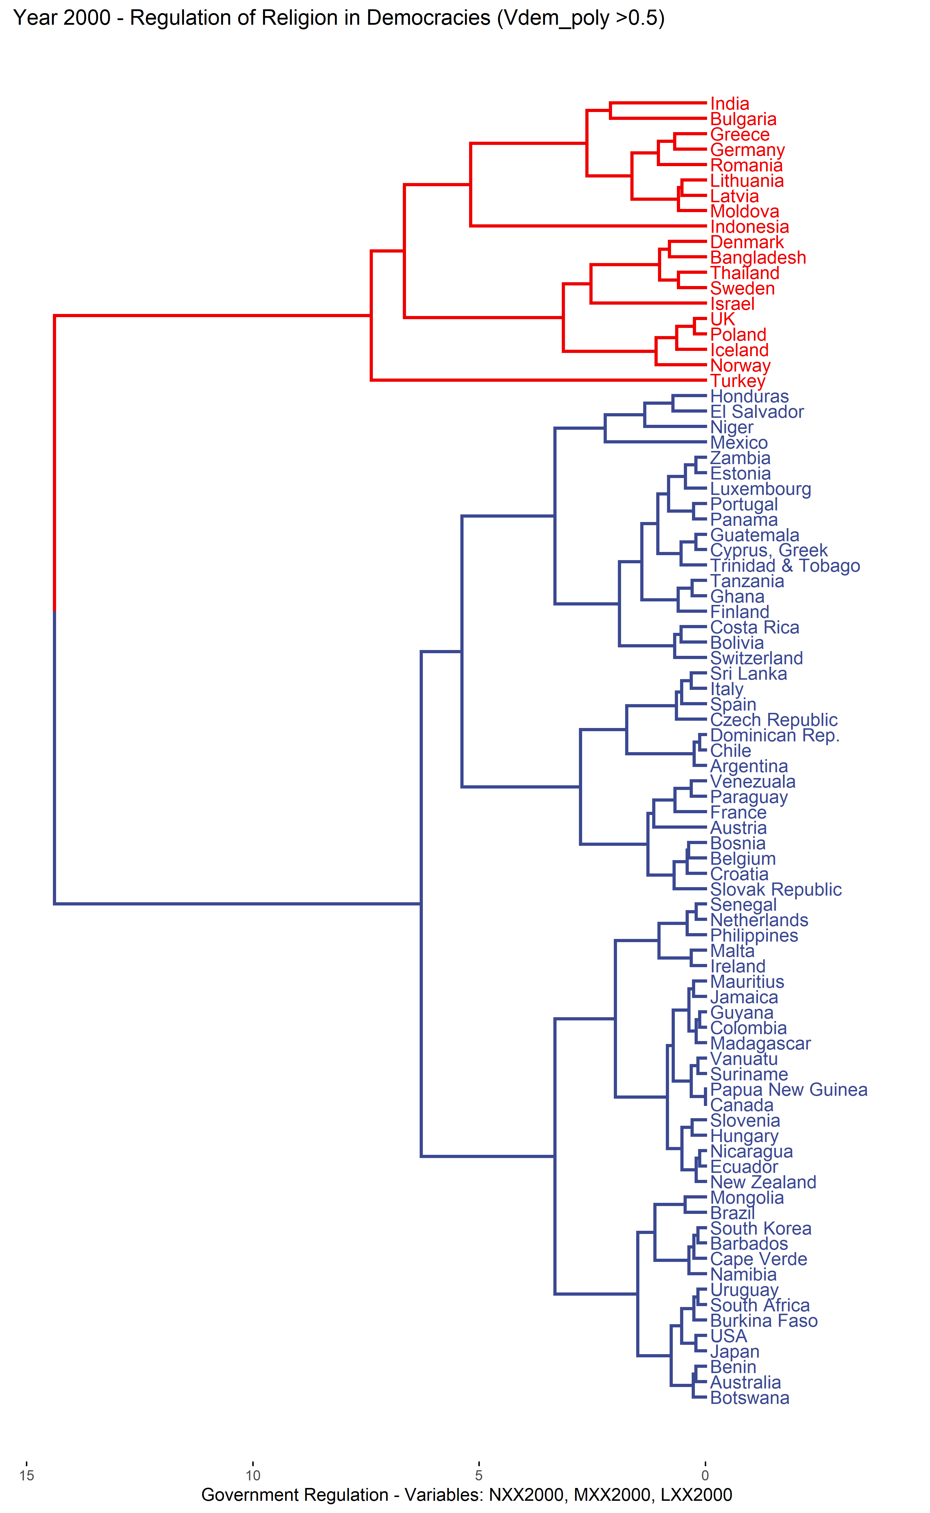

Figure A.8: Dendrogram of democracies – specific types of regulation, 2000
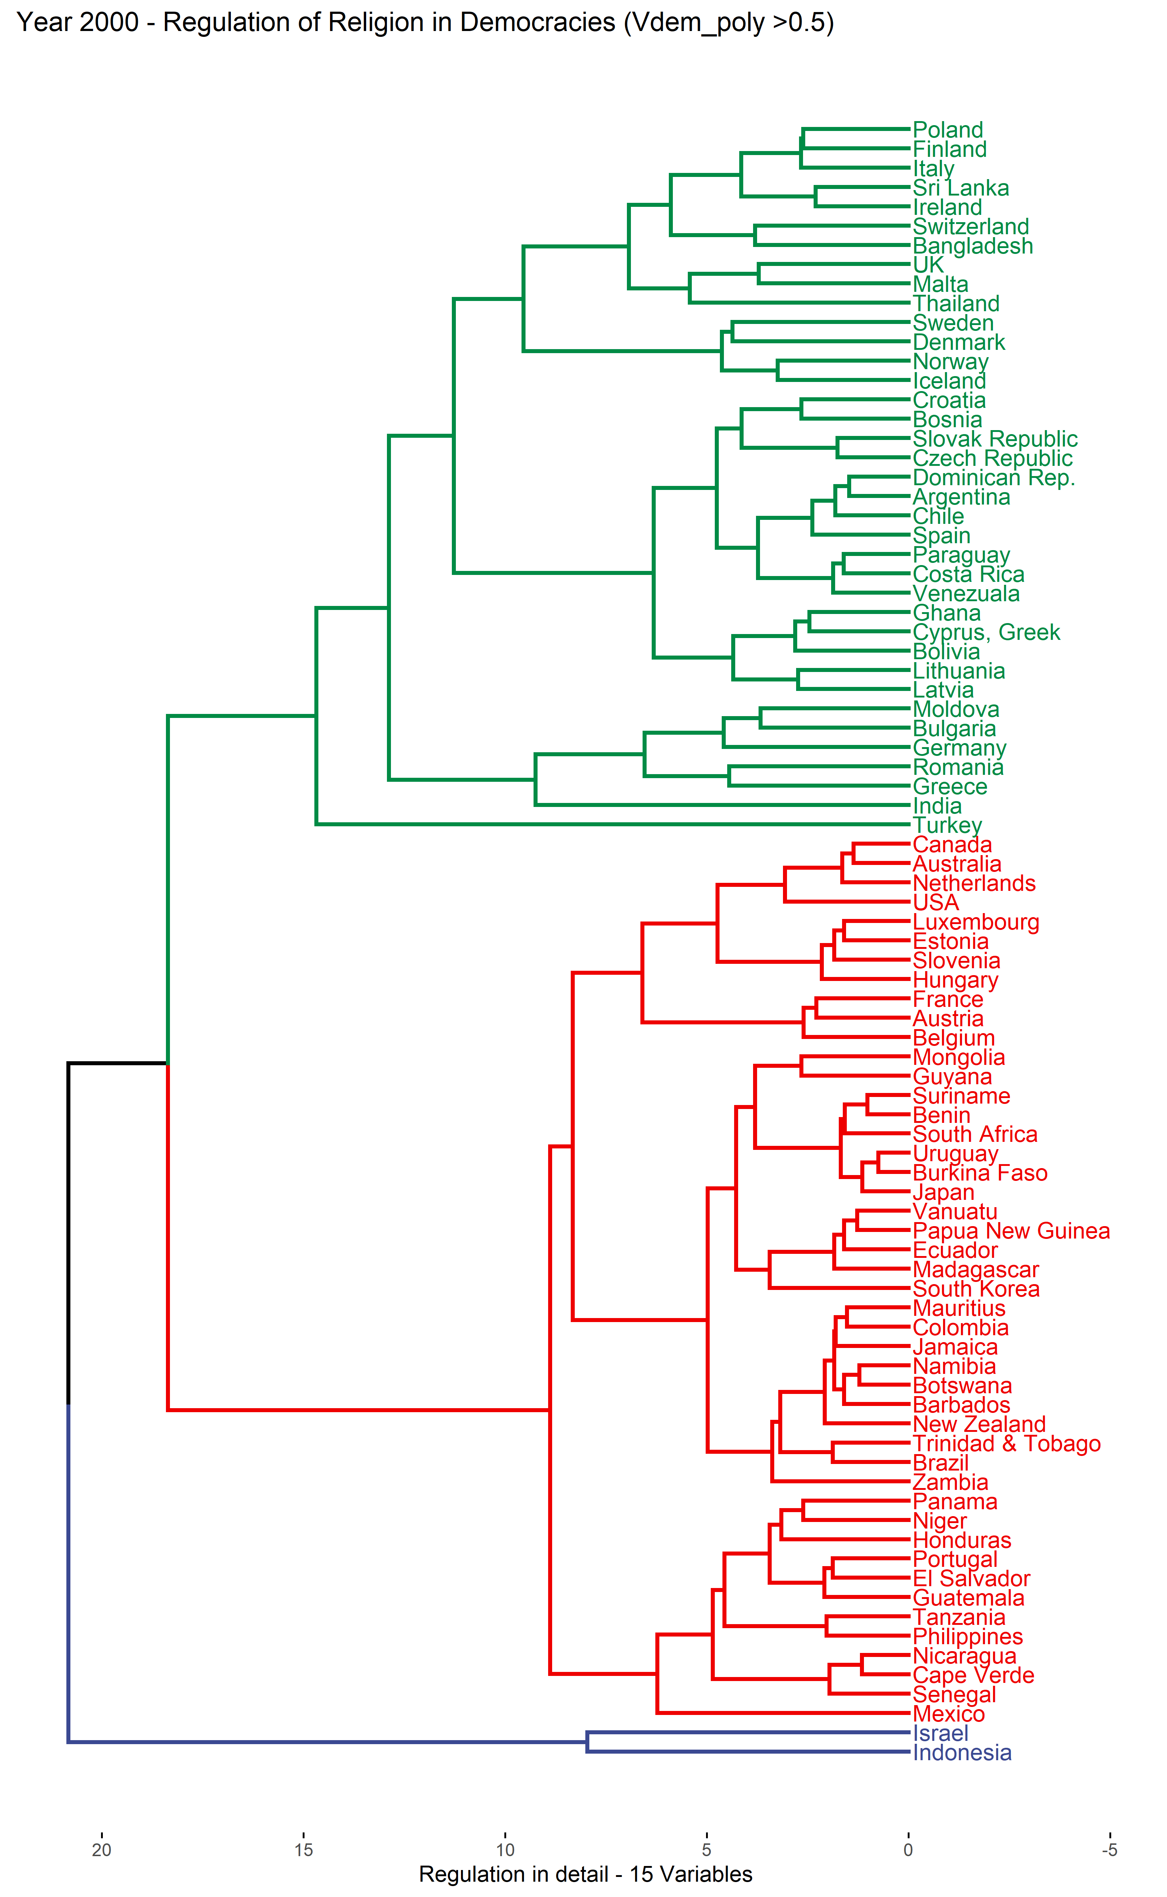
Figure A.9: Cluster mean levels of regulation in 2000: Total level of regulation and government regulation of religion
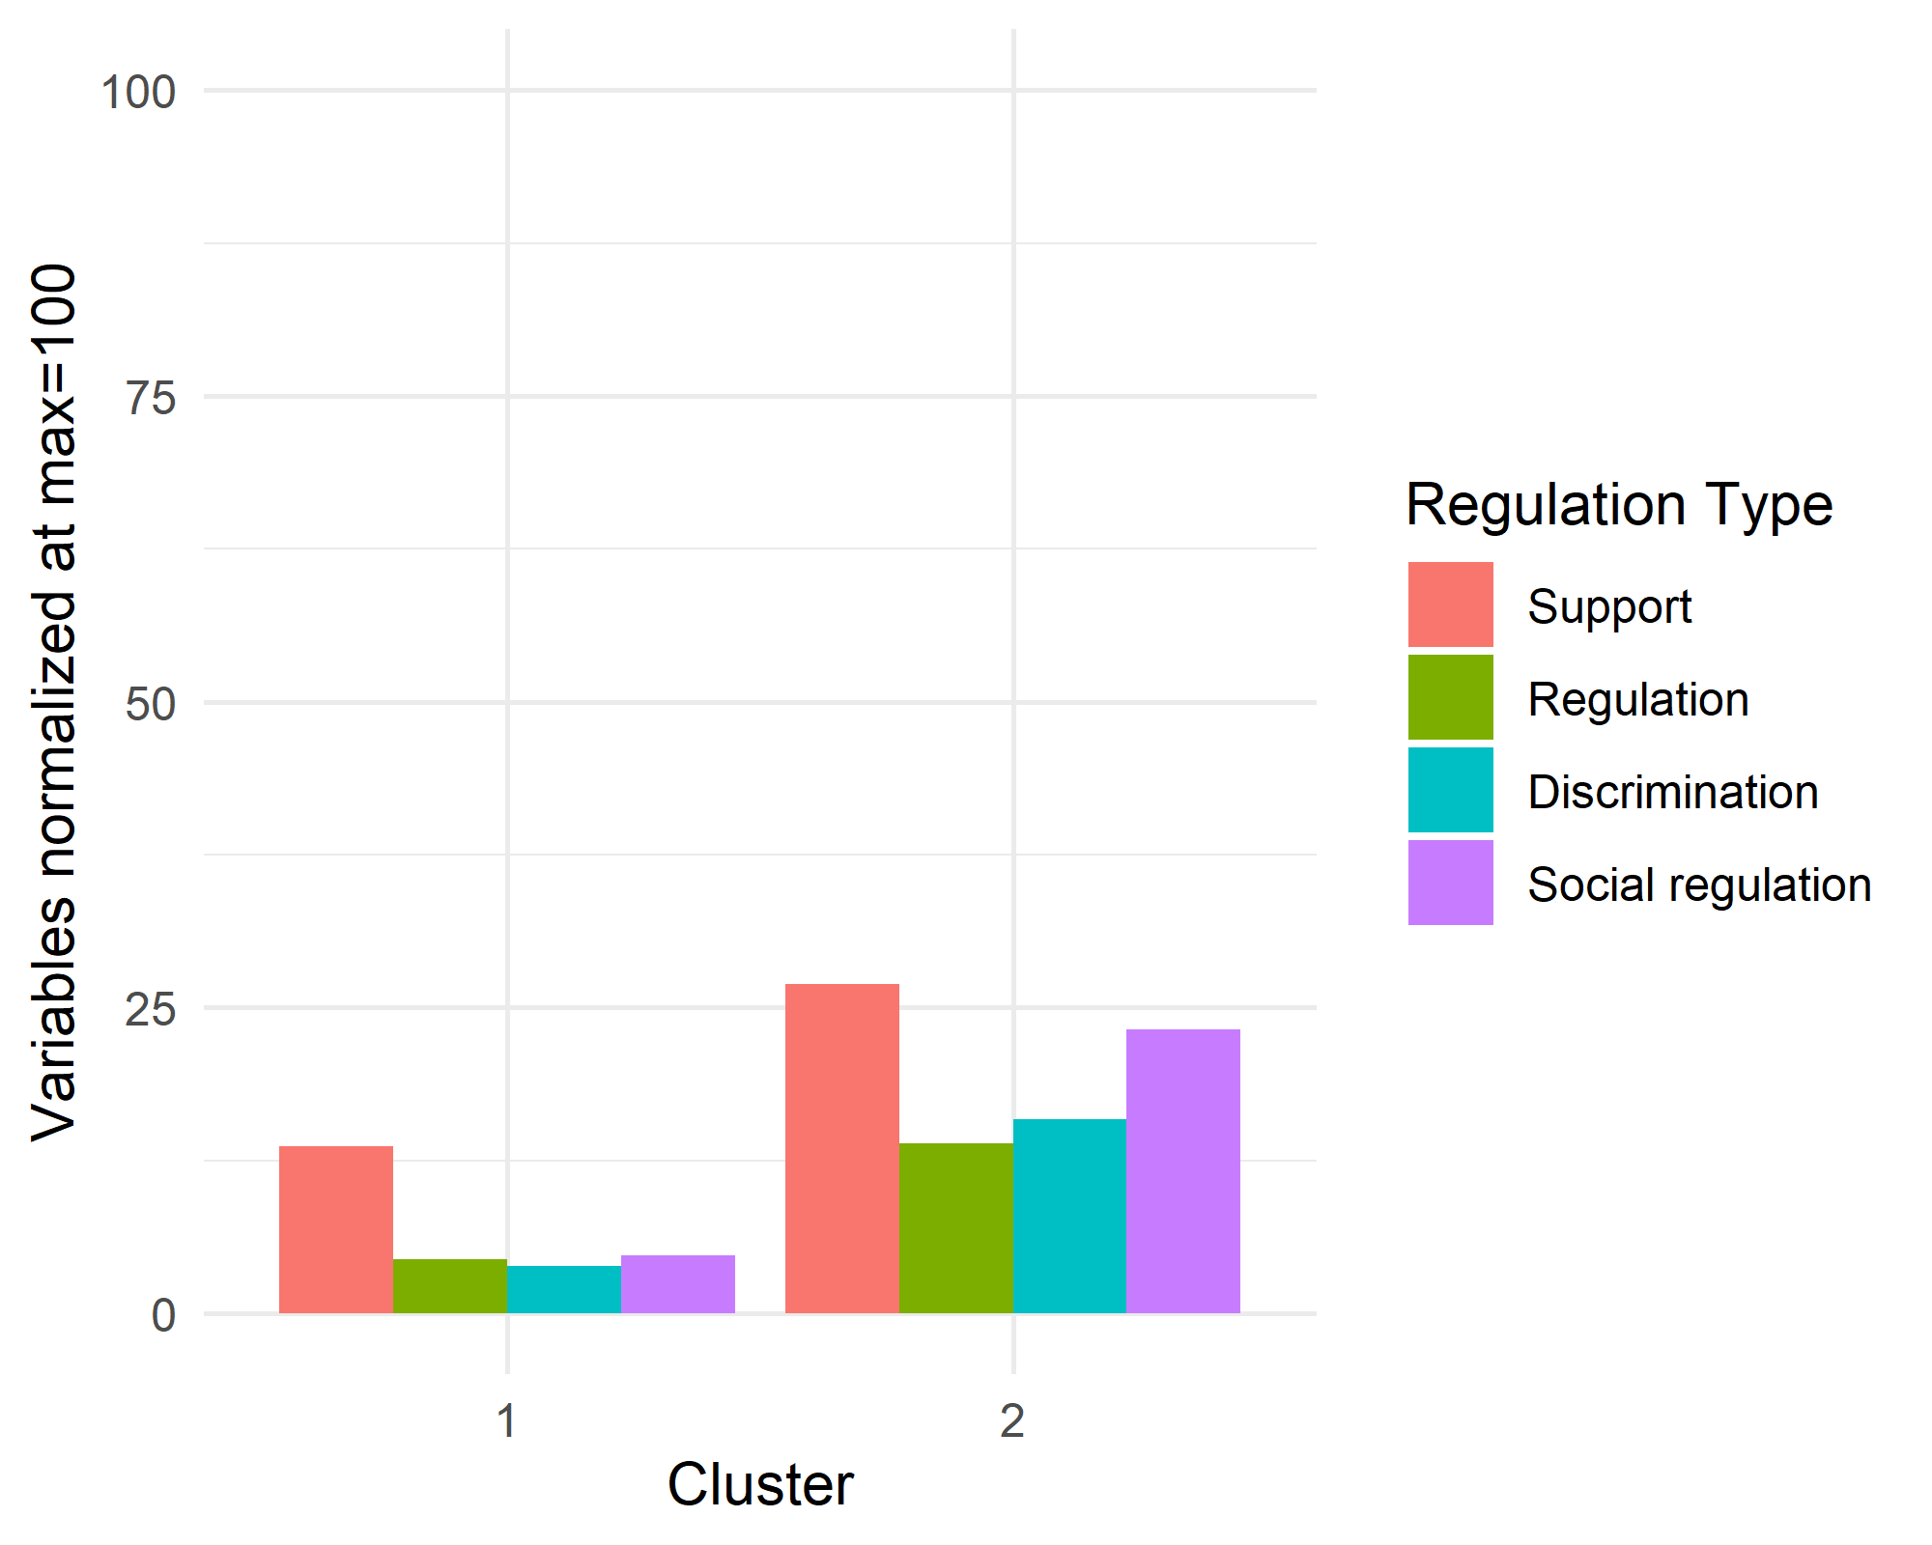 | 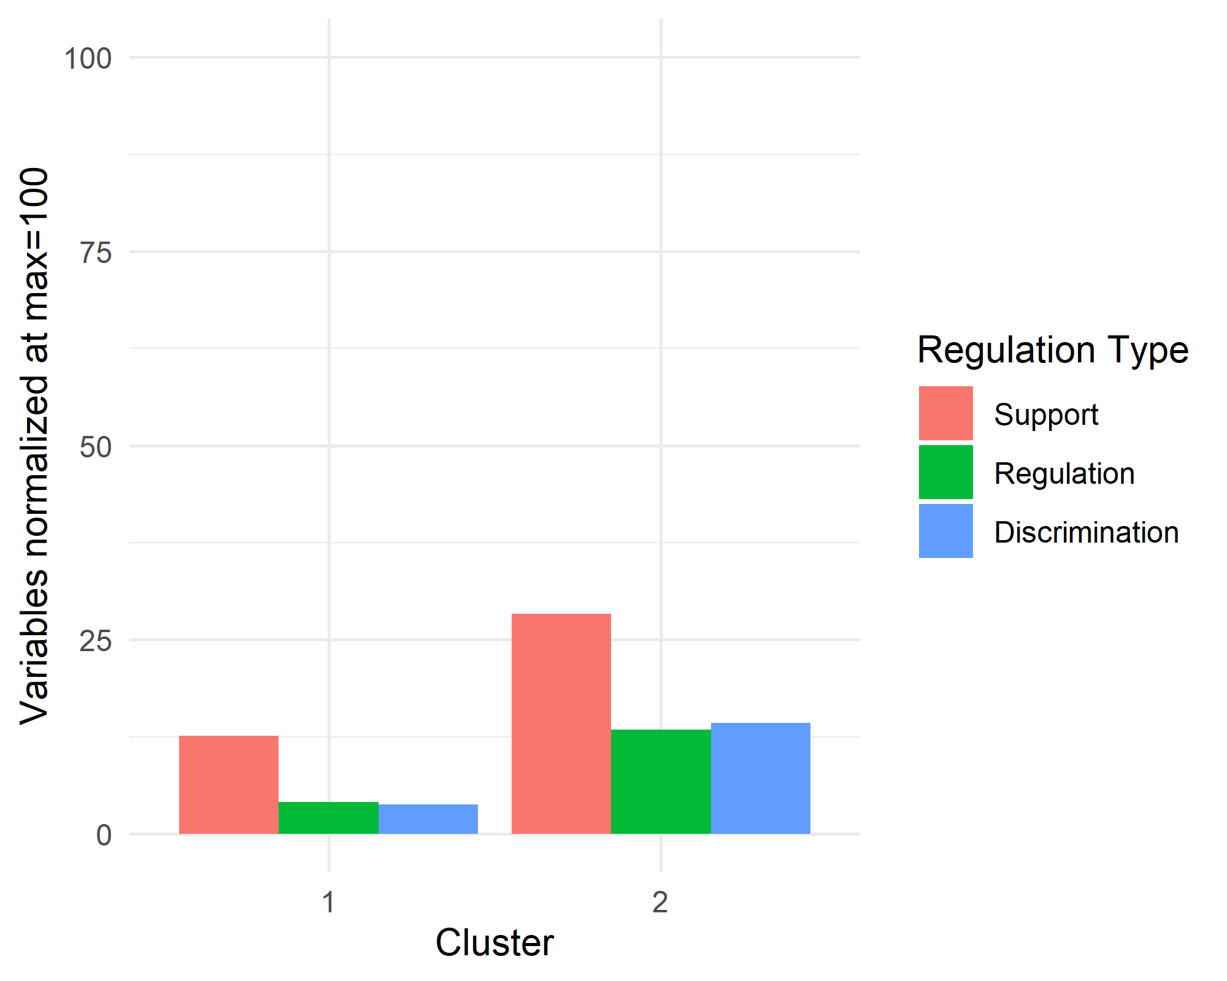
(a) Average level of total regulation | (b) Average level of government regulation

Figure A.10: Cluster mean levels of regulation in 2000: Specific types of regulation
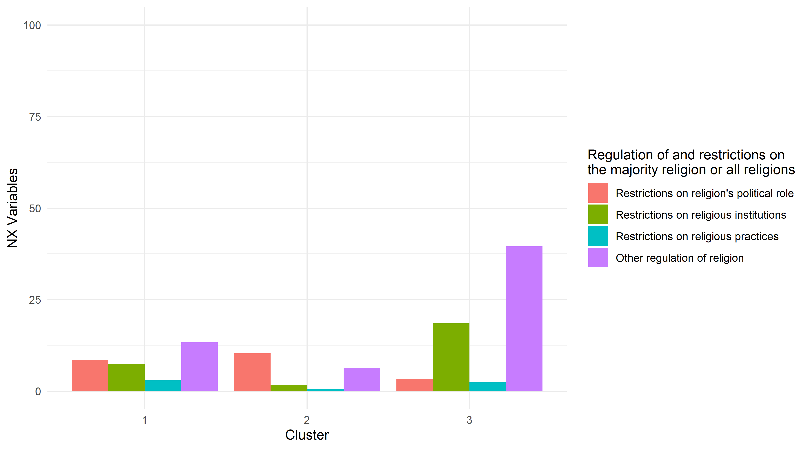
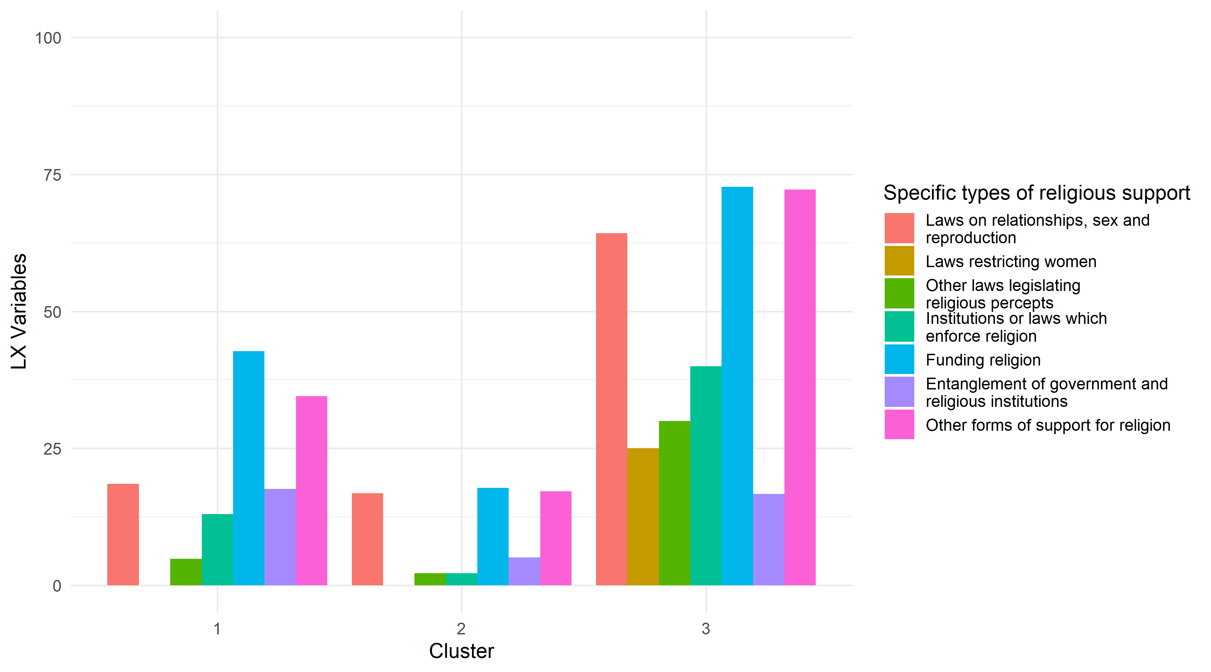
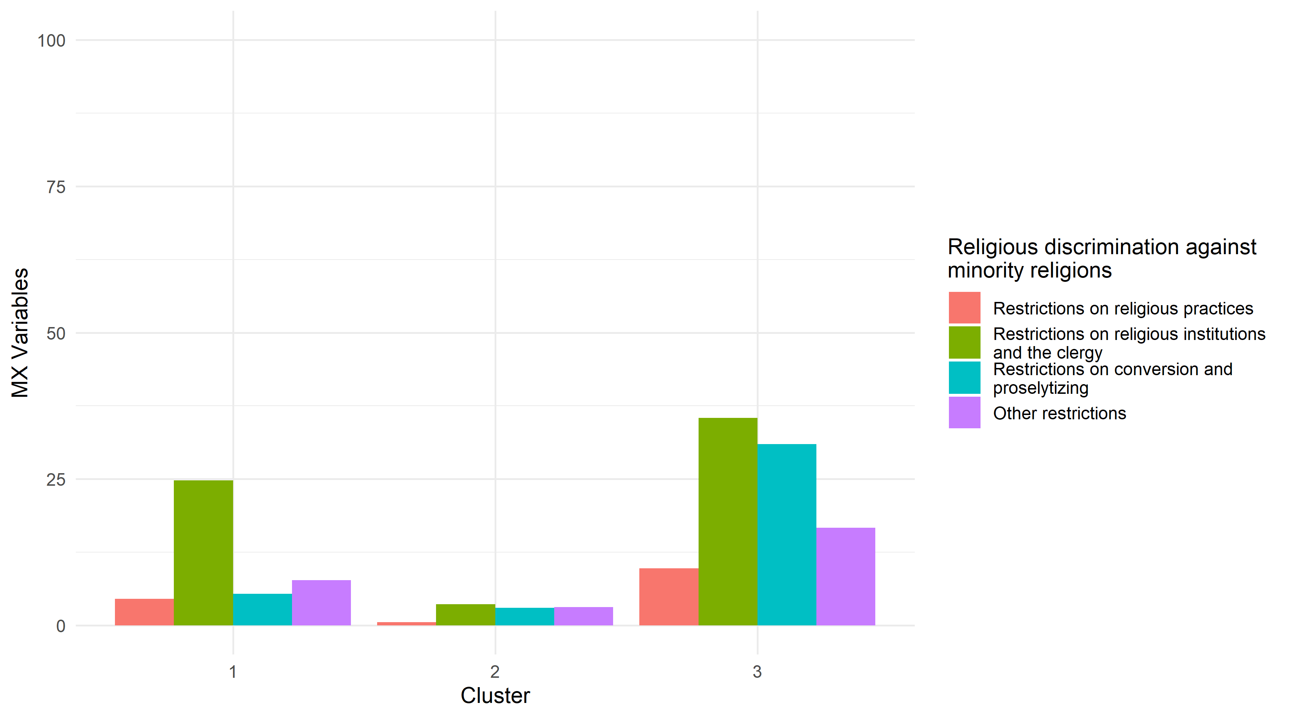

Table A.7: Negative silhouette widths in clustering for total regulation (4-variable clustering) for democratic countries, 2000
Cluster | Neighbor | Silhouette width | Country
2 | 1 | -0.03318646 | France
2 | 1 | -0.07846777 | Bangladesh
2 | 1 | -0.08343938 | Denmark
2 | 1 | -0.12077354 | Thailand

Table A.8: Negative silhouette widths in clustering for government regulation of regulation (3-variable clustering) for democratic countries, 2000
Cluster | Neighbor | Silhouette width | Country
2 | 1 | -0.001691952 | Lithuania
2 | 1 | -0.092776101 | Iceland
2 | 1 | -0.166615444 | Poland
2 | 1 | -0.283598619 | UK

Table A.9: Negative silhouette widths in clustering for specific types of regulation (15-variable clustering) for democratic countries, 2000
Cluster | Neighbor | Silhouette width | Country
1 | 2 | -0.002793097 | Bangladesh
1 | 2 | -0.008849145 | Switzerland
1 | 2 | -0.042697070 | Slovak Republic
1 | 2 | -0.057700278 | Poland
1 | 2 | -0.062290029 | Bosnia
1 | 2 | -0.066224261 | Czech Republic
1 | 2 | -0.067142574 | Bolivia
1 | 2 | -0.080413711 | Croatia
1 | 2 | -0.121739318 | Italy
1 | 2 | -0.133985626 | Malta
1 | 2 | -0.159775664 | Paraguay
1 | 2 | -0.170004891 | Spain
1 | 2 | -0.189068669 | Venezuala
1 | 2 | -0.210443240 | Cyprus, Greek
1 | 2 | -0.220364650 | Costa Rica
1 | 2 | -0.221584741 | Sri Lanka
1 | 2 | -0.225204876 | Finland
1 | 2 | -0.238326026 | Ireland
1 | 2 | -0.245157898 | Ghana
1 | 2 | -0.284728540 | Argentina
1 | 2 | -0.344793060 | Chile
1 | 2 | -0.356681291 | Dominican Rep.

Additional results for 2014 (silhouette widths)

Table A.10: Negative silhouette widths in clustering for total regulation (4-variable clustering) for democratic countries, 2014
Cluster | Neighbor | Silhouette width | Country
2 | 1 | -0.02039925 | Mexico
2 | 1 | -0.10609271 | Sweden
2 | 1 | -0.12253642 | Czech Republic
2 | 1 | -0.32868812 | Poland

Table A.11: Negative silhouette widths in clustering for government regulation of regulation (3-variable clustering) for democratic countries, 2014
Cluster | Neighbor | Silhouette width | Country
2 | 1 | -0.02503065 | Mexico
2 | 1 | -0.03148938 | Lebanon
2 | 1 | -0.13524076 | Bosnia
2 | 1 | -0.18771522 | France
2 | 1 | -0.31572543 | Niger

Table A.12: Negative silhouette widths in clustering for specific types of regulation (15-variable clustering) for democratic countries, 2014
Cluster | Neighbor | Silhouette width | Country
2 | 1 | -0.022063607 | Bolivia
2 | 1 | -0.090786524 | Cyprus, Greek
2 | 1 | -0.093293454 | Belgium
2 | 1 | -0.139353226 | Spain
2 | 1 | -0.147221599 | Ghana
2 | 1 | -0.195491893 | South Korea
3 | 2 | -0.002164984 | Comoros
3 | 1 | -0.006156911 | Lebanon
3 | 2 | -0.042535540 | Tunisia
3 | 2 | -0.129024287 | Bhutan
3 | 2 | -0.162259996 | Israel

Specific type of regulation in 2014
Figure A.11: Dendrogram of autocracies – specific types of regulation, 2014
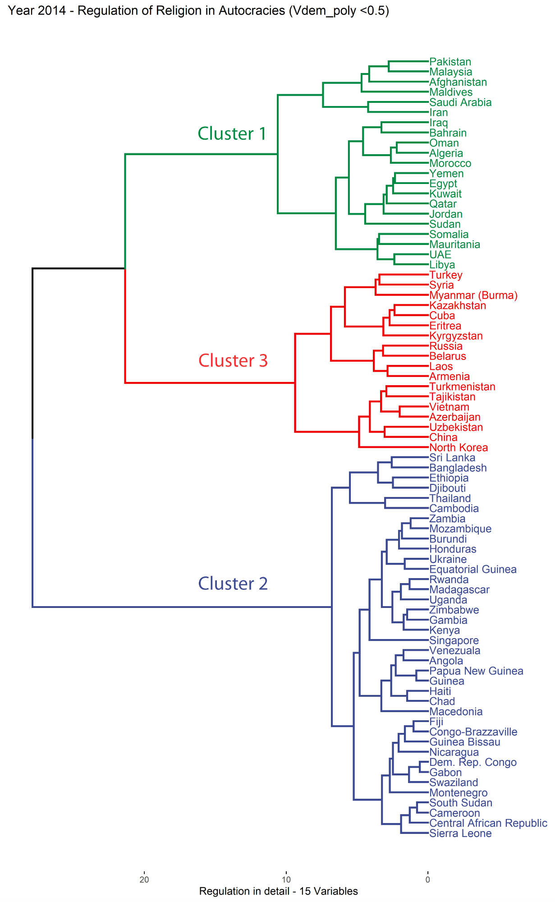
Figure A.12: Cluster mean levels of regulation in 2014: Specific types of regulation in authoritarian regimes
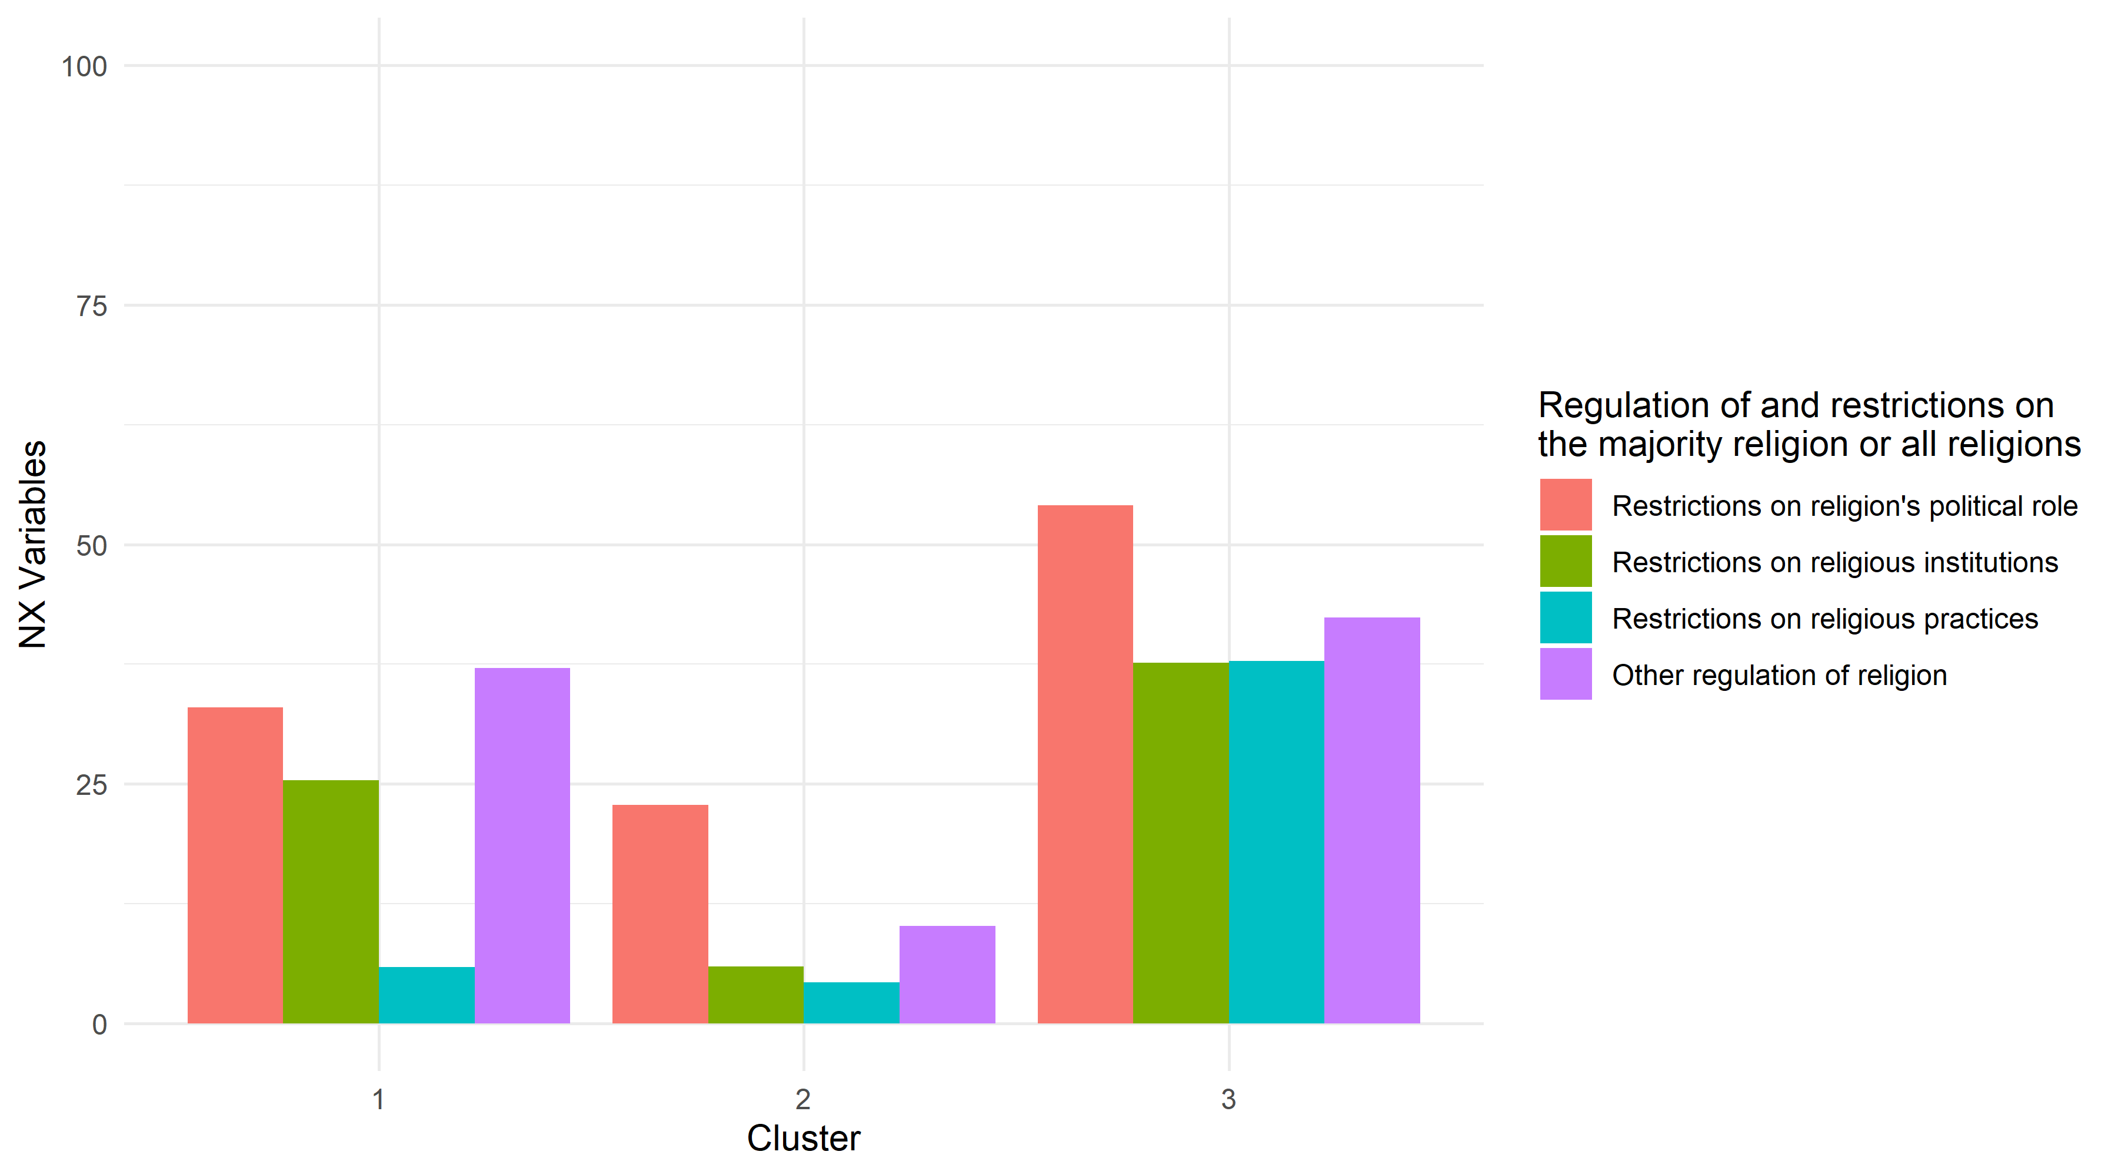
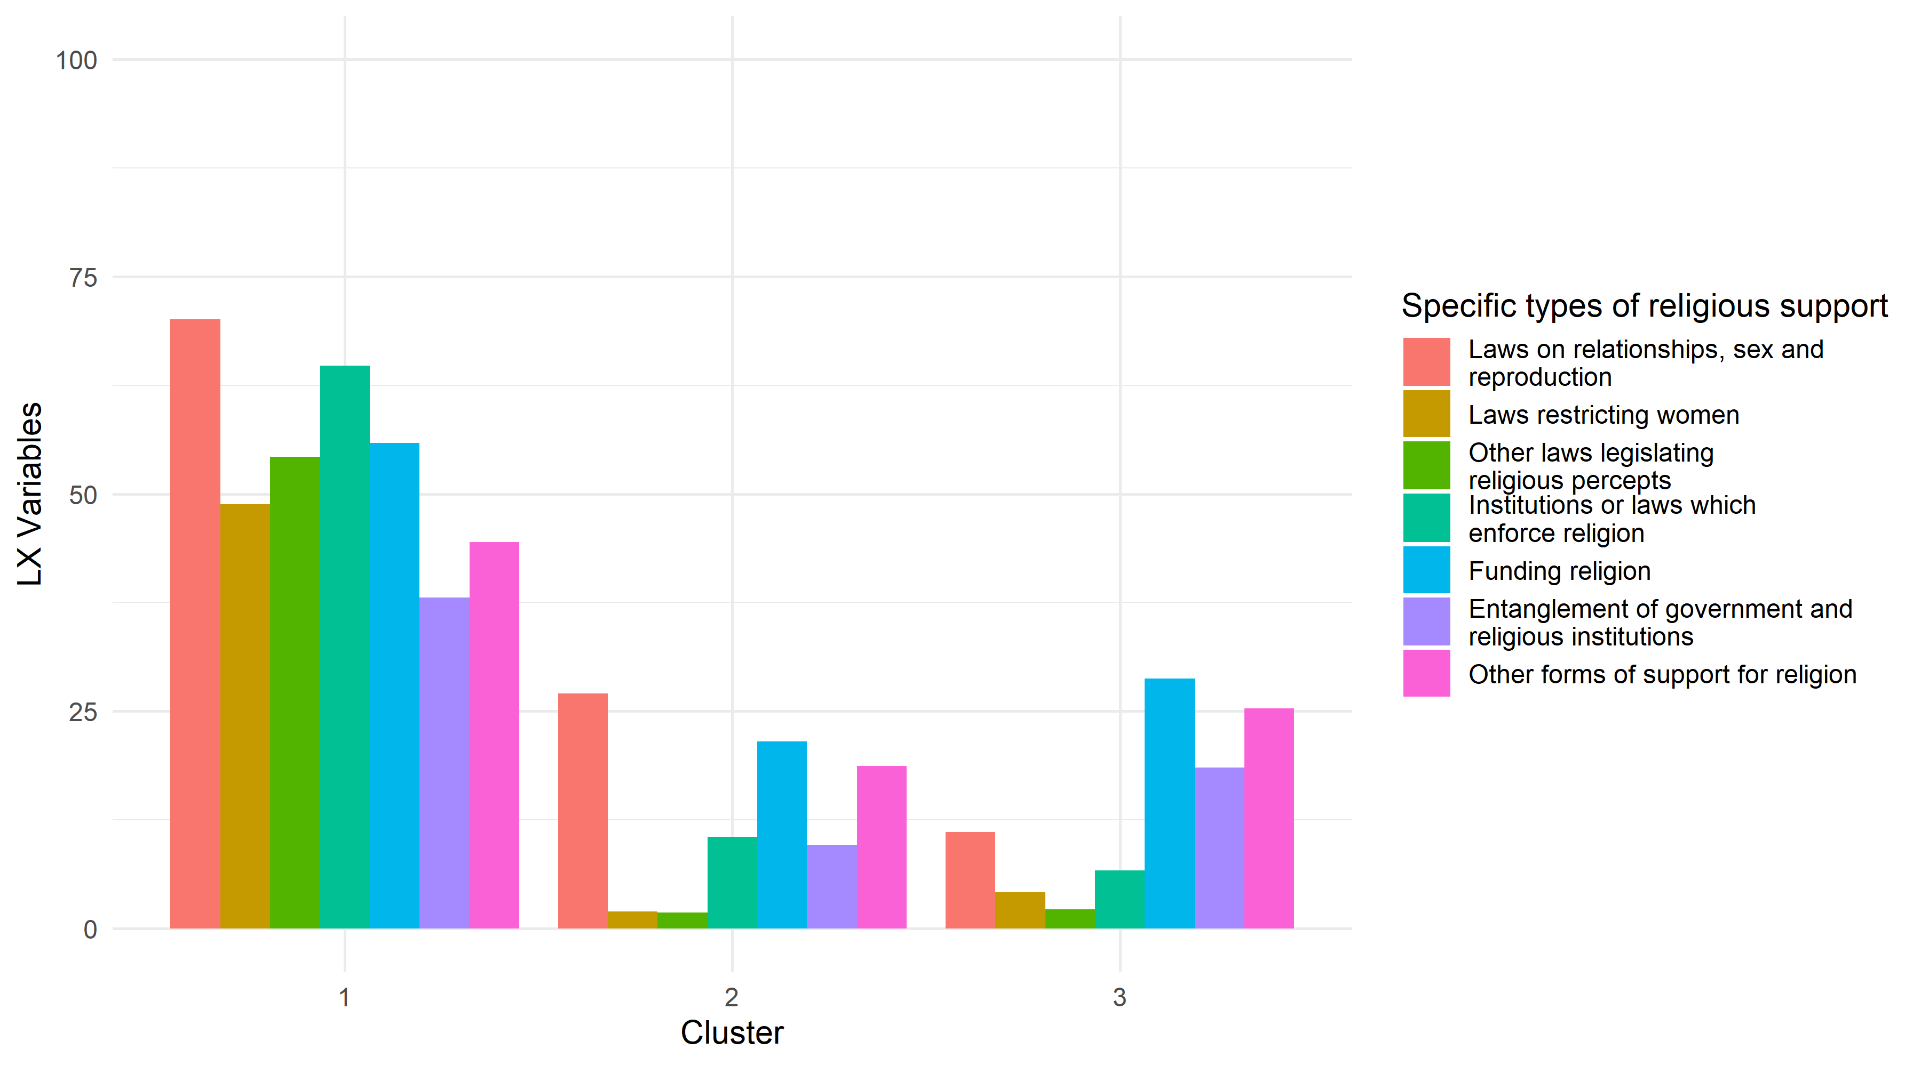
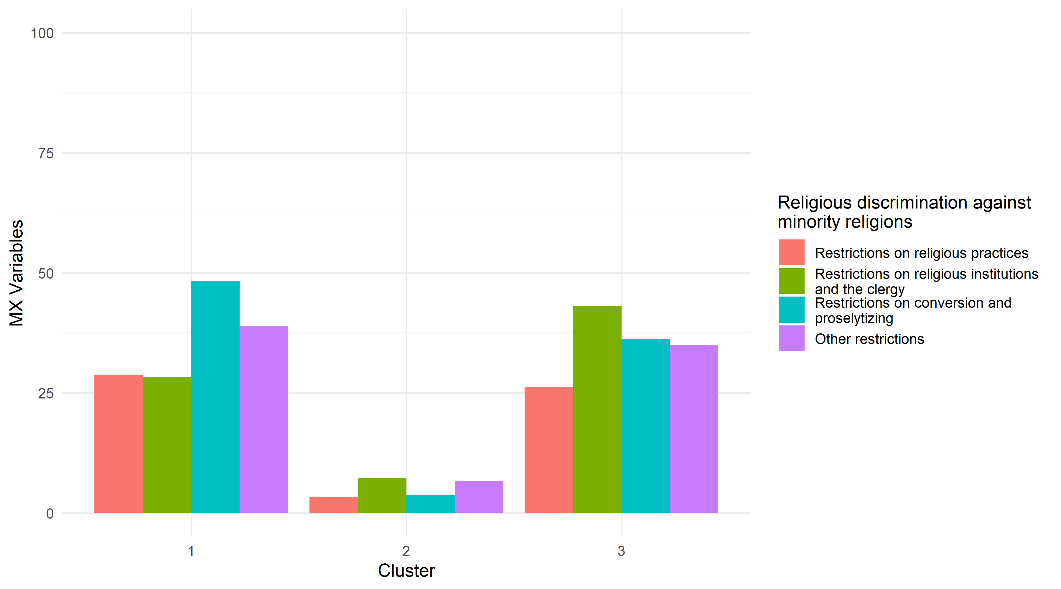

Figure A.13: Dendrogram of democracies – specific types of regulation, 2014 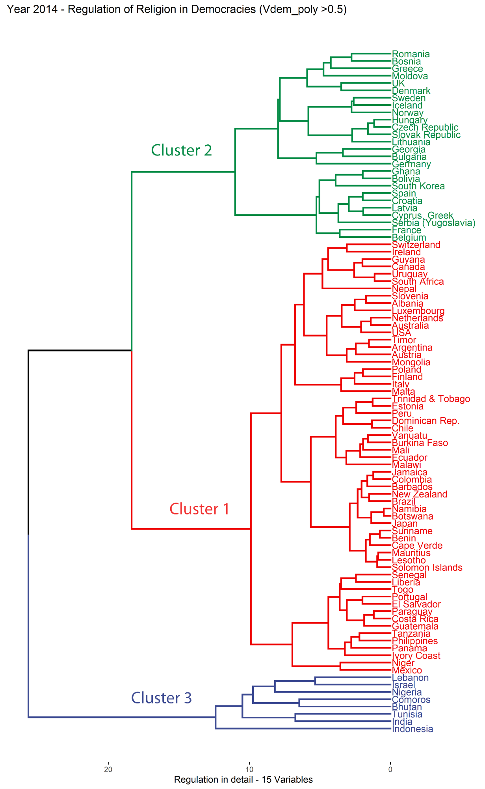
Figure A.14: Cluster mean levels of regulation in 2014: Specific types of regulation in democratic countries
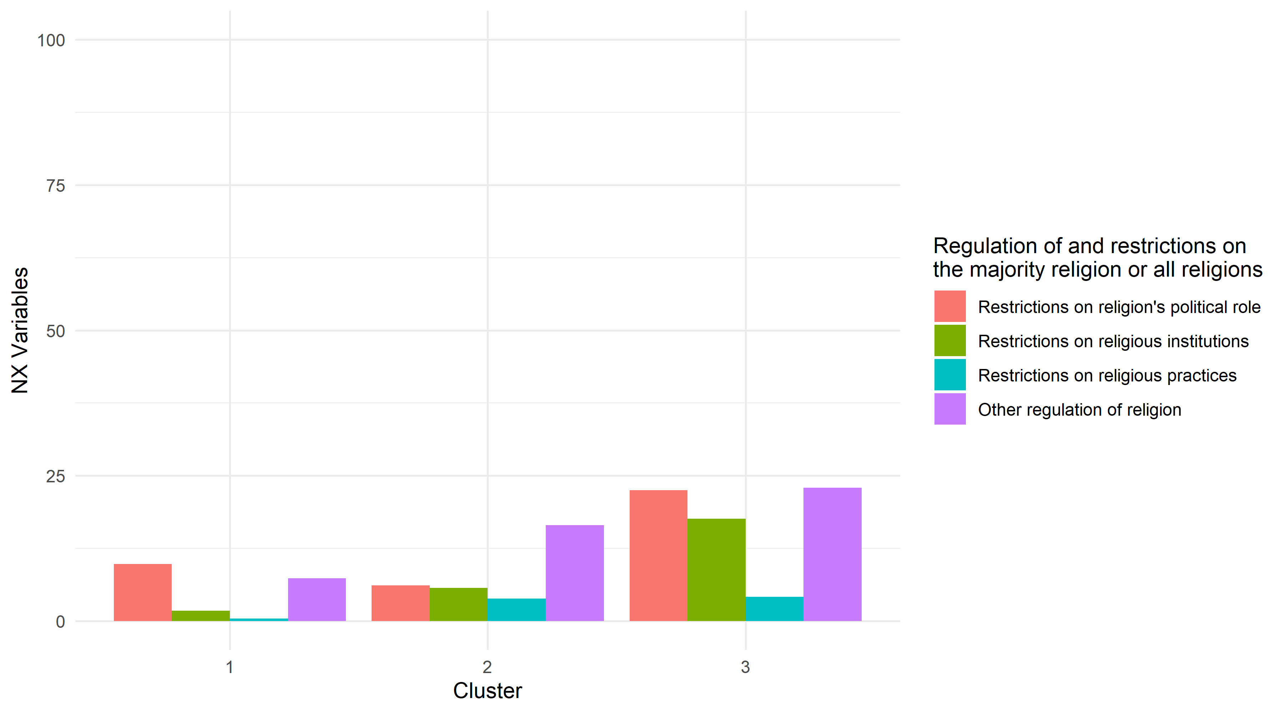
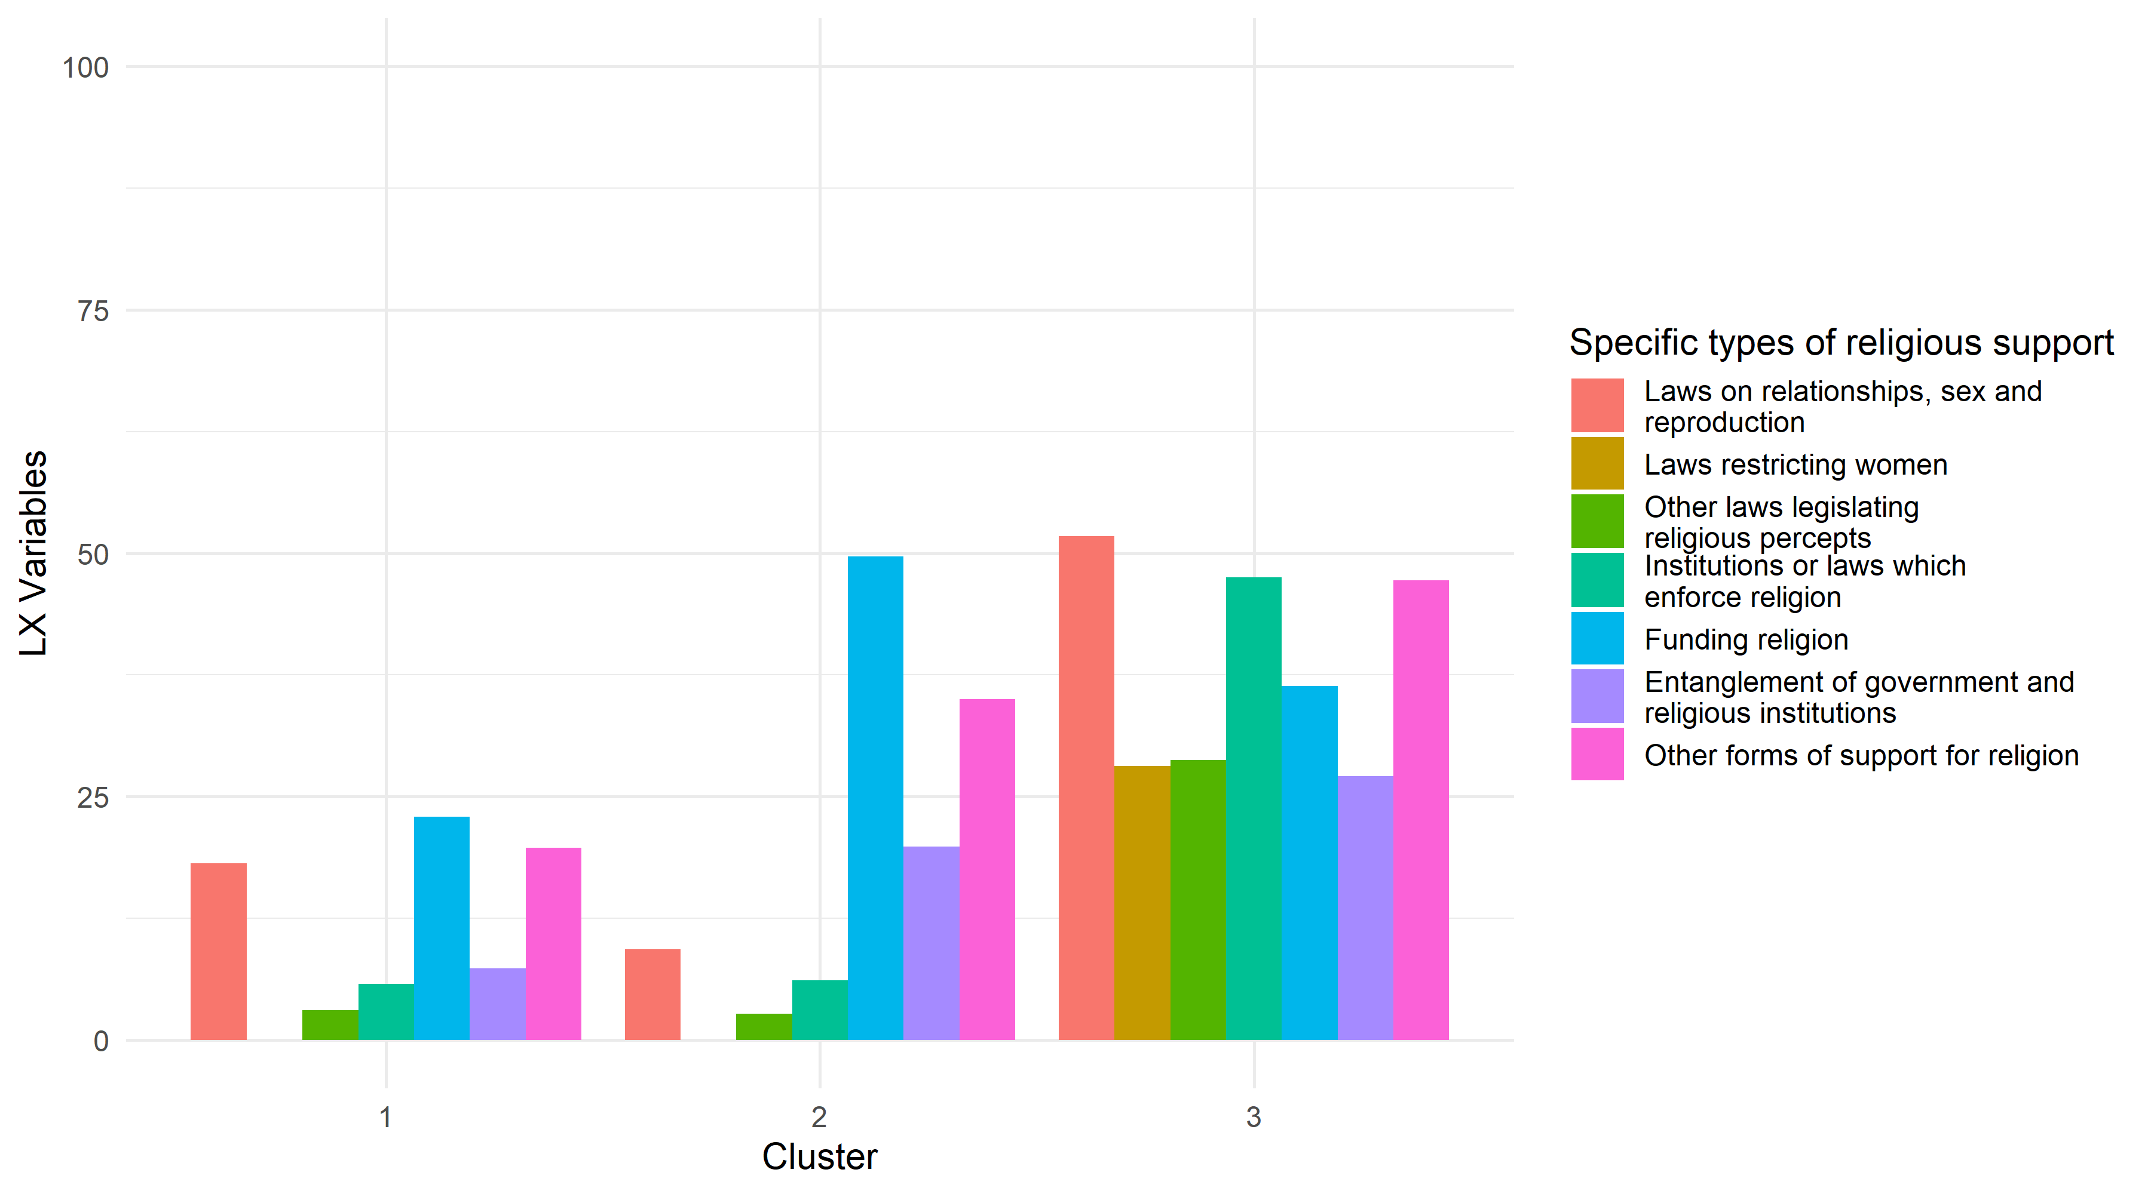
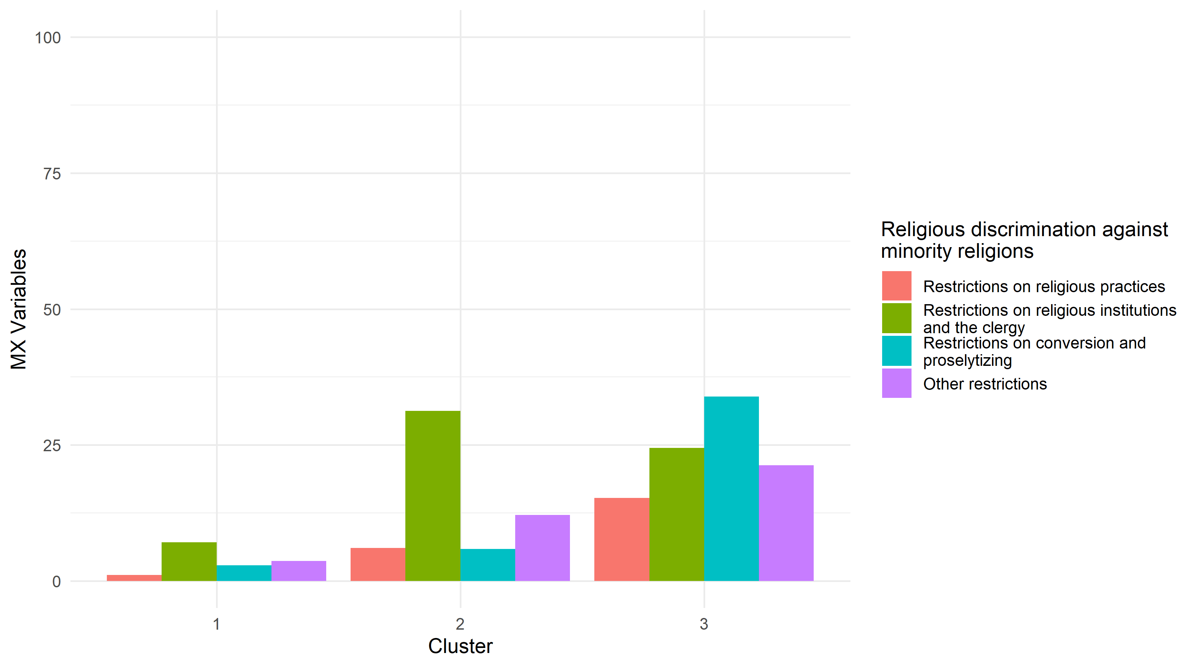

Clustering with adjusted cut-off points and three categories of regime types
The results from NbClust (Table A.13) suggest that when the authoritarian countries are more narrowly defined, the mathematically optimal number of clusters is still three. In most cases, the clustering of the countries bears close resemblance to the authoritarian regime clusters, even though the exact set-up of the clusters varies somewhat. Somewhat simplified, the first cluster consists to a large part of countries in the MENA-region with high levels of regulation. The second cluster consists mainly of Sub Saharan African countries with low levels of regulation. Finally, the third cluster consists of (post-)communist countries with high negative restrictions on religion. Only on two occasions did the clustering substantially deviate from these general patterns. In the 4-variable clustering for 2000, Pakistan and Egypt were placed to a cluster of their own (due to the exceptionally high levels of social regulation), whereas the remaining two clusters distinguish between countries with high and low levels of regulation. Further, in the 3-variable clustering for 2014, a handful of the MENA-countries are placed in the same cluster with Sub Saharan African countries. Despite these deviating results, the overall results support the idea that authoritarian countries are best divided into three clusters of countries, which distinguish from each other both when it comes to the quantity and quality of regulation.
As for anocracies, the optimal number of clusters varies between two and three depending on the year and the number of variables, which are included in the clustering. Given that several countries that in 2000 were anocratic became democratic or autocratic by 2014, and conversely, many countries, which where democratic or autocratic in 2000, became anocratic by 2014, it is difficult to identify stable clusters over time. What can be said is that the two-cluster solutions split anocracies into countries with high and low levels of regulation. The three-cluster solutions, in turn, result into clusters, which bear resemblance to the authoritarian clustering. Considering the similarities and differences between the three-cluster solution for autocratic and anocratic countries, it is questionable if there are, for the purposes of classification based on regulation of religion, any benefits of separating between the two regime types.
Finally, regarding the democratic countries, the optimal number of clusters when the clustering is based on total level of regulation and government regulation is two. The optimal number of clusters for the 15-variable clustering is three. Given, however, the low average silhouette widths for some of the clusters in the 15-variable clustering (Table A.14), the results are not particularly convincing. Interestingly, in accordance with the results presented for the democratic countries, the mathematically optimal two-cluster solution based on total and government regulation divides democratic countries into clusters with low and high levels regulation. For 2000, the clustering based on total level of regulation and government level of regulation are identical when it comes to the countries, which belong to the respective clusters. For 2014, the clustering is likewise very similar, and only four countries cluster differently when social regulation is excluded from the clustering. Interestingly, the number of countries in the second cluster (the cluster with high regulation) is relatively low and the internal structure of the cluster is (with the exception of the 4-variable clustering for 2014) better than in the already discussed results where a broader definition of democracy was applied. Thus, while the narrower definition of democracy does not result to a higher number of clusters, the cluster structure for the second cluster is somewhat improved.

Table A.13: Number of indices, which support a solution with 0-10 clusters
Autocracies | 0 | 1 | 2 | 3 | 4 | 5 | 6 | 7 | 8 | 9 | 10
2000
4-variable clustering | 2 | 1 | 4 | 7 | 0 | 1 | 3 | 1 | 0 | 1 | 6
3-variable clustering | 2 | 1 | 5 | 7 | 5 | 1 | 1 | 0 | 0 | 0 | 4
15-variable clustering | 2 | 0 | 5 | 13 | 0 | 2 | 0 | 1 | 2 | 0 | 1
2014
4-variable clustering | 2 | 1 | 4 | 8 | 0 | 3 | 0 | 1 | 4 | 1 | 2
3-variable clustering | 2 | 1 | 4 | 6 | 0 | 5 | 5 | 0 | 0 | 0 | 3
15-variable clustering | 2 | 1 | 1 | 12 | 1 | 1 | 0 | 3 | 0 | 4 | 1
Anocracies | 0 | 1 | 2 | 3 | 4 | 5 | 6 | 7 | 8 | 9 | 10
2000
4-variable clustering | 2 | 1 | 7 | 2 | 7 | 0 | 4 | 0 | 0 | 0 | 3
3-variable clustering | 2 | 1 | 4 | 8 | 5 | 0 | 2 | 0 | 1 | 0 | 3
15-variable clustering | 2 | 1 | 2 | 17 | 0 | 0 | 2 | 1 | 0 | 0 | 1
2014
4-variable clustering | 2 | 1 | 8 | 3 | 3 | 3 | 3 | 1 | 0 | 0 | 2
3-variable clustering | 2 | 0 | 10 | 3 | 3 | 0 | 5 | 0 | 0 | 0 | 3
15-variable clustering | 2 | 1 | 7 | 9 | 0 | 5 | 0 | 0 | 0 | 1 | 1
Democracies | 0 | 1 | 2 | 3 | 4 | 5 | 6 | 7 | 8 | 9 | 10
2000
4-variable clustering | 2 | 0 | 10 | 5 | 1 | 3 | 1 | 0 | 0 | 0 | 4
3-variable clustering | 2 | 0 | 10 | 3 | 1 | 3 | 2 | 1 | 0 | 2 | 2
15-variable clustering | 2 | 1 | 6 | 9 | 1 | 0 | 1 | 0 | 2 | 0 | 4
2014
4-variable clustering | 2 | 0 | 8 | 3 | 6 | 0 | 0 | 1 | 1 | 1 | 4
3-variable clustering | 2 | 0 | 9 | 4 | 0 | 3 | 3 | 2 | 0 | 1 | 2
15-variable clustering | 2 | 1 | 6 | 9 | 1 | 3 | 0 | 0 | 1 | 0 | 3
Table A.14: Average cluster silhouette widths and number of countries in each cluster
 | 2000 |  |  | 2014
 | Cluster 1 | Cluster 2 | Cluster 3 | Cluster 1 | Cluster 2 | Cluster 3
Autocracies
4-variable clustering | 0.13 (30) | 0.75 (17) | 0.71 (2) | 0.42 (12) | 0.17 (14) | 0.60 (14)
3-variable clustering | 0.28 (19) | 0.65 (21) | 0.42 (9) | 0.36 (14) | 0.42 (19) | 0.50 (9)
15-variable clustering | 0.23 (17) | 0.54 (15) | 0.05 (17) | 0.27 (13) | 0.17 (15) | 0.59 (12)
Anocracies
4-variable clustering | 0.69 (44) | 0.03 (21) |  | 0.13 (22) | 0.69 (54)
3-variable clustering | 0.60 (50) | 0.51 (7) | 0.05 (8) | 0.58 (8) | 0.62 (68)
15-variable clustering | 0.49 (55) | 0.31 (5) | 0.19 (5) | 0.17 (14) | 0.52 (59) | 0.28 (3)
Democracies
4-variable clustering | 0.57 (45) | 0.28 (8) |  | 0.53 (44) | 0.10 (10)
3-variable clustering | 0.59 (45) | 0.28 (8) |  | 0.59 (48) | 0.21 (6)
15-variable clustering | 0.36 (43) | 0.06 (8) | 0.16 (2) | -0.01 (26) | 0.36 (26) | -0.17 (2)

