Assessing the Effect of Media Tone on Attitudes Toward Muslims – Appendix

Section A: Supplementary Data Analysis

In Table A1, we use indicator variables to differentiate between the valence treatments (instead of specifying valence as a continuous variable as in Table 2 in the article). The baseline condition is where valence equals zero. As the coefficients on the Valence = –2 and Valence = 2 regressors indicate, attitudes in the Catholic treatment are significantly lower than in the valence = 0 treatment when Valence = –2 and significantly more positive when Valence = 2. Further, the interaction terms in column (2) where all the controls are included imply that for the Muslim treatment, moving from Valence = 0 to Valence = –2 results in a reduction of attitudes by 7.529 units but increasing valence from 0 to 2 results in only a 0.003 increase in attitudes. In other words, this confirms that while valence increases attitudes from –2 to 0 in both religion treatments, when moving from 0 to 2, attitudes only continue to rise in the Catholic condition.

Table A1: The effect of media valence on attitudes.
 | (1) | (2)
Valence = -2 | -6.387** | -7.052**
 | (3.046) | (2.981)
Valence = +2 | 6.974** | 7.046**
 | (3.017) | (2.969)
Muslim | 13.190*** | 12.427***
 | (3.064) | (3.015)
Valence = -2 × Muslim | -2.159 | -0.477
 | (4.460) | (4.425)
Valence = +2 × Muslim | -7.771* | -7.044
 | (4.341) | (4.282)
Constant | 48.553*** | 46.454***
 | (2.023) | (4.201)
Val =-2 + (Val = -2 × Mus) | -8.546*** | -7.529**
 | (3.258) | (3.253)
Val =2 + (Val 2 × Mus) | -0.737 | 0.003
 | (3.121) | (3.084)
Controls included | No | Yes
Observations | 1013 | 1013
Adjusted R-squared | 0.050 | 0.075
Notes: OLS; dependent variable is feeling
thermometer attitude; robust standard errors;
* p<0.10, ** p<0.05, *** p<0.01.

As in article Table 5, in which we examine the mediating effect of anxiety in our analysis of attitudes, in Table A2 we do the same thing for charitable donations. The results are very similar. Specifically, when we add the anxiety indicator in column (2), we see both that the coefficient on Anxious is large and significant (anxious people donate less) and we also see the telltale reduction in the Valence coefficient. Here the Sobel-Goodman test indicates that anxiety accounts for 16% of the valence effect on donations.

Table A2: Does anxiety mediate the treatment effect (Is induced anxiety a mechanism)?
 | (1) | (2)
Valence | 0.020*** | 0.015**
 | (0.005) | (0.007)
Muslim | 0.069*** | 0.075***
 | (0.015) | (0.019)
Valence × Muslim | -0.011 | -0.007
 | (0.009) | (0.012)
Anxious |  | -0.046***
 |  | (0.018)
Constant | 0.015 | 0.034
 | (0.039) | (0.038)
Val + (Val × Mus) | 0.010 | 0.007
 | (0.008) | (0.010)
Controls included | Yes | Yes
All interactions included | NA | Yes
Observations | 1013 | 1013
Adjusted R-squared | 0.101 | 0.108
Notes: OLS; dependent variable is donation; robust standard errors; * p<0.10, ** p<0.05, *** p<0.01.

The only difference between Table A3 and Table 5 is that instead of creating an anxiety indicator variable based on the factor scores from the STAI instrument, in Table A3 we use the raw factor scores. The results are identical in that anxiety mediates the valence effect on attitudes. In this case, the Sobel-Goodman test indicates that anxiety accounts for 19% of the valence effect on attitudes.

Table A3: Does anxiety mediate the treatment effects (Is induced anxiety a mechanism)?
 | (1) | (2)
Valence | 3.794*** | 3.192***
 | (0.768) | (0.750)
Muslim | 9.426*** | 10.099***
 | (1.790) | (1.761)
Valence × Muslim | -1.927* | -1.750*
 | (1.102) | (1.071)
Anxious |  | -4.997***
 |  | (1.234)
Constant | 41.032*** | 40.704***
 | (4.429) | (4.260)
Val + (Val × Mus) | 1.867** | 1.442*
 | (0.780) | (0.754)
Controls included | Yes | Yes
All interactions included | NA | Yes
Observations | 1013 | 1013
Adjusted R-squared | 0.089 | 0.135
Notes: OLS; dependent variable is attitude; robust standard errors; * p<0.10, ** p<0.05, *** p<0.01.

Section B: Experimental Instructions

Introduction
Thank you for participating today. This Human Intelligence Task (HIT) should take about fifteen minutes to complete and it will consist of three parts: reading two short news articles published within the last 20 years, answering a simple reading comprehension question about the articles, and a survey. For completing all elements of the HIT, you will be paid $1.50.
There is a potential to earn bonus payment amounts that will depend on how well you do on the reading comprehension question and your answers to a few of the survey questions. The total amount of bonus payments you can accumulate is $2.
If you click the next arrow below, we will get started.

Consent

Middlebury College
Media Reading Comprehension Study
Informed Consent Form
I freely and voluntarily consent to be a participant in this research project conducted through April 2019. I understand I will be one of many people participating in this research and that this study will last approximately 15 minutes.
I understand that the purpose of this research is to examine adults' behavior and performance on a reading comprehension task and in decision making settings. To this aim, I will be asked to read previously published news articles, answer questions about the articles' content and fill out a survey. I understand that I am free to discontinue my participation at any time.
I understand that all my responses will be confidential and that no personal identifiers will be kept. Only Professors Erik Bleich, Jeffrey Carpenter, Maurits van der Veen and their research assistants will have access to this data. I understand that information from all the participants will be grouped together to provide general information about human behavior.
I understand that if I would like more information about this research, I can contact Jeffrey Carpenter at 802-443-3241. I understand that questions about my rights as a research subject should be directed toward the Institutional Review Board at irb@middlebury.edu.
I have read and I understand the above. By clicking on the ‘next’ button, I acknowledge that I am at least 18 years old, that I have read and understood the above instructions and that I consent to participate in the study.

Media Treatment Instructions

On the next screens you will be presented with the text of two news articles that were published in American newspapers sometime within the last 20 years.
After you have finished reading the articles, you will be asked a simple reading comprehension question based on the content of the articles. If you answer the question incorrectly, you will not be allowed to continue.

[NOTE: the articles used are presented in the next section of this appendix]

Catholic Treatment Quiz
Different groups were mentioned in these two articles. Which one group was mentioned in both articles?
- Hawaiians (1)
- Nurses (2)
- Muslims (3)
- Doctors (4)
- Catholics (5)
- Alaskans (6)

Muslim Treatment Quiz
Different groups were mentioned in these two articles. Which one group was mentioned in both articles?
- Hawaiians (1)
- Nurses (2)
- Muslims (3)
- Doctors (4)
- Catholics (5)
- Alaskans (6)

If the Participant Answered the Quiz Correctly
That is correct. Now we would like to ask you some survey questions.

If the Participant Failed the Quiz
Unfortunately, you did not answer the reading comprehension question correctly. Your participation will now be ended.

Feeling Thermometer
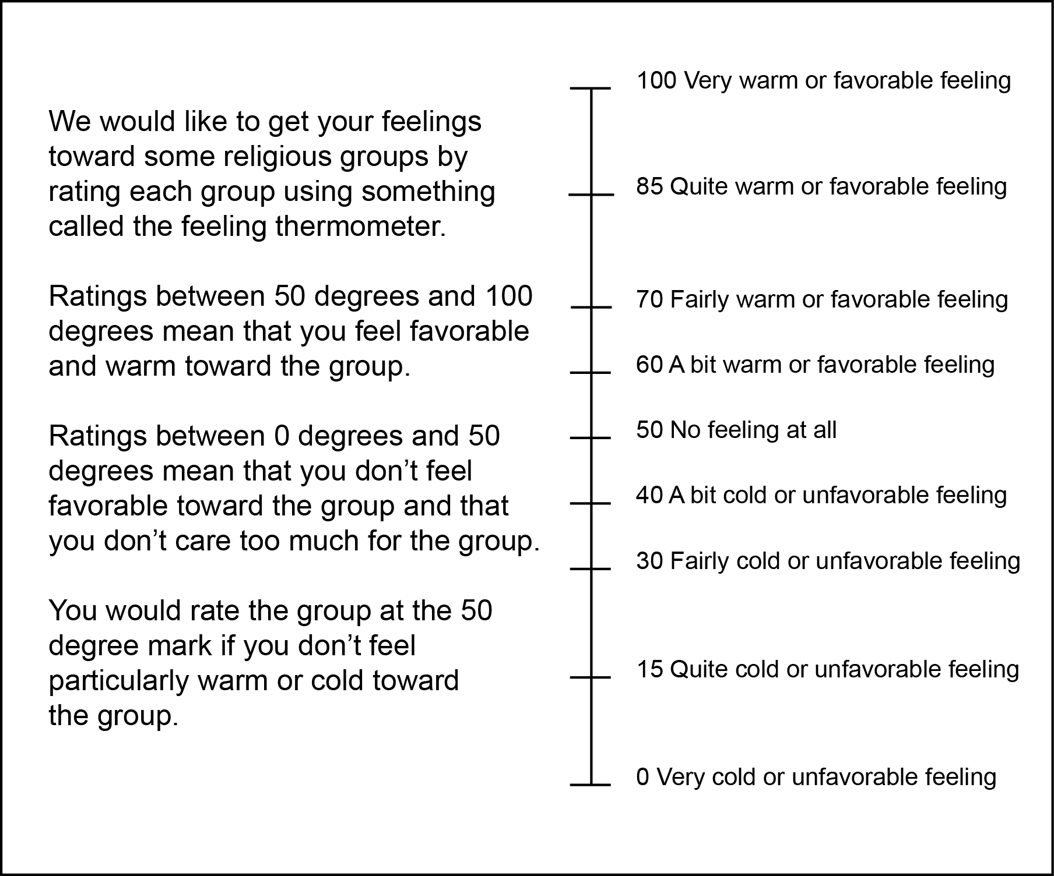

[Catholic Treatment] How do you feel about Catholics.
 | 0 | 10 | 20 | 30 | 40 | 50 | 60 | 70 | 80 | 90 | 100

Your feeling towards Catholics ()

[Muslim Treatment] How do you feel about Muslims.
 | 0 | 10 | 20 | 30 | 40 | 50 | 60 | 70 | 80 | 90 | 100

Your feeling towards Muslims ()

Donations to Charity

[Catholic Treatment] This part of the HIT is a decision-making task involving real money. In this task you will allocate a bonus of $1 between yourself and the charity Catholic Charities USA. You will simply decide how much of the $1 you want us to include in your final payment and how much you want us to send to Catholic Charities USA.
Information on the mission and values of Catholic Charities USA (from its website): The mission of Catholic Charities is to provide service to people in need, to advocate for justice in social structures, and to call the entire church and other people of good will to do the same. We commit ourselves to break down walls of division that keep sisters and brothers separated from one another, excluded, or rendered disposable by our society. With joy, we resolve to build bridges of hope, mercy and justice toward the creation of a culture of communal care responsive to the cries of those who are poor.
Choose the amount of money that you want us to send to Catholic Charities USA. The remaining money will be included in your final payment.
 | 0 | 0 | 0 | 0 | 0 | 1

Allocate this amount of the $1 to Catholic Charities USA and send the rest to me. ()

[Muslim Treatment] This part of the HIT is a decision-making task involving real money. In this task you will allocate a bonus of $1 between yourself and the charity Islamic Relief USA. You will simply decide how much of the $1 you want us to include in your final payment and how much you want us to send to Islamic Relief USA.
Information on the mission and values of Islamic Relief USA (from its website): Islamic Relief USA provides relief and development in a dignified manner regardless of gender, race, or religion, and works to empower individuals in their communities and give them a voice in the world. Working together for a world free of poverty. These traits express the belief and define the culture of the organization. We remain guided by the timeless values and teachings provided by the revelations contained within the Qur’an and prophetic example.
Choose the amount of money that you want us to send to Islamic Relief USA. The remaining money will be included in your final payment.
 | 0 | 0 | 0 | 0 | 0 | 1

Allocate this amount of the $1 to Islamic Relief USA and send the rest to me. ()

Beliefs

We will now explain two scenarios in which you will be asked to make a prediction. In each case, we will show you a graph of data from a number of time periods and then we will ask you to predict what happened in the following time period.
If you correctly predict what happened in both questions, you will earn a bonus of $1.
Click the next arrow to continue.

[Muslim Treatment] First, before we get to the predictions, which of the following three cities of approximately the same size had the highest concentration of Muslims according to the 2010 US census?
- Washington, DC (1)
- Houston, Texas (2)
- Denver, Colorado (3)

[Catholic Treatment] First, before we get to the predictions, which of the following three cities of approximately the same size had the highest concentration of Catholics according to the 2010 US census?
- Washington, DC (1)
- Houston, Texas (2)
- Denver, Colorado (3)

The correct answer is Houston, Texas. Let's consider Houston more closely.

Using data from the FBI, the following graph plots the incidence of violent crime in the city of Houston, Texas between 1997 and 2012.
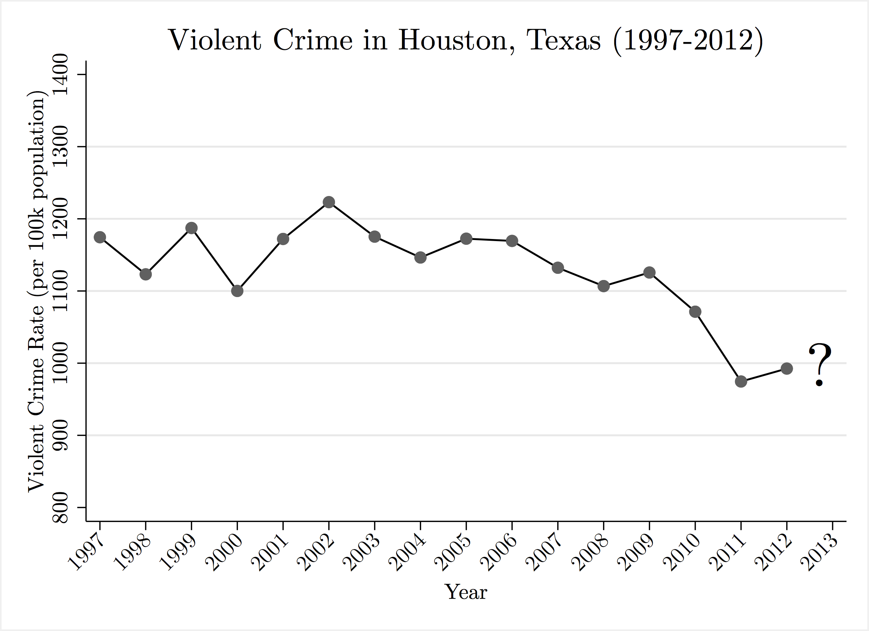

[Muslim Treatment] According to the Religious Census (2010), Houston, Texas has one of the highest rates of Muslim adherents per capita for any U.S. city with a similar population. Do you think the incidence of violent crime increased or decreased in Houston in 2013?
- Violent crime increased between 2012 and 2013 in Houston. (1)
- Violent crime decreased between 2012 and 2013 in Houston. (2)

[Catholic Treatment] According to the Religious Census (2010), Houston, Texas has one of the highest rates of Catholic adherents per capita for any U.S. city with a similar population. Do you think the incidence of violent crime increased or decreased in Houston in 2013?
- Violent crime increased between 2012 and 2013 in Houston. (1)
- Violent crime decreased between 2012 and 2013 in Houston. (2)

The graph below follows the price per share of stock in an undisclosed Firm A traded on the stock market in the United States for 30 consecutive trading days in the winter of 2013.

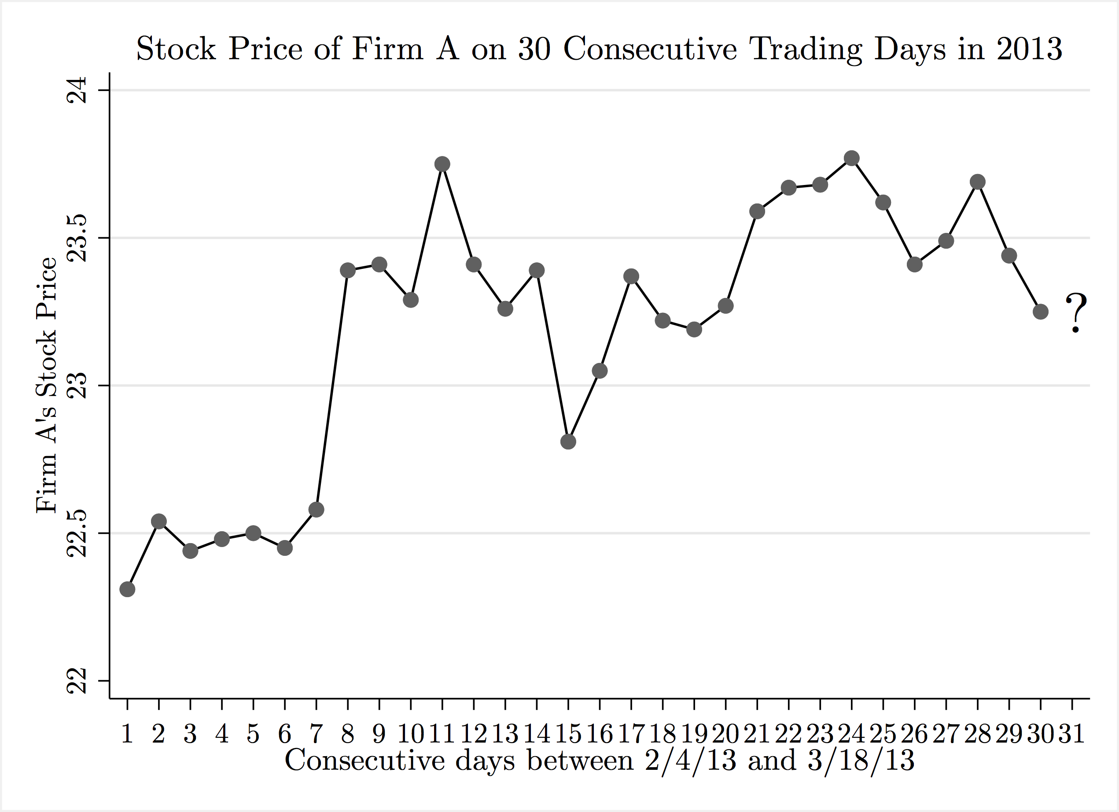

Do you think that the trading price on the 31st consecutive day was higher or lower than the price on the 30th day?
- Higher (i.e., the price went up) (1)
- Lower (i.e., the price went down) (2)

[STAI anxiety questions] A number of statements which people have used to describe themselves are given below. Read each statement and then indicate the most appropriate response to the right to indicate how you feel right now, at this moment.

 | Not at all (1) | Somewhat (2) | Moderately (3) | Very Much (4)
I feel calm. (1)
I am tense. (2)
I feel upset. (3)
I am relaxed. (4)
I feel content. (5)
I am worried. (6)

[Political Affiliation] Where would you place yourself on the following scale?
- Very liberal (1)
- Somewhat liberal (2)
- Closer to liberals (3)
- Neither liberal nor conservative (4)
- Closer to conservatives (5)
- Somewhat conservative (6)
- Very conservative (7)

[Media Source] What would you say is your main source of news?
- Newspaper stories (either in print or online) (1)
- TV (2)
- Radio (3)
- Other (4)

[Media Usage] About how many minutes do you spend on the average day reading, watching, or listening to the news?

[Sex] What is your sex?
- Male (1)
- Female (2)

[Age] In what year were you born?

[Education] What is the highest level of school you have completed or the highest degree you have received?
- Less than High School (1)
- High School Graduate (Diploma or GED) (2)
- Some college but no degree (3)
- Associates degree (4)
- Bachelor’s degree (BA, AB, BS) (5)
- Professional or Master’s degree (MD, DDS, DVM, LLB, JD, MA, MS, Meng, Med, MSW, MBA) (6)
- Doctorate degree (PHD, EdD) (7)

[Hispanic] Are you of Hispanic, Latino or Spanish origin, such as Mexican, Puerto Rican or Cuban?
- Yes (1)
- No (2)
- Prefer to not answer (3)

[Race] Which of the following describes your race? You can select as many as apply.
- White or Caucasian (1)
- Black or African American (2)
- Asian or Asian American (3)
- Some other race (4)
- Prefer to not answer (5)

Section C: News Articles Used in the Experiment

[Catholic, V=-2] Please take the time to read the following news article carefully. After you finish, click the next arrow and you will move on to the next short article.
Allegations of sexual abuse in the Catholic Church appear to have involved hundreds more priests than previous estimates suggest. A survey of U.S. Catholic dioceses conducted by the Associated Press and released Tuesday found that 1,341 clergy members have been accused of molesting children since the 1950s. But the survey found that reports have been released to date by only 80 of the 195 Catholic dioceses in the USA. Among those that have yet to release numbers are large dioceses faced with scores of allegations, including Boston, Los Angeles and Chicago. "The numbers speak of a very sad story," said Sister Mary Ann Walsh, spokeswoman for the U.S. Conference of Catholic Bishops. Previous estimates by news media and victims' groups have suggested that as many as 1,200 priests nationwide had been accused of sex abuse over 50 years. But now the church is producing its own unprecedented, nationwide accounting of abuse claims, to be released Feb. 27. It will not report numbers for individual dioceses. Los Angeles and 59 other dioceses told AP they will release their numbers this month. Individual dioceses were encouraged but not required to report their statistics. The AP survey included 80 dioceses that have elected to release some form of statistics. Ten of those dioceses reported no cases of abuse. The survey found that the other 70 dioceses have spent $186 million to settle or litigate the cases. U.S. bishops established a review board in 2002 to investigate sex-abuse charges. It asked the John Jay College of Criminal Justice in New York City to survey all 195 dioceses for 50 years of statistics on the numbers of abusive priests and victims and the costs of the scandal. Bishop Wilton Gregory, president of the U.S. Conference of Catholic Bishops, has said he expects "shocking" numbers. Walsh said the voluntary release of these statistics shows the "transparency and openness the church has shown in trying to deal with this problem." She said the bishops will rely on the John Jay study "to begin to address this problem adequately." Past estimates vary because they differ on the period of time covered, the definition of "credible" accusations, and whether to include deacons, religious order priests and nuns. A November 2002 study by USA TODAY of the 10 largest U.S. dioceses found 234 allegedly abusive priests among 25,616 diocesan and religious order priests who served since 1965. The study estimated 900 allegedly abusive priests nationwide. The tally was based on church statements, court documents and media reports. A January 2003 review by The New York Times counted 1,205 allegedly abusive priests nationwide over five decades, based on court records and media reports. In the AP survey, the dioceses reported that 179 of the 1,341 accused clergy are dead. Critics of the church reporting said diocese-by-diocese reporting is necessary. Without it, "there's no way of knowing whether the church's reporting on itself is full and accurate," said David Clohessy, director of the Survivors Network of those Abused by Priests.

[Catholic, V=-2] Please read this second news article carefully. After you finish, click the next arrow and you will move on to the reading comprehension question.
A national advocacy group for victims of sexual abuse by Roman Catholic priests and other clergy is asking Pennsylvania legislators to move swiftly to strengthen state laws dealing with the sexual abuse of children. The group, Survivors Network of Those Abused by Priests and Other Clergy, gathered in the statehouse yesterday to urge lawmakers to enact sweeping changes to current law, in light of a recent report by a Philadelphia grand jury that investigated sexual-abuse allegations in the Philadelphia Archdiocese. The report found that dozens of priests sexually abused hundreds of children while Philadelphia archdiocese officials in many cases excused - and enabled - the abuse. But the grand jurors said they could not pursue criminal charges against priests or any of their superiors because of restrictions in Pennsylvania law. The archdiocese has called the report slanted, biased and anti-Catholic. Yesterday, members of Survivors Network, better known as SNAP, said that lawmakers must enact a "comprehensive package" of legislation to correct what they believe are deficiencies in state law. "The road to justice and reform runs through Harrisburg," said John Salveson, spokesperson for the group in Philadelphia. "This is not just a Catholic Church problem. This is a problem that involves any institution or perpetrator with access to children." Among the recommendations made yesterday: creating a one-year window that would suspend the current statute of limitations on civil actions for adults who were victims of sexual abuse during childhood. As it stands now in Pennsylvania, those victims have until age 30 to bring civil charges as well as criminal charges for major crimes such as rape, incest and sexual assault. SNAP members said California is the only state that has enacted legislation allowing for a one-year window in certain molestation cases, although other states have similar bills pending. "The one-year civil window is absolutely the single most effective step toward preventing future abuse," said David Clohessy, SNAP's executive director. "The way Pennsylvania law now stands, every child molester and everyone who hires a molester and enables a molester and turns a blind eye to a molester has a direct incentive to run out the clock - to intimidate victims, to silence witnesses, to destroy evidence." Other recommendations made yesterday include abolishing current criminal and civil statutes of limitations for sexual offenses against children and tightening reporting laws for childhood sex abuse. Robert O'Hara, executive director the Pennsylvania Catholic Conference, the public-affairs arm of bishops and dioceses, said yesterday that the conference does not take official positions "on things that people say - we take positions on legislation." There are a handful of bills pending in the legislature to abolish the statute of limitations on future child sex abuse cases - although none would be retroactive, meaning past victims would not be covered. Salveson said yesterday that those bills "are pieces of a larger package." "They do not deal with all the issues we feel need to be addressed." For archdiocesan documents, the grand jury's report, a catalog of sexually abusive priests, the list of abusive priests by assignment and parish, a discussion board and previous coverage, go to http://go.philly.com/priests.
[Catholic, V=0] Please take the time to read the following news article carefully. After you finish, click the next arrow and you will move on to the next short article.
Mentioning the unmentionables of Roman Catholicism - ordaining women, allowing priests to marry, permitting birth control - will soon be on the agenda if the nation's senior active cardinal has his way. Local Catholic academics say it's about time, but the archdiocese is cool to the idea. Cardinal Joseph Bernardin of Chicago announced yesterday that he would oversee conferences beginning next spring to open dialogue on thorny issues that, in some cases, the Vatican has barred even from discussion. He decried "polarization" and "mean-spiritedness" within the church. "He's saying, 'Hey, guys, the emperor doesn't have any clothes on. They're trying to sew the figleaf back on and it isn't working,' " said Leonard Swidler, professor of religion at Temple University and active in Catholic reform groups. The Rev. Don Clifford, a Jesuit priest and professor of theology at St. Joseph's University, called it a "major development" for a respected church leader like Bernardin to be issuing this call. He noted that, six weeks ago, the retired Archbishop John Quinn of San Francisco sent shock waves with a speech in Oxford, England, that criticized rigid control from the Vatican that stifled debate on a range of controversial issues. Bishop Joseph Martino of the Archdiocese of Philadelphia, said he didn't "want to be a pessimist," and felt dialogue shouldn't go too far. He said Bernardin is likely seeking a "common ground on attitude," not on changing the church. "Sometimes the perception is there is nothing that is not open for discussion," Martino said. "There are obviously things in life that cannot be compromised." Martino said dialogue was fine "if the discussion is aimed at clarifying" what church teaching really is. Swidler said his expectation is "exactly the opposite." "What will happen, I think, is there will be an effort for serious open discussion," he said. "That is exactly what the reformers want. The main bulk of the reform groups are saying, 'Let's have a serious discussion.' " An array of reformers, vowing loyalty to Catholicism but saying they want to save the church from itself, have been stepping up efforts to spark change, especially on women's and sexuality issues. The church's all-male hierarchy has insisted on strict adherence to its teachings. In the case of women's ordination and abortion, it essentially barred all discussion. Bernardin said the conferences won't alter church policy or teachings but would allow reformers and critics a voice. It's his own idea, but he said the Vatican and American church officials approve. He announced a 24-member committee of church and lay leaders to organize the sessions, but did not include some of the most vociferous church critics. Sister Maureen Fiedler, coordinator of We Are Church, a Catholic Referendum, which is collecting a hoped-for one million signatures supporting church change, said Bernardin's call "sounds promising, but it raises questions." She said it was too general. Swidler said he believes the catalyst for Bernardin's call was an order by the bishop of Lincoln, Neb., this spring to excommunicate anyone in his diocese who was a member of any of several Catholic reform groups. "When you get a bishop in boondocksville threatening excommunication out of the blue, you are really running contrary to the spirit even of the Vatican in its present form," Swidler said.

[Catholic, V=0] Please read this second news article carefully. After you finish, click the next arrow and you will move on to the reading comprehension question.
Hard-liners at opposing ends of Northern Ireland politics surged ahead of moderates yesterday in the election of a new legislature, undermining hopes of reviving a Catholic-Protestant government in this British territory. Partial returns from Wednesday's vote showed strong gains for both Ian Paisley's Democratic Unionist Party and Sinn Fein, the party linked to the Irish Republican Army. Paisley, the Protestant firebrand who has spent four decades opposing compromise with Catholics, emphasized the point yesterday. "Are you hearing me clearly? I'll not negotiate with IRA murderers and bombers," he told a reporter. "Never. And any member of my party who does will no longer be in my party." The legislature was originally elected in June 1998 to promote cooperation between the province's British Protestants and Irish Catholics. Forming a new power-sharing administration will require majority support from both the Catholic and Protestant blocs of the legislature. Most of the 108 seats in the legislature remained unfilled yesterday because of a complex system that allowed voters to rank candidates in order of preference. This system means ballots are recounted more than a dozen times as votes are transferred from elected or eliminated politicians to candidates still in the running for a seat. Paisley's Democratic Unionists were in first place with 20 lawmakers elected. David Trimble's Ulster Unionists - the leading Protestant-backed party, which has been badly divided by Trimble's leadership - trailed with 12. Analysts predicted, however, that the two Protestant parties would end up close to each other when final results come today. Whoever prevails on the Protestant side will have to deal with the reality of a much-strengthened Sinn Fein on the Catholic side. Sinn Fein had won 13 seats last night, while its longtime moderate rival, the Social Democratic and Labor Party, had only three declared winners. In 1998, the Ulster Unionists won 28 seats, the SDLP 24, the Democratic Unionists 20, and Sinn Fein 18. London has ruled the province directly for more than a year, since a political truce between Protestants and Catholics who favor rule from Ireland collapsed over allegations of IRA spying and brought the legislature down with it. An unusually low turnout, below 60 percent, Wednesday suggested many voters had despaired of any progress. Sinn Fein leader Gerry Adams, appearing on television alongside SDLP election director Brid Rodgers, poked fun at Rodgers' claim that many of the SDLP's traditional supporters had not bothered to vote this time. "The SDLP vote did come out. The problem is, a sizable section of it voted for us," Adams said. Paul Arthur, a political scientist, said the early returns indicated that the Ulster Unionists might stay one or two seats ahead of the Democratic Unionists, while Sinn Fein would win around 25 and the SDLP fewer than 20. That would leave Trimble with too little support to take his party back into an administration with a strengthened Sinn Fein, Arthur noted. Two of Trimble's harshest critics inside the party, Jeffrey Donaldson and David Burnside, emerged yesterday among the top Ulster Unionist vote-winners. "Trimble's still going to have big difficulties. The people doing really well are the people who have opposed his leadership down the line," Arthur said.

[Catholic, V=2] Please take the time to read the following news article carefully. After you finish, click the next arrow and you will move on to the next short article.
Tens of thousands of pilgrims from all over the world flocked to the Vatican earlier this month to celebrate the six newest saints recognized by the Catholic Church. And there in St. Peter's Square, amid the faithful singing Spanish hymns and the boosters waving flags and scarves, was Father Dan. The Rev. Daniel Kayajan, pastor of St. Rita Roman Catholic Church in Dade City, made the trip to Rome with fellow members of his order to celebrate the canonization of one of their own: Brother Andre, nicknamed the "Miracle Man of Montreal" for healing the crippled and the sick. Upon his return, Kayajan talked to the Times about his trip. So how did you get to go? I'm with Congregation of Holy Cross, and one of our guys was made a saint, Brother Andre. Our province runs from Maine to Florida (and officials decided to send some members to Rome). Basically it was first-come, first-served. I guess I got my foot in the door early on. And what was it like? There must have been tens of thousands of people. We were just in the middle of them. It was fun. There were people from all over the world: Australia, Italy, Poland. It was a lot of fun to be there as a church. It shows the Catholic Church is one of the few organizations in the world that's in just about every country on the planet. What can you tell us about Brother Andre? Andre came to Congregation of Holy Cross in Montreal, and he died in 1937. He was a fairly sick young man. At first there was some resistance from the superiors (to admit him to the religious order); they didn't know if he would be able to do this, physically. Eventually they did allow him in ... and he ends up being the doorman at the College of Notre Dame in Montreal - basically just taking care of things, sweeping up. ... (People who came to him with problems found that) his prayers to St. Joseph helped a great deal. He'd light candles to St. Joseph, and with the oils from the candles he would anoint those folks. Little by little it was obvious he had the gift of healing, through his faith and the gifts God had given him. ... If you go to St. Joseph's Oratory (a basilica in Montreal that started as a small wooden chapel Andre built in 1904) you'll see crutches and braces and wheelchairs from the people who didn't need them anymore. How did this experience help you as you come back to your parish? It helps my faith in God through someone like Andre. He had no airs about him. He was a very simple fellow - simple in the best sense of the word. His dedication, his ability to allow God to use him is just fantastic stuff. To see it within the context of the larger church, the Vatican, St. Peter's Basilica, it was a great trip.... It keeps me humble for sure, it helps me keep my feet on the ground. It helps me understand my congregation's role in the world as teachers and healers of the faith.

[Catholic, V=2] Please read this second news article carefully. After you finish, click the next arrow and you will move on to the reading comprehension question.
Beatrice (Bea) Collins was born November 2, 1927 in McVille, North Dakota to Melvin and Barbara (Pella) Bredeson. She blessed the lives of so many, and was an especially beloved wife, mom, grandmother and great grandmother. She attended country grade schools in Nelson and Griggs counties and graduated from Binford High School. She went on to attend Valley City State University where she graduated with a degree in Elementary Education. She would go on to teach school in Jessie and Cooperstown, ND as well as Rothsay, MN. Beatrice was elected to Kappa Delta Pi, an honor society in education. She was active in PTA, church organizations, Homemakers, Garden Club, and was a Girl Scout leader. Beatrice married Gerald Dahl in Jessie, ND on August 21, 1949. Prior to Gerald's death in 1987, the hard working couple built a large family farm raising small grain, cattle and children - all the while creating a lifetime of wonderful memories for generations to come. Bea balanced a teaching career on top of the many responsibilities that besiege a mom and farmers wife. She married George Collins in Mesa, AZ on May 1, 1989. George introduced Bea to the ranching lifestyle of Western Montana, where she was graciously adopted into her new and loving family. George died in 2004. Retiring to Mesa, AZ in 1979, Bea was one of the original residents of Brentwood West. She immediately immersed herself into the Brentwood West Activities Association (BWAA). She was the BWAA President, BWAA Vice President, chairperson (3 years) for the pancake breakfast and President of the Woman's Club. Beatrice was an active and loved member of Christ the King Catholic Church, where she especially enjoyed helping with HOPe (Helping Other People) - a favorite of several charities that she supported. Bea had a wonderful sense of humor and a very competitive spirit. She enjoyed playing board and card games with family and friends, never shying away from games that would allow her to wager some pocket change. Bea's travels literally took her around the world where she visited the Mediterranean (Italy and the Vatican), the Baltic (including Prussia) and Ireland just to name a few. Beatrice is survived by four children: Richard Dahl (Charlotte), Valpariso, IN; Marilyn Dahl Peda (Kirk), Tempe, AZ; Carol Goplen, Richland, WA; Milt Dahl, Helena, MT; eight grandchildren and four great grandchildren. Four stepchildren: Larry (Sharon) Collins, Tom (Judy) Collins and Gail Robins, all of Broadus, MT and Neil Collins of Biddle, MT; eight step grandchildren and nine step great grandchildren. Beatrice was preceded in death by husbands Gerald Dahl and George Collins, and grandson Chad Goplen. In lieu of flowers, the family is requesting that donations be made to HOPe via Christ the King Catholic Church: 1551 E Dana Ave, Mesa, AZ 85204. Services will be held at 1:00pm at Christ the King Catholic Church in Mesa, AZ with interment to follow at the Mesa Cemetery. Reception to follow at 3:00pm at the Brentwood West clubhouse, 3104 East Broadway Road, Mesa, AZ. Please visit www.melcherchapelofroses.com to share memories and leave condolences.

[Muslim, V=-2] Please take the time to read the following news article carefully. After you finish, click the next arrow and you will move on to the next short article.
Islamists who control northern Mali have publicly amputated the hand of a man they accused of robbery, continuing an increasingly harsh application of what the vast region's new masters consider sacred law. The amputation took place Wednesday morning in the small town of Ansongo, just downriver from the provincial capital, Gao, which is under the rule of an Islamist group, splintered off from Al Qaeda, called the Movement for Oneness and Jihad in West Africa, or Mujao. It was confirmed by a Mujao spokesman in Gao in a telephone interview, and by the Malian government in a statement later from Bamako, the capital. A witness in Ansongo said that the accused man's hand was ''placed on a sort of table,'' in front of dozens of spectators, in the town's main square. Then, ''a gentleman with a sort of cutlass'' -- the witness described him as ''an Arab'' -- swung hard, and sliced off the man's hand, the witness said. ''He cut it. There was a lot of blood.'' ''He held up the man's hand for the people, like a sort of trophy,'' the witness, a local teacher, said Thursday in a telephone interview from Ansongo. ''He said, 'God is great.' It was barbaric.'' He requested anonymity because he said it was dangerous to speak even over the telephone about what was going on in the town. A spokesman for Mujao in Gao, Aliou Mahamar Toure, said Thursday by telephone: ''They cut off the hand of a robber at Ansongo. Yes, yes, they did this. He was a thief. He stole. God has told us to cut off the hands of thieves. It's in the Koran.'' Just 11 days ago, in the desert town of Aguelhok, Islamist allies of Mujao publicly stoned to death a young couple accused of having children outside wedlock. The stoning and now the amputation appear to signal an acceleration of the Islamists' determination to apply Shariah law to the territory they conquered from the Malian government in March and April. Already, the Islamists have driven nearly 400,000 people to flee northern Mali and have spurred calls for a regional intervention force. ''The extremists who are occupying northern Mali have cut off the hand of an inhabitant of Ansongo, adding a new ignoble act to the long list of atrocities they have inflicted on the people,'' the Malian government said in a statement from Bamako. ''The actions of the terrorists and drug traffickers, cloaked in a false veil of religion, reinforce the inevitability of military action.'' In recent days, young people in Gao have resisted the harsh punishments, blocking Mujao's plan to amputate a robbery suspect publicly in the town by descending into the streets to protest. The teacher argued that the Islamists chose to carry out the punishment at Ansongo ''because it didn't come off at Gao.'' He said, ''At Gao there were difficulties.'' But Mr. Toure, the Mujao spokesman, denied that there was any connection between the forestalled amputation in Gao and its application in Ansongo, and he vowed to continue enforcing what he called religious law. ''Even at Gao, there are robbers whose hands we still want to cut, God willing,'' Mr. Toure said. The teacher said the amputee in Ansongo, who was accused of stealing cattle, did not cry out. Many spectators had approved, he said, because of the prevalence of theft in the region, for which he blamed nomadic Tuareg tribesmen. Other witnesses could not be reached; cell phone connections there are minimal. ''There were a lot of spectators,'' he said. Afterward the victim was taken to a local health center, he said. ''As an intellectual, I didn't appreciate this. These are ignoble, terrorist methods.''

[Muslim, V=-2] Please read this second news article carefully. After you finish, click the next arrow and you will move on to the reading comprehension question.
A hatchet-swinging psycho turned a busy Queens street corner into a scene of bloody chaos Thursday, chopping a rookie cop in the back of the head and slicing a second officer in the arm before two other officers shot him dead. In opening fire on the madman, cops accidentally wounded a bystander, authorities said. Officer Kenneth Healy, 25, had just five months on the job when Zale Thompson, 32, of Queens - a "scholarly" but "weird" recent convert to Islam - fractured the back of the cop's skull with one swing of a small, blue-handled hatchet at about 2 p.m. in Jamaica. A 29-year-old woman walking a half-block away was struck in the back by a stray police bullet and was in stable condition, according to police sources. The NYPD is investigating whether Islamic extremism played a role in the attack, which left the rookie in serious but stable condition Thursday night. "There's nothing we know at this time that would indicate that [Islamic terrorism] is the case," Police Commissioner William Bratton said at a press conference at Jamaica Hospital Thursday evening. "That's what the investigation will attempt to determine," Bratton said as Healy, the son of a 34-year Nassau County police detective, underwent surgery. The second injured officer, whose name was not released, was "conscious and alert," also at Jamaica Hospital. Video shows Thompson pulled the hatchet from a bag, then took a running leap at Healey and his four companions as they stood together on the rainy sidewalk. Holding the hatchet in two hands like a baseball bat, he swung three times, one source who saw the video told The Post. The first swing broke the one cop's arm. The second was a miss. The third struck Healy in the back of the head. "The cops yelled, 'Drop it!' " recalled eyewitness Larry Bethune, 44, who watched the violence unspool at Jamaica Avenue and 160th Street. "He raised his arm up high and brought it straight down on the cop's head," the Hollis man added "The cop went down to the ground face-first . . . The cop's just lying there with blood pouring down his face. He didn't move." Another witness, Kelli Reddica, 24, recalled hearing seven police bullets ring out as Thompson was taken down - and seeing the young cop's horrible head injury. "He looked like he couldn't move, and blood was gushing out of his head," Reddica said of Healy. "Blood just drenched the side of his face," she said. Thompson is being investigated for broader terror ties, a law-enforcement source said. "There are suspected terror ties," said the source. His Facebook page includes an passage from the Koran in Arabic script beseeching Allah's guidance in finding "the straight path" and an old black-and-white photograph of a black-scarved militant. Thompson was a "very educated" proponent of "black power" and a graduate of the College of New Rochelle in Harlem, said a classmate who asked not to be identified. "He always spoke very positively," said the classmate, who was unaware of any Islamic leanings. "I would call him a scholar and an intellectual." But former neighbors at Thompson's address in East New York, Brooklyn, said that in recent months, he had become "weird" and argumentative, fighting with his girlfriend and mother before moving to Jamaica this year. In addition to the two cops struck with the hatchet, the officers who opened fire were also rushed to hospitals for ringing in their ears, a source said.

[Muslim, V=0] Please take the time to read the following news article carefully. After you finish, click the next arrow and you will move on to the next short article.
Melanie Gadener was at home in Fremont three weeks ago when she began receiving calls about the killing of Alia Ansari, the 38-year-old mother of six who was shot in the head as she walked with her little girl through a quiet Fremont neighborhood to pick up her children at Glenmoor Elementary School. Very quickly, Gadener was struck with the same suspicion as many others in town. They wondered if Ansari was killed simply because of the way she was dressed, in a loose scarf that some Muslim women wear to cover their heads out of modesty. “I was shocked and saddened, but I was not surprised,” Gadener told me when we met recently. “There is growing racism in Fremont, and a lot of this has come out since 9/11.” Whether or not Ansari's head scarf had anything to do with why she was killed, it's significant that so many people have no trouble believing it was the reason. Support for Afghans Gadener has been especially sensitive to these tensions since she set up the Foundation for Self-Reliance, a non-profit organization that develops programs to promote economic independence in the Afghan community. Over the past three years, she has had a crash course in Muslim beliefs and traditions. “I've learned not to be afraid to ask questions and be honest about my own ignorance,” Gadener said. “We've got to bring the conversation to the table.” In that spirit, she had an idea about how to memorialize Alia Ansari. What if women of all religions pledged to wear a Muslim head covering, a hijab, for one day? It would not only show support for the Ansari family, but it also would be an intriguing social experiment. How might people treat you differently if, for one day, the only thing different about you was what you were wearing on your head? Nov. 13 was the date chosen for “Wear a Hijab Day,” and the plan has taken on a life of its own. Gadener has been deluged with messages of support from all over the world. Soon it became clear that men wanted to participate as well, so the event’s title was changed to “Wear a Hijab or Turban Day.” Reshma Yunus, who is active in the Muslim community and the founder of Semah, a domestic violence-prevention organization based in Newark, said she suggested adding turbans to the event because many Sikh men also have been victims of the backlash since Sept. 11, even though they are not Muslim. “This is another version of walk-in-another-person's-moccasins,” Yunus said. “It's just walk-in-another-person's-headgear.” Gadener is still setting up a panel to speak at noon next Monday at Lake Elizabeth in Central Park, 40000 Paseo Padre Parkway in Fremont. And Shahla Arsala, a prominent member of Fremont's Afghan community, said she hopes that those who show up aren't there only as a gesture of solidarity. “I'm hoping that people really come to get educated, too,” she said. “I'm looking forward to learning from other Muslim women who wear head scarves, since I do not.” Samina Sundas, executive director of American Muslim Voice in Newark, said many more days like Nov. 13 will be needed. “Getting to really know each other is now a matter of survival,” she said. “There's no way we can break down barriers if we only embrace what we believe in and live behind closed doors.” Alia Ansari may be remembered not only as a devoted mother of six but also as a woman who helped her neighbors to understand each other.

[Muslim, V=0] Please read this second news article carefully. After you finish, click the next arrow and you will move on to the reading comprehension question.
Overlooked, until now Assistant journalism professor Nabil Echchaibi knew he was a pioneering researcher, but he didn't realize just how virgin the territory was until he and a team of University of Colorado students began exploring Rocky Mountain Muslim communities. Echchaibi, associate director of CU-Boulder's Center for Media, Religion and Culture - which began the project more than a year ago - aspires to write a cultural history for the region's Muslims. "We want the local story," Echchaibi said. "Our research is part of that new consciousness that Islam is also an American story." Echchaibi's team of four will be working for several years to come. But their documentary, "Muslims in the Rockies," based on interviews with communities in Colorado, Wyoming, New Mexico, Utah, Idaho and Arizona, likely will be finished this spring, he said. "When we began, we thought there must be some kind of historical overview of Muslims in the region, but we were surprised and frustrated that there was almost nothing," Echchaibi said. "We found only the occasional thesis or a history of a mosque." What they uncovered with a great deal of legwork was a surprising, colorful array of Muslim life - from Somali meat-industry workers in Greeley to Denver taxi drivers, from Palestinian refugees working and marrying among the Navajos in Gallup, N.M., to a community re-creating elements of seventh-century Mecca at Dar al Islam in Abiquiu, N.M. "We'd go to these places and ask people, 'Show us your photo album,"' Echchaibi said. One big question mark is the total size of the region's Muslim population. The Pew Forum on Religion & Public Life released a report Thursday estimating the U.S. Muslim population at 2.6million. Researchers there project the number of American Muslims will increase to 6.2 million by 2030, mostly because of immigration and relatively high birth rates. Other national estimates differ widely from these figures. The Council on American-Islamic Relations estimates the number of American Muslims at 3 million to 7 million. CAIR said the numbers most often cited by its sources are 6 million and 7 million. And, Echchaibi said, national polling data historically has relied heavily on sampling from the Northeast, the West Coast and Illinois, where U.S. Muslim populations are heavily concentrated. Pew staff acknowledged to him, he said, that little surveying has been done in the Intermountain West. It is more of a guessing game for this region, based on generalizations, trends and assumptions, Echchaibi said. "We don't really have any detailed information about the mountain states," he said. Commonly used estimates of Muslims in metro Denver, for example, range from 15,000 to 30,000. Based on 2008 Pew data, Colorado Muslims account for less than 0.05 percent of the state's population, or fewer than 25,000. Citing mosque attendance isn't the answer, either, Echchaibi said, because it is probable that a third of American Muslims never go to a mosque. A better understanding of regional demographics, trends and culture is the hoped-for result of CU's groundbreaking research, a joint project of the university's centers for Media, Religion and Culture and for Asian Studies. The New York City-based Social Science Research Council is funding the project.

[Muslim, V=2] Please take the time to read the following news article carefully. After you finish, click the next arrow and you will move on to the next short article.
Iran is 99 percent Muslim. But on Friday night, people across the country celebrated the feast of Yalda, an ancient holiday going back to an earlier religious era, the age of Zoroastrianism. The feast marks the winter solstice, the longest night of the year by one minute. For Iranians, it is a night of eating, celebrating and telling stories until the early morning. Zoroastrianism is one of the world's oldest faiths, dating from sixth or seventh century B.C. to the seventh century A.D., when the conquest of Islam reached the Middle East. It was one of the world's first monotheistic religions. As the official faith in ancient Persia, Zoroastrianism considered life and the universe in a form of cosmic dualism, a constant battle between good and evil. Today, the Zoroastrian community in Iran has dwindled to perhaps 100,000, but its traditions have survived all political upheavals, even the arrival of Islam. On Yalda evenings, families of all faiths gather at an elder's house to celebrate the start of longer days and prepare for a cold winter. Daytime was considered good by Zoroastrians because it was a time for work as opposed to the evening, during which people had to light fires to keep evil spirits away. The dawn represented victory of good over bad, an opportunity for work, which deserved to be celebrated. For Yalda, families feast on nuts, dried fruits, watermelon and pomegranates. Zoroastrians believed that watermelon could keep people healthy in the wintertime. The red seeds of the winter pomegranate symbolized liveliness and joy. In the last week, shops around the country displayed signs advertising watermelons preserved in industrial refrigerators. Newspapers carried front-page pictures of the feast from previous years. Iranian state television on Friday broadcast a special program about the Yalda feast. After midnight, a popular actor, Jahangir Almassi, read poetry, sitting behind a table that held flowers, pomegranates, nuts and a chopped watermelon. Bahar Malek's family, which is Shiite Muslim, has always celebrated Yalda. Ms. Malek is 34 now; when she was younger, her family gathered at the home of her grandfather, Ali Akbar Malek, himself a poet. She still remembers sitting with 20 other family members and listening to her grandfather reading Hafiz, a popular 14th-century Persian poet, or the Book of Kings, 10th-century poems of Iran's greatest epic poet, Abolqassem Ferdowsi. After all, she said, Yalda is a night on which Persian heroes must be celebrated. On Friday, at a table lit with candles and decorated with bowls of fruit, Ms. Malek's father read Hafiz's poetry to the family. Her mother had made Ab-goosht, a rich traditional soup made of meat and beans, to keep everyone awake until dawn. Ms. Malek's aunt Farah Rowhani, 53, a dedicated Shiite, believes that Yalda is a holy night and that if she makes a wish then, it will come true. Last year she prayed that Ms. Malek would get married, and she did. This year, Ms. Rowhani prayed that her son would get married. "I ask God, for the sake of Ali, our innocent saint who became a martyr, make my son get married to a fine woman by next year this time," she said, referring to Imam Ali, the Prophet Muhammad's son-in-law, who is regarded by Shiites as a martyr. She added that Islam, too, is important and that it helps wishes come true on that night.

[Muslim, V=2] Please read this second news article carefully. After you finish, click the next arrow and you will move on to the reading comprehension question.
Ramadan begins this Wednesday. Many Americans who were not previously familiar with Muslim holy days and customs have heard about Ramadan through the media in the past few years. It has become customary in recent decades for the White House to acknowledge Ramadan and even to hold Ramadan functions. On a more disturbing level, we often get the impression from the media that Ramadan is associated with an increase in violence or terrorism. Yet Ramadan as it is understood and experienced by millions of American Muslims probably remains a mystery for most of our neighbors. For generations now, a pervading secular "Christmas spirit" has been familiar to us all. Hanukkah and, more recently, Kwanzaa have become amalgamated into a generalized winter festival of peace and good will. Many Christians have expressed their concern about the possible loss of the underlying sacred meaning of this religious season, but it seems highly unlikely to most of us that any American could (even if he or she wished to) ignore the general import of this holiday that is observed by the overwhelming majority of our nation. What about Ramadan? Is it an exclusively Muslim holy season to be observed by members of the faith? Or is there a "Ramadan spirit" that may be shared with our neighbors and friends? Does this holy month of Islam have any meaning or value that could contribute to the overall American experience? Ramadan commemorates the revelation of the Quran - the Islamic scripture - as according to the Quran itself it was the month of Ramadan in which the Quran was revealed. But according to the Prophet Muhammad, it is also the month in which Moses received the Torah and Jesus received the Gospel. Therefore, it is a month of contemplation of God's divine guidance to all humanity: "Fasting has been decreed for you as it was decreed for those before you, that you may acquire God-consciousness." Fasting is, therefore, a universal form of worship observed by all the prophets of God, and recognized by most world religions. Through fasting we learn to give up things which may give us pleasure for the sake of higher principle. The Prophet taught us to spend Ramadan in acts of charity, feeding the poor, and assisting those who are less fortunate. In fact, the fasting is not complete until food or money is given to those in need. The Prophet also spent the nights of Ramadan not in feasting, but in contemplation of the Quran through reading and prayer. Mosques are always full during the nighttime prayers in which the entire Quran is recited in a beautiful chant, followed by litanies of prayers on behalf of the community. What a tremendous idea: the idea that the creator of the entire universe would actually care to guide us to a better way of life, a life of ethics and service to others. According to the Quran, we Muslims are not the only ones who have divine guidance, but the followers of the other faiths have also received revelation through their prophets. All of us agree on the basic message of universal brotherhood, peace, and charity toward others. Each prophet according to the Quran has taught his own particular "law and way of life," yet they are all "one nation, one community." The Ramadan spirit should not be something exclusive, enjoyed within the confines of our private homes and in the assemblies of our mosques. It is a beautiful season with a message of unity for mankind. Let us wish a blessed Ramadan to all! Ammar Amonette is the imam at the Islamic Center of Virginia.

