Appendix:

Another way to think about these relationships are simple bivariate correlations as displayed in Table 1A. Unsurprisingly, the effect sizes are small, and the correlations for the black participants are under-powered. Yet, an interesting pattern of results emerge demonstrating that the largest relationships between risk and religiosity exist for white women and black men – though the size of this effect is quite small at .07. As we anticipated, there is no relationship between risk and religiosity for black women (r = .00, p = .98). Indeed, the only group with a correlation is white women. Risk aversion is negatively and significantly associated with political acts for all groups except black men, though the latter is likely due to a power problem, the smaller effect size suggests this relationship is weaker than for the other groups.

Table 1A: Bivariate correlations of risk aversion, religiosity and political participation

 | Risk-Religion | Risk-Politics | n
Black Women | r = .00 (p=.98) | r = -.15 (p = .04) | 183
Black Men | r = .07 (p = .38) | r = -.08 (p = .37) | 148
White Women | r = .07 (p = .01) | r = -.16 (p = .00) | 1,149
White Men | r = .03 (p=.29) | r = -.18 (p = .00) | 1,092
Note: Qualtrics Panel sample of 2,572 American adults in September 2016

Figure 1A: Violin plot of distribution of risk by race-gender groups
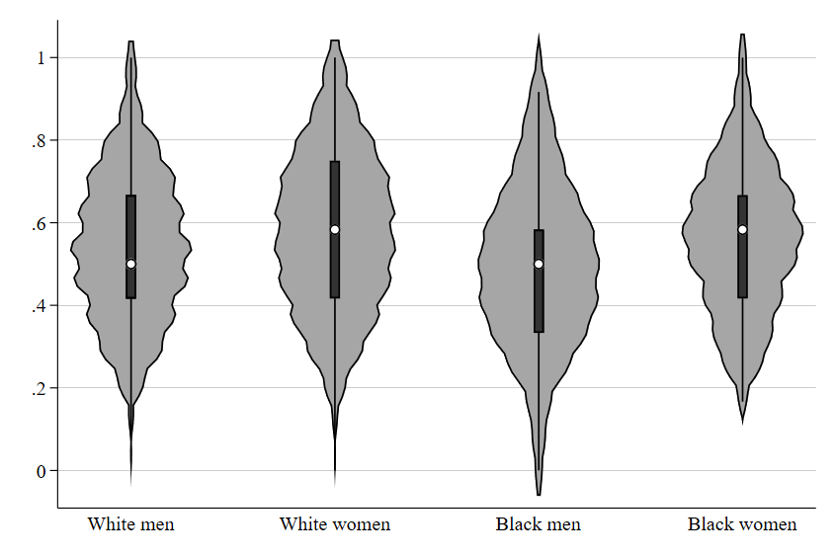

Table 2A: Gender, Race, Risk, and Religiosity
 | White men | White women | Black men | Black women
Risk | 0.219 | 0.241^ | 0.377 | -0.134
 | (0.153) | (0.136) | (0.352) | (0.349)
Education | 0.105*** | 0.017 | 0.044 | 0.009
 | (0.030) | (0.029) | (0.091) | (0.072)
Income | -0.037 | -0.029 | 0.115 | 0.096
 | (0.032) | (0.032) | (0.085) | (0.078)
Age | 0.037 | 0.162*** | 0.012 | 0.094
 | (0.030) | (0.028) | (0.077) | (0.067)
Married | 0.351*** | 0.118* | 0.472** | -0.014
 | (0.065) | (0.057) | (0.148) | (0.132)
Constant | -0.419*** | -0.250** | -0.144 | 0.636**
 | (0.094) | (0.087) | (0.200) | (0.214)
Observations | 971 | 1011 | 144 | 178
R² | 0.058 | 0.043 | 0.128 | 0.022
Standard errors in parentheses
^ p<.10, * p<.05, ** p<.01, *** p<.001

Table 3A: Gender, Race, Risk, and Participation
 | White men | White women | Black men | Black women
Risk | -0.605*** | -0.422** | -0.226 | -1.314**
 | (0.170) | (0.136) | (0.511) | (0.432)
Education | 0.071* | 0.028 | -0.102 | -0.183*
 | (0.034) | (0.029) | (0.131) | (0.089)
Income | 0.043 | 0.071* | -0.018 | -0.130
 | (0.036) | (0.032) | (0.124) | (0.097)
Age | -0.134*** | -0.058* | -0.329** | -0.146^
 | (0.034) | (0.028) | (0.112) | (0.083)
Married | 0.068 | -0.035 | 0.204 | -0.102
 | (0.072) | (0.057) | (0.214) | (0.163)
Constant | 0.305** | 0.083 | 0.322 | 0.859**
 | (0.105) | (0.087) | (0.290) | (0.265)
Observations | 971 | 1011 | 144 | 178
R² | 0.048 | 0.027 | 0.084 | 0.104
Standard errors in parentheses
^ p<.10, * p<.05, ** p<.01, *** p<.001

Table 4A: Triple interactions
 | Religiosity | Political Participation
Risk | 0.148 | -0.652***
 | (0.147) | (0.161)
White women | -0.021 | -0.326*
 | (0.119) | (0.130)
Black men | 0.320 | 0.169
 | (0.208) | (0.228)
Black women | 0.872*** | 0.429^
 | (0.226) | (0.248)
White women * risk | 0.161 | 0.255
 | (0.199) | (0.219)
Black men * risk | 0.215 | 0.451
 | (0.387) | (0.424)
Black women * risk | -0.330 | -0.416
 | (0.384) | (0.421)
Education | 0.059** | 0.025
 | (0.020) | (0.022)
Income | -0.008 | 0.045^
 | (0.021) | (0.023)
Age | 0.105*** | -0.109***
 | (0.019) | (0.021)
Married | 0.209*** | 0.014
 | (0.039) | (0.043)
Constant | -0.311*** | 0.364***
 | (0.087) | (0.095)
Observations | 2304 | 2304
R² | 0.068 | 0.069
Standard errors in parentheses
^ p<.10, * p<.05, ** p<.01, *** p<.001

Figure 2A: Race, Gender, Risk, and Participation – alternative view
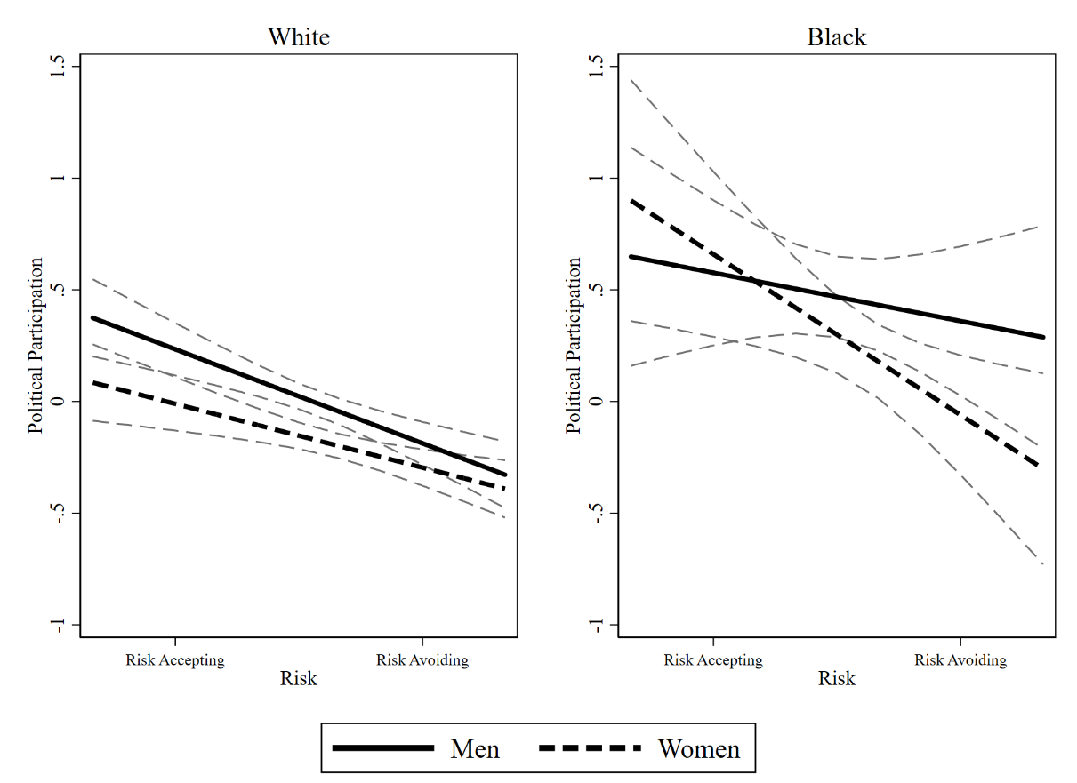

Figure 3A: Race, Gender, Risk, and Religiosity – Alternative view

