Making America Exceptional Again - Appendix
Appendix Table 1: Reliability Statistics for Civil Religious Belief Scale
 | Mean (S.D.) | Inter-Item Correlation Matrix  CRQ1 CRQ2 CRQ3 CRQ4 |  |  |  | Corrected Item-Total Correlation |  | Cronbach’s Alpha if Item Deleted
CRQ1 | 0.56 (1.45) | 1.000 | .578 | .730 | .573 | .787 | .717
CRQ2 | -0.51 (1.40) | .578 | 1.000 | .525 | .339 | .569 | .821
CRQ3 | 0.49 (1.42) | .730 | .525 | 1.000 | .509 | .726 | .748
CRQ4 | 1.04 (1.17) | .573 | .339 | .509 | 1.000 | .552 | .826
Notes: Variables are coded on a 5 point scale (-2, -1, 0, 1, 2) from Strong Disagreement to Strong Agreement. N=423. Cronbach’s Alpha = .828. The Civil Religious Belief Index was calculated by taking the mathematical average of all four responses and had a Mean (S.D.) of .397 (1.11).

Appendix Table 2: OLS Regression Analyzing Civil Religious Beliefs
Variable | B (SE)
(Constant) | -.431 (.227)
Female | .038 (.074)
Age | .065 (.021)**
Education | .039 (.029)
Pol. Know. | .040 (.023)
White | -.111 (.099)
Income | -.076 (.029)**
Income Missing | -.255 (.148)
Catholic | -.005 (.108)
Protestant | .052 (.136)
Other Religion | -.126 (.145)
Atheist | -.638 (.200)**
Agnostic | -.261 (.194)
Unaffiliated | -.016 (.152)
Relig. Import. | .250 (.047)***
Party ID | -.008 (.025)
Ideology | .057 (.030)
Racial Resent. | .221 (.046)***
Authoritarianism | .285 (.053)***
Resent Feminist | .000 (.043)
Adj. R² | .619
N | 382
Notes: Significance levels are presented as: *<.05, **<.010, ***<.001. Other Religion reflects those who self-identify as Jewish, Muslim, Orthodox, Buddhist, Hindu, Mormon, or “Some Other Religion.” Born Again Christians were coded as a mutually exclusive entity and serve as the reference category for religious affiliation.
Appendix Figure 1: Response Distribution for Trump Affect Scale
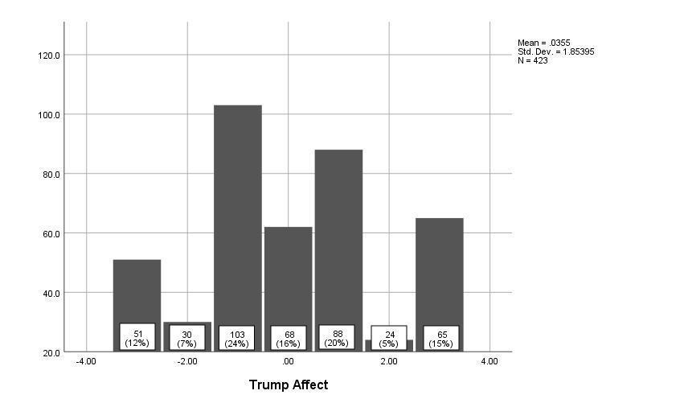
Variable Description and Summary Statistics
Trump’s hostile rhetoric and support for violence against his political opponents (Keneally, 2018) has led some to investigate whether his supporters were more likely to exhibit characteristics associated with Authoritarianism. Although several studies have asserted an association (MacWilliams, 2016; Choma and Hanoch, 2017; Womick et al., 2019), they have been criticized for failing to adequately account for the influence of racist/misogynistic beliefs that mitigate the influence of these authoritarian characteristics when incorporated into statistical models (Setzler and Yanus, 2018; Valentino et al., 2018). While it goes beyond the scope of this study to settle this debate, it is out of an abundance of caution that we have incorporated a measure of Authoritarianism into our statistical models.
This study also controls for a political and demographic covariates common to public opinion studies. The respondent’s age was measured with an ordinal variable reflecting categories commonly employed in the literature, while gender (Female) and race (White) were binary coded. Education was also measured with an ordinal variable while Political Knowledge was a composite measure indicating how often a respondent could correctly identify the party affiliation of their representatives in state and federal government. Family Income was also measured with an ordinal variable, but given the tendency for many survey participants to skip this question (and therefore reduce our sample size) subsequent models include an “Income Missing” binary variable to account for those that refused to answer this question. The participant’s “Religiosity” was operationalized by asking “How important is religion in your life” and their religious affiliation was binary coded (Christian). Finally, this study also includes measures of the respondents’ party affiliation and ideological orientation.
Appendix Table 3: Summary Statistics of Variables
Variable | Mean | SD | Min. | Max. | N
Female | 0.58 | 0.49 | 0 | 1 | 423
Age | 5.69 | 1.84 | 1 | 8 | 423
Education | 3.74 | 1.49 | 1 | 6 | 423
Political Knowledge | 4.65 | 1.87 | 0 | 6 | 415
White | 0.81 | 0.38 | 0 | 1 | 423
Income | 2.72 | 1.47 | 1 | 6 | 382
Christian | 0.56 | 0.49 | 0 | 1 | 423
Religious Importance | 1.67 | 1.19 | 0 | 3 | 423
Party | -0.10 | 2.24 | -3 | 3 | 410
Ideology | 0.17 | 1.98 | -3 | 3 | 404
Authoritarianism | -0.04 | 0.97 | -2 | 2 | 419
Resentment of Feminism | 0.00 | 1.12 | -2 | 2 | 420
Racial Resentment | 0.14 | 1.29 | -2 | 2 | 421
Trump Approval | -0.22 | 1.74 | -2 | 2 | 423
Trump Affect | 0.03 | 1.85 | -3 | 3 | 423

Appendix Table 4: Regression Analyzing Trump Approval with Three-Way Interaction
 | Model 1 | Model 2 | Model 3
Variable | B (SE) | B (SE) | B (SE)
(Constant) | -.767 (.289)** | -.735 (.288)* | -.788 (.288)**
Female | .023 (.107) | .011 (.107) | .009 (.107)
Age | .054 (.031) | .058 (.031) | .059 (.031)
Education | .000 (.041) | -.004 (.041) | -.007 (.041)
Pol. Know. | .026 (.034) | .029 (.034) | .037 (.034)
White | .162 (.144) | .121 (.146) | .102 (.146)
Income | -.077 (.042) | -.079 (.042) | -.077 (.041)
Income Missing | -.241 (.214) | -.270 (.214) | -.279 (.214)
Christian | -.072 (.136) | -.073 (.136) | -.082 (.135)
Relig. Import. | .055 (.063) | .060 (.062) | .059 (.063)
Party ID | .210 (.037)*** | .210 (.037)*** | .198 (.037)***
Ideology | .190 (.044)*** | .191 (.043)*** | .194 (.043)***
Authoritarianism | .113 (.079) | .113 (.079) | .107 (.079)
Resent Feminist | .257 (.061)*** | .211 (.064)** | .300 (.073)***
Racial Resent. | .302 (.069)*** | .337 (.068)*** | .332 (.071)***
Civil Religion | -.022 (.075) | -.016 (.075) | .064 (.081)
CR * Race Resent. | .080 (.040)* | - | .019 (.049)
CR * Resent Fem. | - | .100 (.043)* | .083 (.059)
Racial * Res.Fem. | - | - | .022 (.046)
CR * Racial * Res Fem | - | - | -.086 (.035)*
Adj. R² | .682 | .683 | .686
N | 382 | 382 | 382
Notes: Significance levels are presented as: *<.05, **<.010, ***<.001. “Christian” reflects those who identify as Catholic, Protestant, and/or Born-Again Christian.

Appendix Table 5: Regression Analyzing Trump Affect with Three-Way Interaction
 | Model 1 | Model 2 | Model 3
Variable | B (SE) | B (SE) | B (SE)
(Constant) | -.003 (.314) | .070 (.316) | -.031 (.314)
Female | .029 (.116) | .011 (.117) | .022 (.116)
Age | .031 (.033) | .032 (.034) | .033 (.034)
Education | -.002 (.044) | -.007 (.045) | -.006 (.044)
Pol. Know. | -.056 (.037) | -.045 (.037) | -.046 (.037)
White | .014 (.157) | -.018 (.160) | -.018 (.159)
Income | -.036 (.045) | -.043 (.046) | -.036 (.045)
Income Missing | -.249 (.232) | -.288 (.235) | -.272 (.233)
Christian | .011 (.148) | .002 (.149) | .000 (.148)
Relig. Import. | -.017 (.068) | -.001 (.069) | -.015 (.068)
Party ID | .185 (.040)*** | .196 (.040)*** | .176 (.040)***
Ideology | .219 (.047)*** | .212 (.048)*** | .220 (.047)***
Authoritarianism | .224 (.086)* | .219 (.087)* | .218 (.086)*
Resent Feminist | .225 (.067)** | .169 (.070)* | .286 (.079)***
Racial Resent. | .280 (.075)*** | .340 (.075)*** | .294 (.077)***
Civil Religion | .084 (.081) | .082 (.082) | .158 (.089)
CR * Race Resent. | .154 (.043)*** | - | .125 (.054)*
CR * Resent Fem. | - | .110 (.047)* | .031 (.065)
Racial * Res.Fem. | - | - | .014 (.050)
CR * Racial * Res Fem | - | - | -.078 (.038)*
Adj. R² | .682 | .683 | .686
N | 382 | 382 | 382
Notes: Significance levels are presented as: *<.05, **<.010, ***<.001. “Christian” reflects those who identify as Catholic, Protestant, and/or Born-Again Christian.

Appendix Figure 2: Estimated Marginal Means: Trump Approval

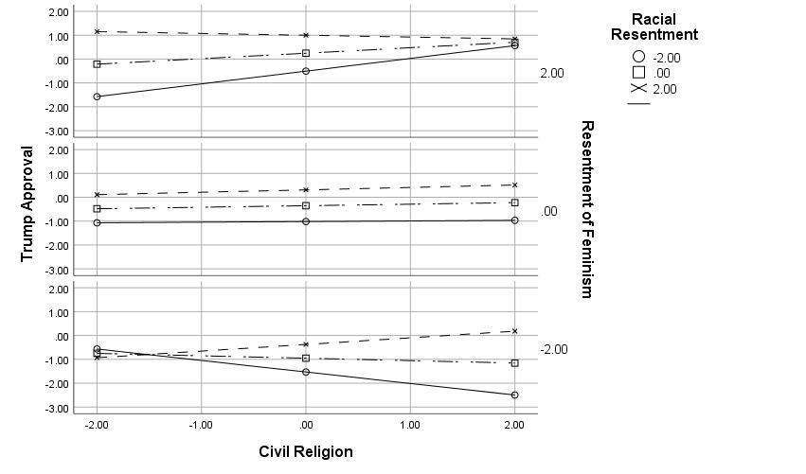

Appendix Figure 3: Estimated Marginal Means: Trump Affect
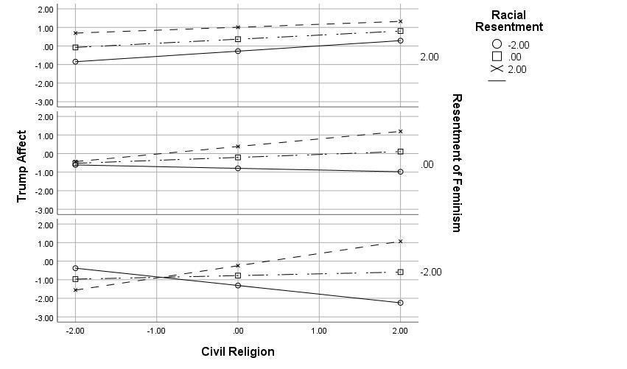
Verifying the Linearity of Interaction Effects
In conducting our analysis we assume that the interaction between civil religious beliefs and racial resentment/resentment of feminism is linear and has a constant rate of change. Hainmueller, Mummolo, and Xu (2018) demonstrate that such assumptions are often faulty and provide a statistical package to assess their validity. Appendix Figures 4a, 4b, and 4c depict the LID, Binning, and Kernel Plots of such an analysis (respectively) and validate the veracity of these assumptions in our models.
Appendix Figure 4a
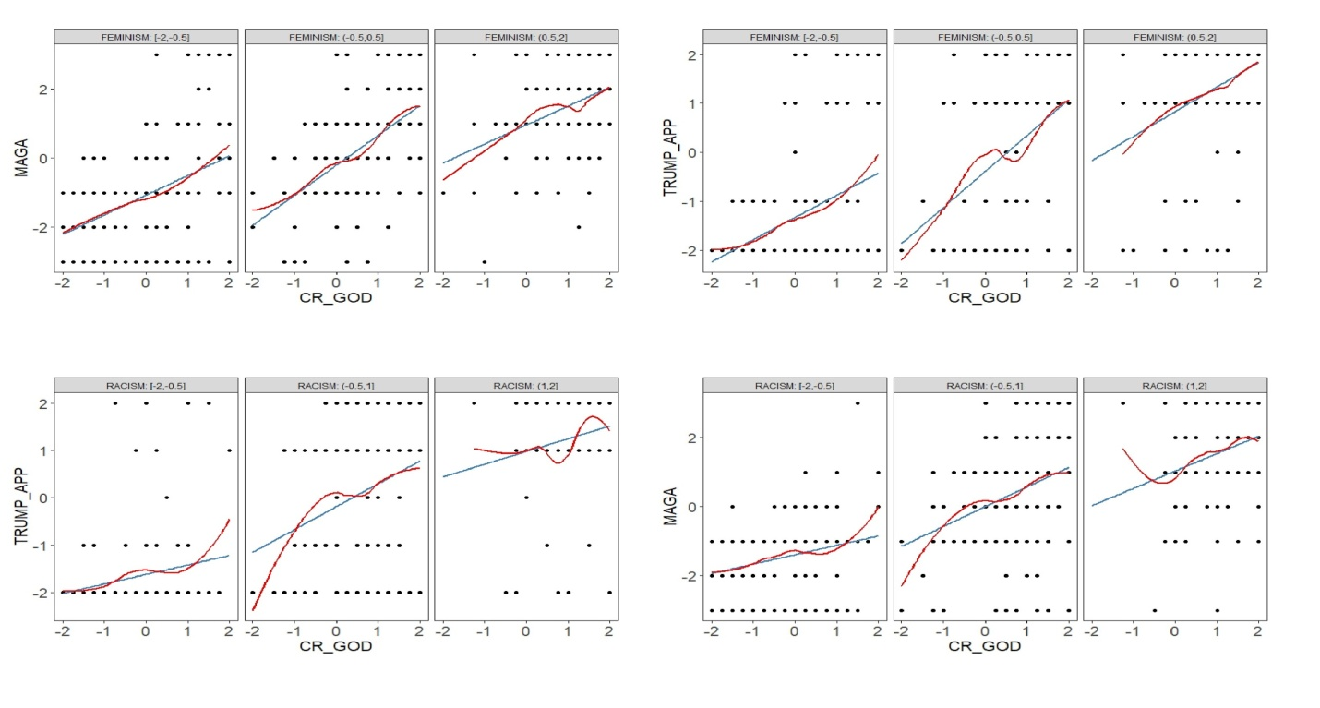

Appendix Figure 4b
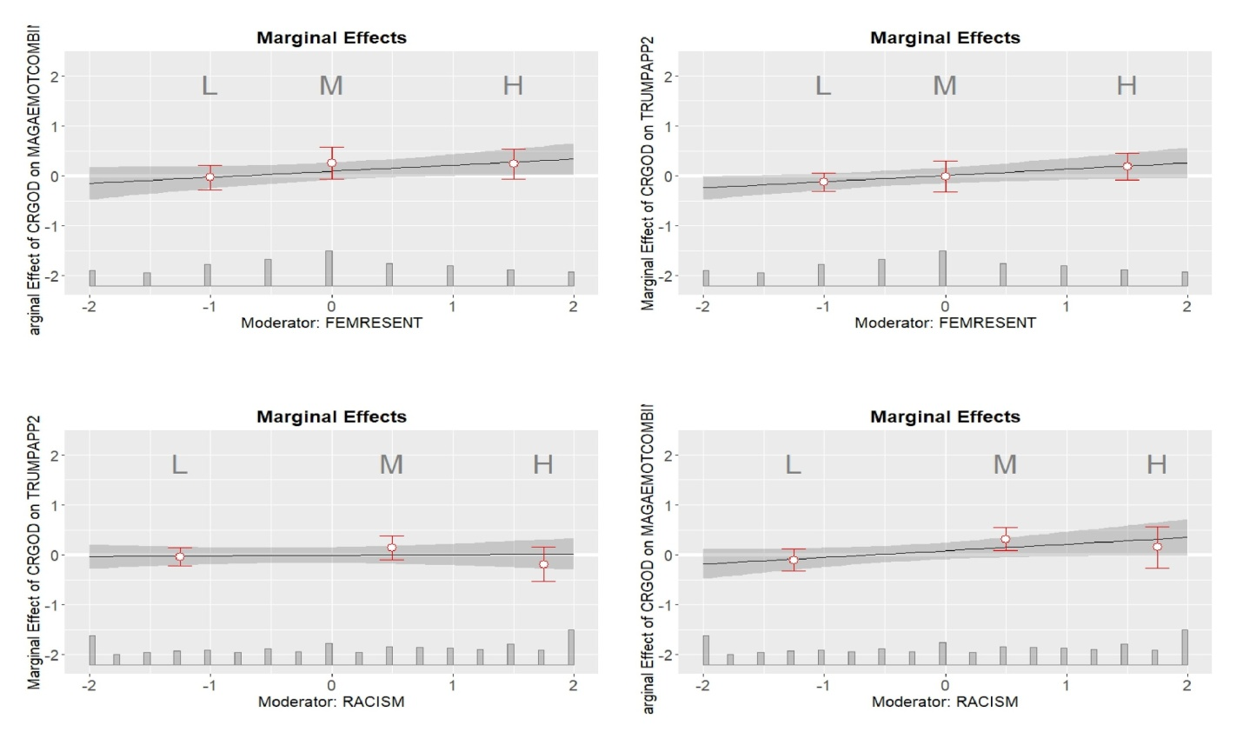

Appendix Figure 4c

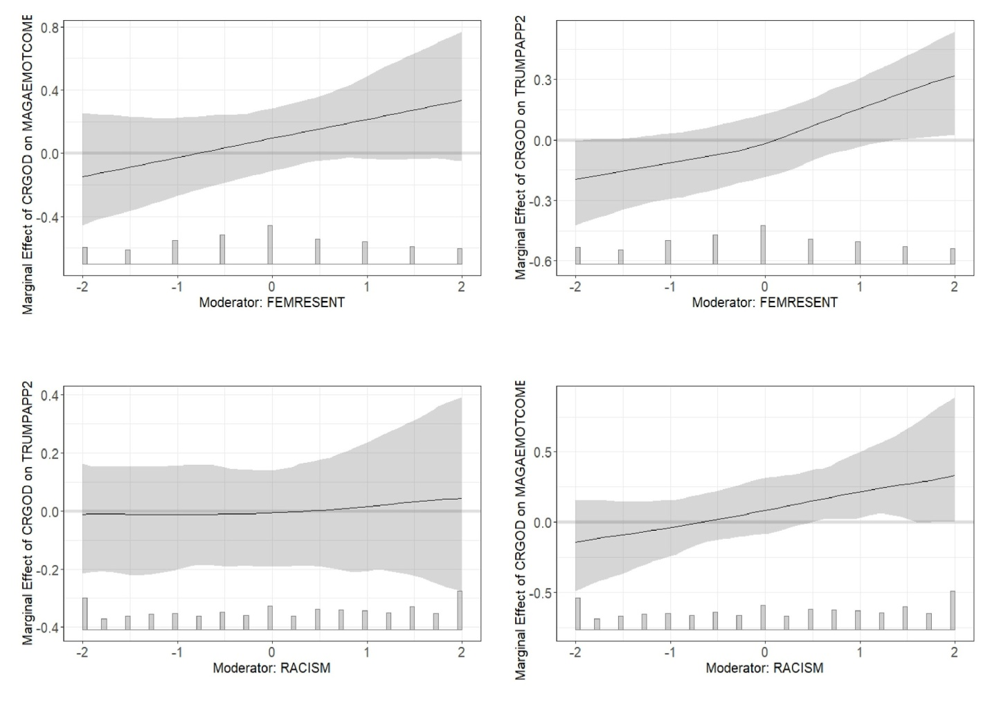

Robustness Check: Republican/Democratic Governors
As a robustness check that the interactions detected in this work are unique to Donald Trump (as opposed to other political figures who have not adopted his rhetorical strategy) we conducted a similar analysis of public approval of Republican and Democratic governors during the pre-election wave of the 2018 CCES. Participants were asked “Do you approve or disapprove of the way the governor of [state] is doing their job.” Responses were scaled in the same fashion as our Trump approval variable (e.g. -2 = Strongly Disapprove, -1 = Somewhat Disapprove, 0 = Not sure, 1 = Somewhat Approve, 2 = Strongly Approve.) We then stratified the sample to isolate participants who reside in states with a Republican or Democratic governor and conducted the same OLS regression analyses as the Trump approval variable (e.g. one model with a Civil Religion and Racial Resentment interaction and another with a Civil Religion and Resentment of Feminism interaction). Our analysis failed to detect a significant interaction effect in either model. We are therefore confident that the relationships hypothesized in our manuscript are unique to Donald Trump.

Appendix Table 6: Regression Analyzing Governor Approval
 | Republican Gov | Republican Gov | Democratic Gov | Democratic Gov
Variable | B (SE) | B (SE) | B (SE) | B (SE)
(Constant) | -.781 (.485) | -.791 (.482) | -.196 (.439) | -.248 (.439)
Female | .106 (.176) | .107 (.175) | .009 (.163) | .017 (.163)
Age | -.054 (.052) | -.053 (.051) | -.034 (.047) | -.030 (.047)
Education | .105 (.067) | .099 (.067) | .011 (.062) | .013 (.062)
Pol. Know. | .111 (.055)* | .109 (.055)* | .019 (.052) | .009 (.052)
White | -.079 (.227) | -.126 (.229) | .188 (.219) | .177 (.222)
Income | .063 (.068) | .072 (.067) | .036 (.063) | .040 (.063)
Income Missing | .327 (.347) | .327 (.344) | .105 (.325) | .117 (.326)
Christian | -.447 (.221)* | -.447 (.220)* | -.096 (.206) | -.086 (.207)
Relig. Import. | .026 (.106) | .033 (.105) | .017 (.095) | .004 (.095)
Party ID | .217 (.059)*** | .211 (.058)*** | .177 (.056)** | .164 (.056)**
Ideology | .224 (.073)** | .221 (.072)** | -.035 (.066) | -.026 (.066)
Authoritarianism | .092 (.139) | .098 (.138) | -.029 (.120) | -.023 (.121)
Resent Feminist | -.040 (.067) | -.083 (.105) | -.163 (.093) | -.150 (.097)
Racial Resent. | .268 (.115)* | .284 (.113)* | .067 (.105) | .036 (.104)
Civil Religion | .018 (.129) | .031 (.128) | .173 (.114) | .182 (.114)
CR * Race Resent. | .009 (.065) | - | -.093 (.060) | -
CR * Resent Fem. | - | .086 (.071) | - | -.016 (.065)
Adj. R² | .451 | .455 | .033 | .027
N | 210 | 210 | 382 | 382
Notes: Significance levels are presented as: *<.05, **<.010, ***<.001. “Christian” reflects those who identify as Catholic, Protestant, and/or Born-Again Christian.

The Interaction between Civil Religious Beliefs and Party ID/Ideology
Appendix Tables 6 and 7 present the results of an alternative specification in which civil religious beliefs are interacted with Ideology and Party ID (respectively) in analyzing Trump Approval. Appendix Tables 8 and 9 present similar results for an analysis of emotional reactions to Trump’s “Make America Great Again” slogan. They demonstrate that Republicans and Conservatives express significantly more approval of Donald Trump and more positive emotions towards his campaign slogan across all model specifications. As was the case with the results presented in the main body of the manuscript, civil religious beliefs have a significant effect in models 1 and 2, but not in model 3 for each of these analyses. Interestingly, while the interaction between civil religious beliefs and ideology was significant in each model, the interaction between civil religious beliefs and Party ID was not significant in model 2. In other words, while civil religious beliefs significantly exacerbated the effects of Ideology, a similar effect for Party ID only emerges once other control variables are introduced (which raises the possibility that these control variables are artificially increasing the significance of the interaction).
Substantively, these results are consistent with the broader theoretical argument presented in this manuscript. In recent years, Liberals/Democrats and Conservatives/Republicans have grown increasingly polarized on issues related to gender and racial equality. While it would be inaccurate to suggest that racial and gender resentments are exclusively held by Conservatives and Republicans, it is certainly the case that their political leaders have been more likely to implicitly or explicitly express these sentiments. As such these results may be interpreted as circumstantial evidence that Donald Trump’s traditional jeremiad similarly exacerbates the attitudes of civil religious partisans/ideologues.
Appendix Table 7: Regression Analyzing Trump Approval with CR/Ideology Interaction
 | Model 1 | Model 2 | Model 3
Variable | B (SE) | B (SE) | B (SE)
(Constant) | -.424 (.064)*** | -.514 (.075)*** | -.757 (.288)**
Female | - | - | .015 (.107)
Age | - | - | .055 (.031)
Education | - | - | .003 (.041)
Pol. Know. | - | - | .019 (.034)
White | - | - | .150 (.144)
Income | - | - | -.073 (.042)
Income Missing | - | - | -.237 (.214)
Christian | - | - | -.089 (.136)
Relig. Import. | - | - | .065 (.063)
Party ID | - | - | .216 (.036)***
Ideology | .528 (.037)*** | .499 (.039)*** | .155 (.045)**
Authoritarianism | - | - | .113 (.079)
Resent Feminist | - | - | .258 (.061)***
Racial Resent. | - | - | .332 (.068)***
Civil Religion | .301 (.066)*** | .325 (.067)*** | -.015 (.075)
CR * Ideology | - | .063 (.029)* | .060 (.025)*
Adj. R² | .528 | .536 | .683
N | 403 | 403 | 382
Notes: Significance levels are presented as: *<.05, **<.010, ***<.001. “Christian” reflects those who identify as Catholic, Protestant, and/or Born-Again Christian.

Appendix Table 8: Regression Analyzing Trump Approval with CR/Party ID Interaction
 | Model 1 | Model 2 | Model 3
Variable | B (SE) | B (SE) | B (SE)
(Constant) | -.317 (.060)*** | -.390 (.071)*** | -.793 (.288)**
Female | - | - | .025 (.107)
Age | - | - | .055 (.031)
Education | - | - | .006 (.041)
Pol. Know. | - | - | .020 (.034)
White | - | - | .153 (.144)
Income | - | - | -.075 (.041)
Income Missing | - | - | -.234 (.213)
Christian | - | - | -.071 (.135)
Relig. Import. | - | - | .057 (.062)
Party ID | .491 (.028)*** | .456 (.033)*** | .172 (.040)***
Ideology | - | - | .195 (.040)***
Authoritarianism | - | - | .111 (.079)
Resent Feminist | - | - | .249 (.061)***
Racial Resent. | - | - | .328 (.068)***
Civil Religion | .360 (.057)*** | .397 (.060)*** | .011 (.076)
CR * Party ID | - | .049 (.026) | .068 (.024)**
Adj. R² | .587 | .589 | .685
N | 409 | 409 | 382
Notes: Significance levels are presented as: *<.05, **<.010, ***<.001. “Christian” reflects those who identify as Catholic, Protestant, and/or Born-Again Christian. CR*Party ID in Model 2 approached statistical significance (p=.054)

Appendix Table 9: Regression Analyzing Trump Affect with CR/Ideology Interaction
 | Model 1 | Model 2 | Model 3
Variable | B (SE) | B (SE) | B (SE)
(Constant) | -.223 (.068)** | -.327 (.080)*** | .034 (.314)
Female | - | - | .015 (.117)
Age | - | - | .030 (.033)
Education | - | - | .001 (.044)
Pol. Know. | - | - | -.061 (.038)
White | - | - | .006 (.157)
Income | - | - | -.033 (.045)
Income Missing | - | - | -.248 (.233)
Christian | - | - | -.018 (.148)
Relig. Import. | - | - | .002 (.068)
Party ID | - | - | .200 (.040)***
Ideology | .538 (.039)*** | .504 (.042)*** | .163 (.049)**
Authoritarianism | - | - | .221 (.086)*
Resent Feminist | - | - | .224 (.067)**
Racial Resent. | - | - | .336 (.074)***
Civil Religion | .391 (.071)*** | .418 (.071)*** | .089 (.082)
CR * Ideology | - | .073 (.030)* | .087 (.027)**
Adj. R² | .532 | .538 | .674
N | 403 | 403 | 382
Notes: Significance levels are presented as: *<.05, **<.010, ***<.001. “Christian” reflects those who identify as Catholic, Protestant, and/or Born-Again Christian.

Appendix Table 10: Regression Analyzing Trump Affect with CR/Party ID Interaction
 | Model 1 | Model 2 | Model 3
Variable | B (SE) | B (SE) | B (SE)
(Constant) | -.098 (.066) | -.164 (.078)* | .002 (.315)
Female | - | - | .027 (.117)
Age | - | - | .028 (.033)
Education | - | - | .004 (.045)
Pol. Know. | - | - | -.056 (.037)
White | - | - | .017 (.157)
Income | - | - | -.037 (.045)
Income Missing | - | - | -.247 (.234)
Christian | - | - | .005 (.148)
Relig. Import. | - | - | -.006 (.068)
Party ID | .487 (.031)*** | .456 (.036)*** | .151 (.044)**
Ideology | - | - | .217 (.048)***
Authoritarianism | - | - | .216 (.086)*
Resent Feminist | - | - | .211 (.067)**
Racial Resent. | - | - | .330 (.074)***
Civil Religion | .470 (.062)*** | .503 (.065)*** | .114 (.083)
CR * Party ID | - | .044 (.028) | .079 (.026)**
Adj. R² | .572 | .573 | .674
N | 409 | 409 | 382
Notes: Significance levels are presented as: *<.05, **<.010, ***<.001. “Christian” reflects those who identify as Catholic, Protestant, and/or Born-Again Christian.

Adorno et al., (1950) introduced the study of the Authoritarian personality to describe traits associated with support for ethnocentrism, anti-democratic ideas, and hostility towards those that challenge traditional social norms and hierarchies. In the ensuing decades, scholars seeking to refine its theoretical underpinnings and measurement have developed “Right-Wing Authoritarianism” and “Social Dominance Orientation.” The former reflects a desire for obedience and respect for authority figures and social conventions (Altemeyer, 1981); the latter captures preferences for the development and maintenance of group-based hierarchies (Pratto et al., 1994).
However, Smith and Hanley (2018) demonstrate that a desire for a “Domineering Leader” had a strong effect on support for Trump even after controlling for these alternative explanations.
“Authoritarianism” is a five-point scale reflecting the average level of agreement with four statements commonly employed in the American National Election Study and administered in our unique module during the post-election wave of the survey. Responses were recoded so that positive values indicated higher levels of authoritarianism. (1) “Our country needs free thinkers who will have the courage to defy traditional ways, even if this upsets many people”; (2) “Our country would be great if we honor the ways of our forefathers, do what the authorities tell us to do, and get rid of the ‘rotten apples’ who are ruining everything”; (3) “What our country really needs is a strong, determined leader who will crush evil and take us back to our true path”; (4) “Having a strong leader in government is good for the United States even if the leader bends the rules to get things done.”
Age categories: 1 = 18-20; 2 = 21-24; 3 = 25-29; 4 = 30-39; 5 = 40-49; 6 = 50-59; 7 = 60-64; 8 = 65+.
Education categories: 1 = Did not graduate from high school; 2 = High school graduate; 3 = Some college, but no degree (yet); 4 = Two year degree; 5 = Four year degree; 6 = Postgraduate degree (MA, MBA, MD, JD, PhD, etc.).
Political knowledge is often operationalized by adding together the number of correct responses to a series of questions about the American system of government, identifying prominent political figures and recognizing which political party controls Congress. While most of these questions were not available in the CCES, the common content did ask participants to identify which party controlled Congress and to identify the party affiliation of their representatives in federal and state government. “Political Knowledge” therefore reflects the number of correct responses to the following questions: (1) “Which party has the majority of seats in the U.S. House of Representatives?”; (2) “Which party has the majority of seats in the U.S. Senate?”; (3) Identify the political affiliation of their state government; (4) Identify the political affiliation of their representative in the U.S. House of Representatives; (5 & 6) Identify the political affiliation of their U.S. Senators.
Family Income categories: 1 = <$30,000; 2 = $30,000 - $59,999; 3 = $60,000 - $79,999; 4 = $80,000 – $99,999; 5 = $100,000 - $149,999; 6 = >=$150,000.
Response options: 0 = Not important at all; 1 = Not too important; 2 = Somewhat important; 3 = Very important.
Christian reflects those who self-identify as “Protestant”, “Catholic”, and/or “Born-Again Christian.”
Variable was coded on a 7 point scale from -3 to +3 (-3 = Strong Democrat, 0 = Independent, and +3 = Strong Republican).
Variable was coded on a 7 point scale from -3 to +3 (-3 = Strong Liberal, 0 = Moderate, +3 = Strong Conservative).

