Coethnicity Beyond Clientelism:
Experimental Insights from a Survey of Political Behavior in Lebanon

Supplemental Appendix

Table of Contents

- Table A.1: Sample Summary Statistics
- Figure A.1: Example of Candidate Conjoint Task
- Figure A.2: Full AMCE results (DV: Rally Attendance)
- Figure A.3: Marginal Mean Results
- Figure A.4: Results by Respondent Socioeconomic Status
- Figure A.5: Results by Partisanship
- Figure A.6: Results by Type of Clientelist Service Provision
- Figure A.7: Results by Party Affiliation of Candidate Relative to Respondent
- Figure A.8: Results by Respondent Education
- Figure A.9: Results by Respondent Age Cohort
- Figure A.10: Results by Respondent Sect (Coethnicity and Policy Platform)
- Figure A.11: Results by Trust in Religious Leaders

Table A.1: Sample Summary Statistics

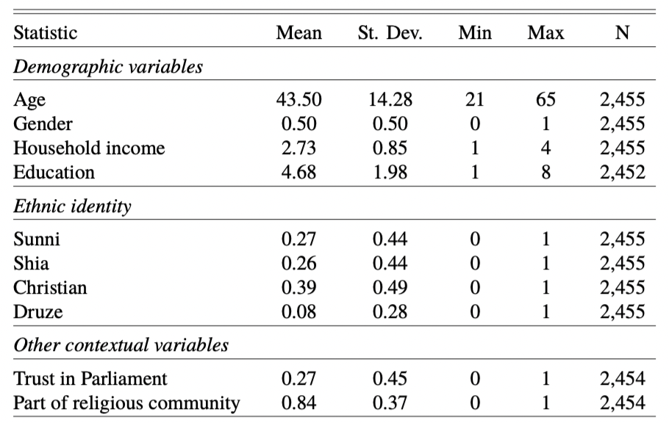

Note: Data come from a survey of nationally representative sample of 2,500 Lebanese citizens conducted in 2017. Gender indicates the percentage of female respondents. Household income is measured on a scale of 1 to 4, 1 indicating a household regularly has difficulties paying for basic items and does not save money, and 4 indicating the household does not have such difficulties and has savings. Education is measured on a scale of 1 (illiterate/no formal education) to 8 (post-graduate education completed).

Figure A.1: Example of Conjoint Task
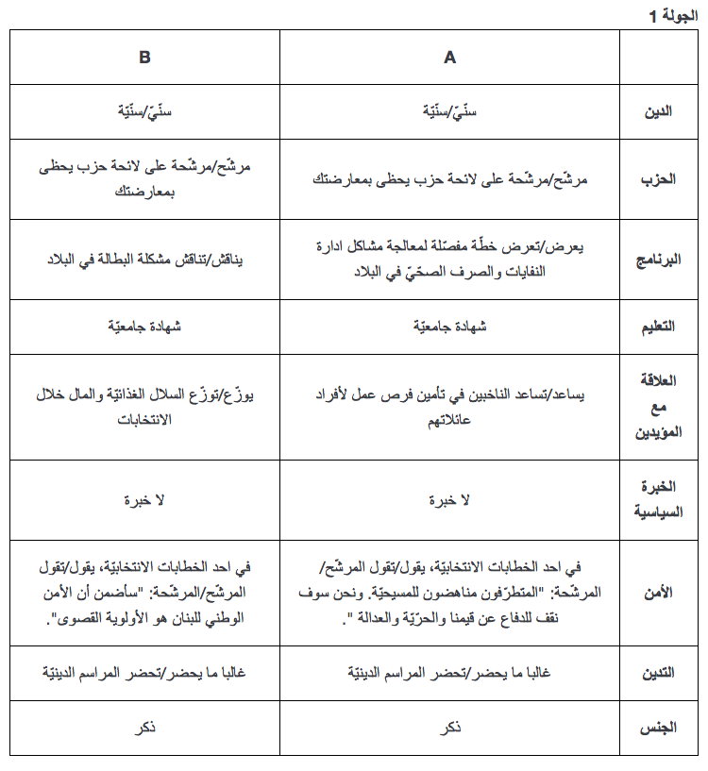
Figure A.2: Full AMCE results (DV: Rally Attendance)

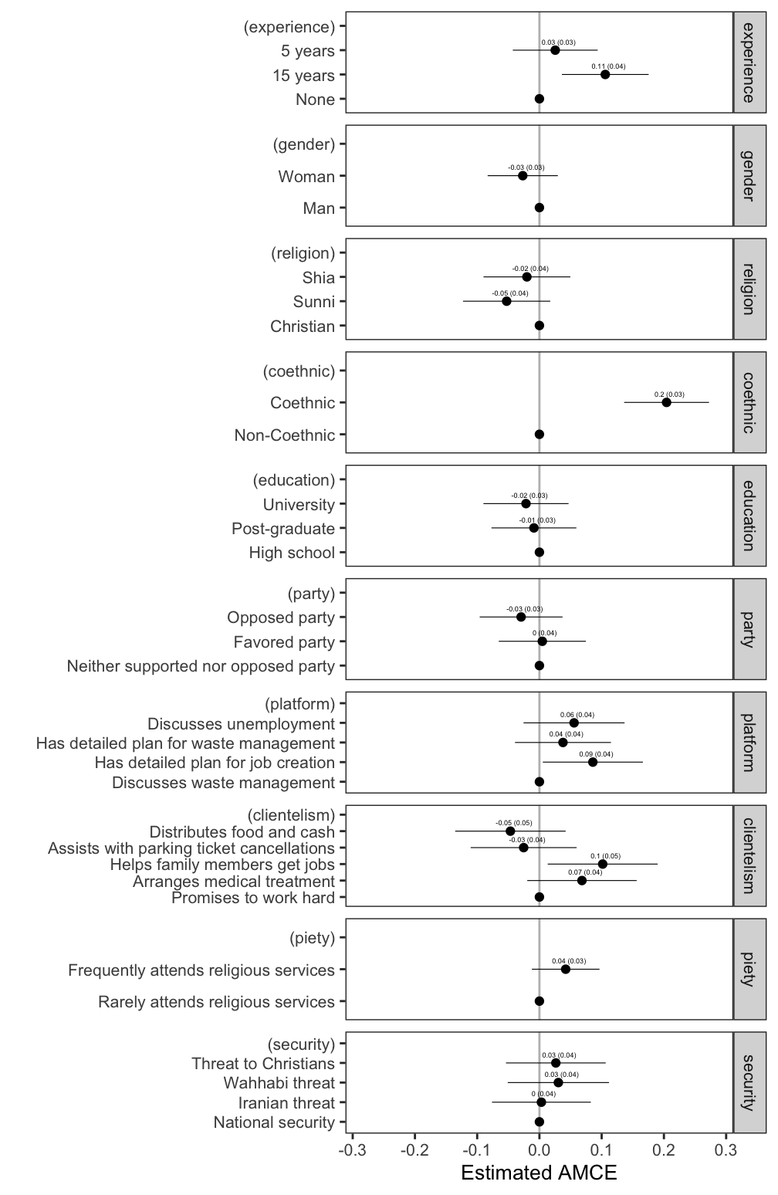

Note: Average effect of candidate attributes on respondents’ stated willingness to attend a rally for hypothetical MP candidates (1-7 scale). Points represents the estimated average marginal component effect (AMCE) of a candidate attribute on respondents’ probability of attending a rally of a candidate with that attribute, compared to a candidate with the baseline attribute quality. Horizontal bars represent 95 percent confidence intervals. All standard errors are heteroskedasticity robust and clustered at the individual level.
Figure A.3: Marginal Mean Results

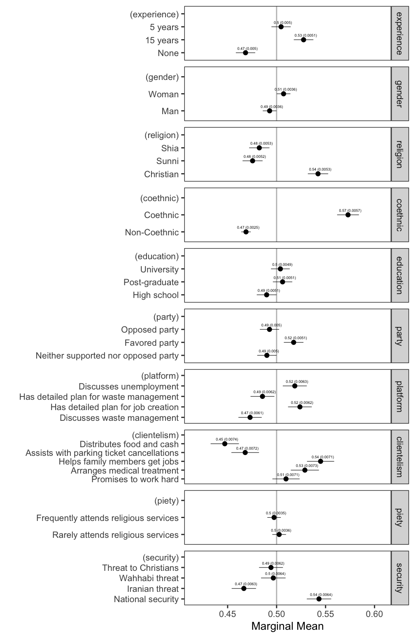
Note: Points represents the unadjusted marginal mean of electoral support for candidates with a given attribute. Marginal means, unlike AMCEs, do not restrict the baseline categories to 0 and provide information about preferences for all attribute levels, addressing concerns about results depending on the choice of baseline. In a forced choice design, like the one employed in this paper, the grand mean is 0.5 because half of all profiles shown are selected. Consequently, in figures below, marginal means above 0.5 indicate a positive preference for a candidate with a particular attribute level (e.g. a candidate prioritizing national security). Horizontal bars represent 95 percent confidence intervals. All standard errors are heteroskedasticity robust and clustered at the individual level.
Figure A.4: Results by Respondent Socioeconomic Status (Household Security)

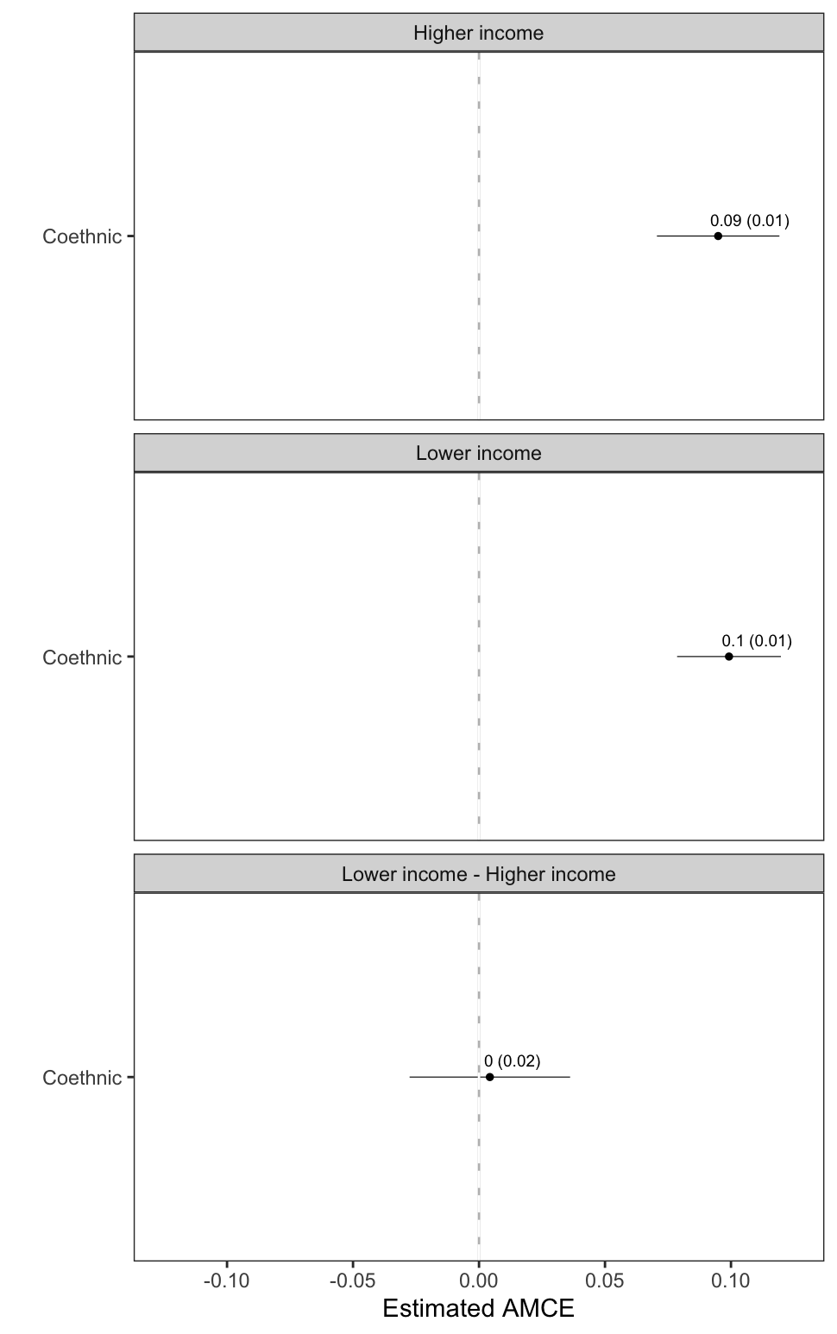

Note: Average effect of candidate attributes on respondents’ preferences for hypothetical MP candidates. Points represents the estimated average marginal component effect (AMCE) of a candidate attribute on respondents’ probability of choosing a candidate with that attribute, compared to a candidate with the baseline attribute quality. Horizontal bars represent 95 percent confidence intervals. All standard errors are heteroskedasticity robust and clustered at the individual level.

Figure A.5: Results by Respondent Partisanship

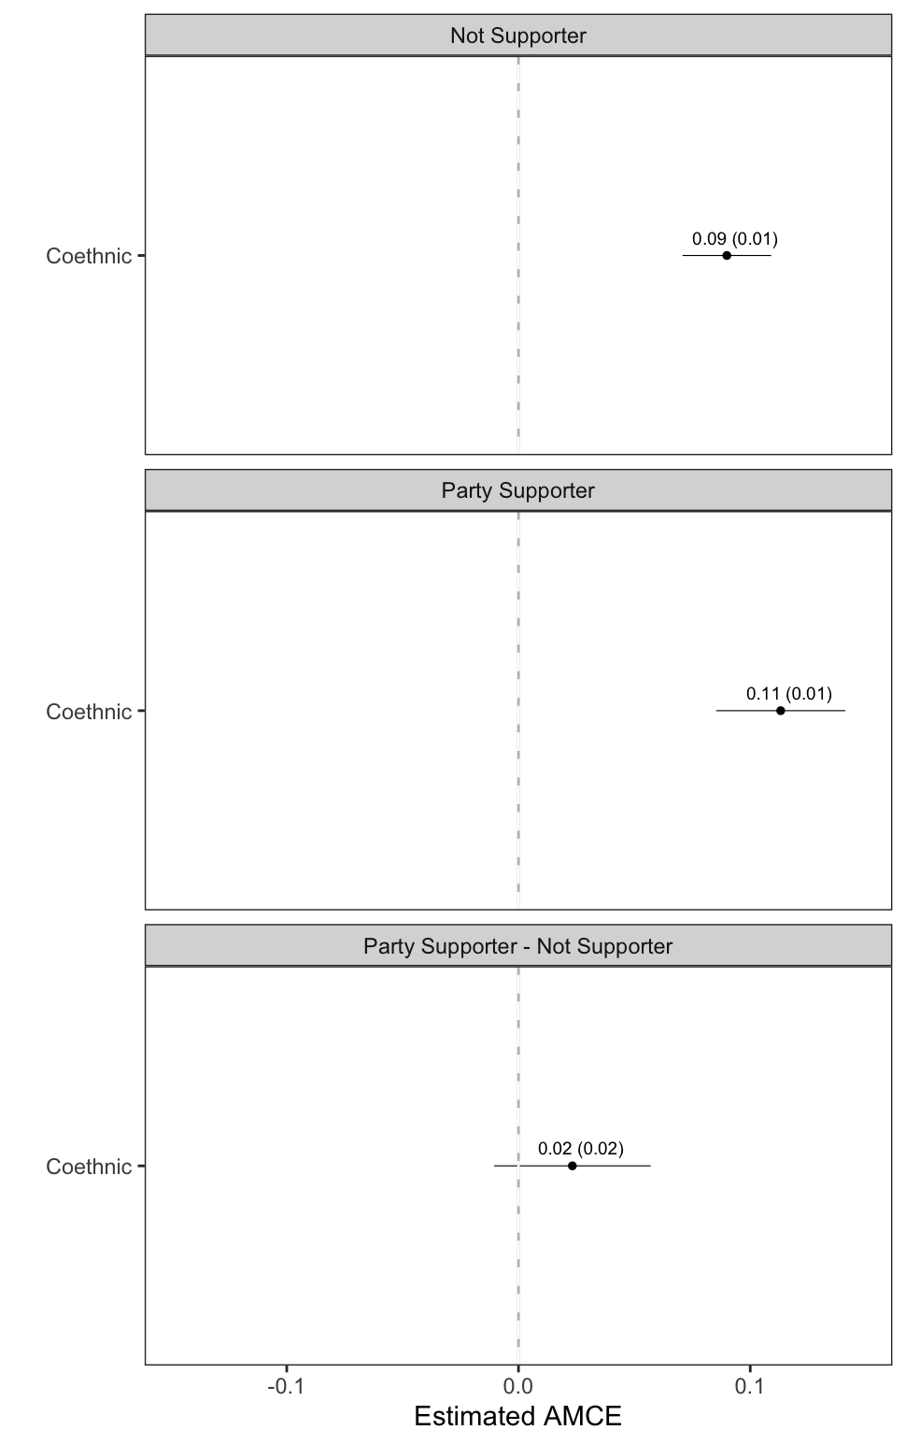

Note: Average effect of candidate attributes on respondents’ preferences for hypothetical MP candidates. Points represents the estimated average marginal component effect (AMCE) of a candidate attribute on respondents’ probability of choosing a candidate with that attribute, compared to a candidate with the baseline attribute quality. Horizontal bars represent 95 percent confidence intervals. All standard errors are heteroskedasticity robust and clustered at the individual level.

Figure A.6: Results by Type of Clientelist Service Provision

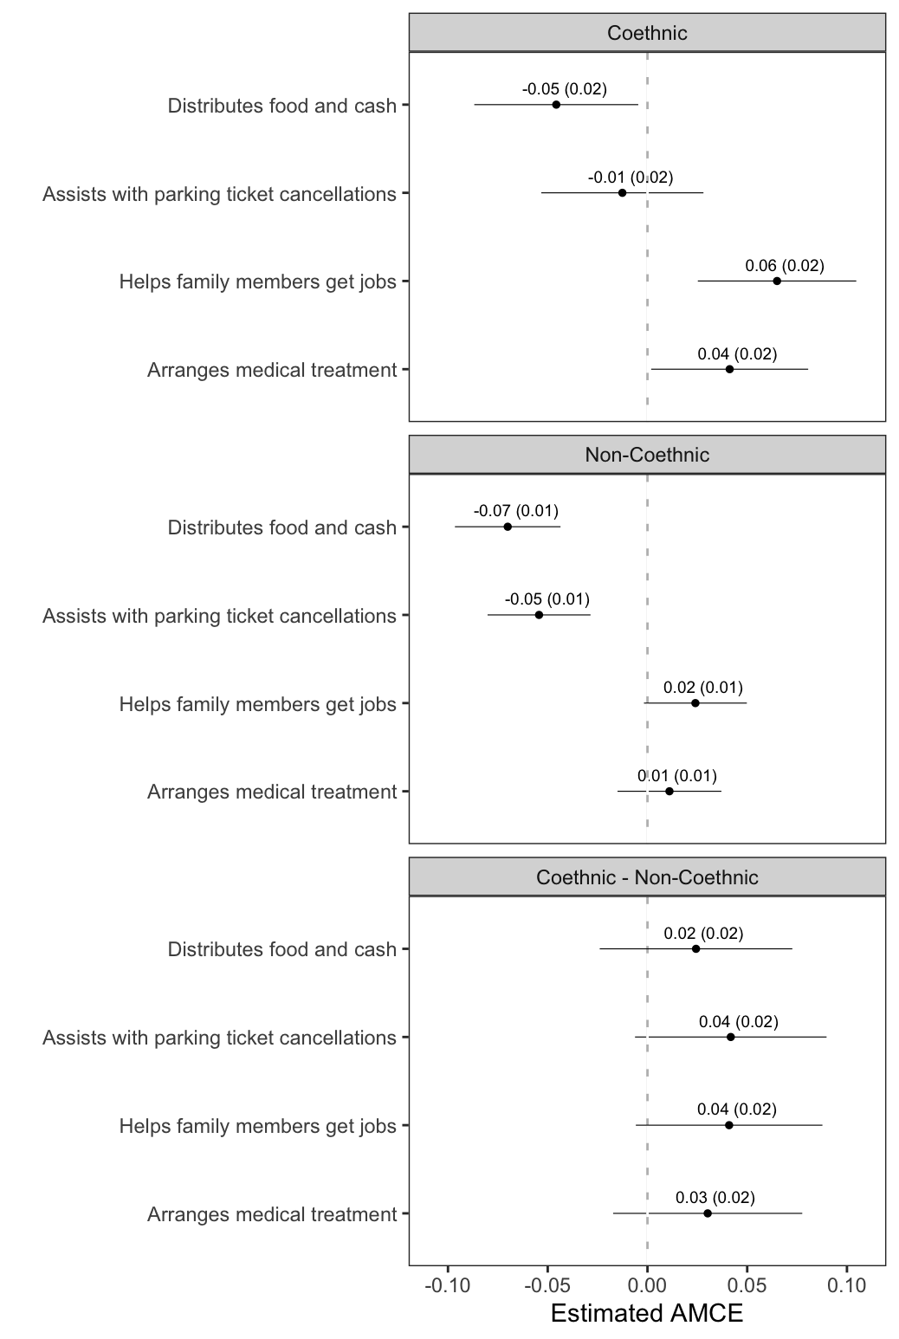

Note: Average effect of candidate attributes on respondents’ preferences for hypothetical MP candidates. Points represents the estimated average marginal component effect (AMCE) of a candidate attribute on respondents’ probability of choosing a candidate with that attribute, compared to a candidate with the baseline attribute quality. Horizontal bars represent 95 percent confidence intervals. All standard errors are heteroskedasticity robust and clustered at the individual level.
Figure A.7: Results by Party Affiliation of Candidate Relative to Respondent
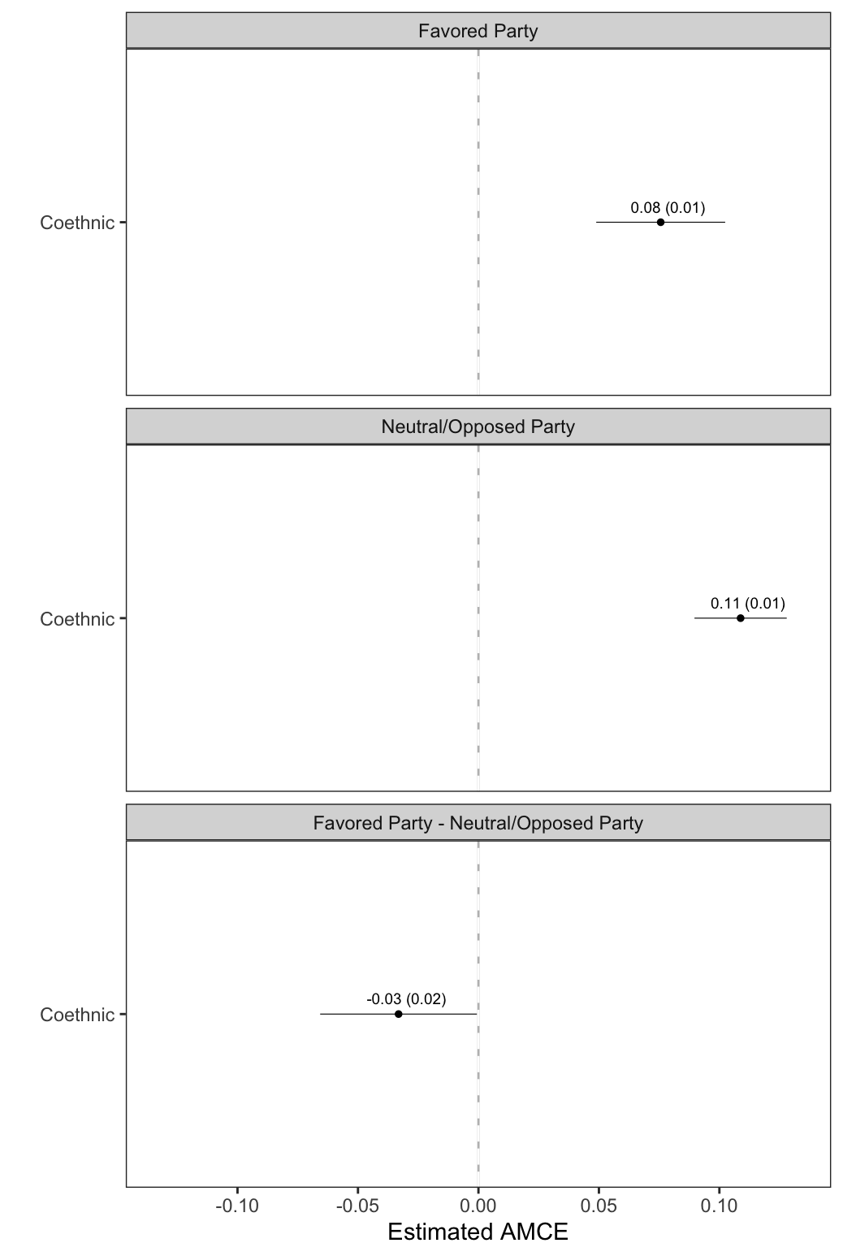

Note: Average effect of candidate attributes on respondents’ preferences for hypothetical MP candidates. Points represents the estimated average marginal component effect (AMCE) of a candidate attribute on respondents’ probability of choosing a candidate with that attribute, compared to a candidate with the baseline attribute quality. Horizontal bars represent 95 percent confidence intervals. All standard errors are heteroskedasticity robust and clustered at the individual level.

Figure A.8: Results by Respondent Education

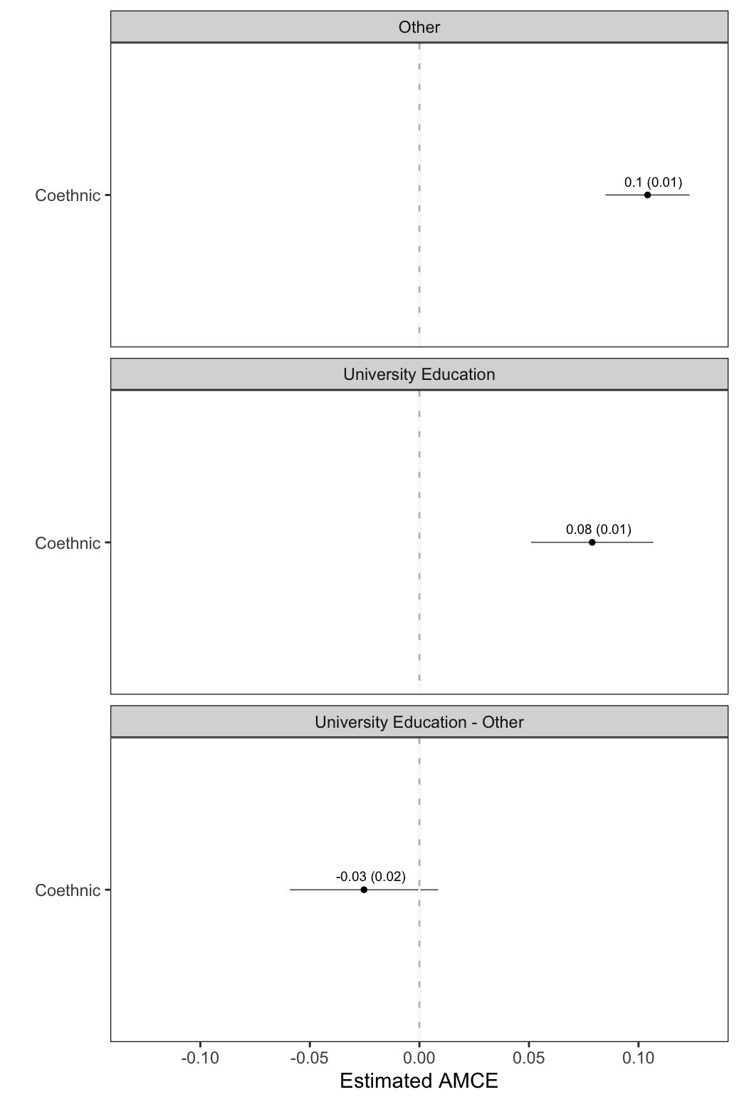

Note: Average effect of candidate attributes on respondents’ preferences for hypothetical MP candidates. Points represents the estimated average marginal component effect (AMCE) of a candidate attribute on respondents’ probability of choosing a candidate with that attribute, compared to a candidate with the baseline attribute quality. Horizontal bars represent 95 percent confidence intervals. All standard errors are heteroskedasticity robust and clustered at the individual level.

Figure A.9: Results by Respondent Age Cohort

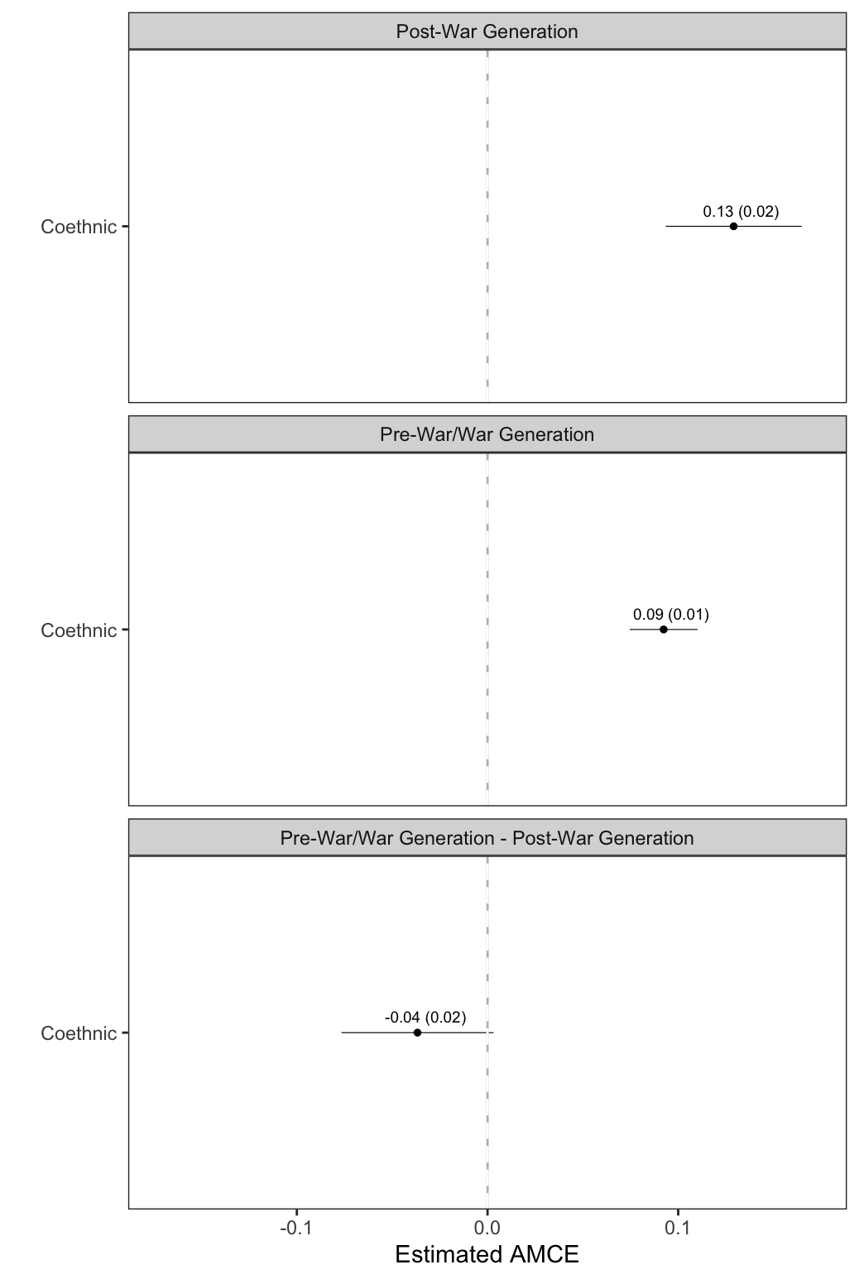

Note: Average effect of candidate attributes on respondents’ preferences for hypothetical MP candidates. Points represents the estimated average marginal component effect (AMCE) of a candidate attribute on respondents’ probability of choosing a candidate with that attribute, compared to a candidate with the baseline attribute quality. Horizontal bars represent 95 percent confidence intervals. All standard errors are heteroskedasticity robust and clustered at the individual level. Post-war generation is defined as respondents born in 1990 (the year the civil war ended) or later.

Figure A.10: Results by Respondent Sect (Coethnicity and Policy Platform)
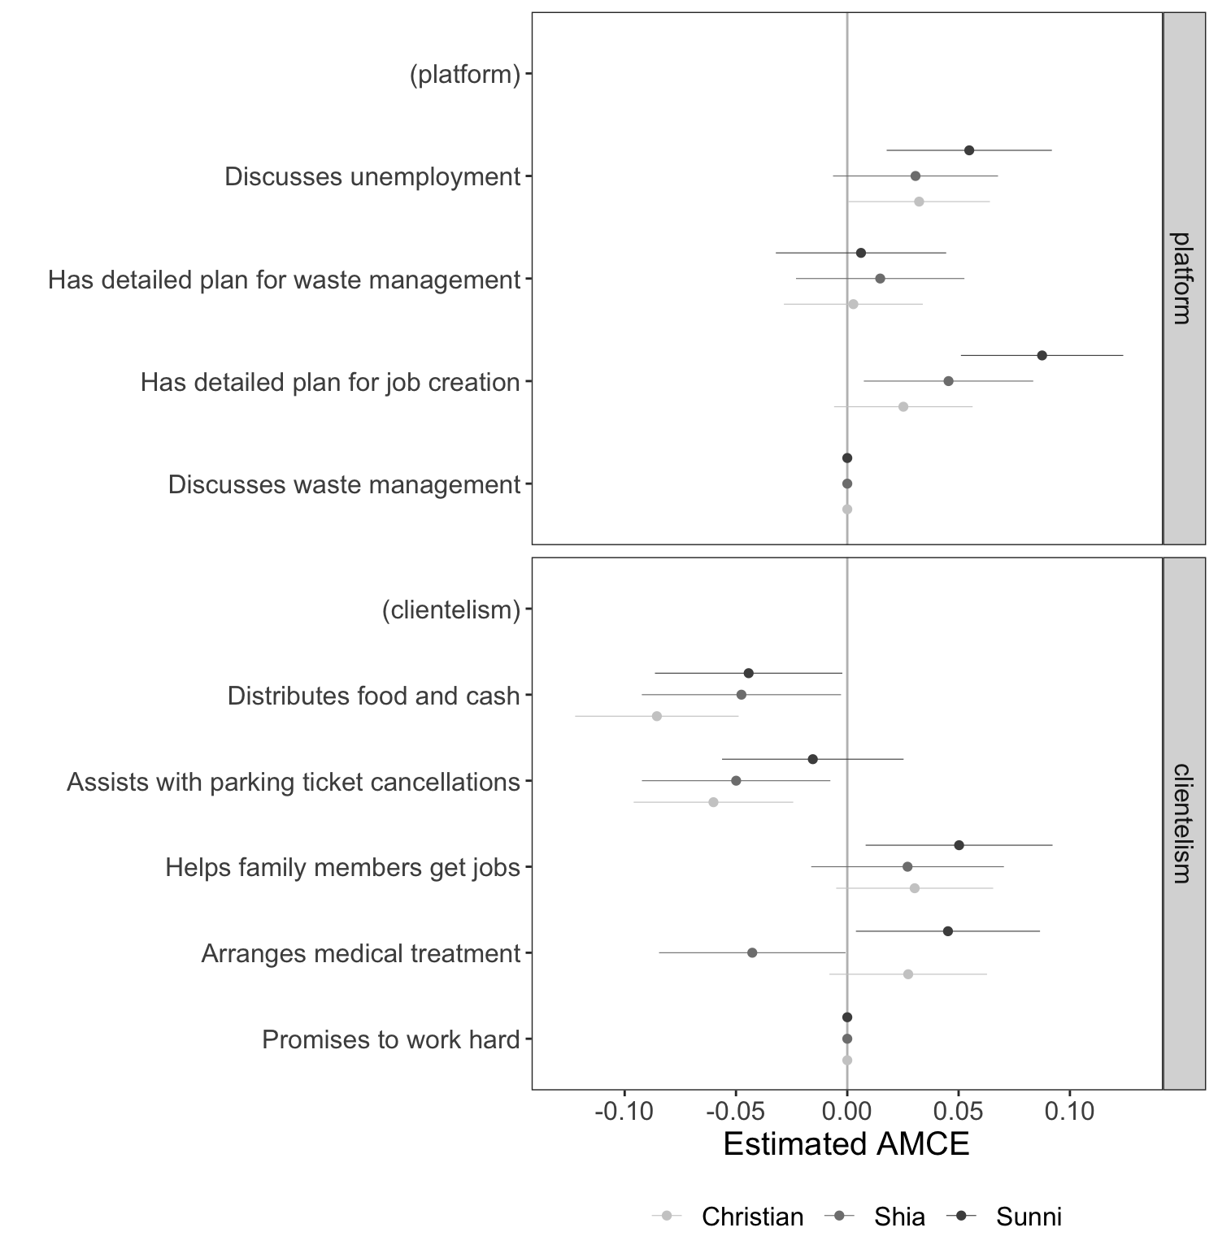
Note: Average effect of candidate attributes on respondents’ preferences for hypothetical MP candidates. Points represents the estimated average marginal component effect (AMCE) of a candidate attribute on respondents’ probability of choosing a candidate with that attribute, compared to a candidate with the baseline attribute quality. Horizontal bars represent 95 percent confidence intervals. All standard errors are heteroskedasticity robust and clustered at the individual level.

Figure A.11: Results by Trust in Religious Leaders

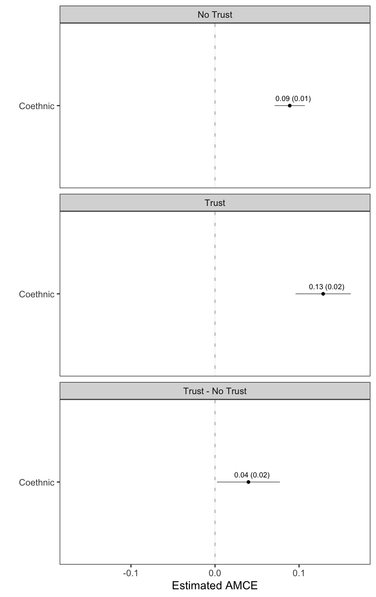

Note: Average effect of candidate attributes on respondents’ preferences for hypothetical MP candidates. Points represents the estimated average marginal component effect (AMCE) of a candidate attribute on respondents’ probability of choosing a candidate with that attribute, compared to a candidate with the baseline attribute quality. Horizontal bars represent 95 percent confidence intervals. All standard errors are heteroskedasticity robust and clustered at the individual level.

