Appendix
Religious Authority in a Democratic Society: Clergy and Citizen Evidence from a New Measure

Variable Coding – 2014 Clergy Sample
Deliberative Values in Adult Education A five-question battery, introduced by, “Do you agree or disagree with the following statements about any adult forums that would be held in your church to address social or political issues?” The index averages responses to the following items, each coded on a 5 point scale from strongly disagree to strongly agree: We would explicitly encourage participants to think seriously about the views of others. It would be essential that all those present participate. It would be essential that a range of views are presented. It would be essential for participants to learn how our values apply to issues. It would be essential for participants to learn how to talk through their differences.
Democratic Norms The average of four items, each coded on a four point scale from strongly disagree to strongly agree (no middle option): It’s very important that politicians air their differences of opinion publicly; You can't have democracy without political opposition; You can’t be sure an opinion is correct unless people are free to argue against it; Unless many views are presented, there is little chance that the truth can ever be known.
Religious conservatism Averages responses (1=strongly disagree to 5=strongly agree) regarding these 6 statements: “The devil exists.”; “The Bible is literally true.”; “Jesus will return to earth in bodily form.”; “Jesus was born of a virgin.”; “There is an objective standard of right and wrong established by God's Word.”; “Men are given authority over women.”
Religious authority values scale Averages responses (1=strongly agree to 5=strongly disagree) regarding these 5 statements: “The more clergy can step out of the way of the congregation the better.”; “It is important for the congregation to construct their own salvation.”; “The Gospel is what the congregation makes of it.”; “The church must adapt to a postmodern culture in order to spread the Gospel.”; “I believe there are many valid interpretations of the Bible.”
Authoritarianism “Although there are a number of qualities that people feel children should have, every person thinks that some are more important than others. Below are pairs of desirable qualities. Please tell me which one you think is more important for children to have.” The pairs include Independence : Respect for elders, Curiosity : Good manners, and Being considerate : Well-behaved. Each is coded 0-1 and the final index is averaged so that 0 means choosing the first term in the three pairs and 1 means choosing the second term in each pair.
Education level “What is the highest level of education you have received?” 1=graduated college/seminary, 2=Master’s degree or working toward a Master’s, 3=Received a doctorate.
Female =1, 0=male.
Partisanship Starts with the question, “Generally speaking, of the following political labels, which do you consider yourself?” 1=Strong Democrat, 2=Democrat, 3=Independent who leans Democratic, 4=Independent /Other party, 5=Independent who leans Republican, 6=Republican, 7=Strong Republican.
Years in the ministry “For how long have you been a clergyperson and how long serving this congregation? Please enter a number (rounding to the nearest year). In the ministry.”
White =1, nonwhite=0.

Variable Coding – 2016 Citizen Sample
Authoritarianism (child-rearing) “Although there are a number of qualities that people feel children should have, every person thinks that some are more important than others. Below are pairs of desirable qualities. Please tell me which one you think is more important for children to have.” The pairs include Independence : Respect for elders, Curiosity : Good manners, and Being considerate : Well-behaved. Each is coded 0-1 and the final index is averaged so that 0 means choosing the first term in the three pairs and 1 means choosing the second term in each pair.
Democratic Norms The average of four items, each coded on a four point scale from strongly disagree to strongly agree (no middle option): It’s very important that politicians air their differences of opinion publicly; You can’t have democracy without political opposition; You can’t be sure an opinion is correct unless people are free to argue against it; Unless many views are presented, there is little chance that the truth can ever be known.
Religiosity is a combination of attendance and religious importance, where each was placed on the same 0-1 scale before averaging their scores. Attendance was asked as follows, “Aside from weddings and funerals, how often have you attended church in the past year?” 1=Never, 2=Seldom, 3=A Few Times a Year, 4=Once or Twice a Month, 5=Once a Week, 6=More than Once a Week, 7=Daily. Importance was asked thusly: “How important is religion in your life?” 1=Not at All Important, 2=Not Very Important, 3=Somewhat Important, 4=Very Important.
Religious authority Introduced by, “What do you think of the following statements? Do you agree or disagree?” The index was composed of the average of the following items coded on a 5 point scale from strongly agree to strongly disagree (higher is more authority, less relativity): Religious truth is what the congregation makes of it; Religion needs to adapt to the modern culture in order to gain and keep members; Religion needs to adapt to the modern culture in order to be relevant.
Education “What is the highest level of school you have completed or the highest degree you have received?” 1=Less than High School Diploma, 2=High School Degree, 3=Some College, 4=Bachelor's Degree, 5=Graduate Degree.
Female =1, 0=male.
Partisanship Starts with the question, “Generally speaking, of the following political labels, which do you consider yourself?” 1=Strong Democrat, 2=Democrat, 3=Independent who leans Democratic, 4=Independent /Other party, 5=Independent who leans Republican, 6=Republican, 7=Strong Republican.
Age in years.
White=1, 0=nonwhite.

Variable Coding – 2019 Protestant Sample
Authoritarianism (child-rearing) “Although there are a number of qualities that people feel children should have, every person thinks that some are more important than others. Below are pairs of desirable qualities. Please tell me which one you think is more important for children to have.” The pairs include Independence : Respect for elders, Curiosity : Good manners, and Being considerate : Well-behaved. Each is coded 0-1 and the final index is averaged so that 0 means choosing the first term in the three pairs and 1 means choosing the second term in each pair.
Deliberative Values in Adult Education A five-question battery, introduced by, “Do you agree or disagree with the following statements about any adult forums that would be held in your church to address social or political issues?” The index averages responses to the following items, each coded on a 5 point scale from strongly disagree to strongly agree: We would explicitly encourage participants to think seriously about the views of others. It would be essential that all those present participate. It would be essential that a range of views are presented. It would be essential for participants to learn how our values apply to issues. It would be essential for participants to learn how to talk through their differences.
Religiosity is a combination of attendance and religious importance, where each was placed on the same 0-1 scale before averaging their scores. Attendance was asked as follows, “Aside from weddings and funerals, how often have you attended church in the past year?” 1=Never, 2=Seldom, 3=A Few Times a Year, 4=Once or Twice a Month, 5=Once a Week, 6=More than Once a Week, 7=Daily. Importance was asked thusly: “How important is religion in your life?” 1=Not at All Important, 2=Very unimportant, 3=Somewhat unimportant, 4=Neither important, nor unimportant, 5=Somewhat important, 6=Very important, 7=Extremely important.
Religious authority Introduced by, “What do you think of the following statements? Do you agree or disagree?” The index was composed of the average of the following items coded on a 5 point scale from strongly agree to strongly disagree (higher is more authority, less relativity): The more clergy can step out of the way of the congregation the better; It is important for the congregation to construct their own salvation; The Gospel is what the congregation makes of it; I believe there are many valid interpretations of the Bible; The church must adapt to a postmodern culture in order to spread the Gospel.
Education “What is the highest level of school you have completed or the highest degree you have received?” 1=Less than High School Diploma, 2=High School Degree, 3=Some College, 4=Bachelor's Degree, 5=Graduate Degree.
Female =1, 0=male.
Partisanship Starts with the question, “Generally speaking, of the following political labels, which do you consider yourself?” 1=Strong Democrat, 2=Democrat, 3=Independent who leans Democratic, 4=Independent /Other party, 5=Independent who leans Republican, 6=Republican, 7=Strong Republican.
Age in years.
White=1, 0=nonwhite.
Clergy as Representatives An averaged index of 3 items, each coded from 1=strongly disagree to 5=strongly agree: It is important to me what leaders of my religious group have to say about politics and current events; I think of my pastor as my representative to the public and government; and I have contacted my pastor with a political concern.

Table A1 – Descriptive Statistics of Included Variables
 | 2014  Clergy Sample |  | 2016  Citizen Sample |  | 2019  Protestant Sample
 | mean | sd | mean | sd | mean | sd
Religious conservatism / religiosity | 0.64 | 0.27 | 0.37 | 0.26 | 0.67 | 0.19
Religious authority | 0.59 | 0.18 | 0.44 | 0.26 | 0.61 | 0.23
Average education | 0.57 | 0.31 | 3.40 | 1.00 | 4.13 | 1.38
Proportion women | 0.18 | 0.39 | 0.50 | 0.50 | 0.66 | 0.47
Partisanship (7 point) | 3.97 | 1.87 | 3.71 | 1.68 | 4.70 | 1.90
Average years in ministry (0-1) / Age in years | 0.45 | 0.25 | 45.60 | 16.02 | 61.76 | 14.17
Proportion whites | 0.94 | 0.24 | 0.74 | 0.44 | 0.88 | 0.33

Table A2 – Bivariate Pearson’s Correlations between Religious Measures and Religious Identities, Clergy and Citizen Samples
 | 2014  Clergy Sample |  |  | 2016  Citizens Sample
 | RAV | Religious Conservatism |  | RAV | Religiosity
Religious conservatism | 0.63 | — | Religiosity | 0.22 | —
Evangelical | 0.27 | 0.46 | Evangelical | 0.16 | 0.19
Fundamentalist | 0.16 | 0.16 | Fundamentalist | 0.04 | 0.05
Liberal | -0.44 | -0.62 | Liberal | -0.13 | -0.03
Orthodox | 0.04 | 0.07 | Born again | 0.14 | 0.23
Ecumenical | -0.21 | -0.28 | Charismatic | 0.01 | 0.08
Pentecostal | 0.06 | 0.12 | Conservative | 0.05 | 0.09
Conservative | 0.30 | 0.41 | Traditional | 0.04 | 0.12
Emergent church | -0.25 | -0.19 | Humanist | -0.06 | -0.03
 |  |  | Emergent | 0.01 | 0.04
 |  |  | Missional | 0.07 | 0.09
 |  |  | Spiritual | 0.00 | 0.13
 |  |  | Atheist/Agnostic | -0.04 | -0.23

Figure A1 – The Links Between Biblical Literalism (y axis) and the Component Questions for the RAV Index (x axis).
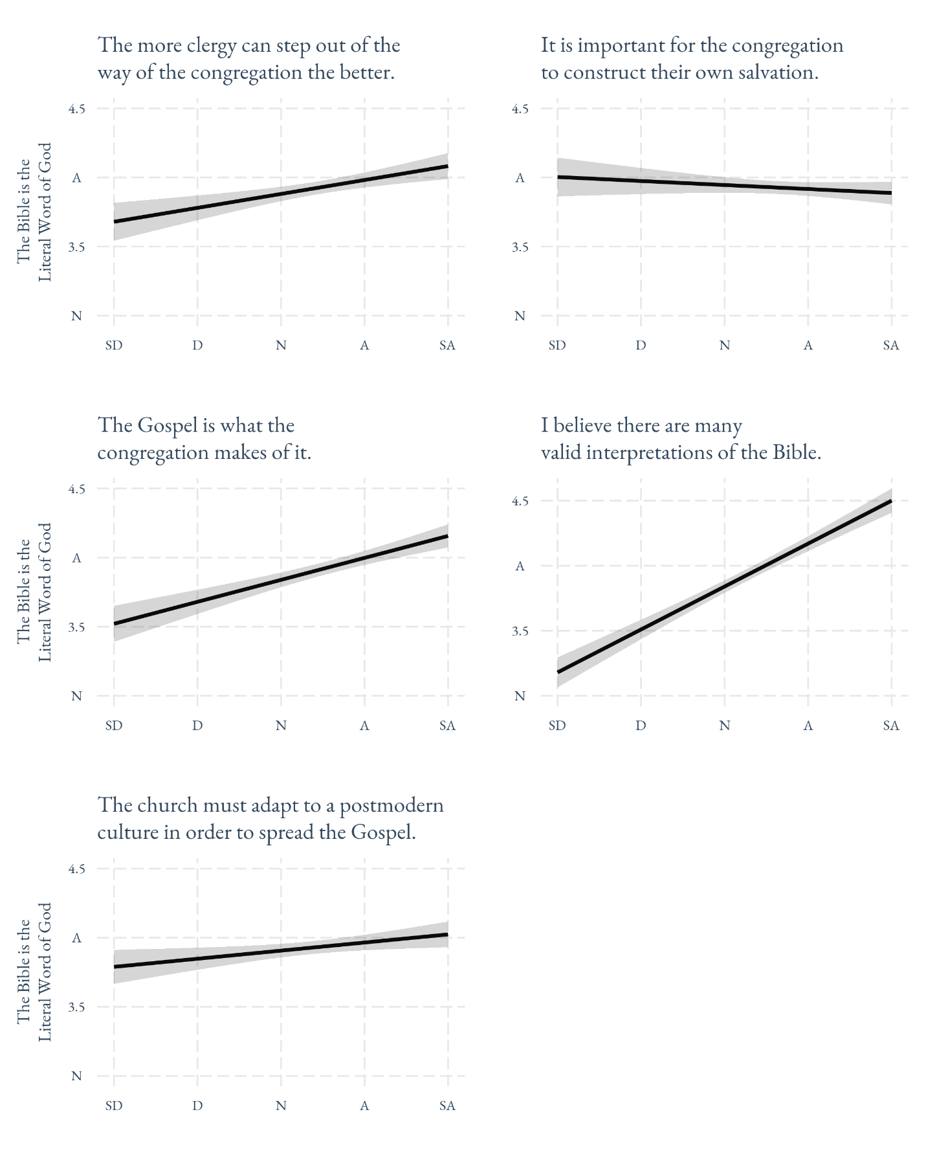

Table A3 – OLS Estimates for Figure 3, Authoritarian Child-Rearing Values (p values in parentheses)
 | Clergy Sample | Citizen Sample | Protestant Sample
(Intercept) | -0.15 | 0.61 | 0.74
 | (0.08) | (0.00) | (0.00)
Religious conservatism / religiosity | 0.38 | 0.19 | 0.09
 | (0.00) | (0.00) | (0.12)
RAV | 0.31 | -0.00 | 0.03
 | (0.00) | (0.98) | (0.49)
Child-rearing authority | 0.03 | -0.06 | -0.05
 | (0.61) | (0.00) | (0.00)
Education | -0.01 | -0.03 | -0.04
 | (0.88) | (0.21) | (0.04)
Female | 0.04 | 0.02 | 0.03
 | (0.00) | (0.00) | (0.00)
Partisanship | -0.05 | 0.00 | 0.00
 | (0.43) | (0.00) | (0.14)
Years in ministry / Age | -0.07 | -0.11 | -0.15
 | (0.29) | (0.00) | (0.00)
N | 322 | 976 | 1010
R² | 0.39 | 0.09 | 0.09

Table A4 – OLS Estimates for Figure 4, Association of Religious Authority with Deliberative Values in Congregational Affairs (p values in parentheses)
 | Clergy Sample | Citizen Sample
(Intercept) | 0.88 | 0.75
 | (0.00) | (0.00)
Religious conservatism / religiosity | 0.02 | 0.07
 | (0.62) | (0.01)
RAV | -0.33 | -0.11
 | (0.00) | (0.00)
Child-rearing authority | 0.03 | -0.01
 | (0.33) | (0.01)
Education | 0.03 | 0.00
 | (0.21) | (0.47)
Female | 0.04 | -0.00
 | (0.07) | (0.63)
Partisanship | -0.00 | -0.00
 | (0.79) | (0.15)
Years in ministry / Age | 0.05 | 0.00
 | (0.13) | (0.85)
White | -0.05 | -0.04
 | (0.12) | (0.01)
N | 320 | 1001
R² | 0.17 | 0.05

Table A5 – OLS Estimates for Figure 5, Association of Religious Authority with Democratic Norms (p values in parentheses)
 | Clergy Sample | Citizen Sample
(Intercept) | 0.92 | 0.64
 | (0.00) | (0.00)
Religious conservatism / Religiosity | -0.09 | 0.02
 | (0.30) | (0.30)
RAV | -0.39 | -0.07
 | (0.00) | (0.00)
Child-rearing authority | 0.03 | -0.01
 | (0.55) | (0.03)
Education | 0.01 | 0.01
 | (0.82) | (0.04)
Female | 0.03 | -0.02
 | (0.47) | (0.05)
Partisanship | 0.01 | 0.00
 | (0.47) | (0.70)
Years in ministry / Age | 0.07 | 0.00
 | (0.21) | (0.00)
White | -0.13 | -0.01
 | (0.02) | (0.62)
N | 320 | 975
R² | 0.10 | 0.05

Table A6 – OLS Estimates for Figure 6, The Substitutive Roles of Religious Authority and Religiosity on Views of Clergy as Political Representatives (p values in parentheses)
 | B | (p)
(Intercept) | 0.36 | (0.00)
Religiosity | 0.32 | (0.00)
RAV | 0.21 | (0.07)
Religiosity * RAV | -0.29 | (0.07)
Child-rearing authority | 0.01 | (0.04)
Education | -0.01 | (0.00)
Women | -0.02 | (0.17)
Partisanship | 0.01 | (0.00)
Age | -0.00 | (0.00)
White | -0.01 | (0.52)
N | 1,010
R² | 0.09

