What Drives Religious Politicking? An Analysis of 24 Democracies
Online Appendix
By Emma Rosenberg and Amy Erica Smith

- Descriptive Statistics: Exposure to Political Messages Among Religious Attenders

In Figure A1 and Figure A2, we present the distribution of exposure to political messages from religious associations and clergy within the subset of respondents who report ever attending religious service. While levels of exposure rise slightly using this alternative measurement, cross-country comparisons remain quite similar. In the remainder of the analysis, we report results for all respondents, not simply those attending religious service. This is important for consistency, since the proportion attending worship services varies substantially across countries.

- Level of Exposure to Summary Measure of Religious Politicking

In Figure A3, we present an election-level average measure of religious politicking, based on each election's mean values of reported exposure to religious association and clergy messages. While this measure loses detail and risks conflating two different types of religious politicking, it has one distinct advantage: it incorporates all 24 countries, including the important case of the United States. On this summary measure, the U.S. is among the countries with highest levels of religious politicking, surpassed only by Mozambique 2004.

- Individual- and Group-Level Determinants of Religious Organization Contact

Tables A1 and A2 present results from a series of hierarchical logistic regression models assessing how religious participation, education, and religious affiliation all shape the likelihood of exposure to political messages from religious associations and clergy. Roman Catholics are treated as the baseline category, so each coefficient should be interpreted as the extent to which the given group is more or less exposed to political messages than Roman Catholics.

Education and religious affiliation consistently have sizable effects on exposure to clergy messages. In addition, the fourth models for each dependent variable show the interaction between education and religious affiliation. The analysis reveals a positive interaction between the two variables in predicting receiving information from religious associations, but not the other two dependent variables. That is, religious associations appear to target people who are both highly educated and highly religious.

We also find substantial differences between religious groups in exposure to political messages from religious leaders. Not surprisingly, the non-religious report much lower levels of exposure than do Catholics—an effect that holds even after controlling for frequency of religious attendance. Confucians, Buddhists, and Taoists likewise report very low levels of receiving political information from religious associations, though the effect of adherence to these two religious groups becomes statistically insignificant once we control for frequency of religious attendance.

More interesting are the effects for Protestants, evangelicals, and Muslims. Consistent with H1, Protestants and evangelicals are exposed to significantly higher levels of religious politicking than are Catholics. However, the effect of Protestant affiliation is only significant in the model of exposure to religious association messages, and disappears after controlling for frequency of religious attendance. By contrast, the effect of evangelicalism is only statistically significant in the model of exposure to clergy messages, and holds after controlling for religious participation. In the models of the summary index, Protestantism and evangelicalism both significantly predict exposure to either type of message; the effect of evangelicalism remains statistically significant even after controlling for religious attendance. Thus, engagement in electoral politics does appear to be a distinctive feature of evangelical groups, and to a lesser extent Protestant ones.

Turning to Islam, our results partially contradict H1, which had predicted a positive effect of this religious affiliation. By contrast, we find that Muslims are less likely than adherents to other major world religions to receive political messages from civic associations. At the same time, they are significantly more likely than Catholics–but less likely than evangelicals–to hear about elections from the pulpit. In models of the summary dependent variable, we find no statistically significant difference between Catholics and Muslims.

Figure A4 examines the role of other demographics in predicting who reports messages from either clergy or religious associations. This analysis involves single-country models because the other demographic variables are missing in scattered other countries. Across the models, there are no other consistently statistically significant effects.

- Alternative Models Assessing Contextual Determinants of Religious Politicking

Table A3 presents multilevel models assessing the contextual determinants of the index of religious politicking. The model is identical to the multilevel models of religious association information found in the main text, with the exception of the change in the dependent variable. Results from the first five models are very similar to those found in the main text. However, in the pooled model incorporating all five contextual variables, there are no statistically significant contextual variables–likely a result of complex multicollinearity among the variables.

Next, Table A4 presents an election-level OLS model, applying multiple regression to the data analyzed using bivariate correlation coefficients in the main text. Here, we find that religious pluralism and human development are the two significant determinants of the summary index of religious politicking.

- Correlations Among Country-Level Variables

In Table A5, we present the correlations among the country-level independent variables. We find strong correlations between liberal democracy and human development; and between religious pluralism and secularism. As discussed in the text, these correlations could introduce some multicollinearity into regression models incorporating all five country-level variables.

- Inequality as a Determinant of Religious Politicking

As discussed in several footnotes within the paper, one plausible alternative hypothesis is that inequality matters, rather than the level of development as such. We develop a measure of inequality based on V-Dem (Varieties of Democracy). Though the results are ambiguous, on balance they suggest that inequality is not a key determinant of religious politicking. The Pearson correlation coefficient between inequality and religious association messages is 0.46 (p = .03). The inequality index is also statistically significant in a multilevel model of religious association messages with a single country-level variable. Including both inequality and human development index in one multilevel model, however, leads both variables to become statistically insignificant, likely in part because inequality and human development are correlated at r = -44 (p = .04).

However, the measure of religious association messages excludes the United States. The U.S. is an important case for examining the role of inequality, since the country has among the highest levels of religious politicking in our data but moderate levels of inequality in cross-national context. The measure of clergy politicking incorporates the United States. Using this measure, the country-level correlation between inequality and politicking is -0.14 (p = 0.76). Developing a summary measure of religious politicking that is present in all cases, as discussed earlier in the Appendix, we find that the correlation between politicking and inequality is 0.34 (p = 0.12). Similarly, the effect of inequality is not statistically significant in country-level OLS models predicting levels of religious politicking; this holds in both bivariate and multivariate analysis.

- Analysis Limited to Catholics

In a cross-national study relying on survey data, it is impossible to control for all the historical and circumstantial forces that might be driving the results. One way to get around such issues would be to run the study only within one single religious traditional, in order to account for civilizational issues. Table A7 presents models limited only to Catholics, within both minority- and majority-Catholic countries. The results are effectively identical to those presented throughout the paper, with a few exceptions. First, education is still positively associated with associational contact, and the coefficient is similar in magnitude, but it is no longer statistically significant. Second, in the final multilevel model including all contextual variables, religious pluralism comes out as the only significant (and positive) predictor of religious group contacting.

- Cross-Level Models: Religious Attendance and Human Development

Table A7 presents results from a cross-level analysis interacting frequency of religious attendance with level of human development. In the first model, we find a significant interactive relationship between religious attendance and human development in the model of exposure to political messages from religious associations; in contexts of higher human development, religious attendance is more strongly correlated with such exposure. However, even among frequent attenders, human development is still strongly and negatively associated with exposure to religious association messages about politics. Follow-up analysis (not shown here) suggests these relationships are somewhat stronger among Christians than among other religious groups.

In the second model, we find no such significant interaction in predicting level of exposure to all religious politicking. Based on substantial subsequent exploration, and in models not shown here, we conclude that this is because the impact of religious attendance on exposure to clergy messages about politics does not depend on level of human development. That is, across contexts, those who attend religious services more frequently are more likely to hear their clergy endorse candidates.

To aid in interpretation of coefficients, Figure A5 presents predicted effects from the first model of Table A7, taking values of the HDI at the 10th and 90th percentiles from our set of country cases. Across the entire range of religiosity, HDI depresses the rate of exposure to politicking from religious organizations. However, religiosity strongly boosts exposure to religious politicking in low-HDI contexts, and does not impact it at all in high-HDI contexts.

It is important to note that the predicted probabilities appear to contradict the results from the regression analysis. While Table A7 shows that the effect of HDI should be largest among those with lowest religiosity, in Figure A5 the effects appear largest among those high in religiosity. The reason for these discrepant results is, we believe, due to the non-linear nature effect of logistic regression coefficients for predicted probabilities very close to zero (and, indeed, the predicted probabilities at the low end of religiosity are extremely close to zero). In any case, the topline conclusion is clear: the impact of human development is strongly negative across the entire range of religiosity.

Figure A1. Exposure to Political Information from Religious Associations (Religious Attenders Only)
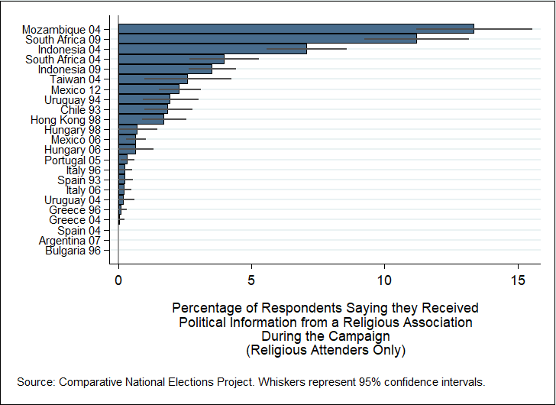

Figure A2. Exposure to Political Messages from Clergy (Religious Attenders Only)
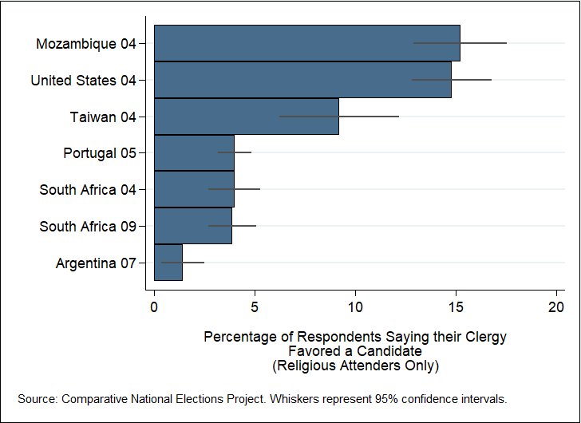
Figure A3. Distribution of Religious Politicking (Combined Country-Level Measure)

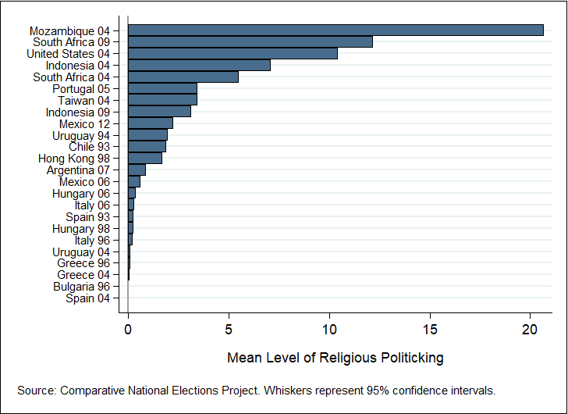

Table A 1. Hierarchical Logistical Regression Models: Individual-Level Determinants of Exposure to Religious Politicking
 | Clergy Support for a Candidate |  |  |  |  | Religious Association Political Information
 | (1) | (2) | (3) | (4) |  | (1) | (2) | (3) | (4)
Religious Attendance |  | 1.219*** | 1.240*** | 1.653*** |  |  | 1.964*** | 2.035*** | 1.417***
 |  | (0.145) | (0.149) | (0.298) |  |  | (0.199) | (0.265) | (0.434)
Education |  |  | 0.782*** | 1.319*** |  |  |  | 0.534* | -0.689
 |  |  | (0.209) | (0.392) |  |  |  | (0.314) | (0.786)
Attendance*Education |  |  |  | -0.831 |  |  |  |  | 1.571*
 |  |  |  | (0.513) |  |  |  |  | (0.918)
None | -1.129*** | -0.737*** | -0.681*** | -0.679*** |  | -2.501*** | -1.194*** | -1.202*** | -1.222***
 | (0.201) | (0.230) | (0.236) | (0.236) |  | (0.317) | (0.399) | (0.463) | (0.464)
Protestant | 0.203 | 0.151 | 0.132 | 0.134 |  | 0.317** | 0.219 | 0.197 | 0.188
 | (0.151) | (0.153) | (0.161) | (0.161) |  | (0.135) | (0.147) | (0.185) | (0.185)
Evangelical | 0.980*** | 0.821*** | 0.867*** | 0.880*** |  | 0.262 | -0.052 | 0.031 | 0.043
 | (0.172) | (0.175) | (0.180) | (0.180) |  | (0.358) | (0.458) | (0.507) | (0.507)
Orthodox | -0.322 | -0.373 | -0.332 | -0.331 |  | 0.238 | 0.158 | 0.341 | 0.337
 | (0.609) | (0.611) | (0.613) | (0.613) |  | (0.459) | (0.459) | (0.454) | (0.454)
Muslim | 0.571*** | 0.524*** | 0.681*** | 0.665*** |  | -0.343* | -0.711*** | -0.423 | -0.414
 | (0.193) | (0.200) | (0.207) | (0.208) |  | (0.181) | (0.249) | (0.265) | (0.265)
Other | 0.062 | 0.098 | 0.130 | 0.103 |  | -0.429** | -0.359 | 0.275 | 0.290
 | (0.207) | (0.211) | (0.244) | (0.245) |  | (0.211) | (0.225) | (0.352) | (0.352)
Buddhist | 0.542 | 0.866* | 0.937* | 0.947* |  | -1.581*** | -0.091 | -0.638 | -0.588
 | (0.482) | (0.481) | (0.490) | (0.491) |  | (0.551) | (0.653) | (0.783) | (0.785)
Taoist | 0.574 | 0.937* | 1.028** | 1.049** |  | -1.773** | -0.508 | -0.655 | -0.631
 | (0.501) | (0.501) | (0.510) | (0.511) |  | (0.831) | (0.890) | (0.886) | (0.887)
Constant | -3.144*** | -3.917*** | -4.270*** | -4.552*** |  | -4.916*** | -6.439*** | -7.123*** | -6.618***
 | (0.360) | (0.341) | (0.411) | (0.451) |  | (0.446) | (0.502) | (0.584) | (0.641)
Observations | 9617 | 9466 | 8239 | 8239 |  | 33305 | 26885 | 21107 | 21107
Countries | 7 | 7 | 6 | 6 |  | 23 | 18 | 14 | 14

Table A 2. Hierarchical Logistical Regression Models: Individual-Level Determinants of Exposure to Any Religious Politicking (DV is Combined Measure)
 | (1) | (2) | (3) | (4)
Religious Attendance |  | 1.596*** | 1.572*** | 1.748***
 |  | (0.117) | (0.129) | (0.253)
Education |  |  | 0.698*** | 0.941***
 |  |  | (0.183) | (0.350)
Attendance*Education |  |  |  | -0.365
 |  |  |  | (0.448)
None | -1.297*** | -0.775*** | -0.706*** | -0.699***
 | (0.145) | (0.188) | (0.198) | (0.198)
Protestant | 0.327*** | 0.174 | 0.123 | 0.125
 | (0.106) | (0.114) | (0.131) | (0.131)
Evangelical | 0.879*** | 0.651*** | 0.731*** | 0.737***
 | (0.148) | (0.157) | (0.165) | (0.165)
Orthodox | 0.148 | 0.065 | 0.203 | 0.203
 | (0.375) | (0.376) | (0.372) | (0.372)
Muslim | 0.055 | -0.015 | 0.254 | 0.249
 | (0.144) | (0.169) | (0.180) | (0.180)
Other | -0.140 | -0.116 | 0.129 | 0.119
 | (0.154) | (0.163) | (0.213) | (0.213)
Buddhist | -0.268 | 0.557 | 0.513 | 0.519
 | (0.334) | (0.395) | (0.426) | (0.426)
Taoist | -0.178 | 0.558 | 0.576 | 0.588
 | (0.394) | (0.440) | (0.449) | (0.449)
Constant | -4.600*** | -5.684*** | -6.238*** | -6.361***
 | (0.423) | (0.490) | (0.582) | (0.601)
Observations | 35193 | 28762 | 22982 | 22982
Countries | 24 | 19 | 15 | 15

Figure A4. Individual-Level Determinants of Receiving Political Information from Religious Organizations (Single-Country Results)

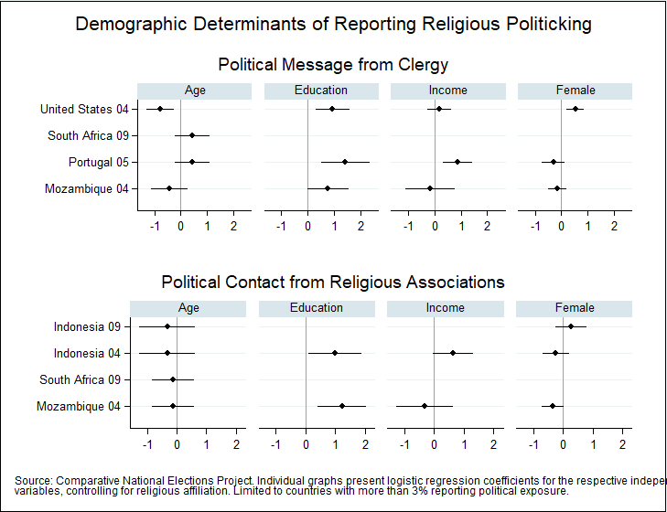
Table A3. Multi-Level Model of Exposure to Any Religious Politicking

 | (1) | (2) | (3) | (4) | (5) | (6)
Liberal Democracy | -3.775∗∗ |  |  |  |  | -2.864
 | (1.442) |  |  |  |  | (2.252)
Human Development Index |  | -4.873∗∗ |  |  |  | -0.854
 |  | (1.731) |  |  |  | (2.497)
Repression of Religious Groups |  |  | 1.862 |  |  | 2.271
 |  |  | (1.804) |  |  | (1.643)
Secularism |  |  |  | 2.499∗∗ |  | 0.950
 |  |  |  | (0.742) |  | (0.854)
Religious Pluralism |  |  |  |  | 3.231∗∗ | 1.332
 |  |  |  |  | (1.237) | (1.231)
Observations | 34207 | 33938 | 34207 | 34207 | 35193 | 32958
Countries | 23 | 23 | 23 | 23 | 24 | 22

Table A4. Determinants of Religious Politicking
(Country-Level OLS Model Using Combined Index)
 | Religious Politicking Index | Religious Association Information
Liberal Democracy | -0.028 | -0.012
 | (0.050) | (0.029)
Human Development Index | -0.119* | -0.132***
 | (0.057) | (0.039)
Religious Repression | -0.007 | 0.013
 | (0.036) | (0.023)
Secularism | -0.011 | 0.002
 | (0.019) | (0.011)
Religious Pluralism | 0.088*** | -0.013
 | (0.029) | (0.025)
Constant | 0.122*** | 0.115***
 | (0.036) | (0.026)
Observations | 22 | 21

NOTE: Standard errors in parentheses. ∗ p < .10, ∗ p < .05, ∗∗ p < .01 Source: Comparative National Elections Project.

Table A5. Correlations among Country-Level Variables

 | Liberal Democracy | Human Development | Religious Repression | Religious Pluralism | Secularism
Liberal Democracy | 1.000
Human Development | 0.747 | 1.000
 | (0.000)
Religious Repression | 0.328 | -0.009 | 1.000
 | (0.127) | (0.969)
Religious Fractionalization | -0.189 | -0.346 | 0.217 | 1.000
 | (0.387) | (0.106) | (0.320)
Secularism | -0.450 | -0.465 | 0.192 | 0.538 | 1.000
 | (0.031) | (0.029) | (0.379) | (0.008)
NOTE: Pearson correlation coefficients. P-values in parentheses. N = 24. Source: Comparative National Elections Project.

Table a6. Individual and Contextual Determinants of Receiving Political Information from Religious Association: Catholics Only

 | (1) | (2) | (3) | (4) | (5) | (6)
Education | 0.654 | 0.563 | 0.653 | 0.696 | 0.692 | 0.656
 | (0.490) | (0.491) | (0.494) | (0.490) | (0.492) | (0.496)
Religious Attendance | 2.180*** | 2.231*** | 2.172*** | 2.198*** | 2.220*** | 1.988***
 | (0.433) | (0.424) | (0.438) | (0.434) | (0.435) | (0.439)
Liberal Democracy | -4.711*** |  |  |  |  | -1.259
 | (1.030) |  |  |  |  | (3.022)
Human Development Index |  | -4.651*** |  |  |  | 0.618
 |  | (0.330) |  |  |  | (3.407)
Religious Repression |  |  | -2.519 |  |  | -6.518
 |  |  | (3.959) |  |  | (4.390)
Secularism |  |  |  | 2.589*** |  | 0.393
 |  |  |  | (0.996) |  | (1.113)
Religious Pluralism |  |  |  |  | 4.802*** | 5.380*
 |  |  |  |  | (1.180) | (2.770)
Observations | 10,426 | 10,411 | 10,426 | 10,426 | 10,426 | 10,411
Countries | 13 | 12 | 13 | 13 | 13 | 12

Table a7. Cross-Level Models: Religious Attendance and Human Development as Determinants of Exposure to Religious Politicking
 | Political Information from Religious Association | Any Exposure to Religious Politicking
Religious Attendance | 1.227*** | 1.300***
 | (0.315) | (0.220)
Human Development Index | -6.794*** | -4.700**
 | (1.310) | (1.829)
HDI*Religious Attendance | 1.564*** | 0.335
 | (0.605) | (0.305)
Observations | 25657 | 27534
Number of Countries | 17 | 18
Note: Results from hierarchical logistical regression models. Standard errors in parentheses. Controls for religious affiliation and random effects not shown.

Figure A5. The Interactive Effect of Human Development and Religious Attendance on Receiving Political Information from Religious Associations

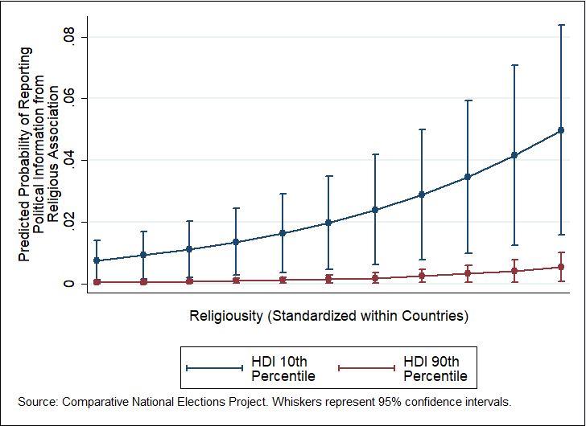

Equivalent fixed effects logistic regression models produce virtually identical results.
The religiously unaffiliated would make an uninformative baseline, since their levels of exposure to political messages are much lower than every religious group, and coefficients would not indicate clearly the differences among various religious groups.

