Online Appendix – The Prosperity Gospel of Coronavirus Response

Table of Contents
Pages | Contents
1 | Variable Coding
2 | Figure A1 – Prosperity Gospel Scores by Religious Tradition
3 | Figure A2 – Prosperity Gospel Belief Averages by Partisanship
4 | Figure A3 – Prosperity Gospel Belief Distribution by Partisanship
5 | Figure A4 – Estimated Effects of Prosperity Gospel with and without Other Religious Variables on Two Dependent Variables
6-7 | Table A1 – Models Behind Figure 3
8-9 | Table A2 – Models Behind Figure 4
10-11 | Table A3 – Comparison of All Suggested Mechanisms on Defying the Order

Variable Coding
Dependent Variables
Six of the 8 DVs are described in full in Figure 2.
Evil Active in the World index – An average index (collapsed to a 0-1 scale) composed of responses to three statements: The devil exists; There is evil out in the world; We must make every effort to avoid sinful people. Each was coded 1=strongly disagree to 5=strongly agree.
Exclusive values – An average index composed of responses to two statements: To be true to my faith, it is important to shop as much as possible at stores owned by other people of my faith; To be true to my faith, it is important to keep company with other people of my faith. Each was originally coded 1=strongly disagree to 5=strongly agree.

Independent Variables
Prosperity Gospel – An average index (collapsed to a 0-1 scale) composed of responses to three statements: God will reward the faithful with health and wealth; Our efforts and our sacrifices to God will be richly rewarded in this life; God will give you the material things you seek if you give to Him and have faith. Each was originally coded 1=strongly disagree to 5=strongly agree.
Partisanship – “Generally, which of these party labels bests describes you?” Collapsed to Democrat = Strong Democrat, Democrat, or Independent but lean Democrat; Independent = Independent (no leaners); Republican=Strong Republican, Republican, or Independent but lean Republican.
White – Identifies as White=1, 0=otherwise.
Age – In years (18 or over)
Gender – 1=Women, 0=Men.
Education – “What is the highest level of education that you have completed?” 1= Less than High School, 2=High School or GED, 3=Some college or trade school, 4=4-year college graduate, 5=Graduate education (toward a master's or doctoral degree)
Religious tradition – Follows the Steensland et al. (2000) approach to differentiate evangelicals from mainline Protestants. All other groups were defined by their response to “What is your present religion, if any?” Small groups were combined into “Other religion.” Atheists, agnostics, and ‘nothing in particular’s were combined into religious nones.
Worship attendance – Aside from weddings and funerals, how often do you typically attend religious services before the corona virus reached the US? 5=More than once a week or Once a week, 4=A few times a month, 3=A few times a year, 2=Seldom, 1=Never.
Figure A1 – Prosperity Gospel Scores by Religious Tradition
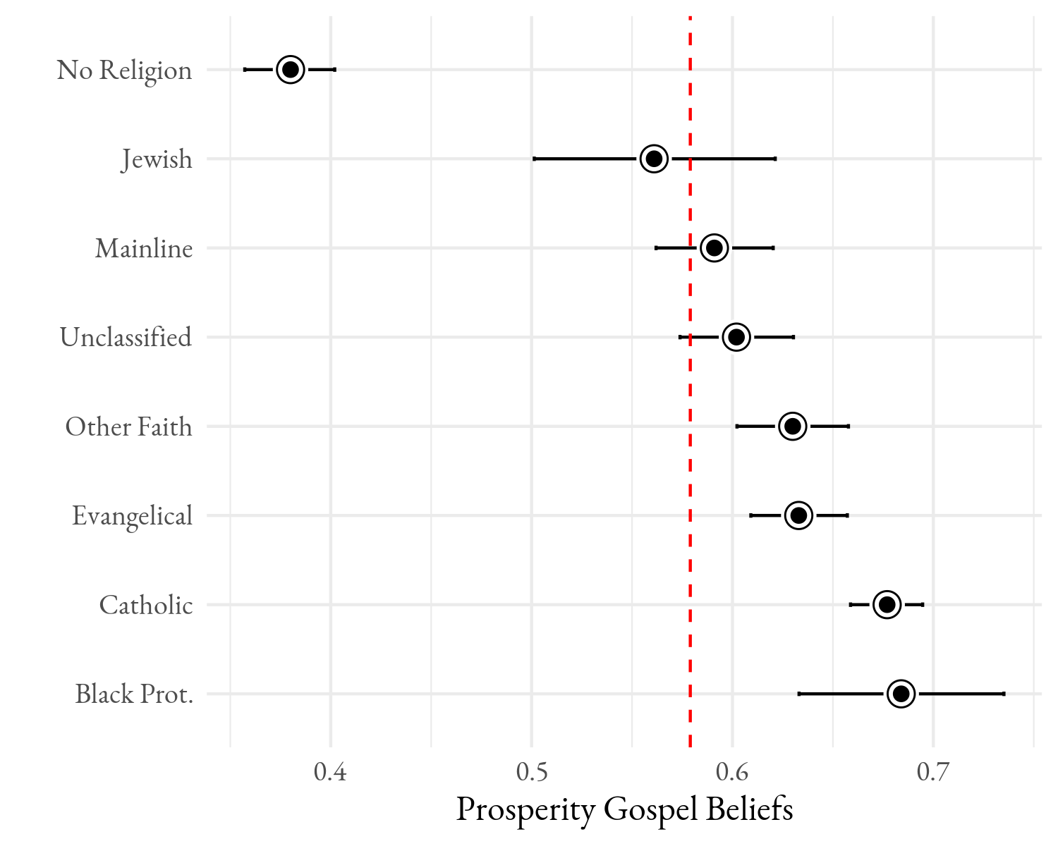
Source: 2020 Religion and C19 Survey
Note: The red vertical line is the sample mean. Confidence intervals are 95%.

Figure A2 – Prosperity Gospel Belief Averages by Partisanship
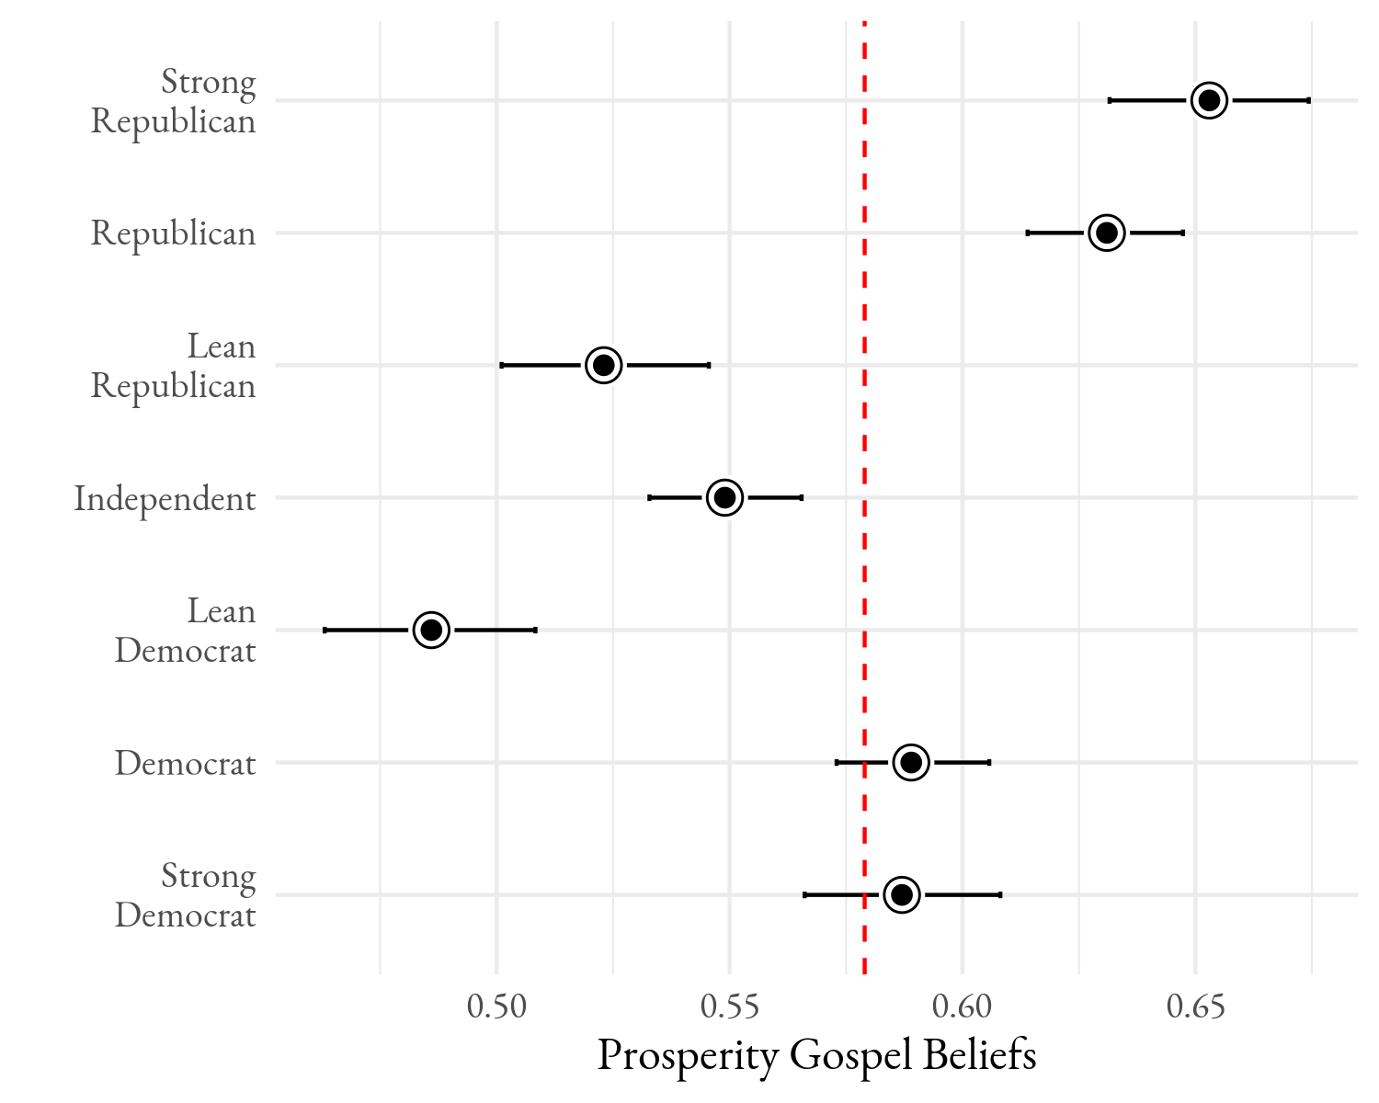
Source: 2020 Religion and C19 Survey
Note: The red vertical line is the sample mean. Confidence intervals are 95%.

Figure A3 – Distribution of Prosperity Gospel by Partisanship
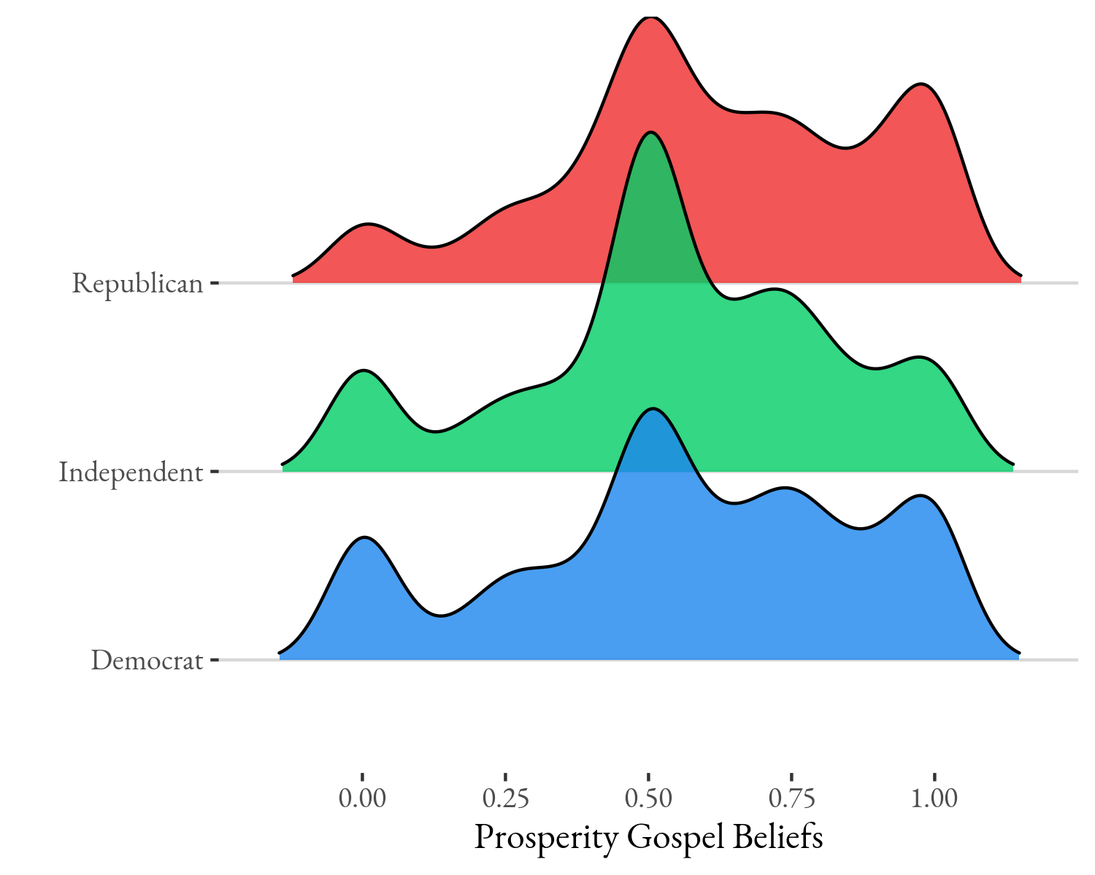
Source: 2020 Religion and C19 Survey

Figure A4 – Estimated Effects of Prosperity Gospel with and without Other Religious Variables on Two Dependent Variables
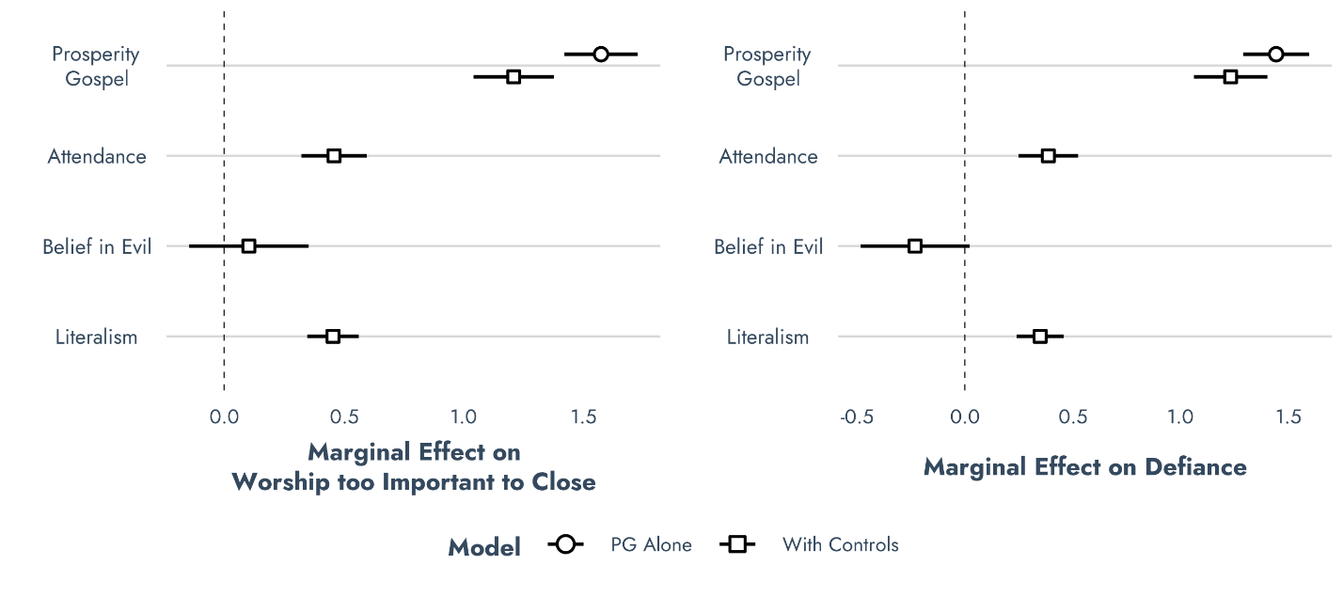

Source: 2020 Religion and C19 Survey

Table A1 – OLS Models For Figure 3 (p values in parentheses)
 | Coronavirus is a  Major Threat | Politically-Motivated  Hysteria
(Intercept) | 3.79 (0.00) | 2.98 (0.00)
Prosperity Gospel squared | 0.34 (0.00) | 1.35 (0.00)
Democrat (reference)
Independent | -0.42 (0.00) | 0.52 (0.00)
Republican | -0.49 (0.00) | 0.76 (0.00)
White | 0.11 (0.01) | -0.05 (0.45)
Age (in years) | 0.01 (0.00) | -0.01 (0.00)
Female | 0.11 (0.00) | -0.04 (0.39)
Education | 0.07 (0.00) | -0.06 (0.01)
Evangelical (reference) | — | —
Mainline Protestant | 0.01 (0.89) | -0.14 (0.11)
Black Protestant | 0.06 (0.64) | -0.04 (0.79)
Catholic | 0.03 (0.61) | -0.01 (0.88)
Jewish | -0.03 (0.74) | 0.21 (0.16)
Other Faith | -0.04 (0.51) | 0.22 (0.01)
No Religion | 0.04 (0.55) | 0.16 (0.07)
Unclassified | -0.10 (0.14) | 0.11 (0.24)
Worship attendance | -0.01 (0.38) | 0.05 (0.00)
Prosperity * Independent | 0.11 (0.48) | -0.80 (0.00)
Prosperity * Republican | 0.41 (0.00) | -0.73 (0.00)
N | 2758 | 2758
R² | 0.09 | 0.16

Table A1, continued – OLS Models For Figure 3 (p values in parentheses)
 | Freedom to Worship  is Too Important | Congregation Should  Defy Government
(Intercept) | 2.55 (0.00) | 2.49 (0.00)
Prosperity Gospel squared | 1.74 (0.00) | 1.59 (0.00)
Democrat (reference) | — | —
Independent | 0.41 (0.00) | 0.40 (0.00)
Republican | 0.31 (0.00) | 0.19 (0.03)
White | -0.21 (0.00) | -0.15 (0.01)
Age (in years) | -0.01 (0.00) | -0.01 (0.00)
Female | -0.34 (0.00) | -0.31 (0.00)
Education | -0.13 (0.00) | -0.14 (0.00)
Evangelical (reference) | — | —
Mainline Protestant | -0.11 (0.23) | -0.01 (0.94)
Black Protestant | 0.08 (0.63) | -0.04 (0.82)
Catholic | 0.08 (0.28) | 0.06 (0.43)
Jewish | 0.15 (0.30) | 0.50 (0.00)
Other Faith | 0.28 (0.00) | 0.27 (0.00)
No Religion | 0.05 (0.59) | 0.17 (0.04)
Unclassified | 0.07 (0.43) | 0.04 (0.67)
Worship attendance | 0.14 (0.00) | 0.11 (0.00)
Prosperity * Independent | -0.78 (0.00) | -0.58 (0.01)
Prosperity * Republican | -0.48 (0.00) | -0.40 (0.01)
N | 2758 | 2758
R² | 0.29 | 0.25

Table A2 – OLS Models For Figure 4 (p values in parentheses)
 | End Times | Exclusive Values
(Intercept) | 2.54 (0.00) | 2.32 (0.00)
Prosperity Gospel squared | 1.62 (0.00) | 1.68 (0.00)
Democrat (reference) | — | —
Independent | 0.25 (0.01) | 0.21 (0.01)
Republican | 0.29 (0.00) | 0.23 (0.00)
White | -0.16 (0.01) | -0.05 (0.25)
Age (in years) | -0.01 (0.00) | -0.00 (0.22)
Female | -0.03 (0.58) | -0.11 (0.00)
Education | -0.08 (0.00) | -0.04 (0.02)
Evangelical (reference) | — | —
Mainline Protestant | -0.34 (0.00) | -0.10 (0.12)
Black Protestant | -0.00 (0.98) | -0.33 (0.01)
Catholic | -0.25 (0.00) | -0.20 (0.00)
Jewish | -0.29 (0.04) | 0.13 (0.23)
Other Faith | -0.04 (0.67) | -0.18 (0.01)
No Religion | -0.23 (0.01) | -0.21 (0.00)
Unclassified | 0.07 (0.48) | -0.07 (0.32)
Worship attendance | 0.15 (0.00) | 0.17 (0.00)
Prosperity * Independent | -0.36 (0.09) | -0.55 (0.00)
Prosperity * Republican | -0.43 (0.01) | -0.34 (0.00)
N | 2758 | 2758
R² | 0.25 | 0.37

Table A2, continued – OLS Models For Figure 4 (p values in parentheses)
 | Evil Active in the World | You Can’t Be  Too Careful
(Intercept) | 0.54 (0.00) | 3.82 (0.00)
Prosperity Gospel squared | 0.28 (0.00) | 1.02 (0.00)
Democrat (reference) | — | —
Independent | 0.04 (0.01) | 0.20 (0.02)
Republican | 0.09 (0.00) | 0.27 (0.00)
White | -0.02 (0.01) | 0.03 (0.59)
Age (in years) | 0.00 (0.00) | -0.00 (0.45)
Female | 0.02 (0.00) | 0.04 (0.26)
Education | -0.01 (0.11) | -0.04 (0.02)
Evangelical (reference) | — | —
Mainline Protestant | -0.02 (0.16) | -0.03 (0.69)
Black Protestant | -0.02 (0.34) | 0.06 (0.66)
Catholic | -0.02 (0.14) | -0.04 (0.51)
Jewish | -0.11 (0.00) | 0.01 (0.94)
Other Faith | -0.05 (0.00) | -0.12 (0.11)
No Religion | -0.11 (0.00) | 0.03 (0.65)
Unclassified | -0.00 (0.94) | -0.11 (0.17)
Worship attendance | 0.02 (0.00) | -0.06 (0.00)
Prosperity * Independent | -0.08 (0.01) | -0.55 (0.00)
Prosperity * Republican | -0.08 (0.00) | -0.42 (0.00)
N | 2758 | 2758
R² | 0.31 | 0.06

Table A3 – Comparison of All Suggested Mechanisms on Defying the Order (OLS)
 | B (p)
(Intercept) | 1.78 *** (0.00)
Prosperity Gospel | 0.99 *** (0.00)
Independent | 0.32 ** (0.00)
Republican | 0.13 (0.10)
White | -0.12 * (0.04)
Age | -0.01 *** (0.00)
Female | -0.25 *** (0.00)
Education | -0.12 *** (0.00)
Mainline | 0.08 (0.34)
Black Prot. | 0.04 (0.78)
Catholic | 0.15 * (0.03)
Jewish | 0.45 ** (0.00)
Other Faith | 0.29 *** (0.00)
No Religion | 0.21 * (0.01)
Unclassified | 0.04 (0.63)
Attendance | 0.04 * (0.02)
Exclusive values | 0.29 *** (0.00)
Belief in evil | -0.68 *** (0.00)
Distrust | -0.03 (0.13)
End times belief | 0.21 *** (0.00)
Prosperity * Independent | -0.42 * (0.04)
Prosperity * Republican | -0.28 (0.05)
N | 2,758
R² | 0.33

