Online appendix

Figure 1: Optimal number of clusters
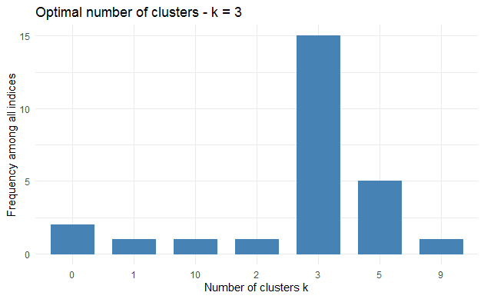
Notes: The optimal number of clusters in NbClust was calculated by using the hierarchical clustering algorithm “Ward.D2”. Distance was defined to be Euclidean; minimum number of clusters was set to two, and maximum number of clusters was set to ten.

Table 1: Average silhouette widths for the three clusters
Cluster | Number of countries in the cluster | Average  silhouette width
1 | 23 | 0.10
2 | 38 | 0.46
3 | 12 | 0.21

Figure 2: Silhouette plots for the three clusters
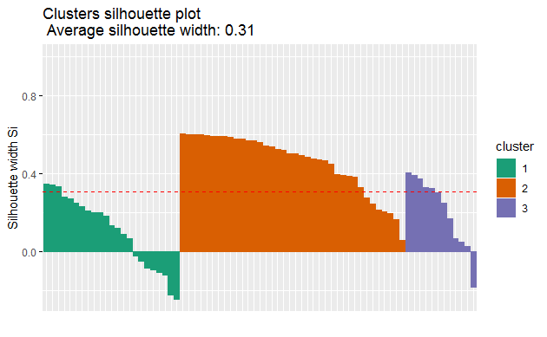
Notes: The values for silhouette width can vary between -1 and 1. Values close to 1 indicate that the country is similar to the other countries in the cluster and thus well placed in the cluster in questions. Values close to -1 indicate that the country is not particularly similar to the other countries in the cluster and may be wrongly classified.

Table 2: Countries with negative silhouette widths
 | Current cluster | Neighbor | Silhouette width
Bangladesh | 1 | 2 | -0.02139623
Belarus | 1 | 2 | -0.11763678
Cuba | 3 | 2 | -0.18110590
Djibouti | 1 | 2 | -0.04741284
Eritrea | 1 | 2 | -0.21933562
Ethiopia | 1 | 2 | -0.24229450
Mauritania | 1 | 2 | -0.08423509
Nigeria | 1 | 2 | -0.09271922
Russia | 1 | 2 | -0.10584780
Notes: Negative silhouette widths indicate that the countries may be placed into wrong cluster. The neighboring cluster informs us about the cluster, which these countries are closer to.

Table 3: Summary statistics for the variables included in the OLS-regressions
 | Mean | SD | Min | Max | N
Share of largest religious group | 79.78 | 17.77 | 33.94 | 99.95 | 69
Ambition of religious groups | 4.12 | 2.91 | 0 | 9 | 69
GDP capita (log) | 3.47 | 0.56 | 2.53 | 4.82 | 69
Religious ideology | 0.19 | 0.27 | 0 | 1 | 69
Socialist or communist ideology | 0.21 | 0.30 | 0 | 1 | 69

Table 4: Variance Inflation Factors
 | VIF
Share of largest religious group | 1.253980
Ambition of religious groups | 1.143791
GDP capita (log) | 1.092278
Religious ideology | 1.254732
Socialist or communist ideology | 1.232713

