Supplemental Information Appendix

Figure A1 – Distribution of Emails Received from the FRC, 2007-2018.
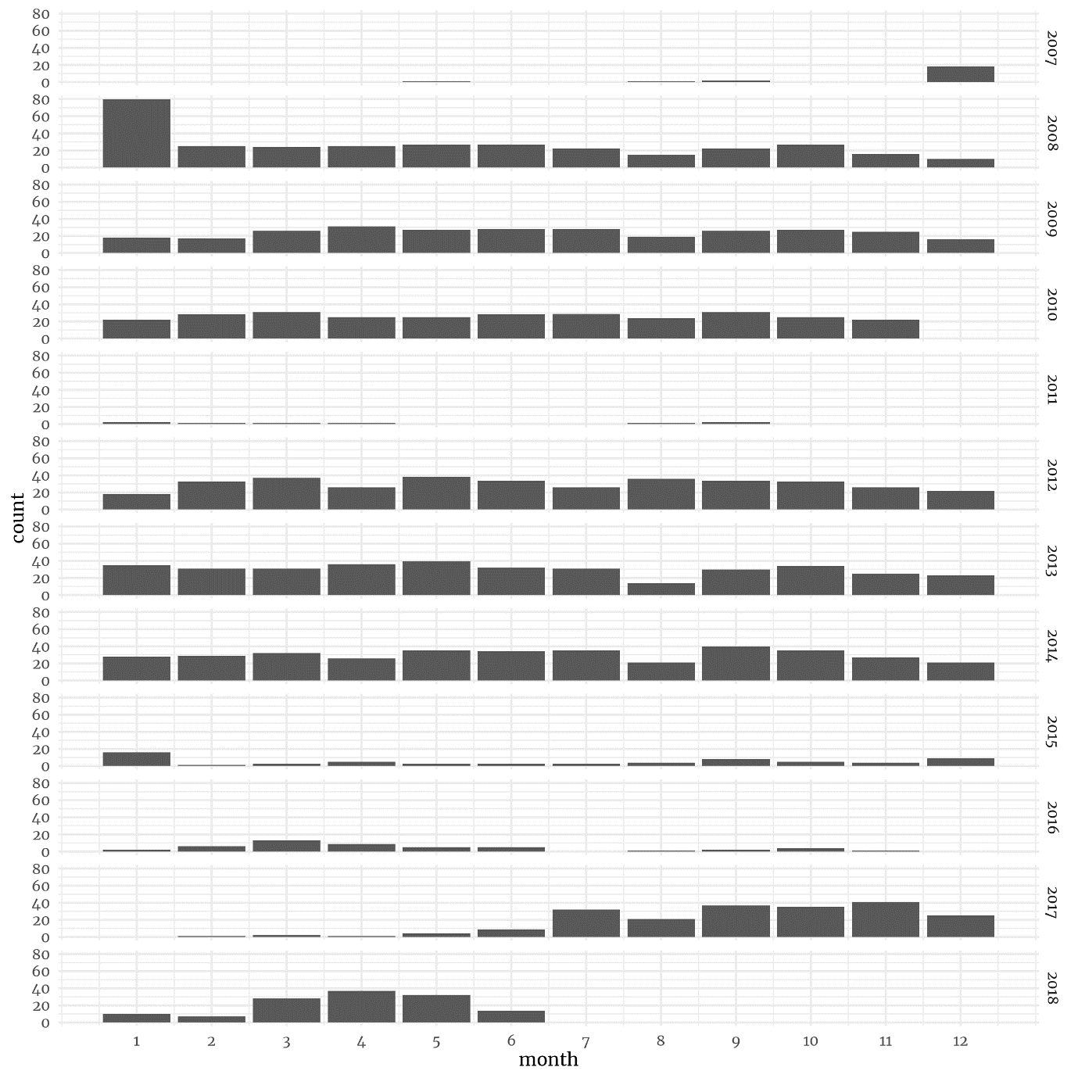

Figure A2 – Press Releases Made by Month by the FRC, 2013-2018
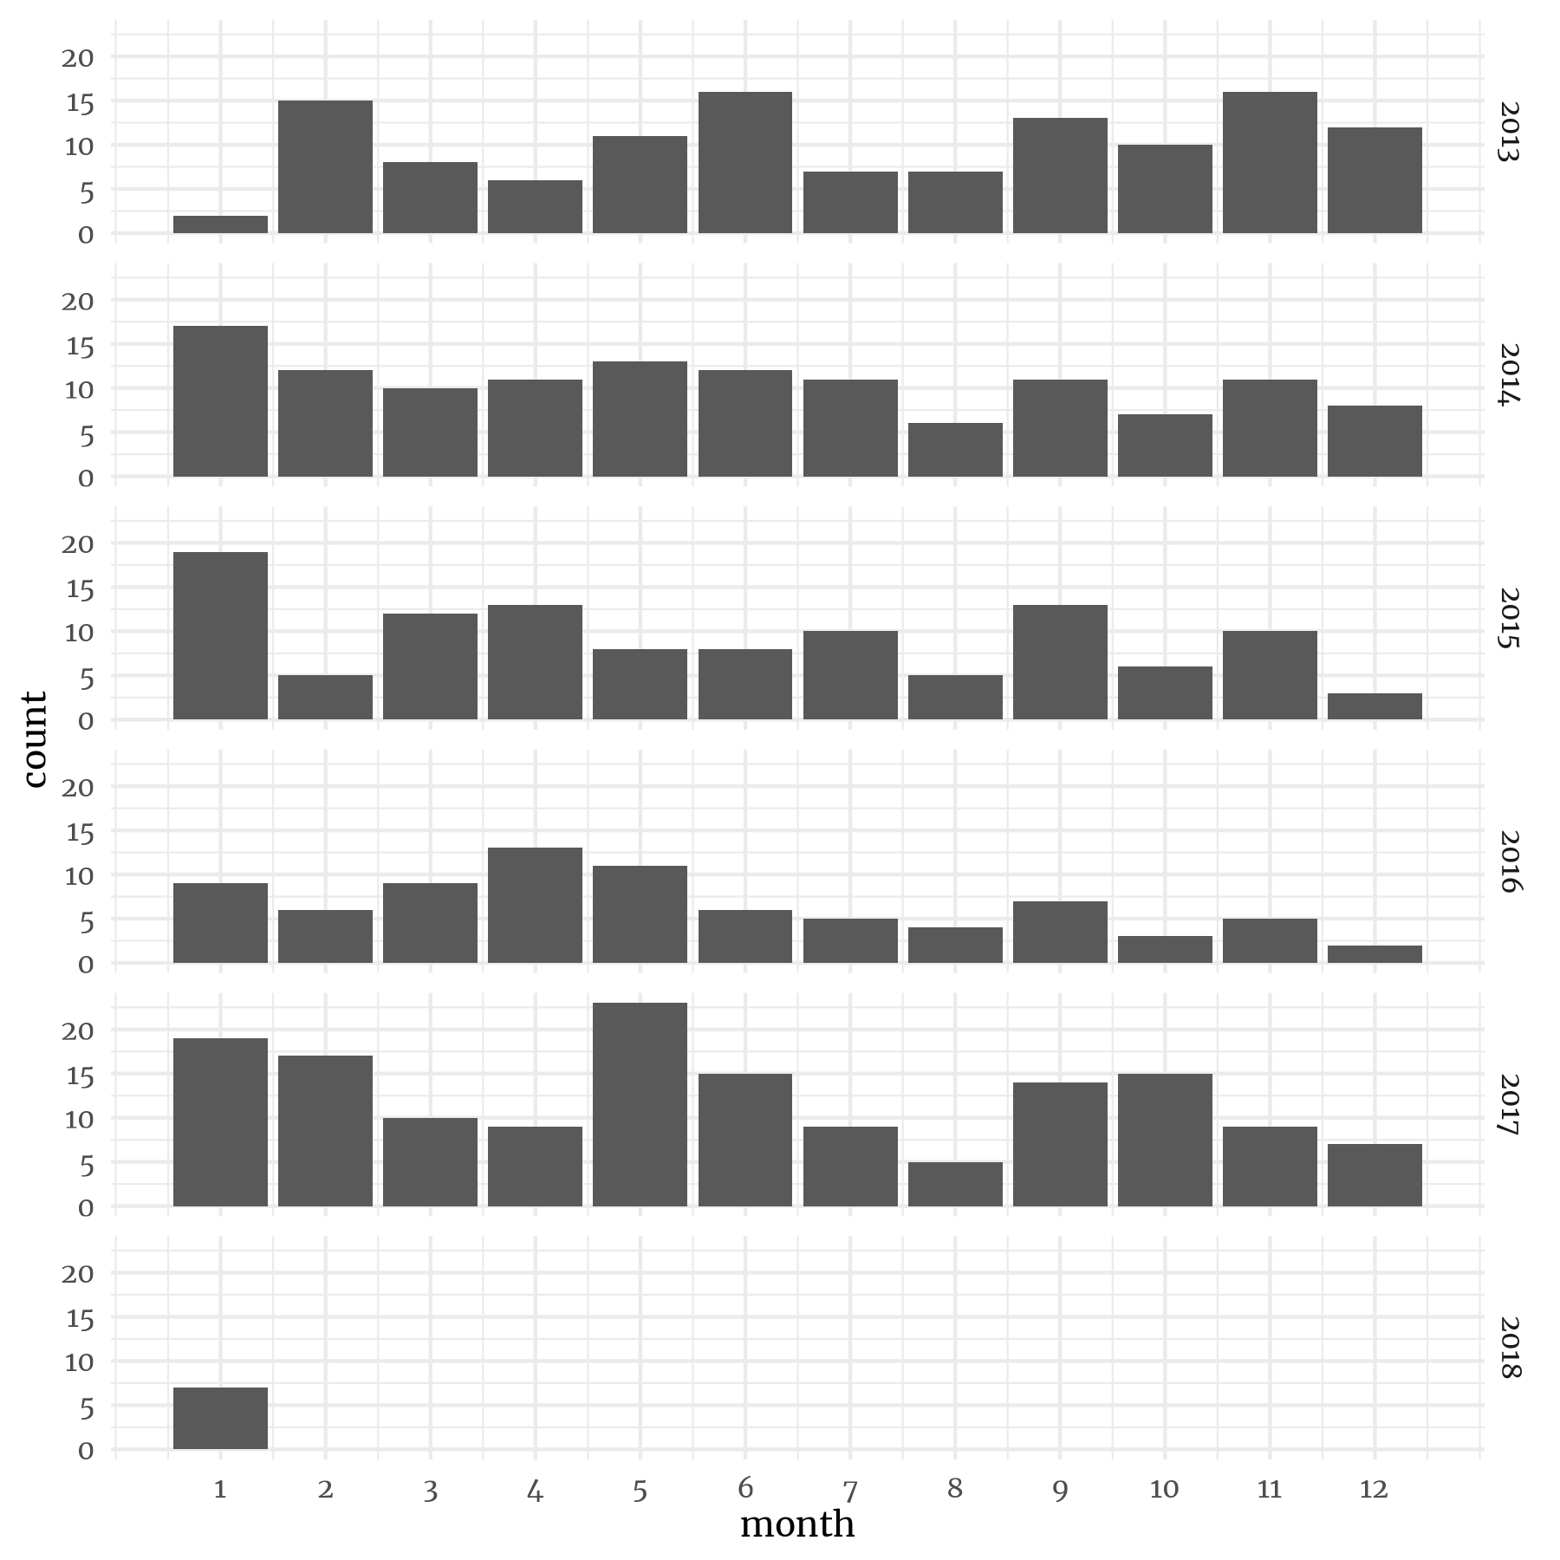

Figure A3 – The Policy Agendas Project Major Issue Areas of FRC Lobbying, 2008-2018
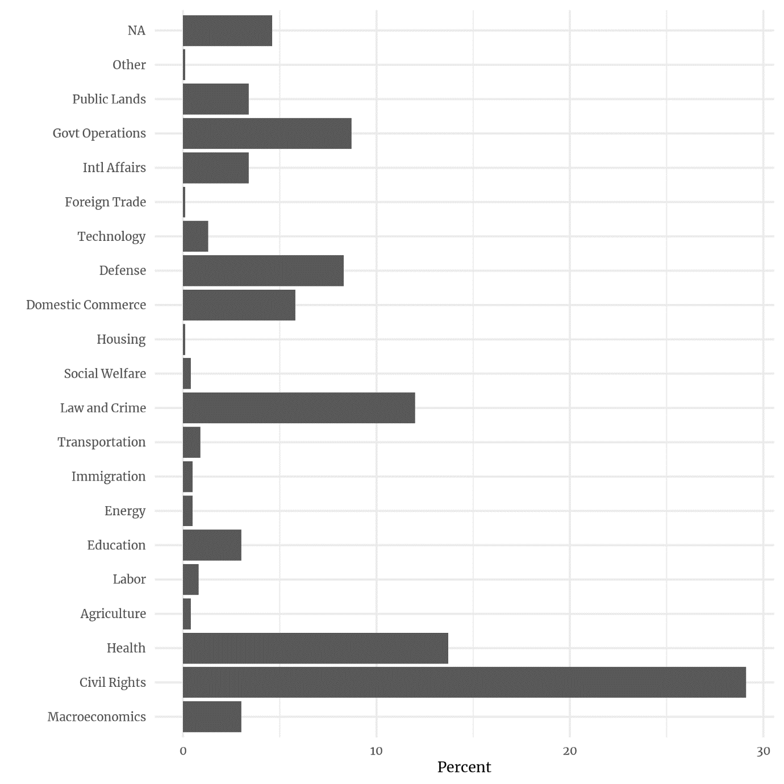

Figure A4 – The Relationship of Simple and Complex Definitions of the Abortion Agenda
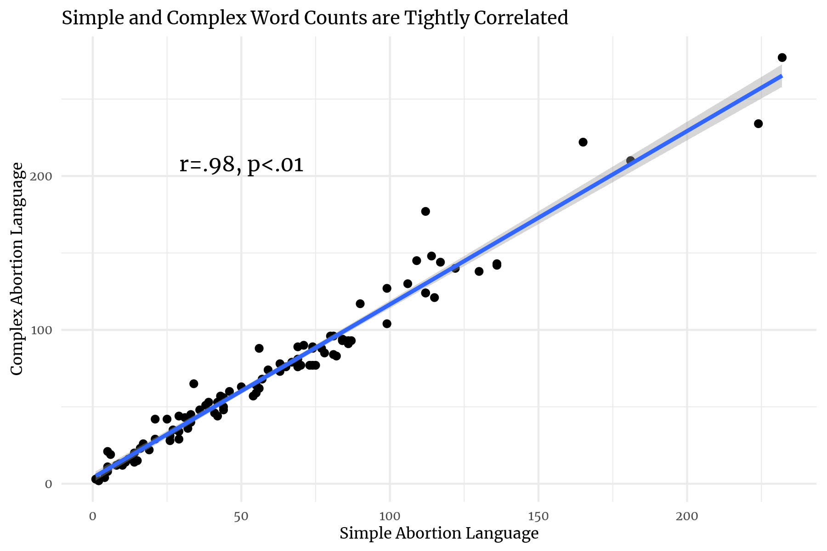

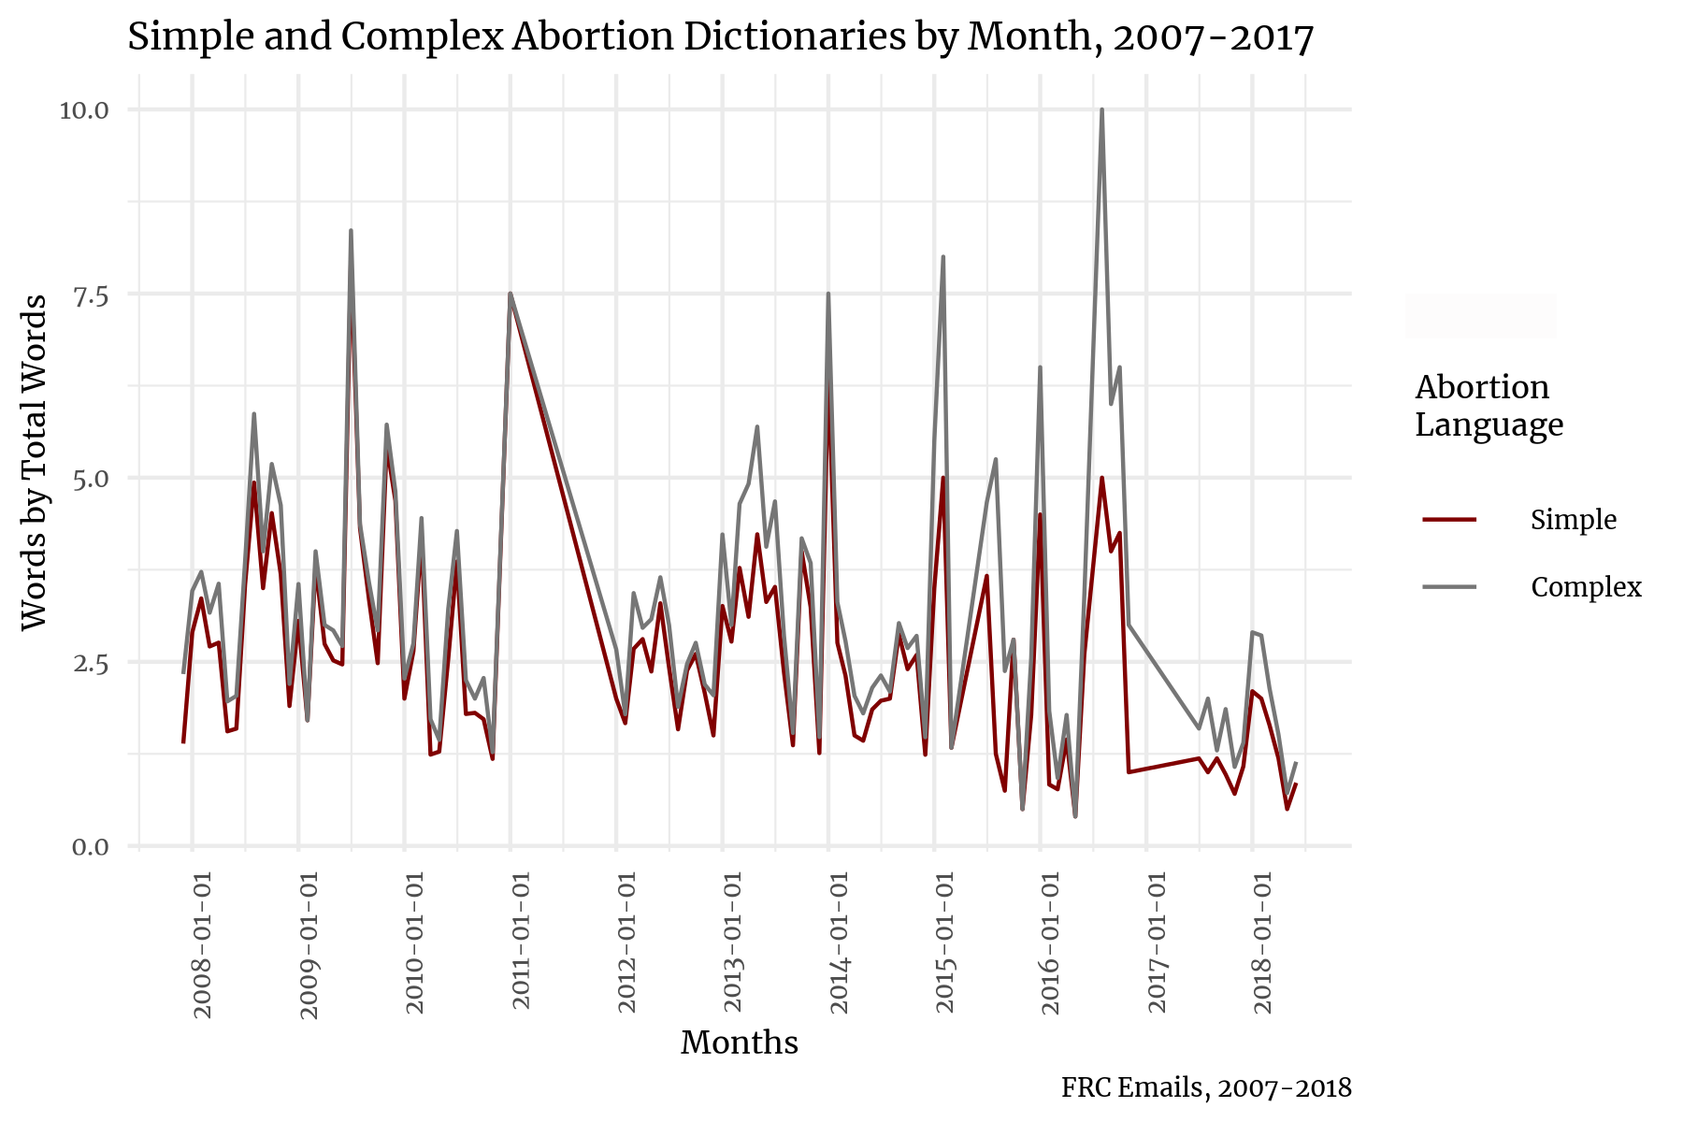

Figure A5 – Core Issue Agenda Email Communication by Month, 2007-2018
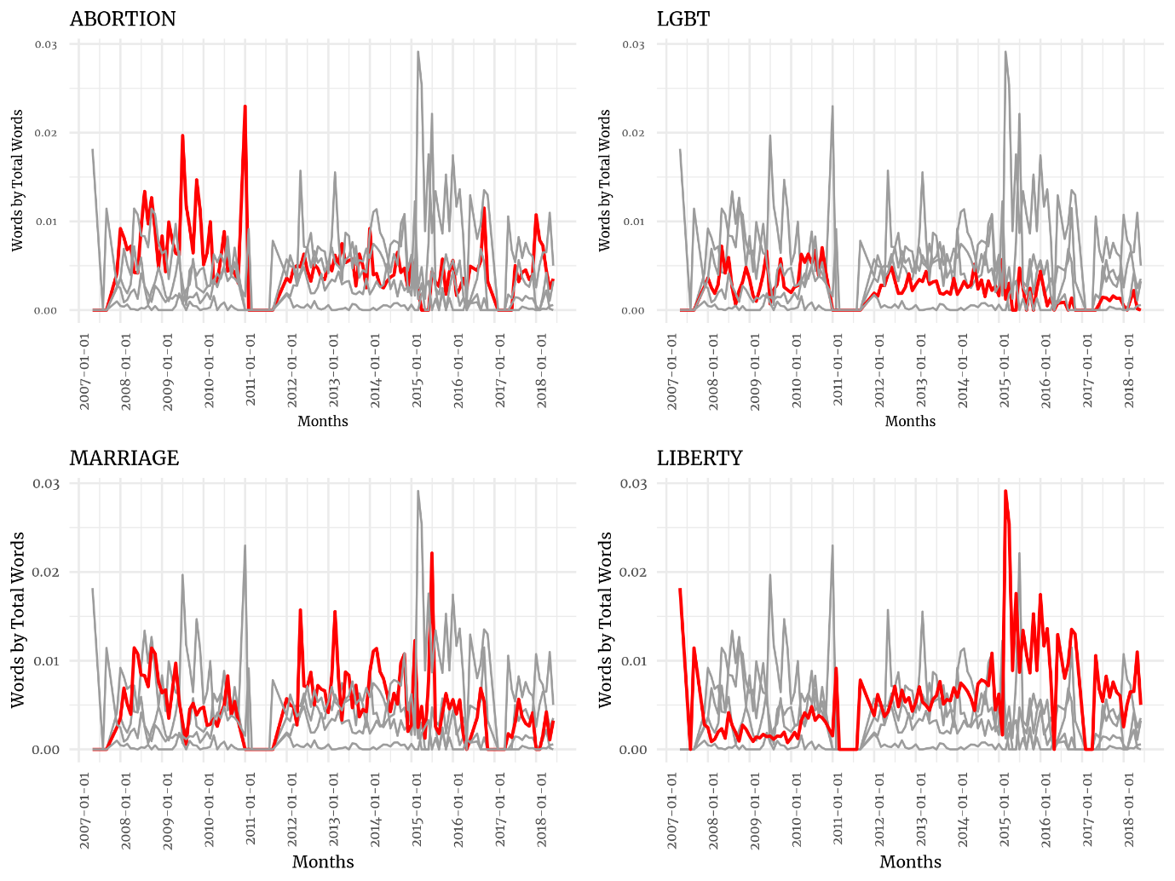

Figure A6 – Core Issue Agenda Press Release Communication by Month, 2013-2018 (Colored by Issue)
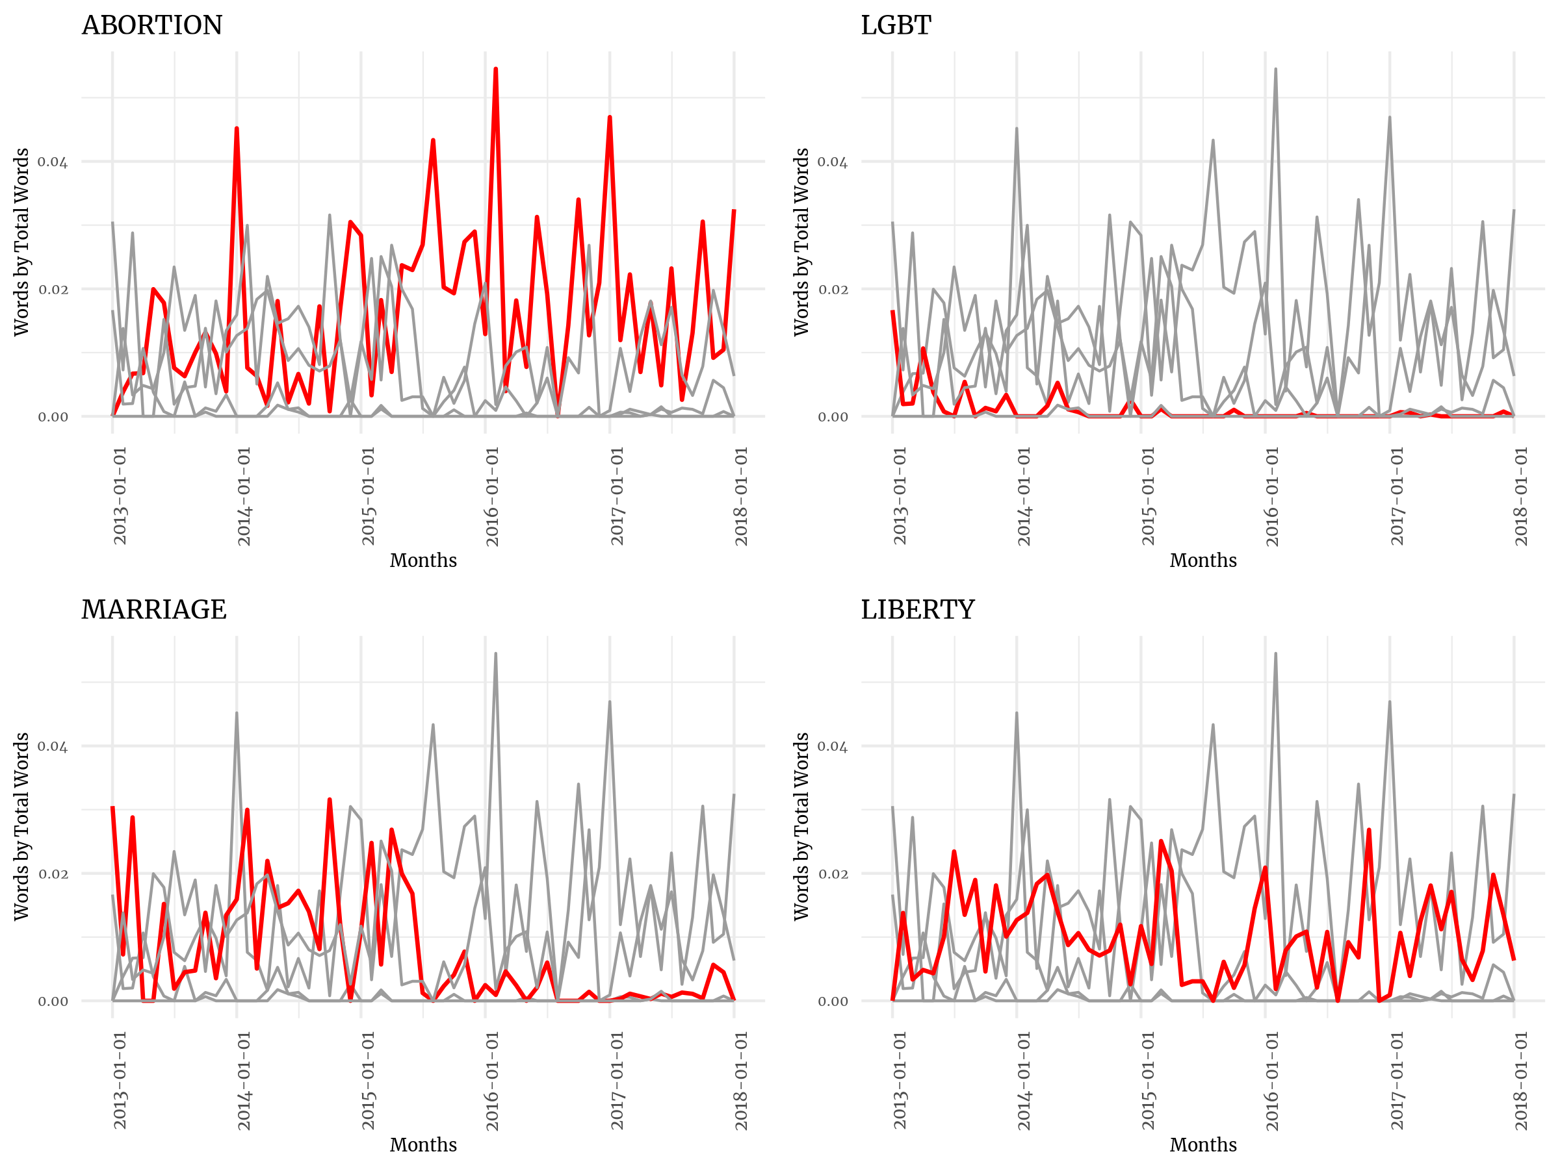

Figure A7 – How Email and Press Release Communication Tracks by Issue
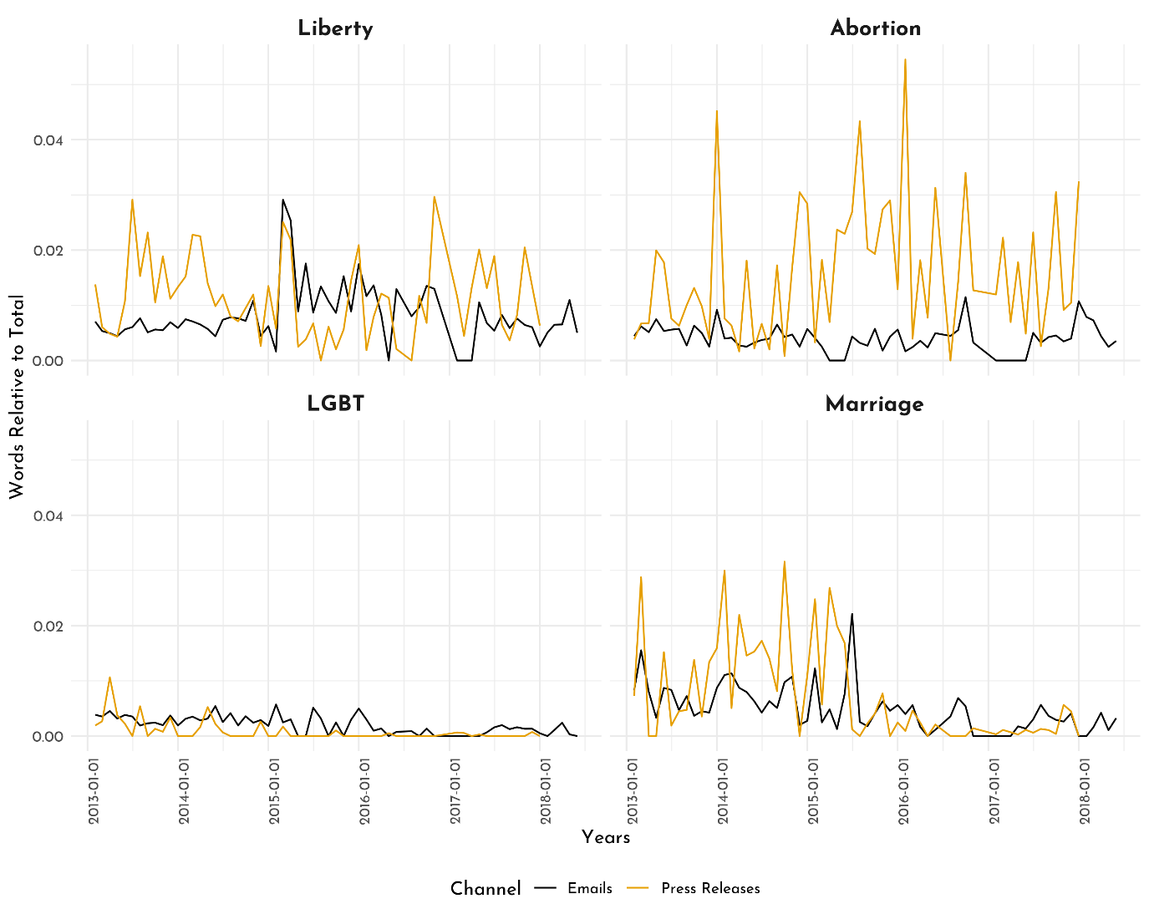
Figure A8 – Most LGBT Mentions Happened in the Context of Marriage (Emails)
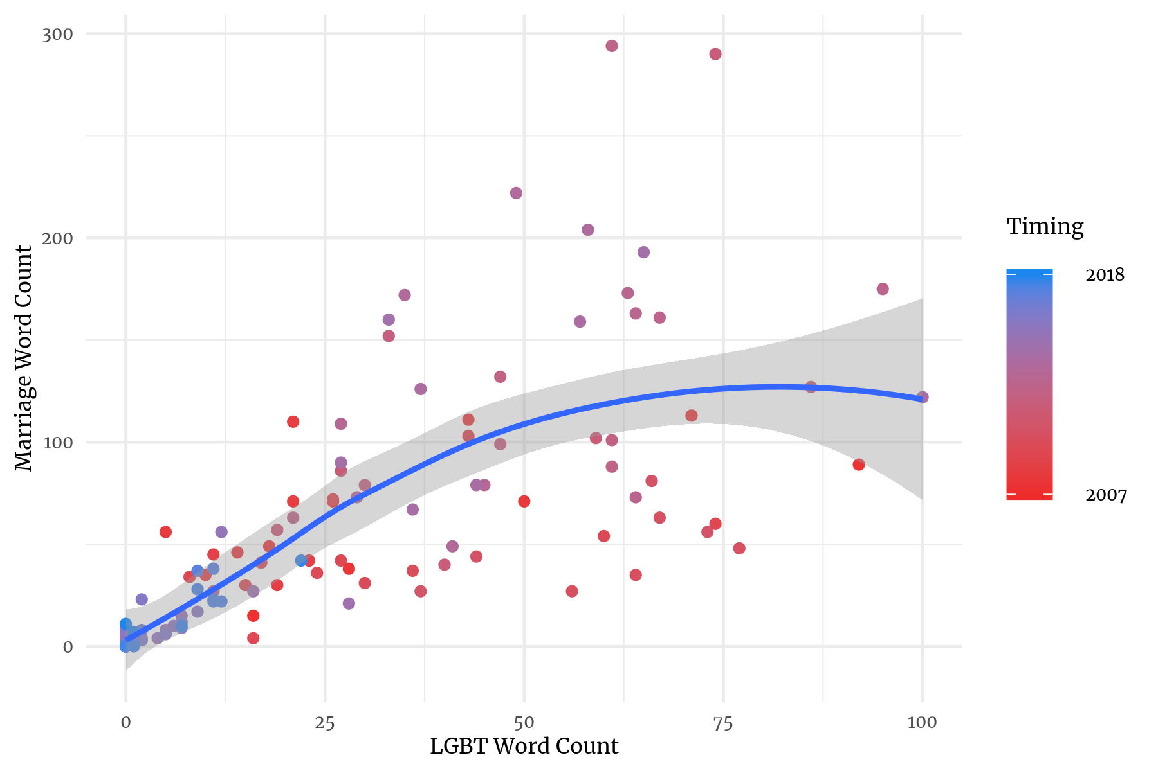

Figure A9 – Abortion and Marriage Are Not Often the Co-Focus of FRC Press Releases
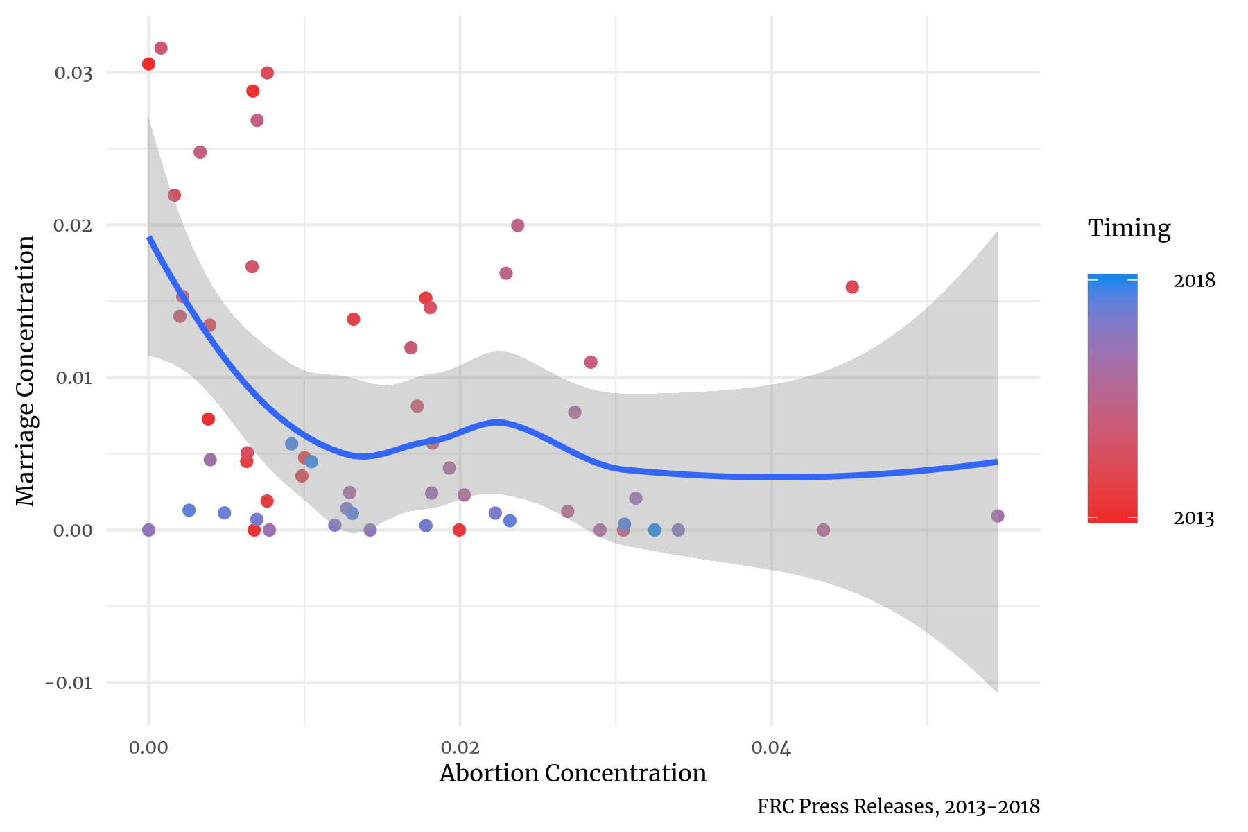

Figure A10 – Bills Mentioned More than Twice in FRC Emails
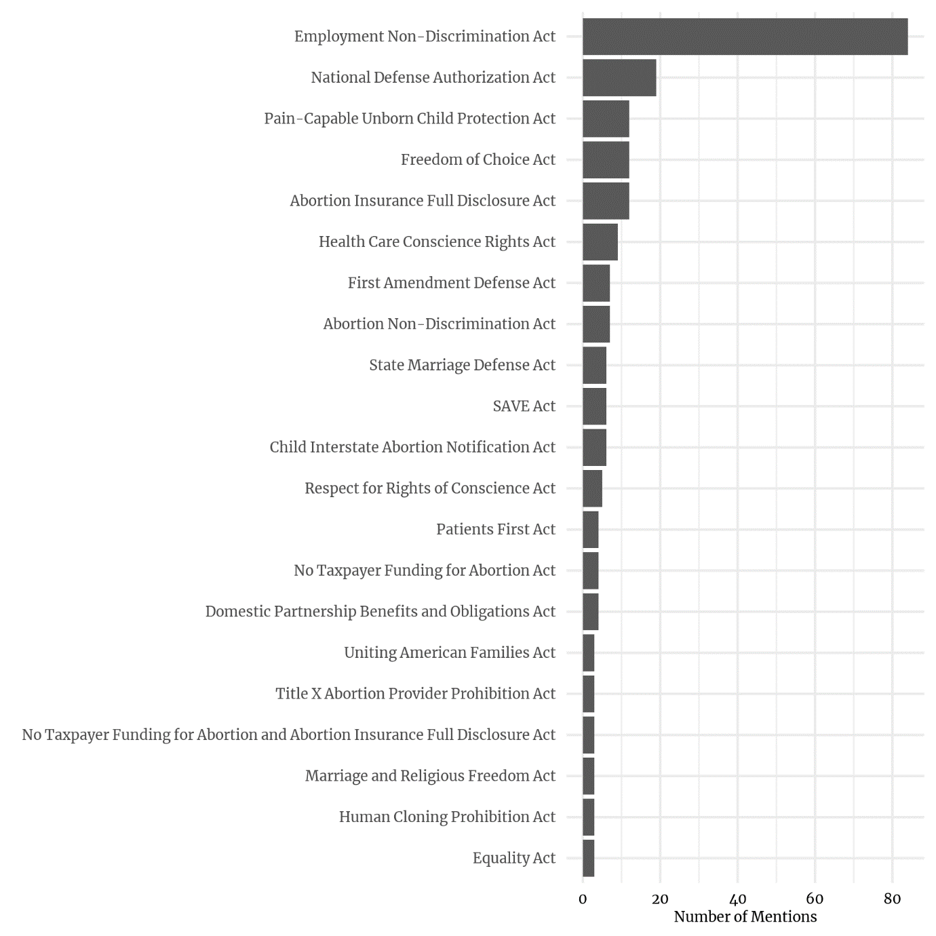

Figure A11 – There is a Slight Relationship Between Email Volume and Bill Mentions
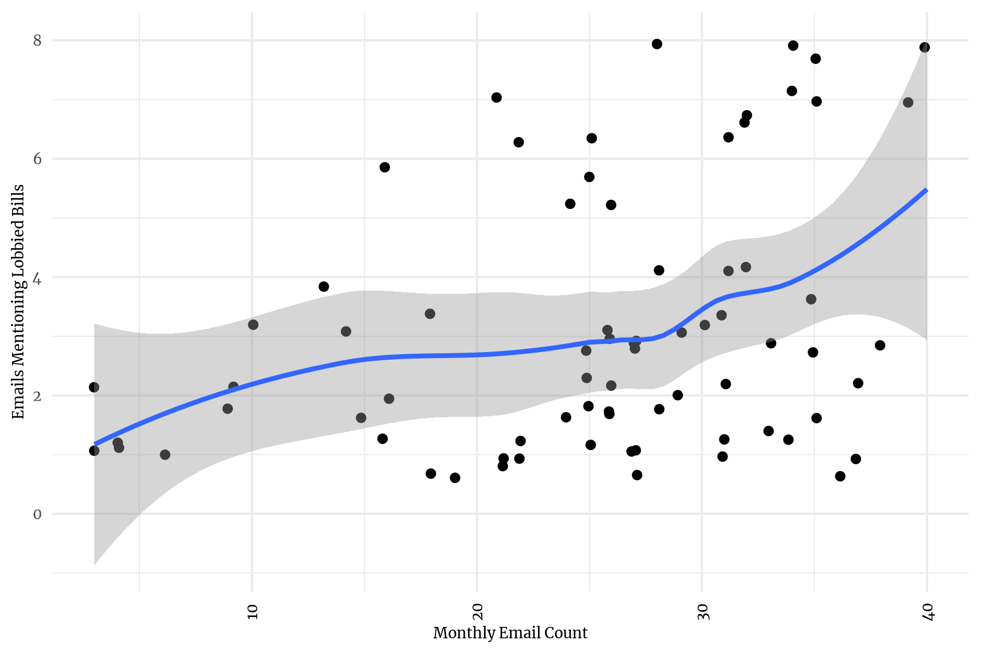
Note: Mentions = 1.82 + .05 * emails in the month (p=.03)

