Table A1. Descriptive Statistics of Pew Survey

Variable | N | Mean | Std. Dev. | Min | Max
Originalism | 3,197 | 0.50 | 0.50 | 0 | 1
Partisanship | 9,334 | 3.82 | 2.04 | 1 | 7
Conservatism | 9,581 | 3.17 | 1.02 | 1 | 5
Tea Party Support | 9,677 | 1.86 | 0.73 | 1 | 3
African American | 9,824 | 0.10 | 0.30 | 0 | 1
Hispanic | 9,824 | 0.09 | 0.29 | 0 | 1
Other Race | 9,824 | 0.07 | 0.26 | 0 | 1
Age | 9,851 | 52.52 | 18.11 | 18 | 97
Sex | 10,013 | 1.50 | 0.50 | 1 | 2
Education | 9,964 | 4.87 | 1.85 | 1 | 8
Follow Politics | 9,999 | 3.34 | 0.90 | 1 | 4
White Evangelical | 9,909 | 0.20 | 0.40 | 0 | 1
Mainline Protestant | 9,909 | 0.16 | 0.37 | 0 | 1
Black Protestant | 9,909 | 0.08 | 0.27 | 0 | 1
Catholic | 9,909 | 0.21 | 0.41 | 0 | 1
Other Christian | 9,909 | 0.11 | 0.32 | 0 | 1
Jewish | 9,909 | 0.02 | 0.15 | 0 | 1
Other Faith | 9,909 | 0.03 | 0.17 | 0 | 1
Religious Attendance | 9,918 | 3.63 | 1.61 | 1 | 6
Favor Same Sex Marriage | 3,086 | 2.63 | 1.06 | 1 | 4
Literal Interpretation | 3,059 | 0.34 | 0.47 | 0 | 1

Table A2. Logistic Regression Model Interacting Ideology and Catholicism
 | Model 1 | Model 2
Partisanship | 0.227*** | 0.231***
 | (0.032) | (0.031)
Conservatism | 0.387*** | 0.350***
 | (0.071) | (0.064)
Tea Party Agreement | 0.719*** | 0.722***
 | (0.088) | (0.088)
African American | -0.264
 | (0.187)
Hispanic | -0.191
 | (0.191)
Other Race | -0.253
 | (0.194)
Age | 0.011*** | 0.010***
 | (0.003) | (0.003)
Female | -0.143 | -0.148
 | (0.104) | (0.104)
Education | -0.104*** | -0.106***
 | (0.030) | (0.029)
Follow Politics | 0.126** | 0.126**
 | (0.059) | (0.059)
Religious Attendance | 0.107*** | 0.106***
 | (0.035) | (0.034)
Catholic | 0.074 | -0.467**
 | (0.458) | (0.237)
Catholic*Conservatism | -0.152
 | (0.136)
White |  | 0.204
 |  | (0.140)
Catholic*White |  | 0.096
 |  | (0.277)
Constant | -3.971*** | -4.063***
 | (0.371) | (0.352)
Observations | 2,872 | 2,872
Pseudo R² | 0.198 | 0.197
Robust standard errors in parentheses. *** p < 0.01, ** p < 0.05, * p < 0.1

Figure A1. Predicted Values of Interaction Effects in Constitutional Interpretation Index Model

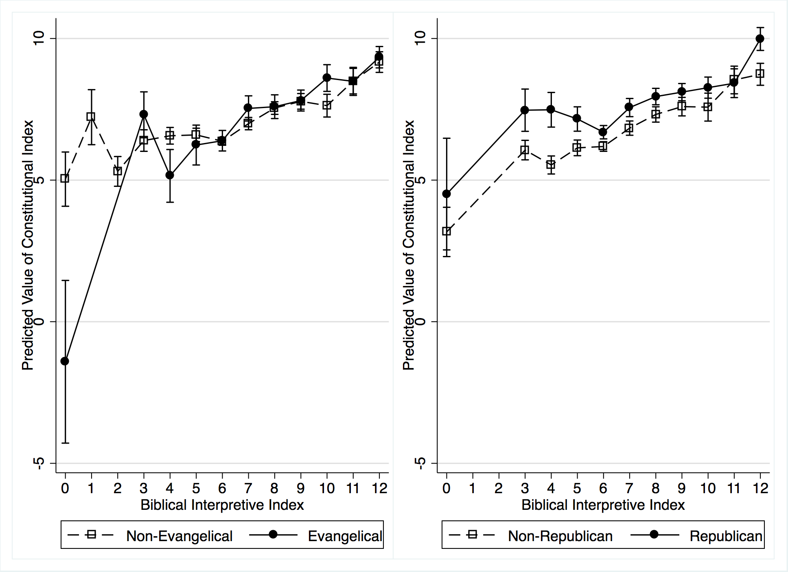

Table A3. Descriptive Statistics of Qualtrics Survey

Variable | N | Mean | Std. Dev. | Min | Max
White | 1,428 | 0.83 | 0.38 | 0 | 1
Hispanic | 1,428 | 0.04 | 0.20 | 0 | 1
African American | 1,428 | 0.07 | 0.26 | 0 | 1
Asian | 1,428 | 0.04 | 0.18 | 0 | 1
Other Race | 1,428 | 0.02 | 0.15 | 0 | 1
Female | 1,428 | 0.50 | 0.50 | 0 | 1
Attendance | 1,428 | 2.49 | 1.63 | 1 | 5
Age | 1,428 | 52.64 | 15.91 | 18 | 102
Education | 1,428 | 3.18 | 1.00 | 1 | 5
Income | 1,425 | 3.14 | 1.83 | 1 | 8
Evangelical | 1,095 | 1.66 | 0.48 | 1 | 2

Appendix: Survey Experiment

Genesis Passage:

The Book of Genesis describes the creation of the earth and human beings in Chapter 1 and Chapter 2. Chapter 2 states: 7 Then the Lord God formed a man from the dust of the ground and breathed into his nostrils the breath of life, and the man became a living being. . . . 20 But for Adam no suitable helper was found. 21 So the Lord God caused the man to fall into a deep sleep; and while he was sleeping, he took one of the man’s ribs and then closed up the place with flesh. 22 Then the Lord God made a woman from the rib he had taken out of the man, and he brought her to the man (Genesis 2:7, 20-22; NIV Translation).

Group 1a: Two Religious Leaders with Different Interpretations:

Recently two prominent religious leaders presented their perspectives on the passage while speaking at their local houses of worship. Here is a quote that summarizes each viewpoint. [Religious leader 1]: The Genesis creation narrative may sound impossible to our modern minds and culture, because it is miraculous. Yet, Genesis is the accurate description of a miraculous God who has always been capable of doing the impossible in our world. God has proven himself to be trustworthy, and so is Scripture—his message to his people. Therefore, I am convinced that Adam and Eve were literal people, created in the way Genesis describes. Human history begins with God forming Adam and Eve, and their existence is an essential part of Scripture’s message of redemption. [Religious leader 2]: The creation narrative in Genesis does not have to be scientifically accurate to tell us something important about humanity and our relationship to the Divine. Like all creation narratives throughout history, the story in Genesis is about a people developing an understanding of something greater than themselves. Adam and Eve are a cultural expression of this reality. Most importantly, the story is a metaphor that describes who God is and God’s relationship with man.

Religious Leaders’ names were inserted based on respondents’ religious affiliation as follows:
For Catholic or Eastern Orthodox respondents: Father Costa and Father Flores
For Jewish respondents: Rabbi Cohen and Rabbi Goldman
For Protestant respondents: Pastor Turner and Pastor Allen
For all other respondent: Pastor Davis and Pastor Kelly

Order of the religious leaders’ quotes was rotated at random.

Group 2a: One Leader with Literal Interpretation Only:

Respondents randomly assigned to receive same passage as above, but with only the literal interpretation from one religious leader.

Group 3a: One Leader with Metaphorical Interpretation Only:

Respondents randomly assigned to receive same passage as above, but with only the metaphorical interpretation from one religious leader.

Joshua Passage:

The Book of Joshua describes the part of the history of Israel under the leadership of Joshua, who came to lead the Israelites after the death of Moses. Chapter 10 depicts the battle of Gibeon where the Israelites defeated the Amorites. 11bAs they [the Amorites] fled before Israel on the road down from Beth Horon to Azekah, the Lord hurled large hailstones down on them, and more of them died from the hail than were killed by the swords of the Israelites. 12 On the day the Lord gave the Amorites over to Israel, Joshua said to the Lord in the presence of Israel: “Sun, stand still over Gibeon, and you, moon, over the Valley of Aijalon.” 13 So the sun stood still, and the moon stopped, till the nation avenged itself on its enemies, as it is written in the Book of Jashar. The sun stopped in the middle of the sky and delayed going down about a full day. 14 There has never been a day like it before or since, a day when the Lord listened to a human being. Surely the Lord was fighting for Israel! (Joshua 10:11-14; NIV Translation)

Group 1b: Two Religious Leaders with Different Interpretations:

Recently two prominent religious leaders presented their perspectives on the passage while speaking at their local houses of worship. Here is a quote that summarizes each viewpoint. [Religious leader 1]: If God is powerful enough to create the universe and humans, then he is surely powerful enough to interrupt the normal course of day and night to achieve his purposes. In this passage, there is some mystery in exactly how the day was prolonged, whether the earth stopped rotating on its axis or if the rotation was slowed to allow for extended daylight. We do not need these details to trust that God is fully capable of doing miracles and to take at face value the description of events in Joshua. I am convinced that God extended the day in Joshua to provide for Israel and to fulfill his plans. He is powerful enough to do the miraculous. [Religious leader 2]: Joshua’s description of the sun standing still and the moon stopping represents the form of song and poetry. It does not require a literal interpretation. Rather, this passage expresses a gratitude to God for what the people of Israel saw as Divine aid in defeating their enemies. Metaphor and exaggeration are common in messages of thankfulness, and this seems to be the case here. Yet, we can take great inspiration from the story. God helps us defeat our enemies, and we should respond with gratitude.

Religious Leaders’ names were inserted based on respondents’ religious affiliation as follows:
For Catholic or Eastern Orthodox respondents: Father Donovan and Father Fitzgerald
For Jewish respondents: Rabbi Roth and Rabbi Schwartz
For Protestant respondents: Pastor Wolf and Pastor Brady
For all other respondent: Pastor Joseph and Pastor Nash

Order of the religious leaders’ quotes was rotated at random.

Group 2b: One Leader with Literal Interpretation Only:

Respondents randomly assigned to receive same passage as above, but with only the literal interpretation from one religious leader.

Group3b: One Leader with Metaphorical Interpretation Only:

Respondents randomly assigned to receive same passage as above, but with only the metaphorical interpretation from one religious leader.

Control Group

Respondents randomly assigned to receive no quotes from religious leaders, only the biblical passages.

When interpreting this passage, which best describes your approach?
- I accept the passage literally as written.
- I view the passage as conveying truth about the Divine, but I do not take it literally, word for word.
- I view the passage as a literary device, such as poetry or metaphor.
- I reject the historical accuracy of the passage, but I recognize its cultural value.
- I reject the accuracy of the passage for being the result of incremental additions and subtractions taking place over centuries.
- I reject the accuracy of the passage because it is contradicted by science.
- Don't know/No opinion

First Amendment Passage

The First Amendment to the United States Constitution protects free speech. It states:
Congress shall make no law . . . abridging the freedom of speech, or of the press; or the right of the people peaceably to assemble, and to petition the government for a redress of grievances (First Amendment, U.S. Constitution). Do you think there are circumstances in which the First Amendment’s protections of free speech should be limited, or do you think there should be no limits on free speech protections? Please enter your answer on the scale below.
 | Must be limits | Must not be limits

 | 0 | 2 | 4 | 6 | 8 | 10

Should there be limits on free speech?

Recently two prominent law school professors debated the proper interpretation of this section of the Constitution at a law school conference. Here is a quote that summarizes each of their perspectives. Professor Smith: The first ten Amendments to the U.S. Constitution, known as the Bill of Rights, were written in general, non-controversial language. They represent general principles and aspirations for the American government and the American people to adhere to, but they cannot be interpreted with rigidity. The First Amendment provides broad protections for free speech, especially political speech. Yet this cannot mean that Congress is unable to pass any laws that regulate speech or expression, particularly because such laws might improve American government and/or protect the safety of the United States. The overarching principle of the Constitution is to promote a healthy federal government, while protecting individual rights. As the people’s representatives, Congress must be given some latitude to pass legislation and not be constrained by rigid absolutes. Professor Ingram: When the Founders wrote the U.S. Constitution, they were concerned about the federal government having too much power over the people. To help prevent this, the First Amendment prohibits the government from limiting people’s ability to speak. Congress must not make any laws that infringe on speech – the people’s ability to express their views and communicate their opinions, even radical, unpopular opinions. When the First Amendment says that Congress shall make “no law,” it literally means that Congress must not pass a law inhibiting free speech.

On a scale of 0-10 (Disagree – Agree), how much do you agree with these law professors?
______ Professor Smith (1)
______ Professor Ingram (2)

If you had to choose, which law professor do you agree with the most?
- Professor Smith (1)
- Professor Ingram (2)
- No Preference (3)

Congress shall make no law . . . abridging the freedom of speech, or of the press; or the right of the people peaceably to assemble, and to petition the government for a redress of grievances (First Amendment, U.S. Constitution). When interpreting this passage, which of the following best describes your approach?
- I accept the passage literally as written. (1)
- I accept the passage literally as written though I seek to understand what the words meant to those who adopted it. (2)
- I view the passage as conveying truth about how we should govern ourselves, but I do not take it literally, word for word. (3)
- I view the passage as written for a particular people in a particular time. As a result, we do not have to govern ourselves by it today. (4)
- I view the passage as part of a flawed system of government that should be reconsidered. (5)
- Don't know/No opinion (6)

Fourth Amendment Passage

The Fourth Amendment to the United States Constitution protects people from unreasonable government interference into their private lives, providing protections of privacy. It states:
The right of the people to be secure in their persons, houses, papers, and effects, against unreasonable searches and seizures, shall not be violated . . . (Fourth Amendment, U.S. Constitution). Do you think the right to privacy should be limited to the items listed in this passage from the Fourth Amendment, or do you think the right to privacy should include other items not mentioned in this passage? Please enter your answer on the scale below.
 | Limited to text | Expanded to other items

 | 0 | 2 | 4 | 6 | 8 | 10

How broad is the right to privacy?

Recently two prominent law school professors debated the proper interpretation of this section of the Constitution at a law school conference. Here is a quote that summarizes each of their perspectives. Professor Rodgers: The Fourth Amendment establishes explicit principles for the right to privacy, declaring that people or their homes may not be unreasonably searched and their personal property may not be improperly taken by the government. This is a vital protection against government interference that must be strongly defended. But the U.S. Constitution does not provide a broad, general right to privacy. In fact, the word privacy does not appear in the U.S. Constitution. The limited government that the Constitution establishes will certainly protect many elements privacy, and the Fourth Amendment provides clear guidelines for criminal protections against searching and seizing. Yet, if our representative government determines that it should regulate an area of life that some deem private, the Fourth Amendment has little to say about such action. The text did not provide a general right to privacy at the Founding, and it does not do so today. Professor Morris: The Fourth Amendment clearly establishes the principle of privacy. Its aim is to prevent the government from both invading areas where the government has no right to be and making decisions regarding things it does not own. What we consider private in the 21st century may be different and broader than what was regarded as private in the 18th century. Yet we should continue to vigorously protect this right to privacy as applied to our context. For example, the Founders were most concerned about criminal privacy, as this is what the British government had been known to violate. As such, the Fourth Amendment lists items related to criminal investigations. In the 21st century, we have come to expect privacy in the area of sexuality and reproduction. Therefore, we must apply the vision of the Fourth Amendment to these contemporary societal demands.

On a scale of 0-10 (Disagree – Agree), how much do you agree with these law professors?
______ Professor Rodgers (1)
______ Professor Morris (2)

If you had to choose, which law professor do you agree with the most?
- Professor Rodgers (1)
- Professor Morris (2)
- No Preference (3)

The Fourth Amendment to the United States Constitution protects people from unreasonable government interference into their private lives, providing protections of privacy. It states: The right of the people to be secure in their persons, houses, papers, and effects, against unreasonable searches and seizures, shall not be violated . . . (Fourth Amendment, U.S. Constitution). When interpreting this passage, which of the following best describes your approach?
- I accept the passage literally as written. (1)
- I accept the passage literally as written though I seek to understand what the words meant to those who adopted it. (2)
- I view the passage as conveying truth about how we should govern ourselves, but I do not take it literally, word for word. (3)
- I view the passage as written for a particular people in a particular time. As a result, we do not have to govern ourselves by it today. (4)
- I view the passage as part of a flawed system of government that should be reconsidered. (5)
- Don't know/No opinion (6)

Table A4. Randomization of Demographics Across Treatment Conditions for MTurk Survey

 | Treatment
Variable | Control | Literal | Metaphorical | Combined
White | 0.83 | 0.79 | 0.81 | 0.81
Black | 0.07 | 0.11 | 0.07 | 0.08
Gender | 1.50 | 1.50 | 1.44 | 1.51
Attendance | 1.07 | 1.16 | 0.94 | 0.94
Age | 1.89 | 1.94 | 1.86 | 1.90
Partisanship | 2.23 | 2.26 | 2.18 | 2.35
Evangelical | 0.14 | 0.13 | 0.14 | 0.15
Catholic | 0.14 | 0.13 | 0.14 | 0.11
N | 468 | 462 | 460 | 459

Figure A2. Distribution of Responses to First Amendment Interpretation Question
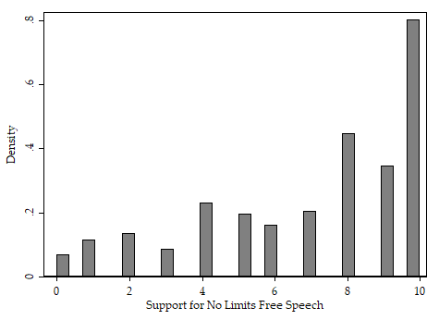

Figure A3. Distribution of Responses to Fourth Amendment Interpretation Question
