Appendix
Political Mobilization in American Congregations:
A Religious Economies Perspective
Page | Content
2-8 | Variable coding
9 | Figure A1 - The Distribution of Congregational Political Activism Across Religious Traditions
10 | Figure A2 – The insignificant link between clergy-congregant disagreement and the extent of church outreach activities, 2014 clergy sample
11 | Figure A3 – Predicted Number of Political Activities by Theological Conservatism Given the Partisan Cast of the County (NCS data)
12 | Table A1 – Logistic Regression Estimates of the Congregational and Environmental Determinants of Political Service Provision in Churches (USCLS)
13 | Table A2 - Comparison of the estimates for services and outreach efforts with and without the inclusion of the public charities count (excerpted from Table 1 model)
14 | Table A3 – Pearson’s Correlations of Religious Competition and Congregational Services and Outreach
15 | Figure A4 – Conditional Probability of Congregational Outreach Activity as a Function of Denominational Affiliation and Logged Marketshare (NCS)
Appendix – Variable Coding
National Congregations Study
Services Provided “Within the past twelve months, have there been any groups of people from your congregation meeting once a month or more for religious, social, recreational, or other purposes?” If yes, “For what purpose or purposes do these groups meet?” Fine or performing arts; Dealing with the loss of a loved one; Bible studies; Business or financial purposes; Care for congregational building or property; Sewing groups; Specifically for young adults (i.e., age 18+); Specifically for couples, including marriage preparation classes; Divorce support groups; Non-religious education purposes; Specifically for senior citizens; Specifically for people from certain racial/ethnic groups; Purpose is supporting families, including marriage training, wedding or baby showers, discussion of pregnancy issues or family values; Specifically for women; Festivals, bazaars, craft fairs, or other celebrations; Explicitly involving food, including picnics, dinners, lunches, coffee hours; Fund-raising; Bingo, cards, or other games; Focused on individuals’ physical well-being; Holy Name Society; Helping individuals find jobs or advance in their careers; Specifically for children and youth; Knights of Columbus; Meetings of congregational leaders; Focused on congregation’s worship or liturgy; Specifically for men; Focused on new members of the congregation; Group is nowhere else classified; Purpose is to recruit new members or evangelize; Prayer, worship, or devotional activity; Promise Keepers; Recreation; Religious purposes; Helping the needy; Specifically for singles; Socializing or “fellowship”; Study, teaching, or education whose specific content is unclear; Helping people with substance abuse problems; Support group for specific problems or issues, except bereavement and substance abuse; Supporting teachers either within the congregation or within congregation-related schools; Vacation or summer Bible school; St. Vincent de Paul; Visiting others, such as shut-ins or incarcerated individuals.”
Outreach activities “Does your congregation make any efforts to recruit new participants?” If yes, “Within the past twelve months have you done any of the following: Placed a paid ad in a newspaper? Encouraged people already in the congregation to invite a new person? Conducted or used a survey of your community? Mailed or distributed a flyer to people in the community? Followed up with visitors to the congregation? Had a special formal committee to work on recruitment?”
Permit “In the past twelve months, has your congregation tried to obtain any sort of permit or license from a government authority or office?” 0=no, 1=yes.
Denominational affiliation “Is your congregation formally affiliated with a denomination, convention, or some similar kind of association?” 0=no, 1=yes (also used in the USCLS).
1/congregation size “How many persons would you say are associated in any way with the religious life of this congregation--counting both adults and children, counting both regular and irregular participants, counting both official or registered members and also participating nonmembers. What is the total number of persons associated with this congregation to any degree at all?” The variable was then inverted (also used in the USCLS).
Income “What is the total amount of money your congregation received in income from all sources during your most recent fiscal year?”
Catholic/Evangelical/Mainline Dummy variables extracted from the NCS “TRAD3” variable, labeled “religious tradition (collapsed).” It identified “Roman Catholic,” “White conservative, evangelical, or fundamentalist,” “Black Protestant,” “White, liberal or moderate,” “or “Non-Christian.”
Midwest/South/West Dummy variables using the standard Census schedule of classifying states (also used in the USCLS).
Conflict Coded 1 if any of the following are true and 0 otherwise. 1. “In every congregation, disagreements and conflicts occasionally arise. Within the last two years, has your congregation experienced a conflict for which a special meeting was called specifically to deal with the disagreement?” 2. “Within the last two years, has your congregation experienced a conflict that led some people to leave the congregation?” 3. “Within the last two years, has your congregation experienced a conflict that led to the departure of a clergyperson or other religious leader?”
Biblical inerrant “Does your congregation consider the Bible to be the literal and inerrant word of God?” 1=yes, 0=no.
Clergy gender 0=female, 1=male.
Pct with college degree “About what percentage would you say have four-year degrees or more?”
Pct female “Thinking again of these regular adult participants, what percent would you say are female?”
Pct over 60 “Of the regular adult participants, about what percentage would you say are over sixty years old?”
Pct under 35 “What percentage of the regular adult participants would you say are under thirty-five years old?”
Pct with long drive “What percent live more than a thirty-minute drive away?”
Pct poor “Of the regular adult participants, what percent would you say live in households with income under $25,000 a year?”
Pct rich “What percent would you say live in households with income higher than $100,000 a year?”
Pct white “What percent of the regular adult participants in your congregation are white and non-Hispanic?”
Pct who are church leaders “Of the regularly participating adults, how many would you say have served in some sort of leadership role in this congregation – such as chairing a committee, serving as an officer, teaching a class, or other leadership roles – within the past twelve months?”
Political ideology “Politically speaking, would your congregation be considered more on the conservative side (=1), more on the liberal side (=3), or right in the middle (=2)?”
Theological liberals “Theologically speaking, would your congregation be considered more on the conservative side, more on the liberal side, or right in the middle?” 0=conservative or middle, 1=liberal (also used in the USCLS).
Theological conservatives “Theologically speaking, would your congregation be considered more on the conservative side, more on the liberal side, or right in the middle?” 0=liberal or middle, 1=conservative (also used in the USCLS).
Logged marketshare We matched up the denominational code from the NCS dataset (denom1) with data from the Religious Congregations and Membership Study data from 2000. Marketshare is the total number of adherents for the denomination divided by total adherence in the county. We substituted the black protestant figures from 2010 since all black Protestant denominations did not participate in 2000. For denominations in the NCS that were not included in the RCMS, we substituted the value for the appropriate religious denominational family (e.g., Baptist) or religious tradition (e.g., evangelical). Then, we took the natural log of this value (also used in the USCLS, using the variable nmednom1 to identify the denomination of the congregation).
Religious concentration This is a Herfindahl-style measure, which sums the squares of the religious tradition adherent proportions in the county. We used the 2000 RCMS religious tradition measures, including evangelical Protestant, Black Protestant (from 2010), Mainline Protestant, Catholic, Orthodox, Jewish, Muslim, and other (also used in the USCLS).
Democratic Share of 2-Party Vote The percent of the county-level, two-party vote for Gore in the 2000 election, taken from the David Leip dataset (uselectionatlas.org) (also used in the USCLS).
Party competition Absolute value of the percentage difference between the Democratic presidential candidate and .5 in the county (also used in the USCLS).
United States Congregational Life Study (USCLS)
Services Provided “In the past 12 months, did your congregation provide the following service for your own congregation’s members or for people in the community? Housing for senior citizens (nursing homes, assisted living); Housing for other groups (crisis, youth shelters, homeless, students); Other senior citizen problems or assistance (Meals on Wheels, transportation); Prison or jail ministry; Care for persons with disabilities (skills training, respite care, home care); Counseling or support groups (marriage or bereavement counseling, parenting programs, women’s groups); Substance abuse or 12-step recovery programs; Day care, preschool, before or after-school programs; Elementary school; Other programs for children and youth (job training, literacy program, scouting, sports); Emergency relief or material assistance (food, clothes for the needy); Health-related programs and activities (blood drives, screenings, health education); Immigrant support activities (English as a second language, refugee support, interpreting service); Activities for unemployed people (preparation for job seeking, skills training); Community organizing or neighborhood action groups; Animal welfare, community service, or social action activities not mentioned above; Sporting activities or teams (intramural teams); Arts, music, or cultural activities or programs; Hobby or craft groups; Other social, recreational, or leisure activities.
Outreach activities “Within the last twelve months, has this congregation done the following to reach out to nonmembers? Mailed or distributed newsletters, letters, or flyers; Placed a paid ad in a newspaper or magazine; Advertised on the radio or TV; Placed a paid ad in the phone book or yellow pages; Established or maintained a web site for the congregation; Had an activity (fair, chili supper) to meet people in the neighborhood; Conducted or used a survey of the community; Encouraged people already in the congregation to invite a new person; Tried to identify and contact people who recently moved into the area; Sponsored or participated in an outreach service or other public event intended to bring people into your congregation; Sent a letter or other material to people who visited your congregation; Had someone from your congregation telephone people who visited your congregation; Had someone from your congregation go to the home of people who visited your congregation; Had a special committee to work on recruiting new members.
Catholic/Evangelical/Mainline Dummy variables created using the USCLS “nmednom1” variable, which provides the name of the denomination with which each congregation is affiliated, and the lists of denominational families outlined by the Religious Congregations & Membership Study (2000).
Conflict Coded 1 if any of the following are true and 0 otherwise. In the last five years has the following occurred? 1. “Experienced a major conflict that resulted in the congregation splitting into two or more congregations.” 2. “Experienced a conflict that led some people to leave the congregation.” 3. “Experienced a conflict that led the pastor, minister, or priest to leave the congregation.”
Pct with college degree The percentage of congregants with at least a college degree as indicated by aggregating the USCLS “EDUC” variable by church.
Pct Over 65 The percentage of congregants over the age of 65 as indicated by aggregating the USCLS “AGE” variable by church.
Pct Under 30 The percentage of congregants under the age of 30 as indicated by aggregating the USCLS “AGE” variable by church.
Avg Income The average member in the congregation’s income.
Pct female The percentage of female congregants as indicated by aggregating the USCLS “gender” variable by church.
Pct white The percentage of white congregants as indicated by aggregating the USCLS “racewh” variable by church.
Pct who are church leaders The percentage of congregants who indicated that they had any of the following roles: 1. Leading or assisting in worship. 2. Sacramental. 3. Sunday school, church school, or Sabbath school teacher. 4. Member of a leadership group. 5. Officer or leader of men’s women’s, youth, or other small group.
Political Ideology “Politically, would your congregation be considered: conservative(=1), middle-of-the-road(=0), or liberal(=-1).”
NCCS Public Charities Data
Public charities count – We used National Center for Charitable Statistics data from 1998 tax filings. We aggregated the number of filing organizations by county. We also tried a per capita measure.

Figure A1 – The Distribution of Congregational Political Activism Across Religious Traditions
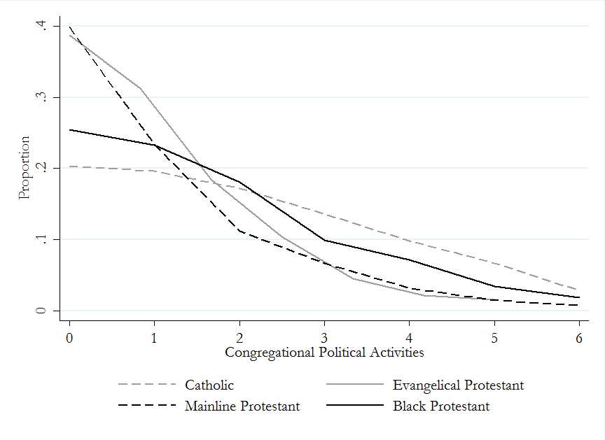
Source: 1998 National Congregations Study.

Figure A2 – The insignificant link between clergy-congregant disagreement and the extent of church outreach activities, 2014 clergy sample
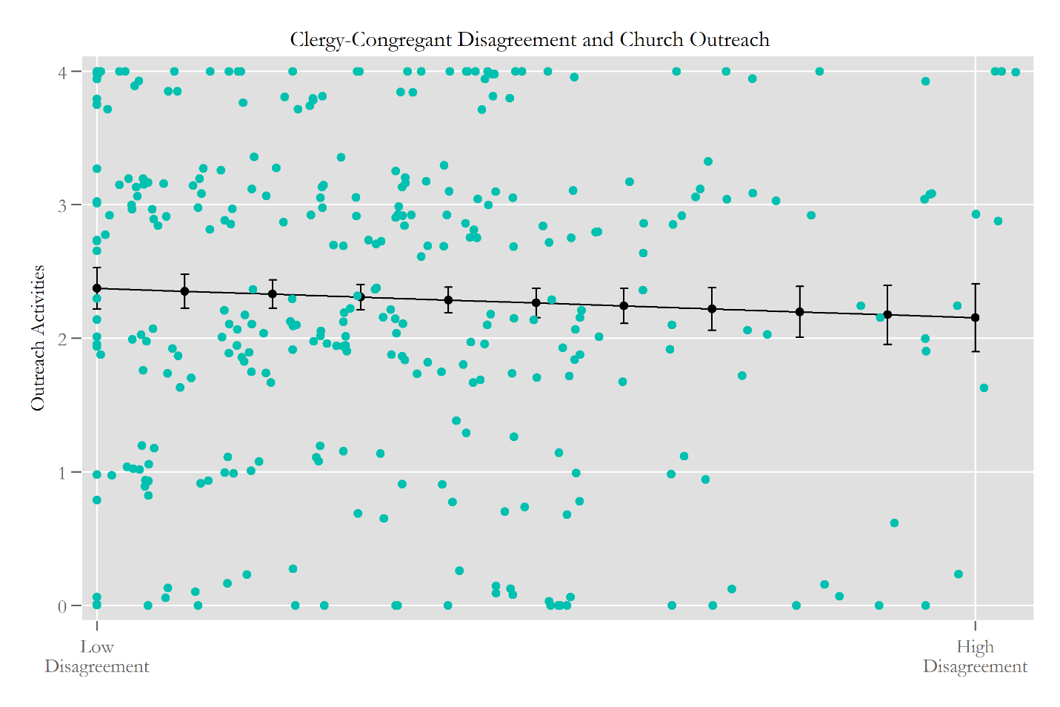
The NCS and USCLS have a paucity of political measures that could capture the degree of disagreement between the congregation and clergy. So, in order to get a sense of the degree that “storms in the churches” over disagreement are driving the patterns we see in this paper, we turned to other data that included suitable, though not comprehensive data – a survey of Christian clergy in 2014 in the US. One question set asked, “How would you compare your own views with congregation members’ views on the following items?” The items included “On social issues like abortion,” “In terms of partisanship,” “On theological issues,” “On issues regarding immigration,” “On government aid to the poor.” The response options ranged from “Mine much more liberal” to “Mine much more conservative” (5 point scale). We folded these so a higher score was much more ideologically different and then averaged them as a measure of political disagreement between the clergy and congregation. The figure above shows how congregational outreach activities (0-4, including committees, mailers, different worship styles, and outreach events) that were modeled after NCS questions were linked to our disagreement measure. The relationship is very slightly negative, but not close to significant (p=.4). Adding any controls, even for the denominations in the sample, makes the relationship weaker. This isn’t quite enough to claim definitively that “storms” are not in the middle of what is happening in this paper, but it seems to suggest they would only play a bit part since they are effectively independent of outreach. Thanks to R2 for pushing us to conduct this test.

Figure A3 – Predicted Number of Political Activities by Theological Conservatism Given the Partisan Cast of the County (NCS data)
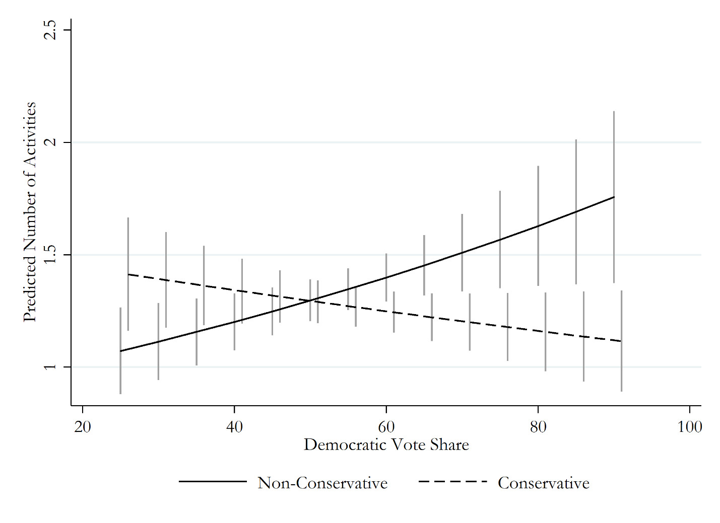
Note: Comparing any two confidence intervals is the equivalent of a 90% difference-of-means test following Payton, Greenstone, and Schenker (2003).
Table A1 – Logistic Regression Estimates of the Congregational and Environmental Determinants of Political Service Provision in Churches (USCLS)
 | Hosted a Voter  Registration Drive |  |  | Sponsored Political or  Social Justice Activities
 | β* | (SE) | p | β* | (SE) | p
Services Provided (Non-Political) | .17 | (.05) | *** | .34 | (.06) | ***
Number of Outreach Activities | .04 | (.07) |  | .10 | (.09)
Catholic | .37 | (.72) |  | 1.42 | (.66) | **
Mainline Protestant | .07 | (.54) |  | -1.01 | (.50) | **
Change in Attendance (2000-2001) | -.00 | (.00) |  | -.00 | (.00)
Politically Conservative | .48 | (.38) |  | -.52 | (.49)
Politically Liberal | -1.18 | (.62) | * | .81 | (.63)
Theologically Liberal | 1.43 | (.56) | ** | 1.13 | (.59) | *
Percent White (Congregation) | -.19 | (.84) |  | -.25 | (.91)
Average Income (Congregation) | -.07 | (.55) |  | -.25 | (.49)
Average Attendance | -.46 | (.50) |  | -.39 | (.52)
Number of Ordained Staff (Full Time) | -.06 | (.12) |  | -.29 | (.18)
Number of Ordained Staff (Part Time) | -.00 | (.06) |  | -.04 | (.07)
Number of Other Full Time Staff | -.02 | (.02) |  | -.01 | (.03)
Number of Other Part Time Staff | .02 | (.02) |  | .02 | (.03)
Percent Over 65 (Congregation) | .50 | (1.44) |  | 1.44 | (1.48)
Percent Under 30 (Congregation) | 5.35 | (2.78) | * | 4.07 | (3.03)
Percent with college degree (Cong.) | -1.67 | (1.55) |  | 3.26 | (1.51) | **
1/Congregation Size | -118.90 | (69.98) | * | 8.99 | (31.73)
Logged county population | .28 | (.23) |  | -.15 | (.18)
Democratic Share of the Two-Party Vote | 2.93 | (1.37) | ** | 2.58 | (1.78)
Party Competition | 1.51 | (2.07) |  | 1.29 | (2.59)
Midwest | .82 | (.63) |  | -.47 | (.55)
South | 1.26 | (.54) | ** | -1.06 | (.58) | *
West | 1.74 | (.53) | *** | -.40 | (.46)
Theological Conservative | 1.21 | (.74) |  | .36 | (.76)
Logged Marketshare | .15 | (.19) |  | -.14 | (.16)
Theo. Conservative * ln(Marketshare) | -.34 | (.20) | * | .12 | (.19)
Religious Pluralism | -.90 | (.66) |  | -.03 | (.88)
Public charities in the county | -.00 | (.00) | ** | .00 | (.00)
Constant | -6.19 | (4.36) |  | -2.47 | (4.00)
Model Statistics | N=345, χ²=102.28***, pseudo R²=.21 |  |  | N=345, χ²=133.24***, pseudo R²=.38
***p<.01, **p<.05, * p<.1.
Source: 2001 U.S. Congregational Life Survey. Standard errors are clustered by county (90 clusters). The models also include controls for the percentage of the congregation with a high school diploma and the percentage of the congregation with a college degree, as well as the percent white, median family income, and the logged population of the surrounding county.

Table A2 – Comparison of the estimates for services and outreach efforts with and without the inclusion of the public charities count (excerpted from Table 1 model)
 | Without Public Charities | With Public Charities
Activity Index
Services provided (non-political) | .0428*** | .0428***
Outreach activities | .1329*** | .1332***
Voter Registration
Services provided (non-political) | .1446*** | .1475***
Outreach activities | .2826*** | .2862***

Table A3 – Pearson’s Correlations of Religious Competition and Congregational Services and Outreach
 |  | Services |  | Outreach
Outreach | NCS | .15 | ***
 | USCLS | .30 | ***
Religious concentration | NCS | -.13 | *** | -.08 | ***
 | USCLS | -.06 |  | -.11 | **
Marketshare, logged | NCS | .02 |  | -.15 | ***
 | USCLS | .23 | *** | -.18 | ***
Sources: USCLS and NCS. ***p<.01, ** p<.05

Figure A4 – Conditional Probability of Congregational Outreach Activity as a Function of Denominational Affiliation and Logged Marketshare (NCS)
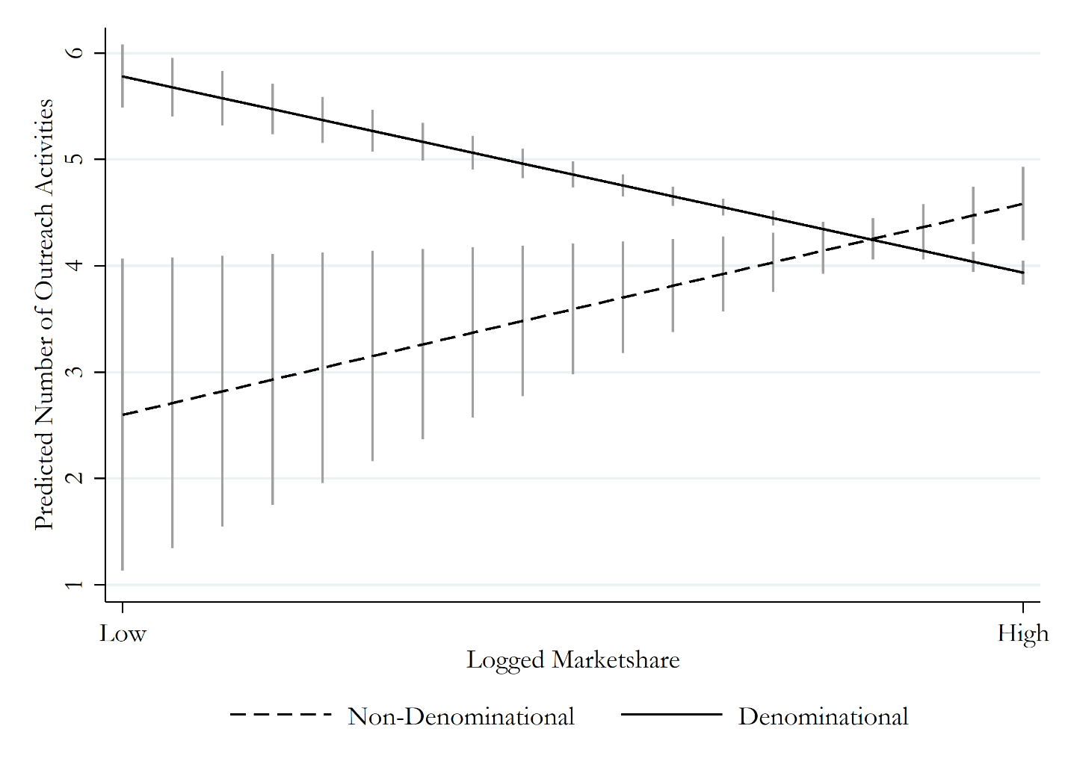
Note: Comparing any two confidence intervals is the equivalent of a 90% difference-of-means test following Payton, Greenstone, and Schenker (2003).

