Appendix Table 1 –
Survey and Year | Total Sample | Affiliation  (95% CI) | Self ID  (95% CI)
GSS 2008 | 2,023 | 23.7% | 25.7%
 |  | (2.2%) | (2.3%)
GSS 2010 | 2,044 | 24.0%  (2.1%) | 23.3%  (2.2%)
GSS 2012 | 1,974 | 24.8% | 23.7%
 |  | (2.3%) | (2.2%)
GSS 2014 | 2,538 | 22.6%  (1.8%) | 23.3%  (1.9%)
GSS 2016 | 2,867 | 23.8%  (1.7%) | 26.1%  (1.9%)
CCES 2008 | 32,800 | 20.6%  (.5%) | 17.8%  (.6%)
CCES 2010 | 55,400 | 19.6% | 22.6%
 |  | (.5%) | (.6%)
CCES 2012 | 54,535 | 21.3%  (.5%) | 23.5%  (.6%)
CCES 2014 | 56,200 | 21.9% | 23.2%
 |  | (.5%) | (.6%)
CCES 2016 | 64,600 | 20.7%  (.5%) | 21.5%  (.5%)

Appendix Table 2 –
Survey and Year |  | Self ID Mean Age |  |  | Affiliation  Mean Age |  | Self ID Male % | Affiliation  Male % |  | Self ID  Educ. (6 pt.) |  | Affiliation Educ. (6 pt.)
GSS 2008 |  | 51.41 |  |  | 48.86 |  | 41.5% | 44.2% |  | 2.92 |  | 2.86
GSS 2010 |  | 51.19 |  |  | 49.26 |  | 39.6% | 40.9% |  | 2.98 |  | 2.84
GSS 2012 |  | 52.40 |  |  | 49.76 |  | 40.0% | 38.1% |  | 3.01 |  | 2.85
GSS 2014 |  | 53.37 |  |  | 50.70 |  | 41.5% | 41.5% |  | 3.06 |  | 2.99
GSS 2016 |  | 53.24 |  |  | 50.91 |  | 41.8% | 39.8% |  | 3.06 |  | 3.01
CCES 2008 |  | 51.60 |  |  | 48.66 |  | 48.0% | 44.2% |  | 3.28 |  | 3.07
CCES 2010 |  | 55.11 |  |  | 53.77 |  | 48.3% | 46.8% |  | 3.57 |  | 3.54
CCES 2012 |  | 55.37 |  |  | 54.10 |  | 46.7% | 45.7% |  | 3.49 |  | 3.49
CCES 2014 |  | 53.35 |  |  | 52.52 |  | 48.0% | 45.4% |  | 3.47 |  | 3.49
CCES 2016 |  | 51.23 |  |  | 51.11 |  | 43.7% | 42.6% |  | 3.46 |  | 3.45

Appendix Table 3 –
Survey and Year |  |  | Total |  | Only Self ID | Only Affiliation |  | Both Measures |  | Neither Measure
GSS 2008 |  |  | 2,023 |  | 153 | 183 |  | 298 |  | 1,389
 |  |  |  |  | 7.6% | 9.1% |  | 14.7% |  | 68.7%
GSS 2010 |  |  | 2,044 |  | 121  5.9% | 198  9.7% |  | 286  14.0% |  | 1,439  70.4%
GSS 2012 |  |  | 1,974 |  | 125  6.3% | 209  10.7% |  | 292  14.8% |  | 1,348  68.3%
GSS 2014 |  |  | 2,538 |  | 169  6.7% | 241  9.5% |  | 342  13.5% |  | 1,786  70.4%
GSS 2016 |  |  | 2,867 |  | 193  6.7% | 242  8.4% |  | 434  15.1% |  | 1,998  69.7%
CCES 2008 |  |  | 32,800 |  | 2,360  7.2% | 3,224  9.8% |  | 3,786  11.5% |  | 23,430  71.4%
CCES 2010 |  |  | 55,400 |  | 4,572 | 3,961 |  | 7,284 |  | 39,583
 |  |  |  |  | 8.3% | 7.1% |  | 13.1% |  | 71.4%
CCES 2012 |  |  | 54,535 |  | 3,686  6.8% | 4,413  8.1% |  | 7,098  13.0% |  | 39,338  72.1%
CCES 2014 |  |  | 56,200 |  | 3,133 | 4,450 |  | 6,446 |  | 42,171
 |  |  |  |  | 5.6% | 7.9% |  | 11.5% |  | 75.0%
CCES 2016 |  |  | 64,600 |  | 3,307  5.1% | 4,983  7.7% |  | 6,980  10.8% |  | 49,330  76.4%

Appendix Graph 1
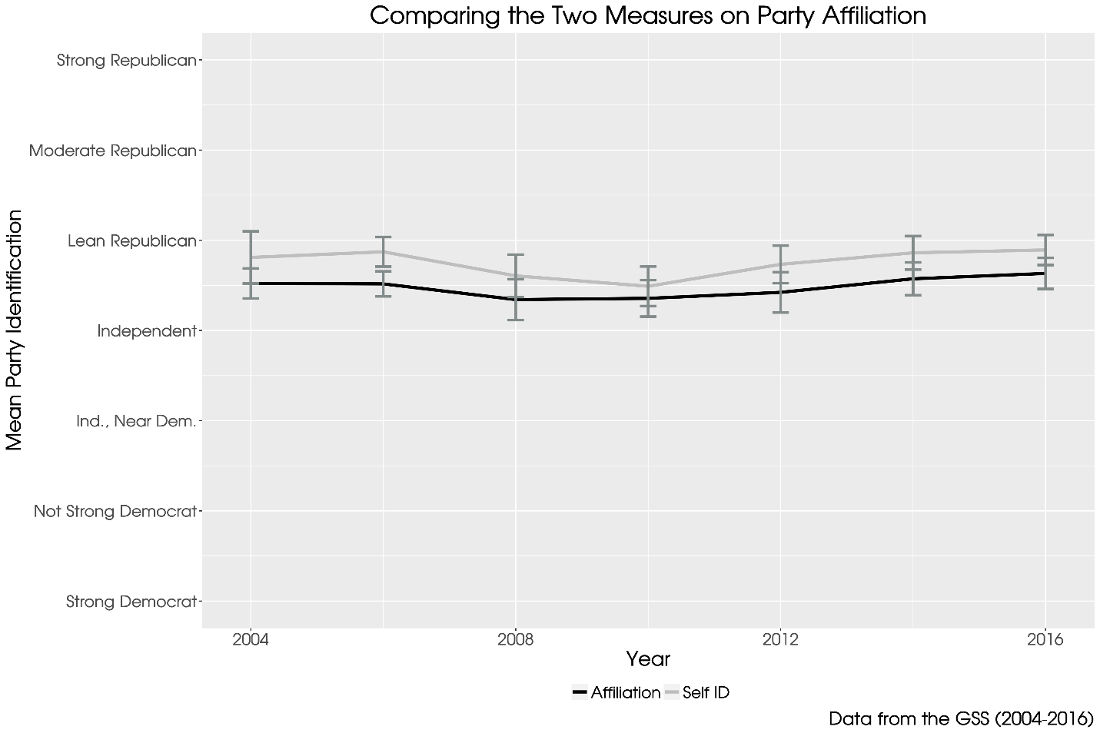

Variable coding for regression analysis
Coding for the dependent variable: As described in footnote 6 of the manuscript
Age: Variable was constructed using birth year of the respondent subtracted from the year the survey was conducted. Then each respondents’ age was divided by the maximum age of the sample to create a scale from 0 – 1.
Education: The GSS asks respondents, “What is the highest grade in elementary school or high school that finished and got credit for?”, while the CCES asks, “What is the highest level of education you have completed?” and gives six options ranging from “Did not graduate high school” to “Postgraduate degree.” These two scales were reconciled as follows: Grades 1-11 were converted to 1, Grade 12 was converted to 2, Grades 13-14 were converted to 3, Grade 15 was converted to 4, Grade 16 was converted to 5, and Grades 17-20 were converted to 6. Each year was divided by six to scale the variable from 0 - 1.
Male: All male respondents were coded as 1, female respondents were coded as zero.
Republican ID: Both the GSS and CCES use the same seven point party identification question with higher values indicating Republican identification. Missing values were eliminated, and each scale was divided by 7 to scale the variable from 0 - 1.

Question Wording for Future Surveys
When length of survey becomes an issue, we recommend that a survey include two religion questions as a means to identify evangelical Protestants. In addition, the survey will likely include a question that measures the racial or ethnic affiliation of the respondent which should be included as a criteria, as well. Both of these questions are typically used in surveys conducted by the Pew Research Center.
- What is your present religion, if any?
- Protestant
- Roman Catholic
- Mormon
- Eastern or Greek Orthodox
- Jewish
- Muslim
- Buddhist
- Hindu
- Atheist
- Agnostic
- Nothing in Particular

- Would you describe yourself as a “born-again” or evangelical Christian, or not?
- Yes
- No

Coefficient Tables for Regression Analysis
