Online Appendix

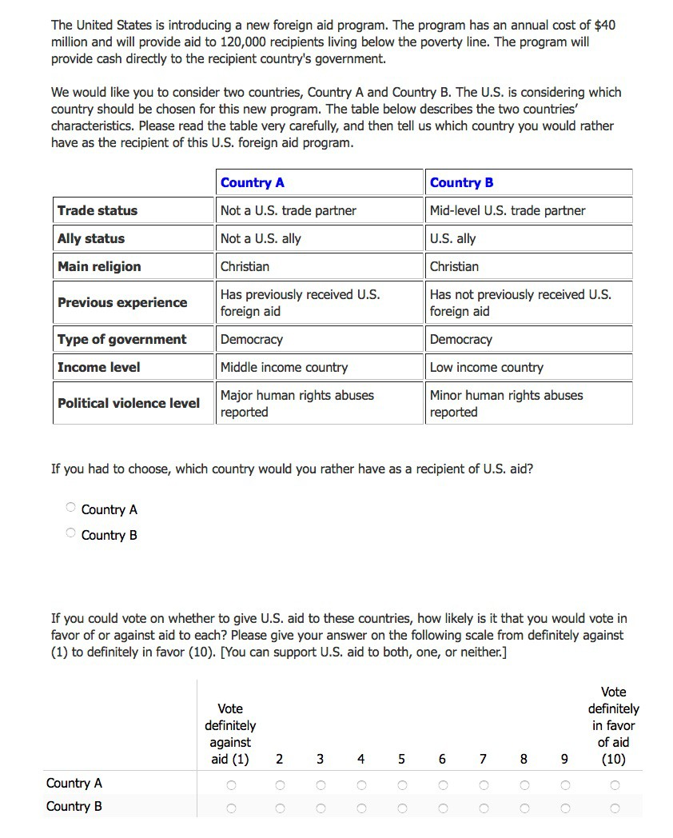

Figure A.1: Conjoint survey design

Table A.2: Characteristics of the national population and the survey samples

 | SSI | Qualtrics | Population
Gender  Male | 47.60 | 48.19 | 49.2
Female | 52.40 | 51.81 | 50.8
Age  18-24 | 8.67 | 12.10 | 13.1
25-34 | 19.85 | 17.71 | 17.5
35-44 | 17.21 | 16.95 | 17.5
45-54 | 17.92 | 18.29 | 19.2
55-64 | 17.97 | 16.57 | 15.5
65 and older | 18.38 | 18.38 | 17.2
Education  No High School Diploma | 2.17 | 11.33 | 12.3
High School Diploma | 19.09 | 28.95 | 29.6
Some College | 31.26 | 22.67 | 28.8
College Degree | 35.42 | 26.95 | 18.9
Advanced Degree | 12.06 | 10.10 | 10.4
Race  White only | 69.96 | 75.71 | 63.7
Nonwhite | 30.04 | 24.29 | 36.3
Religion  Christian | 61.42 | 59.33 | 76.0
Non-Evangelical Protestant | 13.47 | 14.09 | –
Evangelical Protestant | 5.62 | 5.43 | –
Catholic | 22.07 | 17.52 | 25.1
Other Christian | 20.26 | 22.29 | –
Jewish | 3.34 | 2.67 | 1.2
Muslim | 0.47 | 0.57 | 0.6
Buddhist | 0.88 | 1.05 | 0.5
Hindu | 0.70 | 0.76 | 0.3
No affiliation | 27.22 | 22.76 | 13.3
Atheist | – | 6.57 | 7.1
Other | 5.97 | 6.29 | 2.2
Refused to Answer | – | – | 5.2
Note: The population data on education is from the U.S. Census Bureau
Current Population Survey - 2014 Annual Social and Economic Supplement. The religion data is from the 2008 American Religious Identification Survey. The remaining population data is from the 2010 U.S. Census.

Table A.3: Effects of Country Attributes on Probability of Being Selected as Aid Recipient

 | (1) | (2) | (3) | (4)
Christian | – | – | – | –
Buddhist | -9.397*** | 1.212 | -16.102*** | -19.736***
Muslim  Not a U.S. ally | (1.22)  -21.211*** (1.22)  – | (1.97)  -10.568*** (1.94)  – | (1.58)  -27.086*** (1.61)  – | (5.20)  -38.825*** (4.51)  –
U.S. ally  U.S. War on Terror ally Not a U.S. trade partner | 18.214*** (1.18)  23.937*** (1.19)  – | 17.778*** (1.91)  24.287*** (1.94)  – | 18.431*** (1.58)  23.462*** (1.56)  – | 19.757*** (4.91)  27.020*** (5.31)  –
Mid-level U.S. trade partner | 6.780*** | 6.081*** | 7.625*** | 5.367
Major U.S. trade partner  Has not previously received aid | (1.15)  11.354*** (1.13)  – | (1.82)  11.713*** (1.84)  – | (1.55)  11.046*** (1.51)  – | (4.47) 11.353** (4.52)  –
Has previously received aid  Low income | -5.581*** (0.95)  – | -7.160*** (1.52)  – | -4.341*** (1.27)  – | -6.231* (3.73)  –
Middle income | -9.485*** | -13.566*** | -7.506*** | -2.544
Not a democracy | (0.99)  – | (1.64)  – | (1.30)  – | (3.89)  –
Democracy | 14.063*** (1.00) | 16.413*** (1.61) | 12.413*** (1.32) | 15.537*** (4.50)
N | 10230 | 3954 | 5706 | 570
Respondents Sample | 1705  All | 659  Non-Christians | 951  Non-Evangelical Christians | 95  Evangelical Christians
Survey SSI, June 2014

* p<0.10, ** p<0.05, *** p<0.01
Note: These are the linear probability estimates.

Table A.4: Effects of Country Attributes on Probability of Being Selected as Aid Recipient

 | (1) | (2) | (3) | (4)
Christian | – | – | – | –
Buddhist | -9.527*** | -0.772 | -14.454*** | -27.406***
Muslim  Not a U.S. ally | (1.34)  -19.767*** (1.38)  – | (2.15)  -11.777*** (2.10)  – | (1.75)  -23.875*** (1.85)  – | (5.64)  -39.500*** (6.24)  –
U.S. ally  U.S. War on Terror ally No human rights abuses | 17.178*** (1.33)  20.107*** (1.36)  – | 16.608*** (2.08)  19.094*** (2.17)  – | 17.804*** (1.79)  20.505*** (1.83)  – | 19.168*** (5.82)  25.409*** (5.78)  –
Minor human rights abuses | -4.380*** | -4.568** | -4.041** | -7.220
 | (1.32) | (2.10) | (1.79) | (5.73)
Major human rights abuses | -11.665*** | -12.019*** | -11.506*** | -9.834
Not a U.S. trade partner | (1.46)  – | (2.30)  – | (2.00)  – | (5.98)  –
Mid-level U.S. trade partner | 4.553*** | 6.191*** | 3.027* | 10.311
 | (1.30) | (2.10) | (1.71) | (6.32)
Major U.S. trade partner | 9.157*** | 12.236*** | 7.292*** | 7.554
Has not previously received aid | (1.33)  – | (2.05)  – | (1.82)  – | (5.50)  –
Has previously received aid | -2.440** | -3.543** | -1.819 | -0.773
Low income | (1.06)  – | (1.64)  – | (1.44)  – | (4.85)  –
Middle income  Not a democracy | -8.347*** (1.09)  – | -7.036*** (1.74)  – | -9.162*** (1.45)  – | -8.491* (4.92)  –
Democracy | 7.733*** (1.13) | 9.402*** (1.78) | 5.795*** (1.52) | 15.927*** (4.95)
N | 8400 | 3416 | 4528 | 456
Respondents Sample | 1050  All | 427  Non-Christians | 566  Non-Evangelical Christians | 57  Evangelical Christians
Survey Qualtrics, March 2016

* p<0.10, ** p<0.05, *** p<0.01
Note: These are the linear probability estimates.

Table A.5: Effects of Country Attributes on Probability of Being Selected as Aid Recipient

 | (1) | (2) | (3) | (4)
Christian | – | – | – | –
Buddhist | -0.418*** | 0.056 | -0.719*** | -0.929***
Muslim  Not a U.S. ally | (0.05)  -0.944*** (0.06)  – | (0.09)  -0.472*** (0.09)  – | (0.07)  -1.209*** (0.07)  – | (0.25)  -1.817*** (0.24)  –
U.S. ally  U.S. War on Terror ally Not a U.S. trade partner | 0.807*** (0.05)  1.060*** (0.05)  – | 0.786*** (0.09)  1.074*** (0.09)  – | 0.828*** (0.07)  1.053*** (0.07)  – | 0.946*** (0.25)  1.286*** (0.27)  –
Mid-level U.S. trade partner | 0.305*** | 0.274*** | 0.347*** | 0.260
Major U.S. trade partner  Has not previously received aid | (0.05)  0.510*** (0.05)  – | (0.08)  0.527*** (0.08)  – | (0.07)  0.503*** (0.07)  – | (0.22) 0.545** (0.22)  –
Has previously received aid  Low income | -0.251*** (0.04)  – | -0.322*** (0.07)  – | -0.198*** (0.06)  – | -0.305* (0.18)  –
Middle income | -0.426*** | -0.608*** | -0.342*** | -0.109
Not a democracy | (0.04)  – | (0.07)  – | (0.06)  – | (0.19)  –
Democracy | 0.626*** (0.05) | 0.726*** (0.07) | 0.562*** (0.06) | 0.732*** (0.22)
N | 10230 | 3954 | 5706 | 570
Respondents Sample | 1705  All | 659  Non-Christians | 951  Non-Evangelical Christians | 95  Evangelical Christians
Survey SSI, June 2014

* p<0.10, ** p<0.05, *** p<0.01 Note: These are the logit estimates.

Table A.6: Effects of Country Attributes on Probability of Being Selected as Aid Recipient

 | (1) | (2) | (3) | (4)
Christian | – | – | – | –
Buddhist | -0.412*** | -0.033 | -0.630*** | -1.306***
Muslim  Not a U.S. ally | (0.06)  -0.855*** (0.06)  – | (0.09)  -0.507*** (0.09)  – | (0.08)  -1.038*** (0.08)  – | (0.29)  -1.855*** (0.33)  –
U.S. ally  U.S. War on Terror ally No human rights abuses | 0.741*** (0.06)  0.868*** (0.06)  – | 0.708*** (0.09)  0.815*** (0.09)  – | 0.776*** (0.08)  0.895*** (0.08)  – | 0.942*** (0.29)  1.245*** (0.30)  –
Minor human rights abuses | -0.192*** | -0.198** | -0.180** | -0.349
Major human rights abuses Not a U.S. trade partner | (0.06)  -0.509*** (0.06)  – | (0.09)  -0.519*** (0.10)  – | (0.08)  -0.508*** (0.09)  – | (0.28)  -0.498* (0.29)  –
Mid-level U.S. trade partner | 0.199*** | 0.266*** | 0.135* | 0.493
 | (0.06) | (0.09) | (0.08) | (0.31)
Major U.S. trade partner | 0.400*** | 0.526*** | 0.325*** | 0.360
Has not previously received aid | (0.06)  – | (0.09)  – | (0.08)  – | (0.27)  –
Has previously received aid | -0.108** | -0.154** | -0.083 | -0.034
Low income | (0.05)  – | (0.07)  – | (0.06)  – | (0.23)  –
Middle income  Not a democracy | -0.363*** (0.05)  – | -0.302*** (0.07)  – | -0.403*** (0.06)  – | -0.404* (0.23)  –
Democracy | 0.339*** (0.05) | 0.405*** (0.08) | 0.259*** (0.07) | 0.776*** (0.25)
N | 8400 | 3416 | 4528 | 456
Respondents Sample | 1050  All | 427  Non-Christians | 566  Non-Evangelical Christians | 57  Evangelical Christians
Survey Qualtrics, March 2016

* p<0.10, ** p<0.05, *** p<0.01 Note: These are the logit estimates.

Table A.7: AMCEs by respondent education

 | (1) | (2)
Christian | – | –
Buddhist | -12.556*** | -10.815***
 | (1.69) | (1.70)
Muslim | -25.394*** | -21.214***
 | (1.69) | (1.77)
No college education | – | –
College education | -4.822*** | -2.885*
 | (1.44) | (1.62)
Buddhist × No college education | – | –
Buddhist × College education | 6.620*** | 3.353
 | (2.43) | (2.77)
Muslim × No college education | – | –
Muslim × College education | 8.806*** | 3.768
 | (2.42) | (2.82)
Not a U.S. ally | – | –
U.S. ally | 18.149*** | 17.229***
 | (1.18) | (1.33)
U.S. War on Terror ally | 23.803*** | 20.134***
 | (1.19) | (1.36)
No human rights abuses |  | –
Minor human rights abuses |  | -4.372***
 |  | (1.32)
Major human rights abuses |  | -11.648***
 |  | (1.46)
Not a U.S. trade partner | – | –
Mid-level U.S. trade partner | 6.722*** | 4.547***
 | (1.15) | (1.30)
Major U.S. trade partner | 11.334*** | 9.164***
 | (1.13) | (1.33)
Has not previously received aid | – | –
Has previously received aid | -5.653*** | -2.479**
 | (0.95) | (1.07)
Low income | – | –
Middle income | -9.493*** | -8.303***
 | (0.99) | (1.09)
Not a democracy | – | –
Democracy | 14.064*** | 7.723***
 | (1.00) | (1.13)
N | 10230 | 8400
Respondents | 1705 | 1050
Sample | All | All
Survey | SSI | Qualtrics
* p<0.10, ** p<0.05, *** p<0.01
Note: These are linear probability estimates.

Table A.8: AMCEs using alternative measure of Evangelicalism

 | (1) | (2) | (3)
Christian | – | – | –
Buddhist | 3.203 | -12.449*** | -20.326***
Muslim  Not a U.S. ally | (2.09)  -8.478*** (2.10)  – | (1.91)  -24.759*** (1.85)  – | (2.25)  -31.559*** (2.31)  –
U.S. ally  U.S. War on Terror ally Not a U.S. trade partner | 19.247*** (2.06)  26.152*** (2.10)  – | 18.786*** (1.92)  24.137*** (1.85)  – | 16.743*** (2.17)  21.625*** (2.25)  –
Mid-level U.S. trade partner Major U.S. trade partner  Has not previously received aid | 5.061** (1.96)  11.273*** (2.06)  – | 9.046*** (1.87)  12.409*** (1.81)  – | 6.083*** (2.12)  9.827*** (2.00)  –
Has previously received aid  Low income | -7.947*** (1.64)  – | -5.095*** (1.49)  – | -3.176* (1.79)  –
Middle income  Not a democracy | -14.065*** (1.74)  – | -7.955*** (1.56)  – | -6.607*** (1.83)  –
Democracy | 16.555*** (1.71) | 12.023*** (1.60) | 14.407*** (1.90)
N | 3342 | 4092 | 2796
Respondents  Sample | 557  Non-Christians | 682  Non-Evangelical Christians | 466  Evangelical Christians
Survey SSI, June 2014

* p<0.10, ** p<0.05, *** p<0.01
Note: These are the linear probability estimates.

Table A.9: AMCEs for Protestant vs Catholic
(1) (2) (3)

Christian – – –

Buddhist -16.902*** -18.194*** -15.203*** (2.71) (2.90) (3.38)
Muslim -25.872*** -28.866*** -25.291*** (2.69) (3.05) (3.49)
Protestant respondent – – –

Catholic respondent -2.739 -4.212* -1.801
(2.25) (2.54) (2.72)
Buddhist × Protestant respondent – – –
Buddhist × Catholic respondent 4.866 7.393* 4.345
(3.72) (4.20) (4.54)
Muslim × Protestant respondent – – –
Muslim × Catholic respondent -0.464 7.960* 4.312
(3.70) (4.42) (4.75)
Not a U.S. ally – – –

U.S. ally 18.877*** 18.485*** 18.602*** (1.84) (2.20) (2.37)
U.S. War on Terror ally 25.037*** 21.320*** 20.811***
(1.86) (2.24) (2.41)
No human rights abuses – –

Minor human rights abuses -4.622** -4.213* (2.07) (2.22)
Major human rights abuses -11.522*** -11.814*** (2.39) (2.60)
Not a U.S. trade partner – – –

Mid-level U.S. trade partner 7.403*** 4.616** 3.623
(1.84) (2.09) (2.20)
Major U.S. trade partner 9.892*** 8.706*** 9.003***
(1.76) (2.20) (2.41)
Has not previously received aid – – –

Has previously received aid -4.379*** -1.471 -1.630
(1.45) (1.75) (1.88)
Low income – – –

Middle income -7.133*** -10.171*** -10.235*** (1.49) (1.73) (1.85)
Not a democracy – – –

Democracy 12.929*** 9.524*** 8.514*** (1.54) (1.88) (2.03)

N 4206 3112 2656
Respondents 701 389 332
Sample Protestant & Catholic Christians
Survey SSI Qualtrics Qualtrics

* p<0.10, ** p<0.05, *** p<0.01
Note: These are linear probability estimates.

Table A.10: AMCEs for Aid Supporters vs Aid Opponents

 | (1) | (2) | (3) | (4) | (5) | (6) | (7) | (8)
Christian | – | – | – | – | – | – | – | –
Buddhist | -6.854*** | -12.628*** | -1.513 | -0.226 | -10.454*** | -18.535*** | -21.804* | -29.627***
 | (1.84) | (1.95) | (2.89) | (3.20) | (2.39) | (2.56) | (10.65) | (6.64)
Muslim | -13.956*** | -26.489*** | -6.956*** | -18.832*** | -18.678*** | -29.169*** | -30.657** | -44.099***
 | (1.83) | (2.04) | (2.64) | (3.40) | (2.52) | (2.72) | (12.90) | (7.42)
Not a U.S. ally | – | – | – | – | – | – | – | –
U.S. ally | 14.948*** | 19.854*** | 15.306*** | 18.823*** | 15.761*** | 19.822*** | -0.740 | 28.787***
 | (1.78) | (1.98) | (2.69) | (3.30) | (2.44) | (2.65) | (10.28) | (6.73)
U.S. War on Terror ally | 18.048*** | 22.399*** | 17.793*** | 20.695*** | 19.106*** | 21.652*** | 2.979 | 36.562***
 | (1.83) | (2.05) | (2.79) | (3.43) | (2.50) | (2.73) | (9.87) | (6.74)
No human rights abuses | – | – | – | – | – | – | – | –
Minor human rights abuses | -2.709 | -6.356*** | -1.863 | -9.444*** | -3.543 | -4.357* | -2.305 | -7.706
 | (1.90) | (1.80) | (2.80) | (3.07) | (2.66) | (2.39) | (10.90) | (6.49)
Major human rights abuses | -8.517*** | -15.313*** | -9.612*** | -16.087*** | -7.692*** | -15.348*** | -9.628 | -9.803
 | (2.02) | (2.10) | (3.05) | (3.45) | (2.77) | (2.88) | (12.38) | (6.02)
Not a U.S. trade partner | – | – | – | – | – | – | – | –
Mid-level U.S. trade partner | 4.671*** | 4.563** | 4.971* | 8.178** | 3.946* | 2.268 | 16.857 | 7.885
 | (1.79) | (1.88) | (2.79) | (3.22) | (2.39) | (2.43) | (11.72) | (7.30)
Major U.S. trade partner | 8.314*** | 10.054*** | 10.817*** | 14.132*** | 5.759** | 8.770*** | 16.898* | 3.503
 | (1.77) | (2.00) | (2.56) | (3.31) | (2.50) | (2.63) | (9.15) | (6.91)
Has not previously received aid | – | – | – | – | – | – | – | –
Has previously received aid | -2.891* | -1.899 | -3.396 | -4.211* | -2.953 | -0.325 | 4.473 | -1.962
 | (1.51) | (1.50) | (2.20) | (2.52) | (2.12) | (1.95) | (9.40) | (5.47)
Low income | – | – | – | – | – | – | – | –
Middle income | -7.985*** | -8.859*** | -7.031*** | -7.022*** | -8.642*** | -9.901*** | -4.891 | -10.033
 | (1.51) | (1.57) | (2.34) | (2.56) | (2.03) | (2.06) | (7.12) | (6.45)
Not a democracy | – | – | – | – | – | – | – | –
Democracy | 8.833*** | 6.301*** | 12.373*** | 5.429** | 5.311** | 5.975*** | 14.671 | 15.912***
 | (1.58) | (1.60) | (2.38) | (2.60) | (2.15) | (2.17) | (9.31) | (5.69)
N | 4544 | 3856 | 2024 | 1392 | 2360 | 2168 | 160 | 296
Respondents | 568 | 482 | 253 | 174 | 295 | 271 | 20 | 37
Sample | All | All | Non-Christians | Non-Christians | Non-Evangelical | Non-Evangelical | Evangelical | Evangelical
Aid Supporter? | YES | NO | YES | NO | YES | NO | YES | NO
Survey Qualtrics, March 2016

* p<0.10, ** p<0.05, *** p<0.01
Note: These are linear probability estimates.

Table A.11: AMCEs including interaction with Ally Status

(1) (2)

Christian – –

Buddhist -12.660*** -10.474*** (2.03) (2.34)
Muslim -23.780*** -20.222***
(1.94) (2.25)
Not a U.S. ally – –

U.S. ally 16.308*** 17.176*** (2.06) (2.21)
U.S. War on Terror ally 20.043*** 18.638*** (2.02) (2.30)
Buddhist × Not a U.S. ally – –
Buddhist × U.S. ally 2.676 1.516
(2.90) (3.17)
Buddhist × U.S. War on Terror ally 7.082** 1.408
(2.84) (3.18)
Muslim × Not a U.S. ally – –
Muslim × U.S. ally 3.061 -1.487
(2.77) (3.08)
Muslim × U.S. War on Terror ally 4.643* 2.946
(2.76) (3.04)
No human rights abuses –

Minor human rights abuses -4.398*** (1.32)
Major human rights abuses -11.705*** (1.46)
Not a U.S. trade partner – –

Mid-level U.S. trade partner 6.810*** 4.619***
(1.15) (1.30)
Major U.S. trade partner 11.416*** 9.188*** (1.13) (1.33)
Has not previously received aid – –

Has previously received aid -5.550*** -2.414**
(0.95) (1.06)
Low income – –

Middle income -9.466*** -8.331*** (0.99) (1.09)
Not a democracy – –

Democracy 14.072*** 7.733*** (1.00) (1.13)

N 10230 8400
Respondents 1705 1050
Sample All All
Survey SSI Qualtrics

* p<0.10, ** p<0.05, *** p<0.01
Note: These are linear probability estimates.

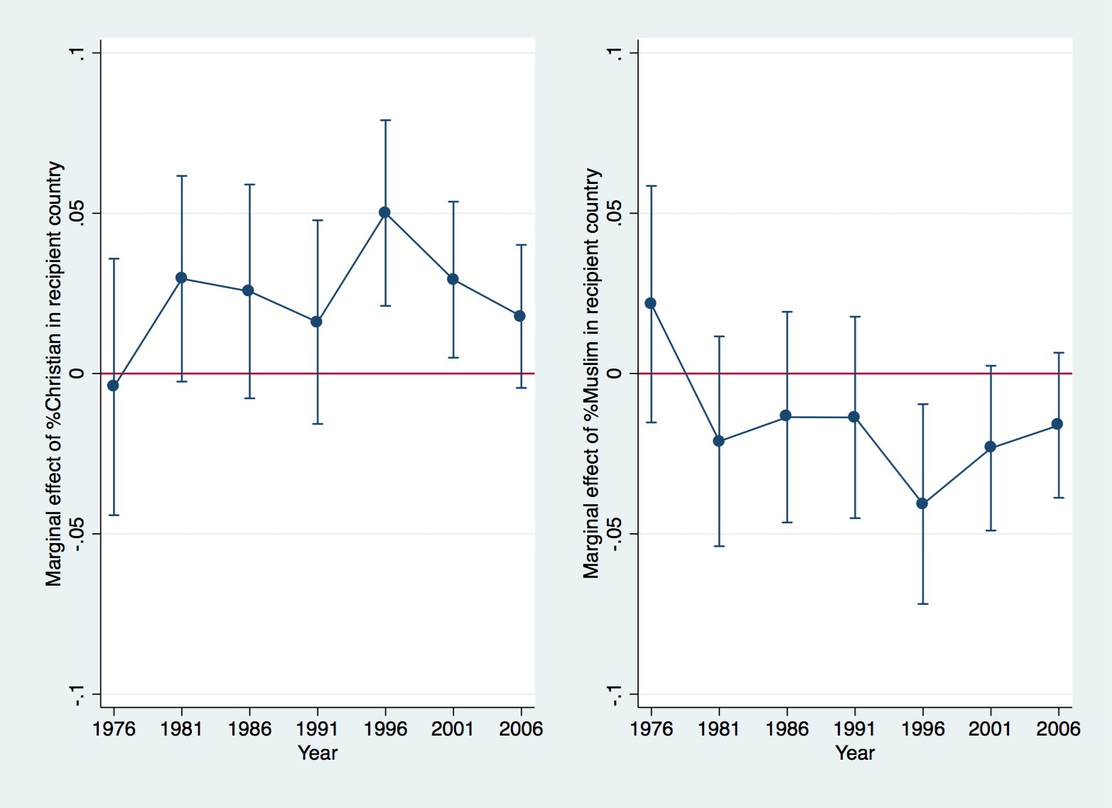

Figure A.12: Marginal effect of recipient country religion over time, 1976-2006

