Supplemental File: Experimental Stimuli

Condition: White candidate; No religious cues
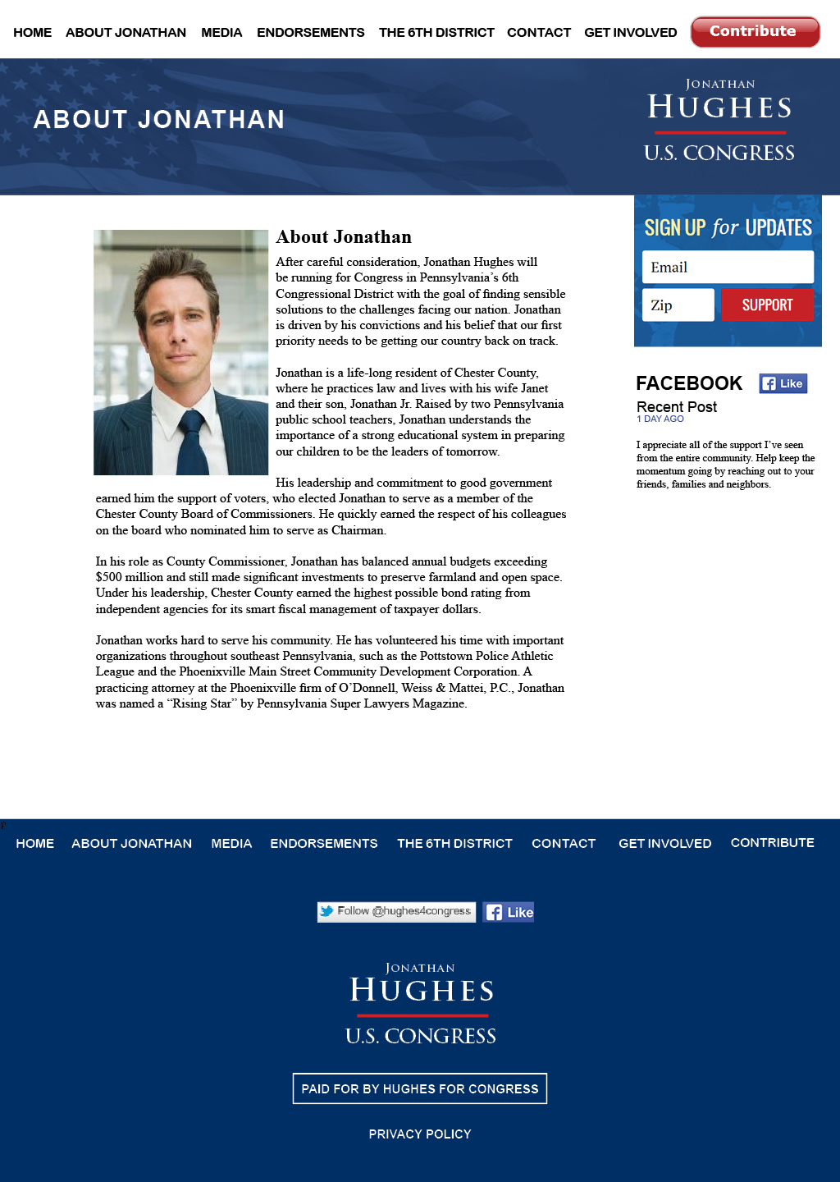
Condition: White candidate; Religious cues
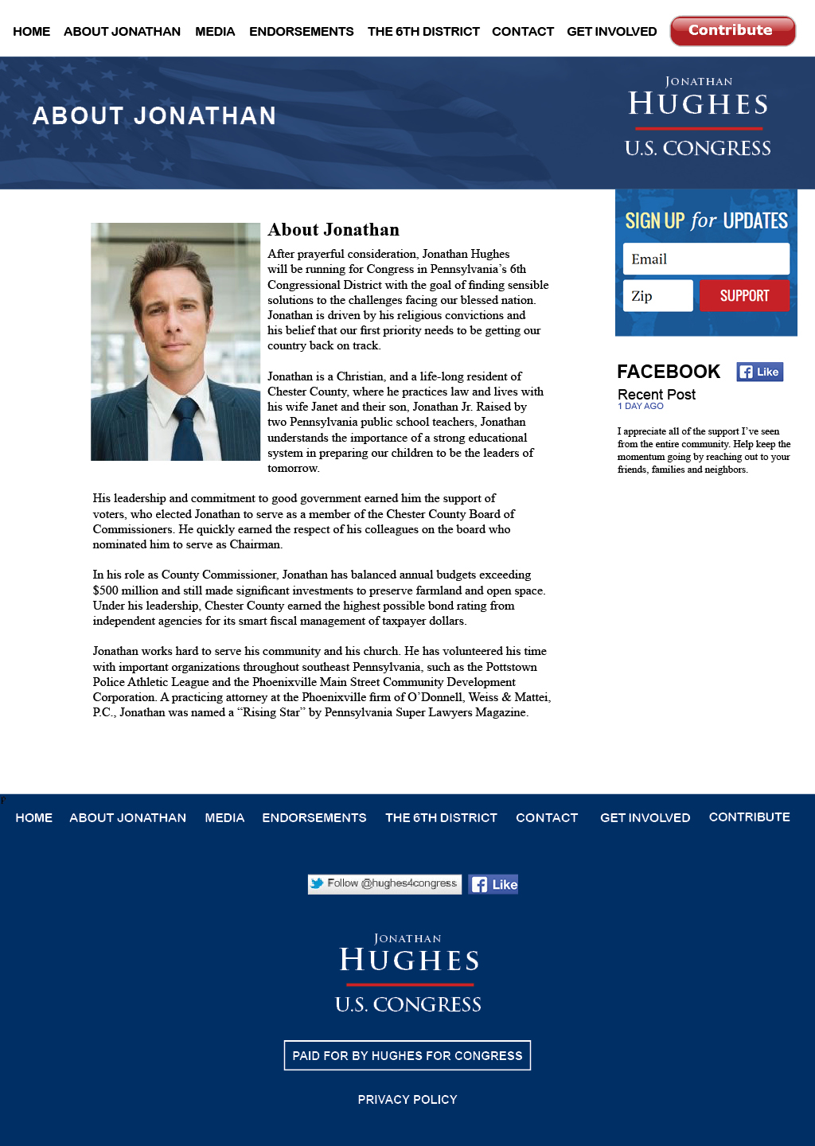
Condition: Black candidate; No religious cues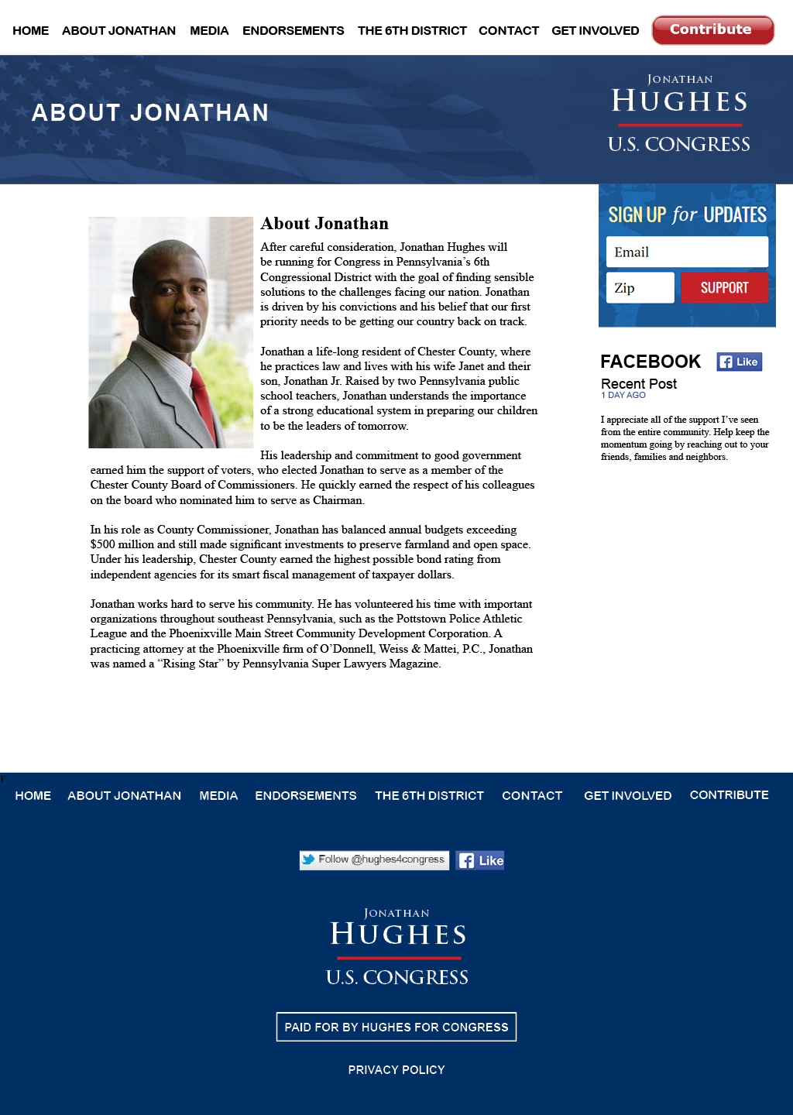
Condition: Black candidate; Religious cues
