The effect of religiosity on political attitudes in Israel. Politics & Religion.
Online Appendix
Will be made available on the author’s websites
Appendix A: Survey Methodology – pp. 1-2
Appendix B: Measurement, Construct Validity, Descriptive Statistics and Graphs – pp. 3-7
Appendix C: Stepwise Regression Analysis – p. 8
Appendix D: Interaction plots for each group with 99% confidence intervals pp. 9-11

Appendix A Survey Methodology
Launched in 1984, the National Security and Public Opinion Project (NSPOP) monitors Israeli public opinion on issues related to national security. Surveys undertaken and cited in the framework of this project were bases on representative samples of the adult Jewish population of Israel. The project was conceived and until 2004 directed by the late Professor Asher Arian, and all the surveys through that year were prepared, conducted, and analyzed by him.
The surveys for the current project were conducted during February 21-March 27, 2006 (22) February 25-March 25, 2007, (23) May-June, 2009, (24) February-April 2012.
Sample sizes were 724 in 2006; 709 in 2007; 616 in 2009 and 632 in 2012.
The fieldwork for the surveys was done by the B. I. and Lucille Cohen Institute of Public Opinion Research at Tel Aviv University. The survey was sensitive to religious necessities of the Orthodox publics. Male and female interviewers from the Orthodox sector dressed accordingly were sent to survey these groups. At least five visits were paid to each household before it was marked as non-response. Table A1 presents the distribution of the religious groups in the pooled sample and the data of the Central Bureau of Statistics (CBS).
Pooling data permits the study of groups whose proportion in the population is small (ultra-Orthodox who served in the IDF constitute about 30 and 8 percent of their population groups, respectively, for men and women).
The ultra-Orthodox and the religious each comprise about 10 percent of the Jewish population in Israel, the former are also systematically underrepresented in national probability samples due to the community’s closed nature and intrinsic unwillingness to cooperate with interviewers associated with non-ultra-Orthodox research institutes. Therefore, telephone surveys have been inefficient in obtaining data on the ultra-Orthodox. NSPOP surveys have run since 1985, but originally Orthodox and ultra-Orthodox respondents were collapsed into one category, namely, the “very observant.” The other categories used in the earlier versions of NSPOP were “observant,” “not very observant” and “non-observant”; and telephone rather than face to face interviews were conducted prior to 2006.

Table A1 Religious groups in Israel (Jews only, NSPOP pooled sample 2006-2012)
 | Ultra-Orthodox | Religious | Traditional religious | Traditional not so religious | Not Religious
Percent in the society  2010 (aged 20 and over), CBS | 8.8 | 9.6 | 13.7 | 24.4 | 43.5
Percent in the pooled sample (aged 18 and over), NSPOP | 9.4 | 12.5 | 12.5 | 21.9 | 43.6
Total N, NSPOP | 251 | 332 | 333 | 583 | 1161

The sample is representative of the Israeli Jewish population. The numbers of ultra-Orthodox in NSPOP sample are higher than in the Central Bureau of Statistics data but it is reasonable that they reflect the actual situation better than the CBS data. The NSPOP sample includes the data for 2012 and has respondents aged 18 and over, while ultra-Orthodox population is on average 12 years younger compared to the general population (average age for the ultra-Orthodox is 34 years while for other groups it ranges from 46 to 48 years).

Appendix B: Measurement, Construct Validity and Descriptive Statistics

Dependent 1 Attitude toward the Palestinian –Israeli Conflict
The index of attitudes toward the Israeli-Palestinian conflict is created with the following eleven items:
“To what extent do you believe that the Palestinians want peace"– 4-point scale;
"Do you agree or disagree that Israel should agree to establishment of the Palestinian State in Judea and Samaria" – 4-point scale;
"To what extent do you support or oppose the principle of the two-states for two peoples?" – 4-point scale;
"Whether Israel should agree to return the following territories as part of permanent settlement with the Palestinians: Gush Etzion,” (0-return all territories 1- retain all territories).
"Whether Israel should agree to return the following territories as part of permanent settlement with the Palestinians: the Temple Mount without the Wailing Wall,” (0-return all territories 1- retain all territories).
"Whether Israel should agree to return the following territories as part of permanent settlement with the Palestinians: Jordanian Valley,” (0-return all territories 1- retain all territories).
"Whether Israel should agree to return the following territories as part of permanent settlement with the Palestinians: Western Samaria, “(0-return all territories 1- retain all territories).
"Whether Israel should agree to return the following territories as part of permanent settlement with the Palestinians: Arab neighbourhoods of Jerusalem,” (0-return all territories 1- retain all territories).
"Whether Israel should agree to return the following territories as part of permanent settlement with the Palestinians: Isolated settlements in the Samaria" - (0-return all territories 1- retain all territories).
"What do you think are the ultimate aspirations of Arabs: 1- return of some territories conquered after 1967, 2 - return of all territories conquered after 1967, 3 - conquer Israel, 4- conquer Israel and destroy the Jewish nation";
"To what extent do you agree or disagree that it is possible to reach a peace agreement with the Palestinians"– 4-point scale.
The items were normalized 0-1 (table A3)

Dependent 2. Support for Democracy

Respondents were asked to rank four key values in order of importance: a country with a Jewish majority; Greater Israel; a democratic country (equal rights); and a state of peace (no war).
“Looking at the four values, which of the values the government should act to achieve in the first place? And in the second? And in the third? The fourth?
The same four value-items – democracy, peace, the Jewish majority, and Greater Israel - that earlier studies have proposed as core political values equally cherished by Jewish Israelis if trade-offs are not required - were the basis (Arian 1995; Liebman and Don-Yehiya 1983:13; Shamir and Shamir 1995). But, I used the ranked options to establish the relative importance of democracy with respect to three competing value-alternatives. As a result, the 24-point scale of support for democracy was composed based on the combination of four value preferences. The ethno-nationalist pole measured as “0” represents the preferences of respondents who chose “Greater Israel” and then “Jewish Majority” as their first and second most important goals, while democracy was listed as the least important of all. The opposite democracy pole measured as “1” captures the preference of those who opted for democracy and, then peace, Jewish majority and greater Israel. The 22 interim categories represent respondents with preferences that comprise other combination of values from the above groups, while there are organized in a descending order of importance that the respondents ascribe to the value of democracy.
The partial scale based on a combination of the first two value preferences was introduced by Asher Arian (1995:219) My 24-point scale that involved all four rank-ordered value preferences (permutations (n!/((n-r)!) i.e. 4! =24 combinations of values). The 24-point scale relates to the 12-point scale based on Arian (1995), the correlation between the scales is r=.86 (p=.000), but 24 point scale is more nuanced as it reflects the full range of options captured by all four competing values.

Dependent 3 Attitudes toward Israeli Arabs

The dependent was measured with an item “Do you agree or disagree with the idea that the government should act to encourage voluntary emigration of Arabs from Israel? 1- Completely Disagree 2- Agree; 3 Disagree; 4-Completely Agree.
The item was originally part of the security policy index introduced by Arian (1995, p.108). Recent literature on the change of status of Arab minority in Israel (Jamal 2011, Rekhess 2014) implies that conceptually the item can serve as an independent analytical concept represents the reaction of the Israeli-Jewish public on the process of Israelization that Israeli Arabs undergo as a distinct Israeli minority population, rather than an out-group perceived exclusively in security terms.
Construct validity tests for discriminant and convergence validity with a security policy scale (Arian 1995), as well as political tolerance toward least-liked groups (LLG) and abstract political tolerance scales (Sullivan et al. 1982) suggest that the item weakly relates to the security policy scale (r=.19, p=.000), possesses a stronger relationship with an abstract tolerance scale r=.29, p=000 and with the scale of political tolerance toward pre-defined least-liked group (Arabs) r=.45, p=.000.
Measures of tolerance:
Political tolerance towards least-liked groups (Arabs). This measure uses a predefined group technique developed in the 1970s by Sullivan and colleagues (Sullivan et al 1982). This approach focuses on the willingness to accord political and civil rights to groups that constitute a threat in the eyes of the respondent or of whose behavior he or she disapproves. Respondents were asked seven 5-point-scale questions regarding their willingness to extend to the group common political and civil rights, and responses were indexed on the political tolerance scale: “To what extent do you agree or disagree with each of the following statements regarding [Israeli Arabs]?”: “An [Arab] should be banned from being Prime Minister in Israel”; “The [Arab parties] should be outlawed”; “Arabs should be allowed to appear on television”; “The Arabs should have their phones tapped”; “Arabs should be allowed to hold demonstrations”; “Arabs should be banned from voting for the Knesset”; “Arabs should be banned from being elected to the Knesset.” Answers were coded to range from definitely agree to definitely disagree. Abstract tolerance was measured with the item “Do you agree or disagree that all people should have equal rights? “

Table A2. Validity, Pearson Correlation Coefficients
 | Security Index (Arian 1995) | Absolute (Moral Tolerance) | Tolerance toward Least –Liked Group | Tolerance toward Arabs
Arab Emigration Item (dependent 3) | .197 *** | .209 *** | .193*** | .400***
N | 1143 | 1131 | 1113 | 1144
Significance p<.001 two –tailed. Moral tolerance and LLG/LLA measures were from NSPOP 2001 (last time when all the measures were available in one survey).

Table A3. Descriptive statistics (pooled sample 2006-2012, original values)
Variable name and Code | Mean | St. dev | Min | Max | % | N
Values (First Choice) |  |  |  |  |  | 2681
Democracy |  |  |  |  | 14.6 | 2662
Peace |  |  |  |  | 29.1 | 2662
Greater Israel |  |  |  |  | 8.7 | 2662
Jewish Majority |  |  |  |  | 47.6 | 2662
Support Arab Emigration  (1-oppose 4-support) | 2.87 | 1.00 | 1 | 4 |  | 2633
Attitudes toward the Palestinian-Israeli Conflict: | .47 | .24 | 0 | 1 |  | 2681
“Believe that Palestinians Want Peace” (1-believe) | 2.68 | .94 | 1 | 4 |  | 2655
“Israel Should Agree to Palestinian State” (1-yes) | 2.46 | 1.01 | 1 | 4 |  | 2625
“Support Two State Solution” (1- yes) | 2.23 | .99 | 1 | 4 |  | 2608
“Support Return of Territories”  (0-return all, 6-retain all) | 4.03 | 2.08 | 0 | 6 |  | 2640
“Aspirations of Arab States: (1-return of territories, 4- destruction of the Jewish nation” | 2.98 | 1.01 | 1 | 4 |  | 2649
“Peace with Palestinians Possible” (1- definitely yes))  Controls: | 2.95 | .86 | 1 | 4 |  | 2651
Ultra-orthodox Dummy | .10 | .29 | 0 | 1 |  | 2681
Religious Dummy | .12 | .33 | 0 | 1 |  | 2681
Religious traditional Dummy | .12 | .33 | 0 | 1 |  | 2681
Traditional non-religious Dummy | .22 | .41 | 0 | 1 |  | 2681
Non-religious Dummy | .43 | .49 | 0 | 1 |  | 2681
Household Expenses | 2.53 | 1.27 | 1 | 5 |  | 2517
Academic degree (1=yes) | .47 | .34 | 0 | 1 |  | 2458
Age | 45.28 | 18.06 | 18 | 94 |  | 2670
Army Service (1=yes) | .67 | .47 | 0 | 1 |  | 2663
Ideology | 4.79 | 1.23 | 0 | 7.00 |  | 1991
Ethnic Origin: |  |  |  |  |  | 2677
Asian-African (1) |  |  |  |  | 16.2
Eastern European (2) |  |  |  |  | 16.1
West (3) |  |  |  |  | 8.9
Israeli Born (4) |  |  |  |  | 58.8
Gender |  |  |  |  |  | 2681
Female=2 |  |  |  |  | 50.1
Year
2006 |  |  |  |  | 27.0 | 724
2007 |  |  |  |  | 26.4 | 709
2009 |  |  |  |  | 23.0 | 616
2012 |  |  |  |  | 23.6 | 632
Figure A1 Distribution of the three attitudes by religious groups
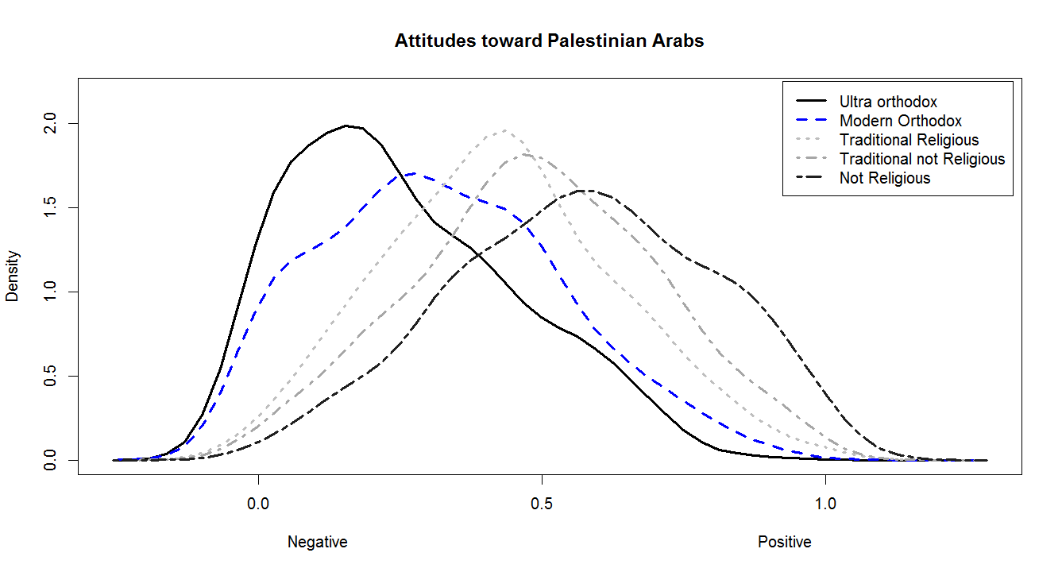
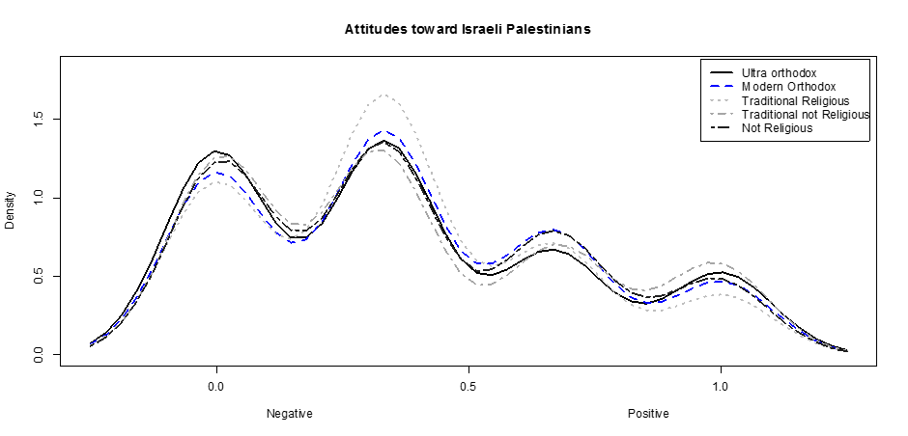

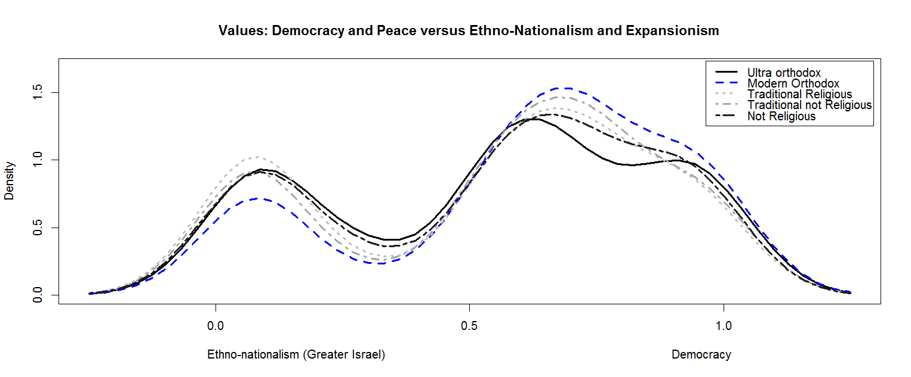
Appendix C Stepwise regression procedure and summary

For each of the three dependent variables of political attitudes, two stepwise multiple regressions in three steps were performed, with the blocs denned a priori. The first regression entered the religiosity variable in the first stage, than ethnicity, class, ideology, and finally the set of control variables in the fifth stage. In the second, stepwise regression the order of the first stage was reversed: first, controls, ethnicity, class and ideology were added and then the religiosity. This design allowed an assessment of the impact of the value rankings in two ways. The R² from the first stepwise regression estimated the contribution of religiosity on dependent variables without taking into account any other variables. The R² from the second stepwise regression provided a minimum estimate of the contribution of religiosity, in that it tells what the information about the full set of value rankings adds to shaping political attitudes above and beyond other individual factors. The lowest contribution of religiosity is in the magnitude of 3 percent of the attitude toward Arab emigration variance, the highest contribution is 20 percent of variance of the attitude toward the Palestinian –Israeli conflict. The numbers for the support for democracy are quite similar (contribution in the magnitude of 18% of variance in the dependent). When religiosity comes after all the other variables, it adds to the "explanation" of dependent variables from 3 to 16 percent.

Table A4. Summary Statistics for Stepwise Regression on three attitudes

 | Attitudes toward Arabs | Attitudes toward Conflict | Support for Democracy
Total R2 | .05 | .24 | .20
R2 religion first | .025 | .20 | .18
R2 change, cleavage bloc first | .002 | .04 | .02
N | 1656 | 1691 | 1674

Appendix D Interactive effects of Religiosity with Army and Education on three attitudes

Figure A2 Interactive effect of Religiosity with Army on Support for Democracy

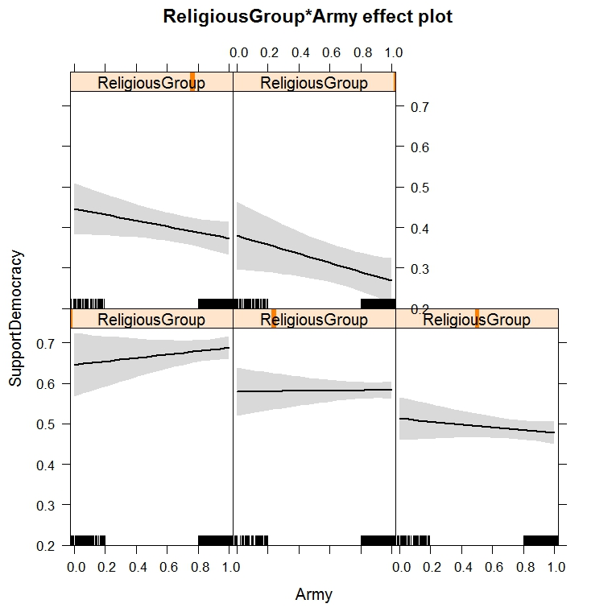
Legend: x-Axis bottom 0-No military Service 1-Veteran; x-Axis top: Religious group 0-Secular; 0.2-Traditional non-Religious; 0.4-Traditional Religious; 0.7-Modern Orthodox; 1-Ultra-Orthodox

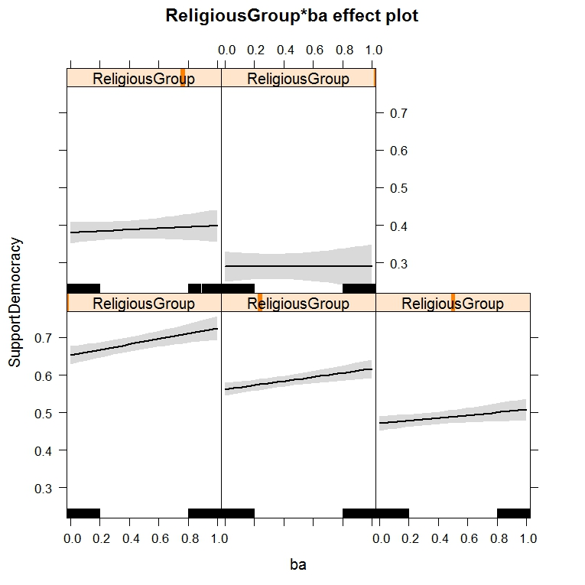
Figure A3 Interactive effect of Religiosity with University Degree on Support for Democracy
Legend: x-Axis bottom 0-No degree Service 1-Degree; x-Axis top: Religious group 0-Secular; 0.2-Traditional non-Religious; 0.4-Traditional Religious; 0.7-Modern Orthodox; 1-Ultra-Orthodox

Figure A5 Interactive effect of Religiosity with Army on Attitudes toward Conflict
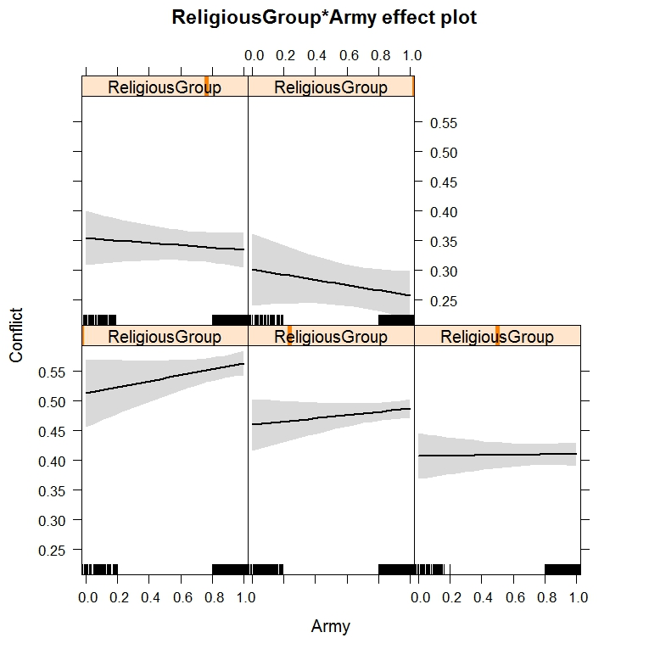
Legend: x-Axis bottom 0-No military Service 1-Veteran; x-Axis top: Religious group 0-Secular; 0.2-Traditional non-Religious; 0.4-Traditional Religious; 0.7-Modern Orthodox; 1-Ultra-Orthodox

Figure A6 Interactive effect of Religiosity with University Degree on Attitudes toward Conflict

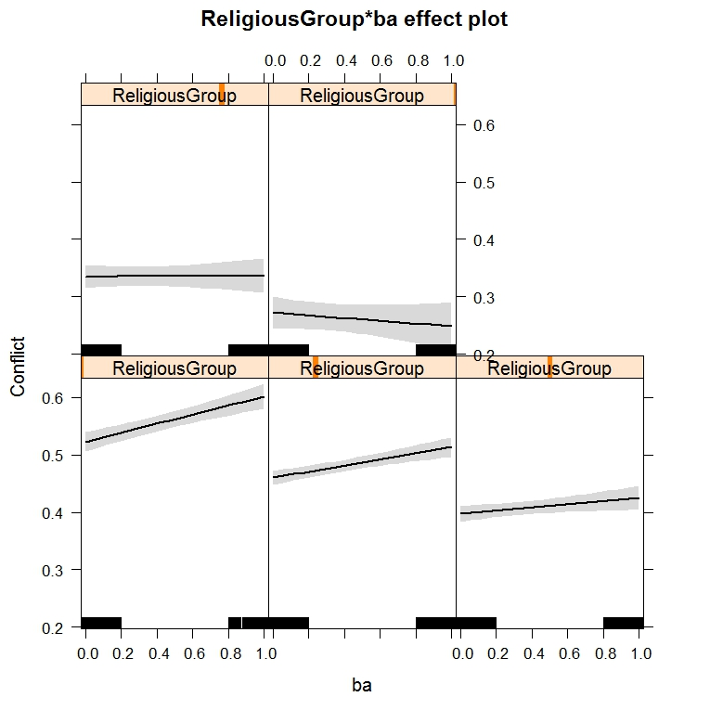
Legend: x-Axis bottom 0-No degree Service 1-Degree; x-Axis top: Religious group 0-Secular; 0.2-Traditional non-Religious; 0.4-Traditional Religious; 0.7-Modern Orthodox; 1-Ultra-Orthodox

Figure A7 Interactive effect of Religiosity with Army on Opposition toward state induced emigration of Arabs form Israel
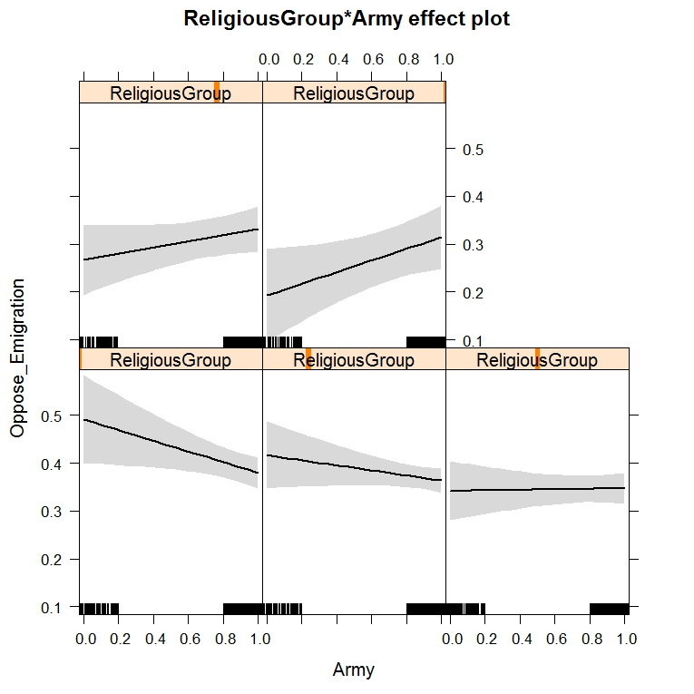
Legend: x-Axis bottom 0-No military Service 1-Veteran; x-Axis top: Religious group 0-Secular; 0.2-Traditional non-Religious; 0.4-Traditional Religious; 0.7-Modern Orthodox; 1-Ultra-Orthodox

Figure A8 Interactive effect of Religiosity with University Degree on Opposition toward state induced emigration of Arabs form Israel

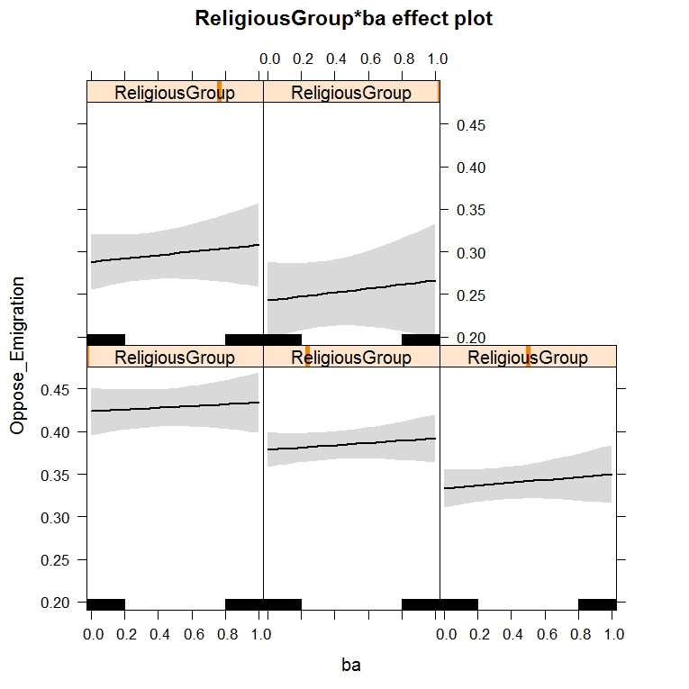
Legend: x-Axis bottom 0-No degree Service 1-Degree; x-Axis top: Religious group 0-Secular; 0.2-Traditional non-Religious; 0.4-Traditional Religious; 0.7-Modern Orthodox; 1-Ultra-Orthodox

References

Arian, Asher. 1995. Security Threatened: Surveying Israeli Opinion on Peace and War. New York, NY: Cambridge University Press
Jamal, Amal. 2011. Arab Minority Nationalism in Israel. New York, NY: Routledge.
Liebman, Charles, and Eliezer Don-Yehiya 1983. Civil Religion in Israel. Berkley, CA: University of California Press.
Rekhess, Elie. 2014. “The Arab Minority in Israel: Reconsidering the "1948 Paradigm." Israel Studies 19:187-217.
Shamir Michal and Shamir Yacob. 1995. “Competing Values in Public Opinion: A Conjoint Analysis.” Political Behavior 17:107-133.
Sullivan, J., Piereson, J., and Marcus, G. 1982. Political tolerance and American democracy. Chicago, IL: University of Chicago.

