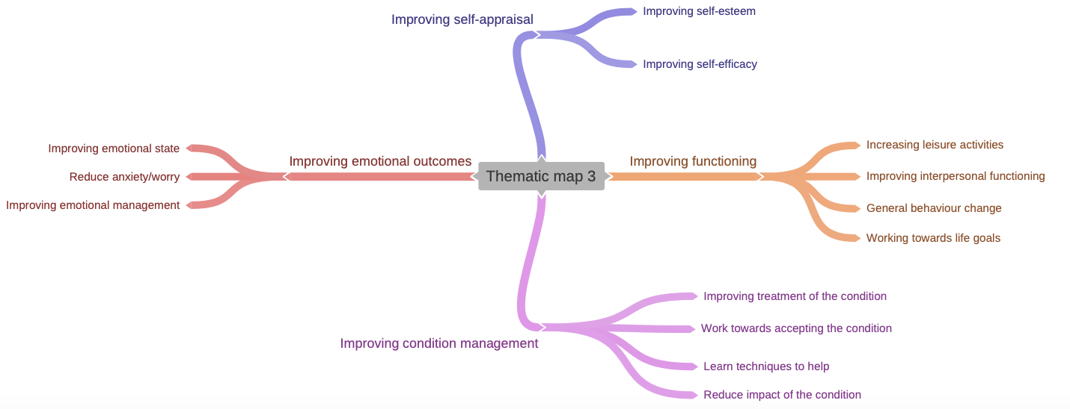
Supplementary information Figure 1. Finalised Thematic Map

Supplementary information Table 1. Theme distribution within groups
Themes |  | Improving Functioning |  | Improving Emotional Outcomes |  | Improving Condition Management |  | Improving Self-Appraisal
 |  | N | Percentage | N | Percentage | N | Percentage | N | Percentage
Gender | Male | 73 | 42.20% | 63 | 36.42% | 48 | 27.75% | 5 | 2.90%
 | Female | 134 | 48.60% | 99 | 35.87% | 47 | 17.03% | 15 | 5.43%
Age Group  (years) | 18-29 | 27 | 40.30% | 24 | 35.82% | 19 | 28.36% | 2 | 2.99%
 | 30-39 | 33 | 39.76% | 31 | 37.35% | 16 | 19.28% | 5 | 6.02%
 | 40-49 | 41 | 48.81% | 27 | 32.14% | 16 | 19.05% | 5 | 5.95%
 | 50-59 | 62 | 55.36% | 40 | 32.79% | 26 | 21.31% | 7 | 5.74%
 | 60+ | 37 | 44.58% | 38 | 45.78% | 15 | 18.07% | 1 | 1.20%
Primary physical condition | Chronic pain | 89 | 46.60% | 65 | 34.03% | 38 | 19.90% | 9 | 4.71%
 | Heart condition | 17 | 33.3% | 25 | 49.02% | 15 | 29.41% | 1 | 1.96%
 | Diabetes | 67 | 50.38% | 47 | 35.34% | 22 | 16.54% | 5 | 3.76%
 | Other | 33 | 42.86% | 26 | 33.77% | 19 | 24.68% | 5 | 6.49%
 | No Condition | 7 | 63.63% | 3 | 27.27% | 1 | 9.09% | 1 | 9.09%
Presenting Problems | Depression | 95 | 44.18% | 73 | 33.95% | 49 | 22.79% | 12 | 5.58%
 | Anxiety | 35 | 34.70% | 49 | 48.51% | 18 | 17.82% | 4 | 3.96%
 | Comorbid depression & Anxiety | 54 | 65.85% | 21 | 25.61% | 15 | 18.29% | 2 | 2.44%
 | Other | 4 | 44.44% | 4 | 44.44% | 2 | 22.22% | 0 | 0.00%
 | None | 26 | 49.06% | 19 | 35.85% | 11 | 20.75% | 0 | 0.00%
PHQ 9 | 0-4 (None) | 7 | 53.85% | 2 | 15.38% | 5 | 38.46% | 1 | 7.69%
 | 5-9 (Mild) | 15 | 45.45% | 13 | 39.39% | 8 | 24.24% | 1 | 3.03%
 | 10-14 (Moderate) | 46 | 42.20% | 40 | 36.70% | 25 | 22.94% | 6 | 5.50%
 | 15-19 (Moderately severe) | 50 | 46.30% | 38 | 35.19% | 22 | 20.37% | 6 | 5.56%
 | 20-27 (Severe) | 77 | 50.66% | 53 | 34.87% | 25 | 16.45% | 3 | 1.97%
 | No value present | 19 | 42.22% | 20 | 44.44% | 10 | 22.22% | 0 | 0.00%
GAD 7 | 0-4 (Minimal) | 12 | 40.00% | 11 | 36.67% | 10 | 33.33% | 1 | 3.33%
 | 5-9 (Mild) | 34 | 48.57% | 28 | 40.00% | 16 | 22.86% | 2 | 2.86%
 | 10-14 (Moderate) | 58 | 50.88% | 32 | 28.07% | 18 | 15.79% | 10 | 8.77%
 | 15+ (Severe) | 91 | 45.73% | 75 | 37.69% | 40 | 20.10% | 8 | 4.02%
 | No value present | 19 | 40.43% | 21 | 44.68% | 11 | 23.40% | 0 | 0.00%
WSAS | 0-9 (low impairment) | 28 | 52.83% | 17 | 32.08% | 13 | 24.53% | 2 | 3.78%
 | 10-20 (Moderate impairment) | 51 | 47.66% | 39 | 36.45% | 18 | 16.82% | 3 | 2.80%
 | 21-40 (Severe impairment) | 108 | 46.15% | 80 | 34.19% | 48 | 20.51% | 14 | 5.98%
 | No value present | 24 | 36.36% | 29 | 43.94% | 16 | 24.24% | 2 | 3.03%
SIMD | 1-2 | 31 | 34.83% | 34 | 38.20% | 26 | 29.21% | 4 | 4.49%
 | 3-4 | 64 | 44.76% | 55 | 38.46% | 29 | 20.28% | 6 | 4.20%
 | 5-6 | 41 | 46.07% | 32 | 35.96% | 19 | 21.34% | 6 | 6.74%
 | 7-8 | 37 | 62.71% | 16 | 27.12% | 7 | 11.86% | 1 | 2.56%
 | 9-10 | 20 | 48.78% | 13 | 31.71% | 9 | 21.95% | 1 | 2.44%
 | No value present | 21 | 53.85% | 16 | 41.03% | 5 | 12.82% | 3 | 7.69%

