Appendix 2a. Female presentation cards for the Linking Activating Events to Emotions Task (Reed and Clements, 1989)

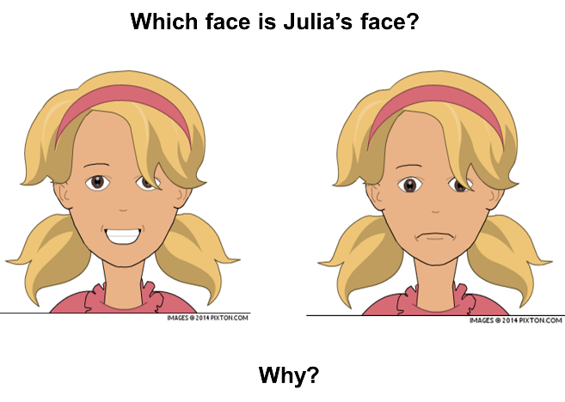

- 2.
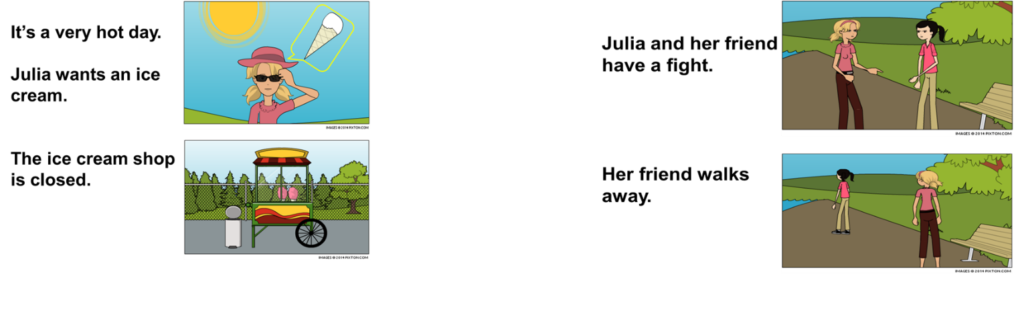
3. 4.
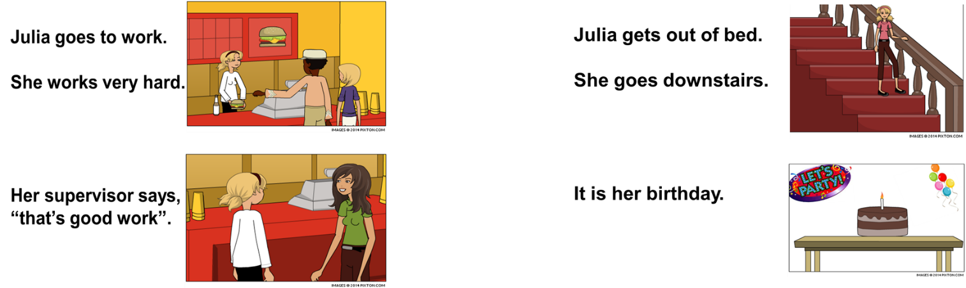

5. 6.
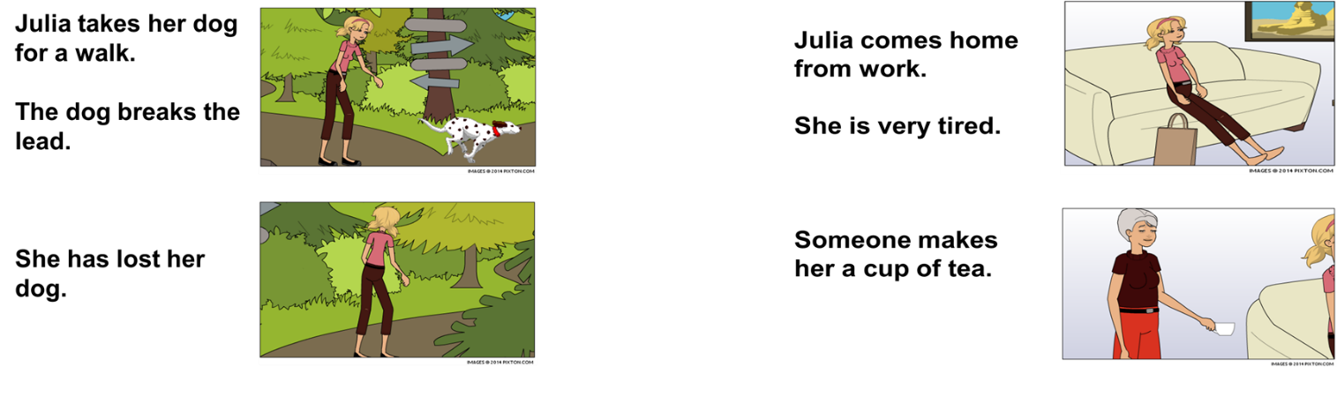

Appendix 2b. Male presentation cards for the Linking Activating Events to Emotions Task (Reed and Clements, 1989)
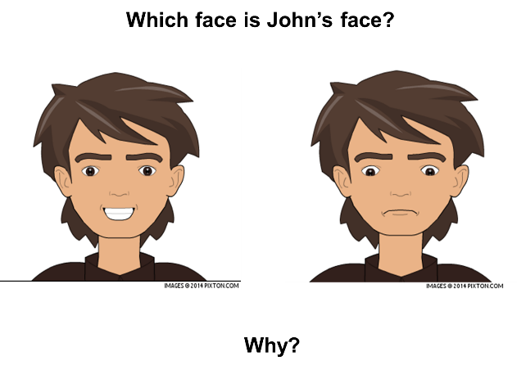

1. 2.
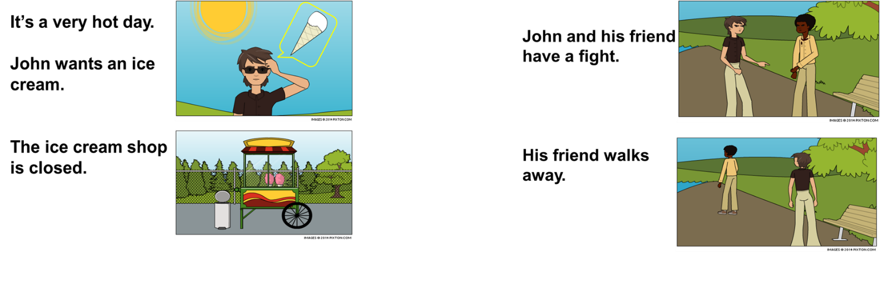

3. 4.
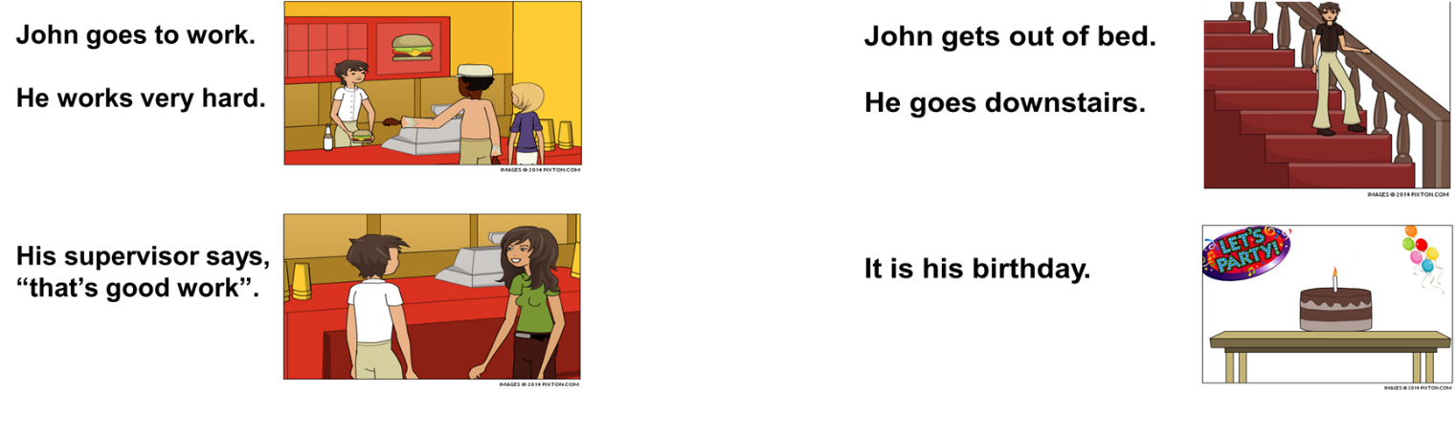

5. 6.
